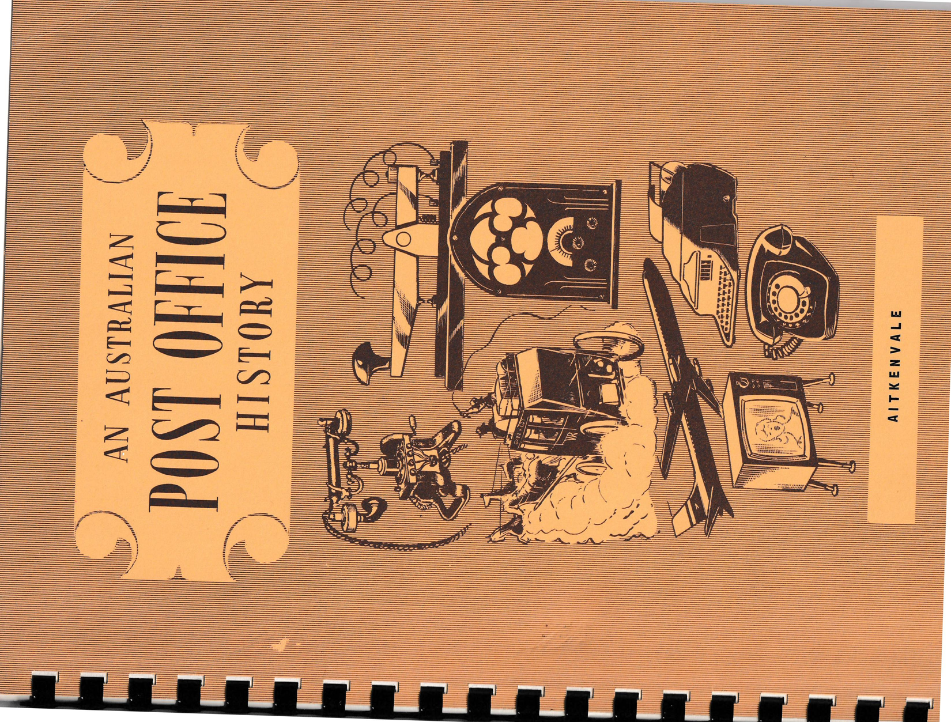
OFFICIAL OPENING - NEW POST OFFICE
AITKENVALE
MONDAY, 15TH NOVEMBER 1971, AT 4 P.M.
BY MR. R.N. BONNETT, FEDERAL MEMBER FOR HERBERT

PROGRAMME
(Chairman of the Day - Mr. J.T. Malpas, District Postal Manager)

Chairman invites Senator C.R, Maunsell to move a vote of thanks to Mr.Bonnett for performing the official opening.
Senator C.R. Maunsell.
Chairman asks for vote of thanks to be carried by acclamation.
Official party move to front of building where Mr. Bonnett unveils plaque which has been provided to record the official opening ceremony, then transacts first official business at Post Office,
4.00 p.m. - 4.05 p.m. | Chairman welcomes those present and invites Alderman C.S. Arnold, Deputy Mayor of Townsville, to present the Address of Welcome.
4.05 p.m. - 4.10 p.m | Alderman C.S. Arnold.
4.10 p.m. | Chairman introduces Senator J.B. Keefe.
4.10 p.m. - 4.15 p.m. | Senator J.B. Keefe
4.15 p.m. | Chairman invites Mr. R.N. Bonnett, M.P., to perform the official opening and hand key of new office to Postmaster, Mr. E.J.D. Neale.
4.15 p.m. 4.25 p.m. | Mr. R.N. Bornnett, M.P.
4.25 p.m. | Mr. Bonnett hands the key of the new building to the Postmaster, Mr, E.J.D. Neale.
4.26 p.m. | Mr. Neale responds.
4.28 p.m. | Chairman invites Senator C.R, Maunsell to move a vote of thanks to Mr.Bonnett for performing the official opening.
4.26p.m. – 4.35p.m. | Senator C.R. Maunsell.
4.33p.m. | Chairman asks for vote of thanks to be carried by acclamation.
4.35p.m. | Official party move to front of building where Mr. Bonnett unveils plaque which has been provided to record the official opening ceremony, then transacts first official business at Post Office,
4.40 p.m. | Visit of inspection of the building.

AN AUSTRALIAN POST OFFICE HISTORY Q/P.O.A. 74
AITKENVALE

Introduction

One of the largest suburbs of Townsville, Aitkenvale, lies about five miles south-west of the busy inner city. Its population three years ago was 3,800, now it is close to 5,000. Ultimately it is expected to reach 10,000. Modern houses and shopping complexes stand where aborigines roamed a hundred years ago while bitumen roads carry motor vehicles where once horse and drays stirred the dust of lonely bush tracks. Overhead jet aircraft streak across the sky where once only the magpies and kookaburras flew.
Times have changed and so has the face of the land. Everywhere you look the bush is falling before the blade of the bulldozer so houses, roads and shops can be built. Even so there are many old homes of yester years standing beside modern air-conditioned houses of today. Electric light line, water pipe and telephone cable reticulation provide the essential services upon which modern man has become so dependent. Yet the story of man's progress from early exploration and settlement days to the building of a city, the setting up of a port, and of postal and telegraph lines, the erection of schools, colleges, a university, churches, shops and Post Offices is so easily forgotten in the "helter skelter" of present day living.
The communications history of Aitkenvale is written to both preserve under one title as much as is known of this fascinating subject and at the same time help its readers remember the part played by so many in establishing a system of which they can feel proud. The pioneering, the service, the sacrifice, that made these facilities available to us today is the heritage of every northerner or Australian.
Early Days of Townsville
In order to trace the history of Aitkenvale it is necessary to go back to the beginning of Townsville, back more than two centuries. It was the courageous and far-sighted Captain James Cook who was the first white man to actually see the area, around Townsville. He sailed the "Endeavour" into Cleveland Bay on 6th June 1770 and named the large island "Magnetical Island". Cook described the hills of the mainland as "both high - the whole forming a surface, the most rocky and barren of any we have seen on the coast".
The next navigator to visit Cleveland Bay was Captain Phillip Parker King in the "Mermaid" on 14th June 1819.
Nothing more was heard of the area until about 1863 when James Morrell (Murrell), a castaway, returned to civilisation after 17 years enforced habitation with local native tribes.
First Settlement
Settlement really began after Captain Robert Towns, a wealthy Sydney business man acquired a leasehold of a wide strip of land from Port Denison (Bowen) to the Gulf of Carpentaria in the early sixties. He set up a chain of cattle stations in the north but these failed until he appointed a canny Scot, John Melton Black as organiser; field manager and co-owner of his vast Queensland pastoral interests. One of these properties was the "Fanning and Dolswood" at Woodstock. Black soon realised he needed a closer port than Bowen through which to ship tallow and hides and receive his mail and supplies. Consequently in April 1864, Black sent Andrew Ball and Mark Reid and a party of blacks to discover a suitable port. They approached Cleveland Bay by way of localities later named Aitkenvale, Mundingburra, German Gardens and round the western side

of Mount Cutheringa (Castle Hill), past the lagoon. Ball saw the advantages of setting up settlement by the delta mouth of the watercourse which he discovered and named Ross River after Andrew Ross a fellow explorer and pioneer grazier.
Port at Cleveland Bay
On their return Cleveland Bay was recommended as a port because of the advantages which it offered to the type of sailing vessels trading along the Queensland coast in those days. John Black was pleased with the report and immediately sought permission of Captain Towns to develop the Bay.
Towns, obtained a lease of crown land under the provisions of the Coffee and Sugar Cultivation Act at 10/- per acre so settlement could be set up. Black was despatched with a party of 16 men in October 1864 to Cleveland Bay. They arrived on 5th November 1864 and commenced the mammoth task of building a town. By January 1865 tremendous progress had been made, as piles were being driven for a wharf. By 31st July 1865 the area was so improved that the first land sale for the new lots was held at Port Denison (Bowen) following survey by A.C. Gregory, Queensland's first Surveyor-General.
Governor's Visit
A little later, in October, Sir George Bowen, first Governor of Queensland, made his only visit to Townsville where he was welcomed by the handful of pioneer builders.
Port of Townsville
On 10th October 1865, Mr. James Gordon, the first Police Magistrate, proclaimed Townsville a port of entry and by 16th February 1866 it was made a municipality. Mr. John Melton Black befittingly became the first Mayor of the new town.

And so the town grew. It had its first newspaper "The Cleveland Bay Herald and Northern Pioneer" published weekly from 3rd March 1866, the telegraph arrived on 15th March 1869, the first Pastoral and Agricultural Show was held, the railway was opened to Charters Towers in December 1882, the first telephone exchange (the fourth in the State) opened in November 1883, while many business houses were established and homes erected in new suburbs.
Origin of Name of Aitkenvale
One of the earliest vendors of suburban lands was Thomas Aitken who arrived in Townsville in 1867. He took up 3,500 acres on the Ross River and named it Aitkenvale. Mr. and Mrs. Aitken lived in a slab hut on the bank of the river but after several floods moved to a spacious new home near where the present Aitkenvale library is situated. The house was destroyed by fire in 1899. Aitken sub-divided the property for housing reserving 30 acres for himself and sold lots during one of Townsville’s early land booms. He died a wealthy man in 1897. Some of the Aitken family still live in Townsville today. The name given by its founder to the suburb remains today, as does several streets named after his daughters and himself - Charlotte, Elizabeth and Aitken Streets.
First Post Office
A Post Office was opened at Aitken Vale (sic) in 1896. No record was made of the name of the Postmaster or his salary. However, the Post and Telegraph Guide of July 1898 list Mr. E. Kerry as Officer-in Charge of the Post Office. This and the October issue appears to be a more accurate record than the Annual Report to Parliament for 1898, which shows "E.J. Kerly" as Postmaster on a salary of £12 p.a.
At that time Mr. E. Da Costa was the Townsville Official Postmaster

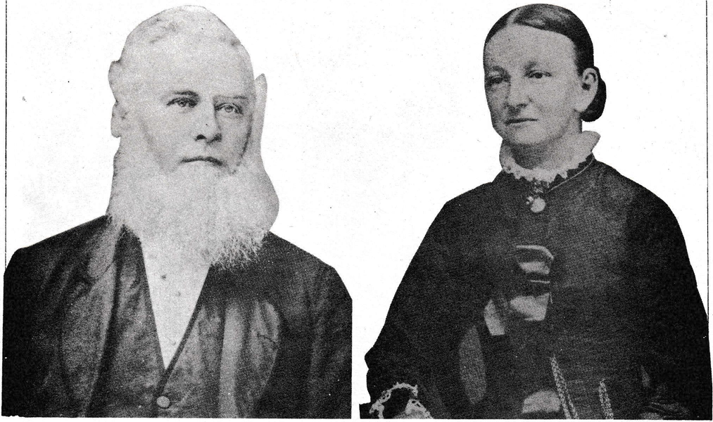

Thomas and Margaret Aitken who first settled at Aitkenvale in 1867.

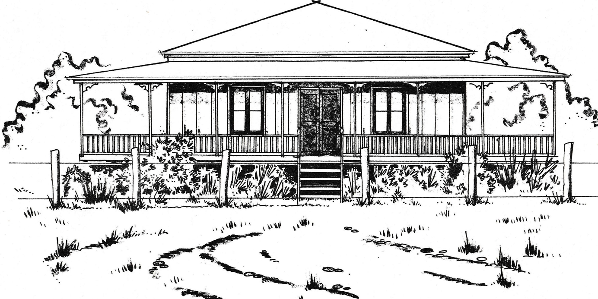
Residence of Mr. & Mrs. Thomas Aitken located just off the present Ross River Road near Aitkenvale Library. Destroyed by fire in 1899.
with Mr. T.A. Gulliver, Officer-in-Charge of the Telegraph Office, and a Railway official in charge of the Railway Telegraph Station.
In 1899 Aitken Vale was listed as an Unofficial Post Office and in 1902 Mrs. A. Da Costa was Postmistress. Townsville was the Post Town for Aitken Vale at the time.
Early Mail Services
Coastal Shipping
For pioneers like Black, Reid, Ross, Towns, Walker and others, the only way for them to receive mail was through Bowen until their own port was established. The only means of reaching Cleveland Bay from Brisbane or other southern ports was by steamer - the "SOS. Williams", under Captain Cattier of the A.S.N. Co. to Rockhampton, then by schooners, or at intervals of every 4 to 6 weeks, a small steamer the "Tinonee" to Bowen, then to Cleveland Bay.
With the proclamation of Townsville as a port in 1865, Mac Leod, Carter and Co., Merchants, were the first to despatch a vessel to the new port. This was the "Amy" under Captain Major which entered Ross Creek and discharged her cargo of provisions and station supplies at Towns wharf. While no record is had of the carriage of mail, no doubt unofficially, private letters and the like were handled on this trip. Other vessels such as the schooners "Ariel", "Three Brothers", the Brig "Amerst" from
Sydney and the steamer (A.S.N. Co.) "Diamentina" followed. Early settlers had to make what arrangements they could to get their mail to and from these early settlements until official contracts to handle the Royal Mail were established by the Postal authorities in Brisbane.
Steamer Mail Service
One of these was Mail Service No. 273 which operated in 1882 by coastal steamer from Brisbane to Cooktown calling at Keppel Bay,
Flat Top Island (Mackay), Bowen, Townsville, Cairns and Port Douglas, once
a week. Other Companies, including the largest, was the A.S.N. Co. which operated coastal services. However, in 1883 the Queensland Government decided to gain more control of shipping services and the Queensland Steam Shipping Co. was formed. Ships included the "Archer", "Corea", "Polly", "Truganini", "Gympie" and "Gunya". Later the "Barcoo", "Maranoa" and "Warrego" were added to the fleet.
The "S.S. Barcoo" was a Mail steamer which operated between Brisbane and Townsville between 1884 and 1905. It was replaced by the "S.S. Bingera", the first turbine ship to sail the Australian coastal waters from 1905.
Thus Townsville inhabitants including those at Aitken Vale were serviced by the early coastal steamers before the advent of the railway line from Brisbane in 1924. Indicative of these early services is a notice in the Post and Telegraph Guide of July 1898 under "Table of Despatch and Arrival of Inland Mails":
Post Town | Mail Closes at G.P.O. (Brisbane) | Mails Arrives at P.O. | Maisl Close for Brisbane | Mails Arrive at G.P.O.
Aitkenvale | Steamer to Townsville thence daily except Sun. 9 a.m. | Daily Except Sun 10.15 a.m. | Daily except Sun.  10.45 a.m. | Steamer from Townsville

Nearest Telegraph Office
Townsville
Road Services and Contractors
One of the earliest official mail services to Aitkenvale was by horse from the Townsville Post Office via the Ross River Meatworks six times a week. The contractor was Mr. Christian Mathiesen of Townsville who was paid t40 p.a. for his services. He held the contract for the years 1898-1900.

Apparently, this run was No. 571 as the Post Office General Notices of 1902-1911 lists it as the Townsville-Aitken Vale Mail Service. On 1st January 1906 the frequency was increased to twice daily. In 1910, Mr. Richard Lee was the Mail Contractor and operated the service via Flinders Street, West End, Hermit Park and Ross River Meat Works - a distance of 7 miles twice a day by omnibus. He was paid £1 a week for his service. Mr. Henry Madden had the run in 1912 but with a reduced distance to 5 miles. Then the Townsville Motor Omnibus Co. Ltd. held the contract from early 1913 for 3 years to terminate at the end of 1915.
It is believed that drays and coaches carrying mail and other goods travelled along the Ross River Road which was once the early road to Charters Towers.
Receiving Offices
A Receiving Office (where mail only was received) was established early in the 1900s at Mrs. Ridges' store, afterwards at Mrs. Hansen's (a Mr. A. Hansen lived in Grosvenor Street in 1905) and then at the Aitken Arms Hotel. However, as parents objected to children collecting mail at the bar and in line with Post Office policy to obtain more suitable accommodation, the office was transferred to Mrs. Chas Kidner's (Jane) general store. The store was situated on the old Charters Towers Road (now Ross River Road) opposite the Mundingburra State School. No date of her taking over the office is available but she had the office for about 9 or 10 years. The hours were 9 a.m. - 6 p.m.
On 1st April 1920, Mrs. Kidner sold her business to Mrs. Ellen C. Mohr who was appointed Receiving Officer on an allowance of £10 p.a. Then on 20th March 1922, Mrs. Mohr sold out to Mrs. Elizabeth
Williams who because of increased postal business was paid £16/10/® p.a. for her duties.

Post and Postal Note Office
The Receiving Office was raised in status to Post and Postal Note Office from 1st July 1923.
A Public Telephone was provided opposite the Golf Links on 5th December 1923. By this time the need for telephonic communication had increased and the private telephone of the Postmistress, Mrs. Williams, was used to provide Trunk Telegraph Services (by telephone) from 18th January 1924.
Hours of service | 9 a.m. – 10 a.m. | Monday to Friday
 | 4 p.m. – 6 p.m. | Monday to Friday
 | 9 a.m. - 12 noon | Saturday

Actually the Postmistress provided a service exceeding the stipulated hours. She attended the telephone from 8 a.m. - 9 p.m. Monday to Saturday.
A Coin Operated Public Telephone was provided at the Post Office from 19th February 1925 so providing an after hours service.
Various Postmasters/Postmistresses
The Williams’ sold their store business to Mr. William Couling on 25th April 1924 and he was appointed Postmaster. The store changed hands as follows:
Mr. Donald Grant on 28th November 1924 | appointed Postmaster
Mrs. Gladys Winifred Rann on 1st April 1927 | appointed Postmistress
Mrs. Johan Grass on 3rd November 1927 | appointed Postmistress
Mr. James Lindsay on 21st October 1935 | appointed Postmaster
Mr. Douglas C. Bennetto on 1st March 1938 | appointed Postmaster

Unfortunately, the records are silent on the names of those who followed until the post war period.

New Facilities
In the meantime Age and Invalid and War Pensions were issued for the first time from this office on 27th June 1929. Then on 19th October 1929 a Savings Bank Agency for deposits only was established. However, on 1st January 1935 the Savings Bank facility at the Post Office was closed and a full private agency opened with the Postmaster, Mr. Grass.
Aitkenvale Non-Official Office
The office was classified as a full-time service Non Official Office from 1st July 1944 as the business conducted during 1943/44 justified this. The increase was due to the concentration of troops in the area, so the Superintendent, Postal Services, observed in August 1944.
The office continued to cater for increased business and on 10th September 1945 was elevated to a Money Order Office. The office at the time provided full postal, telegraph and telephone and Savings Bank facilities.
Proposal to extend Post Office Facilities in South-West Suburbs
The Aitkenvale Non-Official Post Office, was actually located in what is known today as Mundingburra and as the suburbs were expanded and new ones developed, extended postal services were required by the residents.
In a report of 7th November 1945 the Deputy Director, Posts and Telegraphs, stated with regard to a petition for extention of facilities at
Aitkenvale:
"The district in respect of which the petition was lodged extends beyond this office (Aitkenvale) on the Harveys Range Road, the largest settled area of which is around Woolley's store, which is situated approximately one mile and a half from the Aitkenvalle Post Office. Aproximately 200 persons reside within a reasonable
distance of this store and there are another 50 residents further
out. Three small shops are the only business establishments in
the locality.
"A bus service runs from Woolley's store to Townsville, via Aitkenvale daily, leaving the starting point at 8 a.m., 10 a.m., 11 a.m., 2 p.m., 4. p.m., 6 p.m., 7 p.m. and returning at appropriate times.
” An official daily letter delivery from Townsville extends to within 400 yards of Woolley's store and the remainder of the residents in that locality are served by a twice weekly mail service.
All the signatories of the petition receive their mail by means of this mail service.
"It is intended to review the Townsville letter delivery in the near future when it may be found possible to extend one of the rounds to serve at least portion of the residents near Woolley's store."
He went on to say that because of the existing facilities provided in the area there was no justification for the establishment of another Post Office. However, arrangements were made to issue a stamp licence to Mr. Woolley and to extend the letter delivery.
New Office Established
Nevertheless, the residential area continued to grow and the demand for postal services increased and so approval was granted for the establishment of a Non-Official Post Office at Mr. George Woolley's store at the corner of Harveys Range Road (Ross River Road) and Anne Street,
Aitkenvale West. The office was to be called Aitkenvale West.

Change of Names
When the Aitkenvale Non-Official Office was established, it served a large "sprawling" area of residences and businesses extending over the western suburb of Townsville. However, with the development of Aitkenvale into several suburbs additional Post Offices were required. This meant that some existing Post Offices in order to preserve their appropriate geographic place name needed a name change.
Aitkenvale was one affected as it was situated in the middle of the suburb of Mundingburra; Aitkenvale West was another. It was in the middle of the suburb of Aitkenvale.
After consideration of the problem the Postal authorities changed the names of the following offices:
Aitkenvale to Mundingburra
Aitkenvale West to Aitkenvale
from 1st December 1955.
Location of Offices
The Mundingburra office was located on the site - Resub 1 and 2, Sub 74, Portion 2A, Parish to Coonambelah, County of Elphinstone.
It was moved to a new location on 12th December 1969 at the corner of Ross River Road and Water Street, Mundingburra. Aitkenvale was located at the corner of Anne and Ross River Road, facing Anne Street.
"New" Aitkenvale (previously Aitkenvale West)
Prior to its change of name, Mr. Woolley was Non-Official Postmaster and were delivered by a private contractor twice weekly. There was no public telephone.
However, on 1st November 1952, Mr. James E. Rollinson was appointed Postmaster and he was followed by Mr. Sidney C Phillips on 16th March 1953.
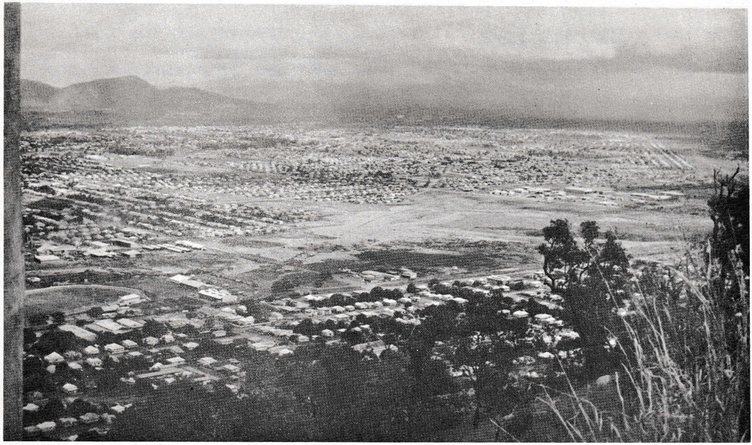
Panoramic view of the suburbs of Aitkenvale, Mundingburra, Gulliver, Vincent and Heatly, with Mt. Stuart (1915 ft.) in background.

On 1st April 1954 the office was elevated to a Money Order Office and the office was faced into Ross River Road. Wireless licences were issued from the same date.
Public Telephone facilities were established at the Post Office during 1954.
Destroyed by Fire
The Aitkenvale Non-Official Post Office and store was destroyed by fire on 22nd January 1959 at about 3 a.m. Mr. Phillips was Postmaster at the time. He offered the front room of his residence in Wotton Street (between Anne and Aitken Streets) as a temporary Post Office. This was accepted. Fortunately the public telephone and multi-coin, attachment were undamaged so full postal and telephone facilities were restored on the day of the fire.
New Premises
Following the fire the Postmaster planned to erect new premises adjacent to the previous site within three months. Actually Mr. L.C.S. Phillips (father of the Postmaster) commenced erection of the new Post Office premises in June 1959. The building was expected to be completed by July 1959, In fact the Post Office was removed to these new premises of concrete and brick (Resub 2, Sub 8 of Section 2, of Sub 2, of Portion 38, County of Elphinstone, Parish of Connambelah) across Anne Street in Ross
River Road in a new block of shops on 6th August 1959, Mr, Phillips conducted the Post Office in conjunction with a modern self service store.
Assistance to Postmaster
Assistance to the Postmaster to the extent of 10 hours weekly was provided by Mrs. Phillips at Departmental expense. Mr. Phillips also employed Mrs. G. C. Krause as an assistant (without Departmental assistance).
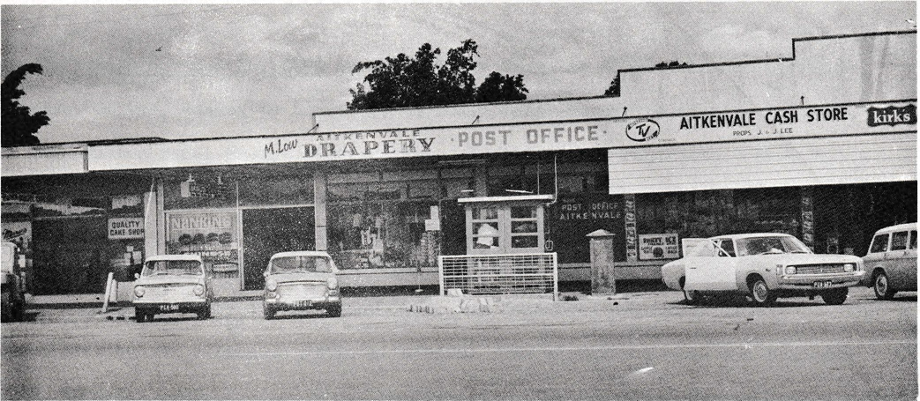
Aitkenvale Non-Official Post Office, Ross River Road, Townsville. (Photo AUG. 1971)
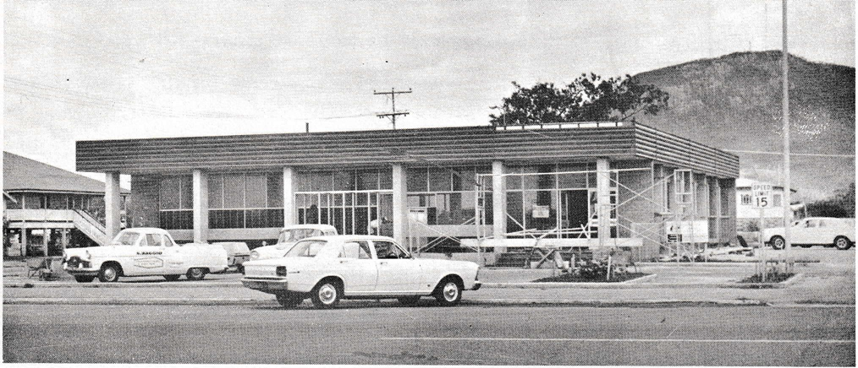
New Aitkenvale Post Office in course of erection at the corner of Elizabeth and Ross River Roads, Aitkenvale. Mt Stuart in background.

Porterage Service No 2094 operated daily from the Aitkenvale Non-Official Post Office, Monday to Saturday, to small farmlets and residences in the Rassmussen rural area. Letters were carried by the contractor, Mrs. M. Horscroft, a distance of 20 miles by her motor vehicle.
Proposal to Elevate Office to Official Status
As early as September 1968, the Department was considering elevating the office to Official status. At the time postal and telegram deliveries were effected from the Vincent Postal Depot and Hermit Park Official Post Office respectively. Investigations were made into the amount of business being handled at the office and its potential growth with the result that approval was given on 14th July 1969 to elevate the office following the erection of a new building.
Resignation of Postmaster
Mr. S.C. Phillips resigned on 16th August 1969 and the position of Postmaster was filled on a temporary basis (pending erection of the new Official office) by Mr. Bede Roggenkamp of Gulliver on 18th August 1969. However, he was appointed permanently in October 1969.
Mr. Roggenkamp remained in this position until the opening of the new office.He was assisted by his wife.
New Post Office Site
Property was acquired for the erection of the new Official Post Office building on -
Lot 3, Reg, plan No. 24332, Parish of Coonambelah,
County of Elphinstone
at 56-58 Elizabeth Street, Aitkenvale, Q. 4814, which was between Ross River Road and Patrick Street.

Rossvale Non-Official Post Office
In the meantime a Non-Official Post Office was established in Brampton Avenue at the Rossvale Shopping Centre on 1st April 1968, with Mrs. D.M.B. Tweed as Postmistress. Hours of service were 9 a.m. - 5 p.m. Monday to Friday and 9 a.m. - 12 Noon Saturday. At the time telegrams were delivered from the Hermit Park Official Post Office and mail from the Vincent Postal Depot.
Contract Let for New Post Office Building
A contract was let for the construction of the new Post Office building to J, Scott Pty. Ltd., Fleming Street, Aitkenvale, on 6th January 1971, at a contract price of $121,490 for completion in October 1971. Plans and specifications were prepared by the Commonwealth Department of Works in collaboration with the Buildings and Properties Section, Engineering Division of the Australian Post Office (Qld.). Officers from both these Departments supervised the construction of the building.
Completion Date
The attractive building was completed by the contractors on 26th October 1971.
Description of Building
The new office consisted of a single storied building with reinforced concrete frame expressed externally. Attention was given to aluminium sun shields on the eastern and western aspects while the deep facia was designed to harmonise with the nearby shopping complex buildings. The roof was made of steel decking.
Internally, rotary cut and sliced plywood panelling was used attractively in the public space and Postmaster’s office. The building

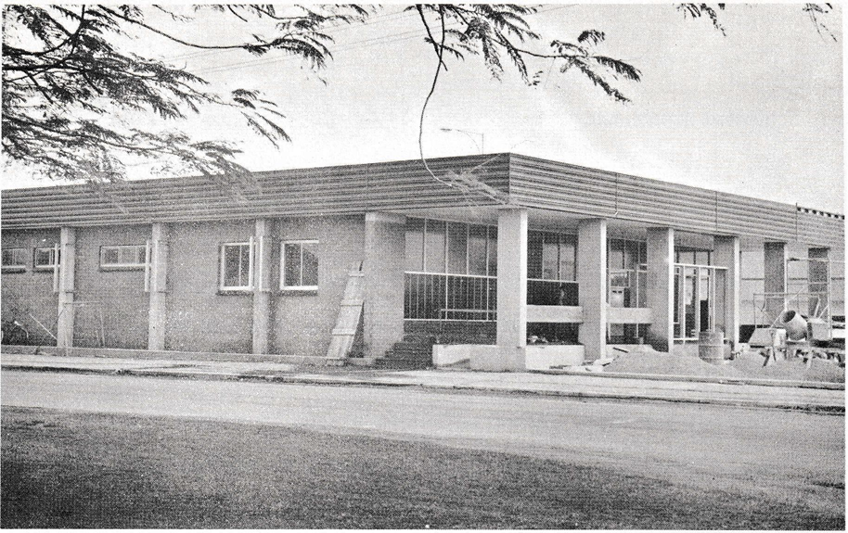
Aitkenvale Official Post Office in course of erection. (Photo AUG 1971)
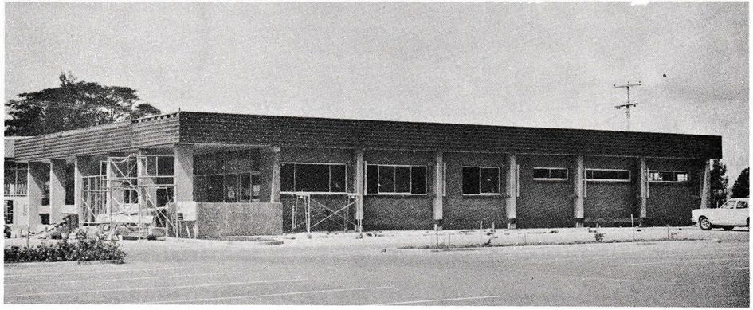
Side View of new Aitkenvale Official Post Office during erection. (Photo AUG 1971)

Official Opening
The Grade III office was officially opened on Monday, 15th November 1971, at 4 p.m., by Mr. R.N. Bonnett, Federal Member for Herbert, on behalf of the Postmaster-General, Sir Alan Hulme.
A large number of guests including local, State and Federal dignitaries; descendants of Thomas Aitken, founder of Aitkenvale, and representatives of various organisations were present at a function on that day to celebrate its opening. Mr. J. Malpas, District Postal Manager, representing the Director, Posts and Telegraphs, Mr. J.H. Curtis, was Chairman of the function.
Unveiling of Plaque
Mr. Bonnett also unveiled a bronze plaque set in the brickwork at the entrance to the public space. The wording read:
THIS POST OFFICE WAS OPENED
ON 15TH NOVEMBER 1971
BY
MR. R.N. BONNETT, M.P.
Closure of Offices
In view of the close proximity (0.6 mile) of Rossvale and Aitkenvale Non-Official Post Office (0.5 mile) to the new Official Post Office at Aitkenvale, these two offices were closed concurrently with the opening of the new official office located in the shopping complex between Ross River Road and Patrick Street. It was considered that the new office would adequately provide the necessary service for the area.

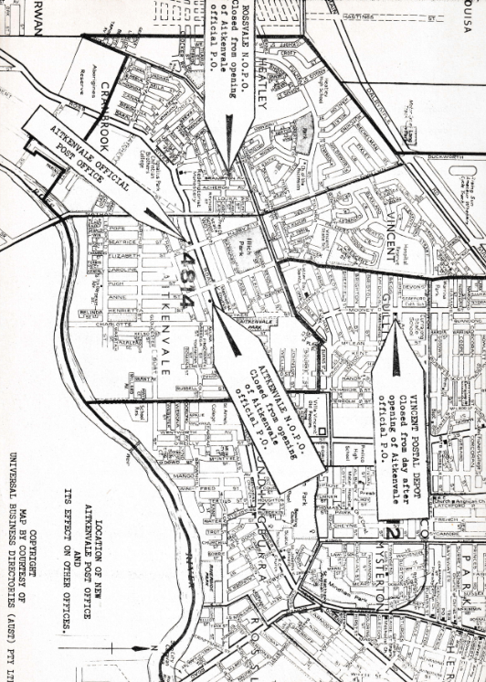
The Vincent Postal Depot, Mooney Street, was likewise affected. Up to its closure on the day after the opening of the Official office at Aitkenvale (16.11.71) mail was delivered to suburbs of Aitkenvale, Vincent, Heatly, Cranbrook, Garbutt and Kerwan.
Mr. Trevor Ashwell was Postman-in-Charge of 4 permanent Postmen, 2 exempt Postmen and one relief Postman. He was responsible to the Postmaster, Hermit Park.
One Postman rode a motor scooter on his rounds to the outer area of the delivery run while the others used bicycles.
Post Office Staff and Facilities
The new office opened with a staff of 15 including 7 Postmen transferred from the Vincent Postal Depot. The official Postmaster was Mr. E.J.D. Neale with a staff consisting of a Senior Postal Clerk Grade I,
2 Postal Clerks, a Postal Officer Grade I, 2 motor cyclist Postmen, one Postman-in-Charge, 6 Postmen and 1 Labourer (Cleaner).
Full postal facilities included the sale of postage and tax stamps, money and postal orders and other postal stationery; the issuing of Wireless and Television licences; Savings Bank facilities and 247 private boxes in various sizes with space for more if needed.
Mails were despatched twice daily to Townsville and this included parcels. However, parcel delivery in the Aitkenvale area was handled from the Townsville office.
Telephone facilities consisted of two multi-coin and one local call public telephone with provision for a Subscriber Trunk Dialling (S.T.D.) public telephone to be installed later.

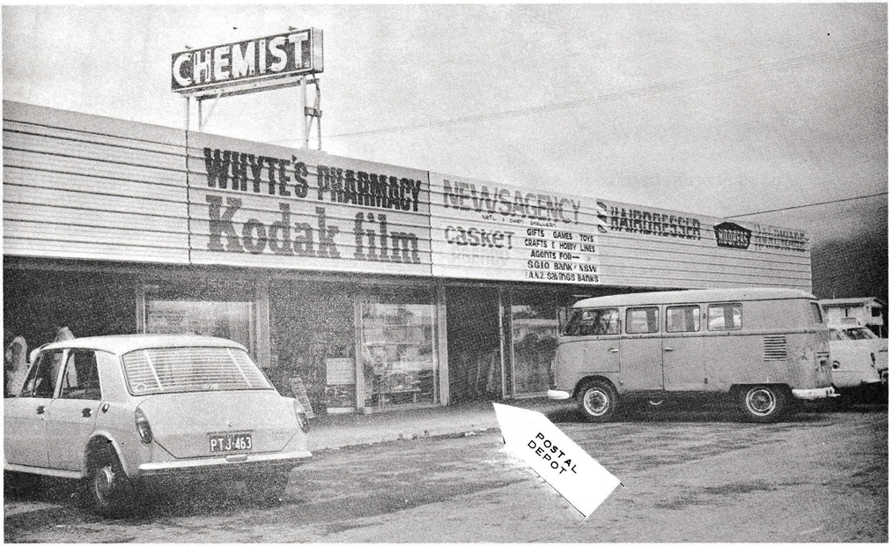
Vincent Postal Depot, Mooney Street, Gulliver, Townsville. (Photo AUG 1971)
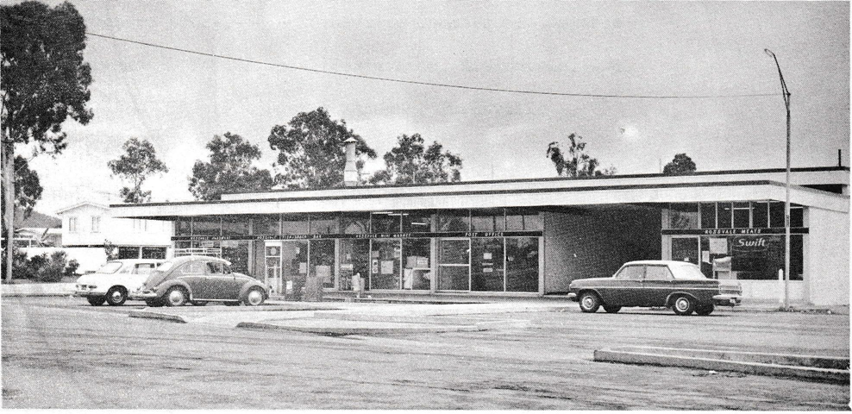
Rossvale Non-Official Post Office, Brampton Avenue. Closed from opening of new Aitkenvale Post Office. (Photo AUG 1971)
Conclusion
For more than 75 years the Post Office has provided service to the people at Aitkenvale and nearby areas. It has been proud to serve and with the modern facilities now available in the new office plans to go right on serving its customers across the street or across the world.
References and Acknowledgements
Official Post Office Files
Commonwealth Archives, Cannon Hill, Brisbane
Pughs Almanacs
Brisbane Post Office Directory and Country Guides
Reports to Parliament (Q) Votes and Proceedings 1863-1898
Post and Telegraph Guides
Townsville Jubilee Carnival Programme 1863-1913 (Aug.)
"Townsville 100" 1864-1964
Jubilee Brochure 1882-1932 - Townsville Chamber of Commerce
Mr. B. Roggenkamp, Non-Official Postmaster, Aitkenvale, Qid.
Mr. J.T. Malpas, District Postal Manager, Townsville
Mr. John Aitken, Mundingburra, Townsville, Qld.
Mr. S. Phillips, Mimosa Hotel, Bowen, Qld.
Public Relations Officer, Townsville Council.
Researched and written by Malcolm M. Rea Historical Officer October 1971. | Issued with the compliments of the Public Relations Section, 1st Floor, G.P.O., BRISBANE.  Australian Post Office

STATEMENT OF BUSINESS TRANSACTED
Office: AITKENVALE Status: N.O.N.M.O. (F.T.S.) District: TOWNSVILLE
MUNDINGBURRA AITKENVALE
ITEM |  | 1954/55 | 1960/61 | 1969/70
MAILS HANDLED ANNUALLY | Despatched  Received | -  - | -  - | 490  572
ORDINARY MAIL POSTED | Group “A”  Group “B”  Parcels | 17,388  2,841  377 | 36225  2,607  540 | -  8,905  2,938
CERTIFIED MAIL POSTED |  |  |  | 176
ORDINARY MAIL RECEIVED | Group “A”  Group “B”  Parcels | 17,310  5,018  221 | 14,242  -  130 | 75,004  13,962  462
ORDINARY MAI REDESPATCHED | Group “A”  Group “B”  Parcels | -  -  - | -  -  - | 4,394  864  26
OTHER MAIL POSTED | Registered Articles  Registered and Insured Parcels  C.O.D. and Customs collect Articles | 803  196  - | 758  84  - | 1300  147  1
OOTHER MAIL RECEIVED | Registered Articles  Registered and Insured Parcels  C.O.D. and Customs collect Articles | 285  57  418 | 279  50  307 | 619  102  286
CERTIFIED ARTICALES RECEIVED |  | - | 16 | 399
TELEGRAMS | Originating  Terminating | 1,242  4,229 | 1,406  6,197 | 3,465  983
POSTAGE STAMP SALES | Inc. Bulk post on M0101 | 529 | 1,520 | 19,067
DUTY STAMPS AND PROM NOTES |  | 1 | 22 | 231
TAX INSTALLMENT STAMPS | Swine and Cattle Duty | 29 | 64 | 11,954
POSTAL ORDERS | Issued  Paid | 1,051  170 | 1,274  - | 3141  734
TELEPHONE ACCOUNTS | PAID | - | 59 | 547
LICENCES ISSUED | TV Broadcast | 129 | 237 | 768
W.S.H. | No of repayments | - | - | 661
EXPENDITURE VOUCHERS | No. of individual Payments | - | - | 51
MONEY ORDERS | Issued  Paid | 749  134 | 836  121 | 3,095  815
SAVINGS BANK | Deposits  Withdrawals  Remittances | 1,979 | -  -  - | 998  1,018  -
PENSIONS PAID | Age, Invalid, Widows | 1,350 | 1,282 | -
CHILD ENDOWMENT | No of Payments | 1,528 | 2,092 | 28
WORK UNITS EARNED | (Non-official Offices) | - | 152,151 | 226,854

