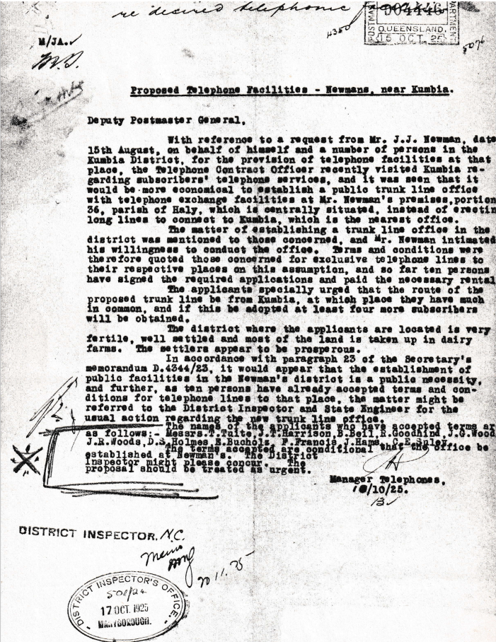

Proposed telephone Facilities - Newman’s near Kumbia.
Deputy Postmaster General,
With reference to a request from Mr. J.J. Newman, date 15th August, on behalf of himself and a number of persons in the Kumbia District, for the provision of telephone facilities at that place, the Telephone Contract Officer recently visited Kumbia regarding subscribers telephone services, and it was seen that it would be more economical to establish a public trunk line office with telephone exchange facilities at Mr. Newman's premises, portion 36, parish of Holy, which is centrally situated, instead of erecting long lines to connect to Kumbia, which is the nearest office.
The matter of establishing a trunk line office in the district was mentioned to those concerned, and Mr. Newman intimated his willingness to conduct the office. Terms and conditions were therefore quoted those concerned for exclusive telephone lines to their respective places on this assumption, and so far ten persons have signed the required applications and paid the necessary rental.
The applicants specially urged that the route of the proposed trunk line be from Kumbia, at which place they have much in common, and if this be adopted at least four more subscribers will be obtained.
The district where the applicants are located is very fertile, well settled and most of the land is taken up in dairy farms. The settlers appear to be prosperous.
In accordance with paragraph 23 of the Secretary’s memorandum D.4344/23, it would appear that the establishment of public facilities in the Newman's district is a public necessity, and further, as ten persons have already accepted terms and conditions for telephone lines to that place, the matter might be referred to the District Inspector and State Engineer for the usual action regarding the new trunk line office.
The names of t he applicants who have accepted terms are as follows:- Messrs T. Tuite, J. T. Harrison, B. Beil, R. Goodhind, J.G. Woods, J. R. Woods, D.S. Holmes, E. Bucholz, F. Francis, J. Hams, C. E. Suley.
The terms accepted are conditional that the office be established at Newman’s. The District Inspector might please concur. The proposal should be treated as urgent.

Manager Telephones,
10/10/25.

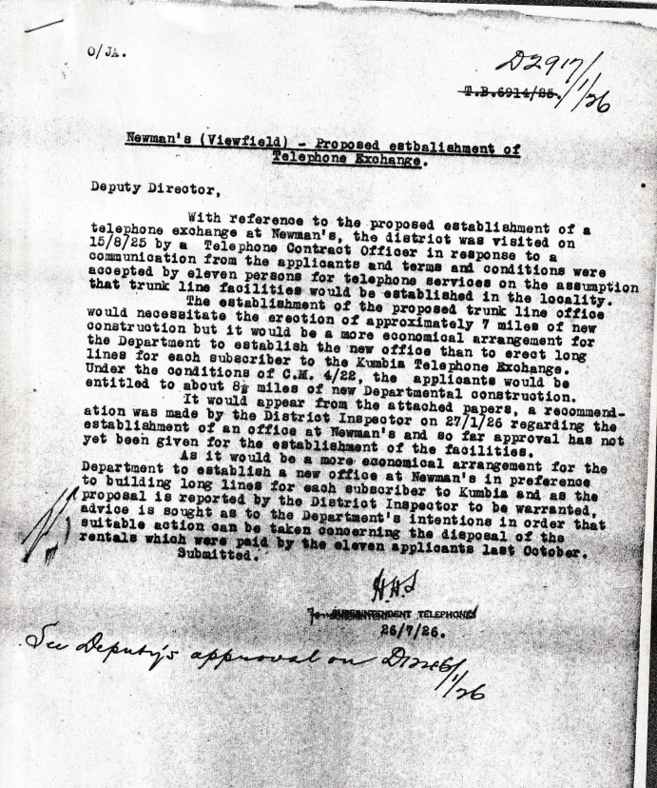

Newman's (Viewfield) - Proposed establishment of
Telephone Exchange.

Deputy Director,
With reference to the proposed establishment of a telephone exchange at Newman's, the district was visited on 15/8/25 by a Telephone Contract Officer in response to a communication from the applicants and terms and conditions were accepted by eleven persons for telephone services on the assumption that trunk line facilities would be established in the locality.
The establishment of the proposed trunk line office would necessitate the erection of approximately 7 miles of new construction but it would be a more economical arrangement for the Department to establish the new office than to erect long lines for each subscriber to the Kumbia Telephone Exchange.
Under the conditions of Ca. 4/22, the applicants would be entitled to about 8 miles of new Departmental construction.
It would appear from the attached papers; a recommendation was made by the District Inspector on 27/1/26 regarding the establishment of an office at Newman's and so far, approval has not yet been given for the establishment of the facilities.
As it would be a more economical arrangement for the Department to establish a new office at Newman's in preference to building long lines for each subscriber to Kumbia and as the proposal is reported by the District Inspector to be warranted, advice is sought as to the Department's intentions in order that suitable action can be taken concerning the disposal of the rentals which wars paid by the eleven applicants last October,
Submitted.

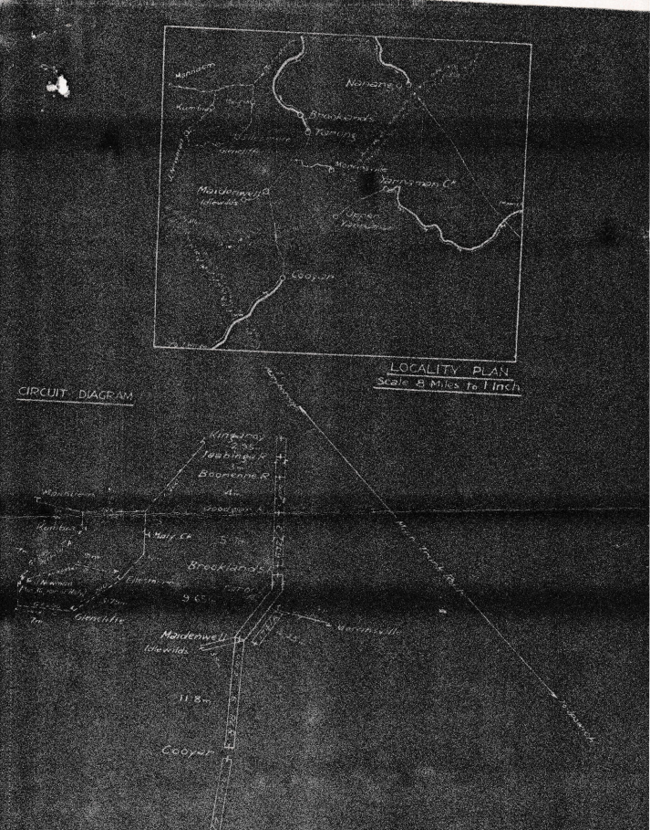

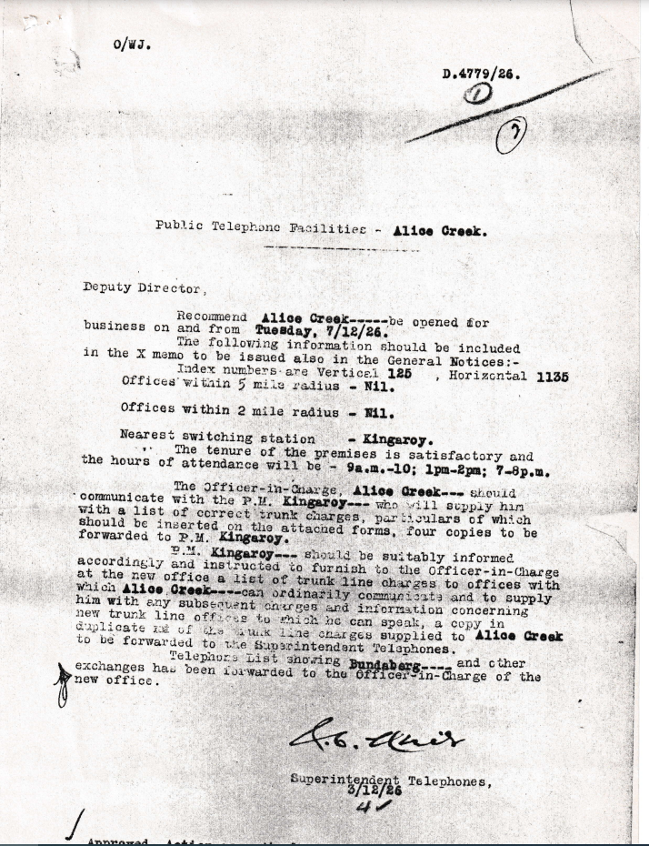
Public Telephone Facilities - Alice Creek.
Deputy Director,
Recommend Alice Creek be opened for business on and from Tuesday, 7/12/26.
The following information should be included in the X memo to be issued also in the General Notices:
Index numbers -are Vertical 126 , Horizontal 1135
Offices’ within 5 mile radius - Nil.
Offices within 2 mile radius. Nil.
Nearest switching station--- Kingaroy.
The tenure of the premises is satisfactory and the hours of attendance will be - 9a.m. - 10; 1pm-2 pm; 7-8p.m.
The Officer-in-Charge, Alice Creek-. should communicate with the P.M. Kingaroy---who) will supply him with a list of correct trunk charges, particulars of which should be inserted on the attached forms, four copies to be forwarded to P.M. Kingaroy.
P.M. Kingaroy --- should be suitably informed accordingly and instructed to furnish to the Officer-in-Charge at the new office a list of trunk line charges to offices with which Alice Creek --- can ordinarily communicate and to supply him with any charges and information concerning new trunk line offices to which he can speak, a copy in duplicate ?? of the trunk line, charges supplied to Alice Creek to be forwarded to the Superintendent Telephones.
Telephone List showing Bundaberg ----- and other exchanges has been forwarded to the Officer-in -Charge of the new office.
Superintendent Telephones,
3/12/26
Approved. Action accordingly.
Inform Federal Member.

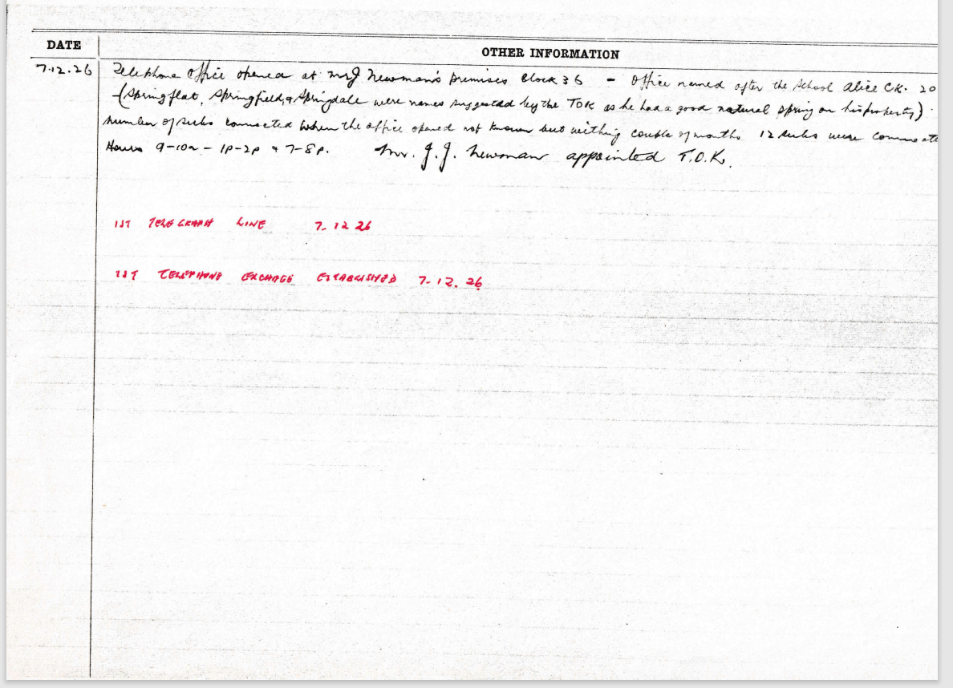

DATE | OTHER INFORMATION
7.12.26 | Telephone opened at Mr. J Newman’s premises Block 36 – Officed named after the school Alice Creek. 20 chains distant – (Spring Flat, Springfield, Springdale were names suggested by the TOK as he had a good natural spring on his property)
 | Number of subs connected when the office opened not known but within a couple of months 12 subs were connected.
 | Hours 9-10am- 1p-2p & 7-8p Mr. JJ Newman appointed T.O.K
 | 1st TELEGRAPH LINE 7.12.26
 | 1ST TELEPHONE EXCHANGE ESTABLISHED 7.12.26

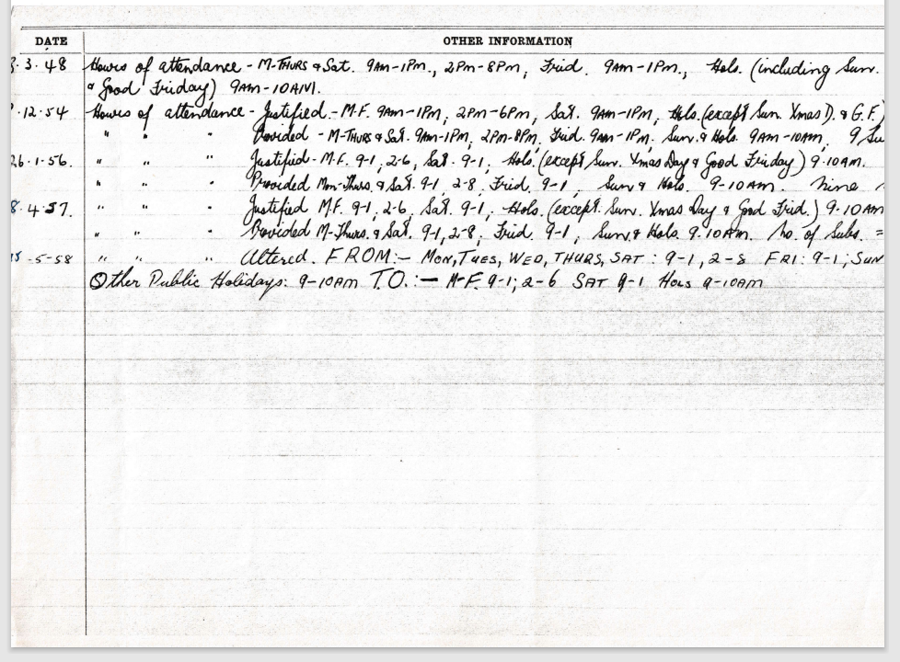

DATE | OTHER INFORMATION
8.3.48 | Hours of attendance-M-Thurs & Sat 9AM – 1PM, 2PM – 8PM Frid 9AM – 1PM, Hols (including Sun, Xmas Day & Good Friday) 9AM – 10AM)
8.12.54 | Hours of attendance – Justified. - M-F 9AM -1PM, 2PM-6PM, Sat 9AM – 1PM, Hols (Except Sun Xmas D & G.F.) 9AM-10am
 | Hours of attendance – Provided -M-F 9AM -1PM, 2PM-8PM, Sat 9AM – 1PM, Sun & Hols 9AM-10AM, 9 Subs
26.1.56 | Hours of attendance – Justified. - M-F 9AM -1PM, 2PM-6PM, Sat 9AM – 1PM, Hols (Except Sun. Xmas D & G.F.) 9AM-10am
 | Hours of attendance – Provided -M-T & Sat 9AM -1PM, 2PM-8PM, Frid 9AM – 1PM, Sun & Hols 9-10AM, 9 Subs
8.4.57 | Hours of attendance – Justified. - M-F 9 -1, 2-6, Sat 9 – 1, Hols (Except Sun. Xmas D & G.F.) 9AM-10am
 | Hours of attendance – Provided -M-T & Sat 9 -1, 2-8, Frid 9 – 1, Sun & Hols 9-10AM, No of Subs 9
15.5.58 | Attend FROM :- MON, TUES, WED, THUR, SAT: 9 -1, 2-8, Sat 9 – 1, Hols (Except Sun. Xmas D & G.F.) 9AM-10am
 | Other Public Holidays 9-10AM TO M-F 9-1; 2-6 SAT 9-1 HOLS 9-10AM

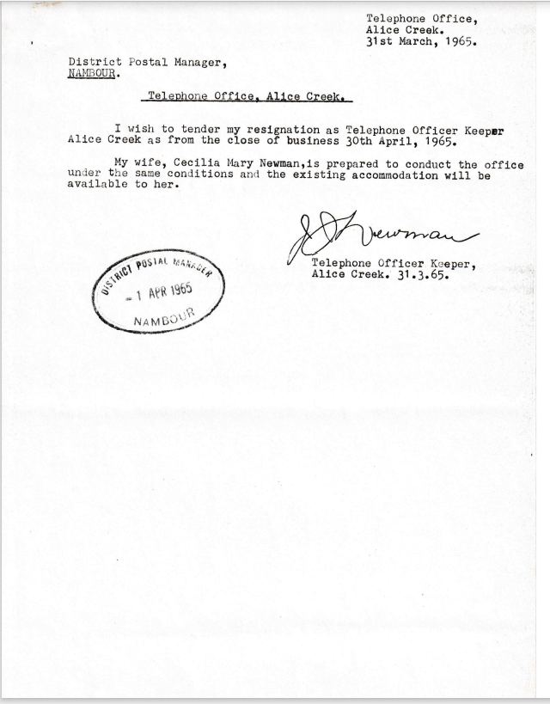

Telephone Office,
Alice Creek.
31st March, 1965.
District Postal Manager,
NAMBOUR.

Telephone Office, Alice Creek.
I wish to tender my resignation as Telephone Officer Keeper Alice Creek as from the close of business 30th April, 1965.
My wife, Cecilia Mary Newman, is prepared to conduct the office under the same conditions and the existing accommodation will be available to her.

Telephone Officer Keeper,
Alice Creek. 31.3.65.
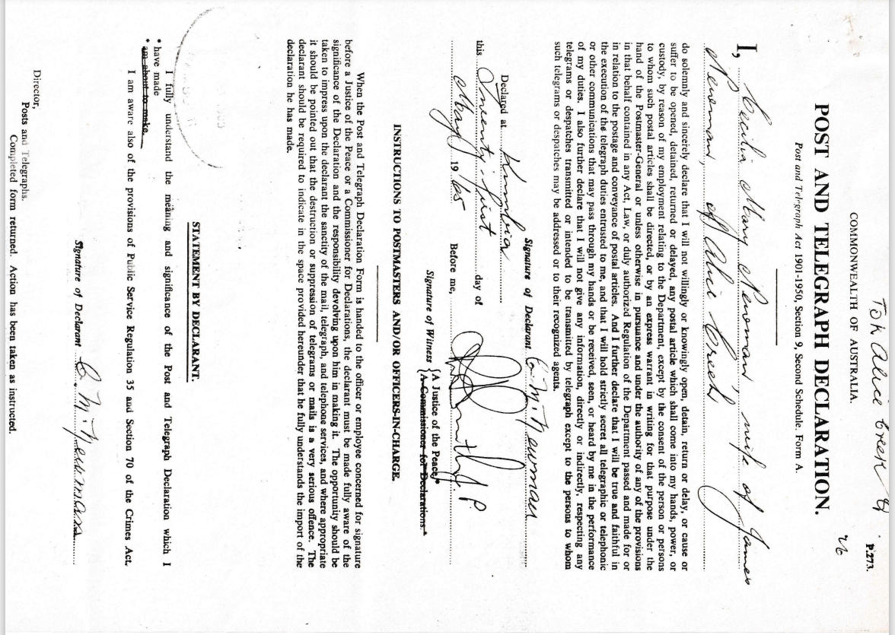
9501.8A
COMMONWEALTH OF AUSTRALIA.
POST AND TELEGRAPH DECLARATION.
Post and Telegraph Act 1901-1950, Section 9, Second Schedule. Form A.
I ........do solemnly and sincerely declare that I will not willingly or knowingly open, detain, return or delay, or cause or suffer to be opened, detained, returned or delayed, any postal article which shall come into my hands, power, or custody, by reason of my employment relating to the Department, except by the consent of the person or persons to whom such postal articles shall be directed, or by an express warrant in writing for that purpose under the hand of the Postmaster-General or unless otherwise in pursuance and under the authority of any of the provisions in that behalf contained in any Act, Law, or duly authorized Regulation of the Department passed and made for or in relation to the postage and conveyance of postal articles. And I further declare that I will be true and faithful in the execution of the telegraph duties entrusted to me, and that I will hold strictly secret all telegraphic or telephonic or other communications that may pass through my hands or be received, seen, or heard by me in the performance of my duties. I also further declare that I will not give any information, directly or indirectly, respecting any telegrams or despatches transmitted or intended to be transmitted by telegraph except to the persons to whom such telegrams or despatches may be addressed or to their recognized agents.
Signature of Declarant ................
Declared at...........
this
.................................. day of
19....................................................
Before me,
Signature of Witness {A Justice of the Peace
{A Commissioner for Declarations

INSTRUCTIONS TO POSTMASTERS AND/OR OFFICERS-IN-CHARGE.
When the Post and Telegraph Declaration Form is handed to the officer or employee concerned for signature before a Justice of the Peace or a Commissioner for Declarations, the declarant must be made fully aware of the significance of the Declaration and the responsibility devolving upon him in making it. The opportunity should be taken to impress upon the declarant the sanctity of the mail, telegraph, and telephone services, and where appropriate it should be pointed out that the destruction or suppression of telegrams or mails is a very serious offence. The declarant should be required to indicate in the space provided hereunder that he fully understands the import of the declaration he has made.

STATEMENT BY DECLARANT.
I fully understand the meaning and significance of the Post and Telegraph Declaration which I
*have made
*or about to make
I am aware also of the provisions of Public Service Regulation 35 Section 70 of the Crimes Act.
Signature of Declarent
Director,
Posts and Telegraphs,
Completed form returned. Action has been taken as instructed.
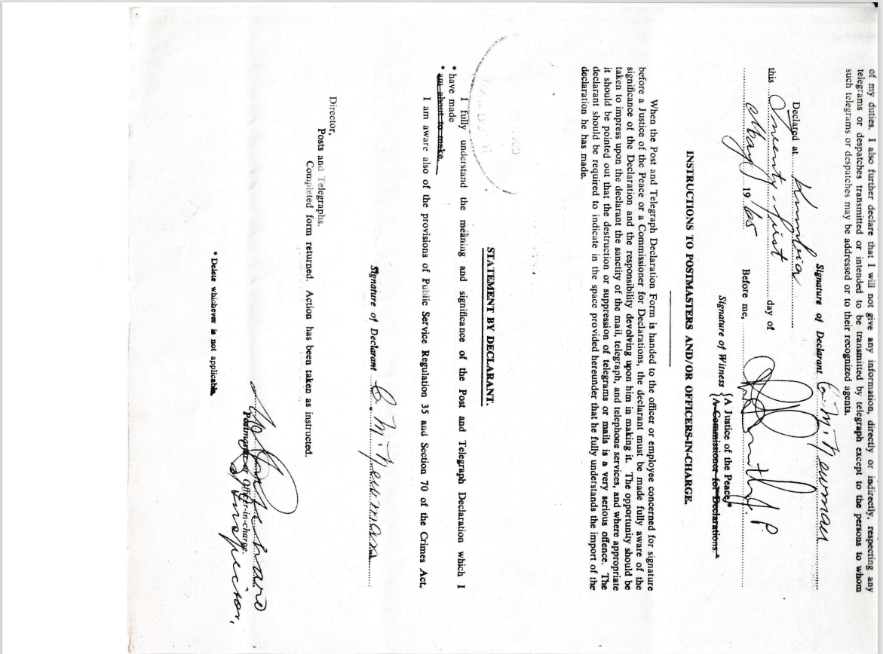

1501.8B

Director,

Posts and Telegraphs.

Completed form returned. Action has been taken as instructed.

............................................

Postmaster or Officer in Charge.

Delete whichever is not applicable.
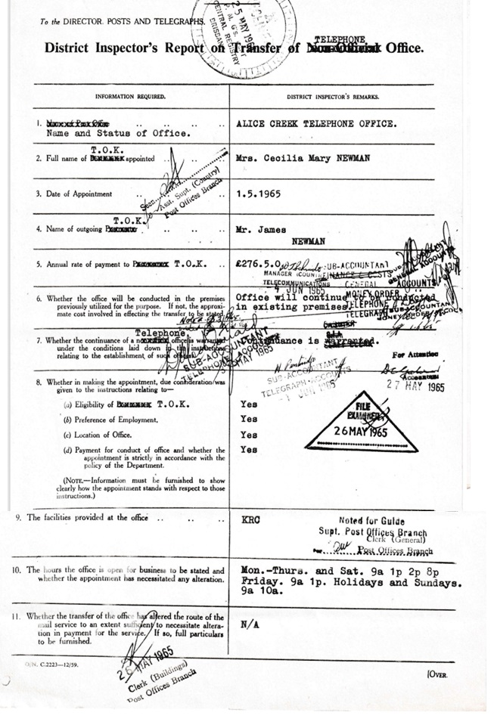
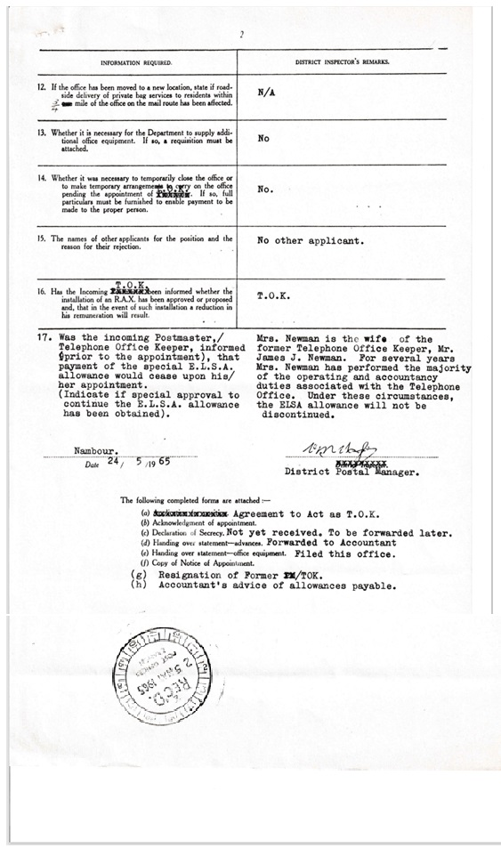
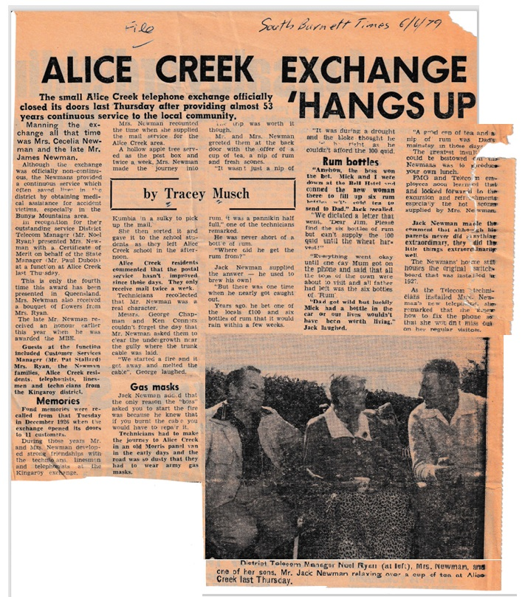

1501.10
South Burnett Times 6/6/79
Alice Creek Exchange Hangs up.
by Tracey Musch
Manning the exchange all that time was Mrs. Cecelia Newman and the late Mr. James Newman.
Although the exchange was officially non-continuous, the Newmans provided a continuous service which often saved lives in the district by obtaining medical assistance for accident victims, especially in the Bunya, Mountains area.
In recognition for their outstanding service District Telecom Manager (Mr. Noel Ryan) presented Mrs. Newman with a Certificate of Merit on behalf of the State Manager (Mr. Paul Dubois) at a function at Alice Creek last Thursday.
This is only the fourth time this award has been presented in Queensland. Mrs. Newman also received a. bouquet of flowers from Mrs. Ryan.
The late Mr. Newman received an honour earlier this year when he was awarded the MBE.
Guests at the function included Customer Services Manager (Mr, Pat Stallard) Mrs. Ryan, the Newman families, Alice Creek residents, telephonists, linesmen and technicians from the Kingaroy district.
Mrs. Newman recounted the time when she supplied the mail service for the Alice Creek area. A hollow apple tree served as the post box and twice a week, Mrs Newman made the journey into Kumbia in a sulky to pick up the mail.
She then sorted it and gave it to the school students as they left Alice Creek school in the afternoon.
Alice Creek residents commented that the postal service hasn't . improved since those days. They only receive mail twice a week.
Technicians recollected that Mr. Newman was a. real character.
Messrs. George Chapman and Ken Conners couldn't forget the day that Mr. Newman asked them to &ear the undergrowth near the gully where the trunk cable was laid.
"We started a fire and it got away and melted the cable", George laughed.
Gas masks
Jack Newman ado,c1 that the only reason the "boss" asked you to start the fire was because he knew that if you burnt the cab e you would have to repa'r it.
Technicians had to make the journey to Alice Creek in an old Morris panel van in the early days and the road was so dusty that they bad to wear army gas masks.
The trip was worth it though.
Mr. and Mrs. Newman greeted them at the back door with the offer of a cup of tea, a nip of rum twice a week, Mrs. Newman and fresh scones. "It wasn't just a nip of rum, it was a pannikin half full," one of the technicians remarked.
He was never short of a bottle of rum.
"Where did he get the rum from?" Jack Newman supplied the answer — he used to brew his own!
"But there was one time when he nearly got caught out.
Years ago, he bet one of the locals £100 and six bottles of rum that it would rain within a few weeks.
"It was during a drought and the bloke thought he couldn't afford the 100 quid.
Rum bottles
"Anyhow, the boss won the bet. Mick and I were down at the Bell Hotel and conned the new woman there to fill up six rum bottles with cold tea to send to Dad," Jack recalled.
"We dictated a letter that went, 'Dear Jim, Please find the six bottles of rum but can't supply the 100 quid until the wheat harvest!"
"Everything went okay until one day Mum got on the phone and said that all the tops of the town were about to visit and all father had left was the six bottles of 'Rum'.
"Dad got wild but luckily Mick had a bottle in the car or our lives wouldn't have been worth living," Jack laughed.
"A good run of tea and a nip of rum was Dad's mainstay in those days
The greatest insult that could be bestowed on the Newman's was to produce your own lunch.
PMG and Telecom employees soon learned that and looked forward to the, excursion and refreshments especially the hot scones, supplied by Mrs. Newman
Jack Newman male the-comment that although his parents never did anything-extraordinary, they did the little things extraordinarily well.
The Newmans' home still houses the original switch board that was installed in 1927.
As the Telecom technicians installed Mr. and Mrs. Newman's new telephone she remarked that she knew how to fix the phone so that she wouldn't miss out on her regular visitors.

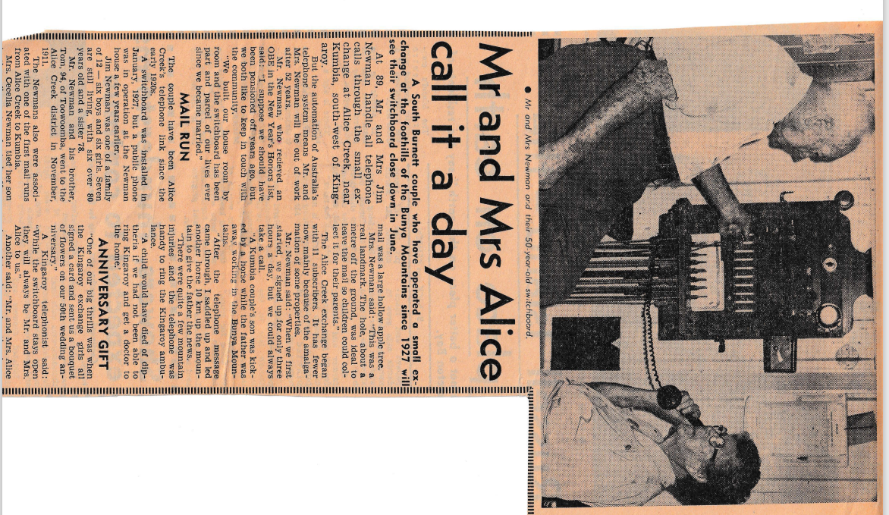
9501.11
Mr. and Mrs. Newman and their 50-year-old switchboard. ·
Mr. and Mrs. Alice
call it a day
A South Burnett couple who have operated a small ex-change at the foothills of the Bunya Mountains since 1927 will see their switchboard close down in June.
At 89, Mr. and Mrs. Jim Newman handle all telephone calls through the small exchange at Alice Creek, near Kumbia, south-west of Kingaroy.
But the automation of Australia's telephone system means Mr. and Mrs. Newman will be out of work after 52 years.
Mr. Newman, who received an OBE in the New Year's Honors list, said: "I suppose we should have been pensioned off years ago, but we both like to keep in touch with the community.
"We built our house room by room and the switchboard has been part and parcel of our lives ever since we became married."
MAIL RUN
The couple have been Alice Creek's telephone link since the early 1920s.
A switchboard was installed in. January, 1927, but a public phone was in operation at the Newman house a few years earlier.
Jim Newman was one of a family of 12 — six boys and six girls. Seven are still living, with six over 80 years old and a sister 78.
Mr. Newman and his brother, Torn, 94, of Toowoomba, went to the Alice Creek district in November, 1911.
The Newman’s also were associated with one of the first mail runs from Alice Creek to Kumbia.
Mrs. Cecelia Newman tied her son in the sulky seat as she took off on the rounds twice a week. One of the receiving points for mail was a large hollow apple tree.
Mrs. Newman said: "This was a real landmark. The hole, about a metre off the ground, was ideal to leave the mail so children could collect it for their parents."
The Alice Creek exchange began with 11 subscribers. It has fewer now, mainly because of the amalgamation of some properties.
Mr. Newman said: "When we first started, we signed up for only three hours a day, but we could always take a call.
"A Kumbia couple's son was kicked by a horse while the father was away working in the Bunya Mountains.
"After the telephone message came through, I saddled up and led another horse 10 km up the mountain to give the father the news.
"There were quite a few mountain injuries. and the telephone was handy to ring the Kingaroy ambulance.
"A child would have died of diptheria if we had not been able to ring Kingaroy and get a doctor to the home.'
ANNIVERSARY GIFT
"One of our big thrills was when the Kingaroy exchange girls all signed a card and sent us a bouquet of flowers on our 50th wedding anniversary."
A Kingaroy telephonist said: "While the switchboard stays open they will always be Mr. and Mrs. Alice to us."
Another said: "Mr. and Mrs. Alice always let us know when they leave for church and return each Sunday.”
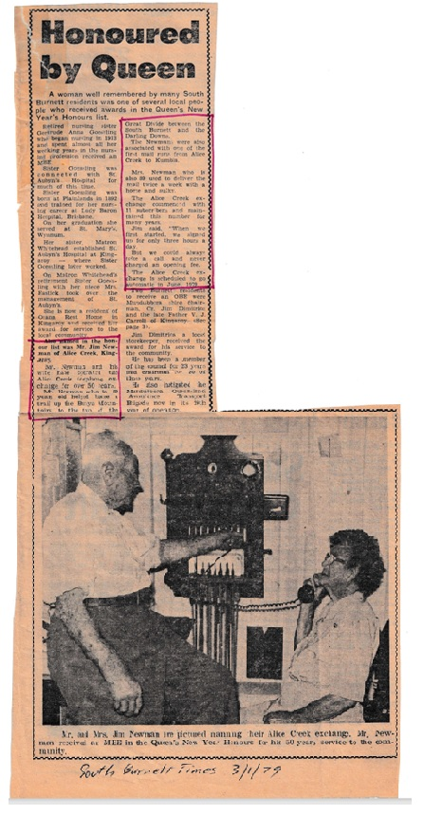
9501.12
Honoured by the Queen
A woman well remembered by many South Burnett residents was one of several local people who received awards in the Queen's New Year's Honours list.
Retired nursing sister Gertrude Anna Goessling who began nursing in 1913 and spent almost all her working years in the nursing profession received an MBE.
Sister Goessling was connected with St. Aubyn's Hospital for much of this time.
Sister Goessling was born at Plainlands in 1892 and trained for her nursing career at. Lady Baron Hospital Brisbane.
On her graduation she served at St. Mary's, Wynnum.
Her sister, Matron WIltehead established SC, Aubyn's Hospital at Kingaroy — where Sister Goessling later worked.
On Matron Whitehead's retirement Sister Goessling with her niece Mrs. Eastick took over the management of St. Aubyn's.
She is now a resident' of Orana Rest Home in Kingaroy end received her award for service to the local community.
Also named in the honour list was Mr. Jim Newman of Alice Creek, Kingaroy.
Mr. Newman and his wife have operated the Alice Creek telephone exchange for over 50 years.
Mr. Newman who is 89 years old helped blaze a trail up the Bunya Mountains to the top of the Great Divide between the South Burnett and the Darling Downs.
The Newman’s were also associated with one of the first mail runs from Alice Creek to Kumbia,
Mrs. Newman who is also 89 used to deliver the mail twice a week with a horse and sulky.
The Alice Creek exchange commenced with 11 subscribers and maintained this number for many years.
Jim said, 'When we first started, we signed up for only three hours a day.
But we could always to a call and never charged an opening fee.
The Alice Creek exchange is scheduled to go automatic in June 1979.
The Burnett resident to receive. an OBE were Mundubbera shire Chairman, Cr. Jim Dimitrios and the late Father V. J. Carroll of Kingaroy- (See page 3).
Jim Dimitrics a local storekeeper, received the award for his service to the community.
He has been a member of the council for 23 years and chairman for 20 of those years.
He also instigated the Mundubbera Queensland Ambulance Transport Brigade now in. its 29th year of operation—

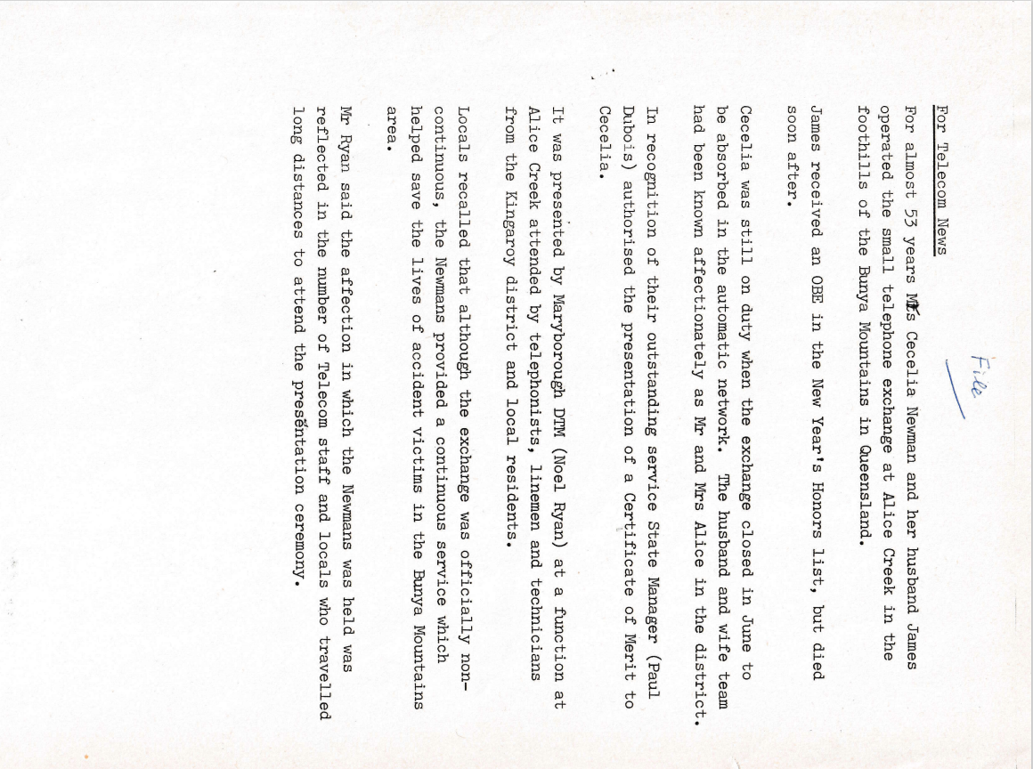

9501.13
For Telecom News
For almost 53 years Mrs. Cecelia Newman and her husband James operated the small telephone exchange at Alice Creek in the foothills of the Bunya Mountains in Queensland.
James received an OBE in the New Year's Honors list, but died soon after.
Cecelia was still on duty when the exchange closed in June to
be absorbed in the automatic network. The husband-and-wife team
had been known affectionately as Mr. and Mrs. Alice in the district.
In recognition of their outstanding service State Manager (Paul Dubois) authorised the presentation of a Certificate of Merit to Cecelia.
It was presented by Maryborough DTM (Noel Ryan) at a function at Alice Creek attended by telephonists, linemen and technicians from the Kingaroy district and local residents.
Locals recalled that although the exchange was officially non-continuous, the Newman’s provided a continuous service which helped save the lives of accident victims in the Bunya Mountains area.
Mr. Ryan said the affection in which the Newman’s was held was reflected in the number of Telecom staff and locals who travelled long distances to attend the presentation ceremony.

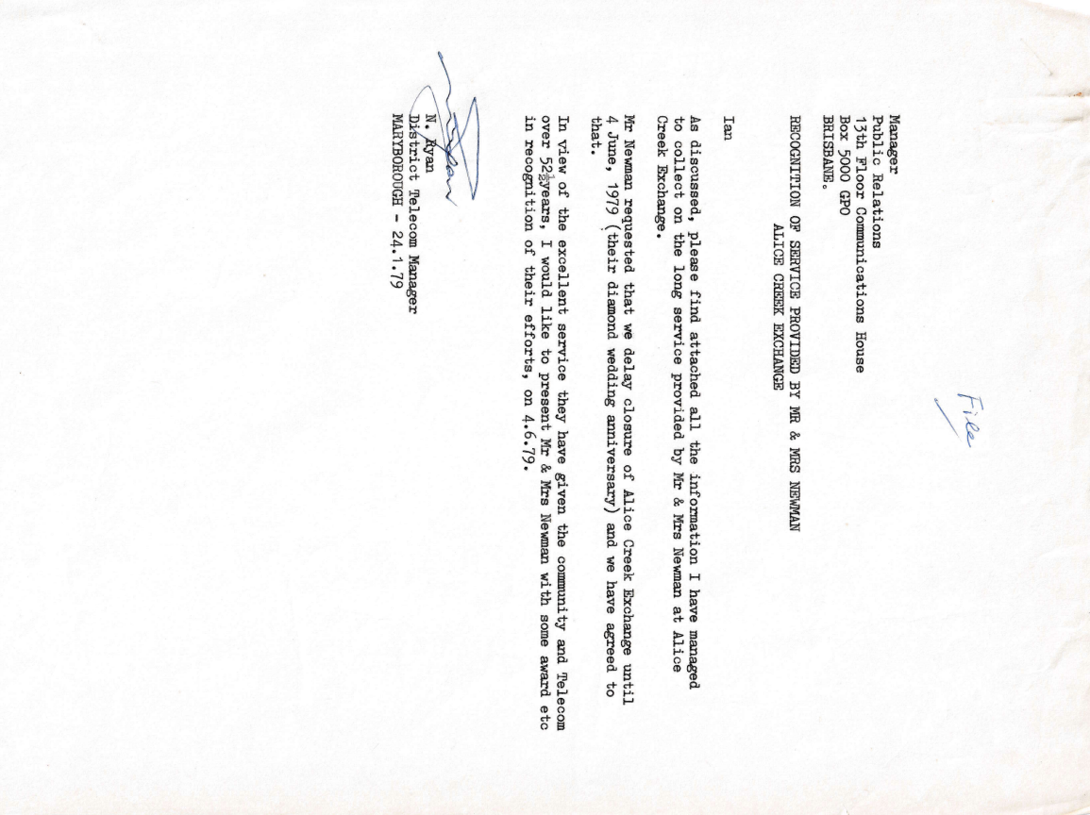
9501.14
Manager
Public Relations
13th Floor Communications House
Box 5000 GPO
BRISBANE
RECOGNITION OF SERVICE PROVIDED BY MR & MRS NEWMAN
ALICE CREEK EXCHANGE
Ian
As discussed, please find attached all the information I have managed to collect on the long service provided by Mr. & Mrs. Newman at Alice Creek Exchange.
Mr. Newman requested that. we delay closure of Alice Creek Exchange until 4 June, 1979 (their diamond wedding anniversary) and we have agreed to that.
In view of the excellent service they have given the community and Telecom over 52 years, I would like to present Mr. & Mrs. Newman with some award etc in recognition of their efforts, on 4.6.79.

N. Ryan
District Telecom Manager
MARYBOROUGH - 24.1.79
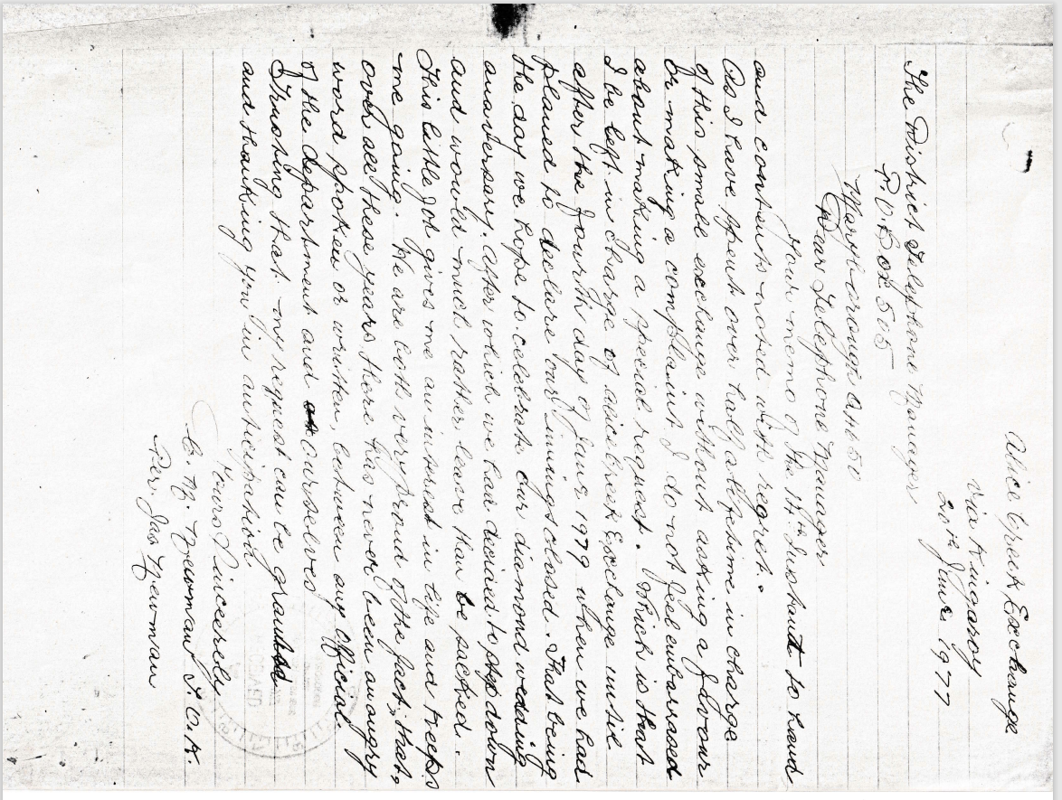
9501.15
Alice Creek Exchange via Kingaroy
20th June 1977
The District Telephone Manager
P.O. Box 505
Marybourgh Q 4650
Dear Telephone Manager
Your memo on the 14th ----------------- and contents noted with regret.
As I have spent over half a lifetime in charge of this small exchange without asking a favour or making a complaint, I do not feel embarrassed about making a special request.
Which is that I be left in charge of the Alice Creek Exchange until after the fourth day of June 1979 when we had planned to declare the innings closed.
That being the day we hope to celebrate our diamond wedding anniversary. After which we would have decided to step down and would much rather leave than be sacked.
This little job gives me an interest in life and keeps me going.
We are both very proud of the fact, that over all these years there has never been an angry word spoken or written between any official of the department and ourselves.
Trusting my request be granted and thanking you in anticipation.
Yours Sincerely
C. M. Newman T.O.K (Telephone Office Keeper)
Per Jas Newman

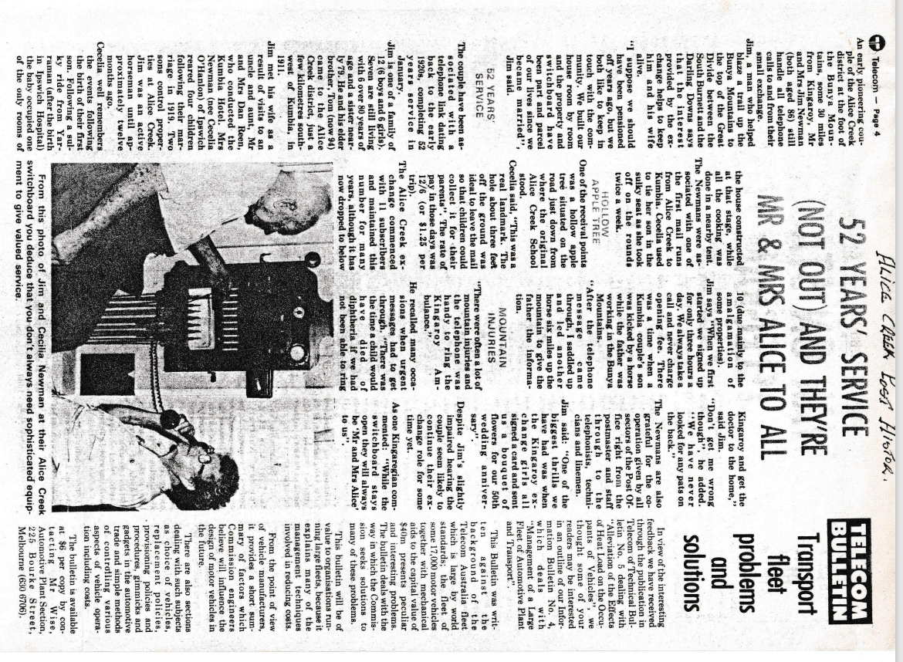
9501.16
52 YEAR’S SERVICE (NOT OUT) AND THEY’RE MR. &MRS. ALICE TO ALL
An early pioneering couple of the Alice Creek district at the foot of the Bunya Mountains, some 30 miles from Kingaroy, Mr. and Mrs. Jim Newman (both aged 86) still handle all telephone calls to and from their small exchange.
Jim, a man who helped blaze a trail up the Bunya Mountains to the top of the Great Divide between the South Burnett and the Darling Downs says that the interest provided by the ex-change helps to keep him and his wife alive.
"I suppose we should have been pensioned off years ago, but we both like to keep in touch with the community. We built our house room by room and the property and switchboard have been part and parcel of our lives since we became married", Jim said.
52 YEARS OF SERVICE
The couple have been as-sociated with a telephone link dating back to the early 1920s, completing 52 years’ service in January.
Jim is one of a family of 12 (6 boys and 6 girls). Seven are still living with 6 over 80 years of age and a sister nearly 79. He and his elder brother, Tom (now 94) came to the Alice Creek district, just a few kilometres south-west of Kumbia, in 1911.
Jim met his wife as a result of visits to an uncle and aunt, Mr. and Mrs. Dan Reen, who conducted the Kumbia Hotel. Mrs. Newman (nee Cecelia O'Hanlon) of Ipswich reared four children following their marriage in 1919. Two sons control properties at Alice Creek. Jim was an active horseman until ap-proximately twelve months ago.
Cecelia well remembers the events following the birth of their first son. Following a sulky ride from Yar-rumen (after the birth in Ipswich Hospital) the baby occupied one of the only rooms of the house constructed at that stage, while all the cooking was done in a nearby tent.
The Newman’s were as-sociated with one of the first mail runs from Alice Creek to Kumbia. Cecelia used to tie her son in the sulky seat as she took off on the rounds twice a week.
HOLLOW APPLE TREE
One of the receival points was a hollow apple tree situated on the road just down from where the original Alice Creek School stood.
Cecelia said, "This was a real landmark. The hole about three feet off the ground was ideal to leave the mail so that children could collect it for their parents". The rate of pay in those days was 12/6 (or $1.25 per trip).
The Alice Creek exchange commenced with 11 subscribers and maintained this number for many years, although it has now dropped to below 10 (due mainly to the amalgamation of some properties).
Jim says "When we first started, we signed up for only three hours a day. We always take a call and never charge opening fee. There was a time when a Kumbia couple's son was kicked by a horse while the father was working in the Bunya Mountains.
"After the telephone message came through, I saddled up and led another horse six miles up the mountain to give the father the information.
MOUNTAIN INJURIES
"There were often a lot of mountain injuries and the telephone was handy to ring the Kingaroy Ambulance."
He recalled many occasions when urgent messages had to get through. "There was the time a child would have died of diphtheria if we had not been able to ring Kingaroy and get the doctor to the home," said Jim.
"Don't get me wrong though", he added. "We have never looked for any pats on the back."
The Newman’s are also grateful for the co-operation given by all sectors of the Post Office right from the postmaster and staff through to the telephonists, technicians and linemen.
Jim said: "One of the biggest thrills we have had was when the Kingaroy exchange girls all signed a card and sent us a bouquet of flowers for our 50th wedding anniversary".
Despite Jim's slightly impaired hearing the couple seem likely to continue their exchange role for some time yet.
As one Kingaregian commented: "While the switchboard stays open they will always be 'Mr. and Mrs. Alice' to us".
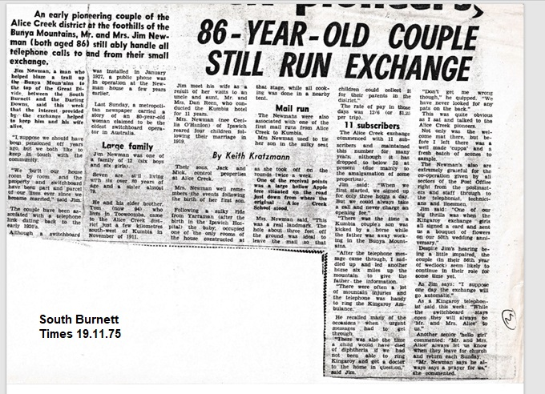

9501.17
86 Year Old Couple still run exchange
An early pioneering couple of the Alice Creek district at the foothills of the Bunya Mountains, Mr. and Mrs. Jim Newman ( both aged 86) still ably handle all telephone calls to and from their small exchange.
Jim Newman, a man who'. helped blaze a trail up; the Bunya Mountains to the top of the Great Divide between the South Burnett and the Darling Downs, said this week that the interest - provided by the exchange helped to keep him and his wife alive,
"I suppose we should have beep pensioned off years ago, but we both like to keep in touch with the community.
"We 'built our house room by room and the property and switchboard have been part and parcel of our lives ever since we became married," said Jim.
The couple have been as-satiated with a telephone link dating back to the early 1920's.
Although a switchboard was installed in January 1927, a public phone was in operation at the Newman house a few years earlier.
Last Sunday, a metropolitan newspaper carried a story of an 80-year-old woman claimed to be the oldest switchboard operator in Australia.
Large family
Jim Newman was one of a family of 12 (six boys and six girls).
Seven are still living with six over 80 years of age and a sister almost 79.
He and his elder brother, Tom (now 94) who lives in Toowoomba, came to the Alice Creek district just a few kilometres south-west of Kumbia in November of 1911.

Jim met his wife as a result of her visits to an uncle and aunt, Mr. and Mrs. Dan Reen, who conducted the Kumbia hotel for 11 years.
Mrs. Newman (nee Cecilia O'Hanlon) of Ipswich reared four children following their marriage in 1919.
Their sons, Jack and Mick, control properties at Alice Creek.
Mrs. Newman well remembers the events following the birth of her first son.
Following a sulky ride from Yarraman (after the birth in the Ipswich Hospital) the baby; occupied one of the only rooms of the house constructed at that stage, while all cooking was done in a nearby tent.
Mail run
The Newman’s were also associated with one of the first mail runs from Alice Creek to Kumbia.
Mrs. Newman used to tie her son in the sulky seat as she took off on the rounds twice a week.
One of the receival points was a large hollow Apple tree situated on the road just down from where the
original Alice Creek School stood.
Mrs., Newman said, "This was a real landmark. The hole about three feet off the ground was ideal to leave the mail .so that children could collect it for their parents in the district."
The rate of pay in those days was 12/6 (or $1.25 per trip).
11 subscribers
The Alice Creek exchange commenced with 11 subscribers and maintained this number for many years, although it has dropped to below 10 at present due mainly to the amalgamation of some properties),
Jim said: "When we first started, we agreed up for only three hours a day. But we could always take a call and never charge an opening fee."
"There was the time a Kumbia couple's son was kicked by a horse while the father was away working in the Bunya Mountains.
"After the telephone message came through, I saddled up and led another horse six miles up the mountain to give the father the information. "There were often a lot of mountain injuries and the telephone was handy to ring the Kingaroy Ambulance.
He recalled many of the occasions when urgent messages had to: get through.
"There was also the time a child would have died of diphtheria if we had not been able to ring Kingaroy and get a doctor to the home in question," said Jim.
"Don't get me wrong though," he quipped. "We have never looked for any pats on the back."
This was quite obvious as I sat and talked to the Alice Creek pioneers.
Not only was the welcome mat there, but before I left there was a well made ‘cuppa' and a fresh batch of scones to sample.
The Newman's, also are extremely grateful for the co-operation given by all sectors of the Post Office right from the postmasters and staff through to the telephonist. technicians and linesmen.
Jim said: "One of our big thrills was when the Kingaroy exchange girls all signed a card and sent us a bouquet of flowers on our 50th wedding anniversary."
Despite Jim's hearing being a little impaired, the couple (in their 56th year of wedlock) seem likely to continue in their role for some time yet.
As Jim says: "I suppose one day the exchange will go automatic."
As a Kingaroy telephonist said this week: "While the switchboard stays open they will always be 'Mr. and Mrs. Alice' to us."
Another senior 'hello girl' commented: "Mr. and Mrs. Alice' always let us know 'When they leave for church and return each Sunday. "Mr. Newman says he always says, a. prayer for us," she commented.
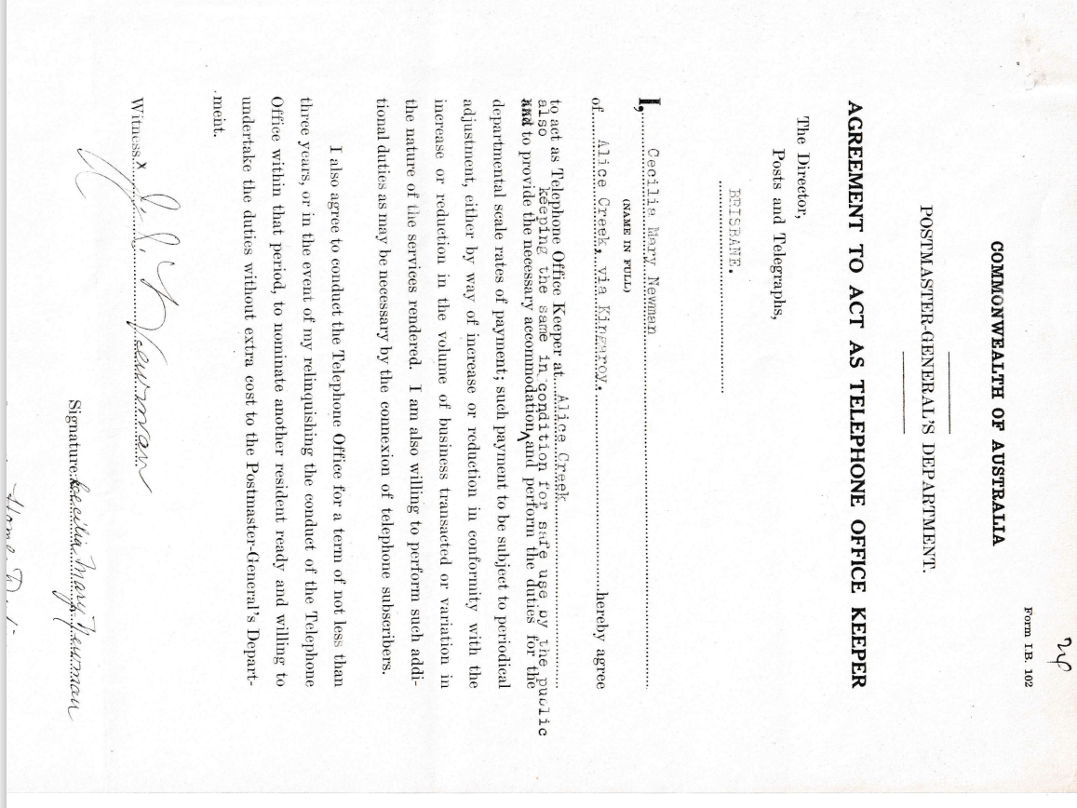
COMMONWEALTH OF AUSTRALIA
POSTMASTER GENERAL’S DEPARTMENT
AGREEMENT TO ACT AS TELEPHONE OFFICE KEEPER
The Director,
Posts and Telegraphs
I, Cecilia Mary Newman of Alice Creek, via Kingaroy hereby agree to act as Telephone Office Keeper at Alice Creek, also to provide the necessary accommodation keeping the same in condition for safe use by the public and perform the duties for the departmental scale rates of payment; such payment to be subject to periodical adjustment, either by way of increase or reduction in conformity with the
increase or reduction in the volume of business transacted or variation in the nature of the services rendered. I am also willing to perform such additional duties as may be necessary by the connexion of telephone subscribers.
I also agree to conduct the Telephone Office for a term of not less than three years, or in the event of my relinquishing the conduct of the Telephone Office within that period, to nominate another resident ready and willing to undertake the duties without extra cost to the Postmaster-General's Department.
Witness
Signature

