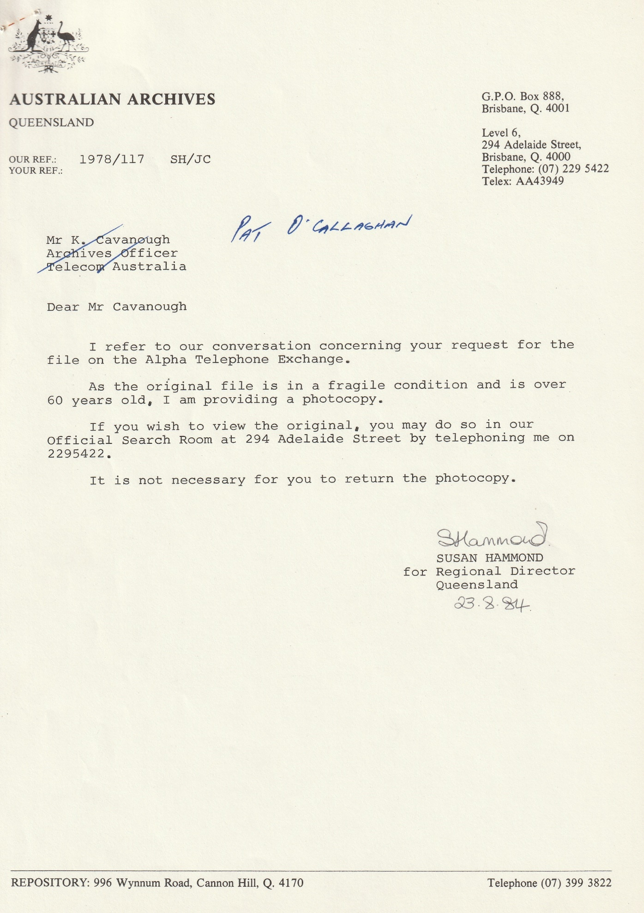
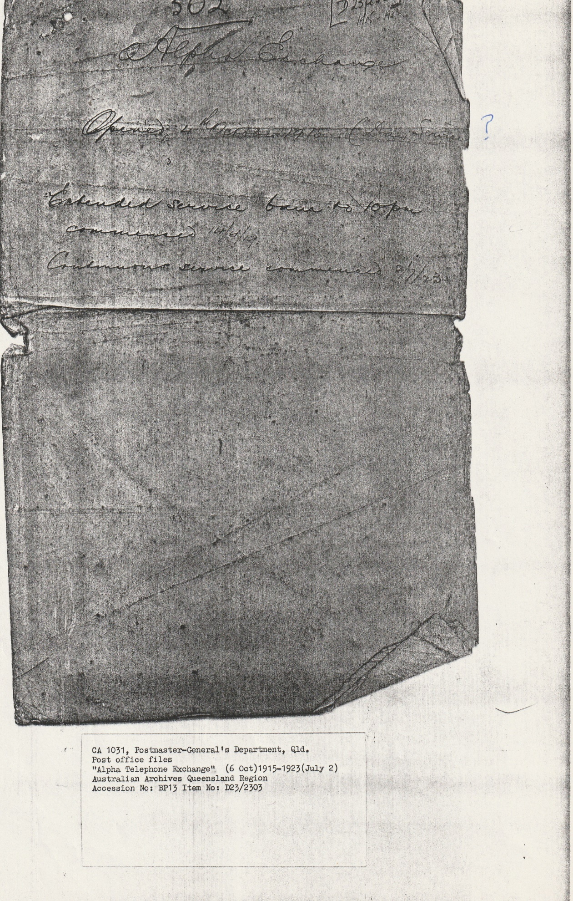
502 D25
1915 - 1928
Alpha Exchange
Opened 4th October 1915 (Day Service)
Extended service 6 am to 10 pm
commenced 14/4/19
Continuous service commenced 2/7/23

502 D25
1915 - 1928
Alpha Exchange
Opened 4th October 1915 (Day Service)
Extended service 6 am to 10 pm
commenced 14/4/19
Continuous service commenced 2/7/23

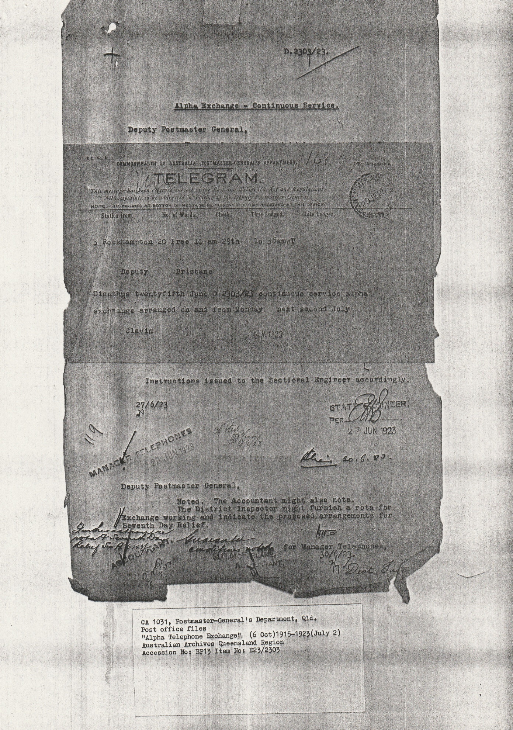
COMMONWEALTH OF AUSTRALIA – POSTMASTER GENERALS OFFICE 168
TELEGRAM
This message has been received subject to the Post and Telegraph Act and regulation. All complaints to be addressed to in writing to the Deputy Postmaster General.
NOTE – THE FIGURES AT THE BOTTOM OF MESSAGE REPRESENT THE TIME RECEIVED AT THIS OFFICE
Station from No of Words Check Time Lodged Date Lodged

3 Rockhampton 20 Free 10 am 29th Io 35am WT
Deputy Brisbane
Dianthus twentyfifth June D 2303/23 continuous service alpha
Exchange arranged on and from Monday next second July
Clavin 29 JUN 1923

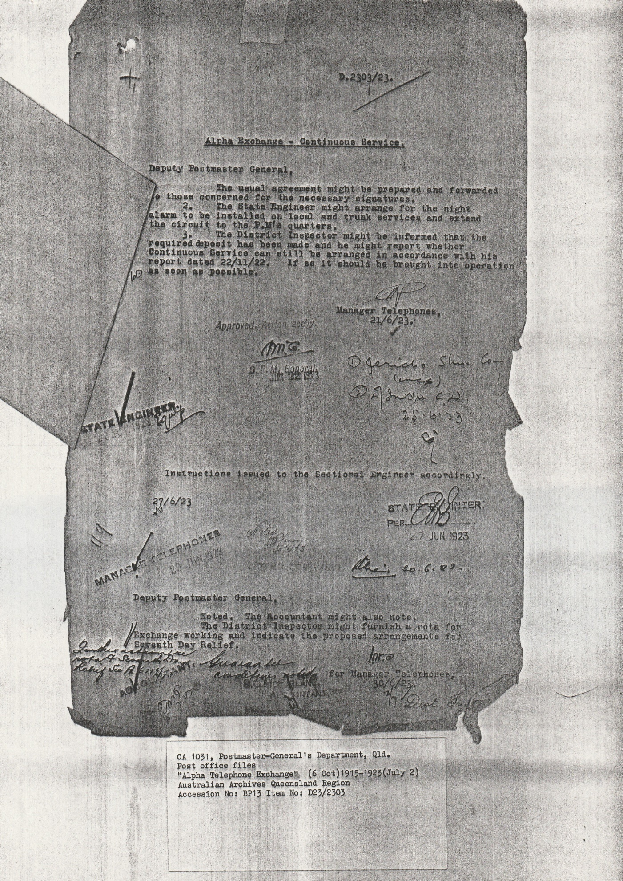D.2303/23
Alpha Exchange - Continuous Service

Deputy Postmaster General,
The usual agreement might be prepared to those concerned for the necessary signatures.
2. The State Engineer might arrange for the night alarm to be installed on local and trunk services and extend the circuit to the P.M.’s quarters.
3. The District Inspector might be informed that the required deposit has been made and he might report whether Continuous Service can still be arranged in accordance with his report dated 22/11/22. If so it should be brought into operation as soon as possible.

Manager Telephones,
21/6/23
Approved Action early
D.P.M General
June 22 1923
STATE ENGINEER
Instructions issued to the Sectional Engineer accordingly

STATE ENGINEER
PER
27JUN 1923
MANAGER TELEPHONES 29 JUN 1923
Deputy Postmaster General
Noted. The Accountant might also note, The District Inspector might furnish a rota for exchange working and indicate the proposed arrangements for Seventh Day relief.
For Manager Telephones,
30/6/23
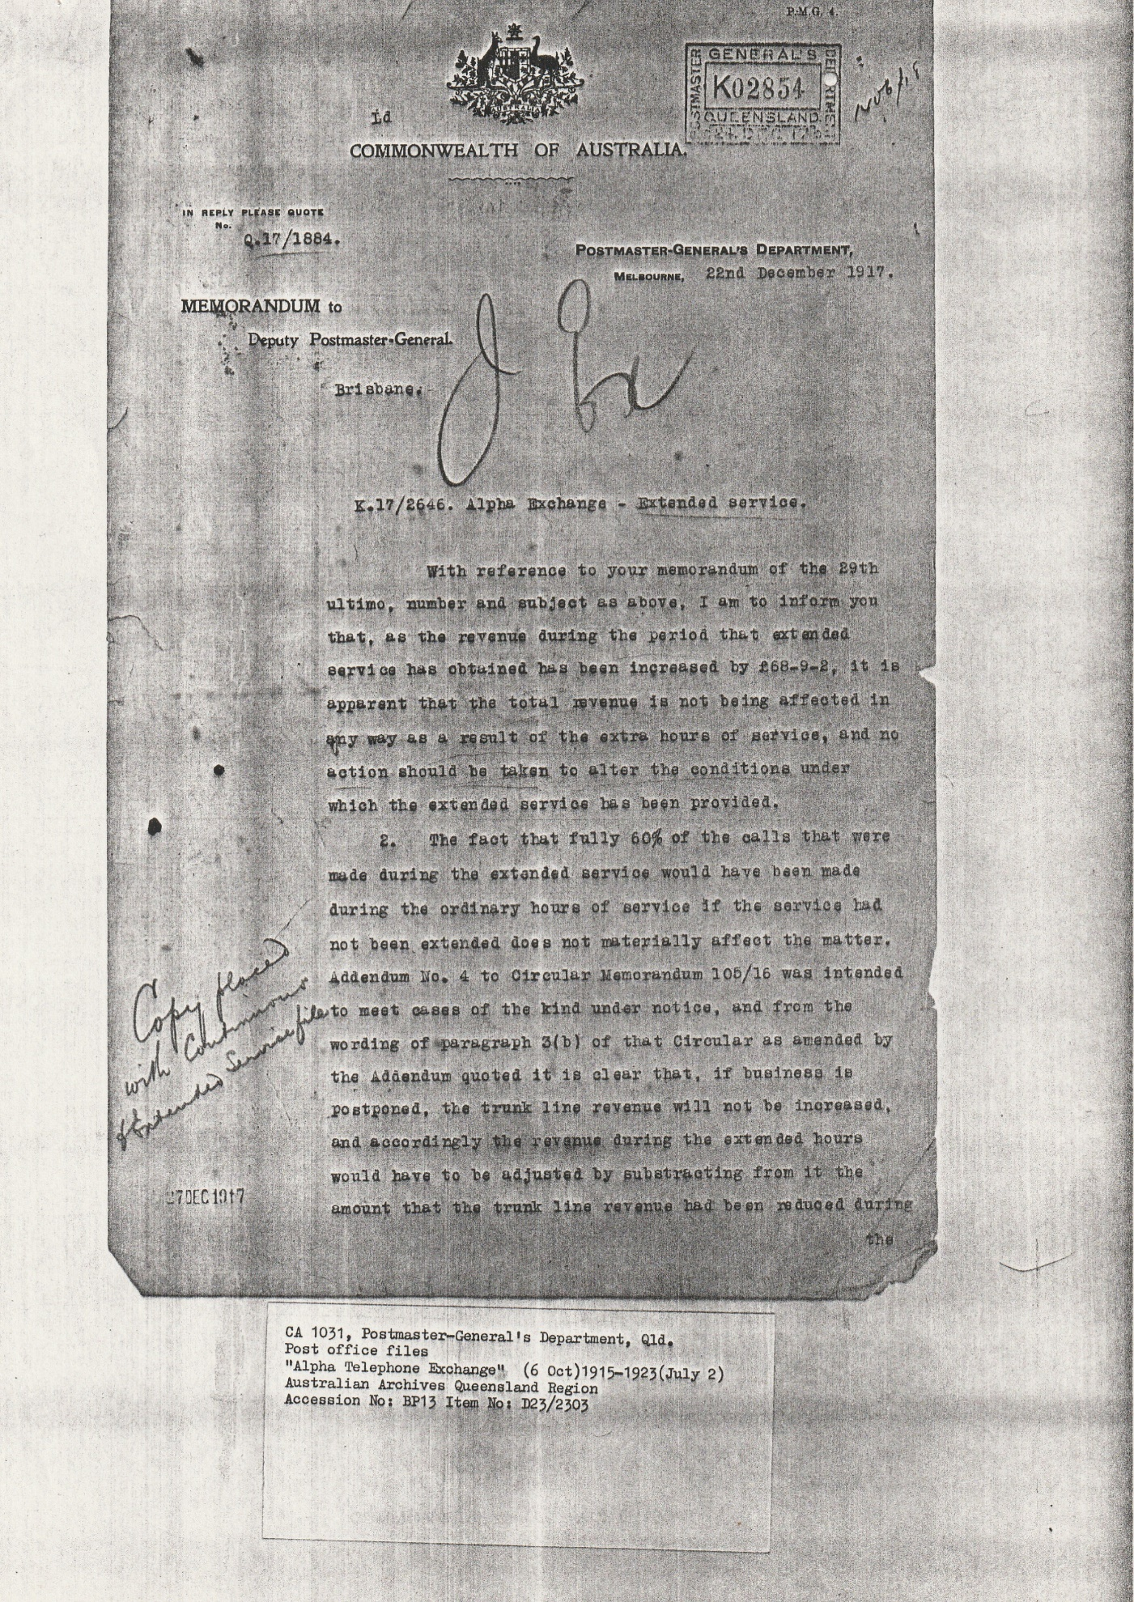
22nd December 1917
Memorandum to
Deputy Postmaster General,
Brisbane.
K.17/2646. Alpha Exchange – Extended services
With reference to your memorandum of the 29th ultimo (last month), number and subject as above, I am to inform you that, as the revenue during the period that extended services has obtained has been increased by £68-9-2, it is apparent that the total revenue is not being affected in anyway as a result of the extra hours of service, and no action should be taken to alter the conditions under which the extended service has been provided.
2. The fact that fully 60% of the calls that were made during the extended service would have been made during the ordinary hours of service if the service had not been extended does not materially affect the matter.
Addendum No. 4 to Circular Memorandum 105/16 was intended to meet cases of the kind under the notice, and from the wording of paragraph 3(b) of that circular as amended by the Addendum quote it is clear that, if business is postponed, the trunk line revenue will not be increased, and accordingly the revenue during the extended hours would have to be adjusted by subtracting from it the amount that the trunk line revenue had been reduced during the

Copy has been placed with Continuous Extended Service Life 27 DEC 1917

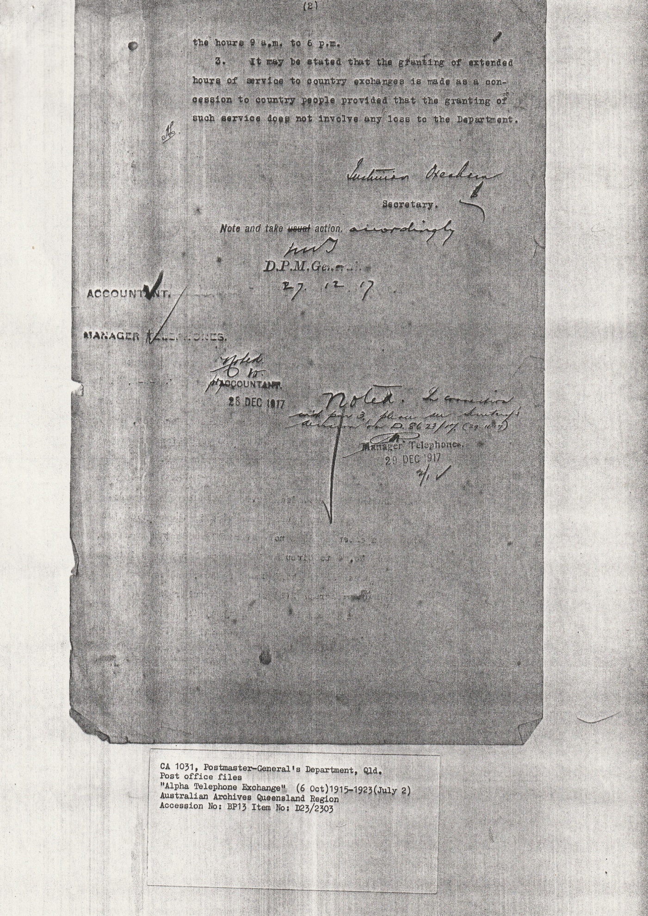
The hours 9 a.m. to 6 p.m.
3. It may be stated that the granting of extended hours of service to country exchanges is made as a concession to country people provided that the granting of such services does not involve any loss to the department.

Secretary
Note and take usual action, accordingly D.P.M. General
27. 12 . 17
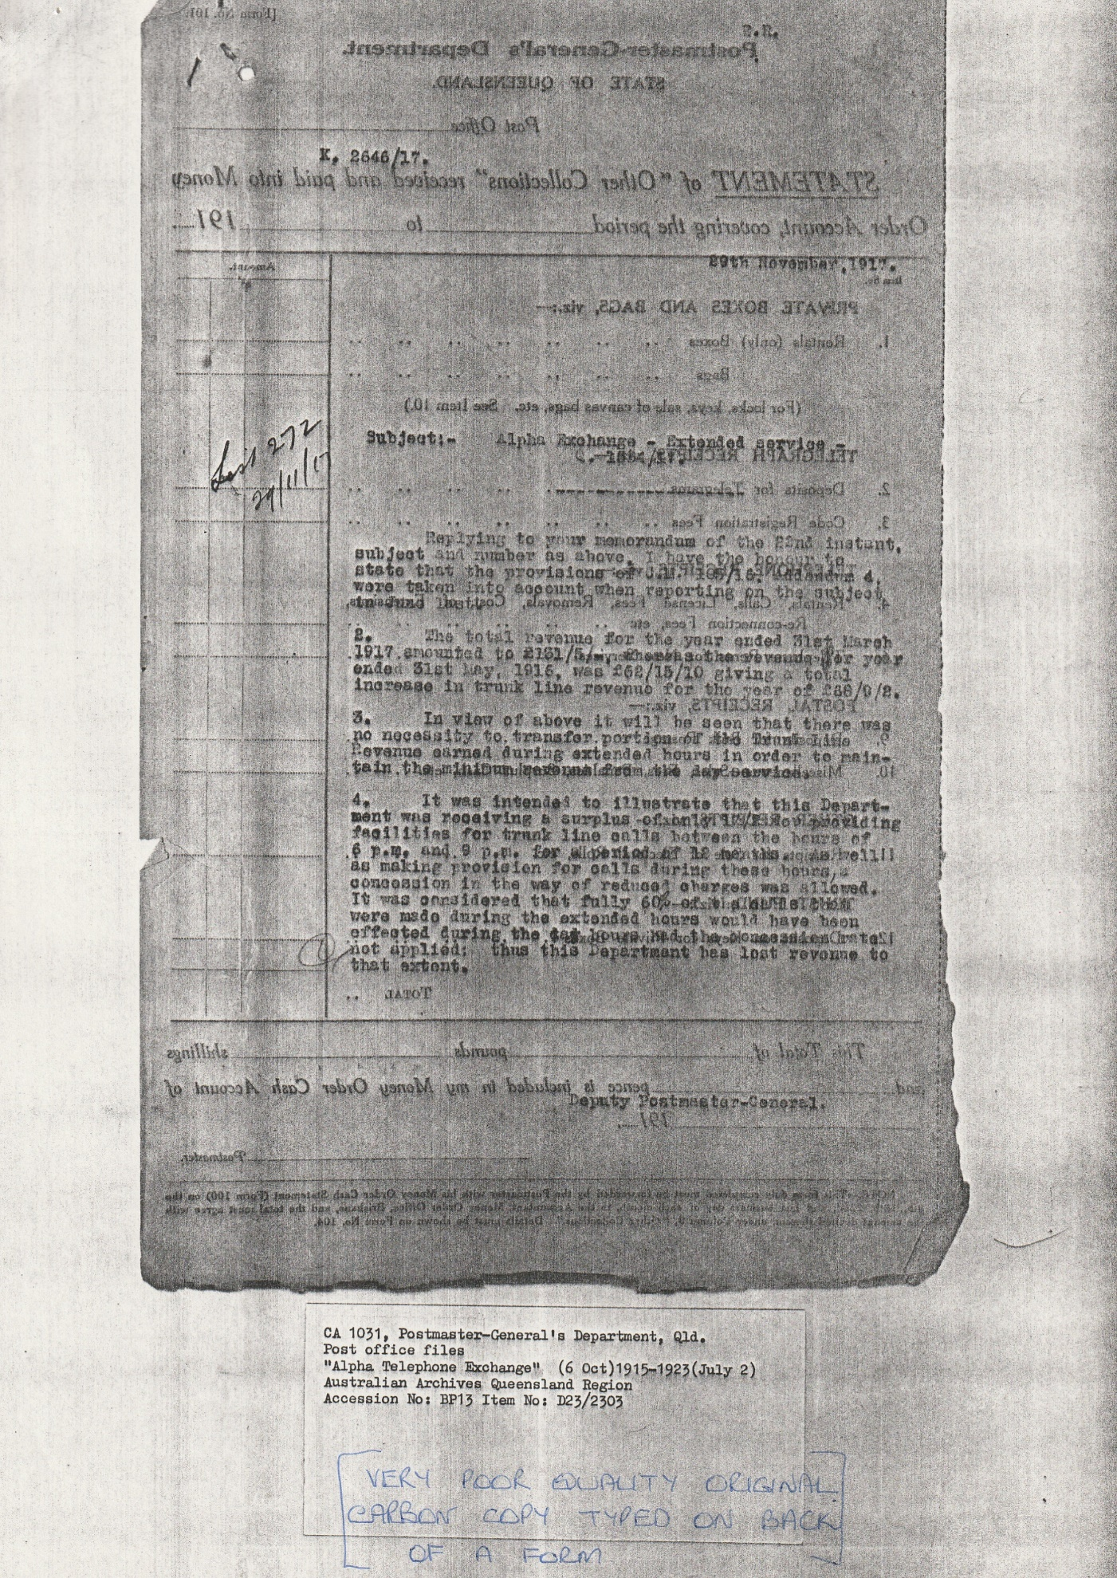
K 2646/17
29th November 1917
Subject:- Alpha Exchange- Extended service
Q.
Replying to your memorandum of the 22nd instant, subject and number as above. I have the honour to state that the provisions of CM 105/16 Addendum No. 4 were taken into account when reporting on the subject????????????
2. The total revenue for the year ended 31st March 1917 amounted to £151/5/ where as the revenue for year ended 31st May 1916, was £62/15/10 giving a total increase in trunk line revenue for the year of £88/9/2.
3. In view of above it will be seen that there was no necessity to transfer portion of the Trunk Line Revenue earned during extended hours in order to maintain minimum revenue from the day service.
4. It was intended to illustrate that this Department was receiving a surplus only ????? ??? providing facilities for trunk line calls between the hours of 6 p.m. and 9 p.m. for a period of 12 months. As well as making provision for call during these hours a concession in the way reduced charges was allowed. It was considered that fully 60% of the ?????? were made during the extended hours would have been affected during the day hours had the ????????????? not applied: thus this Department has lost revenue to that extent.

Deputy Postmaster General
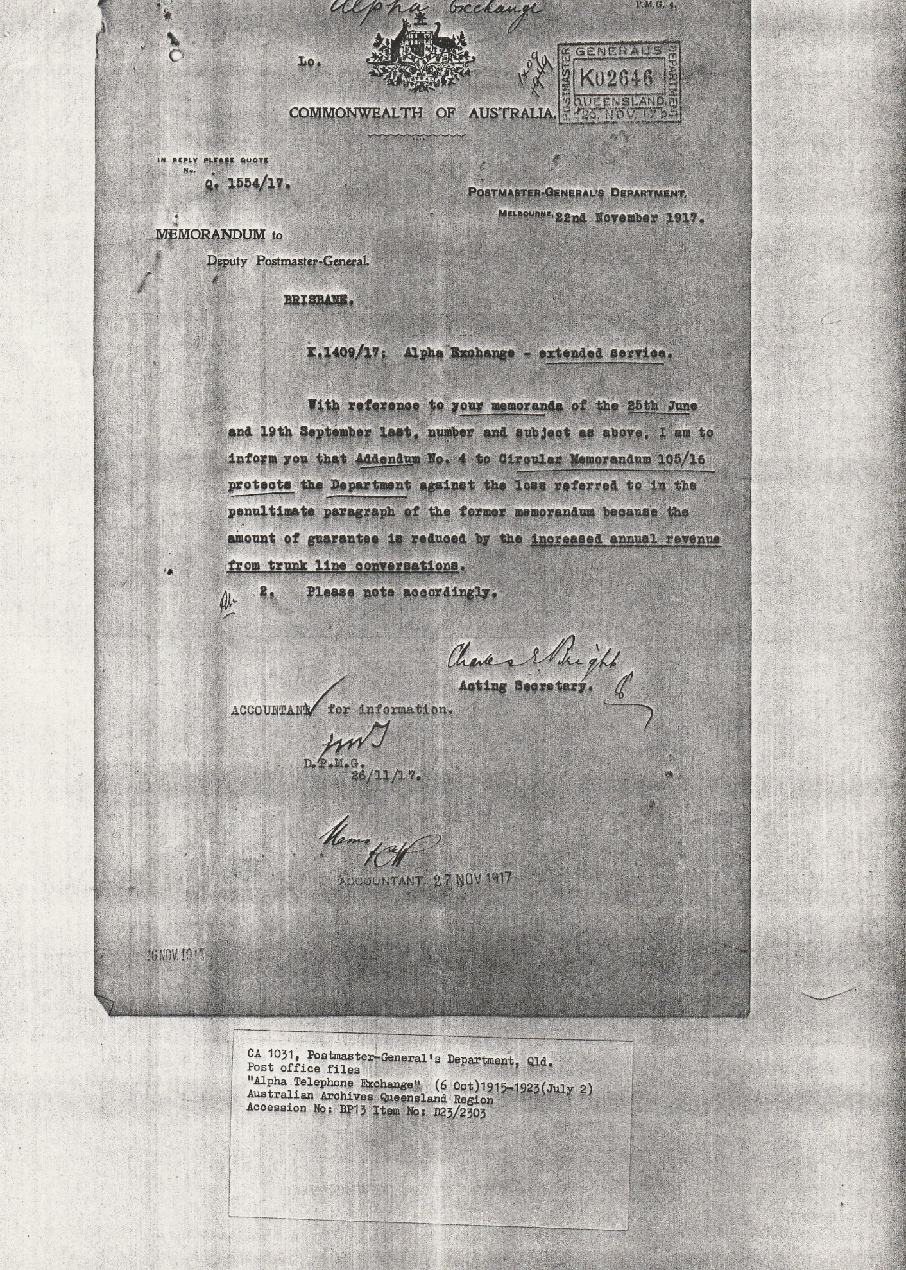
22nd November 1917
Deputy Postmaster General
BRISBANE
K. 1409/17 Alpha Exchange – extended service
With reference to your memoranda of the 25th June and 19th September last. Number and subject as above. I am to inform you that Addendum No. 4 to Circular Memorandum 105/16 protects the Department against the loss referred to in the penultimate paragraph of the former memorandum because the amount of guarantee is reduced by the increased annual revenue from trunk line conversations.
2. Please not accordingly

Acting Secretary

Accountant for information
27 NOV 1917

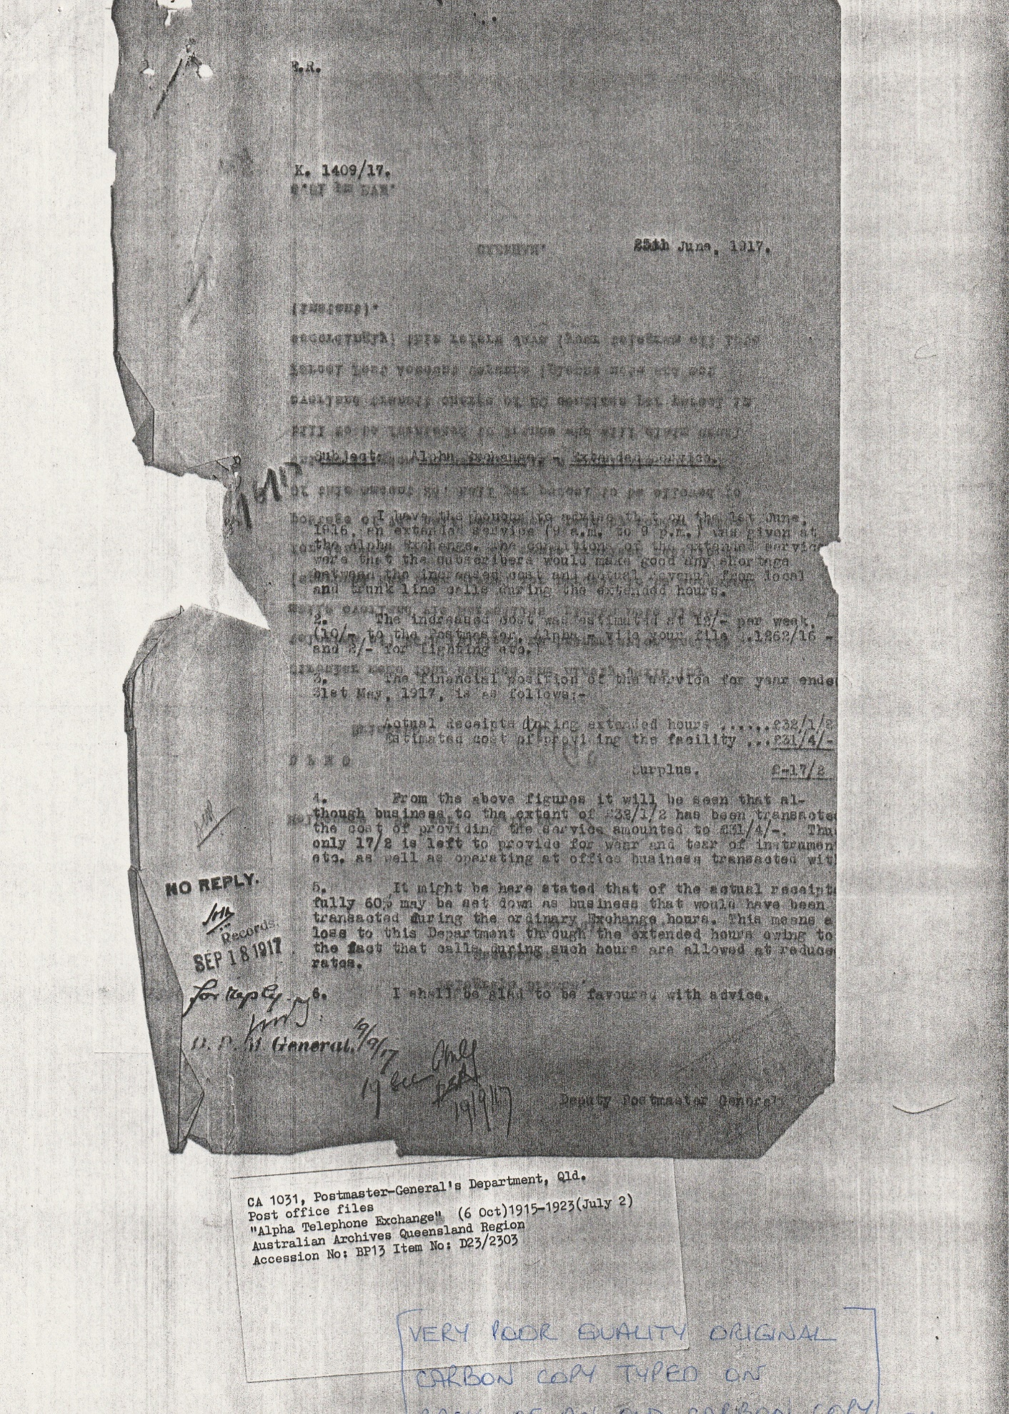
K. 1409/17
25th June 1917
Subject Alpha Exchange Extended service.
I have the honour to advise that on the 1st June 1916 an extended service (9 a.m. – 9 p.m.) was given at Alpha Exchange. The condition of the additional service were that the subscribers would make good any shortage between the increased cost and actual revenue from local and trunk line calls during the extended hours.
2. the increased cost was estimated at 12/- per week. (10/- to the Postmaster. Alpha- Vi Lo your file Q 1262/16 and 2/- for lighting etc.)
3. The financial position of the service for year ended 31st May 1917 is as follows
Actual receipts during extended hours £32/1/8
Estimated cost of providing the facility £31/4/-
Surplus £-17/8
4. From the above figures it will be seen that although business to the extent of £32/1/2 has been transacted the cost of providing the service amounted to £31/4/- Thus only 17/2 is left to provide for wear and tear of instrumentation etc. as well as operating at office business transacted with.
5. It might be here stated that of the actual receipts fully 60% may be fully set down as business that would have been transacted during the ordinary Exchange hours. This means a loss to this Department through the extended hours owing to the fact that calls during such hours are allowed at reduced rates.
6 I shall be glad to be favoured with advice.

Deputy for Postmaster General.
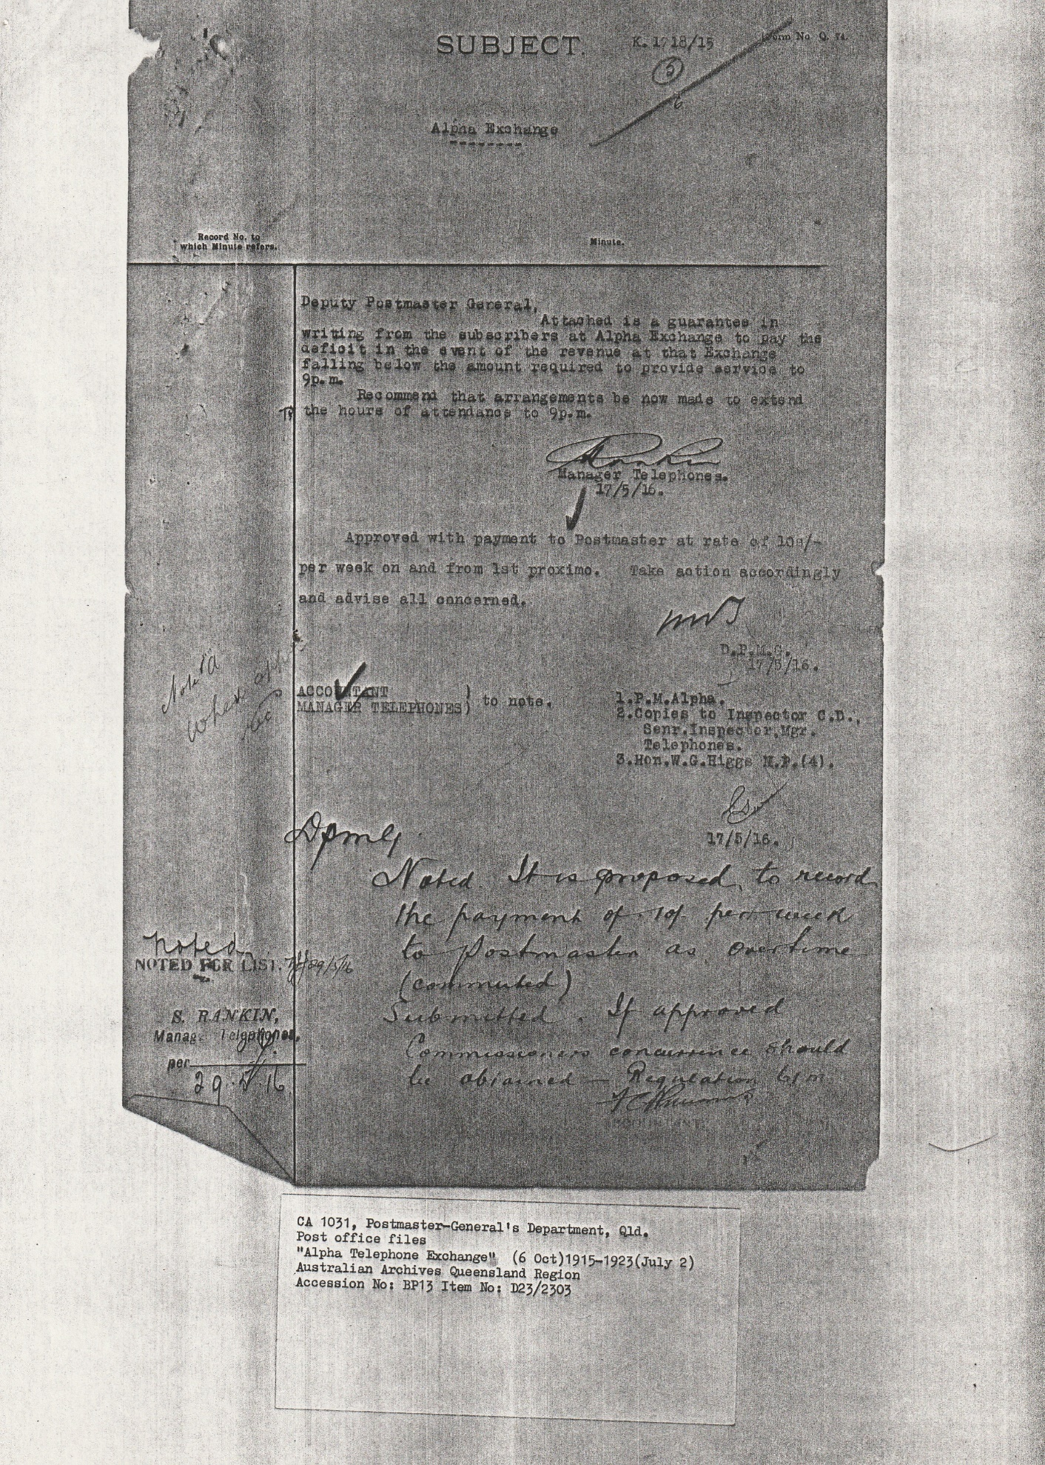
Subject K. 1718/15
Alpha Exchange
Deputy Postmaster General,
Attached is a guarantee in writing from the subscribers at the Alpha Exchange to pay the deficit in the event of the revenue at that Exchange falling below the amount required to provide service to 9p.m.
Recommend that arrangements be now made to extend the hours of attendance to 9p.m.

Manager of Telephones
17/5/16
Approved with payment to Postmaster at rat of 10/- per week and from 1st proximo. Take action accordingly and advise all concerned.

D.P.M.G.
17/5/16
Accountant
Manager Telephones to note

- P.M. Alpha
- Copies to inspector C.D. Senr. Inspector, Mgr. Telephones
- Hon. W. G. Higgs M.P. (4)

17/5//16

Noted it is proposed to record the payment of 10/- per week to Postmaster as overtime (commuted)
Submitted. If approved Commissioner’s concurrence should be obtained- requeation 6pm
S. Rankin Manager Telephones.

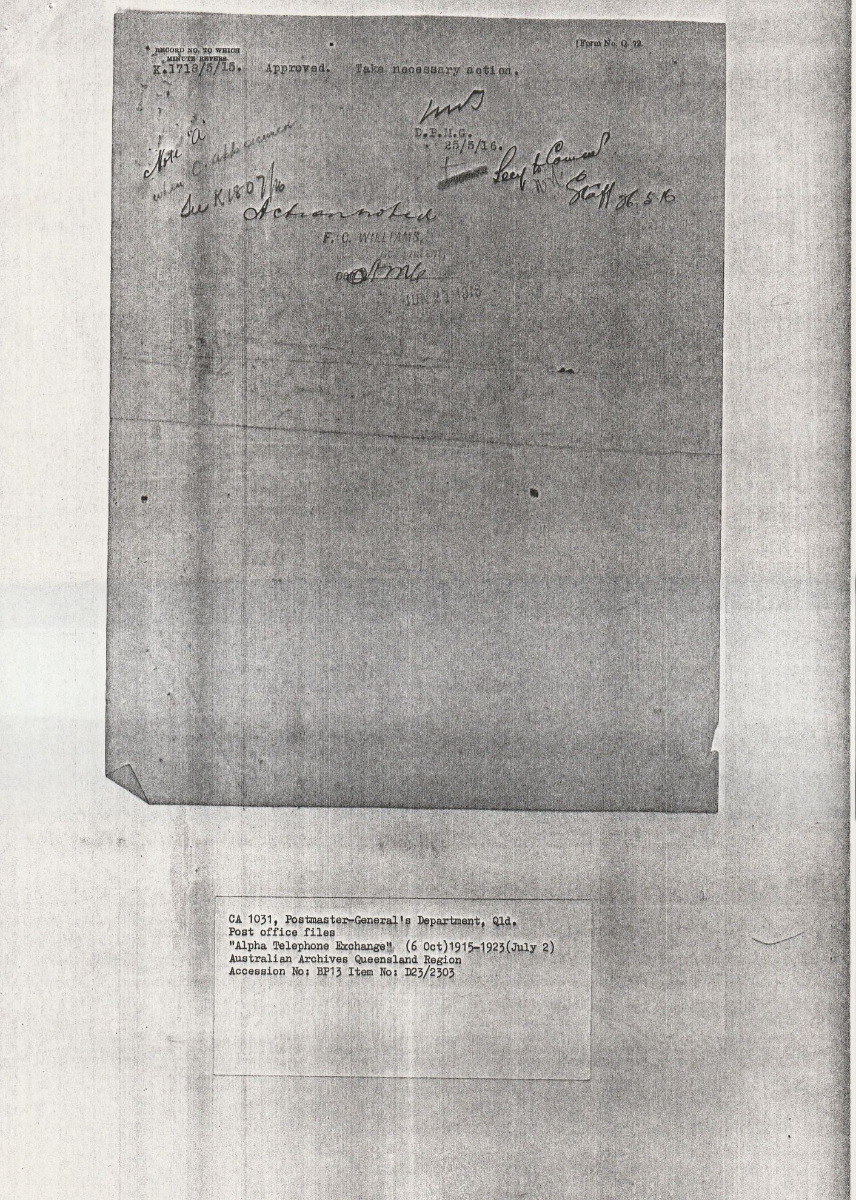K1718/5/15 Approved Take necessary action
D.P.M.G.
25/5/16

F.C. WILLIAMS Accountant
June 27 1916
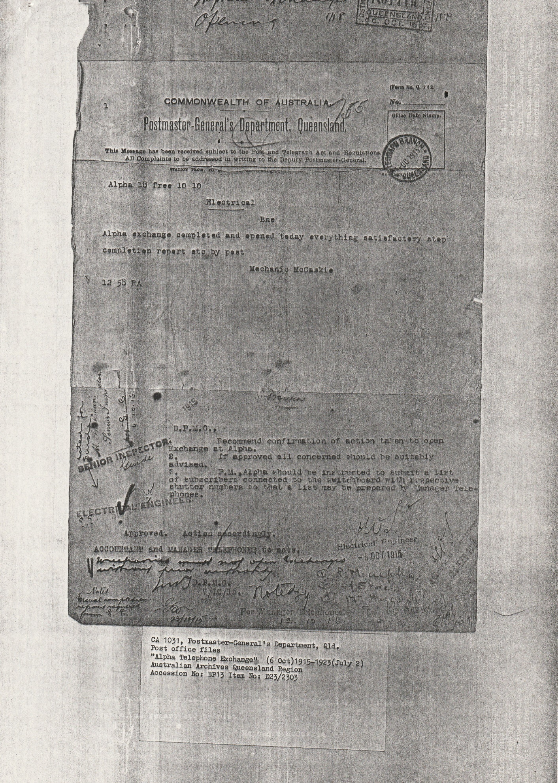
Telegram
Alpha 18 free 10 10
Electrical
Bne
Alpha Exchange completed and opened today everything satisfactory step completion report etc by post
Mechanic McCaskie
12 58 RA

D.P.M.G. ,
Recommend confirmation of action taken to open Exchange at Alpha.
2. If approved all concerned should be suitably advised.
3. P.M. Alpha should be instructed to submit a list of subscribers connected to switchboard with respective shutter numbers so that a list may be prepared by Manager Telephones
Approved. Action accordingly
ACCOUNTANT and MANAGER TELEPHONES to note.

Senior Inspector
Electrical Engineers 6 OCT 1915
Manager of Telephones 12/10/15

