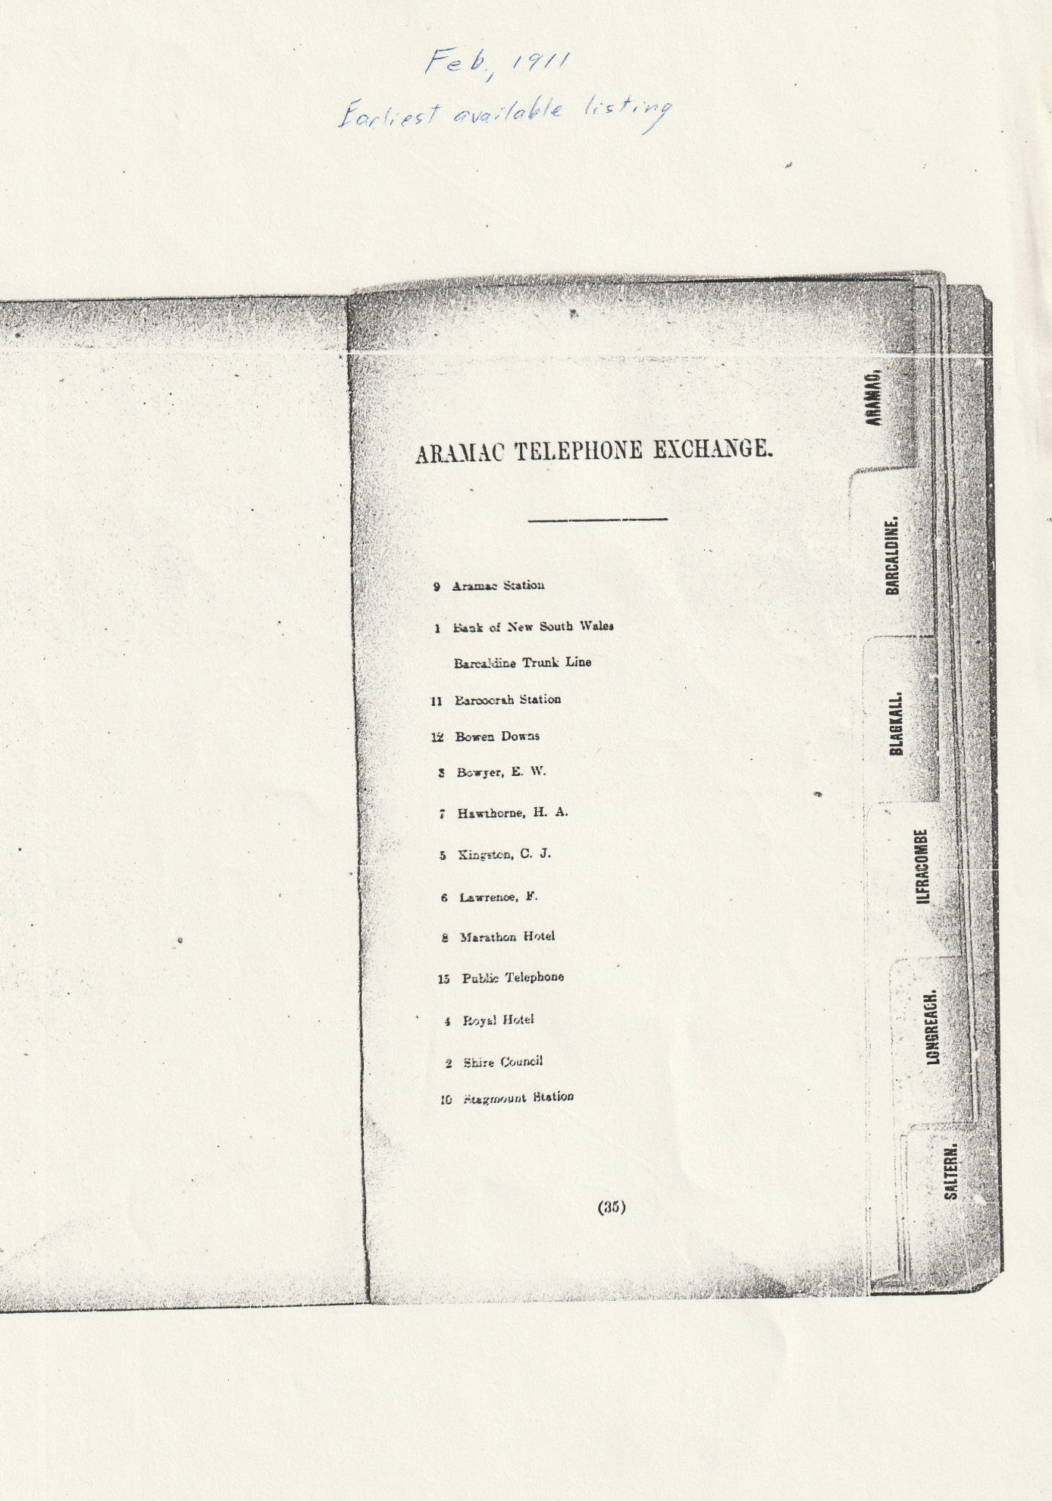Feb, 1911
Earliest Listing
ARAMAC TELEPHONE EXCHANGE
9 Aramac Station
1 Bank of New South Wales
Barcaldine Trunk Line
11 Barcoorah Station
12 Bowen Downs
3 Boyer, E. W.
7 Hawthorne H. A.
5 Kingston, C. J.
6 Lawrence, F.
8 Marathon Hotel
15 Public Telephone
4 Royal Hotel
2 Shire Council
10 Stagmount Station

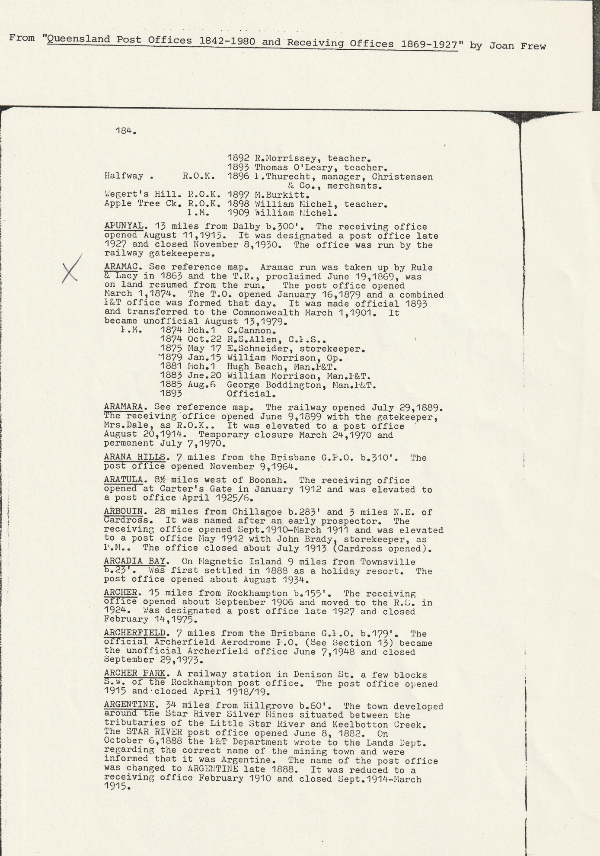
ARAMAC. See reference map. Aramac run was taken up by Rule & Lacy in 1863 and the T.R., proclaimed June 19,1869, was on land resumed from the run. The post office opened March 1,1874. The T.O. opened January 16,1879 and a combined 1&T office was formed that day. It was made official 1893
and transferred to the Commonwealth March 1,1901. It became unofficial August 13,1979.
1.M. 1874 Mch.1 C.Cannon.
1874 Oct.22 R.S.Allen, C.1.S..
1875 May 17 E.Schneider, storekeeper.
'1879 Jan.15 William Morrison, Op.
1881 hch.1 Hugh Beach, Man.F&T.
1883 Jne.20 William Morrison, Man.I&T.
1885 Aug.6 George Boddington, Man.1-LT.
1893 Official.
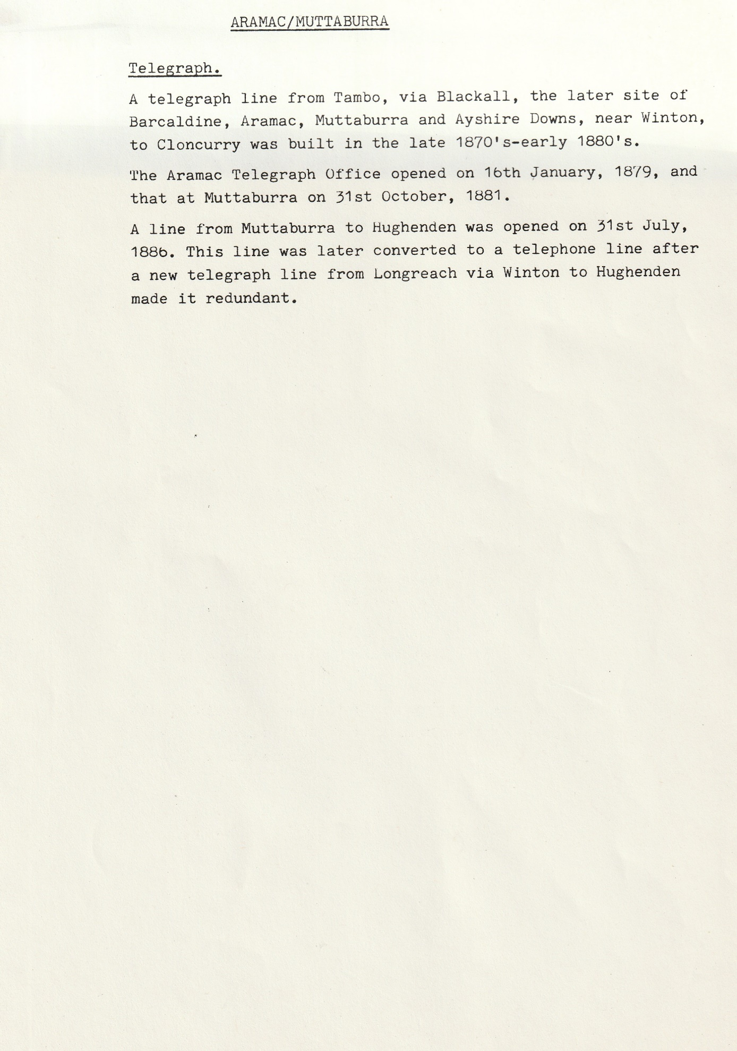
ARAMAC/MUTTABURRA
Telegraph.
A telegraph line from Tambo, via Blackall, the later site of Barcaldine, Aramac, Muttaburra and Ayshire Downs, near Winton, to Cloncurry was built in the late 1870's-early 1880's.
The Aramac Telegraph Office opened on 16th January, 1879, and that at Muttaburra on 31st October, 1881.
A line from Muttaburra to Hughenden was opened on 31st July, 188b. This line was later converted to a telephone line after a new telegraph line from Longreach via Winton to Hughenden made it redundant.
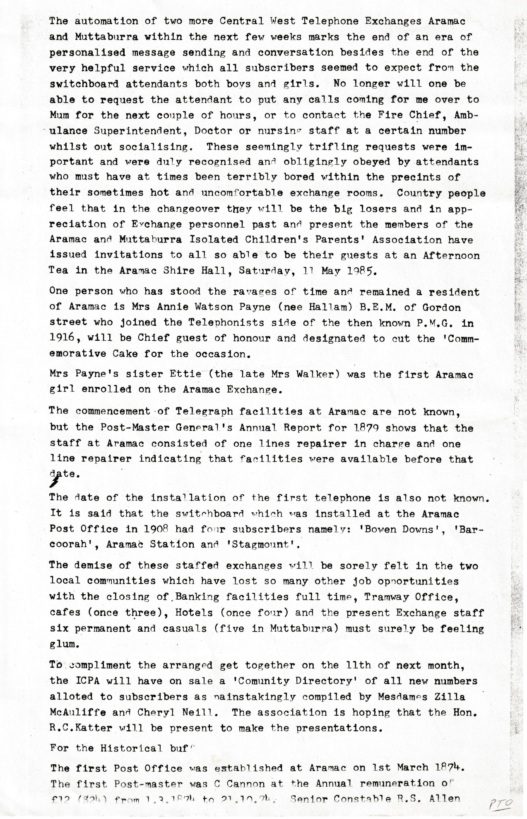
The automation of two more Central West Telephone Exchanges Aramac and Muttaburra within the next few weeks marks the end of an era of personalised message sending and conversation besides the end of the very helpful service which all subscribers seemed to expect from the switchboard attendants both boys and girls. No longer will one be able to request the attendant to put any calls coming for me over to Mum for the next couple of hours, or to contact the Fire Chief, Ambulance Superintendent, Doctor or nursing staff at a certain number whilst out socialising. These seemingly trifling requests were important and were duly recognised and obligingly obeyed by attendants who must have at times been terribly bored within the precincts of their sometimes hot and uncomfortable exchange rooms. Country people feel that in the changeover they will be the big losers and in appreciation of Exchange personnel past and present the members of the Aramac and Muttaburra Isolated Children's Parents' Association have issued invitations to all so able to be their guests at an Afternoon Tea in the Aramac Shire Hall, Saturday, 11 May 11P5.
One person who has stood the ravages of time and remained a resident of Aramac is Mrs. Annie Watson Payne (nee Hallam) B.E.M. of Gordon Street who joined the Telephonists side of the then known P.M.G. in 1916, will be Chief guest of honour and designated to cut the 'Commemorative Cake’ for the occasion.
Mrs. Payne's sister Ettie (the late Mrs. Walker) was the first Aramac girl enrolled on the Aramac Exchange.
The commencement-of Telegraph facilities at Aramac are not known., but the Post-Master General's Annual Report for 1879 shows that the staff at Aramac consisted of one lines repairer in charge and one line repairer indicating that facilities were available before that date.
The date of the installation of the first telephone is also not known. It is said that the switchboard which was installed at the Aramac Post Office in 1908 had four subscribers namely: 'Bowen Downs', 'Bar-coorah', Aramac Station and 'Stagmount'.
The demise of these staffed exchanges will be sorely felt in the two local communities which have lost so many other job opportunities with the closing of, Banking facilities full time, Tramway Office, cafes (once three), Hotels (once four) and the present Exchange staff six permanent and casuals (five in Muttaburra) must surely be feeling glum.
To compliment the arranged get together on the 11th of next month, the ICPA will have on sale a 'Community Directory' of all new numbers allotted to subscribers as painstakingly compiled by Mesdames Zilla McAuliffe and Cheryl Neill. The association is hoping that the Hon. R.C. Katter will be present to make the presentations.
For the Historical buff'
The first Post Office was established at Aramac, on 1st March 1874. The first Postmaster was C. Cannon at the Annual remuneration of £12/ ($24) from 1.3.1874 to 21.10.74. Senior Constable R.S. Allen

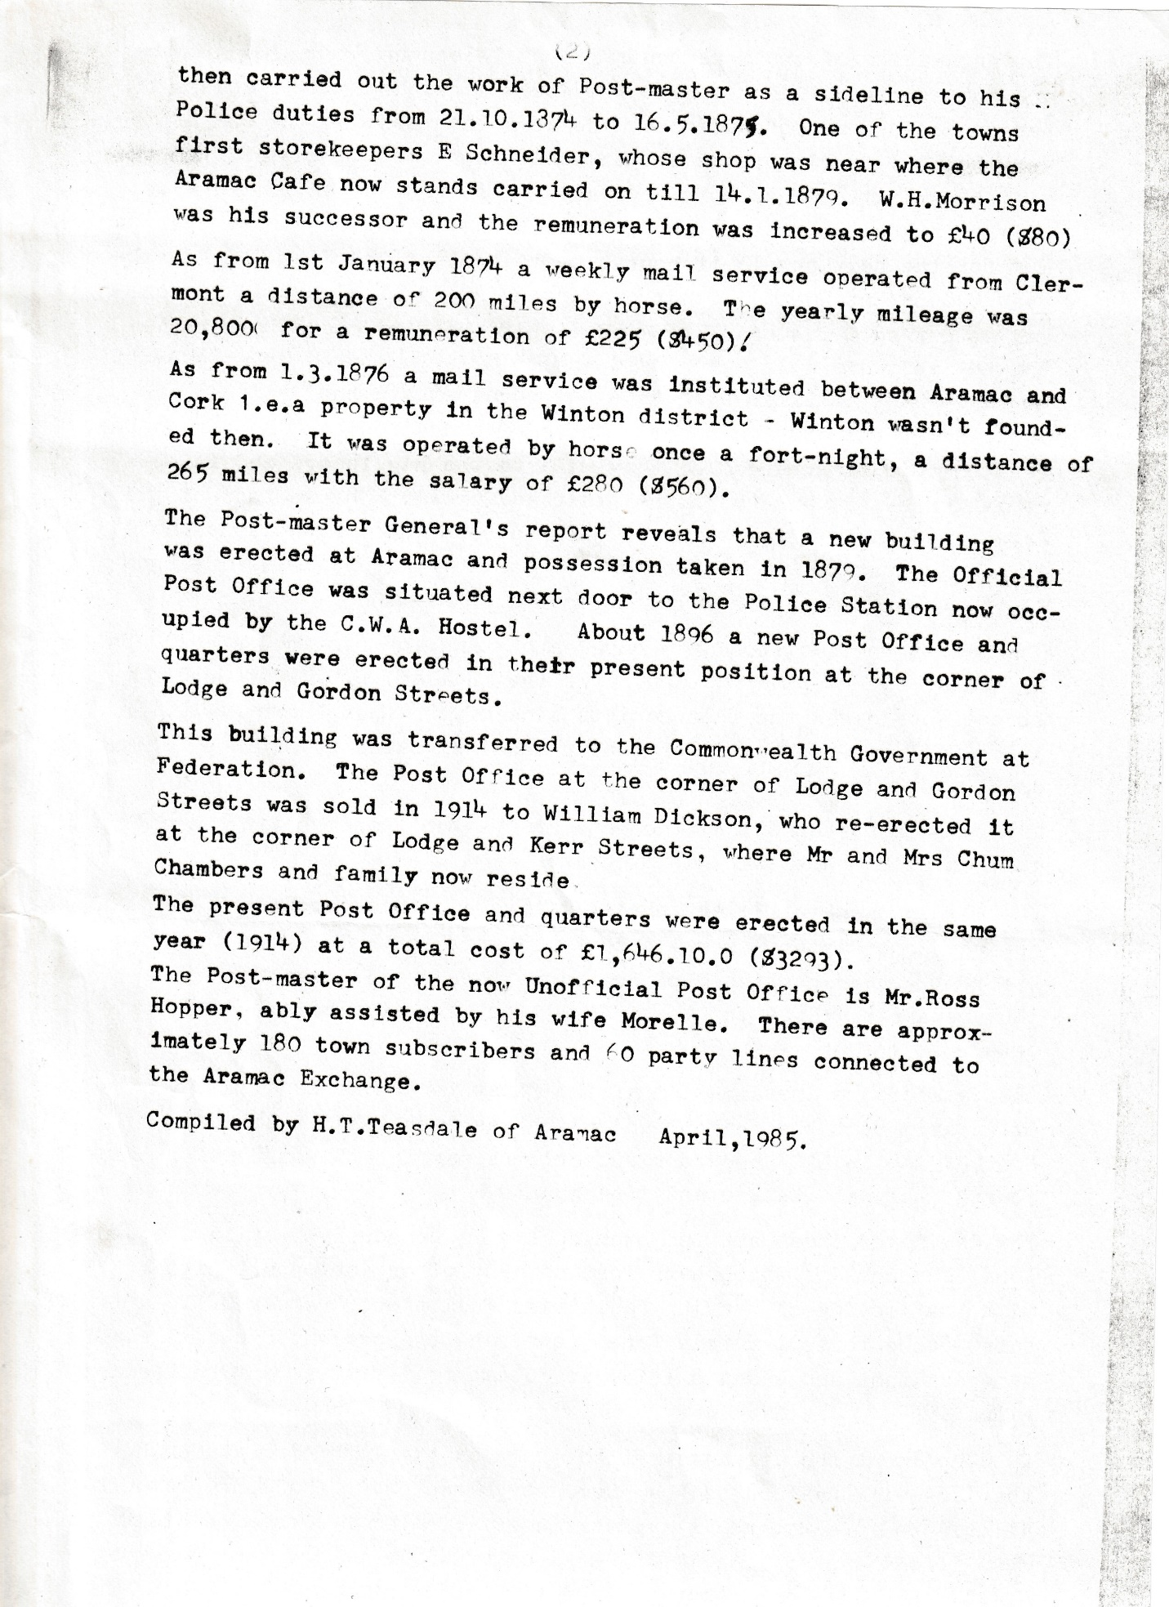
then carried out the work of Postmaster as a sideline to his Police duties from 21.10.1874 to 16.5.1875 One of the towns first storekeepers E Schneider, whose shop was near where the Aramac Cafe now stands carried on till 14.1.1879. W.H. Morrison was his successor and the remuneration was increased to £40 ($80)
As from 1st January 1874 a weekly mail service operated from Clermont a distance of 200 miles by horse. The yearly mileage was 20,800 (for a remuneration of £225 ($450):
As from 1.3.1876 a mail service was instituted between Aramac and Cork 1.e.a property in the Winton district - Winton wasn't founded then. It was operated by horse once a fort-night, a distance of 265 miles with the salary of £280 ($560).
The Postmaster General's report reveals that a new building was erected at Aramac and possession taken in 1870. The Official Post Office was situated next door to the Police Station now occupied by the C.W.A. Hostel. About 1886 a new Post Office and quarters were erected in their present position at the corner of Lodge and Gordon Streets.
This building was transferred to the Commonwealth Government at Federation. The Post Office at the corner of Lodge and Gordon Streets was sold in 1914 to William Dickson, who re-erected it at the corner of Lodge and Kerr Streets, where Mr. and Mrs. Chum Chambers and family now reside.
The present Post Office and quarters were erected in the same year (1914) at a total cost of £1,646.10.0 ($3293).
The Postmaster of the now Unofficial Post Office is Mr. Ross Hopper, ably assisted by his wife Morelle. There are approximately 180 town subscribers and 60 party lines connected to the Aramac Exchange.
Compiled by H.T. Teasdale of Aramac Apri1,1985.

