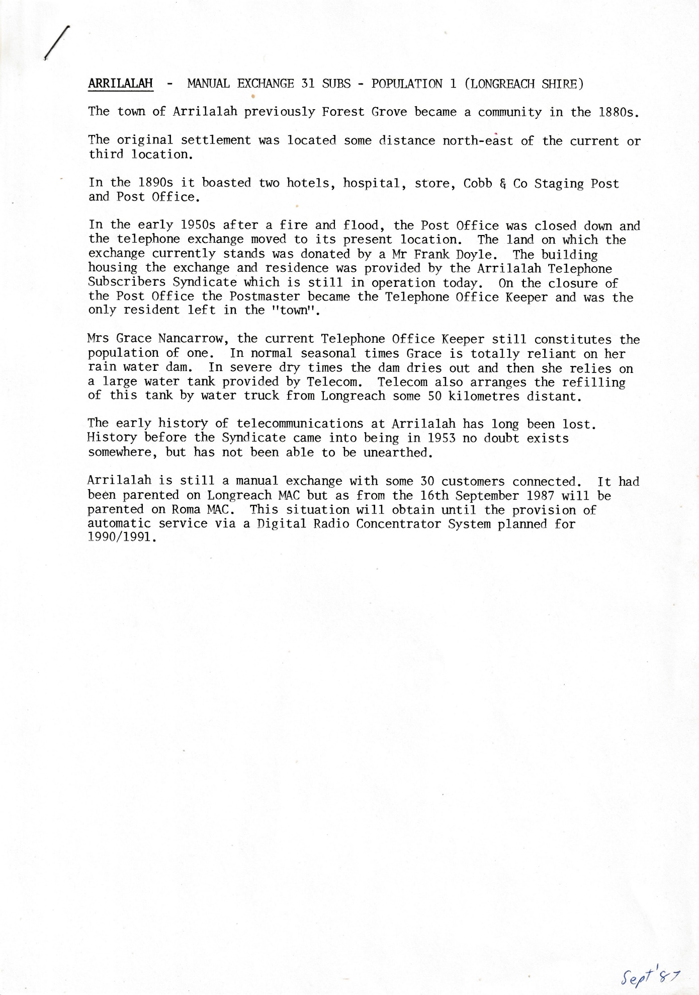
ARRILALAH - MANUAL EXCHANGE 31 SUBS - POPULATION 1 (LONGREACH SHIRE)
The town of Arrilalah previously Forest Grove became a community in the 1880s.
The original settlement was located some distance north-east of the current or third location.
In the 1890s it boasted two hotels, hospital, store, Cobb & Co Staging Post and Post Office.
In the early 1950s after a fire and flood, the Post Office was closed down and the telephone exchange moved to its present location. The land on which the exchange currently stands was donated by a Mr. Frank Doyle. The building housing the exchange and residence was provided by the Arrilalah Telephone Subscribers Syndicate which is still in operation today. On the closure of the Post Office the Postmaster became the Telephone Office Keeper and was the only resident left in the "town".
Mrs. Grace Nancarrow, the current Telephone Office Keeper still constitutes the population of one. In normal seasonal times Grace is totally reliant on her rain water dam. In severe dry times the dam dries out and then she relies on a large water tank provided by Telecom. Telecom also arranges the refilling of this tank by water truck from Longreach some 50 kilometres distant.
The early history of telecommunications at Arrilalah has long been lost. History before the Syndicate came into being in 1953 no doubt exists somewhere, but has not been able to be unearthed.
Arrilalah is still a manual exchange with some 30 customers connected. It had been parented on Longreach MAC but as from the 16th September 1987 will be parented on Roma MAC. This situation will obtain until the provision of automatic service via a Digital Radio Concentrator System planned for 1990/1991.

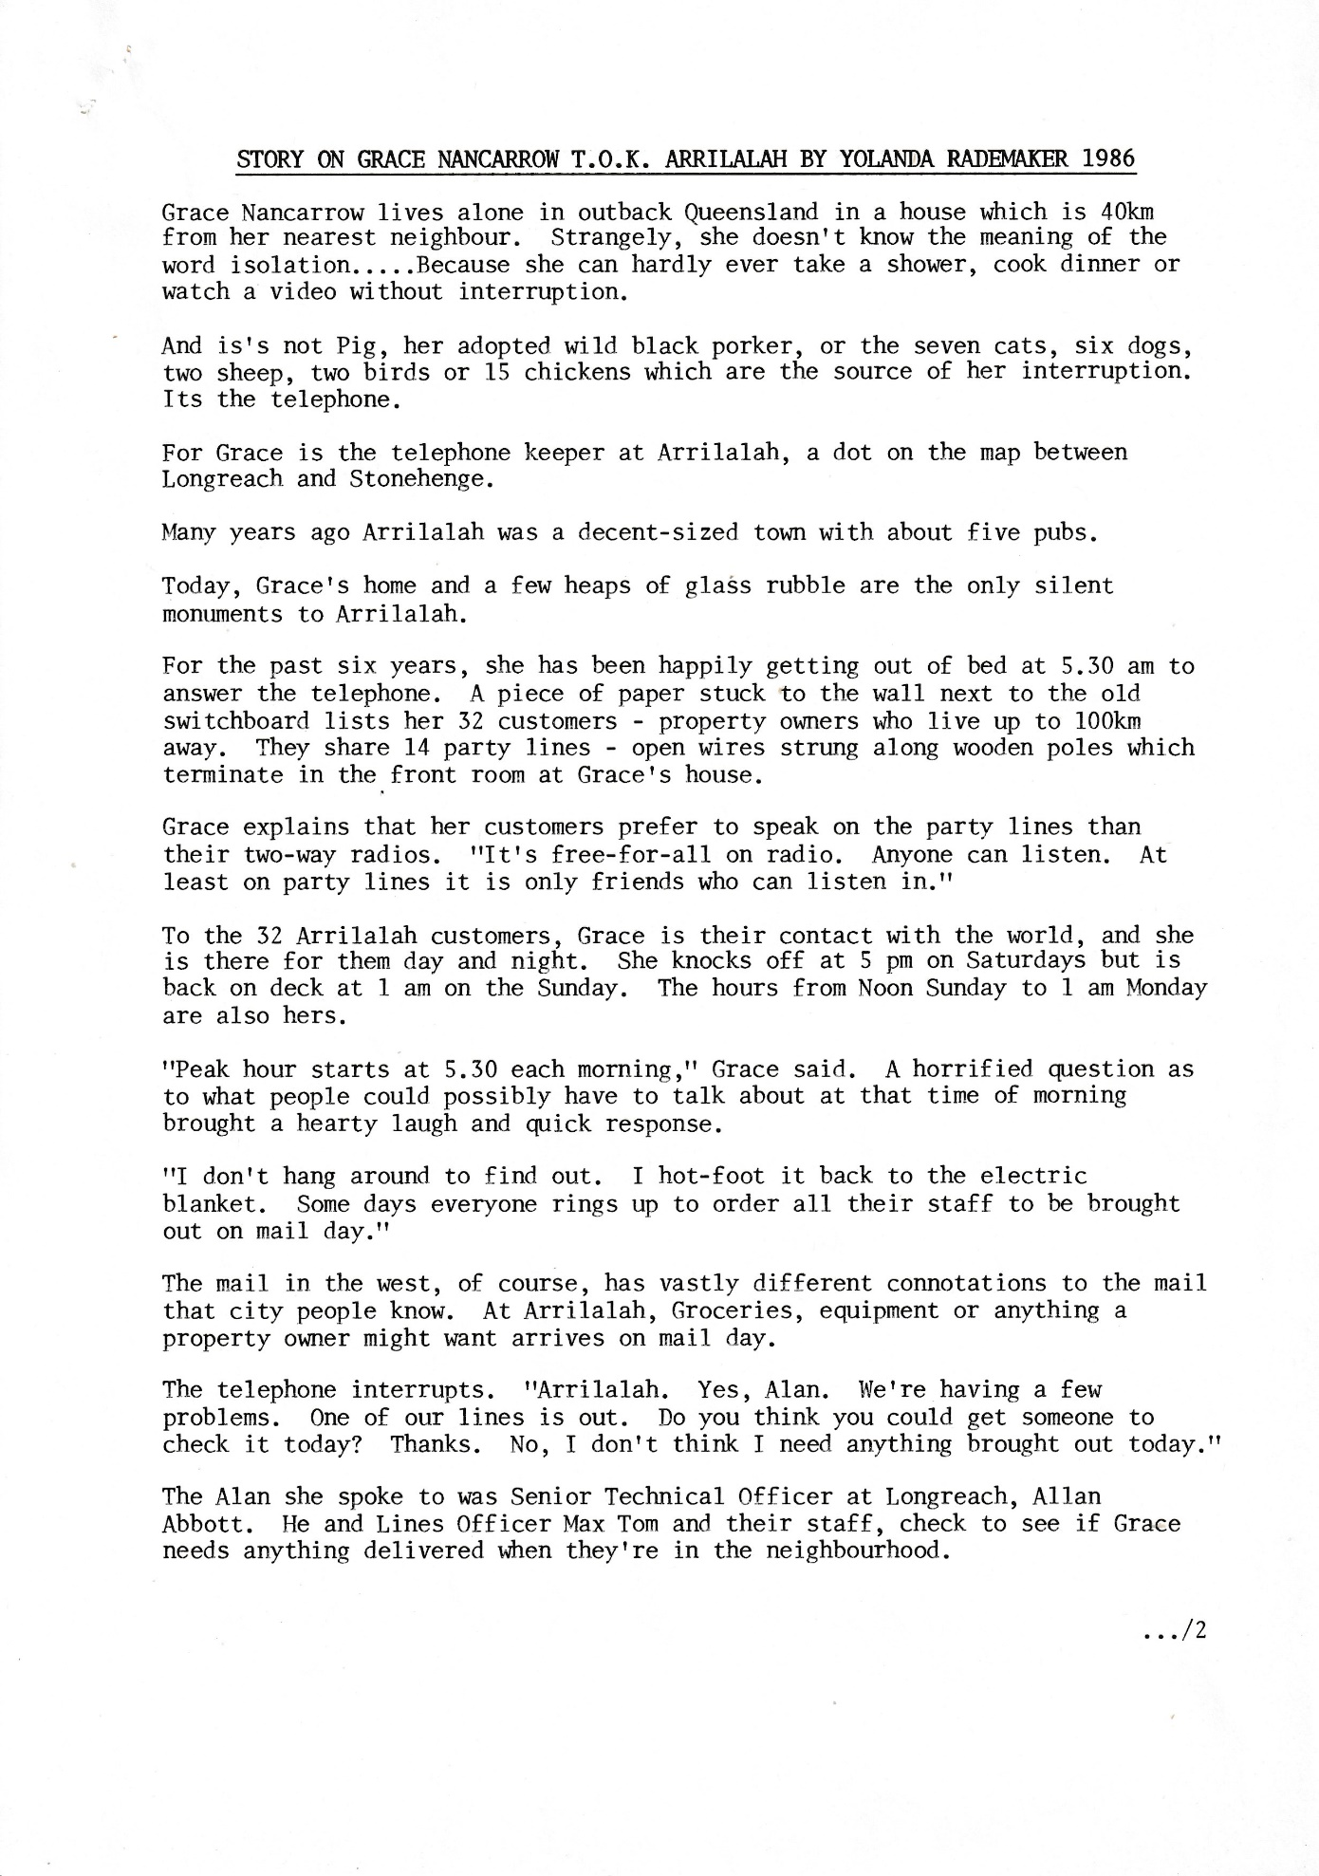
STORY ON GRACE NANCARROW T.O.K. ARRILALAH BY YOLANDA RADEMAKER 1986
Grace Nancarrow lives alone in outback Queensland in a house which is 40km from her nearest neighbour. Strangely, she doesn't know the meaning of the
word isolation Because she can hardly ever take a shower, cook dinner or watch a video without interruption.
And is's not Pig, her adopted wild black porker, or the seven cats, six dogs, two sheep, two birds or 15 chickens which are the source of her interruption. Its the telephone.
For Grace is the telephone keeper at Arrilalah, a dot on the map between Longreach and Stonehenge.
Many years ago, Arrilalah was a decent-sized town with about five pubs.
Today, Grace's home and a few heaps of glass rubble are the only silent monuments to Arrilalah.
For the past six years, she has been happily getting out of bed at 5.30 am to answer the telephone. A piece of paper stuck to the wall next to the old switchboard lists her 32 customers - property owners who live up to 100km away. They share 14 party lines - open wires strung along wooden poles which terminate in the front room at Grace's house.
Grace explains that her customers prefer to speak on the party lines than their two-way radios. "It's free-for-all on radio. Anyone can listen. At least on party lines it is only friends who can listen in."
To the 32 Arrilalah customers, Grace is their contact with the world, and she is there for them day and night. She knocks off at 5 pm on Saturdays but is back on deck at 1 am on the Sunday. The hours from Noon Sunday to 1 am Monday are also hers.
"Peak hour starts at 5.30 each morning," Grace said. A horrified question as to what people could possibly have to talk about at that time of morning brought a hearty laugh and quick response.
"I don't hang around to find out. I hot-foot it back to the electric
blanket. Some days everyone rings up to order all their staff to be brought out on mail day."
The mail in the west, of course, has vastly different connotations to the mail that city people know. At Arrilalah, Groceries, equipment or anything a property owner might want arrives on mail day.
The telephone interrupts. "Arrilalah. Yes, Alan. We're having a few problems. One of our lines is out. Do you think you could get someone to check it today? Thanks. No, I don't think I need anything brought out today."
The Alan she spoke to was Senior Technical Officer at Longreach, Allan Abbott. He and Lines Officer Max Tom and their staff, check to see if Grace needs anything delivered when they're in the neighbourhood.
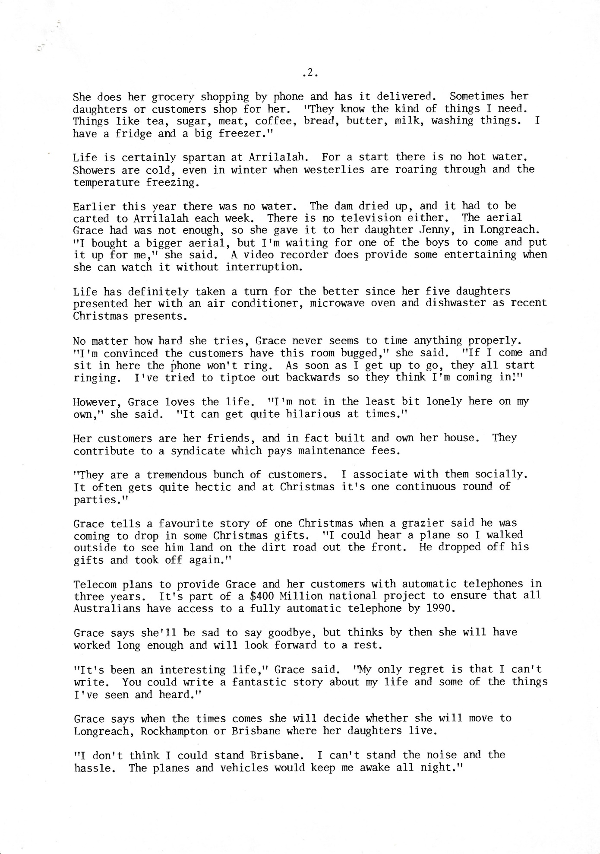
She does her grocery shopping by phone and has it delivered. Sometimes her daughters or customers shop for her. "They know the kind of things I need. Things like tea, sugar, meat, coffee, bread, butter, milk, washing things. I have a fridge and a big freezer."
Life is certainly spartan at Arrilalah. For a start there is no hot water. Showers are cold, even in winter when westerlies are roaring through and the temperature freezing.
Earlier this year there was no water. The dam dried up, and it had to be carted to Arrilalah each week. There is no television either. The aerial Grace had was not enough, so she gave it to her daughter Jenny, in Longreach. "I bought a bigger aerial, but I'm waiting for one of the boys to come and put it up for me," she said. A video recorder does provide some entertaining when she can watch it without interruption.
Life has definitely taken a turn for the better since her five daughters presented her with an air conditioner, microwave oven and dishwasher as recent Christmas presents.
No matter how hard she tries, Grace never seems to time anything properly. "I'm convinced the customers have this room bugged," she said. "If I come and sit in here the Phone won't ring. As soon as I get up to go, they all start ringing. I've tried to tiptoe out backwards so they think I'm coming in!"
However, Grace loves the life. "I'm not in the least bit lonely here on my own," she said. "It can get quite hilarious at times."
Her customers are her friends, and in fact built and own her house. They contribute to a syndicate which pays maintenance fees.
"They are a tremendous bunch of customers. I associate with them socially. It often gets quite hectic and at Christmas it's one continuous round of parties."
Grace tells a favourite story of one Christmas when a grazier said he was coming to drop in some Christmas gifts. "I could hear a plane so I walked outside to see him land on the dirt road out the front. He dropped off his gifts and took off again."
Telecom plans to provide Grace and her customers with automatic telephones in three years. It's part of a $400 Million national project to ensure that all Australians have access to a fully automatic telephone by 1990.
Grace says she'll be sad to say goodbye, but thinks by then she will have worked long enough and will look forward to a rest.
"It's been an interesting life," Grace said. "My only regret is that I can't write. You could write a fantastic story about my life and some of the things I've seen and heard."
Grace says when the times comes, she will decide whether she will move to Longreach, Rockhampton or Brisbane where her daughters live.
"I don't think I could stand Brisbane. I can't stand the noise and the hassle. The planes and vehicles would keep me awake all night."
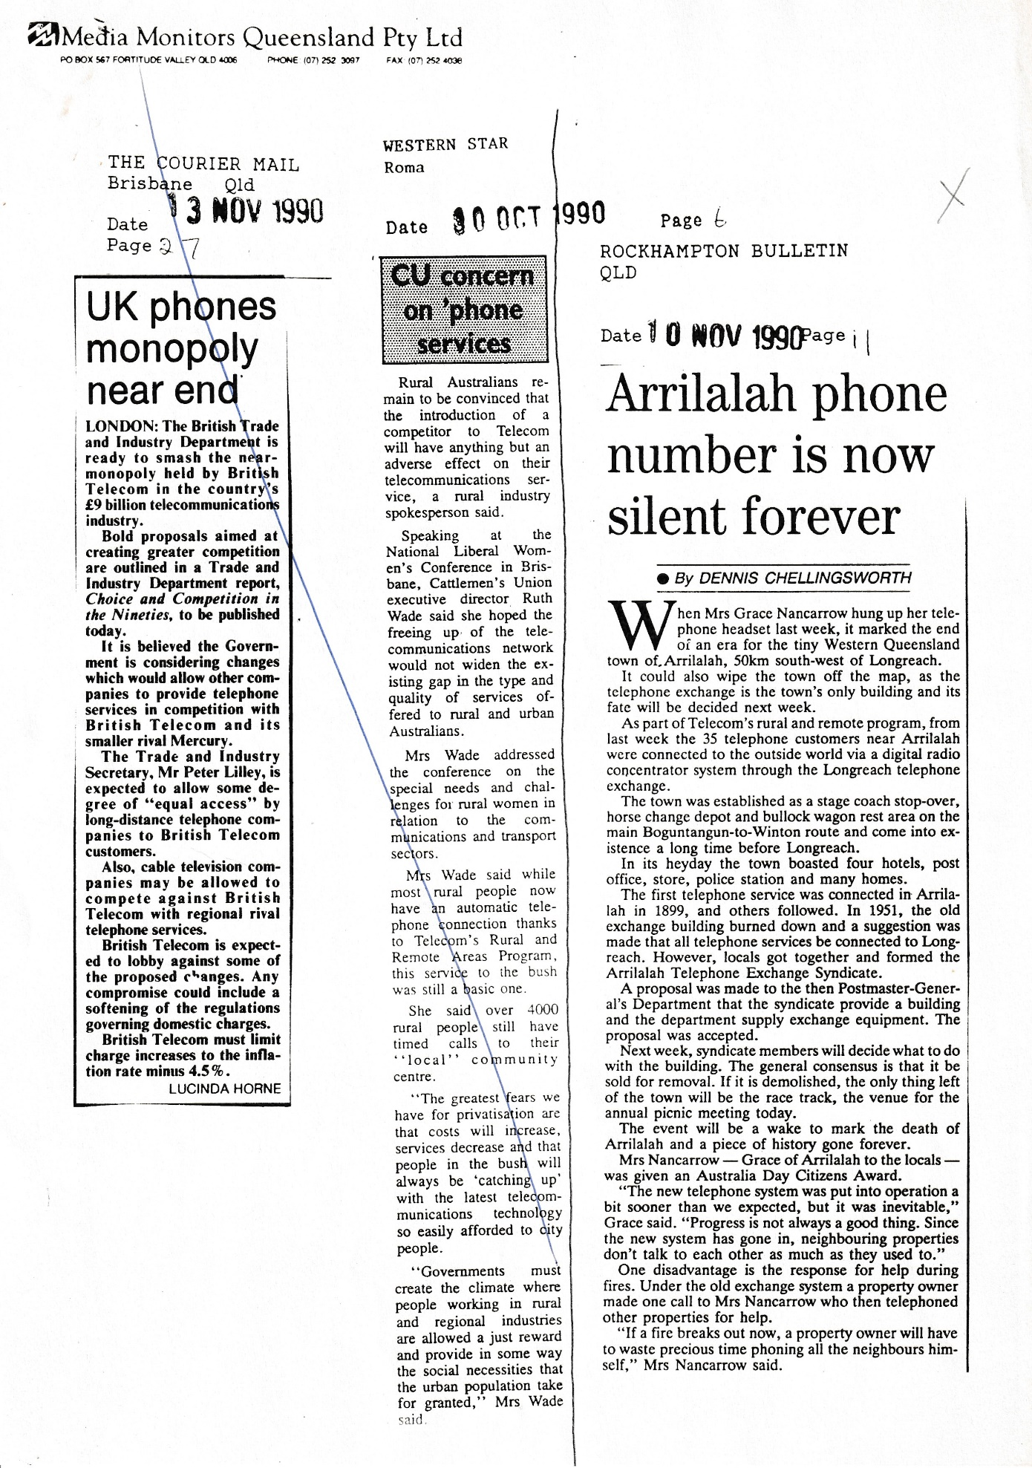
Arrilalah phone number is now silent forever
By DENNIS CHELLINGSWORTH 10/11/1990
When Mr.s Grace Nancarrow hung up her telephone headset last week, it marked the end of an era for the tiny Western Queensland town of, Arrilalah, 50km south-west of Longreach.
It could also wipe the town off the map, as the telephone exchange is the town's only building and its fate will be decided next week.
As part of Telecom's rural and remote program, from last week the 35 telephone customers near Arrilalah were connected to the outside world via a digital radio concentrator system through the Longreach telephone exchange.
The town was established as a stage coach stop-over, horse change depot and bullock wagon rest area on the main Boguntangun-to-Winton route and come into existence a long time before Longreach.
In its heyday the town boasted four hotels, post office, store, police station and many homes.
The first telephone service was connected in Arrilalah in 1899, and others followed. In 1951, the old exchange building burned down and a suggestion was made that all telephone services be connected to Long-reach. However, locals got together and formed the Arrilalah Telephone Exchange Syndicate.
A proposal was made to the then Postmaster General's Department that the syndicate provide a building and the department supply exchange equipment. The proposal was accepted.
Next week, syndicate members will decide what to do with the building. The general consensus is that it be sold for removal. If it is demolished, the only thing left of the town will be the race track, the venue for the annual picnic meeting today.
The event will be a wake to mark the death of Arrilalah and a piece of history gone forever.
Mrs Nancarrow — Grace of Arrilalah to the locals — was given an Australia Day Citizens Award.
"The new telephone system was put into operation a bit sooner than we expected, but it was inevitable," Grace said. "Progress is not always a good thing. Since the new system has gone in, neighbouring properties don't talk to each other as much as they used to."
One disadvantage is the response for help during fires. Under the old exchange system a property owner made one call to Mrs. Nancarrow who then telephoned other properties for help.
"If a Fire breaks out now, a property owner will have to waste precious time phoning all the neighbours him-self," Mrs. Nancarrow said.

