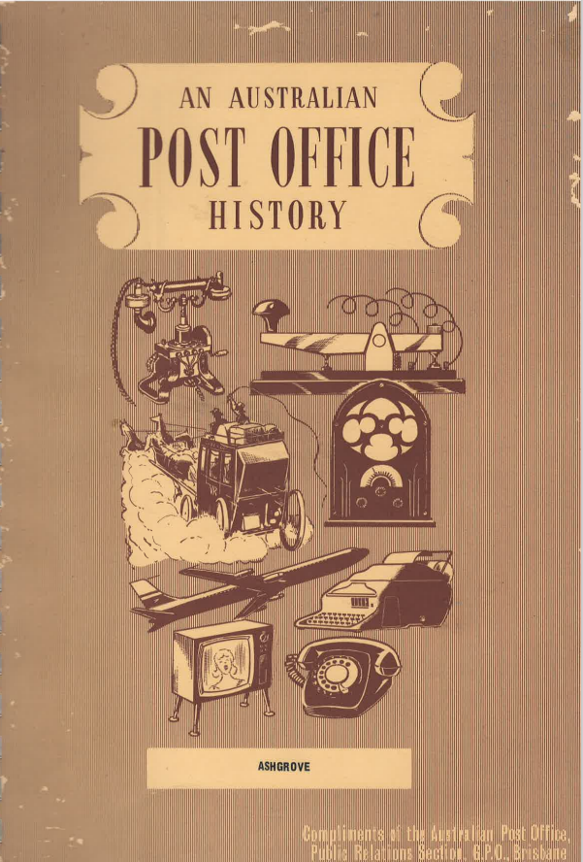
AN AUSTRALIAN POST OFFICE HISTORY
ASHGROVE
FIRST LAND SALES
The first sale of Crown lands in the area now known as Ashgrove was made before Queensland became a State and thus under the authority of the Government of New South Wales. Robert Little and Darby McGrath purchased the land at a public auction on 1st September, 1856: Little bought 50 acres, portion 29, Parish of Enoggera, County of Stanley, for £50 and portion 28, an area of 32 acres 3 roods for £32.15.0. Darby McGrath bought the adjacent portion 27, an area of 34 acres 1 rood for £34.5.0.
Within a few years the area became more popular as evidenced by John F. McDougall and Joseph Grindley buying land in September 1858, Robert Little some in 1859, William Cooksley and Alexander Bennett two portions in 1862. Other purchasers were Plint, Donaldson, Carrington, Peard, Bessac, Fugett, Greenwood, Robinson, Clarke and Harding.
Between 1st September, 1856 and 3rd August, 1869, a total of 454 acres had been sold, and by 1875 all the Crown land which constituted the now Ashgrove area had been sold.
SETTLEMENT
With the purchase of these blocks ranging from 12 acres to 53 acres the area, only 3 miles from Brisbane, developed into a farming settlement and many stately homes were built. John MacDougall had a cattle station on his property purchased in 1858, while others engaged in dairying and crop growing. Two estates that have left their mark on Ashgrove are St. John's Wood and Glenlyon.
St. John's Wood
John F. MacDougall sold part of his land to a former Registrar for Pensions, Mr. Somerset, who planned a granite home on the estate. It was partly built in 1869 when Mr. Justice Harding acquired the St. John's Wood property of 600 acres which stretched back to the Taylor Ranges. Mr. Harding extended the home and planted a 10 acre orange grove in the grounds. Stables were added for his many horses. Many gay society gatherings took place in the mansion on St. John's Wood; even Royalty was entertained there - Princes Albert and George in 1881 and King George V and Queen Mary as the Duke and Duchess of York in 1901.
Glen Lyon House was built by kanakas in 1874 when Ashgrove was still the bush to Brisbane dwellers. They used bricks of local clay. It was the stately home of Alexander Stewart, Brisbane businessman. He came from Scotland and settled at Ashgrove on his new property. Mr. Stewart also bred horses and Herefords and engaged in farming on the estate.
Other old residences dating back to the beginning of Ashgrove are Farnborough, the home of the Hawthorns, Halwyn where Justice Woolcock lived for many years, and Frasers Paddock abutting Enoggera, where many servicemen camped during World War II.
ORIGIN OF NAME
Another estate was "Grove" estate, 200 acres in area, owned by Mr. Henry Holmes. It was divided in 1884 laying the foundations for a new suburb.
It is believed the name of Ashgrove originated from the Grove estate.
FIRST SCHOOL
The inhabitants of Waterworks Road, Upper Ithaca Creek (Ashgrove) and adjoining localities held a public meeting on 29th January, 1876 at the residence of Mr. J. Harding, St. John's Wood. A resolution was passed that it was desirable that a Primary School be established in the area at the junction of roads near Pipe Truck Tunnel. Mr. Harding offered to donate 2 acres of his land. The site at the top of the hill was described as being "the centre of a rapidly increasing district" and was "within 300 yards of permanent water and within half that distance of the Waterworks Main from which water could be easily obtained".
Waterworks Road lead to the Enoggera reservoir which was completed in 1866, and to the gold diggings in the surrounding back country.
The meeting informed the Department of Public Instruction that
"i.. At the present time there is no school within a nameable distance of the proposed site and the district is suffering very much from the want of one, numbers of children are growing up without any education at all ..."
Their efforts must have brought results because District Inspector Anderson visited the area on 4th February, 1876 and reported on the feasibility of the proposed erection of a school.
"The District is thinly inhabited, the soil being little fit for cultivation, and the land being held to a considerable extent in large holdings, with no immediate prospect of subdivision or further settlement. Harding and Stewart hold many hundred acres around the school site, none of which is practically available for settlement. The former gentleman alone holds almost 300 acres as he informed me. The school will accommodate these gentlemen and their resident employee’s (sic), some farmers on the Waterworks Road, settlers among the ranges to the northward between Enoggera Creek and Kedron Brook and the settlers on Upper Ithaca Creek. I find that thirty-seven children of school age reside within two miles of the proposed site. I am under the impression however that some residents on Ithaca. Creek have not been included and Mr. Arundel (sic) has promised me to ascertain the facts and report them to you."
In May 1876 the School Committee was asked to clear the school reserve except for shade trees and work began probably in August on the erection of the school buildings and teacher's residence. Contractors were used but their names have not been recorded. However, in spite of the work being well advanced by September 1876, the Ashgrove State School was not opened until 22nd January, 1877. Total cost of the school buildings was £678.6.3. with local subscriptions amounting to £104.19.0.
The Queenslander dated Saturday, November 11th, 1876, reported -
"The Ashgrove State School, the first erected under the operation of the Education Act passed last year, was formally opened on Saturday afternoon by the Minister for Education (the Hon. S.W. Griffith) in the presence of a large number of visitors.
The school has been built on an elevated site on the Waterworks Road, near St. John's Wood, the residence of G.R. Harding, Esq. and consists of a neat little hardboard building, 33 feet long by 17 feet wide, with a height in the walls of 12 feet 6 inches. It is built with a sheeted roof covered with hardwood shingles and is well ventilated with revolving casement windows."
FIRST HEAD TEACHER
Mr. James Brunton Stephens, the well-known Queensland poet, was the first Head Teacher. He was succeeded by Messrs W. Reinhold, J.C. Towell, W. Croston, R.G. Avenel, James Johnston, Thomas Fielding, Tsaac Waddle and C.E. Daniels.
FIRST POST OFFICE
Just prior to the official opening of the Ashgrove State School a very significant event took place which was to assist the development of the area. This was the establishment of the first Post Office and soon after a regular mail service to Brisbane.
A Post Office was opened on 1st January, 1877, with Mr. J.B. Stephens as Postmaster. For some reason unrecorded he received no salary. It is thought the office was located in a small store in Waterworks Road.
A regular mail service by coach began operating between Brisbane and Ashgrove from 15th March, 1877, six times a week. The distance of the route was 3 miles. The service replaced the carriage of mail by horseback.
MAIL SERVICE
In 1879 the coach mail service was designated Mail Service No.183 and was increased to 4 route miles. In 1880 it was extended a mile to 5 miles, although still operating 6 times a week. The coach was replaced with an omnibus in 1883.
EARLY POSTMASTERS
On 15th January, 1883, Mr. J.B. Stephens ceased as Postmaster. At the time he was still not paid for this responsibility, although it seems likely he had some other arrangement with the Postal Department to cover his services.
Mrs. F. Bailey took over the office for a short period until 9th February. She was paid at the rate of £6 p.a. (There was a Mr. Alexander Bailey, Solicitor, who lived in Waterworks Road at that time). Mr. W. Reinhold became Postmaster from 10th February, 1883, also at no salary. However, later he was paid at the rate of £12 p.a. to 19th September, 1884.
The Brisbane Town and Country Guide for 1883/4 lists a Post Office store owned by Park and Gibson, but official records do not indicate they conducted the office.
At the time there were 67 residents listed in the Directory including: -
Alex Bailey, Solicitor, Waterworks Road. L. Carmichael, Chemist, off Waterworks Road. Joseph Dorset, Engineer. George R. Harding, Justice, Supreme Court.
J.C. Towell was the next Postmaster. Mrs. B. Thomson took over from him on 27th June, 1887, at £12 p.a. She stayed until 27th May, 1888, when Mrs. A. Bailey appeared on the scene again to remain until 1905. During 1890 the mail was carried by wagonette between the Post Office and the city but reverted to the omnibus the following year. About that time a ride to the city in the omnibus cost 6d.
CLOSER SETTLEMENT
By 1905 Ashgrove had become a popular residential area for those who liked the rural scene. A street guide of the time lists the following families and businesses:
Waterworks Road, Ashgrove
Left hand side of road
Trouton, W.J., "Beth-Eden"
(off) Byron, Jas. T., "Sorell"
Fish, Walter P.
Sewell, Robert, "Carannock"
Bryant, Frederick
Troy, Michael (Constable), Ashgrove Police Station
Trout, Richard, "Cumstree"
Bailey, Mrs. A., Post Office
Bailey, Alexander
Right hand side
McMillan, Mrs. M., Store
McMillan, William
Warren, Ernest, "Kenilworth"
Crawford, Wm. H.
Three Mile Scrub Road
Gale, Harold R., "Kempenfeldt"
Young, Samuel, Storekeeper
Frazer's Road
Stewart, John K., "Grantully"
Hawthorne, Arthur G., M.L.A., "Farnboro"
Stewart, Alex., J.P., "Glenlyon"
Allen, Edward
Miss Cooper - Store
Mrs. M. McMillan - Store
Mrs. A. McMullen - Store
Jno W. Sherwin - Grocer
Police Station
TRAM EXTENSION
Following demands for the extension of the tram line from Red Hill as early as 1922, the Tramway Trust opened a line to Ashgrove on 23rd March, 1924.
RAPID GROWTH
This was the beginning of rapid development of the select suburb which up to this time contained many large land holdings. Two well-known estates, Glenlyon (250 acres) and Grove (200 acres) were divided into 16 perch lots. In 1924 Glenlyon allotments sold for £90, whereas in 1915 the same sized allotments brought only £15.
Model Suburb
Plans were made to make Ashgrove a model suburb with natural trees preserved on allotments, gardens, parks and modern residences. The project was so successful that only 2 years later in 1926, the Brisbane City Council declared Ashgrove a first-class residential area. There were about 2500 people living there by then.
EARLY POSTMAN
In the meantime, Mr. C.W. Burton, retired postal worker, who lived at Ashgrove at the time of this writing, recalls he delivered the mail to the Ashgrove area from the Red Hill Post Office in 1921. There was no Post Office or trams at Ashgrove at the time. Later he held the contract for delivery of postal articles in an area bounded by Stewarts Road, Enoggera Creek and Ithaca Creek to The Gap. In the early 20s the houses and farms were scattered over a new office on 20th May, 1929. Mails were carried to and from the new office to the G.P.O. by tram.
TRUNK LINE AND TELEGRAMS
A little earlier, on let May, 1929, telephone trunk line and telegram facilities were introduced at the Post Office. Paddington telephone exchange served the area for many years. Telegrams were handled by telephone between the office and the G.P.O. Telegrams were called for at the Post Office. However, on Monday, 2nd December, 1935, a telegram delivery was introduced at this office (concurrently with Moorooka and Greenslopes Post Offices on the south side). In 3 months ending 29th February, 1936, 1380 telegrams terminated at the Ashgrove office.
MONEY ORDER FACILITIES
At the end of 1935 plans were in mind to introduce Money Order facilities and by 13th July, 1936 the service began.
POSTAL DEPOT
During 1936 it was proposed to establish a Postman's Depot in the vicinity of the existing non official office. It was not to provide any additional facilities but to ensure earlier delivery of mail. Also, afternoon delivery of mail was to be introduced throughout the whole suburb of Ashgrove. No exact date is recorded of the introduction of the depot, but it was in 1936 and the building was located in Waterworks Road (present site of new official Post Office). The depot remained until 1970 when it was moved to the rear of the allotment to make way for the construction of the new Post Office building. At 5a.m. on Tuesday, 27th October, 1970, it was removed to the Technician's Training School, Banfield Street, Chermside, to serve as an amenities area.

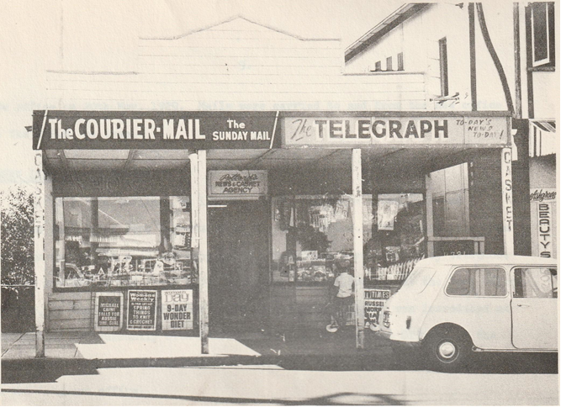
THIS SHOP AT 239 WATERWORKS ROAD, ASHGROVE WAS A POST OFFICE FOR MANY YEARS UNTIL 1940
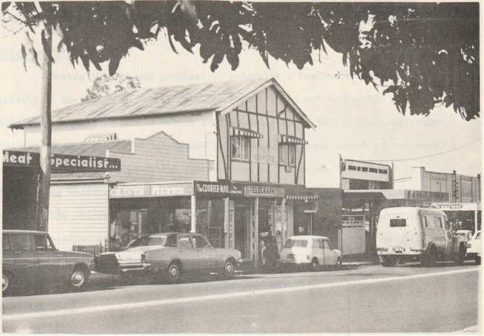
WATERWORKS ROAD, ASHGROVE 1970 — NEWSAGENT'S SHOP WAS POST OFFICE FOR
MANY YEARS
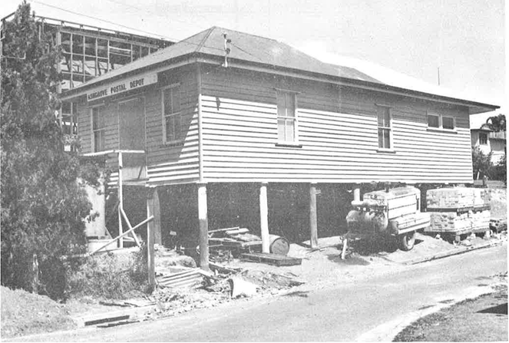
TEMPORARY LOCATION OF POSTAL DEPOT AT REAR OF NEW POST OFFICE, ASHGROVE
IT SERVED THE AREA FOR MANY YEARS
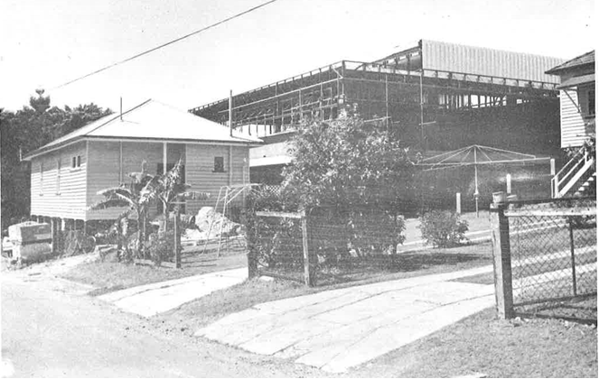

NON-OFFICIAL POSTMASTERS
Mr. H.P. Ryder's store (now Pollards Newsagent, 239 Waterworks Road) was sold to Mr. Henry G. Underhill, who took over the Post Office in January 1939. Business increased rapidly and by March 1939, an assistant was needed. Miss Mavis Walsh was appointed. At the time the office had the following facilities:
Postal
Trunk line
Telegraph by telephone
Money Order
Old Age payments
War Pension payments
C.O.D. Parcels
(Telegrams were delivered in the Ashgrove area by a Junior Postal Officer attached to the office) (approved in June 1936)
It was one of the largest non-official offices in Brisbane at the time. However, due to the heavy pressure of war time conditions, Mr. Underhill, through illness, resigned from the Post Office duties on 23rd September, 1940 but retained his business.
NEW LOCATION OF POST OFFICE
The Post Office was then transferred to Mr. W.A. Moloney who had a business at 214 Waterworks Road (on the opposite side of the street about 100 yards toward Ashgrove Ave.). He took charge on 23rd September, 1940.
Hours of Attendance
On 11th October, 1940, hours of attendance provided by Postmaster Moloney were 9a.m. - 6p.m. Monday to Friday and 9a.m. - 1p.m. Saturdays.
Heavy demands were made upon the service during the dark years of World War II and Age, War, Military and Air Force Allotments were paid. An adult assistant was employed until 12th October, 1942.
ASHGROVE WEST POST OFFICE
Ashgrove West Post Office, located near The Gap, was opened on 9th November, 1942, to relieve the position and provide more convenient postal facilities for residents in that area.
FULL TIME OFFICE
However, business continued to grow and by 14th October, 1944, the Ashgrove office was made full time service.
A Junior Assistant and Telegraph Messenger were employed full time as a result. However, the office was too busy to handle the Agency for the Commonwealth Bank like so many other offices. It was conducted by the Chemist shop located nearby.
ASSISTANT
During the early fifties, Mrs. F.E. Johnston joined the Post Office staff as an assistant and for the next 18 years remained in that position at the Ashgrove Post Office.
APPOINTMENTS OF POSTMASTERS
Mr. Moloney ceased during 1957 and Mr. H.V. Greeves relieved for a short period. Owing to the Bardon Non-Official Post Office being elevated to official status on 1st April, 1957, Mr. W.J. Payne, the Non-Official Postmaster, was transferred to Ashgrove and took up duty on the same day. However, due to ill health he resigned on 7th September, 1957 but ceased on 28th September, 1957. Mrs. Johnston became relieving Postmistress until a new Postmaster could be appointed. Mr. Ivars Mastins became temporary Postmaster on 26th October, 1957 until Mr. William H. Pan, previously of Theodore, took charge on 26th February, 1958. He resigned and ceased duty on 1st May, 1960.
SALE OF SHOP
Mrs. Sharkey, owner of the small room (292 sq. ft.) where the Post Office was conducted, sold the premises in 1961 and the Post Office had to be accommodated in other quarters. It had been in operation 21 years at this location, 214 Waterworks Road.
ANOTHER MOVE
On 1st December, 1961 the office was moved to a block of ten brick shops constructed at the corner of Waterworks Road and Ashgrove Avenue. The shop used was on the ground floor about 30 paces from the corner of Waterworks Road and approximately 80 yards from the previous location. The area was 25' x 16', larger than the previous office. Owners of the building were Mr. and Mrs. Symod.
In 1962 the ownership of the shop changed hands and was purchased by R. & P. Gurnalnek. Mr. C. March was Postmaster at the time.
On 31st January, 1963, Mr. David S. Yule became Postmaster and he was followed by Mr. Roy Victor Grice on 11th March, 1964. Mr. Grice (with Mesdames F.E. Johnston and D.I. McKee as his assistants) remained as Post-Master until the transfer of the Non-Official office to official conditions.
TELEPHONE FACILITIES
When Brisbane's first telephone exchange opened at the O.P.O. in 1880, it serviced a few subscribers scattered over a wide area of Brisbane, although most of them were inner city businesses and Government offices. However, by Federation there were manual exchanges at Central (G.P.O.), Toowong and Albion. Central exchange continued to provide service for subscribers at Ithaca, Paddington, Red Hill, Ashgrove and some parts of Toowong for many years.
It is interesting to note that John Fenwick, Waterworks Road, Red Hill, had telephone number Central 911, and the Red Hill Post Office which served Ashgrove at the time, was Central 897.

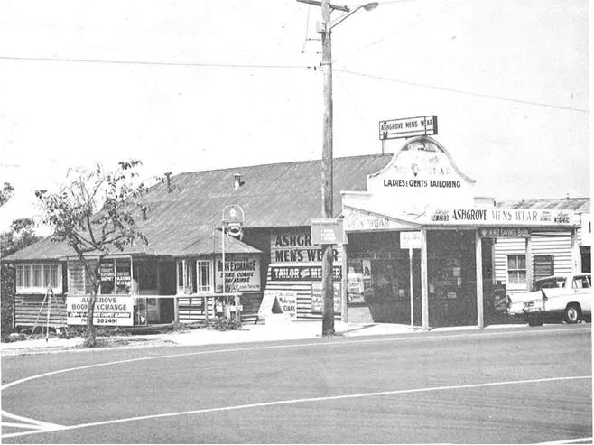
P.O. LOCATED HERE, 214 WATERWORKS ROAD, FROM 1940 TO 1961

Even as late as 1928, Ashgrove which had few subscribers, and Red Hill were part of the Central telephone exchange area.
When Paddington automatic exchange was opened, Ashgrove services were connected to this exchange.
AUTOMATIC TELEPHONE EXCHANGE
Following the rapid post war development of housing at Ashgrove, heavy demand for telephone services occurred.
Plans were therefore laid in the late 1940s to erect a new brick building to house an automatic telephone exchange in Kilawarra Street, Ashgrove.
By December 1948 the initial portion of the building was completed and work started on the rear extension.
Approval was obtained on 25th January, 1949 to install a 2400 line automatic telephone exchange using 2000 type step by step equipment and costing over £73,000 ($146,000). Initially 1800 lines of equipment were to be installed but due to equipment shortage only 1500 lines were installed.
MANUAL SWITCHBOARD
In the meantime, a 500 line manual exchange switchboard had been installed in the new building to cater for the many applications for telephone service in the area.
However, this board only catered for 485 subscribers, while 1175 had to be connected to a temporary automatic exchange at Paddington automatic telephone exchange and 97 were served from the Newmarket exchange. By 22nd September, 1950 there were 617 manual subscribers, as the board had been extended to an 800 line unit.

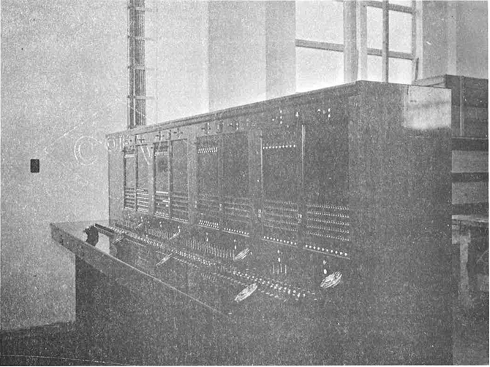
800 LINE MANUAL SWITCHBOARD COPED WITH RAPID TELEPHONE DEVELOPMENT AT
ASHGROVE INSTALLED 1948 AND REMOVED LATE 1950

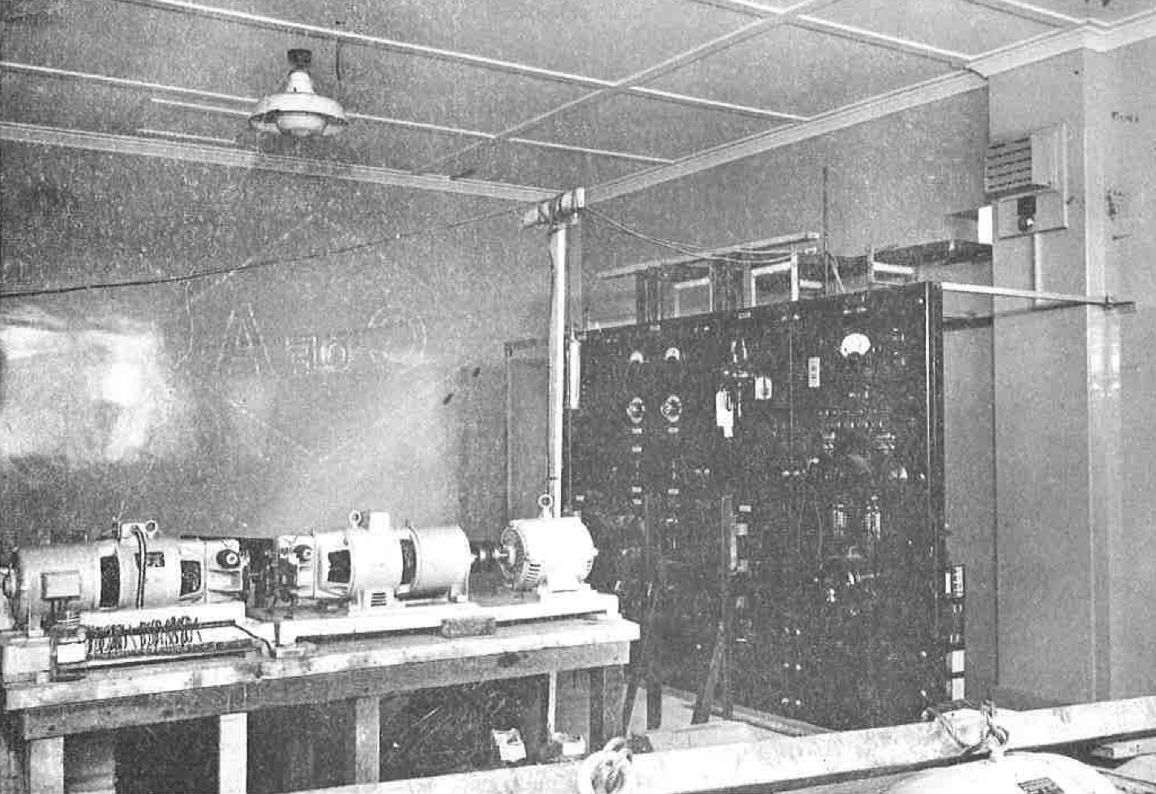
TEMPORARY POWER PANEL AND GENERATORS AT ASHGROVE AUTOMATIC TELEPHONE
EXCHANGE IN 1950
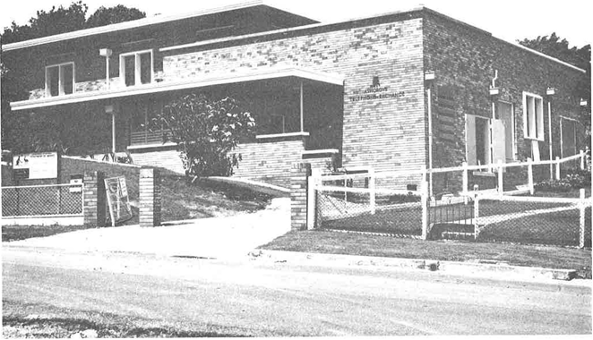
ASHGROVE TELEPHONE EXCHANGE KILLAWARRA ROAD, ASHGROVE
(PHOTO 1970)
Additions
On 14th November, 1950 approval was received to add 1200 lines of automatic equipment and remove the switchboard at a total cost of £20,370 ($40,740).
The switchboard was removed some time later and all subscribers given automatic service. Between,1955 and 1967 (12 years) almost $70,000 was spent on additional equipment on the automatic exchange. In 1970 there were 4100 telephone services connected to the Ashgrove exchange with pro-vision for growth.
Further Additions to Telephone Exchange
On 6th May, 1970 a contract was let to Glencoe Constructions Pty. Ltd. for extensions to the brick telephone exchange building. The cost of this contract was $63,926 and work was completed early in November 1970.
NEW POST OFFICE BUILDING
Contract let
On 24th March, 1970 a $94,484 contract was let to Kratzmann Holdings Pty. Ltd. of 52 High Street, Toowong, for the erection of a new Post Office at Ashgrove.
Site
The new building was located on the site occupied at the time by the Postal Depot in Waterworks Road and an adjoining block acquired in 1951 to allow for this erection which was then projected. Total cost of the property was $1,219.
The allotment, 72 feet wide by 125 feet deep, faced south and was located a short distance from the then existing shopping area.
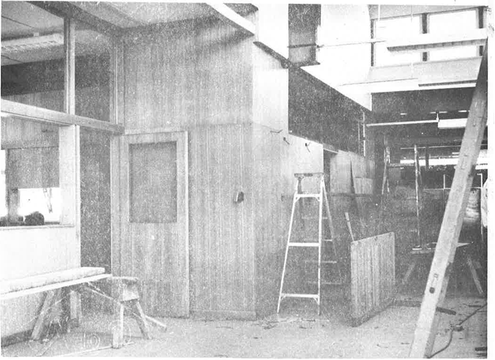
INTERIOR OF NEW POST OFFICE, ASHGROVE, OCTOBER 1970 - POSTMASTER'S OFFICE
ON LEFT
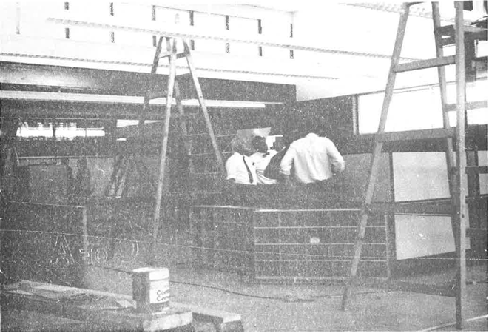
INTERIOR OF ASHGROVE POST OFFICE DURING FINAL STAGES OF CONSTRUCTION -PHOTO SHOWS MAIL ROOM AND REAR OF PRIVATE BOXES (PHOTO OCT. 1970)
Description of building
The building was constructed of quality materials to a modern design prepared by the Commonwealth Department of Works working to a brief compiled by the Buildings and Properties Section of the Postmaster-General's Department. The design made use of the sloping site contours to provide modern amenities for the staff on a lower rear floor, permitting the upper floor to be used entirely for postal operations. This floor accommodated a modern and spacious porch, public space, offices and mail handling area, designed to meet development for a period up until 1990. Also, provision had been made for future expansion to the rear of the site as the useful life of the building was anticipated to be about sixty years or until the year 2030.
Construction was basically in reinforced concrete with large steel portal frames spanning the 54'0" width of the building without intermediate supports. The cavity brick exterior walls were of a distinctive deep coffee colour tone.
The roof design featured a raised section with clerestory window to provide diffused natural lighting over the working area. The roof cladding was of galvanised steel and floor coverings generally were of vinyl asbestos tiles with ceramic tiles in the public areas. The location of the public telephones was rather unusual, being combined with structural elements at the front of the building. The materials used in these were selected specifically to combat the vandalism to which these facilities are invariably subjected.
Completion of the building
The attractive building was handed over to the Post Office shortly before the official opening in early November 1970.
POSTMEN
The Ashgrove postmen moved from the old wooden building at the rear of the allotment to the new Post Office on 23rd October, 1970, so the old wooden building could be removed. On 26th October, postmen from The Gap joined the Ashgrove staff and on 16th November, 1970, postmen from Bardon were to operate from the new quarters. An overseer was to be placed in charge of the 14 postmen to be stationed at Ashgrove. Their mail delivery was to more than 600 points per day each. Suburbs covered in the delivery rounds were -
Rainworth
Bardon
Jubilee
The Gap
St. John's Wood
Dorrington
Ashgrove

OFFICIAL POSTMASTER
Mr. Roy Grice, Non-Official Postmaster away on furlough, was relieved by Mr. George Weise at the time of closure of the Non-Official Post Office on 13th November, 1970.
Mr. C.F. Wells was appointed the new official Grade IV Postmaster at Ashgrove.
OFFICIAL OPENING
At an official function held on the premises, Mr. Manfred Cross, Federal Member for Brisbane, on behalf of the Postmaster General the Hon. Alan S. Hulme, officially opened the Ashgrove Post Office on Friday, 13th November, 1970, at 3p.m.
More than 100 guests, including Federal, State and Local Government representatives, business and professional people from the Ashgrove shopping area and others attended the function where afternoon tea was served.
CONCLUSION
Since 1877, over 93 years, the Post Office has served the people of Ashgrove - first with mail by horse and coach, then the telegraph and finally the telephone. During the growth of Ashgrove from a farming settlement to a modern and thriving suburb of the large metropolis of Brisbane, the Australian Post Office has shared in its pioneering work. Today may be seen the fruits of this pioneering labour for Ashgrove has a modern Post Office and Automatic Telephone Exchange. By using the facilities provided, residents and visitors at Ashgrove may communicate by the written or spoken word across the world or across the street, bringing man in touch with man.

Researched and written By courtesy of the
by Malcolm M. Rea Public Relations Section
Historical Officer Australian Post Office
G.P.O. Brisbane. Q4000. Queensland.

4th November, 1970. /Acknowledgements
References and Acknowledgements
Newspapers: The Sunday Mail, Brisbane, Feb. 17th, 1929 p.23. Ashgrove, the Royal Suburb.
The Courier Mail, Brisbane, Aug. 19th, 1950. Ashgrove was once under Royal Patronage.
The Courier Mail, Brisbane, Jan. 14th, 1965. Ashgrove and The Gap.
The Telegraph, Brisbane, April 17th, 1965 p.10. It's a Country Club Atmosphere.
North West News, Brisbane, April 8th, 1970. Contract let for New Ashgrove P.O.
The Queenslander, Brisbane, Nov. 11th, 1876 p. 11. Opening of the Ashgrove School.
The Queenslander, Brisbane, 1922 and 1923 - Photographs of Ashgrove.
Public Library of Queensland,
William Street, Brisbane.
Oxley Memorial Library 4th Floor
Pughs Almanacs
Brisbane Town & Country Guide &
Directory
Queensland State Archives, Annerley
Road, Brisbane
Sale of land and first school
Commonwealth Archives, Wynnum Road, Cannon Hill - archival files of Ashgrove P.O.
P.M.G. Department - Central Registry, GPO - official files
Public Relations –
Historical Archives
Postmaster General's Annual Reports 1863-1899
Mr. C.W. Burton, 22 Glory Street, Ashgrove - early Postman at Ashgrove.
Mr. George Dixon, A/Supervising Engineer, Country Installation, Australia House, Brisbane - Engineer in charge of first installation work at Ashgrove Exchange.
District Postal Manager, No. 2 Division, 580 Lutwyche Road, Lutwyche.
Field Officers, Buildings & Properties, Engineering Division, PMG Department.
STATEMENT OF BUSINESS TRANSACTED
Office: ASHGROVE Status: NON-OFFICIAL MONEY ORDER District: MET. NO. 2
Item |  | 1949/50 | 1959/60 | 1968/69
MAILS HANDLED ANNUALLY | Despatched | 572 | 799 | 936
 | Received | 312 | 301 | 302
ORDINARY MAIL POSTED | Letters |  | 85,722 | 1,111
 | Newspapers & Packets | 9,672 | 9,795 | 22.672
 | Parcels | 2,659 | 1,820 | 6,896
ORDINARY MAIL RECEIVED | Letters |  | 5,772 | 12,883
 | Newspapers & Packets |  | “ | 1,176
 | Parcels | 468 | 221 | 384
OTHER MAIL POSTED | Registered Articles | 4,012 | 1,776 | 2,010
 | Registered Parcels | 1,322 | 264 | 451
 | Insured Parcels | 57 | 11
 | C.O.D. & Customs Collect Articles | 16 | 32 | 6
OTHER MAIL RECEIVED | Registered Articles | 882 | 509 | 563
 | Registered & Insured Parcels | 271 | 260 | 264
 | C.O.D. & Customs Collect Articles | 105 |  | 106
CERTIFIED MAIL ARTICLES RECEIVED |  |  | 43 | 219
TELEGRAMS | Originating | 4,013 | 1,998 | 2,983
 | Terminating | 270 | 186 | 508
POSTAGE STAMP SALES | Inc. Bulk Post etc. on M0101 | £3,174 | £7,046 | $39,518
DUTY STAMPS & PROM. NOTES |  | £108 | £233 | $1,721
TAX INSTALMENT STAMPS | Inc. Swine & Cattle Duty | £1,018 | £5,697 | $53,866
POSTAL ORDERS | Issued | 4,394 | 5,068 | 5,524
 | Paid | 2,930 | “ | 3,974
TELEPHONE ACCOUNTS | Paid | 529 | 1,144 | 2,736
LICENCES ISSUED | Television, Broadcast & Combined Receiving |  | 1,568 | 2,213
WAR SERVICE HOMES | No. of Repayments |  | 1,291 | 1,895
EXPENDITURE VOUCHERS | No. of Individual Payments |  | 138 | 177
ALLOTMENTS PAID | Naval | 720 | 382 | 2
PENSIONS PAID | Age, Invalid & Widows | 4,482 | 3,555 | 106
CHILD ENDOWMENT | No. of Payments | 4,322 | 4,272 | 1,148

