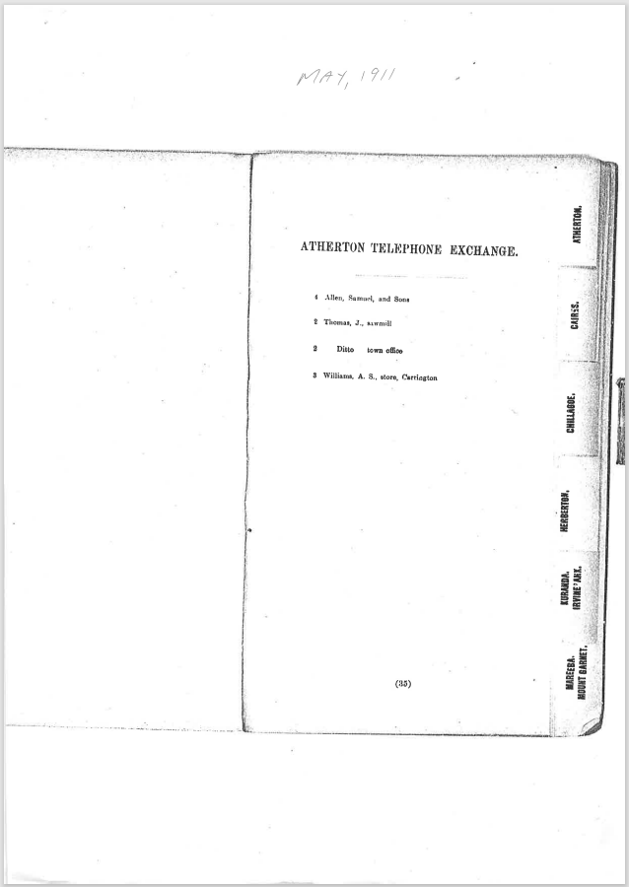

9508.1
May, 1911
Atherton Telephone Exchange
4 Allen, Samna', and Sons
2 Thomas, J., sawmill
2 Ditto town office
3 Williams, A. S., store, Carrington

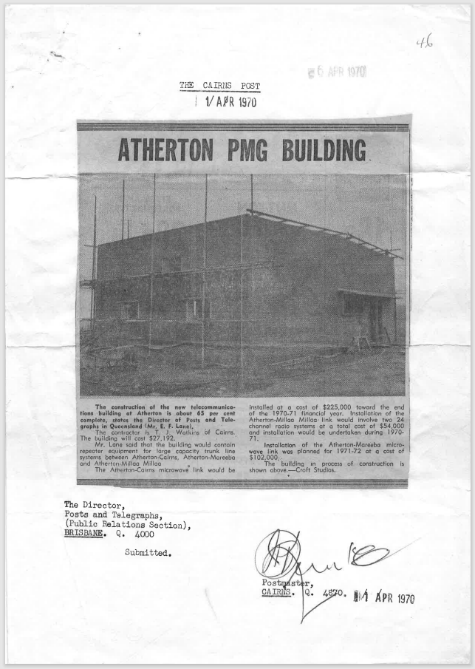
9508.2
THE CAIRNS POST
1 APR 1970

The Cairns Post
1 April 1970
The construction of the new telecommunications building at Atherton is about 65 per cent complete, states the Director of Posts and Telegraphs in Queensland (Mr. E. F. Lane).
The contractor is T .1 Watkins of Cairns.
The building will cost $27,192.
Mr. Lane said that the building would contain repeater equipment for large capacity trunk line systems between Atherton-Cairns, Atherton-Mareeba and Atherton Millaa Millaa
The Atherton-Cairns microwave link would be installed at a cost of $225,000 toward the end of the 1970-71 financial year. Installation of the Atherton-Millaa Millaa, link would involve two 24 channel radio systems at a total cost of $54,000 and installation would be undertaken during 1970¬71.
Installation of the Atherton-Mareeba microwave link was planned for 1971-72 at a cost of $102,000.
The building in process of construction is shown above—Croft Studios.
The Director
Posts and Telegraphs,
(Public Relations Section)
Brisbane Q 4000

Postmaster
Cairns Q 4870 1 APR 1970
Filed 6 APR 1970

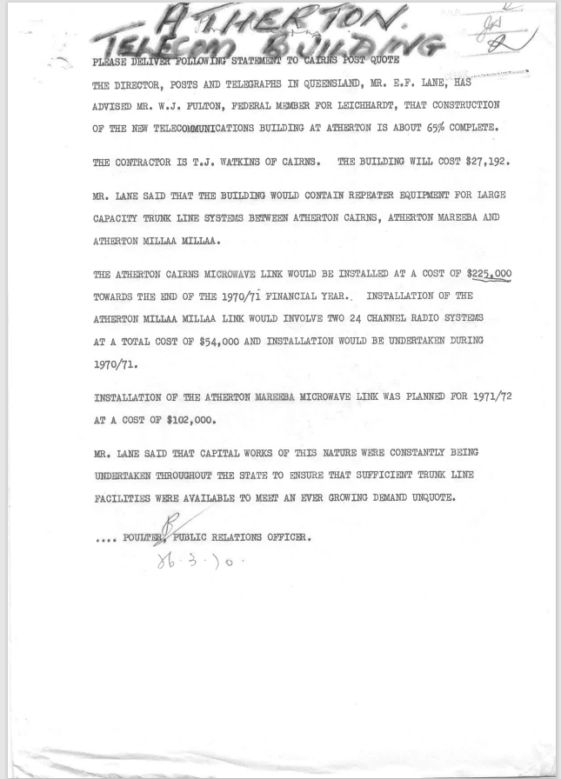
9508.3
Atherton Telecom Building
PLEASE DELIVER FOLLOWING STATEMENT to cairns post quote
THE DIRECTOR, POSTS AND TELEGRAPHS IN QUEENSLAND, MR. E.F. LANE, HAS ADVISED MR. W.J. FULTON, FEDERAL MEMBER FOR LEICHHARDT, THAT CONSTRUCTION OF THE NEW TELECOMMUNICATIONS BUILDING AT ATHERTON IS ABOUT 65% COMPLETE.
THE CONTRACTOR IS T.J. WATKINS OF CAIRNS. THE BUILDING WILL COST $27,192.
MR. LANE SAID THAT THE BUILDING WOULD CONTAIN REPEATER EQUIPMENT FOR LARGE CAPACITY TRUNK LINE SYSTEMS BETWEEN ATHERTON CAIRNS, ATHERTON MAREEBA AND ATHERTON MILLAA MILLAA.
THE ATHERTON CAIRNS MICROWAVE LINK WOULD BE INSTALLED AT A COST OF $225,000 TOWARDS THE END OF THE 1970/71 FINANCIAL YEAR., INSTALLATION OF THE ATHERTON MILLAA MILLAA LINK WOULD INVOLVE TWO 24 CHANNEL RADIO SYSTEMS AT A TOTAL COST OF $54,000 AND INSTALLATION WOULD BE UNDERTAKEN DURING 1970/71.
INSTALLATION OF THE ATHERTON MAREEBA MICROWAVE LINK WAS PLANNED FOR 1971/72 AT A COST OF $102,000.
MR. LANE SAID THAT CAPITAL WORKS OF THIS NATURE WERE CONSTANTLY BEING UNDERTAKEN THROUGHOUT THE STATE TO ENSURE THAT SUFFICIENT TRUNK LINE FACILITIES WERE AVAILABLE TO MEET AN EVER-GROWING DEMAND UNQUOTE.
POULTER PUBLIC RELATIONS OFFICER.
28.3.70

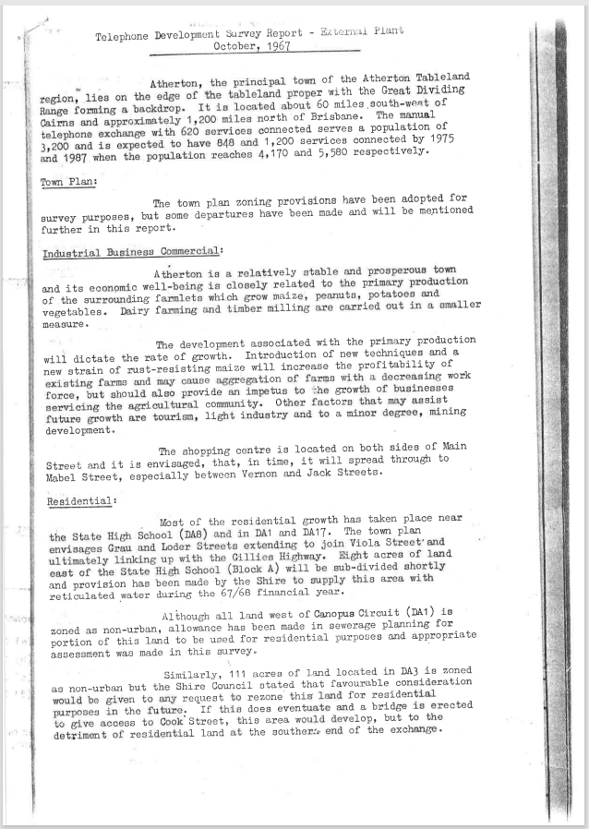
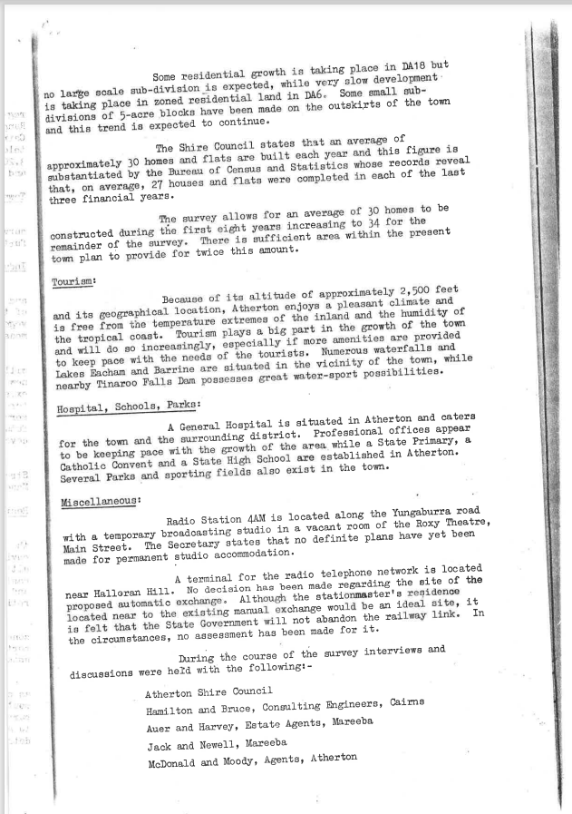
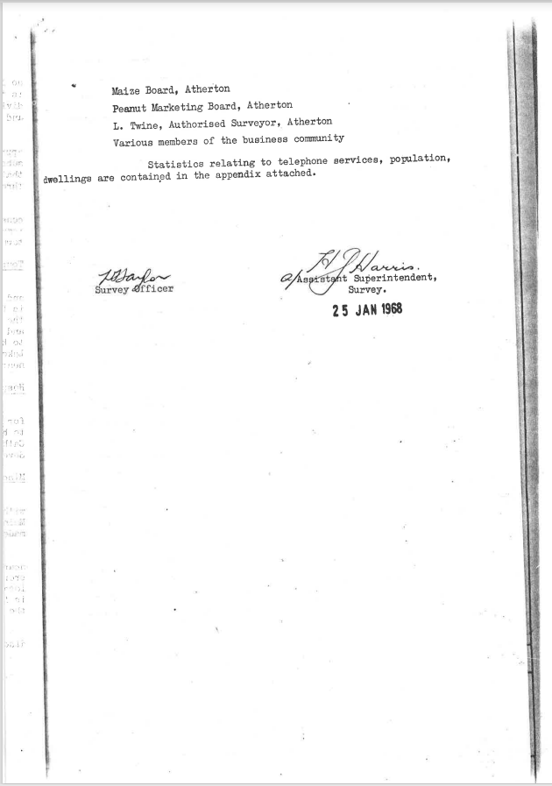
9508.4
Telephone Development Survey Report - External Plant October, 1967
Atherton, the principal town of the Atherton Tableland region, lies on the edge of the tableland proper with the Great Dividing Range forming a backdrop. It is located about 60 miles south-welt of Cairns and approximately 1,200 miles north of Brisbane. The manual telephone exchange with 620 services connected serves a population of 3,200 and is expected to have 848 and 1,200 services connected by 1975 and 1987 when the population reaches 4,170 and 5,580 respectively.
Town Plan:
The town plan zoning provisions have been adopted for survey purposes, but some departures have been made and will be mentioned further in this report.
Industrial Business Commercial:
Atherton is a relatively stable and prosperous town and its economic well-being is closely related to the primary production of the surrounding farmlets which grow maize, peanuts, potatoes and vegetables. Dairy farming and timber milling are carried out in a smaller measure.
The development associated with the primary production will dictate the rate of growth. Introduction of new techniques and a new strain of rust-resisting maize will increase the profitability of existing farms and may cause aggregation of farms with a decreasing work force, but should also provide an impetus to the growth of businesses servicing the agricultural community. Other factors that may assist future growth are tourism, light industry and to a minor degree, mining development.
The shopping centre is located on both sides of Main Street and it is envisaged, that, in time, it will spread through to Mabel Street, especially between Vernon and Jack Streets.
Residential:
Most of the residential growth has taken place near the State High School (DAB) and in DA1 and DA17. The town plan envisages Grau and Loder Streets extending to join Viola Street'and ultimately linking up with the Gillies Highway. Eight acres of land east of the State High School (Block A) will be sub-divided shortly and provision has been made by the Shire to supply this area with reticulated water during the 67/68 financial year.
Although all land west of Canopus Circuit (DA1) is zoned as non-urban, allowance has been made in sewerage planning for portion of this land to be used for residential purposes and appropriate assessment was made in this survey.
Similarly, 111 acres of land located in DA3 is zoned as non-urban but the Shire Council stated that favourable consideration would be given to any request to rezone this land for residential purposes in the future: If this does eventuate and a bridge is erected to give access to Cook Street, this area would develop, but to the detriment of residential land at the southern, end of the exchange.

Some residential growth is taking place in DA18 but no large scale sub-division is expected, while very slow development is taking place in zoned residential land in DA6 Some small sub-divisions of 5-acre blocks have been made on the outskirts of the town and this trend is expected to continue.
The Shire Council states that an average of approximately 30 homes and flats are built each year and this figure is substantiated by the Bureau of Census and Statistics whose records reveal that, on average, 27 houses and flats were completed in each of the last three financial years.
The survey allows for an average of 30 homes to be constructed during the first eight years increasing to 34 for the remainder of the survey. There is sufficient area within the present town plan to provide for twice this amount.
Tourism:
Because of its altitude of approximately 2,500 feet and its geographical location, Atherton enjoys a pleasant climate and is free from the temperature extremes of the inland and the humidity of the tropical coast. Tourism plays a big part in the growth of the town and will do so increasingly, especially if more amenities are provided to keep pace with the needs of the tourists. Numerous waterfalls and Lakes Eacham and Barrine are situated in the vicinity of the town, while nearby Tinaroo Falls Dam possesses great water-sport possibilities.
Hospital, Schools, Parks:
A General Hospital is situated in Atherton and caters for the town and the surrounding district. Professional offices appear to be keeping pace with the growth of the area while a State Primary, a Catholic Convent and a State High School are established in Atherton. Several Parks and sporting fields also exist in the town.
Miscellaneous:
Radio Station 4AM is located along the Yungaburra road with a temporary broadcasting studio in a vacant room of the Roxy Theatre, Main Street. The Secretary states that no definite plans have yet been made for permanent studio accommodation.
A terminal for the radio telephone network is located near Halloran Hill. No decision has been made regarding the site of the proposed automatic exchange. Although the stationmaster's residence located near to the existing manual exchange would be an ideal site, it is felt that the State Government will not abandon the railway link. In the circumstances, no assessment has been made for it.
During the course of the survey interviews and discussions were held with the following:
Atherton Shire Council
Hamilton and Bruce, Consulting Engineers, Cairns
Auer and Harvey, Estate Agents, Mareeba
Jack and Newell, Mareeba
McDonald and Moody, Agents, Atherton
Maize Board, Atherton
Peanut Marketing Board, Atherton
L. Twine, Authorised Surveyor, Atherton
Various members of the business community
Statistics relating to telephone services, population, dwellings are contained in the appendix attached.

Survey Officer
Harris
Assistant Superintendent,
Survey
25 JAN 1968

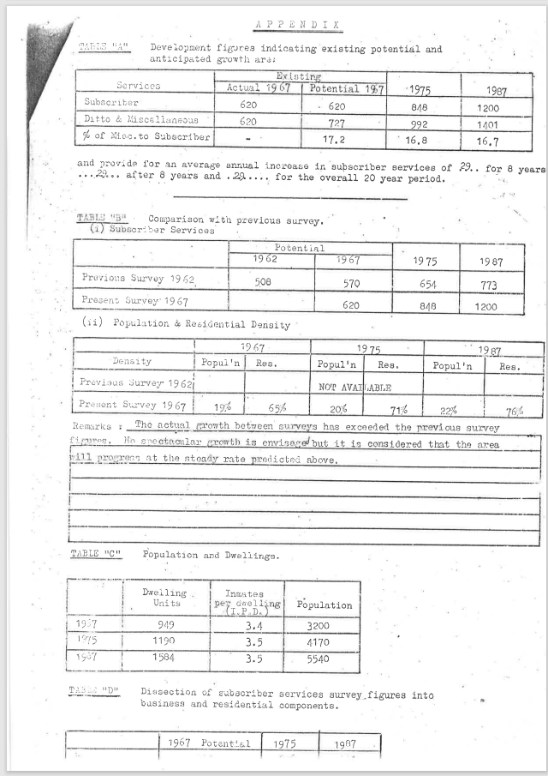
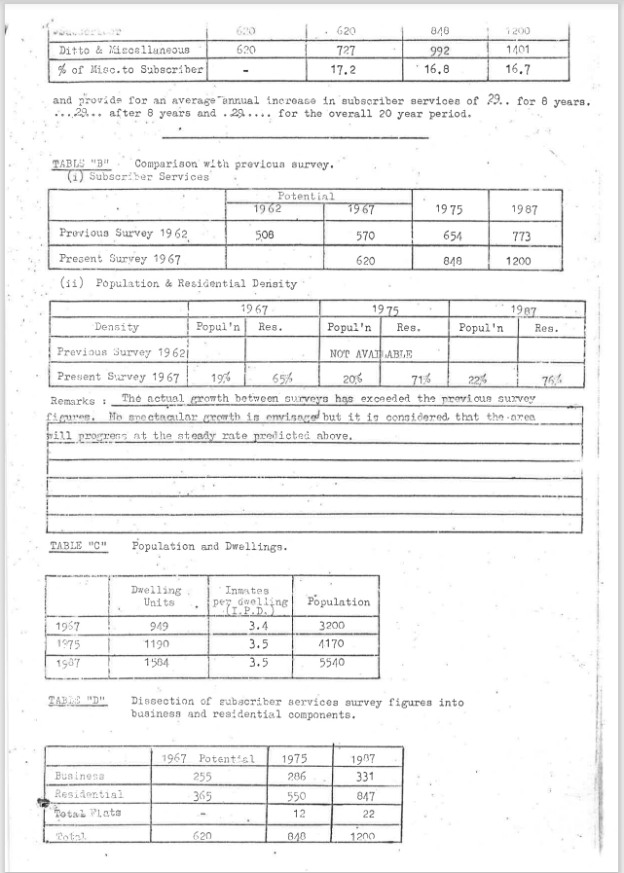
9508.5 Appendix to report
APPENDIX
Development figures indicating existing potential and anticipated growth are:
Services | Existing |  | 1975 | 1987
Services | Actual 1967 | Potential 1967 | 1975 | 1987
Subscriber | 620 | 620 | 848 | 1200
Ditto & Miscellaneous | 620 | 727 | 992 | 1401
% Misc.to Subscriber |  | 17.2 | 16.8 | 16.7
and provide for an average annual increase in subscriber services of 29 for 8 years 29 after 8 years and 29 for the overall 20-year period.

TABLE “B” Comparison with previous survey.
- Subscriber Services
Services | Potential |  | 1975 | 1987
Services | 1962 | 1967 | 1975 | 1987
Previous Survey 1962 | 508 | 570 | 654 | 773
Present Survey 1967 |  | 620 | 848 | 1200

- Population & Residential Density
 | 1967 |  | 1975 |  | 1987
Density | Population | Res | Population | Res | Population | Res
Previous Survey 1962 | NOT AVAILABLE
Present Survey 1967 | 19% | 65% | 20% | 71% | 22% | 76%

Remarks: The actual growth between surveys has exceeded the figures. No spectacular growth is envisaged but it is considered that the area will progress at the steady rate predicted above.
TABLE "C" Population and Dwellings.
 | Dwelling Units | Inmates per dwelling (I.P.D.) | Population
1967 | 949 | 3.4 | 3200
1975 | 1190 | 3.5 | 4170
1987 | 1584 | 3.5 | 5540

TABLE "D" Dissection of subscriber services survey figures into business and residential components.
 | 1967 Potential | 1975 | 1987
Business | 255 | 286 | 331
Residential | 365 | 550 | 847
Total Flats | - | 12 | 22
Total | 620 | 848 | 1200


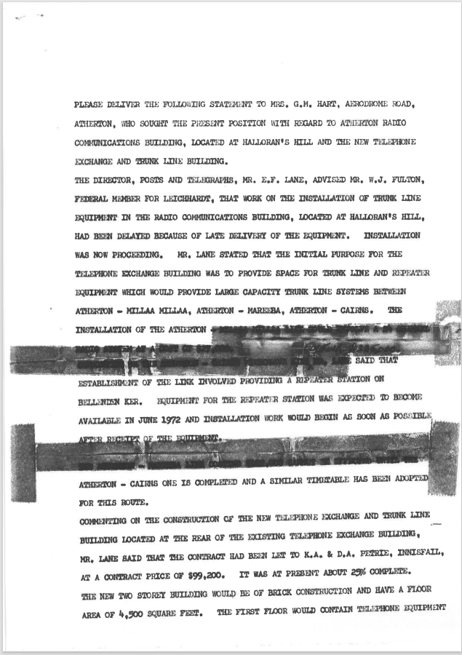
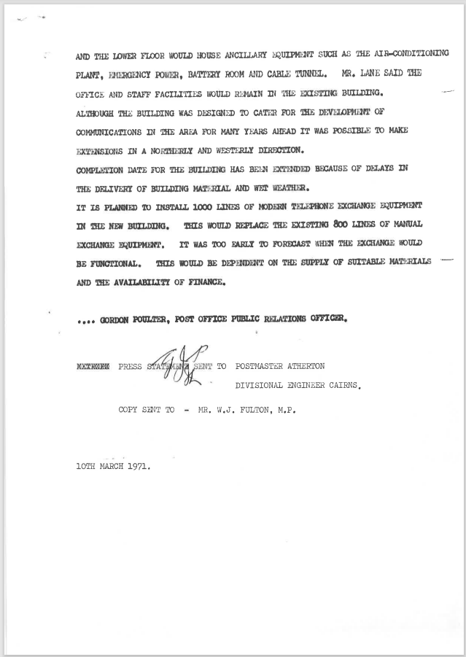

9508.6
Obliterated sections read:
(The installation of the Atherton) - Millaa Millaa link would involve a 24 channel radio system at a cost of $27,000.
Commenting on the Atherton - Cairns microwave link costing $225,000 Mr. Lane (said that ...)
The Atherton - Mareeba link costing $102,000 cannot be effected until the (Atherton - Cairns one is completed ...)

PLEASE DELIVER THE FOLLOWING STATEMENT TO MRS G M HART, AERODROME ROAD ATHERTON, WHO SOUGHT THE PRESENT POSITION WITH REGARD TO ATHERTON RADIO COMMUNICATIONS BUILDING, LOCATED AT HALLORAN’S HILL AND THE NEW TELEPHONE EXCHANGE AND TRUNK LINE BUILDING.
THE DIRECTOR, POSTS AND TELEGRAPHS, MR. E.F. LANE, ADVISED MR. W. J. FULTON, FEDERAL MINISTER FOR LEICHHARDT THAT WORK ON THE INSTALLATION OF TRUNK LINE EQUIPMENT IN THE RADIO COMMUNICATIONS BUILDING, SITUATED AT HALLORAN’S HILL, HAD BEEN DELAYED BECAUSE OF LATE ARRIVAL OF THE EQUIPMENT. INSTALLATION WAS NOW PROCEEDING. MR. LANE STATED THAT THE INITIAL PURPOSE MR THE TELEPHONE EXCHANGE BUILDING WAS TO PROVIDE SPACE FOR TRUNK LINE AND REPEATER EQUIPMENT WHICH WOULD PROVIDE LARGE CAPACITY TRUNK LINE SYSTEMS BETWEEN ATHERTON - MILLAA MILLAA, ATHERTON – MAREEBA, ATHERTON – CAIRNS THE INSTALLATION OF THE ATHERTON
(The installation of the Atherton) - Millaa Millaa link would involve a 24 channel radio system at a cost of $27,000.
Commenting on the Atherton - Cairns microwave link costing $225,000 Mr. Lane (said that ...)
ESTABLISHMENT OF THE LINK INVOLVED PROVIDING A REPEATER STATION ON BELLINDEN KER. EQUIPMENT FOR THE REPEATER STATION WAS EXPECTED TO BECOME AVAILABLE IN JUNE 1972 AND INSTALLATION WORK WOULD BEGIN AS SOON AS POSIBLE AFTER RECEIPT OF THE EQUIPMENT.
The Atherton - Mareeba link costing $102,000 cannot be effected until the (Atherton - Cairns one is completed ...)
ATHERTON - CAIRNS ONE IS COMPLETED AND A SIMILAR TIMETABLE HAS BEEN ADOPTED FOR THIS ROUTE.
COMMENTING ON THE CONSTRUCTION OP THE NEW TELEPHONE EXCHANGE AND TRUNK LINE BUILDING LOCATED AT THE REAR OF THE EXISTING TELEPHONE EXCHANGE BUILDING,
MR. LANE SAID THAT THE CONTRACT HAD BEM LES TO K. A. & D. A. PETRIE INNISFAIL AT A CONTRACT PRICE OF $99 4200, IT WAS AT PRESENT ABOUT 25% COMPLETE.
THE NEW TWO STOREY BUILDING WOULD BE OF BRICK CONSTRUCTION AND HAVE A FLOOR AREA Of 4,500 SQUARE FEET. THE FIRST FLOOR WOULD CONTAIN TELEPHONE EQUIPMENT AND THE LOWER FLOOR WOULD HOUSE ANCILLARY EQUIPMENT SUCH AS THE AIR CONDITIONING PLANT, EMLRGENCY POWER, BATTERY ROOM AND CABLE TUNNEL. MR. LANE SAID THE OFFICE AND STAFF FACILITIES WOULD RAIAIN IN THE EXISTING BUILDING.
ALTHOUGH THE BUILDING WAS DESIGNED TO CATER FOR THE DEVELOPMENT OF COMMUNICATIONS IN THE AREA FOR MANY YEARS AHEAD IT WAS POSSIBLE TO MAKE EXTESIONS IN A NORTHERLY AND WESTERLY DIRECTION.
COMPLETION DATE FOR THE BUILDING HAS BEEN EXTENDED BECAUSE OF DELAYS IN THE DELIVERY OF BUILDING MATERIAL AND WET WEATHER.
IT IS PLANNED TO INSTALL 1000 LINES OF MODERN TELEPHONE EXCHANGE EQUIPMENT IN THE NEW BUILDING. THIS WOULD REPLACE THE EXISTING 800 LINES OF MANUAL EXCHANGE EQUIPMENT. IT WAS TOO EARLY TO FORECAST WHEN THE EXCHANGE WOULD BE FUNCTIONAL. THIS WOULD BE DEPENDENT ON THE SUPPLY OF SUITABLE MATERIALS AND THE AVAILABILITY OF FINANCE.

GORDON POULTER, POST OFFICE PUBLIC RELATIONS OFFICER.
PRESS STATEMENT SENT TO POSTMASTER ATHERTON
DIVISIONAL ENGINEER CAIRNS,
COPY SENT TO - MR. W.J. FULTON, M.P.

10TH MARCH 1971.
9508.7 Newspaper article
Cairns Post 27 JUN 1973
Atherton telephone exchange
The Member for Leichharch, Mr. W. J. Fulton, has been advised by the Acting Postmaster - General, Senator McClelland, that Atherton's automatic telephone exchange will be brought into operation on Saturday at 6 am.
Senator McClelland said that Atherton subscribers would be able to make their own local calls to east Barron, Rairi, Lake Ilarrine, Tolga, Yungeburra, and Upper Barron by dialling only the required number.
Local calls to Herberton, Malanda and Mareeba will be obtained by first dialing the appropriate code and then asking the telephonist for the wanted number.
Atherton subscribers will have access to the national STD network which will enable them to dial direct to more than 2500 centres throughout Australia.
Eighty-eight additional telephone channels will be brought into service between Atherton and Cairns and a number of surrounding centres at the time that the new exchange begins operating.
They will cater for the expected Increases in tele-phone calls.
Yungaburra
Senator McClelland also announced that the Yungaburra automatic exchange would begin operating on Friday.
Subscribers with services connected to this exchange would enjoy the same facilities as those being provided for the Atherton exchange.

The Director,
Posts and Telegraphs, (Public Relations Section) BRISBANE. Q. L000
Submitted.

Postmaster Cairns 4870 27 JUL 1973

Atherton Microwave Link
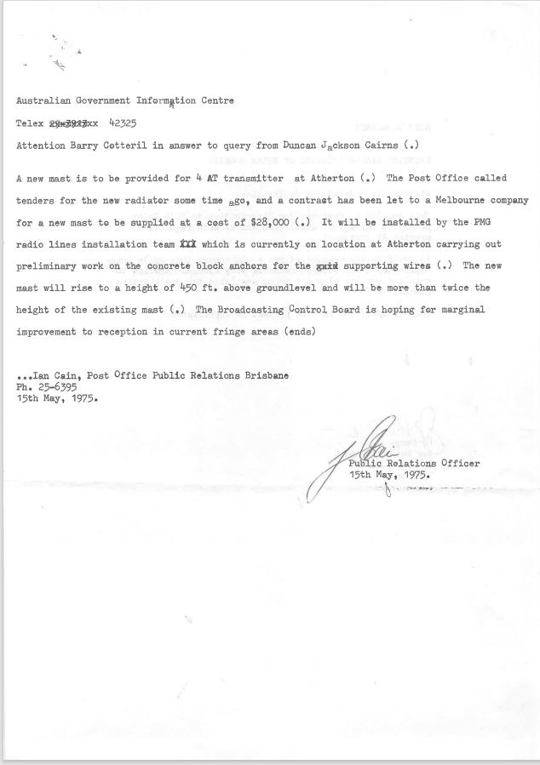9508.8
Australian Government Information Centre
Telex 42325
Attention Barry Cotteril in answer to query from Duncan Jackson Cairns (.)
A new mast is to be provided for 4 AT transmitter at Atherton (.) The Post Office called tenders for the new radiator some time ago, and a contract has been let to a Melbourne company for a new mast to be supplied at a cost of $28,000 (.) It will be installed by the PMG radio lines installation team In which is currently on location at Atherton carrying out preliminary work on the concrete block anchors for the supporting wires (.) The new mast will rise to a height of 450 ft. above ground level and will be more than twice the height of the existing mast (.) The Broadcasting Control Board is hoping for marginal improvement to reception in current fringe areas (ends)
Ian Cain, Post Office Public Relations Brisbane
Ph. 25-6395
15th May, 1975.

Public Relations Officer
15th May, 1975.

9508.9
MAREEBA
1905: Telegraph station opened?
1911: First directory entry, May.
1955? 1959?: CB exchange installed.
1980: 1292 subscribers.

