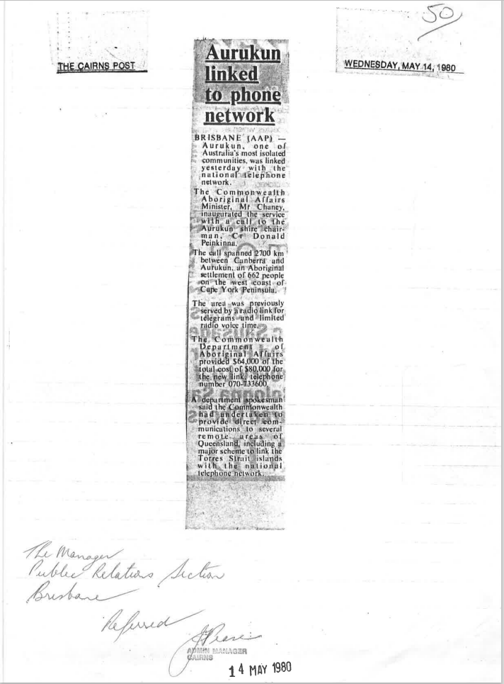

9509.1
Aurukun linked to phone network
BRISBANE (AAP) — Aurukun, one of Australia's most isolated communities was linked yesterday with the national Telephone network.
The Commonwealth Aboriginal Affairs Minister, Mr. Chaney. inaugurated the service with a cull to the Aurukun shire Chairman, Cr Donald Peinkinnu.
The call spanned 2700 km between Canberra add Aurukun, an Aboriginal settlement of 662 people on the west coast of Cape York Peninsula
The area was previously served by a radio link for telegrams and limited radio voice time.
The Commonwealth Department of Aboriginal Affairs provided $64,000 of the total cost of $80,000 for the new link, telephone number 070-733600.
A department spokesman said the Commonwealth had undertaken to provide direct communications to several remote areas of Queensland, including a link to the Torres Strait Islands with the national Telephone Network.

Wednesday 14 MAY 1980
The Cairns Post

