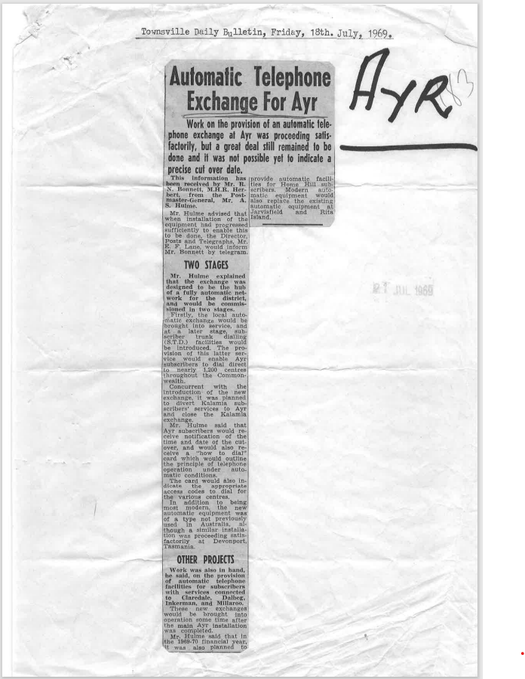

9510.1
Townsville Daily Bulletin, Friday, 18th. July, 1969.
Automatic Telephone Exchange For Ayr
Work on the provision of an automatic tele-phone exchange at Ayr was proceeding satisfactorily, but a great deal still remained to be done and it was not possible yet to indicate a precise cut over date.
This information has been received by Mr. R. Bonnett, M.H.R. Herbert, from the Postmaster General Mr. A. Hulme.
Mr. Hulme advised that when installation of the equipment had progressed sufficiently to enable this to be done, the Director, Posts and Telegraphs, Mr. E. F. Lane, would Inform Mr. Bonnett by telegram.
TWO STAGES
Mr. Hulme explained that the exchange was designed to be the huh of a fully automatic network for the district, and would be commissioned in two stages.
Firstly, the local automatic; exchange would he brought into service, and at a later stage, subscriber trunk dialing (S.T.D.) facilities would be introduced. The provision of this latter service would enable Ayr subscribers to dial direct to nearly 1,200 centres throughout the Commonwealth.
Concurrent with the introduction of the new exchange, it was planned to divert Kalamia subscribers' services to Ayr and close the Kalamia exchange.
Mr. Hulme said that Ayr subscribers would receive notification of the time and date of the cut-over, and would also receive a "how to dial" card which would outline the principle of telephone operation under automatic conditions.
The card would also indicate the appropriate access codes to dial for the various centres.
In addition to being most modern, the new automatic equipment was of a type not previously used in Australia, although a similar Installation was proceeding satisfactorily at Devonport, Tasmania.
OTHER PROJECTS
Work was also in hand he said, on the provision of automatic telephone facilities for subscribers with services connected to Claredale. Dalbeg, Inkerman, and Miliaroo. These new exchanges would he brought into operation sometime after the main Ayr installation was completed.
Mr. Wilma said that in the 1989.10 financial year, it was also planned to provide automatic facilities for Home Hill subscribers. Modern automatic equipment would also replace the existing automatic equipment at Jarvisfield and Rita Islands.

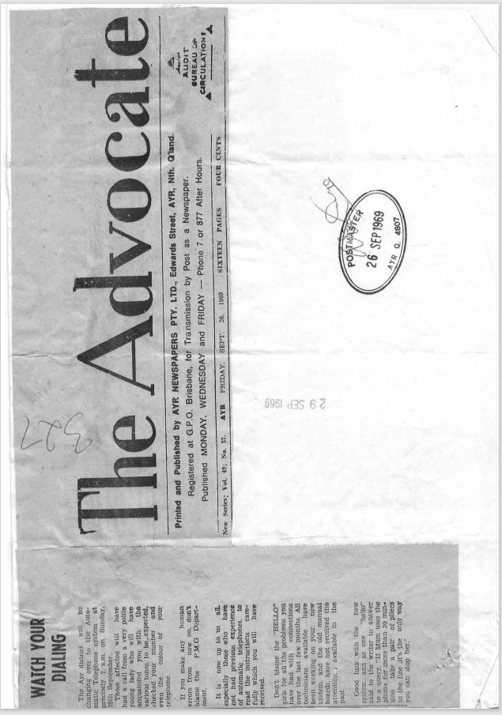

9510.2
WATCH YOUR DIALING
The Ayr district will be changing over to the Automatic Telephone system at precisely 7 am, on Sunday. 28th September.
Those affected will have had a call from a very polite young lady who will have acquainted you with the various tones to be expected, checked your number and even the colour of your telephone. If you make any human errors from now on, don't blame the P.M.G Department.
It is now up to us all. especially those who have not had previous experience of automatic telephones. to read the instructions care-fully which you will have received.
Don't blame the "HELLO" girls for all the problems you have had with connections over the last few months. All technicians available have been working on your new system, and the old manual boards, have not received the attention available in the past.
Good luck, with the new system, and as one "hello" said to the writer in answer to a query. If Mum uses the phone for more than 20! min. take a pair of pliers to the line, it's the only way “you can stop her."

The Advocate
AYR FRIDAY, SEPT. 26, 1969
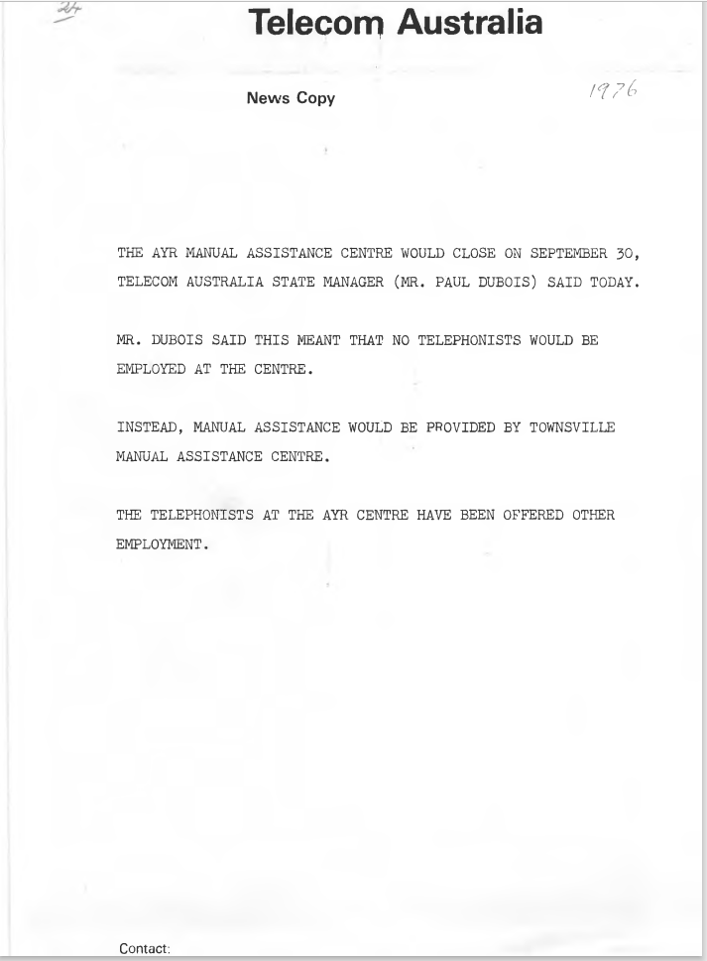

9510.3
Telecom Australia
News Copy

THE AYR MANUAL ASSISTANCE CENTRE WOULD CLOSE ON SEPTEMBER 30, TELECOM AUSTRALIA STATE MANAGER (MR. PAUL DUBOIS) SAID TODAY.
MR. DUBOIS SAID THIS MEANT THAT NO TELEPHONISTS WOULD BE EMPLOYED AT THE CENTRE.
INSTEAD, MANUAL ASSISTANCE WOULD BE PROVIDED BY TOWNSVILLE MANUAL ASSISTANCE CENTRE.
THE TELEPHONISTS AT THE AYR CENTRE HAVE BEEN OFFERED OTHER EMPLOYMENT.
Contact:

1976

