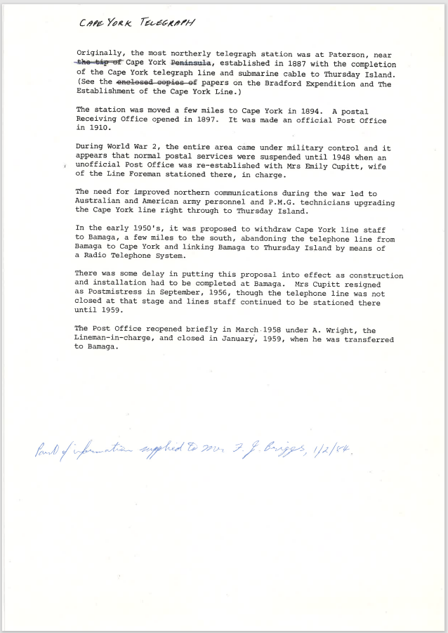

9511.1
Cape York Telegraph
Originally, the most northerly telegraph station was at Paterson, near the tip Cape York Peninsula, established in 1887 with the completion of the Cape York telegraph line and submarine cable to Thursday Island. (See the enclosed copies of papers on the Bradford Expedition and The Establishment of the Cape York Line.)
The station was moved a few miles to Cape York in 1894. A postal Receiving Office opened in 1897. It was made an official Post Office in 1910.
During World War 2, the entire area came under military control and it appears that normal postal services were suspended until 1948 when an unofficial Post Office was re-established with Mrs. Emily Cupitt, wife of the Line Foreman stationed there, in charge.
The need for improved northern communications during the war led to Australian and American army personnel and P.M.G. technicians upgrading the Cape York line right through to Thursday Island.
In the early 1950's, it was proposed to withdraw Cape York line staff to Bamaga, a few miles to the south, abandoning the telephone line from Bamaga to Cape York and linking Bamaga to Thursday Island by means of a Radio Telephone System.
There was some delay in putting this proposal into effect as construction and installation had to be completed at Bamaga. Mrs. Cupitt resigned as Postmistress in September, 1956, though the telephone line was not closed at that stage and lines staff continued to be stationed there until 1959.
The Post Office reopened briefly in March.1958 under A. Wright, the Lineman-in-charge, and closed in January, 1959, when he was transferred to Bamaga.

Part of information supplied to F J Briggs 1/2/84

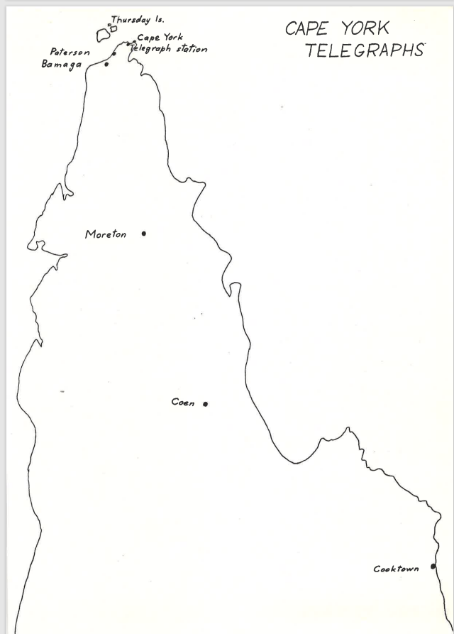

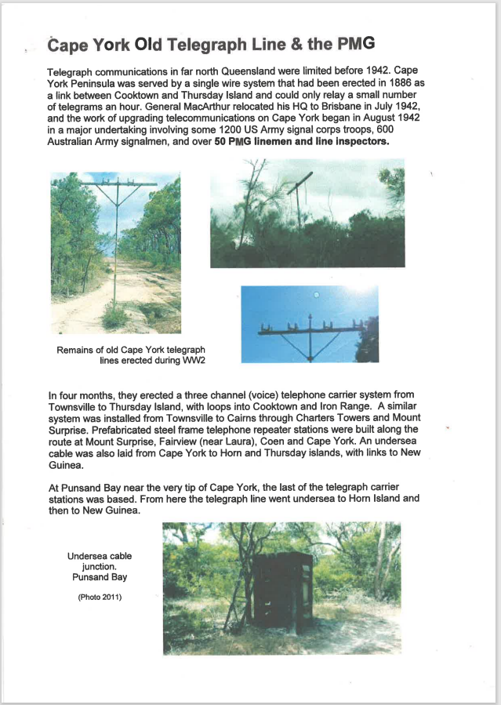

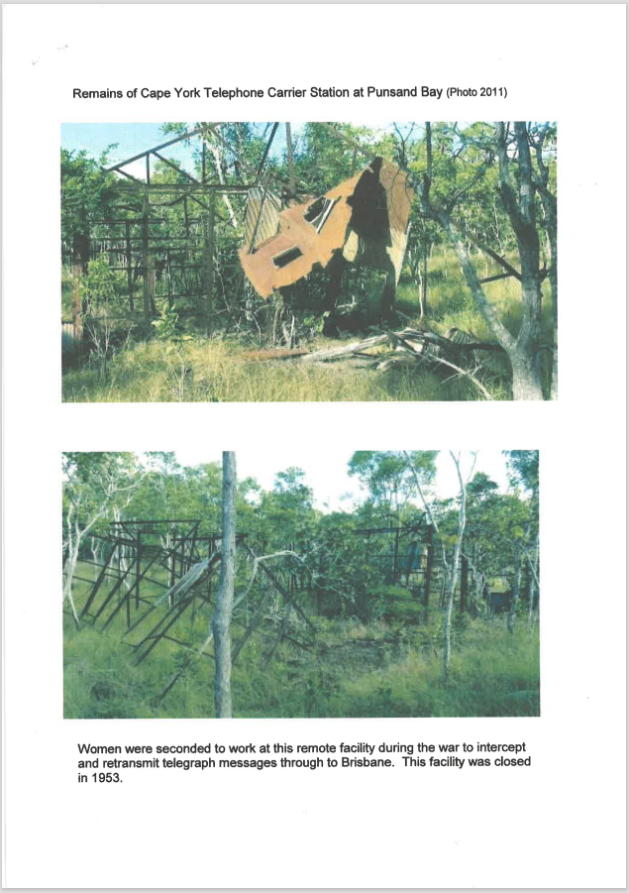
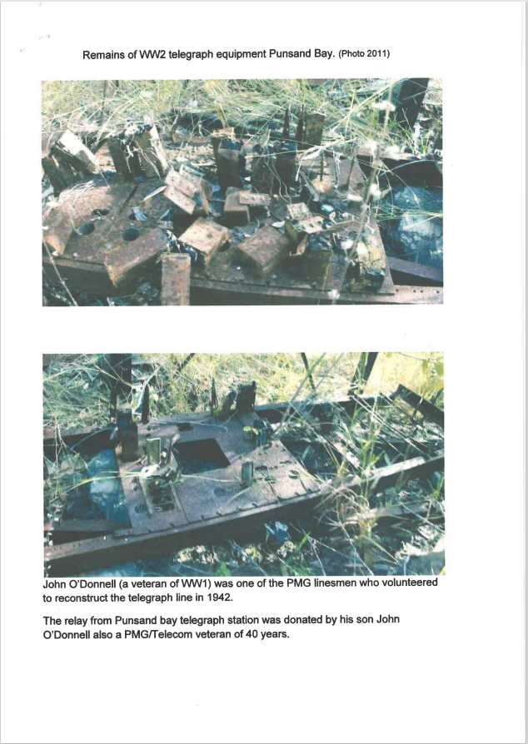



9511.3
Cape York Old Telegraph Line & the PMG
Telegraph communications in far north Queensland were limited before 1942. Cape York Peninsula was served by a single wire system that had been erected in 1886 as a link between Cooktown and Thursday Island and could only relay a small number of telegrams an hour. General MacArthur relocated his HQ to Brisbane in July 1942, and the work of upgrading telecommunications on Cape York began in August 1942 in a major undertaking involving some 1200 US Army signal corps troops, 600 Australian Army signalmen, and over 50 PMG linemen and line inspectors.
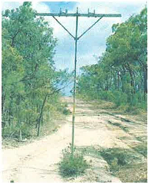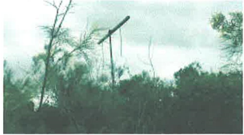
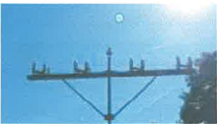
Remains of old Cape York telegraph lines erected during WW2
In four months, they erected a three channel (voice) telephone carrier system from Townsville to Thursday Island, with loops into Cooktown and Iron Range. A similar system was installed from Townsville to Cairns through Charters Towers and Mount Surprise. Prefabricated steel frame telephone repeater stations were built along the route at Mount Surprise, Fairview (near Laura), Coen and Cape York. An undersea cable was also laid from Cape York to Horn and Thursday islands, with links to New Guinea.
At Punsand Bay near the very tip of Cape York, the last of the telegraph carrier stations was based. From here the telegraph line went undersea to Horn Island and then to New Guinea.
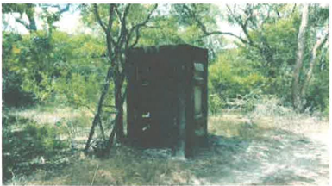
Undersea cable junction. Punsand Bay. (Photo 2011)

Remains of Cape York Telephone Carrier Station at Punsand Bay (Photo 2011)
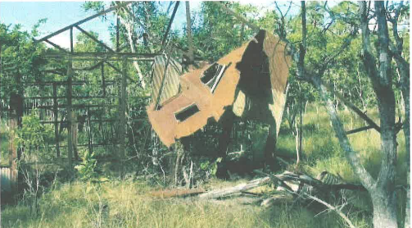
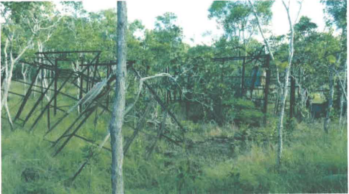
Women were seconded to work at this remote facility during the war to intercept and retransmit telegraph messages through to Brisbane. This facility was closed in 1953.
Remains of WW2 telegraph equipment Punsand Bay. (Photo 2011)
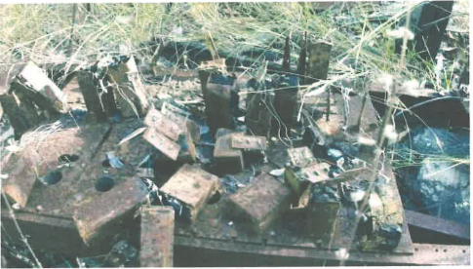
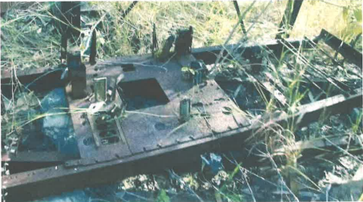
John O'Donnell (a veteran of WW1) was one of the PMG linesmen who volunteered to reconstruct the telegraph line in 1942.
The relay from Punsand bay telegraph station was donated by his son John O'Donnell also a PMG/Telecom veteran of 40 years.

References:
Unable to get them to work.
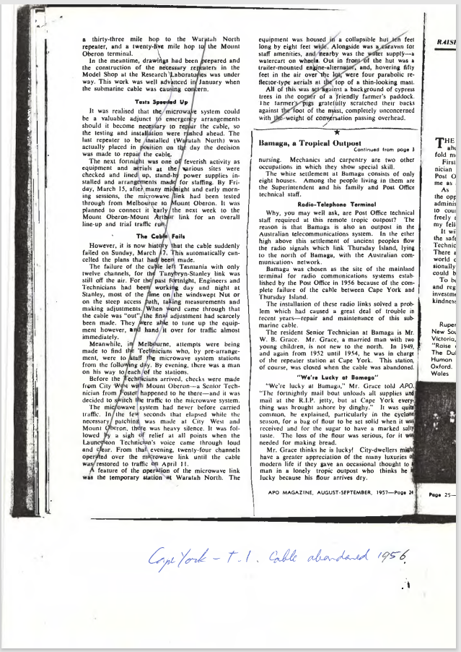

9511.4
Bamaga, a Tropical Outpost
Continued from page 3
nursing. Mechanics and carpentry are two other occupations in which they show special skill.
The white settlement at Bamaga consists of only eight houses. Among the people living in them are the Superintendent and his family and Post Office technical staff.
Radio-Telephone Terminal
Why, you may well ask, are Post Office technical staff required at this remote tropic outpost? The reason is that Bamaga is also an outpost in the Australian telecommunications system. In the ether high above this settlement of ancient peoples flow the radio signals which link Thursday Island, lying to the north of Bamaga, with the Australian communications network.
Bamaga was chosen as the site of the mainland terminal for radio communications systems established by the Post Office in 1956 because of the complete failure of the cable between Cape York and Thursday Island.
The installation of these radio links solved a problem which had caused a great deal of trouble in recent years—repair and maintenance of this submarine cable.
The resident Senior Technician at Bamaga is Mr. W. B. Grace. Mr. Grace, a married man with two young children, is not new to the north. In 1949, and again from 1952 until 1954, he was in charge of the repeater station at Cape York. This station, of course, was closed when the cable was abandoned.
"We're Lucky at Bamaga"
"We're lucky at Bamaga," Mr. Grace told APO. "The fortnightly mail boat unloads all supplies and mail at the R.I.P. jetty, but at Cape York everything was brought ashore by dinghy." It was quite common, he explained, particularly in the cyclone season, for a bag of flour to he set solid when it was received and for the sugar to have a marked salty taste. The loss of the flour was serious, for it was needed for making bread.
Mr. Grace thinks he is lucky! City-dwellers might have a greater appreciation of the many luxuries modern life if they gave an occasional thought to man in a lonely tropic outpost who thinks he lucky because his flour arrives dry.
APO MAGAZINE, AUGUST - SEPTEMBER 1957—Page 24

