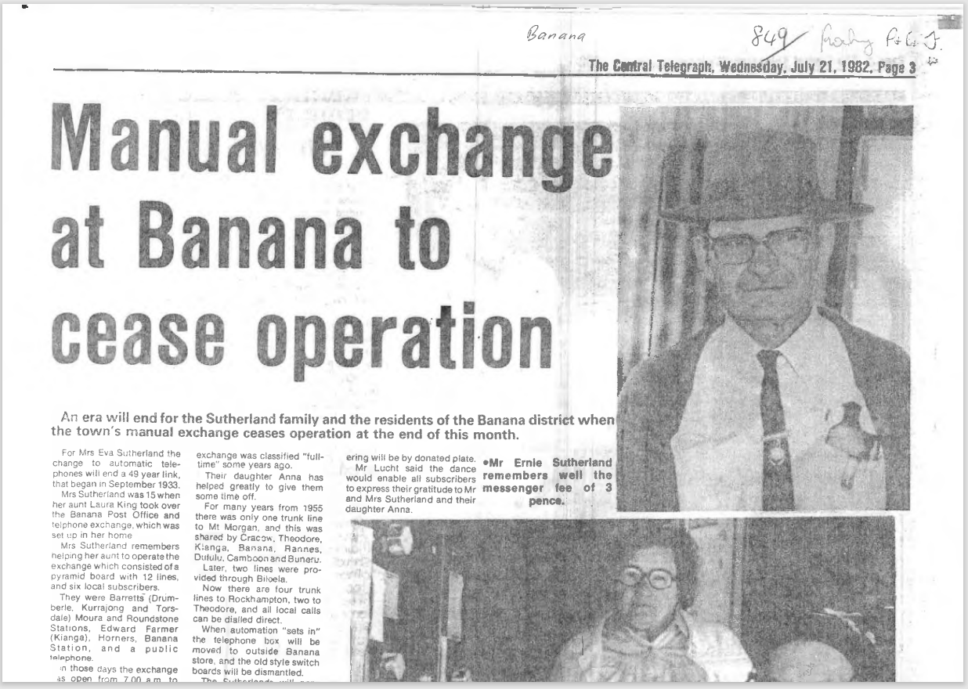
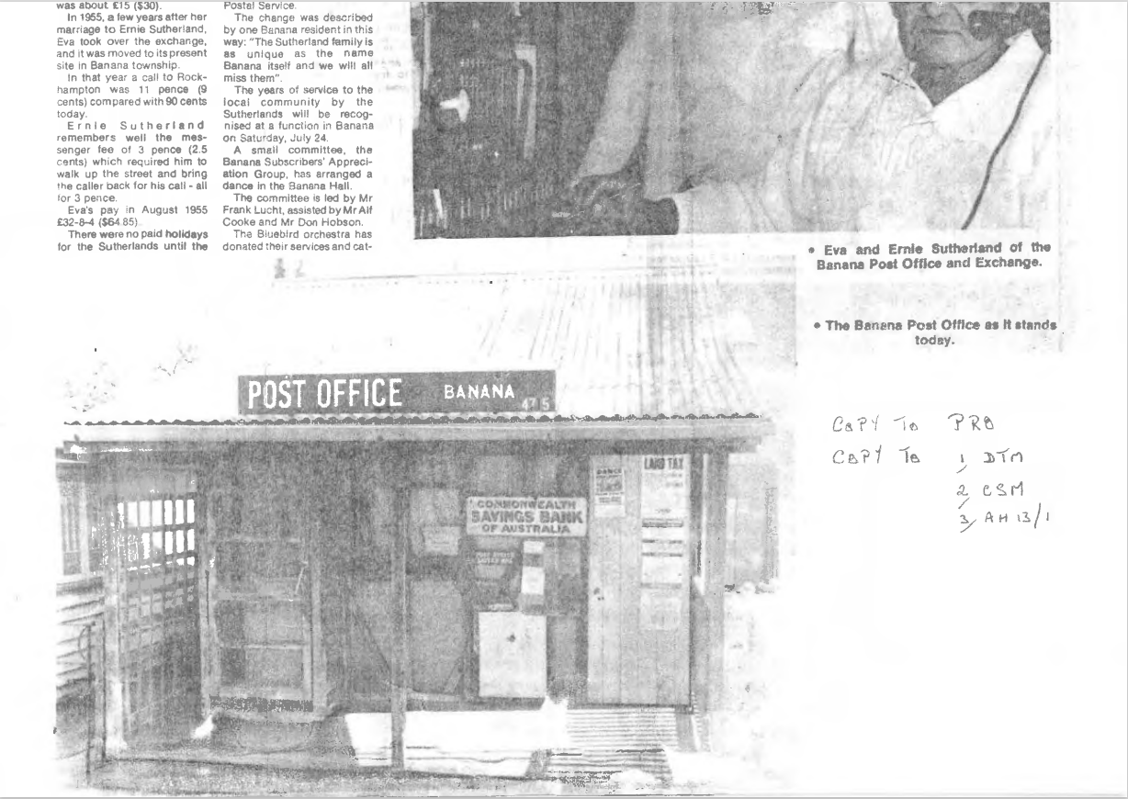

9512.1
Manual exchange at Banana to cease operation
An era will end for the Sutherland family and the residents of the Banana district when the town's manual exchange ceases operation at the end of this month.
For Mrs. Eva Sutherland the change to automatic telephones will end a 49 year link, that began in September 1933. Mrs. Sutherland was 15 when her aunt Laura King took over the Banana Post Office and telephone exchange, which was set up in her home.
Mrs. Sutherland remembers helping her aunt to operate the exchange which consisted of a pyramid board with 12 lines, and six local subscribers.
They were Barretts (Drumberle, Kurrajong and Torsdale) Moura and Roundstone Stations, Edward Farmer (Kianga), Homers, Banana and a public telephone.
In those days the exchange was open from 7.00 a.m to 4.00 p.m. monthly payment was about £15 (30.00).
In 1955, a few years after her marriage to Ernie Sutherland, Eva took over the exchange, and it was moved to its present site in Banana township.
in that year a call to Rockhampton was 11 pence (9 cents) compared with 90 cents today.
Ernie Sutherland remembers well the messenger fee of 3 pence (2.5 cents) which required him to walk up the street and bring the caller back for his call - all for 3 pence.
Eva's pay in August 1955 £32-8-4 ($64 85)
There were no paid holidays for the Sutherlands until the exchange was classified "full time" some years ago.
Their daughter Anna has helped greatly to give them some time off. For many years from 1955 there was only one trunk line to Mt Morgan, and this was shared by Cracow, Theodore, Kianga, Banana, Rennes, Dululu, Camboon and Buneru.
Later, two lines were provided through Biloela.
Now there are four trunklines to Rockhampton, two to Theodore, and all local calls can be dialed direct.
When automation "sets in" the telephone box will be moved to outside Banana and the old style switch boards will be dismantled.
The Sutherlands run the Postal Service.
The change was described by one Banana resident in this way: "The Sutherland family is as unique as the name Banana itself and we will all miss them".
The years of service to the local community by the Sutherlands will be recognised at a function in Banana on Saturday, July 24.
A small committee, the Banana Subscribers' Appreciation Group, has arranged a dance in the Banana Hall.
The committee is led by Mr. Frank Lucht, assisted by Mr. Alf Cooke and Mr. Don Hobson.
The Bluebird orchestra has donated their services and catering will be by donated plate.
Mr. Lucht said the dance would enable all subscribers to express their gratitude to Mr. and Mrs. Sutherland and their daughter Anna.

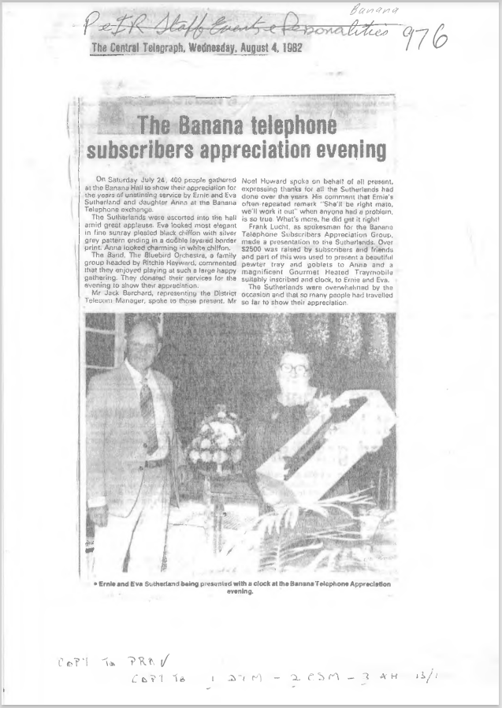

9512.2
The Banana telephone subscribers appreciation evening
On Saturday July 24, 400 people gathered at the Banana Hall to show their appreciation for the years of unstinting service by Ernie and Eva Sutherland and daughter Anna at the Banana Telephone exchange.
The Sutherlands were escorted into the hall amid great applause. Eva looked most °elegant” in fine sunray pleated black chiffon with silver grey pattern ending in a double layered border print. Anna looked charming in white chiffon.
The Band, The Bluebird Orchestra, a family group headed by Ritchie Hayward commented that they enjoyed playing at such a large happy gathering. They donated their services for the evening to show their appreciation.
Mr. Jack Berchard, representing the District Telecom Manager. spoke to those present. Mr. Noel Howard spoke on behalf of all present, expressing thanks for all the Sutherlands had done over the years. His comment that Ernie's often. repeated remark "She’ll be right mate, we'll work it out" when anyone had a problem, is so true. What's more, he did get it right!
Frank Lucre, as spokesman for the Banana Telephone Subscribers Appreciation Group, made a presentation to the Sutherlands Over $2500 was raised by subscribers and friends and part of this was used to present a beautiful pewter tray and goblets to Anna and a magnificent Gourmet Heated Traymobile suitably inscribed and clock, to Ernie and Eva.
The Sutherlands were overwhelmed by the occasion and that so many people had traveled so far to show their appreciation.
The Central Telegraph Wednesday August 4th 1982.

