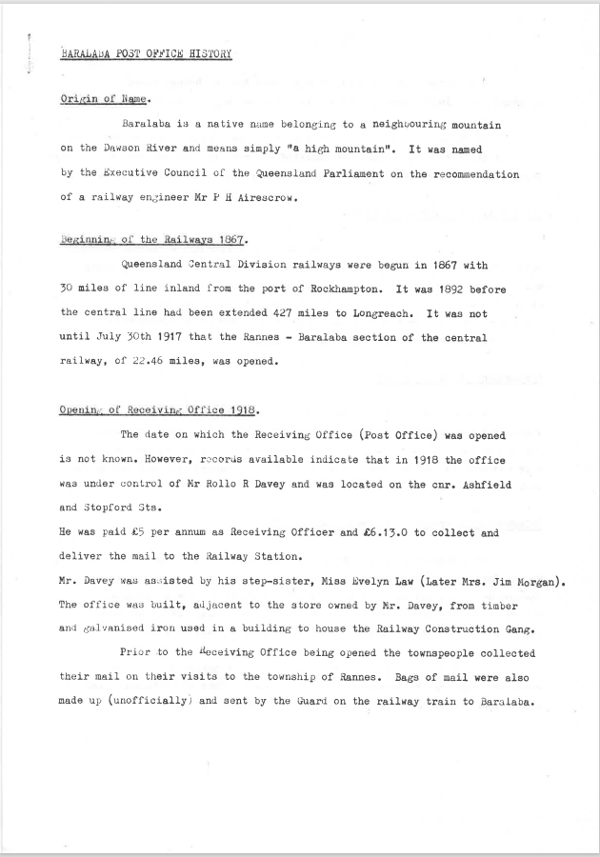

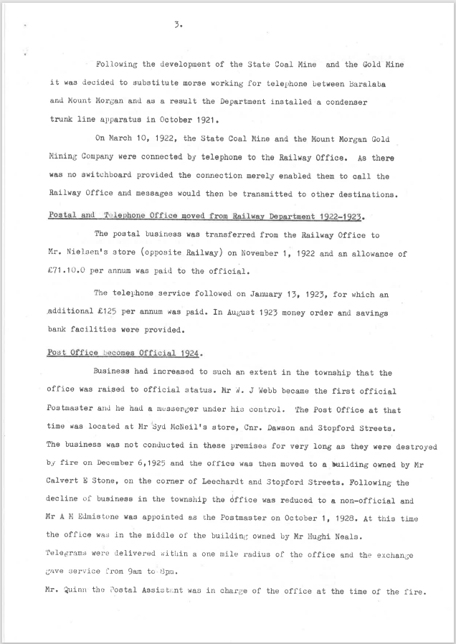

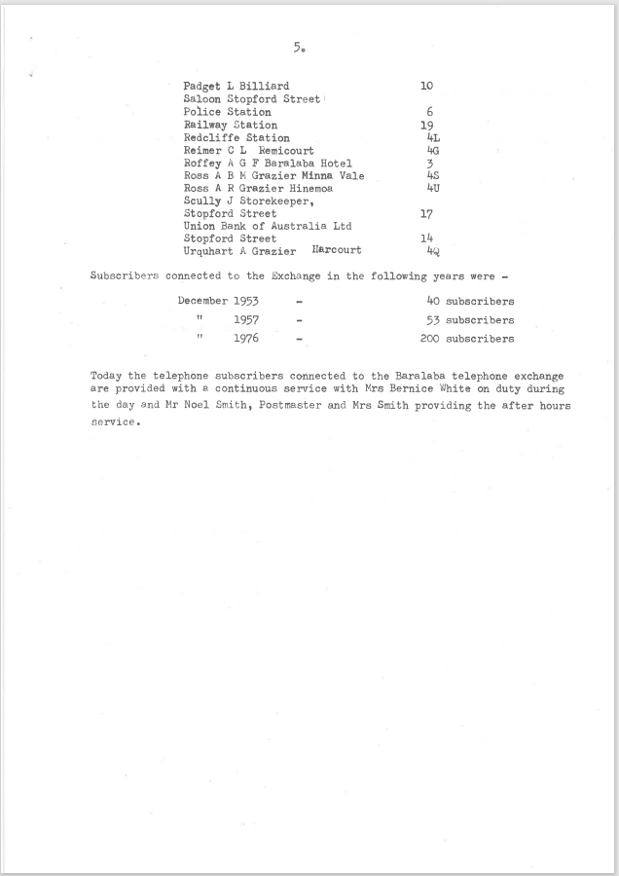
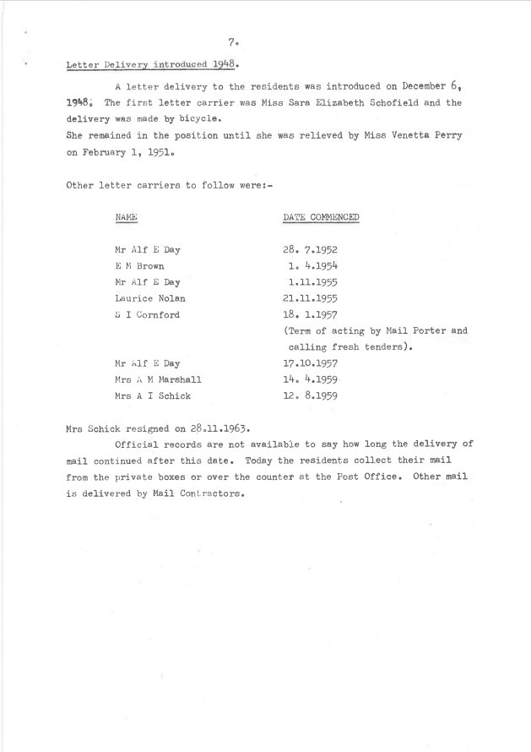

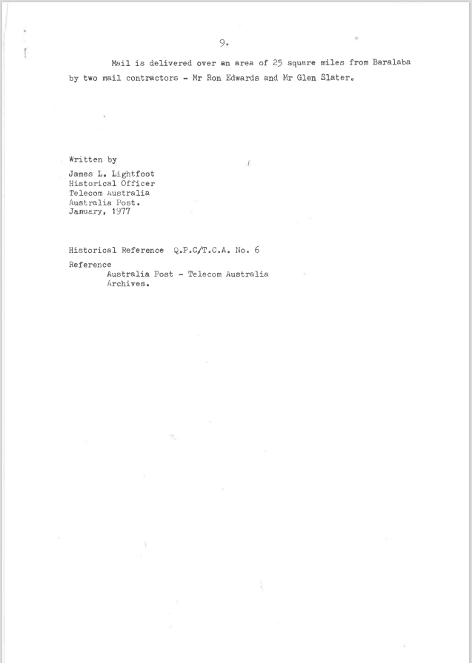

9514.1
BARALABA POST OFFICE HISTORY
Origin of Name.
Baralaba is a native name belonging to a neighbouring mountain on the Dawson River and means simply "a high mountain". It was named by the Executive Council of the Queensland Parliament on the recommendation of a railway engineer Mr.. P H Airescrow.
Beginning of the Railways 1867.
Queensland Central Division railways were begun in 1867 with 30 miles of line inland from the port of Rockhampton. It was 1892 before the central line had been extended 427 miles to Longreach. It was not until July 30th 1917 that the Rannes - Baralaba section of the central railway, of 22.46 miles, was opened.
Opening of Receiving: Office 1918.
The date on which the Receiving Office (Post Office) was opened is not known. However, records available indicate that in 1918 the office was under control of Mr.. Rollo R Davey and was located on the cnr. Ashfield and Stopford Sts.
He was paid £5 per annum as Receiving Officer and £6.13.0 to collect and deliver the mail to the Railway Station.
Mr.. Davey was assisted by his step-sister, Miss Evelyn Law (Later Mrs.. Jim Morgan).
The office was built, adjacent to the store owned by Mr.. Davey, from timber and galvanised iron used in a building to house the Railway Construction Gang.
Prior to the receiving Office being opened the townspeople collected their mail on their visits to the township of Rannes. Bags of mail were also made up (unofficially) and sent by the Guard on the railway train to Baralaba.

3.
Following the development of the State Coal Mine and the Gold Mine it was decided to substitute morse working for telephone between Baralaba and Mount Morgan and as a result the Department installed a condenser trunk line apparatus in October 1921.
On March 10, 1922, the State Coal Mine and the Mount Morgan Gold Mining Company were connected by telephone to the Railway Office. As there was no switchboard provided the connection merely enabled them to call the Railway Office and messages would then be transmitted to other destinations.
Postal and Telephone Office moved from Railway Department 1922-1923.
The postal business was transferred from the Railway Office to
Mr.. Nielsen's store (opposite Railway) on November 1, 1922 and an allowance of
£71.10.0 per annum was paid to the official.
The telephone service followed on January 13, 1923, for which an additional £125 per annum was paid. In August 1923 money order and savings bank facilities were provided.
Post Office Becomes Official 1924.
Business had increased to such an extent in the township that the office was raised to official status. Mr.. W. J Webb became the first official Postmaster and he had a messenger under his control. The Post Office at that time was located at Mr.. Syd McNeil's store, Cnr. Dawson and Stopford Streets.
The business was not conducted in these premises for very long as they were destroyed by fire on December 6,1925 and the office was then moved to a building owned by Mr.. Calvert E Stone, on the corner of Leechardt and Stopford Streets. Following the decline of business in the township the Office was reduced to a non—official and Mr.. A M Edmiston was appointed as the Postmaster on October 1, 1928. At this time the office was in the middle of the building owned by Mr.. Hughi Neals.
Telegrams were delivered within a one mile radius of the office and the exchange gave service from 9am to 8pm.
Mr.. Quinn the Postal Assistant was in charge of the office at the time of the fire.

Padget L Billiard 10
Saloon Stopford Street
Police Station 6
Railway Station 19
Redcliffe Station 4L
Reimer C L Remicourt 4G
Roffey A G F Baralaba Hotel 3
Ross A B N Grazier Minna Vale 4S
Ross A R Grazier Hinemoa 4U
Scully J Storekeeper,
Stopford Street 17
Union Bank of Australia Ltd
Stopford Street 14
Urquhart A Grazier Harcourt 4Q
Subscribers connected to the Exchange in the following years were
December 1953 40 subscribers
1957 53 subscribers
1976 200 subscribers
Today the telephone subscribers connected to the Baralaba telephone exchange are provided with a continuous service with Mrs. Bernice White on duty during the day and Mr. Noel Smith, Postmaster and Mrs. Smith providing the after hours service.

7.

Letter Delivery introduced 1948.
A letter delivery to the residents was introduced on December 6, 19480 The first letter carrier was Miss Sara Elizabeth Schofield and the delivery was made by bicycle.
She remained in the position until she was relieved by Miss Venetta Perry on February 1, 1951.
Other letter carriers to follow were:
NAME DATE COMMENCED
Mr. Alf E Day 28. 7.1952
E M Brown 1. 4.1954
Mr. Alf E Day 1.11.1955
Laurice Nolan 21.11.1955
S I Cornford 18. 1.1957
(Term of acting by Mail Porter and calling fresh tenders).
Mr. Alf E Day 17.10.1957
Mrs. i M Marshall 14. 4.1959
Mrs. A I Schick 12. 8.1959
Mrs. Schick resigned on 28.11.1963.
Official records are not available to say how long the delivery of mail continued after this date. Today the residents collect their mail from the private boxes or over the counter at the Post Office. Other mail is delivered by Mail Contractors.
9.
Mail is delivered over an area of 25 square miles from Baralaba by two mail contractors - Mr. Ron Edwards and Mr. Glen Slater.
Written by
James L. Lightfoot
Historical Officer
Telecom Australia
Australia Post.
January, 1977
Historical Reference Q.P.C/T.C.A. No. 6
Reference
Australia Post - Telecom Australia
Archives.

9514.2 AUTOMATIC TELEPHONE FOR BARALABA Central Telegraph May 26 1982
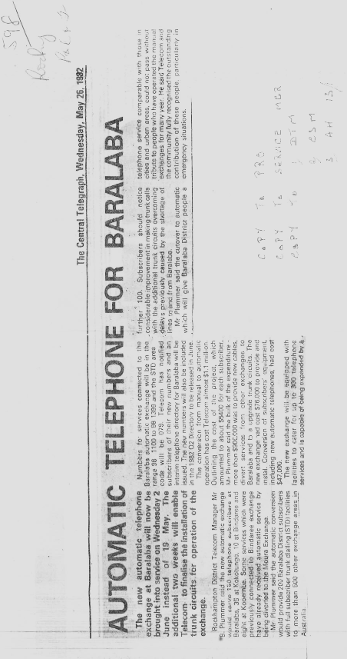
AUTOMATIC TELEPHONE FOR BARALABA

The new automatic telephone exchange at Baralaba will now be brought into service on Wednesday 2 June instead of 19 May. The additional two weeks will enable Telecom to finalise the installation of trunk circuits for operation of the exchange.
Rockhampton District Telecom Manager Mr. B. Plummer said the new automatic exchange would serve 150 telephone subscribers at Baralaba, 35 at Kokotungo, 10 at Bindaree and eight at Kooemba. Some services which were previously connected to Bindaree exchange have already received automatic service by being diverted to the Moura Exchange.
Mr Plummer said the automatic conversion would provide 200 Baralaba District subscribers with full subscriber trunk dialling (STD) facilities to more than 500 other exchange areas in Australia.
Numbers for services connected to the Baralaba automatic exchange will be in the range 98 1100 to 98 1399 and the STD area code will be 079. Telecom has notified subscribers of their new numbers and an interim telephone directory for Baralaba will be issued. The new numbers will also be included in the 1982 Q2 Directory to be released in June.
The conversion from manual to automatic operation has cost Telecom almost $1.1 million. Outlining the cost of the project, which amounted to about $5400 for each subscriber, Mr Plummer said the bulk of the expenditure more than $900,000 was to provide new cables, divert services from other exchanges to Baralaba and to upgrade trunk circuits. The new exchange had cost $76,000 to provide and install. Conversion of subscriber’s equipment, including new automatic telephones, had cost $47,000.
The new exchange will. be equipped with facilities to cater for up to 300 telephone services and is capable of being expanded by, a further 100, Subscribers should notice considerable improvement in making trunk calls with the additional trunk circuits overcoming delays previously caused by the shortage of lines to and from Baralaba.
Mr Plummer said the cutover to automatic which will give Baralaba District people a telephone service comparable with those in cities and urban areas, could not pass without tribute to people who have operated the manual exchanges for many years. He said Telecom and the community fully recognised the outstanding contribution of these people, particularly in emergency situations.

