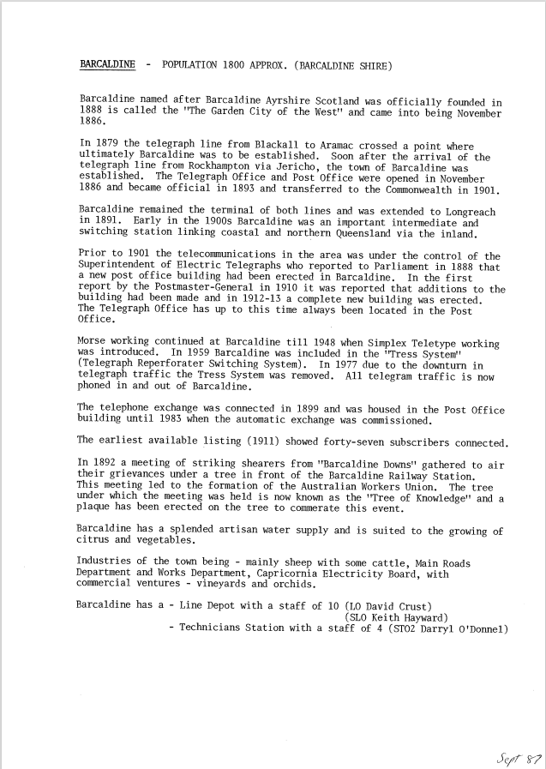
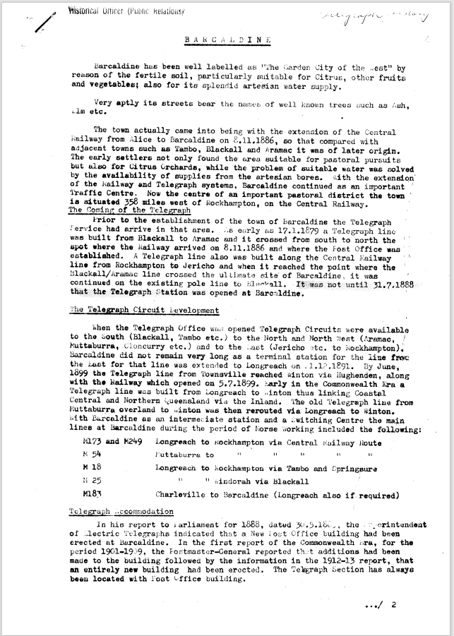

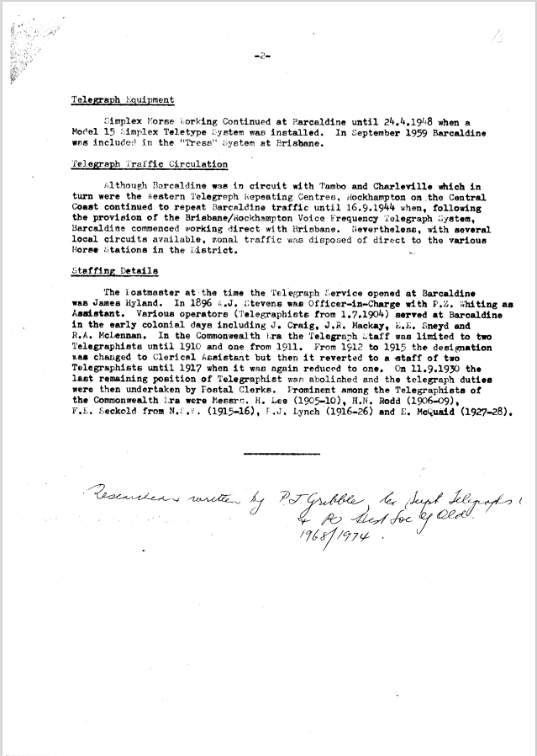

9515.1
BARCALDINE - POPULATION 1800 APPROX. (BARCALDINE SHIRE)
Barcaldine named after Barcaldine Ayrshire Scotland was officially founded in 1888 is called the "The Garden City of the West" and came into being November 1886.
In 1879 the telegraph line from Blackall to Aramac crossed a point where ultimately Barcaldine was to be established. Soon after the arrival of the telegraph line from Rockhampton via Jericho, the town of Barcaldine was established. The Telegraph Office and Post Office were opened in November 1886 and became official in 1893 and transferred to the Commonwealth in 1901.
Barcaldine remained the terminal of both lines and was extended to Longreach in 1891. Early in the 1900s Barcaldine was an important intermediate and switching station linking coastal and northern Queensland via the inland.
Prior to 1901 the telecommunications in the area was under the control of the Superintendent of Electric Telegraphs who reported to Parliament in 1888 that a new post office building had been erected in Barcaldine. In the first report by the Postmaster-General in 1910 it was reported that additions to the building had been made and in 1912-13 a complete new building was erected. The Telegraph Office has up to this time always been located in. the Post Office.
Morse working continued at Barcaldine till 1948 when Simplex Teletype working was introduced. In 1959 Barcaldine was included in the "Tress System" (Telegraph Reperforater Switching System). In 1977 due to the downturn in telegraph traffic the Tress System was removed. All telegram traffic is now phoned in and out of Barcaldine.
The telephone exchange was connected in 1899 and was housed in the Post Office building until 1983 when the automatic exchange was commissioned.
The earliest available listing (1911) showed forty-seven subscribers connected.
In 1892 a meeting of striking shearers from "Barcaldine Downs" gathered to air their grievances under a tree in front of the Barcaldine Railway Station. This meeting led to the formation of the Australian Workers Union. The tree under which the meeting was held is now known as the "Tree of Knowledge" and a plaque has been erected on the tree to commerate this event.
Barcaldine has a splended artisan water supply and is suited to the growing of citrus and vegetables.
Industries of the town being - mainly sheep with some cattle, Main Roads Department and Works Department, Capricornia Electricity Board, with commercial ventures - vineyards and orchids.
Barcaldine has a - Line Depot with a staff of 10
(LO David Crust)
(SLO Keith Hayward)
- Technicians Station with a staff of 4 (STO2 Darryl O'Donnel)
BARCALDINE
Barcaldine has been well labelled as "The 6arden City of the “cst" by reason of the fertile soil, particularly suitable for Citrus, other fruits and vegetables; also for its splendid artesian water supply.
Very aptly its streets bear the names of well-known trees such as Ash, Elm etc.
The town actually came into being with the extension of the Central Railway from Alice to Barcaldine on 8.11.1886, so that compared with adjacent towns such as Tambo, Blacken and Aramac it was of later origin. The early settlers not only found the area suitable for pastoral pursuits but also for Citrus Orchards, while the problem of suitable water was solved by the availability of supplies from the artesian bores. With the extension' of the Railway and Telegraph systems, Barcaldine continued as an important Traffic Centre. Now the centre of an important pastoral district the town is situated 358 miles west of Rockhampton, on the Central Railway.
The Coming of the Telegraph
Prior to the establishment of the town of Barcaldine the Telegraph Service had arrive in that area. As early as 17.1.1879 a Telegraph line was built from Blackall to Aramac and it crossed from south to north the spot where the Railway arrived on 8.11.1886 and where the Fort Office was established. A Telegraph line also was built along the Central Railway line from Rockhampton to Jericho and when it reached the point where the Blackall/Aramac line crossed the ultimate site Of Barcaldine, it was continued on the existing pole line to Blackall. It was not until 31.7.1888 that the Telegraph station was opened at Barcaldine.
The Telegraph Circuit Development
When the Telegraph Office was opened Telegraph Circuits were available to the South (Blackall, Tambo etc.) to the North and North West (Aramac, Muttaburra, Cloncurry etc.) and to the East (Jericho etc. to Rockhampton), Barcaldine did not remain very long as a terminal station for the line from the East for that line was extended to Longreach on .1-12.1891. By June, 1899 the Telegraph line from Townsville reached Winton via Hughenden, along with the Railway which opened on 5.7.1899. Early in the Commonwealth Era a Telegraph line was built from Longreach to Winton thus linking Coastal Central and Northern Queensland via the Inland. The old Telegraph line from Muttaburra overland to Winton was then rerouted via Longreach to Winton. With Barcaldine as an intermediate station and a Switching Centre the main lines at Barcaldine during the period of Morse Working included the following:
M173 and M249 Longreach to Rockhampton via Central Railway Route
M 54 Muttaburra to Rockhampton via Central Railway Route
M 18 Longreach to Rockhampton via Tambo and Springsure
N 25 Longreach to Mindorah via Blackall
M183 Charleville to Barcaldine (Longreach also if, required)
Telegraph Accommodation
in his report to Parliament for 1888, dated 30.5.1&„ the Superintendent of electric Telegraphs indicated. that a New lost Office building had been erected at Barcaldine. In the first report of the Commonwealth Era, for the period 1901-1909, the Postmaster-General reported that additions had been made to the building followed by the information in the 1912-13 report, that an entirely new building had been erected. The Telegraph Section has always been located with Post Office building.
Telegraph Equipment
Simplex Morse working Continued at Barcaldine until 24.4.1948 when a Model 15 simplex Teletype System was installed. In September 1959 Barcaldine was included in the "Tress" System at Brisbane.
Telegraph Traffic Circulation
Although Barcaldine was in circuit with 'Tambo and Charleville which in turn were the Western Telegraph Repeating Centres. Rockhampton on the Central Coast continued to repeat Barcaldine traffic until 16.9.1944 when, following the provision of the Brisbane/Rockhampton Voice Frequency Telegraph System, Barcaldine commenced working direct with Brisbane. Nevertheless, with several local circuits available, zonal traffic was disposed of direct to the various Morse Stations in the District.
Staffing Details
The Postmaster at the time the Telegraph Service opened at Barcaldine was James Hyland. In 1896 A.J. Stevens was Officer-in-Charge with P.Z. Whiting as Assistant. Various operators (Telegraphists from 1.7.1904) served at Barcaldine in the early colonial days including J. Craig, J.R. Mackay, E.E. Sneyd and R.A. McLennan. In the Commonwealth Era the Telegraph Staff was limited to two Telegraphists until 1910 and one from 1911. From 1912 to 1915 the designation vas changed to Clerical Assistant but then it reverted to a staff of two Telegraphists until 1917 when it was again reduced to one. On 11.9.1930 the last remaining position of Telegraphist war; abolished and the telegraph duties were then undertaken by Postal Clerks. Prominent among the Telegraphists of the Commonwealth Era were Messrs,. H. Lee (1905-10), H.N. Rodd (1906-09),
F.E. Seckold from (1915.16), T.J. Lynch (1916-26) and E. McQuaid (1927-28).

Researched and written by P.J. Gribble for Sept Telegraphs and PO Historical Soc of Queensland 1968/1974.

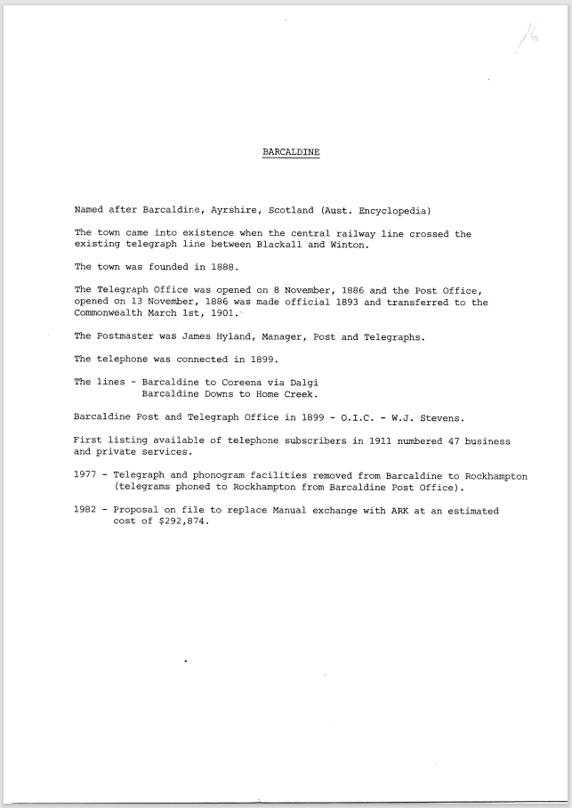

9515.2
BARCALDINE
Named after Barcaldine, Ayrshire, Scotland (Aust. Encyclopedia)
The town came into existence when the central railway line crossed the existing telegraph line between Blackall and Winton.
The town was founded in 1888.
The Telegraph Office was opened on 8 November, 1886 and the Post Office, opened on 13 November, 1886 was made official 1893 and transferred to the Commonwealth March 1st, 1901.
The Postmaster was James Hyland, Manager, Post and Telegraphs. The telephone was connected in 1899.
The lines - Barcaldine to Coreena via Dalgi
Barcaldine Downs to Home Creek.
Barcaldine Post and Telegraph Office in 1899 - O.I.C. - W.J. Stevens.
First listing available of telephone subscribers in 1911 numbered 47 business and private services.
1977 - Telegraph and phonogram facilities removed from Barcaldine to Rockhampton (telegrams phoned to Rockhampton from Barcaldine Post Office).
1982 - Proposal on file to replace Manual exchange with ARK at an estimated cost of $292,874.
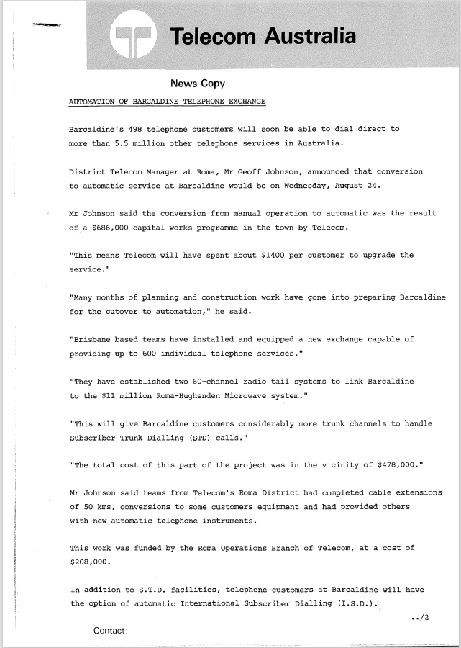
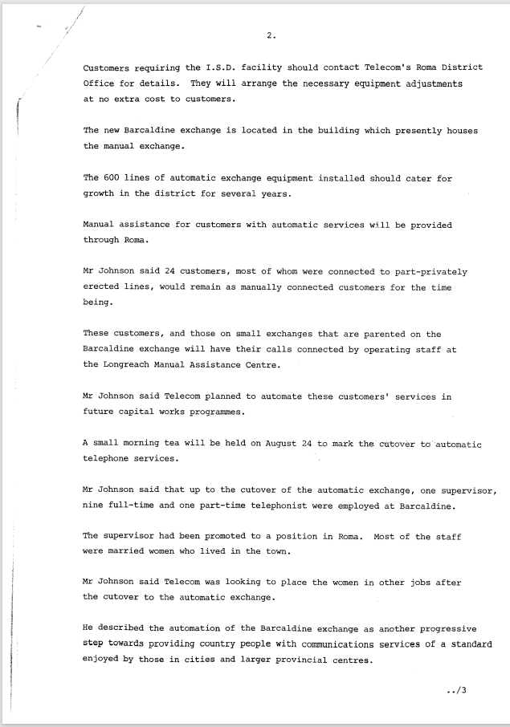
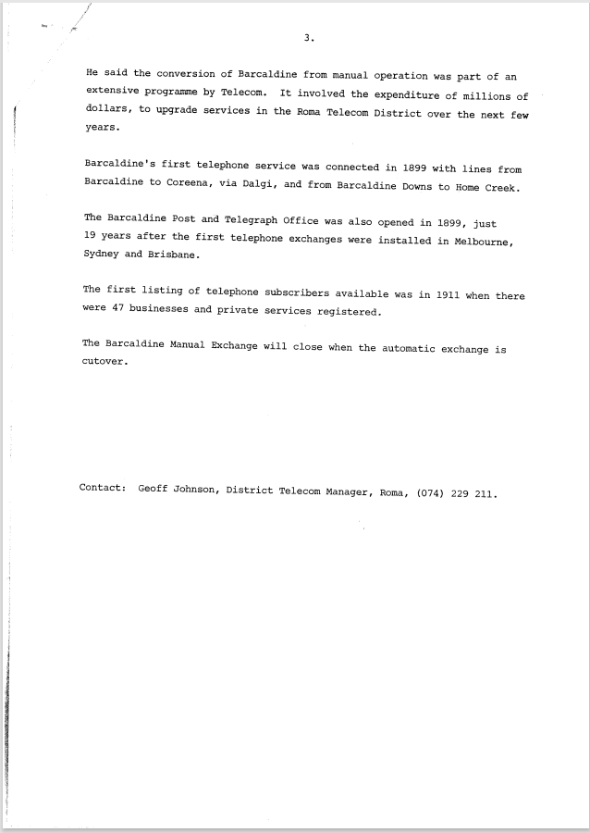

9515.3
Telecom Australia
News Copy
AUTOMATION OF BARCALDINE TELEPHONE EXCHANGE
Barcaldine's 498 telephone customers will soon be able to dial direct to more than 5.5 million other telephone services in Australia.
District Telecom Manager at Roma, Mr Geoff Johnson, announced that conversion to automatic service at Barcaldine would be on Wednesday, August 24.
Mr Johnson said the conversion from manual operation to automatic was the result of a $686,000 capital works programme in the town by Telecom.
"This means Telecom will have spent about $1400 per customer to upgrade the service."
"Many months of planning and construction work have gone into preparing Barcaldine for the cutover to automation," he said.
"Brisbane based teams have installed and equipped a new exchange capable of providing up to 600 individual telephone services."
"They have established two 60-channel radio tail systems to link Barcaldine to the $11 million Roma-Hughenden Microwave system."
"This will give Barcaldine customers considerably more trunk channels to handle Subscriber Trunk Dialling (STD) calls."
"The total cost of this part of the project was in the vicinity of $478,000."
Mr Johnson said teams from Telecom's Roma District had completed cable extensions
of 50 kms, conversions to some customers equipment and had provided others with new automatic telephone instruments.
This work was funded by the Roma Operations Branch of Telecom, at a cost of $208,000.
In addition to S.T.D. facilities, telephone customers at Barcaldine will have the option of automatic International Subscriber Dialling (I.S.D.).
2.
Customers requiring the I.S.D. facility should contact Telecom's Roma District
Office for details. They will arrange the necessary equipment adjustments at no extra cost to customers.
The new Barcaldine exchange is located in the building which presently houses the manual exchange.
The 600 lines of automatic exchange equipment installed should cater for growth in the district for several years.
Manual assistance for customers with automatic services will be provided through Roma.
Mr. Johnson said 24 customers, most of whom were connected to part-privately erected lines, would remain as manually connected customers for the time being.
These customers, and those on small exchanges that are parented on the Barcaldine exchange will have their calls connected by operating staff at the Longreach Manual Assistance Centre.
Mr Johnson said Telecom planned to automate these customers' services in future capital works programmes.
A small morning tea will be held on August 2.4 to .mark the cutover to. automatic telephone services.
Mr Johnson said that up to the cutover of the automatic exchange, one supervisor, nine full-time and one part-time telephonist were employed at Barcaldine.
The supervisor had been promoted to a position in Roma. Most of the staff were married women who lived in the town.
Mr Johnson said Telecom was looking to place the women in other jobs after the cutover to the automatic exchange.
He described the automation of the Barcaldine exchange as another progressive step towards providing country people with communications services of a standard enjoyed by those in cities and larger provincial centres.
3.
He said the conversion of Barcaldine from manual operation was part of an extensive programme by Telecom. It involved the expenditure of millions of dollars, to upgrade services in the Roma Telecom District over the next few years.
Barcaldine's first telephone service was connected in 1899 with lines from Barcaldine to Coreena, via Dalgi, and from Barcaldine Downs to Home Creek.
The Barcaldine Post and Telegraph Office was also opened in 1899, just
19 years after the first telephone exchanges were installed in Melbourne,
Sydney and Brisbane.
The first listing of telephone subscribers available was in 1911 when there were 47 businesses and private services registered.
The Barcaldine Manual Exchange will close when the automatic exchange is cutover.
Contact: Geoff Johnson, District Telecom Manager, Roma, (074) 229 211.

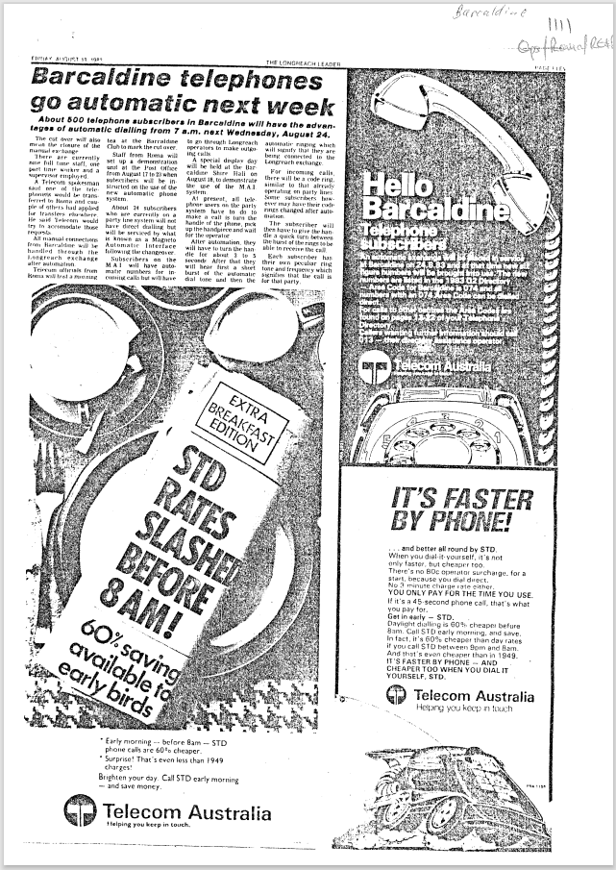

9515.4
Barcaldine telephones go automatic next week
About 500 telephone subscribers in Barcaldine will have the advantages of automatic dialing from 7 a.m. next Wednesday, August 24.
The cut over will also mean the closure of the manual exchange
There are currently nine hill tune staff. one part time worker and a supervisor employed.
A Telecom spokesman said one of the telephonists would be transferred to Roma and couple of others had applied for transfers elsewhere. He said Telecom would try to accommodate those requests.
All manual connections from Barcaldine will be handled through the Longreach exchange after automation.
Telecom officials from Roma will host a morning tea at the Barcaldine Club.
Staff from Roma will set up a demonstration unit at the Post Office from August 17th to 23rd when subscribers will be in-structed on the use of the new automatic phone system.
About 24 subscribers who are currently on a party line system will not have direct dialing but will be serviced by what is known as a Magneto Automatic Interface following the changeover.

Early morning before 8am — STD phone calls are 60% cheaper. Surprise! That's even less than 1949 charges! Brighten your day. Call STD early morning — and save money.
Telecom Australia
Helping you keep in touch.
IT'S FASTER BY PHONE!
... and better all round by STD.
When you dial-it-yourself. it's not only faster. but cheaper too.
There's no 80c operator surcharge. for a start, because you dial direct.
No 3-minute charge rate either.
YOU ONLY PAY FOR THE TIME YOU USE.
If it's a 45-second phone call, that's what you pay for.
Get in early — STD.
Daylight dialing is 60% cheaper before 8am. Call STD early morning, and save. In fact, it's 60% cheaper than day rates if you call STD between 9pm and 8am. And that's even cheaper than in 1949. IT'S FASTER BY PHONE — AND CHEAPER TOO WHEN YOU DIAL IT YOURSELF, STD.
Telecom Australia
Helping you keep in touch

Hello Barcaldine
Telephone subscribers
An automatic exchange will be placed in service at Barcaldine on 24.8.83 and at that time six figure numbers will be brought into use. The new numbers are listed in the 1983 02 Directory.
- Area Code for Barcaldine is 074 and all numbers with an 074 Area Code can be dialed direct.
For calls to other centres the Area Code is found on pages 12-22 of your Telephone Directory.
Callers wanting other information should call 013 – their directory assistance operator.
Telecom Australia
Helping you keep in touch.
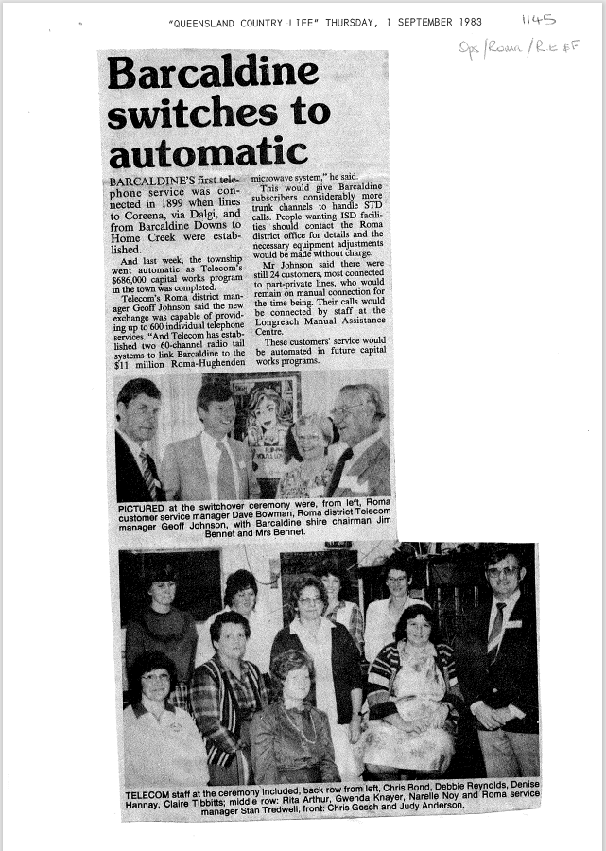

9515.5
Barcaldine switches to automatic
BARCALDINE'S first telephone service was connected in 1899 when lines to Coreena, via Dalgi, and from Barcaldine Downs to Home Creek were established.
And last week, the township went automatic as Telecom's $686,000 capital works program in the town was completed.
Telecom's Roma district man-ager Geoff Johnson said the new exchange was capable of providing up to 600 individual telephone services. "And Telecom has established two 60-channel radio tail systems to link Barcaldine to the $11 million Roma-Hughenden microwave system," he said.
This would give Barcaldine subscribers considerably more trunk channels to handle STD calls. People wanting ISD facilities should contact the Roma district office for details and the necessary equipment adjustments would be made without charge.
Mr Johnson said there were still 24 customers, most connected to part-private lines, who would remain on manual connection for the time being. Their calls would be connected by staff at the Longreach Manual Assistance Centre.
These customers' service would be automated in future capital works programs.

PICTURED at the switchover ceremony were, from left, Roma customer service manager Dave Bowman, Roma district Telecom manager Geoff Johnson, with Barcaldine shire chairman Jim Bennet and Mrs Bennet.

TELECOM staff at the ceremony included, back row from left, Chris Bond, Debbie Reynolds, Denise
Hannay, Claire Tibbitts; middle row: Rita Arthur, Gwenda Knayer, Narelle Noy and Roma service
manager Stan Tredwel, front: Chris Gesch and Judy Anderson.
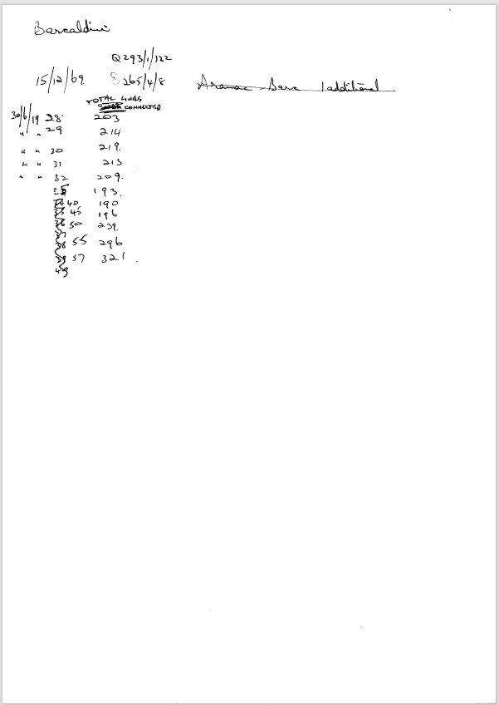

9515.6
Barcaldine
15/12/69 | Q293/1/122
 | Q265/4/8
 | Total Lines Connected
30/6/1928 | 203
30/6/1929 | 214
30/6/1930 | 219
30/6/1931 | 213
30/6/1932 | 209
30/6/1935 | 193
30/6/1940 | 190
30/6/1945 | 196
30/6/1950 | 229
30/6/1955 | 296
30/6/1957 | 321

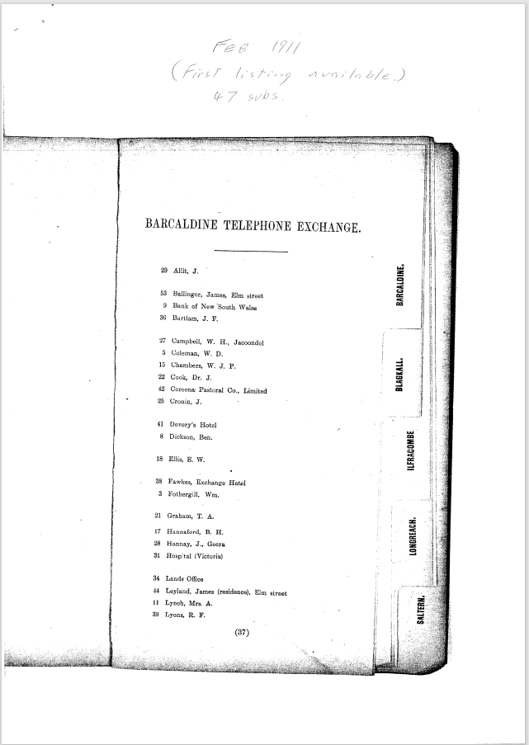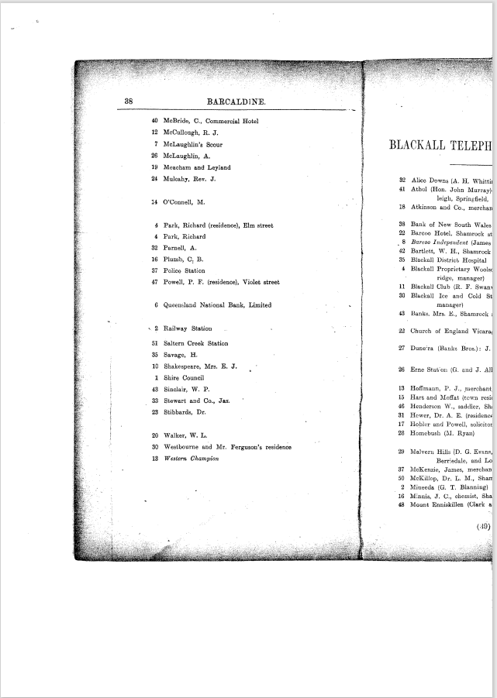

9515.7
Barcaldine Telephone Exchange
Feb 1911
(First Listing Available 47 Subs)
BARCALDINE TELEPHONE EXCHANGE
29 Allit, J.
53 Ballinger, James, Elm Street
9 Bank of New South Wales
36 Bartlam, J. F.

27 Campbell, W. H., Jacoondol
5 Coleman, W. D.
15 Chambers, W. J. P.
22 Cook, Dr. J.
42 Coreena Pastoral Co., Limited
25 Cronin, J.

41 Devery's Hotel
8 Dickson, Ben.

18 Ellis, E. W.

38 Fawkes, Exchange Hotel
3 Fothergill, Wm.

21 Graham, T. A.

17 Hannaford, B. H.
28 Hannay, J., Geera
31 Hospital (Victoria)

34 Lands Office
44 Leyland, James (residence), Elm street
11 Lynch, Mrs. A.
30 Lyons, R. F.

40 McBride, C., Commercial Hotel
12 McCullough, R. J.
7 McLaughlin's Scour
26 McLaughlin, A.
19 Meacham and Leyland
24 Mulcahy, Rev. J.

14 O'Connell, M.

4 Park, Richard (residence), Elm street
4 Park, Richard
32 Parnell, A.
16 Plumb, C. B.
37 Police Station
47 Powell, P. F. (residence), Violet street

6 Queensland National Bank, Limited

2 Railway Station

51 Saltern Creek Station
35 Savage, H.
10 Shakespeare, Mrs. E. J.
1 Shire Council
43 Sinclair, W. P.
33 Stewart and Co., Jas.
23 Stibbards, Dr.

20 Walker, W. L.
30 Westbourne and Mr. Ferguson's residence
13 Western Champion

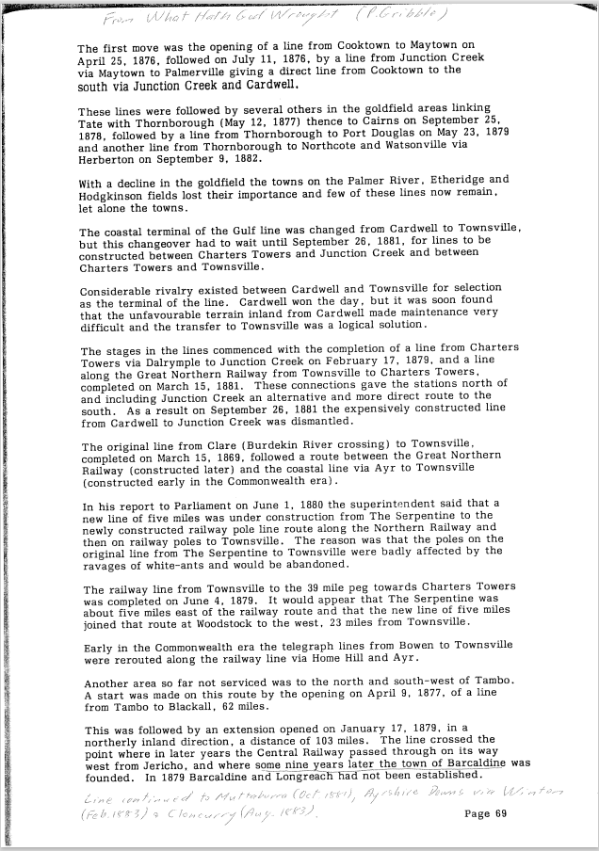

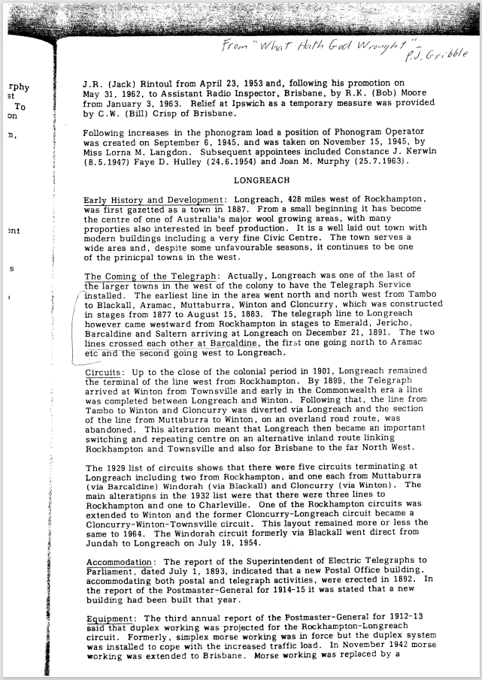

9515.8
From What God Has Wrought (P. Gribble)
The first move was the opening of a line from Cooktown to Maytown on April 25, 1876, followed on July 11, 1876, by a line from Junction Creek via Maytown to Palmerville giving a direct line from Cooktown to the
south via Junction Creek and Cardwell.
These lines were followed by several others in the goldfield areas linking Tate with Thornborough (May 12, 1877) thence to Cairns on September 25, 1878, followed by a line from Thornborough to Port Douglas on May 23, 1879 and another line from Thornborough to Northcote and Watsonville via Herberton on September 9, 1882.
With a decline in the goldfield the towns on the Palmer River, Etheridge and Hodgkinson fields lost their importance and few of these lines now remain, let alone the towns.
The coastal terminal of the Gulf line was changed from Cardwell to Townsville, but this changeover had to wait until September 26, 1881, for lines to be constructed between Charters Towers and Junction Creek and between Charters Towers and Townsville.
Considerable rivalry existed between Cardwell and Townsville for selection as the terminal of the line. Cardwell won the day, but it was soon found that the unfavourable terrain inland from Cardwell made maintenance very difficult and the transfer to Townsville was a logical solution.
The stages in the lines commenced with the completion of a line from Charters Towers via Dalrymple to Junction Creek on February 17, 1879, and a line along the Great Northern Railway from Townsville to Charters Towers, completed on March 15, 1881. These connections gave the stations north of and including Junction Creek an alternative and more direct route to the south. As a result on September 26, 1881 the expensively constructed line from Cardwell to Junction Creek was dismantled.
The original line from Clare (Burdekin River crossing) to Townsville, completed on March 15, 1869, followed a route between the Great Northern Railway (constructed later) and the coastal line via Ayr to Townsville (constructed early in the Commonwealth era).
In his report to Parliament on June 1, 1880 the superintendent said that a new line of five miles was under construction from The Serpentine to the newly constructed railway pole line route along the Northern Railway and then on railway poles to Townsville. The reason was that the poles on the original line from The Serpentine to Townsville were badly affected by the ravages of white-ants and would be abandoned.
The railway line from Townsville to the 39 mile peg towards Charters Towers was completed on June 4, 1879. It would appear that The Serpentine was about five miles east of the railway route and that the new line of five miles joined that route at Woodstock to the west, 23 miles from Townsville.
Early in the Commonwealth era the telegraph lines from Bowen to Townsville were rerouted along the railway line via Home Hill and Ayr.
Another area so far not serviced was to the north and south-west of Tambo. A start was made on this route by the opening on April 9, 1877, of a line from Tambo to Blackall, 62 miles.
This was followed by an extension opened on January 17, 1879, in a northerly inland direction, a distance of 103 miles. The line crossed the point where in later years the Central Railway passed through on its way west from Jericho, and where some nine years later the town of Barcaldine was founded. In 1879 Barcaldine and Longreach had not been established.
Written note: Line continued to Muttaburra (Oct 1881), Ayrshire Downs via Winton (Feb 1883) & Cloncurry (Aug. 1883)
Page 69
J.R. (Jack) Rintoul from April 23, 1953 and, following his promotion on May 31, 1962, to Assistant Radio Inspector, Brisbane, by R.K. (Bob) Moore from January 3, 1963. Relief at Ipswich as a temporary measure was provided by C.W. (Bill) Crisp of Brisbane.
Following increases in the phonogram load a position of Phonogram Operator was created on September 6, 1945, and was taken on November 15, 1945, by Miss Lorna M. Langdon. Subsequent appointees included Constance J. Kerwin (8.5.1947) Faye D. Hulley (24.6.1954) and Joan M. Murphy (25.7.1963).
LONGREACH
Early History and Development: Longreach, 428 miles west of Rockhampton, was first gazetted as a town in 1887. From a small beginning it has become the centre of one of Australia's major wool growing areas, with many properties also interested in beef production. It is a well laid out town with modern buildings including a very fine Civic Centre. The town serves a wide area and, despite some unfavourable seasons, it continues to be one of the principal towns in the west.
The Coming of the Telegraph: Actually, Longreach was one of the last of the larger towns in the west of the colony to have the Telegraph Service installed. The earliest line in the area went north and north west from Tambo to Blackall, Aramac, Muttaburra, Winton and Cloncurry, which was constructed in stages from 1877 to August 15, 1883. The telegraph line to Longreach however came westward from Rockhampton in stages to Emerald, Jericho, Barcaldine and Saltern arriving at Longreach on December 21, 1891. The two lines crossed each other at Barcaldine, the first one going north to Aramac etc and the second going west to Longreach.
Circuits: Up to the close of the colonial period in 1901, Longreach remained the terminal of the line west from Rockhampton. By 1899, the Telegraph arrived at Winton from Townsville and early in the Commonwealth era a line was completed between Longreach and Winton. Following that, the line from Tambo to Winton and Cloncurry was diverted via Longreach and the section of the line from Muttaburra to Winton, on an overland road route, was abandoned. This alteration meant that Longreach then became an important switching and repeating centre on an alternative inland route linking Rockhampton and Townsville and also for Brisbane to the far North West.
The 1929 list of circuits shows that there were five circuits terminating at Longreach including two from Rockhampton, and one each from Muttaburra (via Barcaldine) Windorah (via Blackall) and Cloncurry (via Winton). The main alterations in the 1932 list were that there were three lines to Rockhampton and one to Charleville. One of the Rockhampton circuits was extended to Winton and the former Cloncurry-Longreach circuit became a Cloncurry-Winton-Townsville circuit. This layout remained more or less the same to 1964. The Windorah circuit formerly via Blackall went direct from Jundah to Longreach on July 19, 1954.
Accommodation: The report of the Superintendent of Electric Telegraphs to Parliament, dated July 1, 1893, indicated that a new Postal Office building, accommodating both postal and telegraph activities, were erected in 1892. In the report of the Postmaster-General for 1914-15 it was stated that a new building had been built that year.
Equipment: The third annual report of the Postmaster-General for 1912-13 said that duplex working was projected for the Rockhampton-Longreach circuit. Formerly, simplex morse working was in force but the duplex system was installed to cope with the increased traffic load. In November 1942 morse working was extended to Brisbane. Morse working was replaced by a

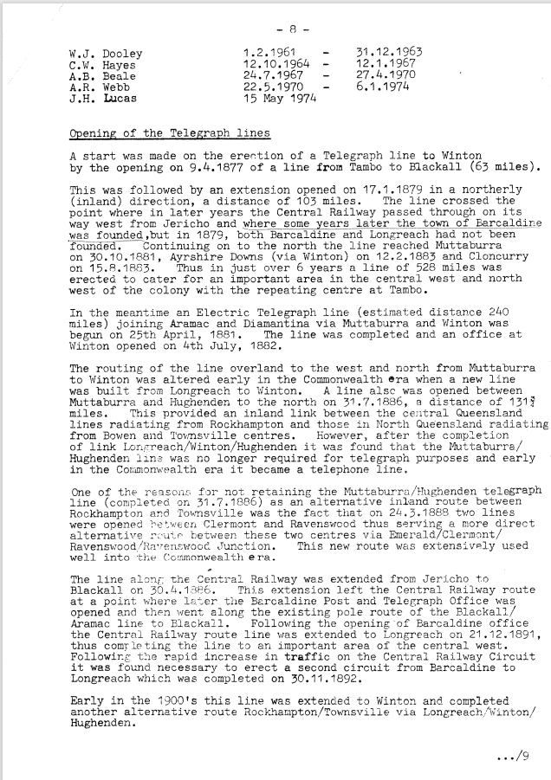

9515.9
- 8 -
W.J. Dooley 1.2.1961 - 31.12.1963
C.W. Hayes 12.10.1964 - 12.1.1967
A.B. Beale 24.7.1967 - 27.4.1970
A.R. Webb 22.5.1970 - 6.1.1974
J.H. Lucas 15 May 1974

Opening of the Telegraph lines
A start was made on the erection of a Telegraph line to Winton by the opening on 9.4.1877 of a line from Tambo to Blackall (63 miles).
This was followed by an extension opened on 17.1.1879 in a northerly (inland) direction, a distance of 103 miles. The line crossed the point where in later years the Central Railway passed through on its way west from Jericho and where some years later the town of Barcaldine was founded, but in 1879, both Barcaldine and Longreach had not been founded. Continuing on to the north the line reached Muttaburra on 30.10.1881, Ayrshire Downs (via Winton) on 12.2.1883 and Cloncurry on 15.8.1883. Thus, in just over 6 years a line of 528 miles was erected to cater for an important area in the central west and north west of the colony with the repeating centre at Tambo.
In the meantime, an Electric Telegraph line (estimated distance 240 miles) joining Aramac and Diamantina via Muttaburra and Winton was begun on 25th April, 1881. The line was completed and an office at Winton opened on 4th July, 1882.
The routing of the line overland to the west and north from Muttaburra to Winton was altered early in the Commonwealth era when a new line was built from Longreach to Winton. A line also was opened between Muttaburra and Hughenden to the north on 31.7.1886, a distance of 131 miles. This provided an inland link between the central Queensland lines radiating from Rockhampton and those in North Queensland radiating from Bowen and Townsville centres. However, after the completion of link Longreach/Winton/Hughenden it was found that the Muttaburra/ Hughenden line was no longer required for telegraph purposes and early in the Commonwealth era it became a telephone line.
One of the reasons for not retaining the Muttaburra/Hughenden telegraph line (completed. on 31.7.1886) as an alternative inland route between. Rockhampton and Townsville was the fact that on 24.3.1888 two lines were opened between Clermont and Ravenswood thus serving a more direct alternative route between these two centres via Emerald/Clermont/ Ravenswood/Ravenswood Junction. This new route was extensively used well into the Commonwealth era.
The line along the Central Railway was extended from Jericho to Blackall on 30.4.1886. This extension left the Central Railway route at a point where later the Barcaldine Post and Telegraph Office was opened and then went along the existing pole route of the Blackall/ Aramac line to Blackall. Following the opening-of Barcaldine office the Central Railway route line was extended to Longreach on 21.12.1891, thus come feting the line to an important area of the central west. Following the rapid increase in traffic on the Central. Railway Circuit it was found necessary to erect a second circuit from Barcaldine to Longreach which was completed on 30.11.1892.
Early in the 1900's this line was extended to Winton and completed another alternative route Rockhampton/Townsville via Longreach/Winton/ Hughenden.
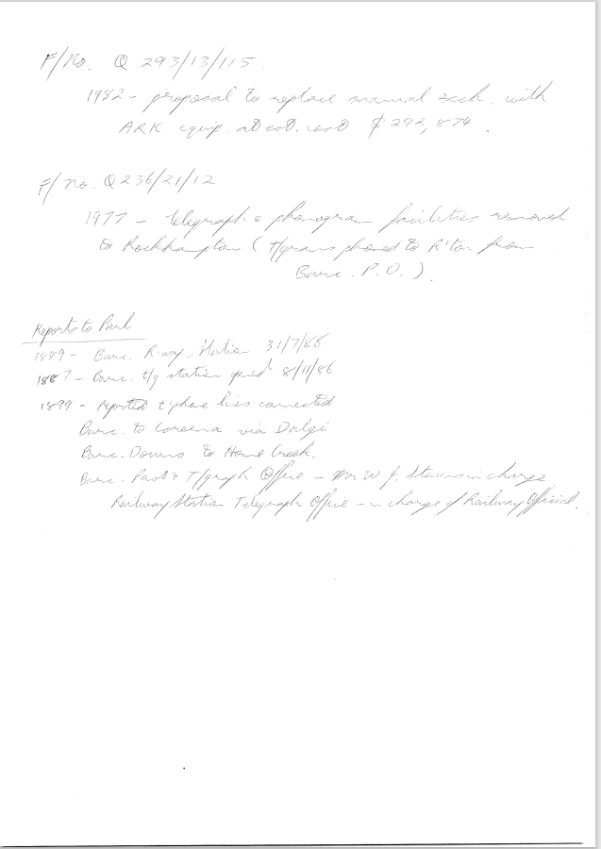

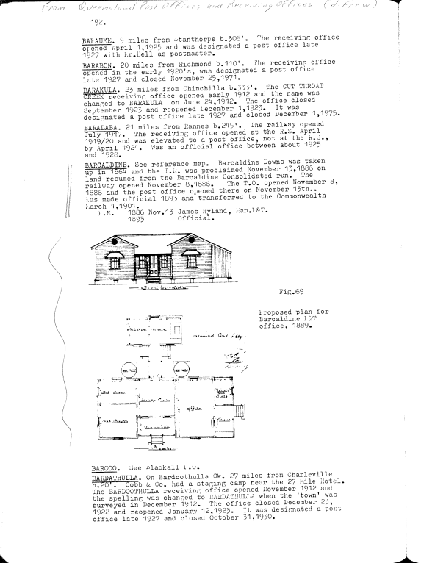

9515.10
Hand written note.
F/No Q293/13/115
1982 – proposal to replace manual exch with ARK equip at est cost $292,874.
F/No Q236/21/12
1977- telegraph and phonogram facilities removed to Rockhampton (t/grams phoned to R’ton from Barc. P.O.)
Reports to Parl
1889 - Barc R’way Station 31/7/88
1887 – Barc. t/g station opened 8/11/86
1899- Reported t’phone lines connected
Barc to Coreena via Dalgi
Barc Downs to Home Creek
Barc Post& T/graph Office – Mr W J Stevens in charge
Railway Station Telegraph Office- in charge of Railway Official.
Parl = Parliament
F/No = File Number
R’ton = Rockhampton

Paragraph from Queensland Post Offices and Receiving Offices (J Frew)
BARCALDINE. See reference map. Barcaldine Downs was taken up in 1864 and the T.R. was proclaimed November 13,1886 on land resumed from the Barcaldine Consolidated run. The railway opened November 8,1886. The T.O. opened November 8, 1886 and the post office opened there on November 13th was made official 1893 and transferred to the Commonwealth March 1,1901.
P.M. 1886 Nov.15 James Hyland, Man.P&T.
1893 Official.

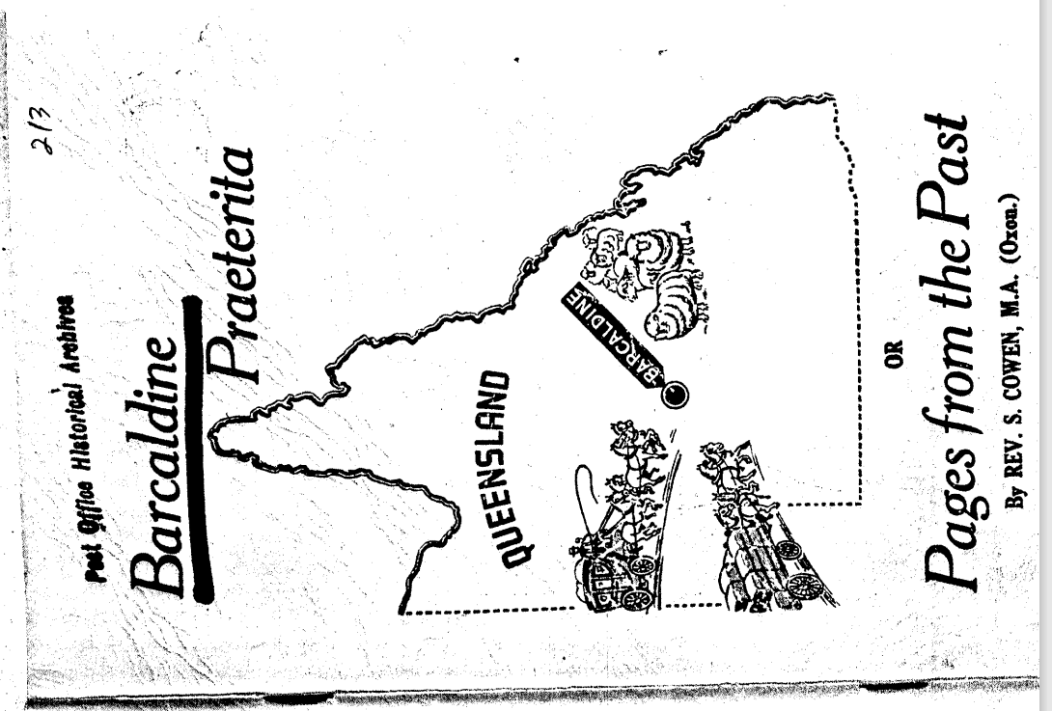
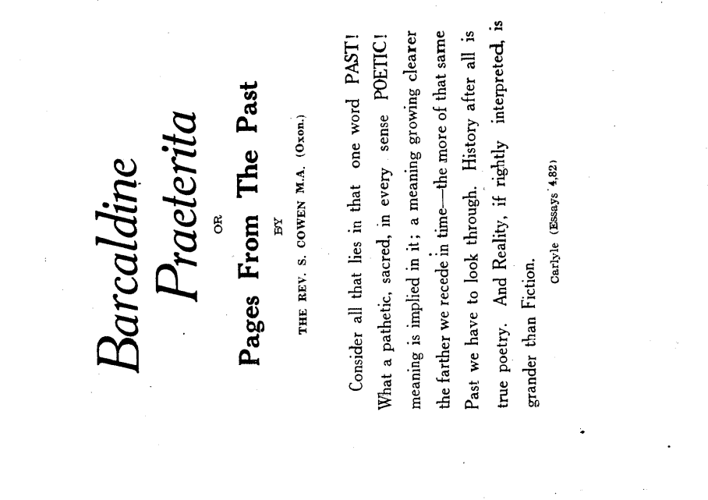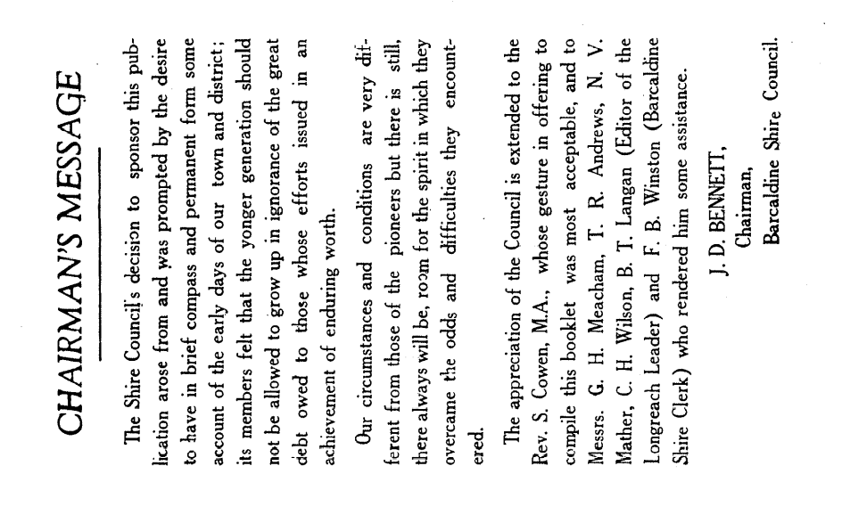

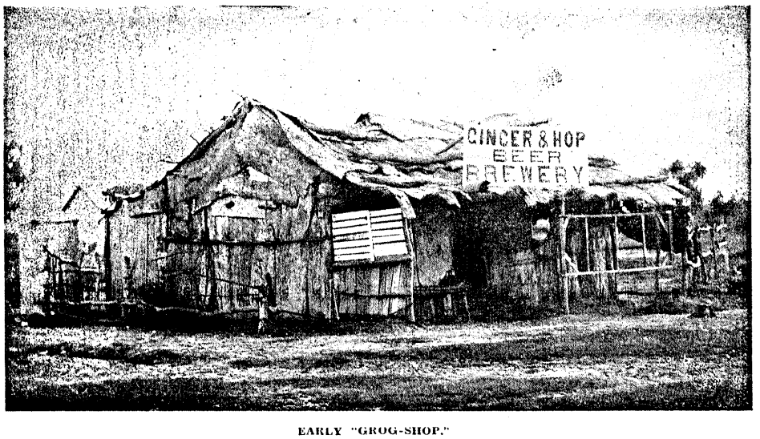
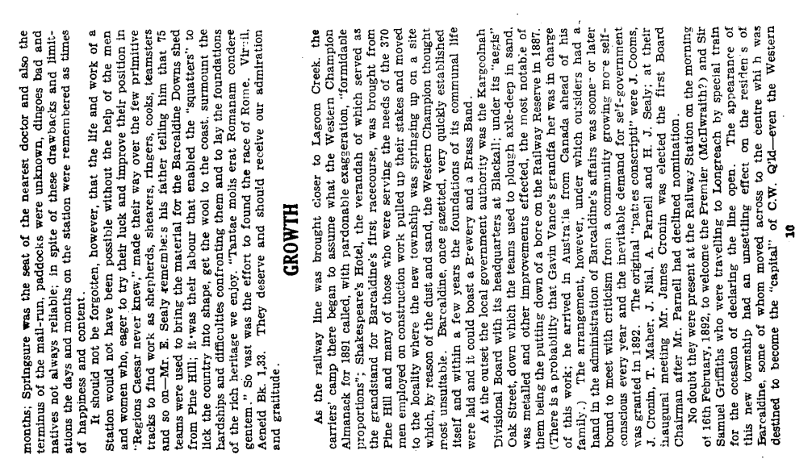
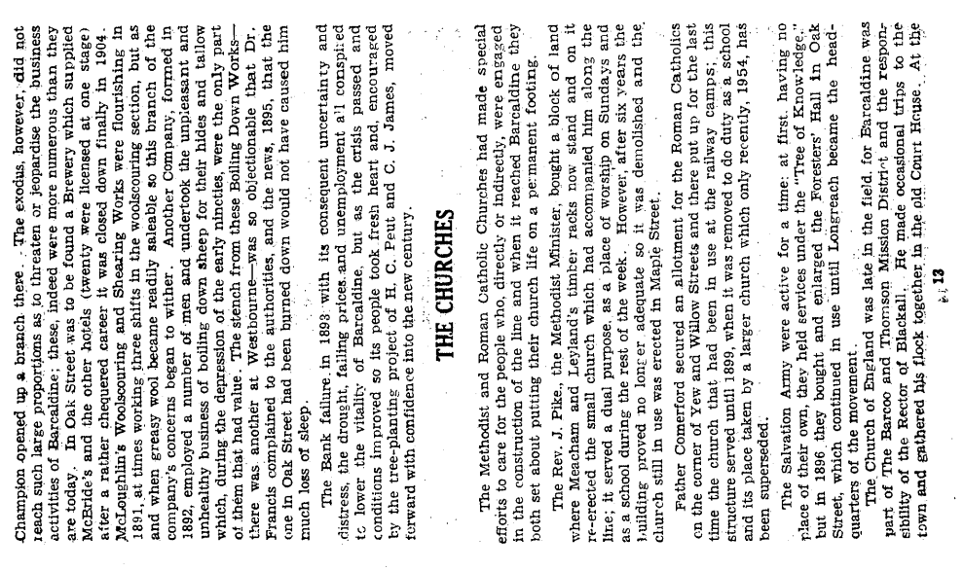

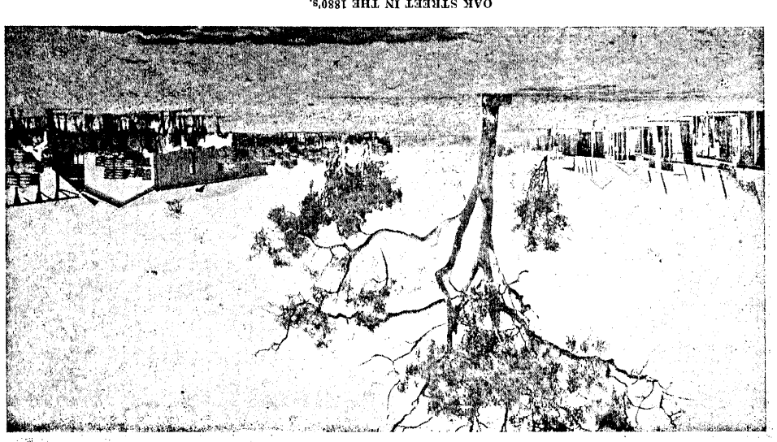
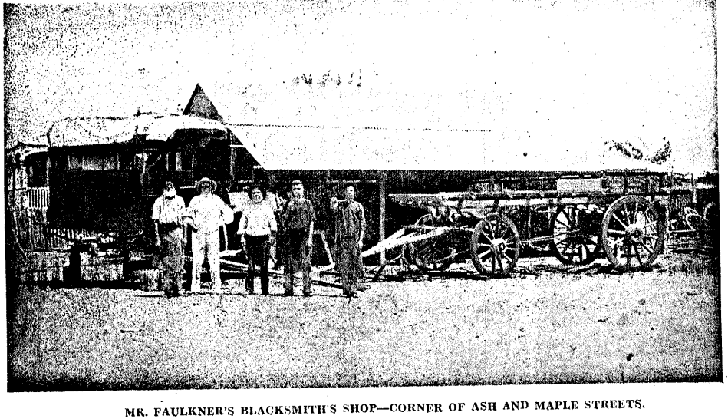

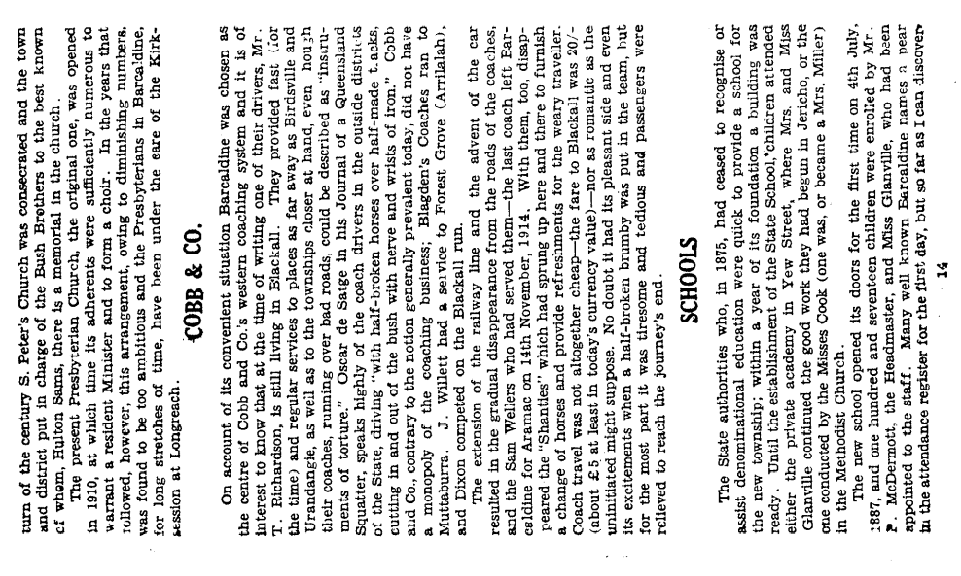
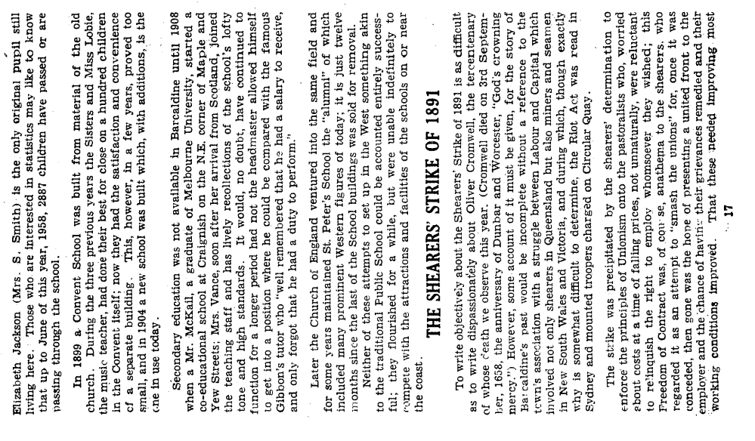
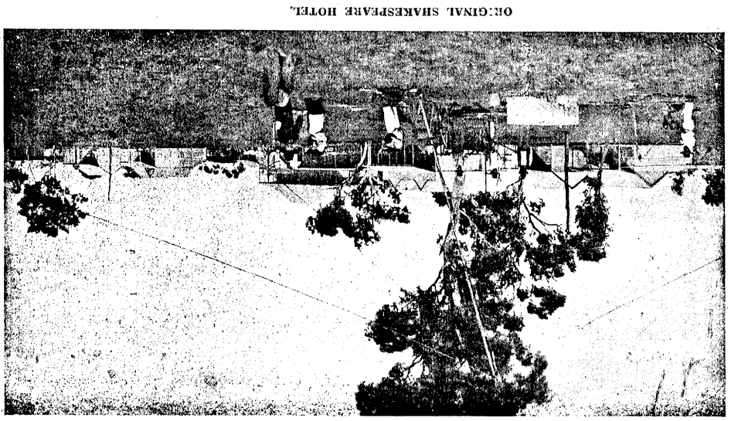

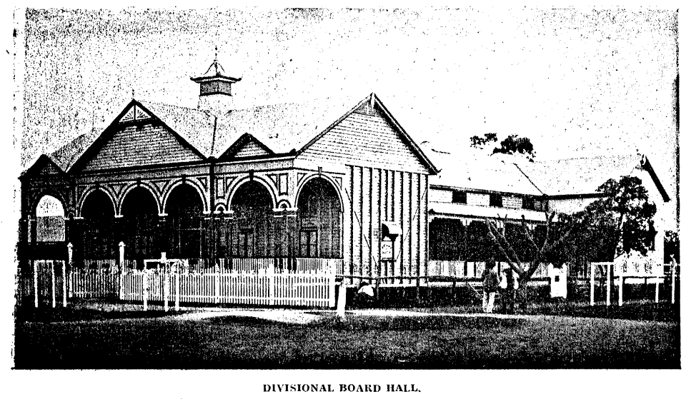

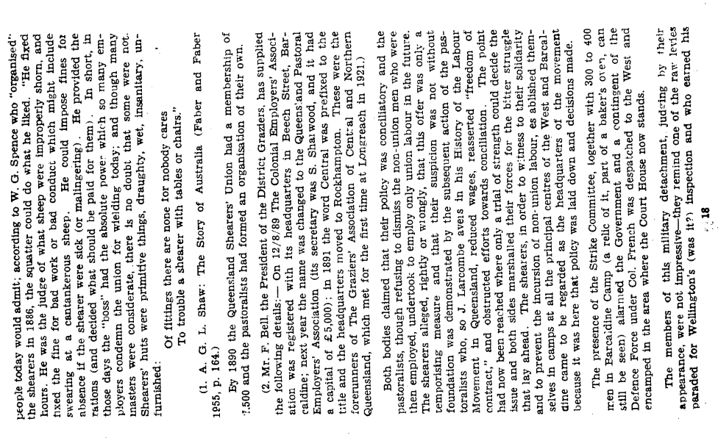
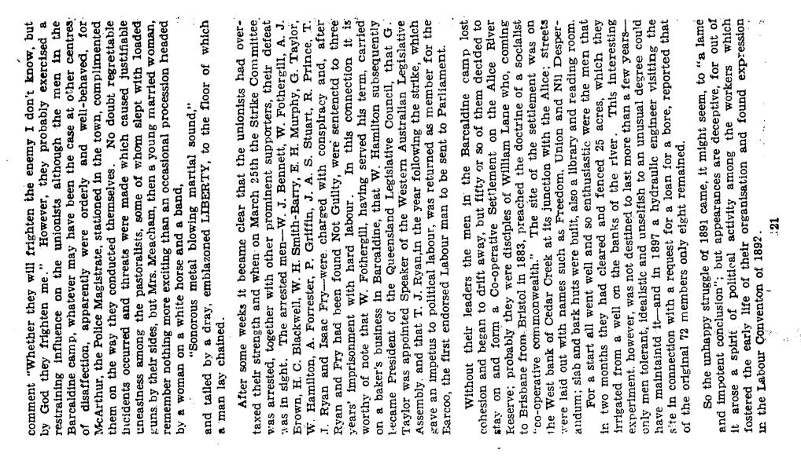

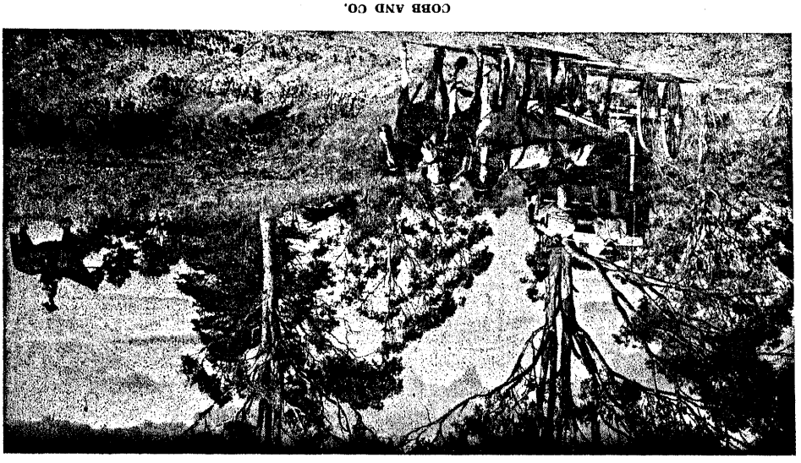

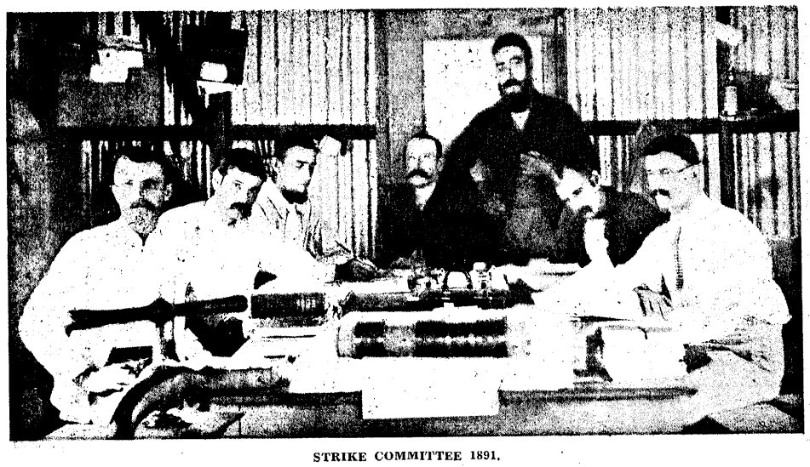
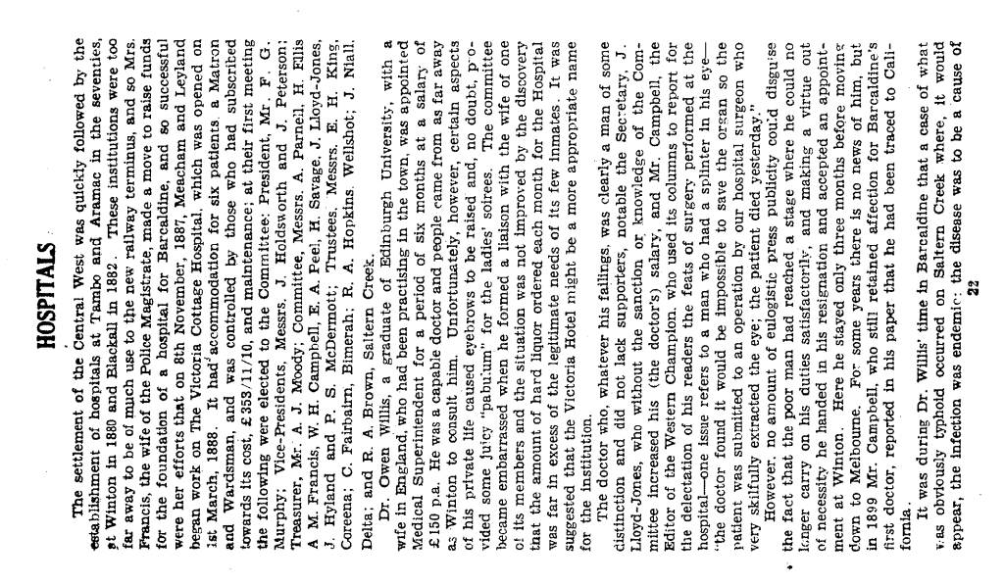
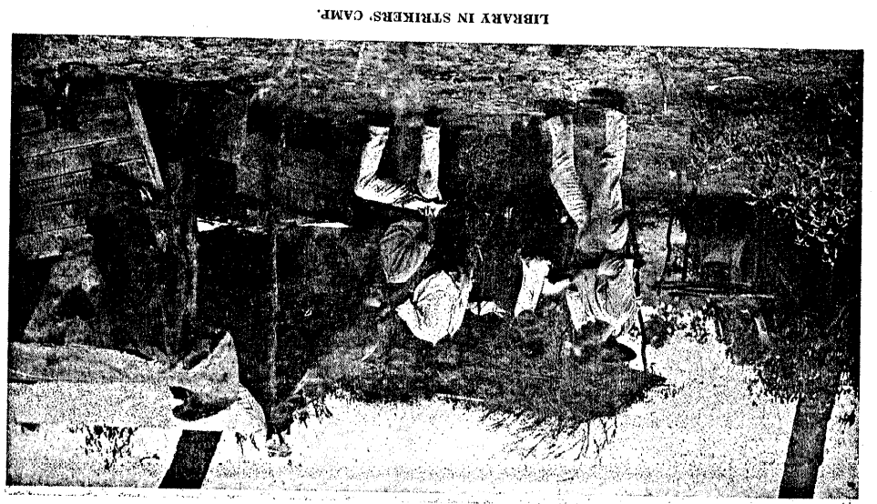

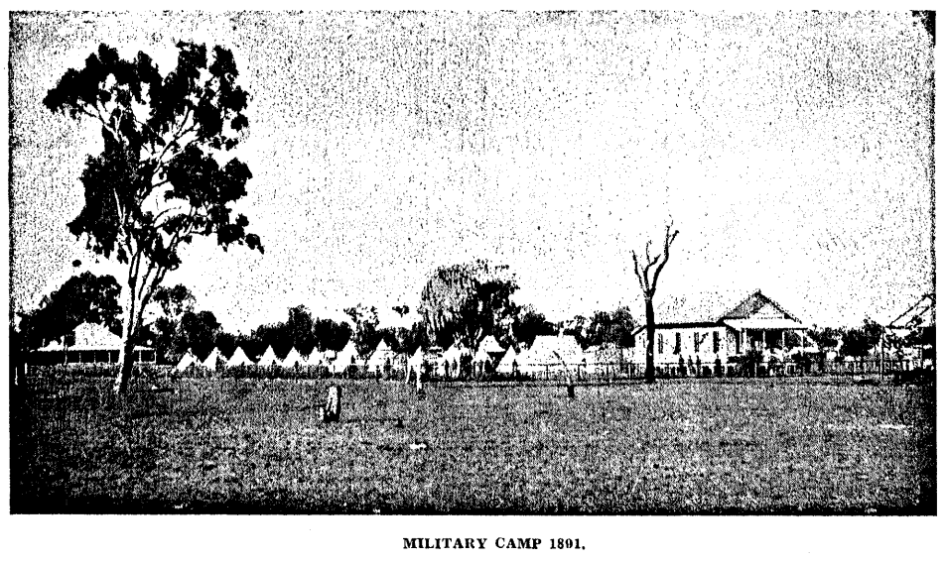
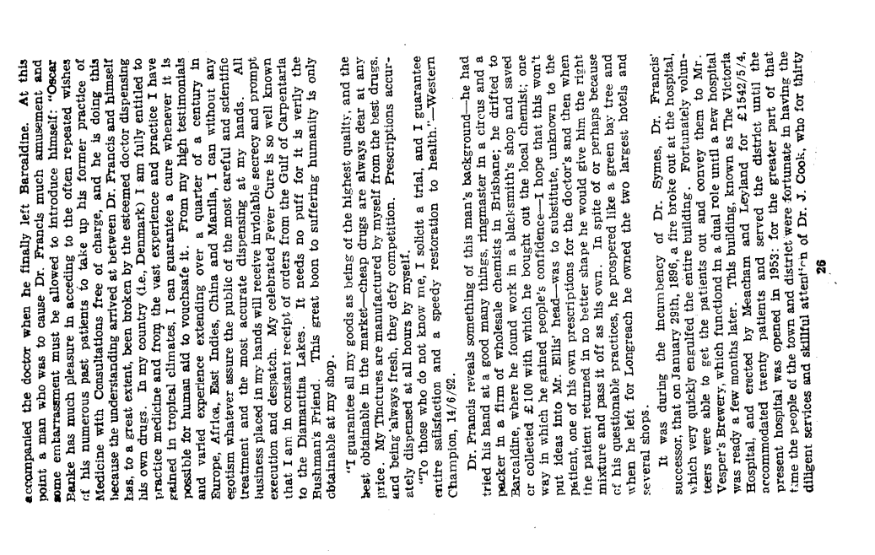
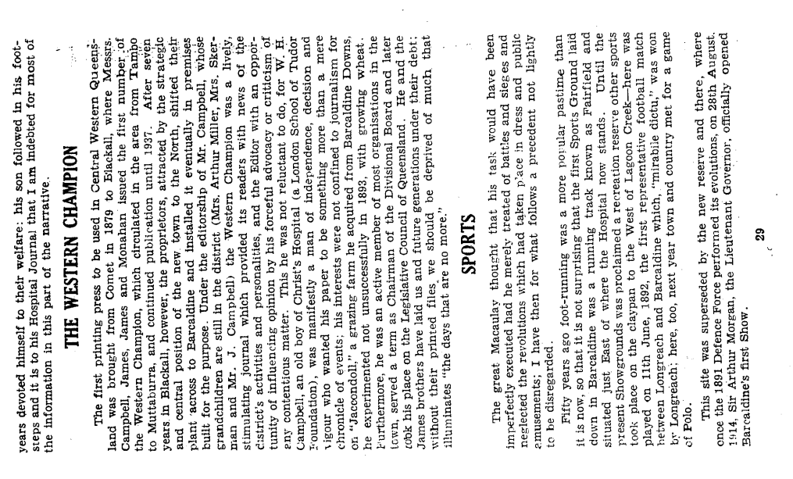
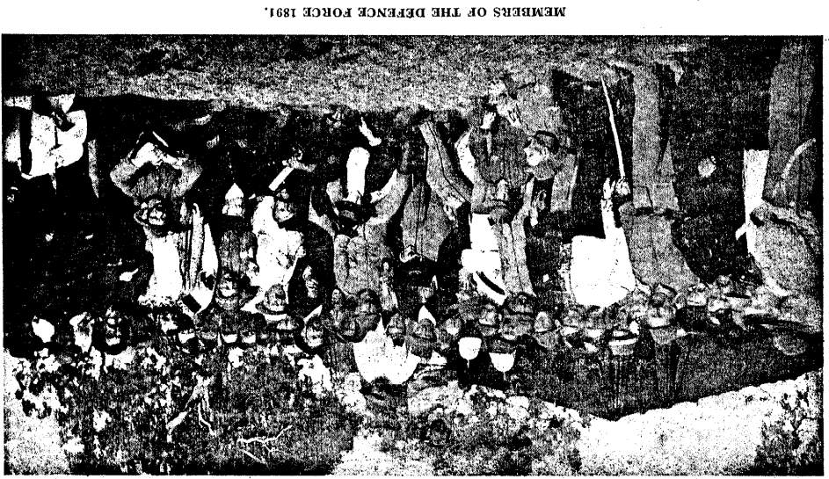

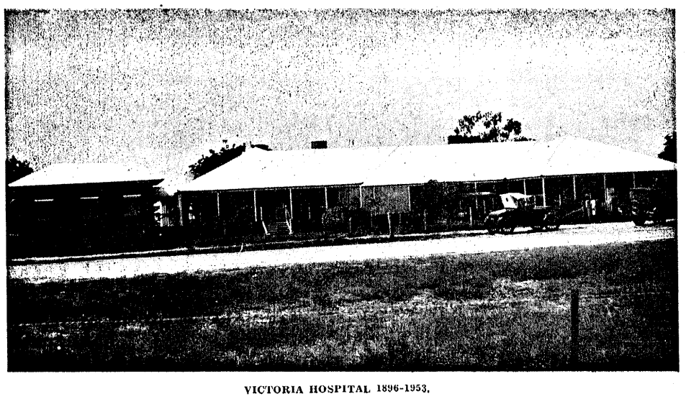
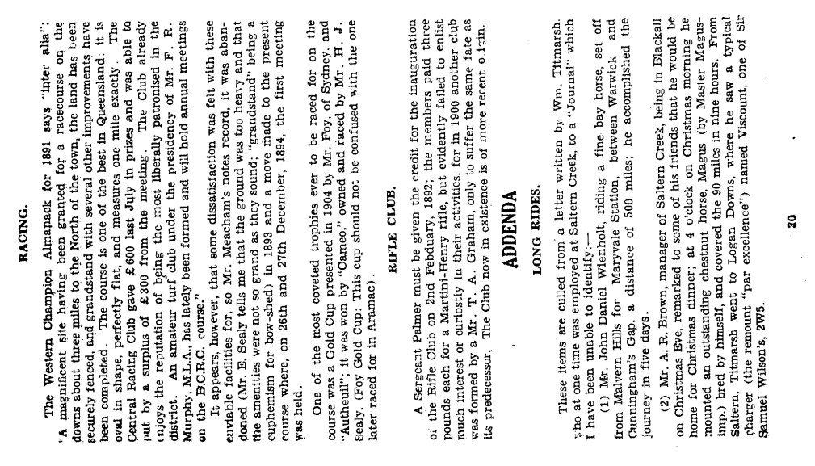
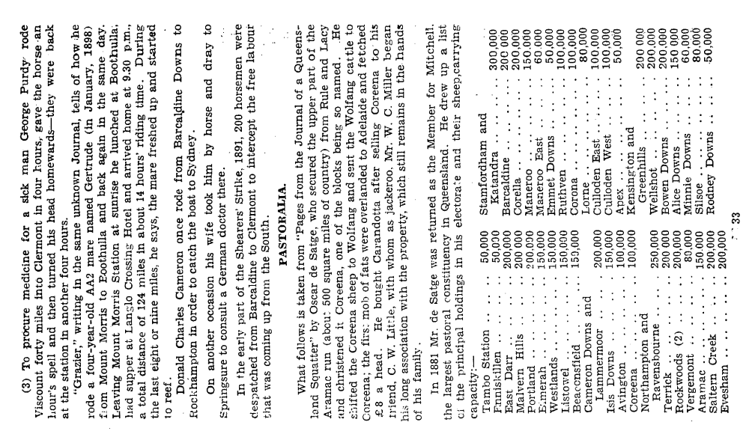

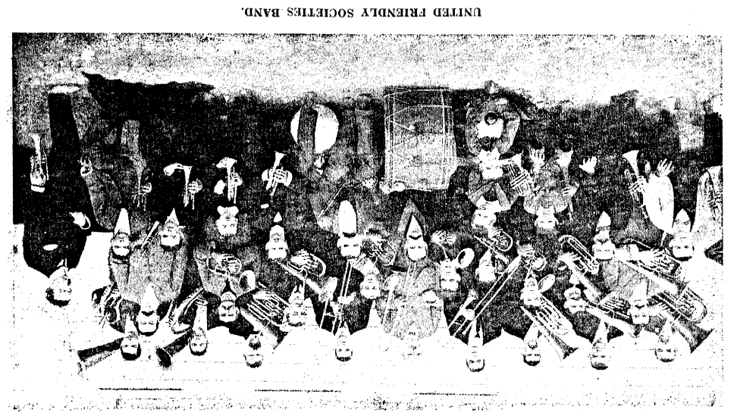
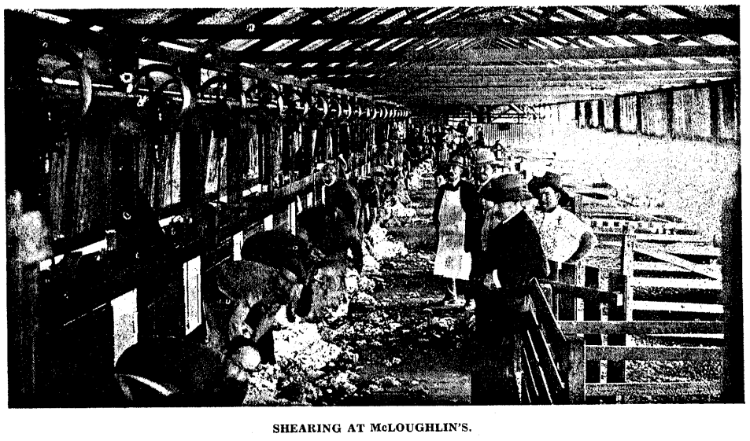
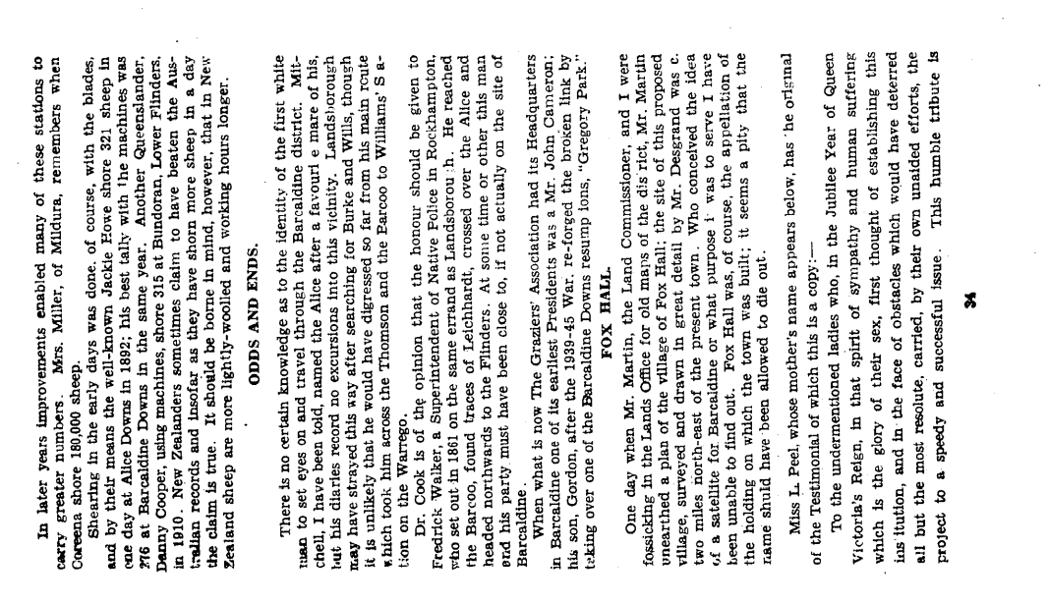
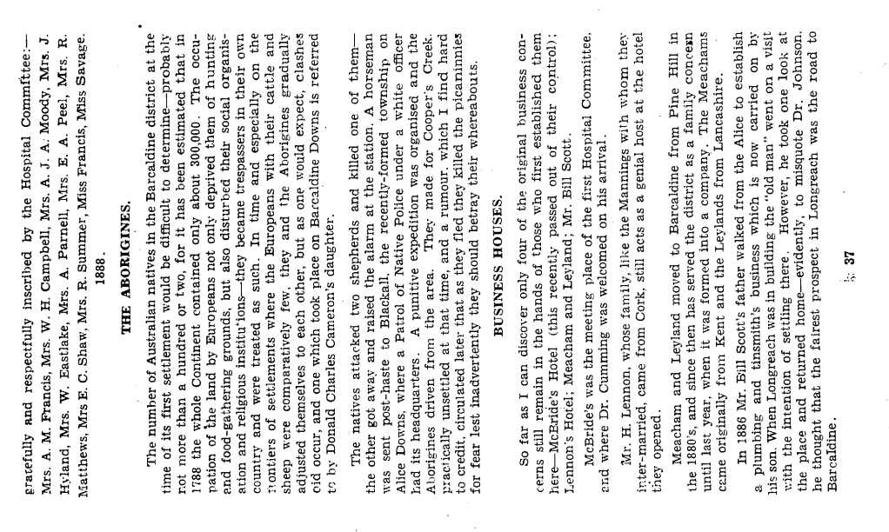
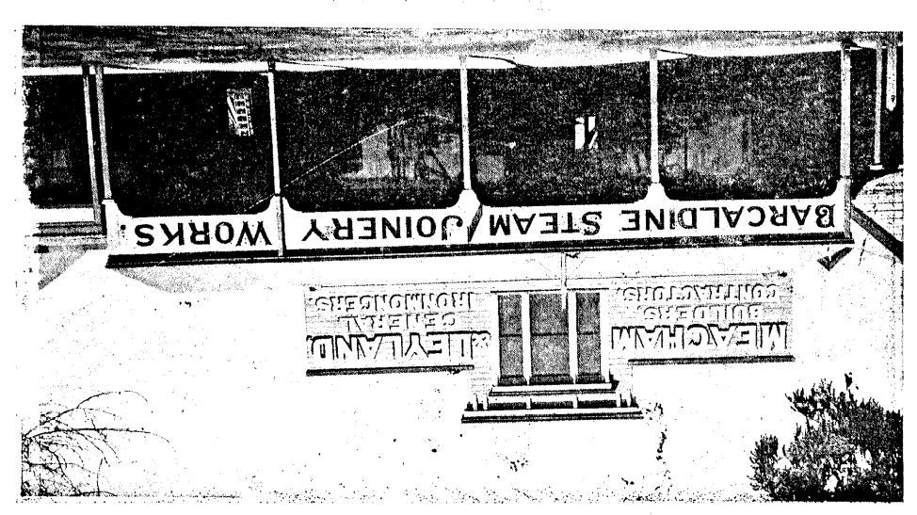

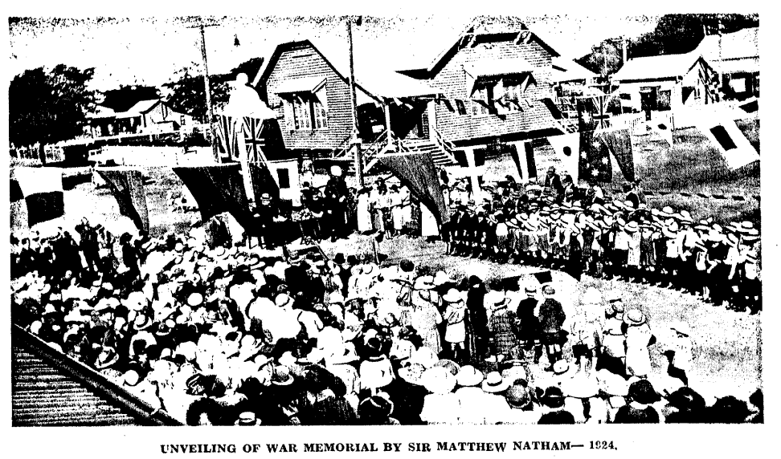

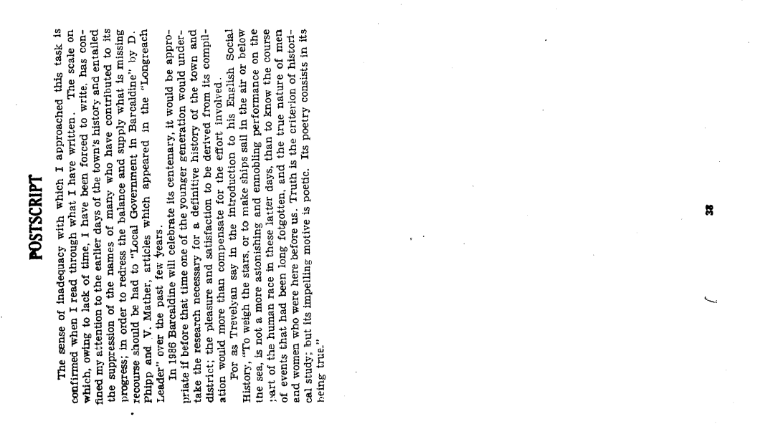
Barcaldine
Praeterita
OR
Pages From The Past
BY
THE REV. S. COWEN M.A. (Oxon.)
Consider all that lies in that one-word PAST! What a pathetic, sacred, in every sense POETIC! meaning is implied in it; a meaning growing clearer the farther we recede in time—the more of that same Past we have to look through. History after all is true poetry. And Reality, if rightly interpreted, is grander than Fiction.
Carlyle (Essays 4,82)

CHAIRMAN'S MESSAGE
The Shire Councils decision to sponsor this publication arose from and was prompted by the desire to have in brief compass and permanent form some account of the early days of our town and district its members felt that the younger generation should not be allowed to grow up in ignorance of the great debt owed to those whose efforts issued in an achievement of enduring worth.
Our circumstances and conditions are very different from those of the pioneers but there is still, there always will be, morn for the spirit in which they overcame the odds and difficulties they encountered.
The appreciation of the Council is extended to the Rev. S. Cowen, M.A., whose gesture in offering to compile this booklet was most acceptable, and to Messrs. G. H. Meacham, T. H. Andrews, N. V. Mather, C. H. Wilson, B. T. Langan (Editor of the Longreach Leader) and F. B. Winston (Barcaldine Shire Clerk) who rendered him some assistance.
J. D. BENNETT,
Chairman,
Barcaldine Shire Council.
months; Springsure was the seat of the nearest doctor and also the terminus of the mail-run, paddocks were unknown, dingoes bad and natives not always reliable; in spite of these drawbacks and limitations the days and months on the station were remembered as times of happiness and content.
It should not be forgotten, however, that the life and work of a Station would not have been possible without the help of the men and women who, eager to try their luck and improve their position in -Regions Caesar never knew," made their way over the few primitive tracks to find work as shepherds, shearers, ringers, cooks, teamsters and so on—Mr. E. Sealy remembers his father telling him that 75 teams were used to bring the material for the Barcaldine Downs shed from Pine Hill; it was their labour that enabled the "squatters" to lick the country into shape, get the wool to the coast. surmount the hardships and difficulties confronting them and to lay the foundations of the rich heritage we enjoy, "Tantae molis erat Romanam condere gentem." So vast was the effort to found the race of Rome. Virgil, Aeneid Bk. 1,33. They deserve and should receive our admiration and gratitude.
GROWTH
As the railway line was brought closer to Lagoon Creek the carriers' camp there began to assume what the Western Champion Almanack for 1891 called, with pardonable exaggeration, "formidable Proportions"; Shakespeare's Hotel, the verandah of which served as the grandstand for Barcaldine's first racecourse, was brought from Pine Hill and many of those who were serving the needs of the 370 men employed on construction work pulled up their stakes and moved to the locality where the new township was springing up on a site which, by reason of the dust and sand, the Western Champion thought most unsuitable. Barcaldine, once gazetted, very quickly established itself and within a few years the foundations of its communal life were laid and it could boast a Brewery and a Brass Band.
At the outset the local government authority was the Kargoolnah Divisional Board with its headquarters at Blackall; under its "aegis" Oak Street, down which the teams used to plough axle-deep in sand, was metalled and other improvements effected, the most notable of them being the putting down of a bore on the Railway Reserve in 1887. (There is a probability that Gavin Vance's grandfather was in charge of this work; he arrived in Australia from Canada ahead of his family.) The arrangement, however, under which outsiders had a hand in the administration of Barcaldine's affairs was scone or later bound to meet with criticism from a community growing more self-conscious every year and the inevitable demand for seq-government was granted in 1892. The original "patres conscripti" were J. Coon's, J. Cronin, T. Maher, J. Nial, A. Parnell and H. J. Sealy; at their inaugural meeting Mr. James Cronin was elected the first Board Chairman after Mr. Parnell had declined nomination.
No doubt they were present at the Railway Station on the morning of 16th February, 1892, to welcome the Premier (Mcilwraith?) and Sir Samuel Griffiths who were travelling to Longreach by special train for the occasion of declaring the line open. The appearance of this new township had an unsettling effect on the residents of Barcaldine, some of whom moved across to the centre which was destined to become the "capital" of C.W. Q'Id—even the Western Champion opened up a branch there. The exodus, however, did not /each such large proportions as to threaten or jeopardise the business activities of Barcaldine; these, indeed were more numerous than they are today. In Oak Street was to be found a Brewery which supplied McBride's and the other hotels (twenty were licensed at one stage) after a rather chequered career it was closed down finally in 1904. McLoughlin's Woolscouring and Shearing Works were flourishing in 1891, at times working three shifts in the woolscouring section, but as and when greasy wool became readily saleable so this branch of the company's concerns began to wither. Another Company, formed in 1892 employed a number of men and undertook the unpleasant and unhealthy business of boiling down sheep for their hides and tallow which, during the depression of the early nineties, were the only part of them that had value. The stench from these Boiling Down Works—there was another at Westbourne— was so objectionable that Dr. Francis complained to the authorities, and the news, 1895, that the one in Oak Street had been burned down would not have caused him much loss of sleep.
The Bank failure, in 1893 with its consequent uncertainty and distress, the drought, failing prices and unemployment all conspired to lower the vitality of Barcaldine, but as the crisis passed and conditions improved so its people took fresh heart and, encouraged by the tree-planting project of H. C. Pent and C. J. James, moved forward with confidence into the new century.
CHURCHES
The Methodist and Roman Catholic Churches had made special efforts to care for the people who, directly or indirectly, were engaged in the construction of the line and when it reached Barcaldine, they both set about putting their church life on a permanent footing.
The Rev. J. Pike., the Methodist Minister, bought a block of land where Meacham and Leyland's timber racks now stand and on it re-erected the small church which had accompanied him along the line; it served a dual purpose, as a place of worship on Sundays and as a school during the rest of the week. However, after six years the Minding proved no lone er adequate so it was demolished and the, church still in use was erected in Maple Street.
Father Comerford secured an allotment for the Roman Catholics on the corner of Yew and Willow Streets and there put up for the last time the church that had been in use at the railway camps: this structure served until 1899, when it was removed to do duty as a school and its place taken by a larger church which only recently, 1954, has been superseded.
The Salvation Army were active for a time: at first, having no place of their own, they held services under the "Tree of Knowledge." but in 1898. they bought and enlarged the Foresters' Hall in. Oak Street, which continued in use until Longreach became the head-quarters of the movement.
The Church of England was late in the field, for Barcaldine was part. of The Barcoo and Thomson Mission District and the reasonability of the Rector of Blackall. He made occasional trips to the town and gathered his flock together in the old Court House. At the turn of the century S. Peter's Church was consecrated and the town and district put in charge of the Bush Brothers to the best known of whom, Hulton Sams, there is a memorial in the church.
The present Presbyterian Church, the original one, was opened in 1910, at which time its adherents were sufficiently numerous to warrant a resident Minister and to form a choir. In the years that followed, however, this arrangement, owing to diminishing numbers, was found to be too ambitious and the Presbyterians in Barcaldine, for long stretches of time, have been under the care of the Kirk-session at Longreach.
COBB & CO.
On account of its convenient situation Barcaldine was chosen as the centre of Cobb and Co.'s western coaching system and it is of interest to know that at the time of writing one of their drivers, Mr. T. Richardson, is still living in Blackall. They provided fast (for the time) and regular services to places as far away as Birdsville and Urandangie, as well as to the townships closer at hand, even though their coaches, running over bad roads. could be described as “instruments of torture." Oscar de Satge in his Journal of a Queensland Squatter, speaks highly of the coach drivers in the outside districts is of the State, driving "'with half-broken horses over half-made tacks, cutting in and out of the bush with nerve and wrists of iron." Cobb and Co., contrary to the notion generally prevalent today, did not have a monopoly of the coaching business; Blagden's Coaches ran to Muttaburra. J. Willett had a service to Forest Grove (Arrilalaha) and Dixon competed on the Blackall run.
The extension of the railway line and the advent of the car resulted in the gradual disappearance from the roads of the coaches, and the Sam Wellers who had served them—the last coach Left Barcaldine for Aramac on 14th November, 1914. With them, too, disappeared the "Shanties" which had sprung up here and there to furnish a change of horses and provide refreshments for the weary traveler. Coach travel was not altogether cheap—the fare to Blackall was 20/- (about £5 at least in today's currency value)—nor as romantic as the` uninitiated might suppose. No doubt it had its pleasant side and even its excitements when a half-broken brumby was put in the team, hut for the most part it was tiresome and tedious and passengers were relieved to reach the journey's end.
SCHOOLS
The State authorities who, in 1815, had ceased to recognise or assist denominational education were quick to provide a school for the new township; within a year of its foundation a building was ready, Until the establishment of the State Schoo1,4children attended either the private academy in Yew Street, where Mrs. and Miss Glanville continued the good work, they had begun in Jericho, or the one conducted by the Misses Cook (one was, or became a Mrs. Miller) In the Methodist Church.
The new school opened its doors for the first time on 4th July, 1881, and one hundred and seventeen children were enrolled by Mr. P. McDermott, the Headmaster, and Miss Glanville, who had been appointed to the staff. Many well-known Barcaldine names appear in the attendance register for the first day, but so far as I can discover Elizabeth Jackson (Mrs. S. Smith) is the only original pupil still living here. Those who are Interested in statistics may like to know that up to June of this year, 1958, 2881 children have passed or are passing through the school.
In 1899 a Convent School was built from material of the old church, During the three previous years the Sisters and Miss Lobie, the music teacher, had done their best for close on a hundred children in the Convent itself; now they had the satisfaction and convenience of a separate building. This, however, in a few years, proved too small, and in 1904 a new school was built which, with additions, is the one in use today.
Secondary education was not available in Barcaldine until 1908 when a Mr. McKail, a graduate of Melbourne University, started a co-educational school at Craignish on the N.E. corner of Maple and Yew Streets; Mrs. Vance, soon after her arrival from Scotland, joined the teaching staff and has lively recollections of the school's lofty tone and high standards. It would, no doubt, have continued to function for a longer period had not the headmaster allowed himself to get into a position where he could be compared with the famous Gibbon's tutor who "well remembered that he had a salary to receive, and only forgot that he had a duty to perform."
Later the Church of England ventured into the same field and for some years-maintained St. Peter's School the "alumni" of which included many prominent Western figures of today; it is just twelve months since the last of the school buildings was sold for removal.
Neither of these attempts to set up in the West something akin to the traditional Public School could be accounted entirely successful; they flourished for a while, but were unable indefinitely to compete with the attractions and facilities of the schools on or near the coast.
THE SHEARERS' STRIKE OF 1891
To write objectively about the Shearers' Strike of 1891 is as difficult as to write dispassionately about Oliver Cromwell. the tercentenary of whose death we observe this year. (Cromwell died on 3rd September, 1658, the anniversary of Dunbar and Worcester, "God's crowning mercy.") However, some account of it must be given, for the story of Barcaldine’s past would be incomplete without a reference to the town's association with a struggle between Labour and Capital which involved not only shearers in Queensland but also miners and seamen in New South Wales and Victoria, and during which, though exactly why is somewhat difficult to determine, the Riot Act was read in Sydney and mounted troopers charged on Circular Quay.
The strike was precipitated by the shearers' determination to enforce the principles of Unionism onto the pastoralists who, worried about costs at a time of falling prices, not unnaturally, were reluctant to relinquish the right to employ whomsoever they wished; this freedom of Contract was, of CQU' se, anathema to the shearers. who regarded it as an attempt to "smash the unions" for, once it was conceded, then gone was the hone of presenting a united front to the employer and the chance of having their grievances remedied and their working, conditions improved That these needed Improving most people today would admit; according to W. G. Spence who "organised'. the shearers in 1886, the squatter could do what he liked. "He fixed hours. He was the judge of what sheep were improperly shorn. and fixed the fine for bad work or bad conduct which might include swearing at a cantankerous sheep, He could impose fines for absence if the shearer were sick (or malingering) He provided the rations (and decided what should be paid for them) in short, in those days the "boss" had the absolute power which so many employers condemn the union for wielding today; and though many masters were considerate, there is no doubt that some were not. Shearers' huts were primitive things, draughty. wet, insanitary, Un-furnished:
Of fittings there are none for nobody cares
To trouble a shearer with tables or chairs.
- A, G. L. Shaw: The Story of Australia (Faber and Faber 195S, p. 164.)
By 1890 the Queensland Shearers' Union had a membership of 1,500 and the pastoralists had formed an organisation of their own.
(2. Mr. F. Bell. the President of the District Graziers. has supplied the following details: — On 12/8/89 The Colonial Employers' Association was registered with its headquarters in Beech Street, Barcaldine; next year the name was changed to the Queens and Pastoral Employers' Association (its secretary was S. Sharwood, and it had a capital of £5,000): in 1891 the word Central was prefixed to the title and the headquarters moved to Rockhampton. These were the forerunners of The Graziers' association of Central and Northern Queensland, which met for the first time at Longreach in 1921.)
Both bodies claimed that their policy was conciliatory and the pastoralists, though refusing to dismiss the non-union men who were then employed, undertook to employ only union labour in the future. The shearers alleged, rightly or wrongly, that this offer was only a temporising measure and that their suspicion was not without foundation was demonstrated by the subsequent action of the pastoralists who, so J. Larcombe avers in his History of the Labour Movement in Queensland, reduced wages, reasserted "freedom of contract," and obstructed efforts towards conciliation. The point had now been reached where only a trial of strength could decide the issue and both sides marshalled their forces for the bitter struggle that lay ahead. The shearers, in order to witness to their solidarity and to prevent the incursion of non-union labour, established themselves in camps at all the principal centres of the West and Barcaldine came to be regarded as the headquarters of the movement because it was here that policy was laid down and decisions made.
The presence of the Strike Committee, together with 300 to 400 men In Barcaldine Camp (a relic of it, part of a baker's ores, can still be seen) alarmed the Government and a contingent of the Defence Force under Col. French was despatched to the West and encamped in the area where the Court House now stands.
The members of this military detachment, judging by their appearance, were not impressive—they remind one of the raw levies Paraded for Wellington's (was it?) inspection and who earned his comment "Whether they will frighten the enemy I don't know, but by God they frighten me." However, they probably exercised a restraining influence on the unionists although the men in the Barcaldine camp, whatever may have been the case at other centres of disaffection, apparently were orderly and well-behaved, for McArthur, the Police Magistrate, stationed in the town, complimented them on the way they conducted themselves. No doubt regrettable incidents occurred and threats were made which caused Justifiable uneasiness among the pastoralists, some of whom slept with loaded guns by their sides, but Mrs. Meacham, then a young married woman, remember nothing more exciting than an occasional procession headed by a woman on a white horse and a band,
"Sonorous metal blowing martial sound,"
and tailed by a dray, emblazoned LIBERTY, to the floor of which a man lay chained.
After some weeks it became clear that the unionists had over-taxed their strength and when on March 25th the Strike Committee. was arrested, together with other prominent supporters, their defeat e as in sight. The arrested men—W. J. Bennett, W. FothergiII, A. J. Brown, H. C. Blackwell, W. H. Smith-Barry, E. H. Murphy, G. Taylor, W. Hamilton, A. Forrester, P. Griffin, J. A. S. Stuart, R. Prince, T. J, Ryan and Isaac Fry—were charged with conspiracy and, after Ryan and Fry had been found Not Guilty, were: sentenced to three years' imprisonment with hard labour. In this connection it is worthy of note that W. Fothergill, having served his term, carried' on a baker's business in Barcaldine, that W. Hamilton subsequently Became President of the Queensland Legislative Council, that G Taylor was appointed Speaker of the Western Australian Legislative Assembly. and that T, J. Ryan in the year following the strike, which gave an impetus to political labour, was returned as member for the Barcoo, the first endorsed Labour man to be sent to Parliament.
Without their leaders the men in: the Barcaldine camp lost cohesion and began to drift away, but fifty or so of them decided to stay on and form a Co-operative Settlement on the Alice River Reserve; probably they were disciples of William Lane who, coming' to Brisbane from- Bristol in 1883, preached the doctrine of a socialist '-co-operative commonwealth." The site of the settlement was on the West bank of Cedar Creek at its junction with the Alice; streets were laid out with names such as Freedom, Union and Nil Desperandum; slab and bark huts were built, also a library and reading room.
For a start all went well and so enthusiastic were the men that in two months they had cleared and fenced 25 acres, which they irrigated from a well on the banks of the river. This interesting experiment, however, was not destined to last more than a few years—only men tolerant, idealistic and unselfish to an unusual degree could have maintained it—and in 1897 a hydraulic engineer visiting the site in connection with a request for a loan for a bore, reported that of the original 72 members only eight remained.
So, the unhappy struggle of 1891 came, it might seem, to "a Iame and impotent conclusion"; but appearances are deceptive, for out of it, arose a spirit of political activity among the workers which fostered the early life of their organisation and found expression in the Labour Convention of 1892.
HOSPITALS -
The settlement of the Central West was quickly followed by the establishment of hospitals at Tambo and Aramac in the seventies, et Winton in 1880 and Blackall in 1882. These institutions were too far away to be of much use to the new railway terminus, and so Mrs. Francis, the wife of the Police Magistrate, made a move to raise funds for the foundation of a hospital for Barcaldine, and so successful were her efforts that on 8th November, 1887, Meacham and Leyland began work on The Victoria Cottage Hospital. which was opened on 1st March, 1888. It had accommodation for six patients, a Matron and Wardsman, and was controlled by those who had subscribed towards its cost, £353/11/10, and maintenance; at their first meeting the following were elected to the Committee: President, Mr. F. G. Murphy; Vice-Presidents, Messrs. J. Holdsworth and J. Peterson; Treasurer, Ms. A. J. Moody; Committee, Messrs. A. Parnell, H. Ellis, A M. Francis, W. H. Campbell, E. A. Peel, H. Savage, J. Lloyd-Jones, J. Hyland and P. S. McDermott; Trustees. Messrs. E. H. King. Coreena; C. Fairbairn, Bimerah; R. A. Hopkins, Wellshot; J. Niall. Delta; and R. A, Brown, Saltern Creek.
Dr. Owen Willis, a graduate of Edinburgh University, with a 'ire in England, who had been practicing in the town, was appointed Medical Superintendent for a period of six months at a salary of £150 p.a. He was a capable doctor and people came from as far away as Winton to consult him. Unfortunately, however, certain aspects of his private life caused eyebrows to be raised and, no doubt, p- o-vided some juicy "pabulum" for the ladies' soirees. The committee became embarrassed when he formed a liaison with the wife of one of its members and the situation was not improved by the discovery that the amount of hard liquor ordered each month for the Hospital was far in excess of the legitimate needs of its few inmates. It was suggested that the Victoria Hotel might, be a more appropriate name for the institution.
The doctor who, whatever his failings. was clearly a man of some distinction and did not lack supporters, notable the Secretary, J Lloyd-Jones, who without the sanction or knowledge of the Committee increased his {the doctor's) salary, and Mr. Campbell, the Editor of the Western Champion. who used its columns to report for the delectation of his readers the feats of surgery performed at the hospital—one issue refers to a man who had a splinter in his eye—"the doctor found it would be impossible to save the organ so the patient was submitted to an operation by our hospital surgeon who very skillfully extracted the eye; the patient died yesterday."
However no amount of eulogistic press publicity could disguise the fact that the poor man had reached a stage where he could no longer carry on his duties satisfactorily, and making a virtue out of necessity he handed in his resignation and accepted an appointment at Winton. Here he stayed only three months before moving down to Melbourne. For some years there is no news of him, but in 1899 Mr. Campbell. who still retained affection for Barcaldine’s first doctor, reported in his paper that he had been traced to California.
It was during Dr. Willis' time In Barcaldine that a case of what v. as obviously typhoid occurred on Saltern Creek where, it would appear, the infection was endemics the disease was to be a cause of accompanied the doctor when he finally left Barcaldine. At this point a man who was to cause Dr. Francis much amusement, and some embarrassment must be allowed to introduce himself: "Oscar Banks has much pleasure in acceding to the often-repeated wishes of his numerous past patients to take up his former practice of Medicine with Consultations free of charge, and he is doing this because the understanding arrived at between Dr. Francis and himself has, to a great extent, been broken by the esteemed doctor dispensing his own drugs. In my country (i.e., Denmark) I am fully entitled to practice medicine and froz9 the vast experience and practice I have gained in tropical climates, I can guarantee a cure whenever it Is possible for human aid to vouchsafe it, From my high testimonials and varied experience extending over a quarter of a century in Europe, Africa, East Indies, China and Manila, I can without any egotism whatever assure the public of the most careful and scientific treatment and the most accurate dispensing at my hands. All business placed in my hands will receive inviolable secrecy and prompt execution and despatch. My celebrated Fever Cure is so well known that I arr. in constant receipt of orders from the Gulf of Carpentaria to the Diamantina Lakes. It needs no puff for it is verily the Bushman's Friend. This great boon to suffering humanity is only obtainable at my shop.
"I guarantee all my goods as being of the highest quality, and the best obtainable in the market—cheap drugs are always dear at any price. My Tinctures are manufactured by myself from the best drugs. and being 'always fresh, they defy competition. Prescriptions accurately dispensed at all hours by myself.
"To those who do not know me, I solicit a trial, and I guarantee entire satisfaction and a speedy restoration to health."—Western Champion, 14/6/92.
Dr. Francis reveals something of this man's background—he had tried his hand at a good many things, ringmaster in a circus and a packer in a firm of wholesale chemists in Brisbane; he drifted to Barcaldine, where he found work in a blacksmith's shop and saved or collected £ 100 with which he bought out the local chemists one way in which he gained people's confidence—I hope that this won't put ideas into Mr. Ellis' head—was to substitute, unknown to the patient, one of his own prescriptions for the doctor's and then when the patient returned in no better shape he would give him the right mixture and pass it off as his own. In spite of or perhaps because of his questionable practices, he prospered like a green bay tree and when he left for Longreach he owned the two largest hotels and several shops.
It was during the incumbency of Dr. Symes, Dr. Francis' successor, that on January 29th, 1896, a fire broke out at the hospital, which very quickly engulfed the entire building. Fortunately, volunteers were able to get the patients out and convey them to Mr. Vesper's Brewery, which functioned in a dual role until a new hospital was ready a few months later. This building, known as The Victoria Hospital, and erected by Meacham and Leyland for R1542/5/4, accommodated twenty patients and served the district until the present hospital was opened in 1953: for the greater part of that time the people of the town and district were fortunate in having the diligent services and skillful attention of Dr. J. Cook, who for thirty years devoted himself to their welfare: his son followed in his, foot-steps and it is to his Hospital Journal that I am indebted for most of the information in this part of the narrative.
THE WESTERN CHAMPION
The first printing press to be used in Central Western Queensland was brought from Comet in 1879 to Blackall, where Mesers. Campbell, James, James and Monahan issued the first number the Western Champion, which circulated in the area from Tambo to Muttaburra, and continued publication until 1937. After seven years. in Blackall, however, the proprietors, attracted by the strategic and central position of the new. town to the North, shifted their plant 'across to Barcaldine and installed it eventually in premises built for the purpose. Under the editorship of Mr. Campbell, whose grandchildren are still in the district (Mrs. Arthur Miller, Mrs. Skerman and Mr. J. Campbell) the Western Champion was a lively, stimulating journal which provided its readers with news of the district's activities and personalities, and the Editor with an opportunity of influencing opinion by his forceful advocacy or criticism of any contentious matter. This he was not reluctant to do, for W. H. Campbell, an old boy of Christ's Hospital (a London School of Tudor Foundation), was manifestly a man of independence, decision and vigour who wanted his paper to be something more than a mere chronicle of events: his interests were not confined to journalism for on `"Jaccondoll," a grazing farm he acquired from Barcaldine Downs, he experimented not unsuccessfully in 1893, with growing wheat, furthermore, he was an active member of most organisations in the town, served a term as Chairman of the Divisional Board and later took his place on the Legislative Council of Queensland. He and the James brothers have laid us and future generations under their debt; without their printed files. we should be deprived of much, that illuminates "the days that are no more."
SPORTS
The great Macaulay thought that his task would have been imperfectly executed had he merely treated of battles and sieges and neglected the revolutions which had taken place in dress and public amusements; I have then for what follows a precedent not lightly to be disregarded.
Fifty years ago foot-running was a more popular pastime than it is now, so that it is not surprising that the first Sports Ground laid down in Barcaldine was a running track known as Fairfield and situated just. East of where the Hospital now stands. Until the present Showgrounds was proclaimed a recreation reserve other sports took place on the claypan to the West of Lagoon Creek—here was played on 11th June, 1892, the first representative football match between Longreach and Barcaldine which, “mirabile dictu," was won by Longreach: here, too, next year town and country met for a game Polo.
This site was superseded by the new reserve and there, where once the 1891 Defence Force performed its evolutions, on 28th August., 1914, Sir Arthur Morgan, the Lieutenant Governor, officially opened Barcaldine's first Show
RACING.
The Western Champion Almanack for 1891 says "inter Alia"; "A magnificent site having been granted for a racecourse on the downs about three miles to the North of the town, the land has been securely fenced, and grandstand with several other improvements have been completed. The course is one of the best in Queensland: it is oval in shape, perfectly flat, and measures one mile exactly. The Central Racing Club gave £600 last July in prizes and was able to put by a surplus of £300 from the meeting. The Club already enjoys the reputation of being the most liberally patronised in the district. An amateur turf club under the presidency of Mr. F. R. Murphy, M.LA., has lately been formed and will hold annual meetings on the B.C.R.C. course."
It appears, however, that some dissatisfaction was felt with these enviable facilities for, so Mr. Meacham's notes record, it was abandoned (Mr. K Sealy tells me that the ground was too heavy and that the amenities were not so grand as they sound; "grandstand" being a euphemism for bow-shed) in 1893 and a move made to the present course where, on 26th and 27th December, 1894, the first meeting was held.
One of the most coveted trophies ever to be raced for on the course was a Gold Cup presented in 1904 by Mr. Foy. of Sydney. and "Autheuil"; it was won by "Cameo," owned and raced by Mr. H. Sealy. (Foy Gold Cup: This cup should not be confused with the one later raced far in Aramac).
RIFLE CLUB.
A Sergeant Palmer must be given the credit for the inauguration of the Rifle Club on 2nd February, 1892; the members paid three pounds each for a Martini-Henry rifle, but evidently failed to enlist much interest or curiosity in their activities. for in 1900 another club was formed by a Mr. T. A. Graham, only to suffer the same fate as its predecessor, The Club now in existence is of more recent origin
ADDENDA
LONG RIDES.
These items are culled from a letter written by Wm. Titmarsh who at one time was employed at Saltern Creek. to a "Journal" which I have been unable to identify:
(1) Mr. John Daniel Wienholt, riding a fine bay horse, set off from Malvern Hills for Mary vale Station, between Warwick and Cunningham's Gap. a distance of 500 miles; he accomplished the journey in five days,
(2) Mr. A. R. Brown, manager of Saltern Creek, being in Blackall on Christmas Eve, remarked to some of his friends that he would be home for Christmas dinner; at 4 o'clock on Christmas morning he mounted an outstanding chestnut horse, Magus (by Master Magusimp) bred by himself, and covered the 90 miles in nine hours. From Saltern, Titmarsh went to Logan Downs, where he saw a typical charger (the remount "par excellence") named Viscount, one of Sir Samuel Wilson's, 2W5.
(3) To procure medicine for a sick man George Purdy rode Viscount forty miles into Clermont in four hours, gave the horse -an hour's spell and then turned his head homewards—they were back at the station in another four hours.
"Grazier," writing in the same unknown Journal, tells of how he rode a four-year-old AA2 mare named Gertrude (in January, 1898) from Mount Morris to Boothulla and back again in the same day. Leaving Mount Morris Station at sunrise he lunched at Boothulla, had supper at Langlo Crossing Hotel and arrived home at 9.30 p.m., a total distance of 124 miles in about 14 hours' riding time. During the last eight or nine miles, he says, the mare freshed up and started to reef.
Donald Charles Cameron once rode from Barcaldine Downs to Rockhampton in order to catch the boat to Sydney.
On another occasion his wife took him by horse and dray to Springsure to consult a German doctor there.
In the early part of the Shearers' Strike, 1891, 200 horsemen were despatched from Barcaldine to Clermont to intercept the free labour that was coming up from the South.
PASTORALIA
What follows is taken from "Pages from the Journal of a Queenslasnd Squatter" by Oscar de Satge, who secured the upper part of the Aramac run (about, 500 square miles of country) from Rule and Lacy and christened it Coreena, one of the blocks being so named. He shifted the Coreena sheep to Wolfang and sent the Wolfang cattle to Coreena; the first mob of fats were overlanded to Adelaide and fetched £8 head. He bought Carandotta after selling Coreena to his friend, C. W. Little, with whom as jackeroo. Mr. W. C. Miller began his long association with the property, which still remains in the hands of his family.
In 1881 Mr. de Satge was returned as the Member for Mitchell. the largest pastoral constituency in Queensland. He drew up a list ci the principal holdings in his electorate and their sheep, carrying
capacity:—
Tambo Station | 50,000 | Stamfordham and Katandra | 300,000
Fnniskillen | 50,000 | Barcaldine | 200,000
East Darr | 200,000 | Corella | 200,000
Malvern Hills | 200,000 | Maneroo | 150,000
Portland | 200,000 | Maneroo East | 60,000
Bimerah | 150,000 | Emmet Downs | 50,000
Westlands | 150,000 | Ruthven | 100,000
Listowel | 150,000 | Corona | 100,000
Beaconsfield | 150,000 | Lorne | 80,000
Cameron Downs and Lammermoor | 200,000 | Culloden East | 100,000
Isis Downs | 150,000 | Culloden West | 100,000
Avington | 100,000 | Apex | 50,000
Coreena | 100,000 | Kensington and Greenhills | 200,000
Northampton and Ravensbourne | 250,000 | Wellshot | 200,000
Terrick | 200,000 | Bowen Downs | 200,000
Rockwoods (2) | 200,000 | Alice Downs | 150,000
Vergemont | 80,000 | Minnie Downs | 60,000
Aramac | 150,000 | Silsoe | 80,000
Saltern Creek | 200,000 | Rodney Downs | 50,000
Evesham | 200,000

In later years improvements enabled many of these stations to carry greater numbers. Mrs. Miller, of Mildura, remembers when Coreena shore 180,000 sheep.
Shearing in the early days was done, of course, with the blades, and by their means the well-known Jackie Hove shore 321 sheep in cue day at Alice Downs in 1892; his best tally with the machines was 276 at Barcaldine Downs in the same year. Another Queenslander, Danny Cooper, using machines, shore 315 at Bundoran, Lower Flinders, in 1910. New Zealanders sometimes claim to have beaten the Australian records and insofar as they have shorn more sheep in a day the claim is true. It should be borne in mind, however, that in New Zealand sheep are more lightly-woolled and working hours longer.
ODDS AND ENDS.
There is no certain knowledge as to the identity of the first 'white man to set eyes on and travel through the Barcaldine district. Mitchell, I have been told, named the Alice after a favourite mare of his, but his diaries record no excursions into this vicinity. Landsborough may have strayed this way after searching for Burke and Wills, though it is unlikely that he would have digressed so far from his main route which took him across the Thomson and the Barcoo to Williams` Station on the Warrego.
Dr. Cook is of the opinion that the honour should be given to Fredrick Walker, a Superintendent, of Native Police in Rockhampton. who set out in 1861 on the same errand as Landsborough. He reached the Barcoo, found traces of Leichhardt, crossed over the Alice and headed northwards to the Flinders. At some time or other this man and his party must have been close to, if not actually on the site of Barcaldine
When what is now The Graziers' Association had its Headquarters in Barcaldine one of its earliest Presidents was a Mr. John Cameron; his son, Gordon, after the 1939-45 War, re-forged the broken link by taking over one of the Barcaldine Downs resumptions, "Gregory Park."
FOX HALL
One day when Mr. Martin, the Land Commissioner, and I were fossicking in the Lands Office for old maps of the district, Mr. Martin unearthed a plan of the village of Fox Hall; the site of this proposed village, surveyed and drawn in great detail by Mr. Desgrand was c. two miles north-east of the present town. Who conceived the idea of a satellite for Barcaldine or what purpose it was to serve I have been unable to find out. Fox Hall was, of course, the appellation of the holding on which the town was built; it seems a pity that the name should have been allowed to die out.
Miss L. Peel, whose mother's name appears below, has ' he original of the Testimonial of which this is a copy: —
TO the undermentioned ladies who, in the Jubilee Year of Queen Victoria's Reign, in that spirit of sympathy and human suffering which is the glory of their sex, first thought of establishing this institution, and in the face of obstacles which would have deterred an but the most resolute, carried, by their own unaided efforts, the project to a speedy and successful issue. This humble tribute is gratefully and respectfully inscribed by the Hospital Committee: —Mrs. A. M. Francis, Mrs. W. H Campbell, Mrs. A. J. A. Moody, Mrs. J. Hyland, Mrs. W. Eastlake, Mrs. A. Parnell, Mrs. E. A. Peel, Mrs. R. Matthews, Mrs. E. C. Shaw, Mrs. R. Summer, Miss Francis, Miss Savage, 1888
THE ABORIGINES.
The number of Australian natives in the Barcaldine district at the time of its first settlement would be difficult to determine—probably not more than a hundred or two, for it has been estimated that in 1788 the whole Continent contained only about 300,000. The occupation of the land by Europeans not only deprived them of hunting and food-gathering grounds, but also disturbed their social organisation and religious institutions—they became trespassers in their own country and were treated as such, In time and especially on the frontiers of settlements where the Europeans with their cattle and sheep were comparatively few, they and the Aborigines gradually adjusted themselves to each other, but as one would expect, clashes did occur, and one which took place on Barcaldine Downs is referred to by Donald Charles Cameron's daughter.
The natives attacked two shepherds and killed one of them—the other got away and raised the alarm at the station. A horseman was sent post-haste to Blackall, the recently-formed township on Alice Downs, where a Patrol of Native Police under a white officer lad its headquarters. A punitive expedition was organised and the Aborigines driven from the area. They made for Cooper's Creek. practically unsettled at that time, and a rumour which I find hard to credit, circulated later that as they fled, they killed the picaninnies for fear lest inadvertently they should betray their whereabouts.
BUSINESS HOUSES.
So far as I can discover only four of the original business concerns still remain in the hands of those who first established them here—McBride's Hotel (this recently passed out of their control): Lennon's Hotel; Meacham and Leyland; Mr. Bill Scott.
McBride's was the meeting place of the first Hospital Committee. 2nd where Dr. Cumming was welcomed on his arrival, Mr. H. Lennon, whose family, like the Manning’s with whom they inter-married, came from Cork, still acts as a genial host at the hotel they opened.
Meacham and Leyland moved to Barcaldine from Pine Hill in the 1880's, and since then has served the district as a family conceal until last year, when it was formed into a company. The Meacham’s came originally from Kent and the Leyland’s from Lancashire.
In 1886 Mr. Bill Scott's father walked from the Alice to establish a plumbing and tinsmith's business which is now carried on by his son. When Longreach was in building the "old man" went on a visit with the intention of settling there. However, he took one look at the place and returned home—evidently, to misquote Dr. Johnson. be thought that the fairest prospect in Longreach was the road to Barcaldine
POSTSCRIPT
The sense of inadequacy with which I approached this task is confirmed when I read through what I have written. The scale on which, owing to lack of time, I have been forced to write, has confined my attention to the earlier days of the town's history and entailed the suppression of the names of many who have contributed to its progress; in order to redress the balance and supply what is missing recourse should be had to "Local Government in Barcaldine" by D. Phipp and V. Mather, articles which appeared in the "Longreach Leader" over the past few years.
In 1986 Barcaldine will celebrate its centenary, it would be appropriate if before that time one of the younger generation would undertake the research necessary for a definitive history of the town and district; the pleasure and satisfaction to be derived from its compilation would more than compensate for the effort involved.
For as Trevelyan say in the introduction to his English Social History, "To weigh the stars, or to make ships sail in the air or below the sea, is not a more astonishing and ennobling performance on the part of the human race in these latter days, than to know the course of events that had been long forgotten, and the true nature of men and women who were here before us. Truth is the criterion of historical study; but its impelling motive is poetic. Its poetry consists in its being- true."

