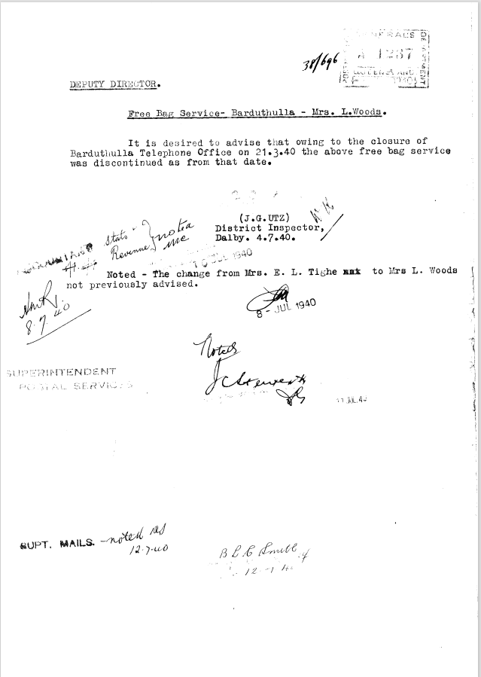

9516.1
38/696
DEPUTY DIRECTOR.
Free Bag Service- Barduthulla Mrs. L.Woods.
It is desired to advise that owing to the closure of Barduthulla Telephone Office on 21.3.40 the above free bag service was discontinued as from that date.
(JG.UTZ)
District Inspector,
Dalby. 4.7.40.
Noted - the change from Mrs. E. L. Tighe to Mrs. L. Woods not previously advised.

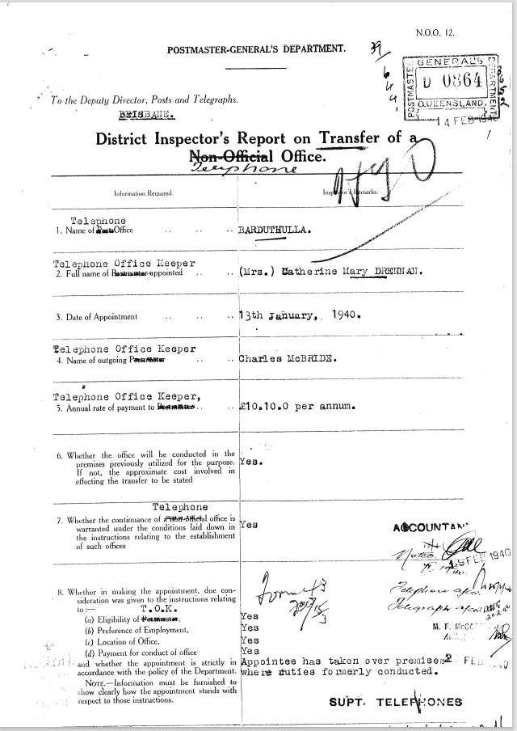

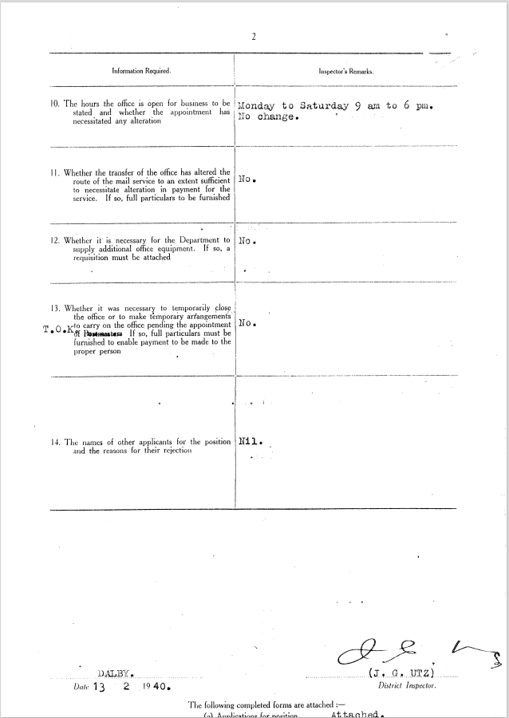

9516.2
POSTMASTER-GENERAL'S DEPARTMENT.
To the Deputy Director, Posts and Telegraphs.
BRISBANE
District Inspector's Report on Transfer of Telephone Office
- Name of Telephone Office | BARDUTHULLA
- Telephone Office Keeper  Full name appointed | (Mrs.) Katherine Mary DRENNAN
- Date of Appointment | 13th January, 1940
- Telephone Office Keeper  Name of outgoing | Charles McBride
- Telephone Office Keeper  Annual Rate of Payment | £10.10.0 per annum.
- Whether the office will he conducted in the premises previously utilized for the purpose. If not, the approximate cost involved in effecting the transfer to be stated | Yes
- Whether the continuance Telephone Office is warranted under the conditions laid down in the instructions relating to the establishment of such offices | Yes
- Whether in making the appointment, due consideration was given to the instructions relating to :—  - Eligibility of T.O.K.  - Preference of Employment,  - Location of Office,  - Payment for conduct of office  and whether the appointment is strictly in accordance with the policy of the Department.  NOTE—Information must be furnished to show clearly how the appointment stands with respect to those instructions. | Yes  Yes  Yes  Yes  Appointee has taken over premises  where duties formerly conducted.
- The facilities provided at the office | Telephone and Telegraph
- The hours the office is open for business to be stated and whether the appointment has necessitated any alteration | Monday to Saturday 9am to 6pm.  No Change
Whether the transfer of the office has altered the route of the mail service to an extent sufficient to necessitate alteration in payment for the service. If so, full particulars to be furnished | No
12. Whether it is necessary for the Department to supply additional office equipment. If so, a  requisition must be attached | No
13. Whether it was necessary to temporarily close the office or to make temporary arrangements to carry on the office pending the appointment of T.O.K If so, full particulars must be furnished to enable payment to be made to the proper person | No
14. The names of other applicants for the position and the reasons for their rejection | Nil

J.G. Utz
District Inspector.
13.2.1940
District Inspector.
The following completed forms are attached: —
- Applications for position Attached
- Acknowledgement of appointment Attached
- Declaration of Secrecy Filed at D.I.’s office
- Handing over statement – advances ---
- Handing over statement - office equipment Filed at D.I.’s office

Sch. C.1534 – 4/1936 -0717
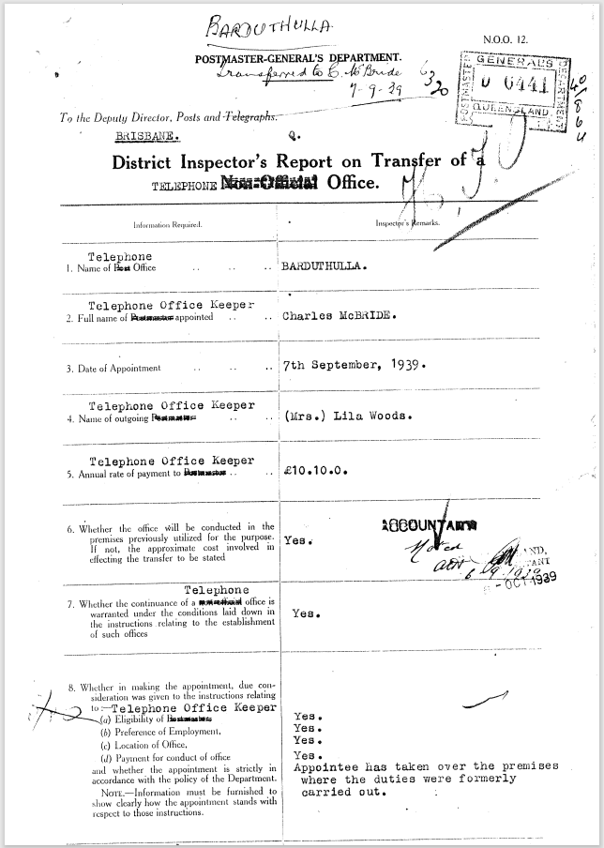
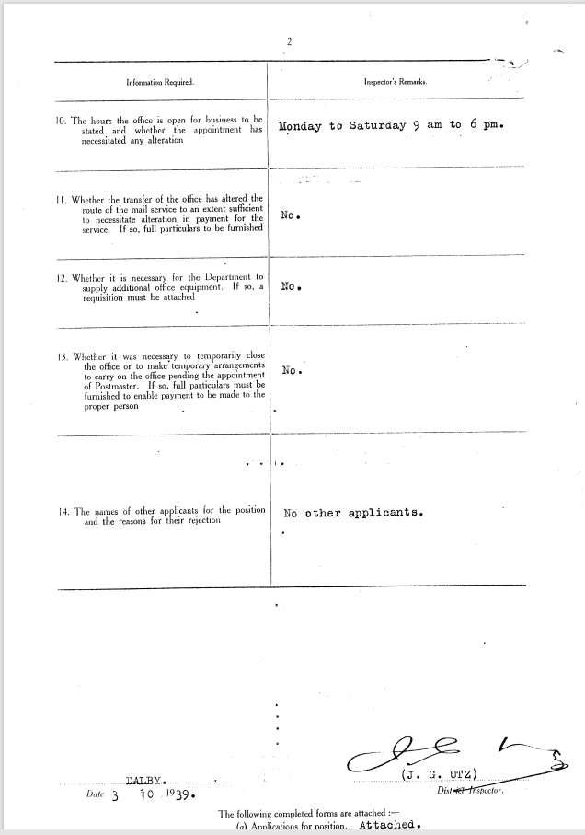

9516.3
POSTMASTER-GENERAL'S DEPARTMENT.
To the Deputy Director, Posts and Telegraphs.
BRISBANE
District Inspector's Report on Transfer of Telephone Office
- Name of Telephone Office | BARDUTHULLA
- Telephone Office Keeper  Full name appointed | Charles McBride
- Date of Appointment | 7th September, 1939
- Telephone Office Keeper  Name of outgoing | (Mrs.) Lila Woods.
- Telephone Office Keeper  Annual Rate of Payment | £10.10.0 per annum.
- Whether the office will he conducted in the premises previously utilized for the purpose. If not, the approximate cost involved in effecting the transfer to be stated | Yes
- Whether the continuance Telephone Office is warranted under the conditions laid down in the instructions relating to the establishment of such offices | Yes
- Whether in making the appointment, due consideration was given to the instructions relating to :—  - Eligibility of T.O.K.  - Preference of Employment,  - Location of Office,  - Payment for conduct of office  and whether the appointment is strictly in accordance with the policy of the Department.  NOTE—Information must be furnished to show clearly how the appointment stands with respect to those instructions. | Yes  Yes  Yes  Yes  Appointee has taken over premises  where duties formerly conducted.
- The facilities provided at the office | Telephone and Telegraph
- The hours the office is open for business to be stated and whether the appointment has necessitated any alteration | Monday to Saturday 9am to 6pm.  No Change
Whether the transfer of the office has altered the route of the mail service to an extent sufficient to necessitate alteration in payment for the service. If so, full particulars to be furnished | No
12. Whether it is necessary for the Department to supply additional office equipment. If so, a  requisition must be attached | No
13. Whether it was necessary to temporarily close the office or to make temporary arrangements to carry on the office pending the appointment of T.O.K If so, full particulars must be furnished to enable payment to be made to the proper person | No
14. The names of other applicants for the position and the reasons for their rejection | Nil

J.G. Utz
District Inspector.
3.10.1939
District Inspector.
The following completed forms are attached: —
- Applications for position Attached
- Acknowledgement of appointment Attached
- Declaration of Secrecy Filed at D.I.’s office
- Handing over statement – advances ---
- Handing over statement - office equipment Filed at D.I.’s office

Sch. C.1534 – 4/1936 -0717

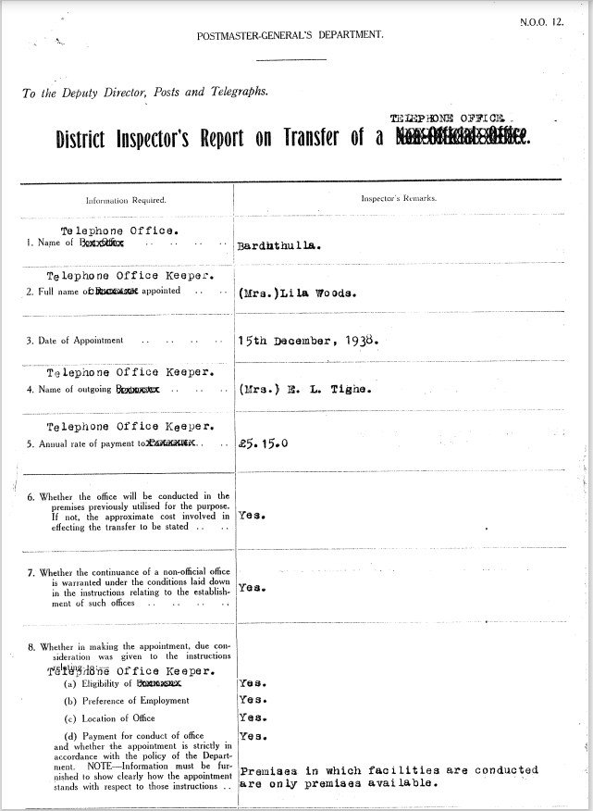

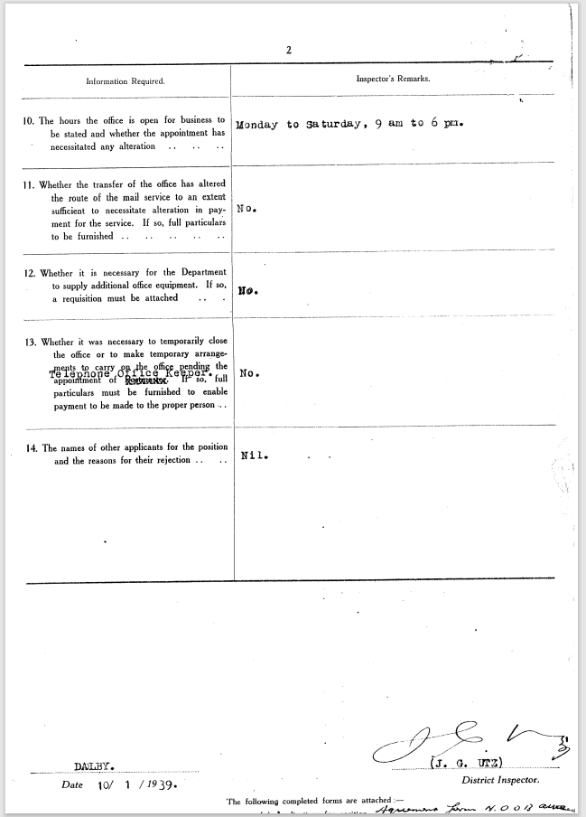

9516.4
POSTMASTER-GENERAL'S DEPARTMENT. N.O.O. 12
To the Deputy Director, Posts and Telegraphs.
BRISBANE
District Inspector's Report on Transfer of Telephone Office
- Name of Telephone Office | BARDUTHULLA
- Telephone Office Keeper  Full name appointed | (Mrs.) Lila Woods.
- Date of Appointment | 7th September, 1939
- Telephone Office Keeper  Name of outgoing | (Mrs.) E.L. Tighe
- Telephone Office Keeper  Annual Rate of Payment | £5.15.0 per annum.
- Whether the office will he conducted in the premises previously utilized for the purpose. If not, the approximate cost involved in effecting the transfer to be stated | Yes
- Whether the continuance Telephone Office is warranted under the conditions laid down in the instructions relating to the establishment of such offices | Yes
- Whether in making the appointment, due consideration was given to the instructions relating to :—  - Eligibility of T.O.K.  - Preference of Employment,  - Location of Office,  - Payment for conduct of office  and whether the appointment is strictly in accordance with the policy of the Department.  NOTE—Information must be furnished to show clearly how the appointment stands with respect to those instructions. | Yes  Yes  Yes  Yes  Premises in which facilities are conducted are only premises available.
- The facilities provided at the office | Telephone and Telegraph
- The hours the office is open for business to be stated and whether the appointment has necessitated any alteration | Monday to Saturday 9am to 6pm.  No Change
Whether the transfer of the office has altered the route of the mail service to an extent sufficient to necessitate alteration in payment for the service. If so, full particulars to be furnished | No
12. Whether it is necessary for the Department to supply additional office equipment. If so, a  requisition must be attached | No
13. Whether it was necessary to temporarily close the office or to make temporary arrangements to carry on the office pending the appointment of T.O.K If so, full particulars must be furnished to enable payment to be made to the proper person | No
14. The names of other applicants for the position and the reasons for their rejection | Nil

J.G. Utz
District Inspector.
10.1.1939
District Inspector.
The following completed forms are attached: —
- Applications for position Attached
- Acknowledgement of appointment Attached
- Declaration of Secrecy Filed at D.I.’s office
- Handing over statement – advances ---
- Handing over statement - office equipment Filed at D.I.’s office

Sch. C.1326 – 5/1936

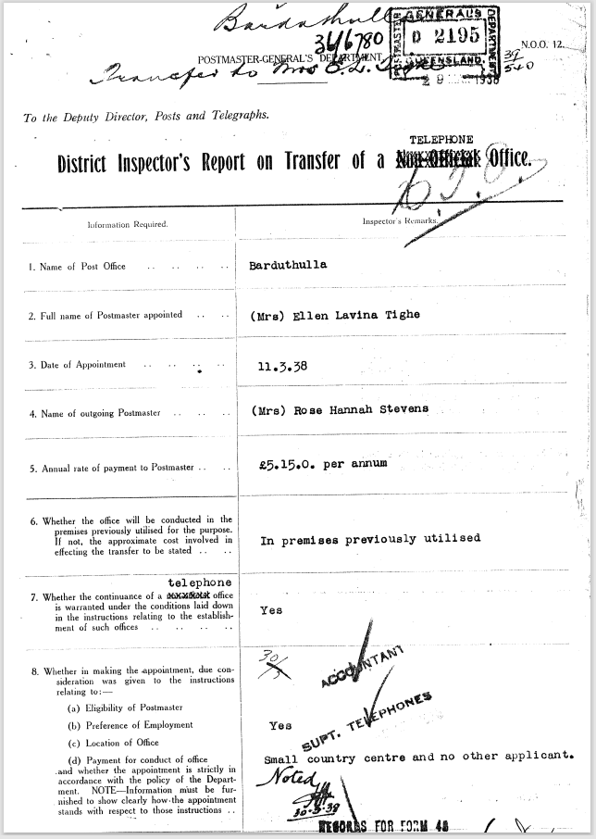

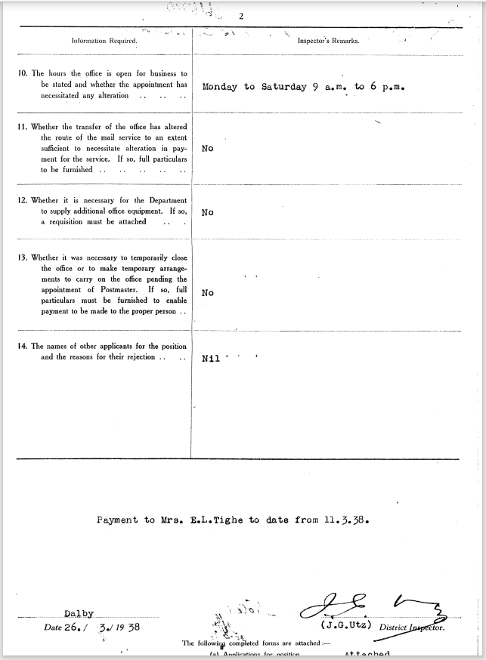

9516.5
POSTMASTER-GENERAL'S DEPARTMENT. N.O.O. 12
To the Deputy Director, Posts and Telegraphs.
BRISBANE
District Inspector's Report on Transfer of Telephone Office
- Name of Telephone Office | BARDUTHULLA
- Telephone Office Keeper  Full name appointed | (Mrs.) Ellen Lavina Tighe
- Date of Appointment | 7th September, 1939
- Telephone Office Keeper  Name of outgoing | (Mrs.) Rose Hannah Stevens
- Telephone Office Keeper  Annual Rate of Payment | £5.15.0 per annum.
- Whether the office will he conducted in the premises previously utilized for the purpose. If not, the approximate cost involved in effecting the transfer to be stated | In premises previously utilised
- Whether the continuance Telephone Office is warranted under the conditions laid down in the instructions relating to the establishment of such offices | Yes
- Whether in making the appointment, due consideration was given to the instructions relating to :—  - Eligibility of T.O.K.  - Preference of Employment,  - Location of Office,  - Payment for conduct of office  and whether the appointment is strictly in accordance with the policy of the Department.  NOTE—Information must be furnished to show clearly how the appointment stands with respect to those instructions. | Yes  Yes  Yes  Yes  Small country centre no other applicant
- The facilities provided at the office | Telephone and Telegraph
- The hours the office is open for business to be stated and whether the appointment has necessitated any alteration | Monday to Saturday 9am to 6pm.  No Change
Whether the transfer of the office has altered the route of the mail service to an extent sufficient to necessitate alteration in payment for the service. If so, full particulars to be furnished | No
12. Whether it is necessary for the Department to supply additional office equipment. If so, a  requisition must be attached | No
13. Whether it was necessary to temporarily close the office or to make temporary arrangements to carry on the office pending the appointment of T.O.K If so, full particulars must be furnished to enable payment to be made to the proper person | No
14. The names of other applicants for the position and the reasons for their rejection | Nil

Payment to Mrs. E.L. Tighe to date from 11.3.38
J.G. Utz
District Inspector.
10.1.1939
District Inspector.
The following completed forms are attached: —
- Applications for position Attached
- Acknowledgement of appointment Attached
- Declaration of Secrecy Filed
- Handing over statement – advances ---
- Handing over statement - office equipment Filed

Sch. C.1326 – 5/1935

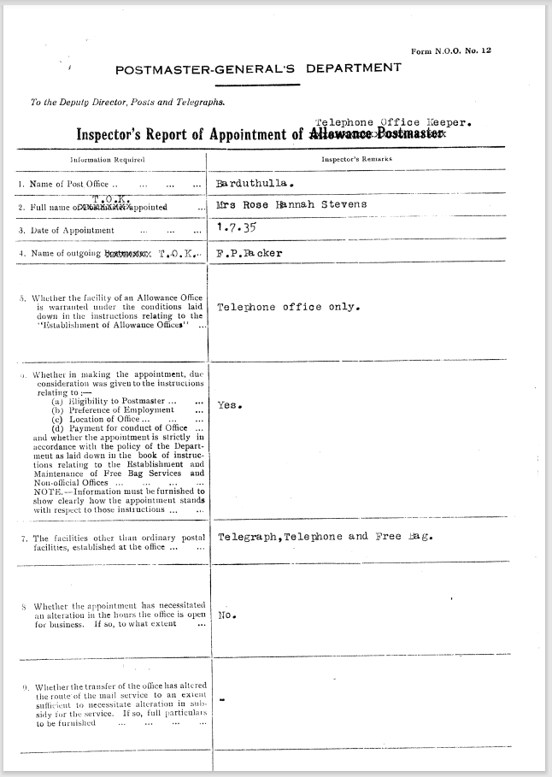

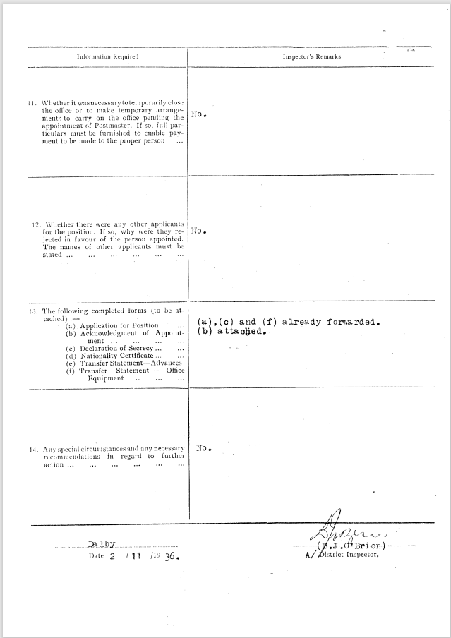

9516.6
POSTMASTER-GENERAL'S DEPARTMENT. N.O.O. 12
To the Deputy Director, Posts and Telegraphs.
BRISBANE
District Inspector's Report of Appointment of Telephone Office Keeper
Information Required | Inspector’s Remarks
- Name of Telephone Office | BARDUTHULLA
- Telephone Office Keeper  Full name appointed | (Mrs.) Rose Hannah Stevens
- Date of Appointment | 1.7.35
- Telephone Office Keeper  Name of outgoing | F. P. Packer
- Whether the facility of an Allowance Office is warranted under the conditions laid down in the instructions relating to the “Establishment of Allowance Offices” | Telephone office only
- Whether in making the appointment, due consideration was given to the instructions relating to :—  - Eligibility to Postmaster  - Preference of Employment,  - Location of Office,  - Payment for conduct of office  and whether the appointment is strictly in accordance with the policy of the Department as laid down in the book of instructions relating to the establishment and Maintenance of Free Bag Services and Non-official Offices.  NOTE—Information must be furnished to show clearly how the appointment stands with respect to those instructions. | Yes  Yes  Yes  Yes  Small country centre no other applicant
- The facilities other than ordinary postal facilities, established at the office. | Telegraph, Telephone and Free Bag.
- Whether the appointment has necessitated an alteration in the hours the office is open or business. If so, to what extent | No
- Whether the transfer of the office has altered the route of the mail service to an extent sufficient to necessitate alteration in payment for the service. If so, full particulars to be furnished | -
- Whether it is necessary for the Department to supply additional office equipment. If so, a requisition must be attached | No
- Whether it was necessary to temporarily close the office or to make temporary arrangements to carry on the office pending the appointment of Postmaster. If so, full particulars must be furnished to enable payment to be made to the proper person | No
- Whether there were any other applicants for the position. If so, why were they rejected in favour of the person appointed. The names of other applicants must be stated
- The following completed forms are attached: —  - Applications for position  - Acknowledgement of appointment  - Declaration of Secrecy  - Nationality Certificate  - Handing over statement – advances  - Handing over statement - office equipment | (a), (c) and (f) already forwarded.  (b) attached.
- Any special circumstances and any necessary recommendations in regard to further action ... | No

Payment to Mrs. E.L. Tighe to date from 11.3.38
B. J. O’Brien
A/District Inspector.
2.11.1936

9516.7
POSTMASTER-GENERAL'S DEPARTMENT. N.O.O. 12
To the Deputy Director, Posts and Telegraphs.
BRISBANE
Inspectors Report of Appointment of Allowance Postmaster.
Information Required | Inspector’s Remarks
- Name of Telephone Office | BARDUTHULLA
- Telephone Office Keeper  Full name appointed | Mr. David Joseph Hassett
- Date of Appointment | January 1st 1929
- Telephone Office Keeper  Name of outgoing | F. D. Walsh
- Whether the facility of an Allowance Office is warranted under the conditions laid down in the instructions relating to the “Establishment of Allowance Offices” | Yes
- Whether in making the appointment, due consideration was given to the instructions relating to :—  - Eligibility to Postmaster  - Preference of Employment,  - Location of Office,  - Payment for conduct of office  and whether the appointment is strictly in accordance with the policy of the Department as laid down in the book of instructions relating to the establishment and Maintenance of Free Bag Services and Non-official Offices.  NOTE—Information must be furnished to show clearly how the appointment stands with respect to those instructions. | Yes  Yes  Yes  Yes  Office conducted in same premises as previously  No other applicants.
- The facilities other than ordinary postal facilities, established at the office. | Trunkline and minor exchange
- Whether the appointment has necessitated an alteration in the hours the office is open or business. If so, to what extent | No alteration in hours
- Whether the transfer of the office has altered the route of the mail service to an extent sufficient to necessitate alteration in payment for the service. If so, full particulars to be furnished | No alteration
- Whether it is necessary for the Department to supply additional office equipment. If so, a requisition must be attached | No
- Whether it was necessary to temporarily close the office or to make temporary arrangements to carry on the office pending the appointment of Postmaster. If so, full particulars must be furnished to enable payment to be made to the proper person | No Business conducted as usual
- Whether there were any other applicants for the position. If so, why were they rejected in favour of the person appointed. The names of other applicants must be stated | No other applicants
- The following completed forms are attached: —  - Applications for position  - Acknowledgement of appointment  - Declaration of Secrecy  - Nationality Cerificate  - Transfer statement – advances  - Transfer statement - office equipment | Attached  Attached  Attached  Attached
- Any special circumstances and any necessary recommendations in regard to further action ... | Payment should be made to late Postmaster  F D Walsh to the close of December and from 1.1.1928 to Mr. D. J. Hassett.  Accountant to see

Johnson
District Inspector.
18/12/28
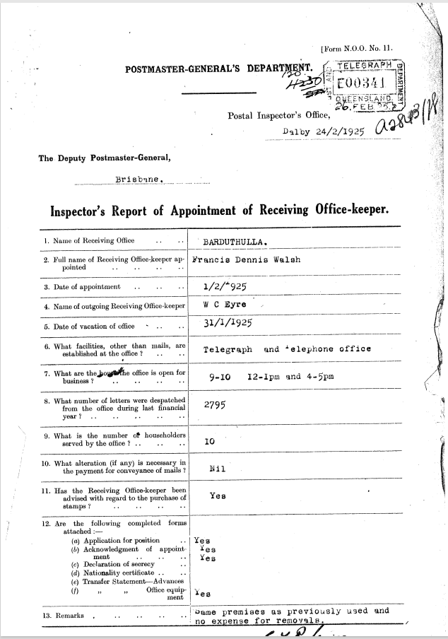

9516.9
POSTMASTER-GENERAL'S DEPARTMENT
Postal Inspector's Office,
Dalby 24/2/1925
The Deputy Postmaster-General,
Brisbane.
Inspector's Report of Appointment of Receiving Office-keeper.
- Name of Receiving Office | BARDUTHULLA
- Full name of Receiving Office-keeper appointed | Francis Dennis Walsh
- Date of appointment | 1/2/1925
- Name of outgoing Receiving Office-keeper | W C Ayre
- Date of vacation of office | 31/1/1925
- What facilities, other than mails, are established at the office? | Telegraph and Telephone Office
- What are the hours the office is open for business? | 9-10 12-1pm and 4-5pm
- What number of letters were despatched from the office during last financial year? | 2795
- What is the number of householders served by the office? | 10
- What alteration (if any) is necessary in the payment for conveyance of mails? | Nil
- Has the Receiving Office-keeper been advised with regard to the purchase of stamps? | Yes
- The following completed forms are attached: —  - Applications for position  - Acknowledgement of appointment  - Declaration of Secrecy  - Nationality Certificate  - Transfer statement – advances  - Transfer statement - office equipment | Yes  Yes  Yes  Yes
- Remarks | same premises as previously used and  no expense for removals.

Inspector
24/2/25
Payment should be made to W.C. Eyre to end Jan 1925 and from 1/2/25 to Walsh

9516.9
POSTMASTER-GENERAL'S DEPARTMENT
Postal Inspector's Office,
Dalby 24/2/1925
The Deputy Postmaster-General,
Brisbane.
Inspector's Report of Appointment of Receiving Office-keeper.
- Name of Receiving Office | BARDUTHULLA
- Full name of Receiving Office-keeper appointed | Francis Dennis Walsh
- Date of appointment | 1/2/1925
- Name of outgoing Receiving Office-keeper | W C Ayre
- Date of vacation of office | 31/1/1925
- What facilities, other than mails, are established at the office? | Telegraph and Telephone Office
- What are the hours the office is open for business? | 9-10 12-1pm and 4-5pm
- What number of letters were despatched from the office during last financial year? | 2795
- What is the number of householders served by the office? | 10
- What alteration (if any) is necessary in the payment for conveyance of mails? | Nil
- Has the Receiving Office-keeper been advised with regard to the purchase of stamps? | Yes
- The following completed forms are attached: —  - Applications for position  - Acknowledgement of appointment  - Declaration of Secrecy  - Nationality Certificate  - Transfer statement – advances  - Transfer statement - office equipment | Yes  Yes  Yes  Yes
- Remarks | same premises as previously used and  no expense for removals.

Inspector
24/2/25
Payment should be made to W.C. Eyre to end Jan 1925 and from 1/2/25 to Walsh

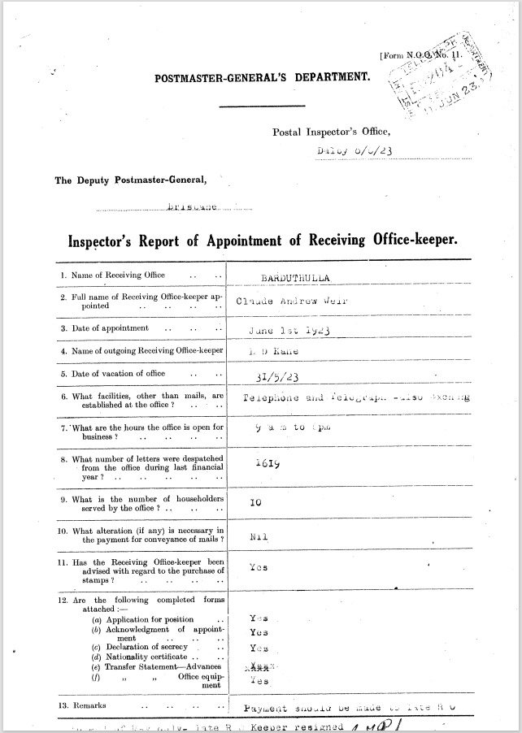

9516.10
POSTMASTER-GENERAL'S DEPARTMENT
Postal Inspector's Office,
Dalby January 13th 1925
The Deputy Postmaster-General,
Brisbane.
Inspector's Report of Appointment of Receiving Office-keeper.
- Name of Receiving Office | BARDUTHULLA
- Full name of Receiving Office-keeper appointed | Claude Andrew Wier
- Date of appointment | June 1st 1923
- Name of outgoing Receiving Office-keeper | L. D. Kane
- Date of vacation of office | 31/5/1923
- What facilities, other than mails, are established at the office? | Telegraph and Telephone Exchange
- What are the hours the office is open for business? | 9am – 6pm
- What number of letters were despatched from the office during last financial year? | 1619
- What is the number of householders served by the office? | 10
- What alteration (if any) is necessary in the payment for conveyance of mails? | Nil
- Has the Receiving Office-keeper been advised with regard to the purchase of stamps? | Yes
- The following completed forms are attached: —  - Applications for position  - Acknowledgement of appointment  - Declaration of Secrecy  - Nationality Certificate  - Transfer statement – advances  - Transfer statement - office equipment | Yes  Yes  (Being obtained)  Yes
- Remarks | Payment should be made to Late R O to end of May only – late R O Keeper resigned

Robinson
Inspector
8/6/1923

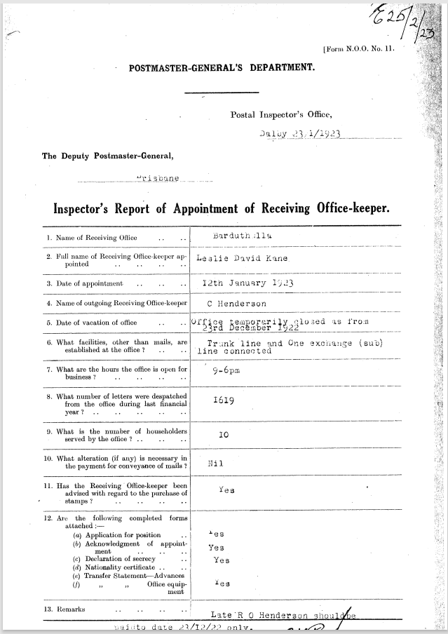

9516.11
POSTMASTER-GENERAL'S DEPARTMENT
Postal Inspector's Office,
Dalby January 13th 1925
The Deputy Postmaster-General,
Brisbane.
Inspector's Report of Appointment of Receiving Office-keeper.
- Name of Receiving Office | BARDUTHULLA
- Full name of Receiving Office-keeper appointed | Leslie David Kane
- Date of appointment | 12th January 1923
- Name of outgoing Receiving Office-keeper | C Henderson
- Date of vacation of office | Office temporarily closed as from 23rd December 1922
- What facilities, other than mails, are established at the office? | Telegraph and One Exchange (sub) line connected
- What are the hours the office is open for business? | 9am – 6pm
- What number of letters were despatched from the office during last financial year? | 1619
- What is the number of householders served by the office? | 10
- What alteration (if any) is necessary in the payment for conveyance of mails? | Nil
- Has the Receiving Office-keeper been advised with regard to the purchase of stamps? | Yes
- The following completed forms are attached: —  - Applications for position  - Acknowledgement of appointment  - Declaration of Secrecy  - Nationality Certificate  - Transfer statement – advances  - Transfer statement - office equipment | Yes  Yes  Yes  Yes
- Remarks | Late R O Henderson should be paid to date 23/12/22 only.

Robinson
Inspector
23/1/1923

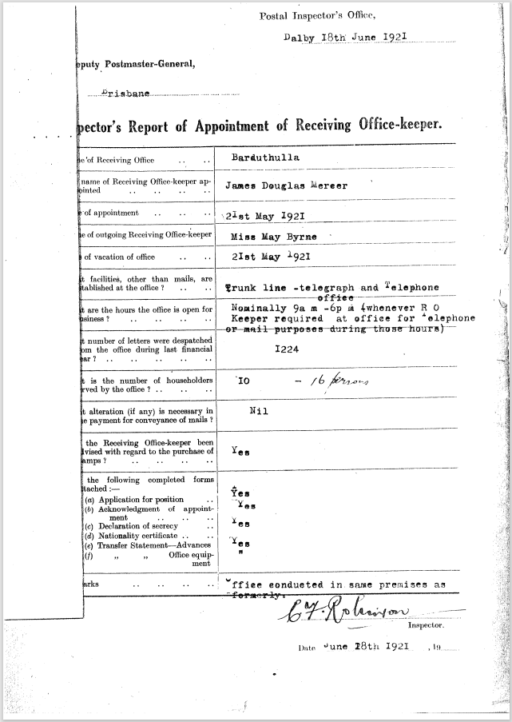

9516.12
POSTMASTER-GENERAL'S DEPARTMENT
Postal Inspector's Office,
Dalby 18th June 1921
The Deputy Postmaster-General,
Brisbane.
Inspector's Report of Appointment of Receiving Office-keeper.
- Name of Receiving Office | BARDUTHULLA
- Full name of Receiving Office-keeper appointed | James Douglas Mercer
- Date of appointment | 21st May 1921
- Name of outgoing Receiving Office-keeper | Miss May Byrne
- Date of vacation of office | 21st May 1921
- What facilities, other than mails, are established at the office? | Trunkline telegraph and telephone office
- What are the hours the office is open for business? | Nominally 9am – 6pm (Whenever R O Keeper required at office for telephone or mail purposes during those hours.
- What number of letters were despatched from the office during last financial year? | 1224
- What is the number of householders served by the office? | 10 16 persons
- What alteration (if any) is necessary in the payment for conveyance of mails? | Nil
- Has the Receiving Office-keeper been advised with regard to the purchase of stamps? | Yes
- The following completed forms are attached: —  - Applications for position  - Acknowledgement of appointment  - Declaration of Secrecy  - Nationality Certificate  - Transfer statement – advances  - Transfer statement - office equipment | Yes  Yes  Yes  Yes
- Remarks | Office conducted in same premises as formerly

Robinson
Inspector
28/6/1921
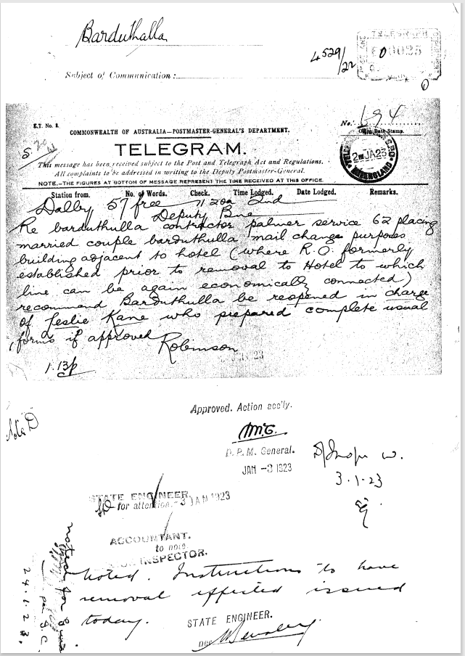

9516.13
Barduthulla
Dalby 57 Free 11.20a 2nd
Deputy Brisbane
Re Barduthulla contractor palmer service62 placing married couple Barduthulla mail change purposes building adjacent hotel (where R O formerly established prior to removal to hotel to which line can be economically connected) Recommend Barduthulla be reopened in charge of Leslie Kane who prepared complete usual forms if approved.
Robinson 1.13pm

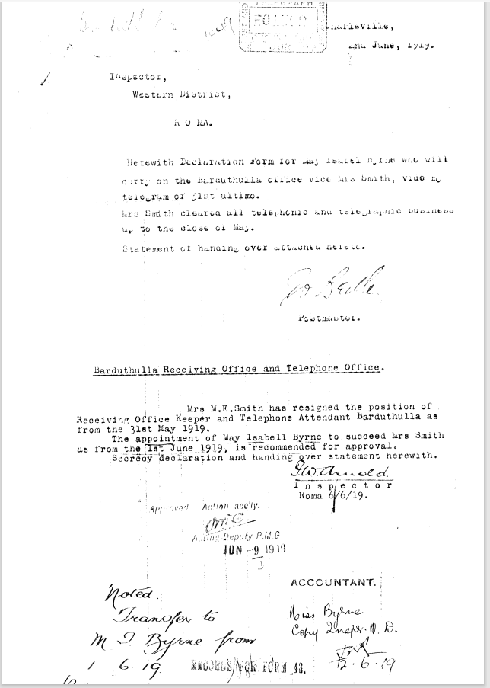

9516.14
Charleville
2 June 1919
Inspector Western District
R O MA
Herewith declaration Form for May Isobel Byrne who will carry on the Barduthulla Office vice Mrs. Smithvide my telegram of 31st ultimo.
Mrs. Smith cleared all telephone and telegraphic business up to the close 01 May
Statement of handing over attached hereto.
Postmaster

Barduthulla Receiving Office and Telephone Office
Mrs. M.E. Smith has resigned the position of Receiving Office Keeper and Telephone Attendant Barduthulla as from the 31st May 1919.
The appointment of May lsabell Byrne to succeed Mrs. Smith as from the 1st June 1919, is recommended for approval. Secretary declaration and handing over statement herewith.
Arnold
Inspector Roma
6/6/19
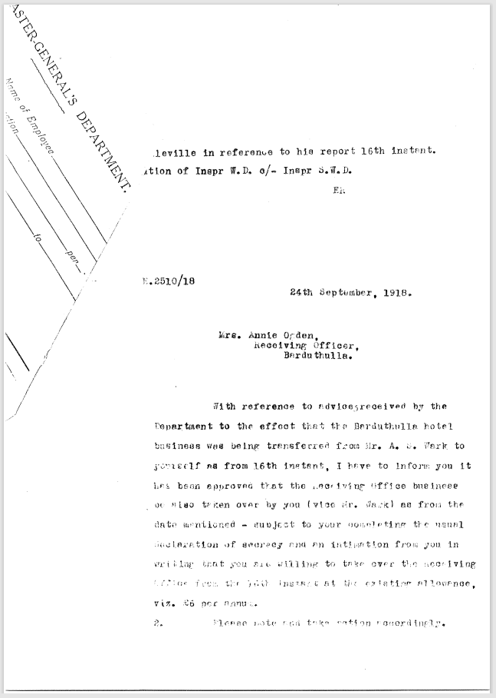

9516.16
Charleville in reference to his report 16th instant ? of inspr WD c/- Inspr SWD
ER
E2510/18
24th September 1918
With reference to advices received by the Department to the effect that the Barduthulla hotel
Business was being transferred from Mr. A S Wark to yourself from 16th instant, I have to Inform you it been approved that the Receiving Office are also taken over by you (vice Mr. Wark) as from the date mentioned – subject to your completing the usual declaration of secrecy and an intimation from you in writing that that you are willing to take over the receiving Office from the 16th instant at the existing allowance, viz £6 per annum.
Please note and take action accordingly.

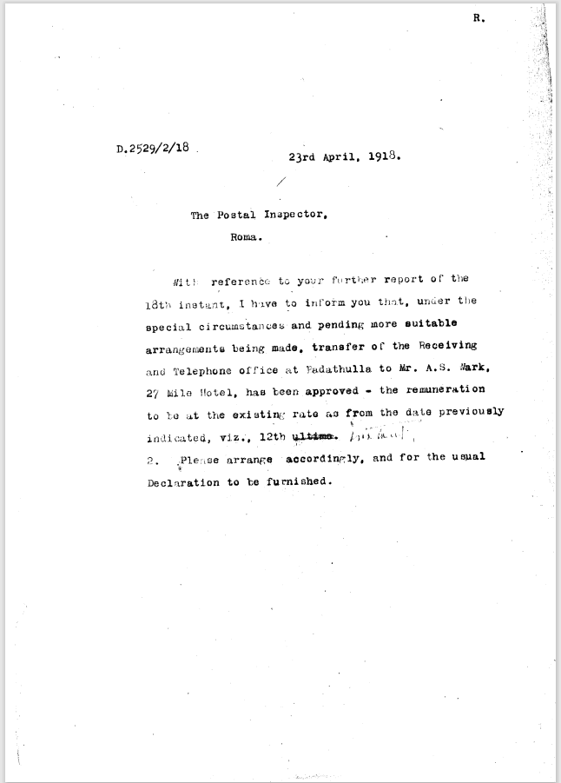

9516.16
R.
D.2529/2/18 23rd April, 1918.
The Postal Inspector,
Roma.
With reference to your further report of the 18th instant, I have to inform you that, under the special circumstances and pending more suitable arrangements being made, transfer of the Receiving and Telephone office at Barduthulla to Mr. A.S. Nark, 27 Mile Hotel, has been approved the remuneration to be at the existing rate as from, the date previously indicated, viz., 12th instant
2. Please arrange accordingly and for the usual Declaration to be furnished.

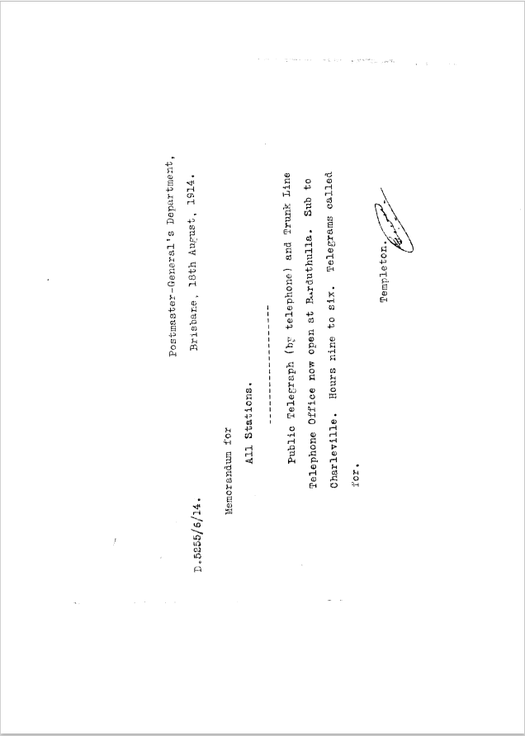

9516.17
Postmaster-General's Department,
D.5255/6/14. Brisbane, 18th August, 1914.
Memorandum for
All Stations.
Public Telegraph (by telephone) and Trunk Line Telephone Office now open at Barduthulla. Sub to Charleville. Hours nine to six. Telegrams called for.
Templeton

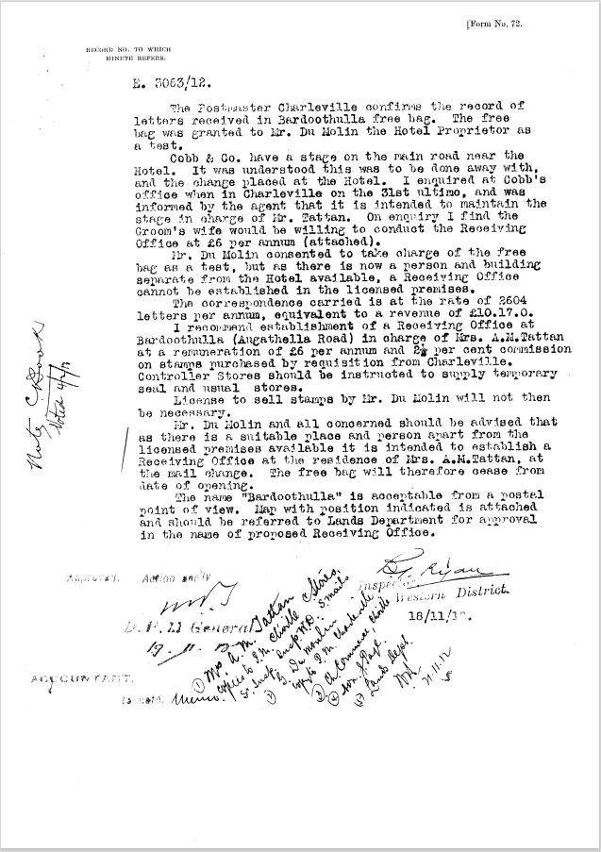

9516.18
Minute Record
L. 5063/12.

The Postmaster Charleville confirms the record of letters received in Barduthulla free bag. The free bag was granted to Mr. Du Molin the Hotel Proprietor as a test.
Cobb & Co. have a stage on the main road near the Hotel. It was understood this was to be done away with, and the change placed at the Hotel. I enquired at Cobb's office when in Charleville on the 31st ultimo, and was informed by the agent that it is intended to maintain the stage in charge of Mr Tattan. I enquiry I find the Groom's wife would be willing to conduct the Receiving Office at £6 per annum (attached).
Mr. Du Molin consented to take charge of the free bag as a test, but as there is now a person and building separate from the Hotel available, a Receiving Office cannot he established in the licensed premises.
The correspondence carried is at the rate of 2604 letters per annum, equivalent to a revenue of £10.17.0.
I recommend establishment of a Receiving Office at Barduthulla (Augathella Road) in charge of Mrs. A.N.Tattan at a remuneration of £6 per annum and 2 1/2 per cent commission on stamps purchased by requisition from Charleville. Controller Stores should be instructed to supply temporary seal and usual stores.
License to sell stamps by Mr. Du Molin will not then be necessary.
Mr. Du Molin and all concerned should be advised that as there is a suitable place and person apart from the licensed premises available it is intended to establish a Receiving Office at the residence of Mrs. A. M Tattan, at the mall change. The free bag will therefore cease from date of opening.
The name "Barduthulla" is acceptable from a postal point of view. Map with position indicated is attached and should be referred to Lands Department for approval in the name of proposed Receiving Office.

Inspector Western District 18/11/12
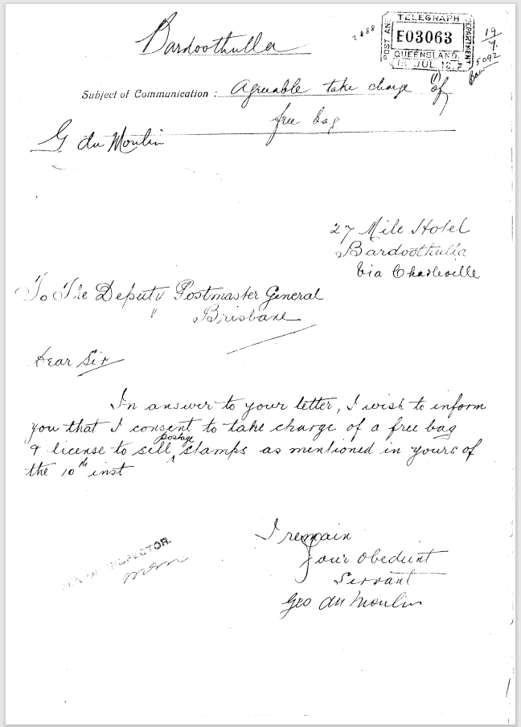

9516.19
Bardoothulla
Subject of Communication “Agreeable to take charge of free bag”
G du Moulin
27 Mile Hotel Bardoothulla
Via Charleville
To the Deputy Postmaster General Brisbane.
Dear Sir,
In answer to your letter, I wish to inform you that I consent to take charge of a free bag & license to sell postage stamps as mentioned in yours of the 10th instant.
I remain your obedient servant
Geo du Moulin.

(Tag Barduthulla)

9516.18
Minute Record
L. 5063/12.

The Postmaster Charleville confirms the record of letters received in Barduthulla free bag. The free bag was granted to Mr. Du Molin the Hotel Proprietor as a test.
Cobb & Co. have a stage on the main road near the Hotel. It was understood this was to be done away with, and the change placed at the Hotel. I enquired at Cobb's office when in Charleville on the 31st ultimo, and was informed by the agent that it is intended to maintain the stage in charge of Mr Tattan. I enquiry I find the Groom's wife would be willing to conduct the Receiving Office at £6 per annum (attached).
Mr. Du Molin consented to take charge of the free bag as a test, but as there is now a person and building separate from the Hotel available, a Receiving Office cannot he established in the licensed premises.
The correspondence carried is at the rate of 2604 letters per annum, equivalent to a revenue of £10.17.0.
I recommend establishment of a Receiving Office at Barduthulla (Augathella Road) in charge of Mrs. A.N.Tattan at a remuneration of £6 per annum and 2 1/2 per cent commission on stamps purchased by requisition from Charleville. Controller Stores should be instructed to supply temporary seal and usual stores.
License to sell stamps by Mr. Du Molin will not then be necessary.
Mr. Du Molin and all concerned should be advised that as there is a suitable place and person apart from the licensed premises available it is intended to establish a Receiving Office at the residence of Mrs. A. M Tattan, at the mall change. The free bag will therefore cease from date of opening.
The name "Barduthulla" is acceptable from a postal point of view. Map with position indicated is attached and should be referred to Lands Department for approval in the name of proposed Receiving Office.

Inspector Western District 18/11/12

9516.19
Bardoothulla
Subject of Communication “Agreeable to take charge of free bag”
G du Moulin
27 Mile Hotel Bardoothulla
Via Charleville
To the Deputy Postmaster General Brisbane.
Dear Sir,
In answer to your letter, I wish to inform you that I consent to take charge of a free bag & license to sell postage stamps as mentioned in yours of the 10th instant.
I remain your obedient servant
Geo du Moulin.

(Tag Barduthulla)

