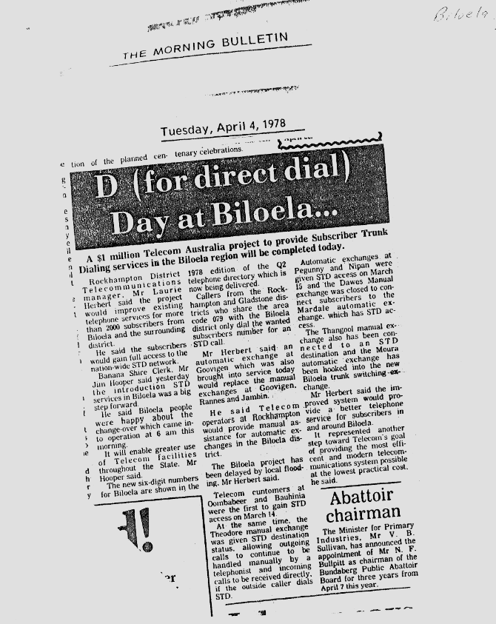

9523.1
Tuesday, April 4, 1978
A $1. million Telecom Australia project to provide Subscriber Trunk Dialling services in the Biloela region will be completed today.
Rockhampton District Telecommunications manager. Mr Laurie Herbert said the project would improve existing telephone services for more than 2000 subscribers from Biloela and the surrounding district.
He said the subscribers would gain full access to the nation-wide STD network.
Banana Shire Clerk, Mr Jim Hooper said yesterday the introduction STD services in Biloela was a big step forward.
He said Biloela people were happy about the change-over which came into operation at 6 am this morning.
It will enable greater use of Telecom facilities throughout the State. Mr Hooper said.
The new six-digit numbers for Biloela are shown in the 1978 edition of the Q2 telephone directory which is now being delivered.
Callers from the Rockhampton and Gladstone districts who share the area code 079 with the Biloela district only dial the wanted subscribers number for an STD call.
Mr Herbert said, an automatic exchange at Goovigen which was also brought into service today would replace the manual exchanges at Goovigen, Rannes and Jarribin.
He said Telecom operators at Rockhampton would provide manual assistance for automatic exchanges in the Biloela district.
The Biloela project has been delayed by local flooding. Mr Herbert said.
Telecom customers at Oombabeer and Bauhinia were the first to gain STD access on March 14.
At the same time, the Theodore manual exchange was given STD destination status. allowing outgoing calls to continue to be handled manually by a telephonist and incoming calls to be received directly. if the outside caller dials STD.
Automatic exchanges at Pegunny and Nipan were given STD access on March 15 and the Dawes Manual exchange was closed to connect subscribers to the Mardale automatic exchange. which has STD access.
The Thangool manual ex. change also has been connected to an STD destination and the Moura automatic exchange has been hooked into the new Biloela trunk switching-exchange.
Mr Herbert said the improved system would provide a better telephone service for subscribers in and around Biloela.
It represented another step toward Telecom's goal of providing the most efficient and modern telecommunications system possible at the lowest practical cost, he said.

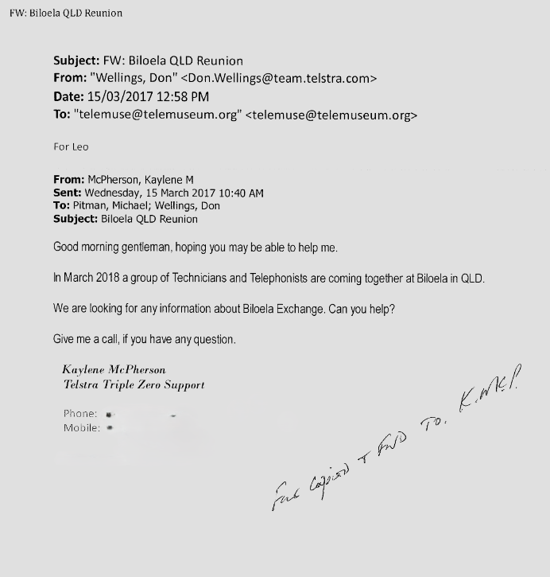

9523.2
FW: Biloela QLD Reunion
Subject: FW: Biloela QLD Reunion
From: "Wellings, Don" <Don.Wellings@team.telstra.com>
Date: 15/03/2017 12:58 PM
To: "telemuse@telemuseum.org" <telemuse@telemuseum.org> For Leo
From: McPherson, Kaylene M
Sent: Wednesday, 15 March 2017 10:40 AM
To: Pitman, Michael; Wellings, Don
Subject: Biloela QLD Reunion
Good morning gentleman, hoping you may be able to help me.
In March 2018 a group of Technicians and Telephonists are coming together at Biloela in QLD.
We are looking for any information about Biloela Exchange. Can you help?
Give me a call, if you have any question.
Kaylene McPherson  Telstra Triple Zero Support | 

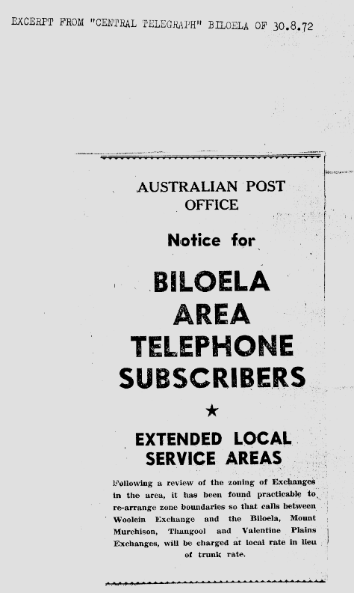
9523.3
AUSTRALIAN POST OFFICE
Notice for,
BILOELA
AREA
TELEPHONE
SUBSCRIBERS.

EXTENDED LOCAL. SERVICE AREAS
Following a review of the zoning of Exchange in the area, it has been found practicable to re-arrange zone boundaries so that calls between Woolein Exchange and the Biloela, Mount Murchison, Thangool and Valentine Plains Exchanges, will be charged at local rate In lieu of trunk rate.

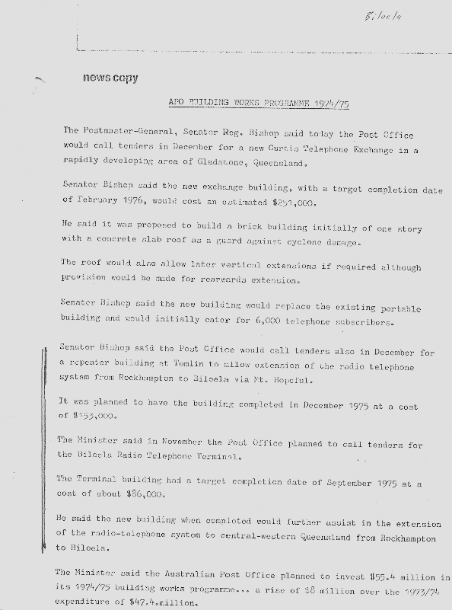

9523.4
Biloela
news copy
APO BUILDING WORKS PROGRAMME 1974/75
The Postmaster-General, Senator Reg. Bishop said today the Post Office would call tenders in December for a new Curtis Telephone Exchange in a rapidly developing area of Gladstone, Queensland.
Senator Bishop said the new exchange building, with a target completion date of February 1976, would cost an estimated $251,000.
He said it was proposed to build a brick building initially of one story with a concrete slab roof as a guard against cyclone damage.
The roof would also allow later vertical extensions if required although provision would be made for rearwards extension.
Senator Bishop said the new building would replace the existing portable building and would initially cater for 6,000 telephone subscribers.
Senator Bishop said the Post Office would call tenders also in December for a repeater building at Tomlin to allow extension of the radio telephone system from Rockhampton to Biloela via Mt. Hopeful.
It was planned to have the building completed in December 1975 at a cost of 1153,000.
The Minister said in November the Post Office planned to call tenders for the Biloela Radio Telephone Terminal.
The Terminal building had a target completion date of September 1975 at a cost of about $86,000.
He said the new building when completed would further assist in the extension of the radio-telephone system to central-western Queensland from Rockhampton to Biloela.
The Minister said the Australian Post Office planned to invest $55.4 million in its 1974/75 building works programme... a rise of $8 million over the 1973/74 expenditure of $47.4 million.

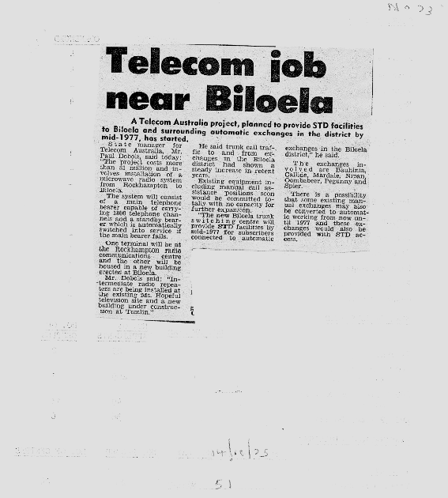

9523.5
No 73
Telecom job
near Bioella
A Telecom Australia project, planned to provide STD facilities to Biloela and surrounding automatic exchanges in the district by mid-1977, has started.
State manager for Telecom Australia, Mr. Paul Dobois, said today: "The project costs more than $1 million and involves installation of a microwave radio system from Rockhampton to Biloela.
The system will consist of a main telephone bearer capable of carrying 1800 telephone channels and a standby bearer which is automatically switched into service if the main bearer fails.
One terminal will be at the Rockhampton radio communications centre and the other will be housed in a new building erected at Biloela.
Mr. Dobbis said: "Intermediate radio repeaters are being installed at the existing Mt. Hopeful television site and a new building under construction at Tomlin."
He said trunk call traffic to and from exchanges in the Biloela district had shown a steady increase in recent years.
Existing equipment including manual Call assistance positions soon would be committed totally with no capacity for further expansion.
"The new Biloela trunk switching centre will provide STD facilities by mid-1977 for subscribers connected to automatic exchanges in the Biloela district," he said.
T h e exchanges involved are Bauhinia, Collide, Mardale, Nipan, Oombabeer, Pegunny and Spier.
There is a possibility that some existing manual exchanges may also be converted to automatic working from now until 1977 and these exchanges would also be provided with STD access.

14/10/1975
51

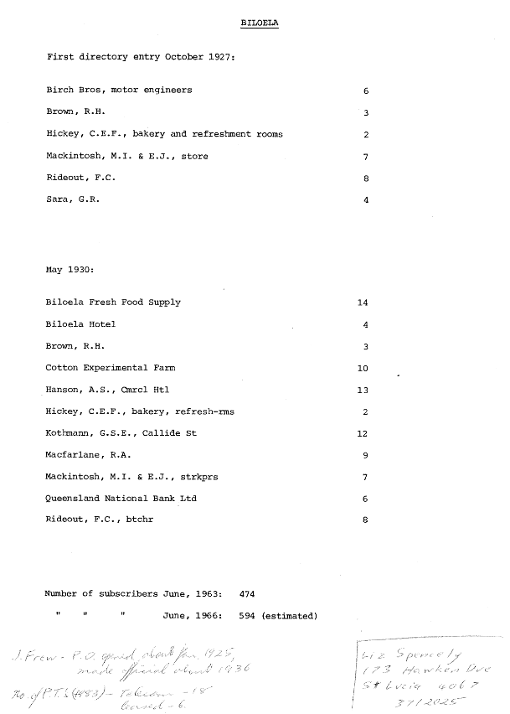

9523.6
BILOELA
First directory entry October 1927:
Birch Bros, motor engineers 6
Brown, R.H.
Hickey, C.E.F., bakery and refreshment rooms 2
Mackintosh, M.I. & E.J., store 7
Rideout, F.C. 8
Sara, G.R. 4

May 1930:
Biloela Fresh Food Supply 14
Biloela Hotel 4
Brown, R.H. 3
Cotton Experimental Farm 10
Hanson, A.S., Cmrcl Htl 13
Hickey, C.E.F., bakery, refresh-rms 2
Kothmann, G.S.E., Callide St 12
Macfarlane, R.A. 9
Mackintosh, M.I. & E.J., strkprs 7
Queensland National Bank Ltd 6
Rideout, F.C., btchr 8

Number of subscribers
June, 1963: 474

11 June, 1966: 594 (estimated)
J Frew P.O. opened about Jan 1925
Made official around 1936
No of P.T.’s (Public Telephone) 1983 Telecom 18
Leased 6

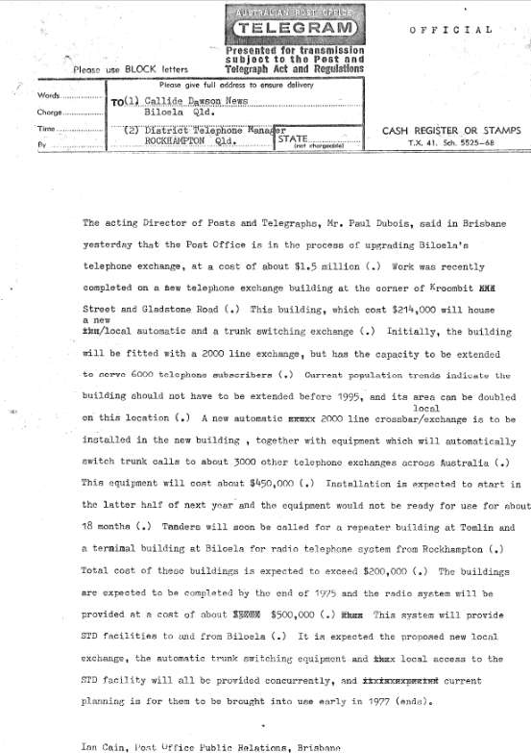

9523.7
OFFICIAL
Please use BLOCK letters
Presented for transmission subject to the Post and Telegraph Act and Regulations
The acting Director of Posts and Telegraphs, Mr. Paul Dubois, said in Brisbane yesterday that the Post Office is in the process of upgrading Biloela's telephone exchange, at a cost of about $1.5 million (.) Work was recently completed on a hew telephone exchange building at the corner of Kroombit Street and Gladstone Road (.) This building, which cost $214,000 will house a new
A new local automatic and a trunk switching exchange (.) Initially, the building will be fitted with a 2000 line exchange, but has the capacity to be extended to serve 6000 telephone subscribers (.) Current population trends indicate the building should not have to be extended before 1995, and its area can be doubled local
on this location (.) A new automatic 2000 line crossbar/exchange is to be installed in the new building , together with equipment which will automatically switch trunk calls to about 3000 other telephone exchanges across Australia (.) This equipment will cost about $450,000 (.) Installation is expected to start in the latter half of next year and the equipment would not be ready for use for about 18 months (.) Tenders will soon be called for a repeater building at Tomlin and a termimal building at Biloela for radio telephone system from Rockhampton (.) Total cost of these buildings is expected to exceed $200,000 (.) The buildings are expected to be completed by the end of 1975 and the radio system will be provided at a cost of about $500,000 (.) This system will provide STD facilities to and from Biloela (.) It is expected the proposed new local exchange, the automatic trunk switching equipment-and irkiscx local access to the STD facility will all be provided concurrently, and current planning is for them to be brought into use early in 1977 (ends).
Ian Cain, Post Office Public Relations, Brisbane

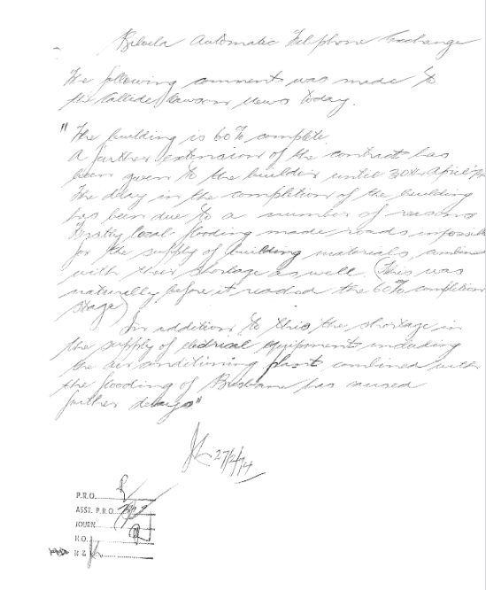

9523.8
Biloella Automatic Telephone Echange
The following comment was made by the Callide Dawson News today.
“The building is 60% complete.
A further extension of the contract has been given to the builders until 30th April 1974.
The delay in the completion of the building has been due to a number of reasons.
Firstly local flooding made roads impossible for the supply of building materrials, combined with their shortage as well. (This was naturaly before it reached the 60% completion.
In addition to this the shortage of in the supply of additional equipment including the air conditioning plant combined with the flooding of Brisbane has caused further delays.”

27/2/1974

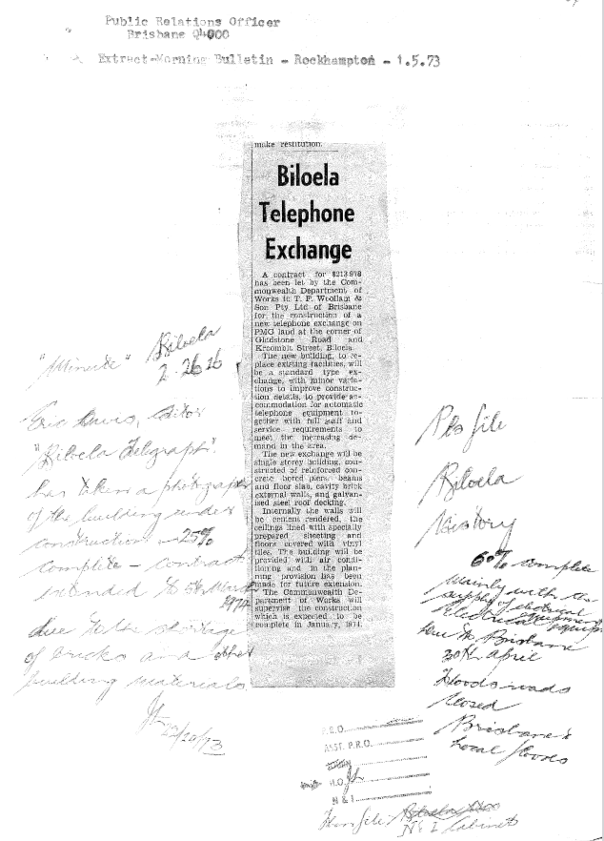

9523.9
Public Relations Officer
Brisbane 4000.
Extract Morning Bulletin Rockhampton 1 5 1973
Biloela
Telephone
Exchange
A contract for $213,a78 has been let by the Commonwealth Department of Works to T. P. Woollam & Son Pty Ltd of Brisbane for the construction of a new telephone exchange on PMG land at the corner of Gladstone Road and Kroombit Street; Biloela.
The 'new building, to replace existing facilities, will be a standard type exchange, with minor variations to improve construction details, to provide accommodation for automatic telephone equipment together with full staff and service requirements to meet the increasing , demand in the area.
The new exchange will be single storey building, constructed of reinforced concrete bored piers, beams and floor slab, cavity brick external walls, and galvanised steel roof decking.
Internally the walls will be cement rendered, the ceilings lined with specially prepared sheeting and floors . covered with vinyl tiles. The building will be provided with air conditioning and in the planning - provision has been made for future extension.
The Commonwealth Department of Works will supervise the construction
Which is expected to be complete in January, 1974.

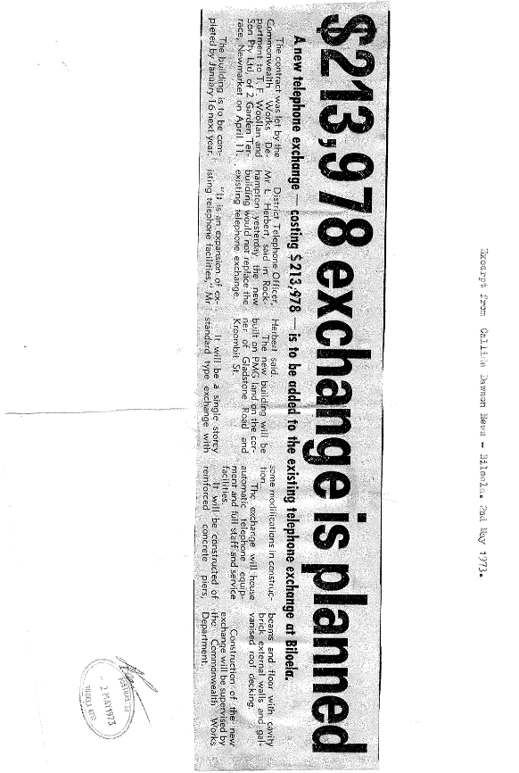

9523.10
$213,978 exchange is planned
A new telephone exchange — costing $213.978 — is to be added to the existing telephone exchange at Billoea.
The contract was let by the Commonwealth Works Department to T. F. Woollan and Son Pty Ltd, of 2 Garden Terrace, Newmarket on April 11.
The building is to be completed by January 16 next year.
District Telephone Officer, Mr L. Herbert, said in Rockhampton yesterday the new building would not replace the existing telephone exchange.
"It is an expansion of ex-isting telephone facilities," Mr Herbert said.
The new building will be built on PMG land on the corner of Gladstone Road and Kroombit St.
It will be a single storey standard type exchange with some modifications in construction..
The exchange will house automatic telephone equipment and full staff and service facilities.
It will be constructed of reinforced concrete piers, beams and floor with cavity brick external walls and galvanised roof decking.
Construction of the new exchange will be supervised by the Commonwealth Works Department.

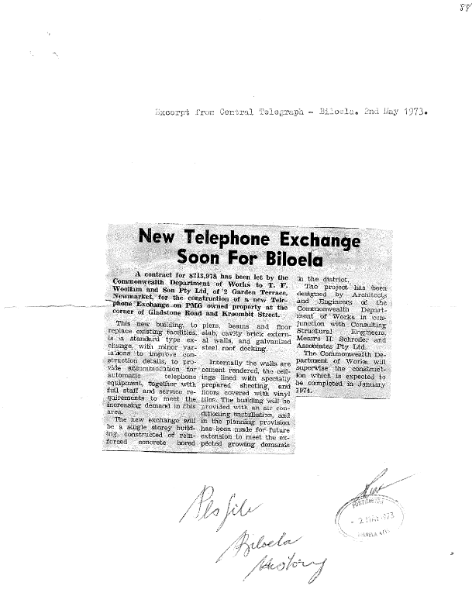

9523.11
Excerpt from Central Telegraph — Biloela. 2nd May 1973.
New Telephone Exchange
Soon For Biloela
A contract for $213,978 has been let by the Commonwealth Department of Works to T. F. Woollam and Son Pty Ltd, of 2 Garden Terrace, Newmarket, for the construction of a new Telephone Exchange on PMG owned property at the corner of Gladstone Road and Kroombit Street.
This new building, to replace existing facilities, Is a standard type exchange, with minor variations to improve construction details, to provide accommodation for automatic telephone equipment, together with full staff and service requirements to meet the increasing demand in this area.
The new exchange will be a single storey building, constructed of reinforced concrete piers, beams and floor slab, cavity brick external walls, and galvanised steel roof decking.
Internally the walls are cement rendered, the ceilings lined wiith specially prepared sheeting, and floors covered with vinyl tiles. The building will be provided with an air conditioning installation, and in the planning provision has been made for future extension to meet the expected growing demands in the district.
The project has been designed by Architects and Engineers of the Commonwealth Depart-ment of Works in conjunction with Consulting Structural Engineers, Messrs H. Schroder and Assoiciates Pty Ltd.
The Commonwealth Department of Works will supervise the construction which is expected to be completed in January 1974.

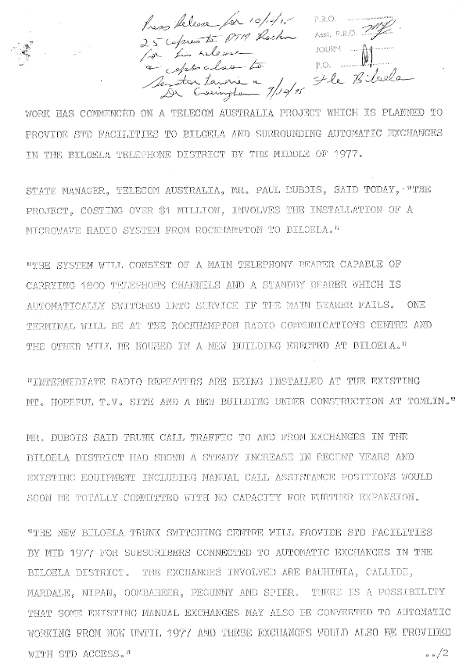

9523.12
WORK HAS COMMENCED ON A TELECOM AUSTRALIA PROJECT WHICH IS PLANNED TO PROVIDE STD FACILITIES TO BILOELA AND SURROUNDING AUTOMATIC EXCHANGES IN THE BILOELA TELEPHONE DISTRICT BY THE MIDDLE OF 1977.
STATE MANAGER, TELECOM AUSTRALIA, MR, PAUL DUBOIS, SAID TODAY, "THE PROJECT, COSTING OVER $1 MILLION, INVOLVES THE INSTALLATION OF A MICROWAVE RADIO SYSTEM FROM ROCKHAMPTON TO BILOELA."
"THE SYSTEM WILL CONSIST OF A MAIN TELEPHONY BEARER CAPABLE OF CARRYING 1800 TELEPHONE CHANNELS AND A STANDBY BEARER WHICH IS AUTOMATICALLY SWITCHED INTO SERVICE IF THE MAIN BEARER FAILS. ONE TERMINAL WILL BE AT THE ROCK HAMPTON RADIO COMMUNICATIONS CENTRE AND THE OTHER WILL BE HOUSED IN A NEW BUILDING ERECTED AT BILOELA."
"INTERMEDIATE RADIO REPEATERS ARE BEING INSTALLED AT THE EXISTING MT. HOPEFUL T.V. SITE AND A NEW BUILDING UNDER CONSTRUCTION AT TOMLIN."
MR. DUBOIS SAID TRUNK CALL TRAFFIC TO AND FROM EXCHANGES IN THE BILOELA DISTRICT HAD SHOWN A STEADY INCREASE IN RECENT YEARS AND EXISTING EQUIPMENT INCLUDING MANUAL CALL ASSISTANCE POSITIONS WOULD SOON BE TOTALLY COMMITTED WITH NO CAPACITY FOR FURTHER EXPANSION.
"THE NEW BILOELA TRUNK SWITCHING CENTRE WILL PROVIDE STD FACILITIES BY MID 1977 FOR SUBSCRIBERS CONNECTED TO AUTOMATIC EXCHANGES IN THE BILOELA DISTRICT. THE EXCHANGES INVOLVED ARE BAUHINIA, CALLIDE, MARDALE, NIPAN, OOMBABEER, PEGUNNY AND SPIER. THERE IS A POSSIBILITY THAT SOME EXISTING MANUAL EXCHANGES MAY ALSO BE CONVERTED TO AUTOMATIC WORKING FROM NOW UNTIL 1977 AND THESE EXCHANGES WOULD ALSO BE PROVIDED WITH STD ACCESS."

