9750.1
CE

Strowger Progress

History and development of the Strowger Automatic Telephone System.
1889 Almon B Strowger invents a switch having line contacts in circular rows inside a cylinder controlled by push buttons on the telephone.
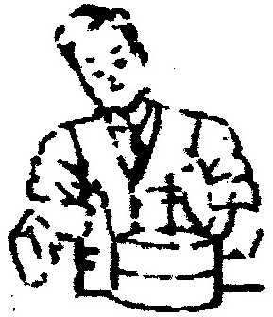
1891 Invention of 1000 line switch with disc bank having ten concentric rows of line contacts. Not used commercially. Formation of Strowger Automatic Telephone Exchange.
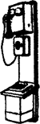
1892 First commercial Strowger installation LaPorte, IND. Used switches with 100 line disk type banks.
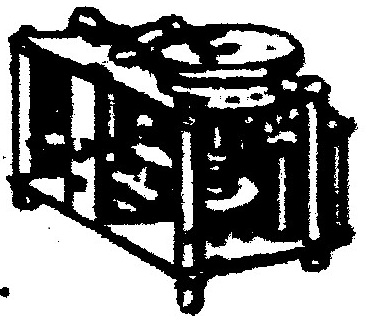
1894 Invention of gear driven switch with “zither” (piano wire) line banks. Not used commercially. 200 line “zither” board with ratchet drive installed at La Porte, Ind.
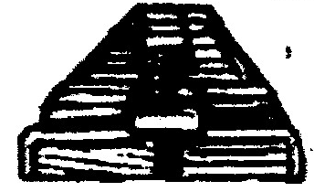
1895 Third installation at LaPorte. Earliest use of switch with semi-cylindrical bank and shaft with vertical and rotary motions. Invention or earliest dial type calling device.
1896 Invention of selector trunking; first use of dial telephones in large exchange. (Augusta, Ga.)
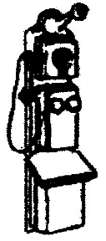
1898 Earlies use of relays for switch control, instead of direct operation of' magnets. over line wires. First die cast switch frame.
1899 Strowger Automatic goes abroad. (Berlin, Germany). Earliest use of automatic trunk selection, with busy test.

1900 Basic trunking principles established for large exchanges used at New Bedford, Mass. Bank terminals moulded in plaster of paris.
1901 Formation of Automatic Electric Company to take over Strowger Automatic Telephone Exchange Installation at Fall River, Mass., used line banks with fiber insulators and aluminum fillers. First use of “slip multiple”.
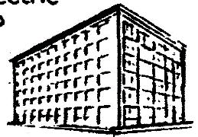
1902 First installation in Chicago begun. Earliest use of measured service in automatic exchanges.
1903 Large Strowger installations placed in service in Grand Rapids, Dayton, Akron, Columbus.
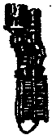
1904 First use of multi- office trunking, and connections between automatic and. manual offices. (Los Angeles, Cal)
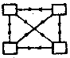
1905 Earliest use of party lines and. reverting calls First system using common battery. talking. (South Bend, Ind.)

1906 invention of Keith Line switch, resulting in enormous reduction in cost of automatic boards. First used at Wilmington, Del.
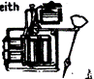
1907 First installation in Canada (Edmonton, Alta.) Invention of small dial and two-wire system, eliminating ground at subscriber's station.
1908 First two-wire system (large dial) installed at Pontiac III. Earliest use of automatic, intermittent ringing. Installation at Lansing, Mich., features use of small dial, secondary line switch, and 200-pt. selectors and connectors.
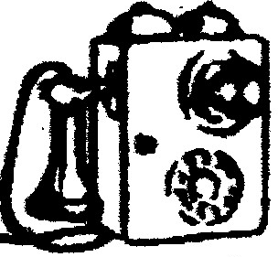
1909 Invention of outgoing secondary line switch, resulting in economy of inter-office trunks. First used at San Francisco.
1910 Strowger system introduced in Hawaii and Cuba. Earliest use of dialling over toll lines. Introduction of revertive ringing tone.

1911 Formation of Automatic Telephone Manufacturing Co., Ltd., for production of Strowger system in England.
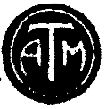
1912 First Strowger installation in 'England. (Epsom “Official Switch”).
1913 Strowger system introduced in Australia and New Zealand. Development of key type impulse sender, and simplex dialling on toll lines.
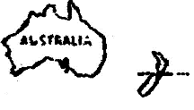
1914 Automatic' Switches used as traffic distributors in manual exchanges. (Indianapolis and Defiance, Ohio)
1915 Development of modern covered switch with horizontal relays - used at St. Paul and Minneapolis. First use of cast iron switch frame at Hazelton, Pa.
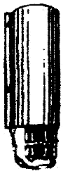

1916 Earliest - community automatic exchange network, installed in Wisconsin.
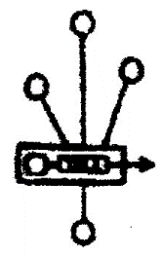
1917 Rapid expansion in the use of automatic branch exchanges. Development of remote alarm equipment for unattended exchanges.
1918 First installation using rotary primary line switches. (Elyria. Ohio).

1919 First Strowger board manufactured for Bell system. (Norfolk, Va.)
1920 Beginning of widespread adoption of Strowger equipment for metropolitan areas both in U.S. and abroad. First installation of call-indicator equipment, for automatic-manual connections in multi-office areas.
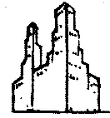
1922 Introduction of improved steel wall telephones and improved desk stands (Type 21)
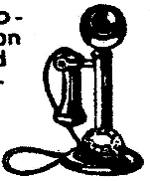
1923 British Post Office announces adoption of Strowger system (with Director) for London.
1924 Strowger exchanges installed throughout Canal Zone. First Strowger “Directors” installed in Havana.

1925 Introduction of the Monophone first hand set telephone of modern type.

1926 Introduction of the type 24 dial modern, quiet-running, long life calling device. Strowger system adopted by Japan.
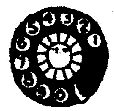
1927 First “Director” Installation in London. Introduction of line switch with self - aligning plunger.
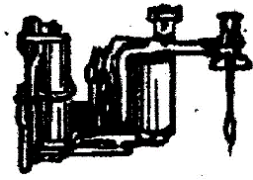
1928 First extended use of Strowger 200-point Line Finder. Introduction or improved Mono-phone designs.
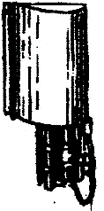
1929 U.S. Navy begins use of Strowger equipment Monophones made available in colour.
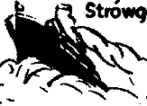
1930 Development of new small switchboards of unit type. Networks of small Strowger exchanges installed in Italy.
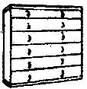
1931 Development of Strowger Remote Toll Board. First installed in Elyra Ohio.
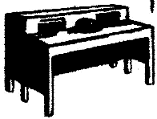
1932 Development of unattended private automatic branch ex-changes. Two-line Monophones introduced.
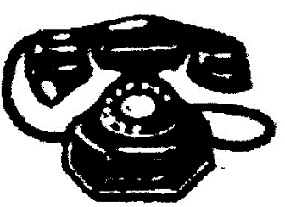
1933 New small private automatic exchanges introduced.
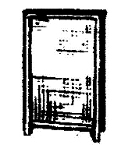
1934 Introduction of new self -contained desk Monophone moulded in Bakelite (Type 34A3)
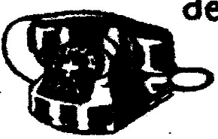
1935 New “all positions” transmitter. New Bakelite wall monophone (type 35A5)
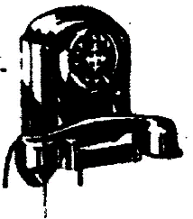
1936 Small, compact community automatic exchanges introduced.
