9752.1
RADIO SAVES LIFE IN THE OUTBACK
The vast area of our island continent' makes aerial services essential as a means of maintaining communication. Radio must also be used to play its part in the tying together of the settlers who cannot reach civilisation by any other method. Here we give a picture story of how radio and aviation have combined to bring relief and succor to hundreds of Australians who hold in their hands the future of Australia's open spaces.
RELIABLE medical facilities are an essential factor in the development of the Australian outback. The Australian Aerial Medical Service provides them to inland settlers, and radio makes It possible for them to do so. About 400 miles north-west of Broken Hill Is Cordillo Downs. If the weather Is favorable the mail truck can make the Journey in a week. At Cordillo Downs there is a station hand ill, he may be dying, he needs medical aid, and needs it quickly.
Despite its isolation, Cordillo Downs Is In contact with the Broken Hill base of the Australian Aerial Medical Service. and the station manager can, by operating a pedal generator, establish immediate contact with the base per medium of a combination transmitting and receiving radio set
On the -transceiver." he calls the flying doctor, and In a two-way phone conversation explains the sick man's condition.
Inside four hours the doctor is with the sick man. The journey is made by plane over largely uninhabited country, with two stops for refueling, one at Tibooburra and one at Innamincka. just over the South Australian border.
The doctor decides the man needs hospital attention and makes arrangements to transport him back by plane. Once again the pedal transceiver is used to contact the Broken Hill base and arrange for an ambulance to meet the plane.
Prompt attention saved the man's life. Such is the work of the Australian Aerial Medical Service. The Idea was originally conceived by the Rev. John Flynn, OBE., "Flynn of the Inland," who travelled by means of pack-horse and car and organised, through the Australian Inland Mission, nursing centres.
Then. in 1925. the A.I.M. began experimenting with radio, and three years later, Introduced the first flying doctor service.
In these days the radio transmitters

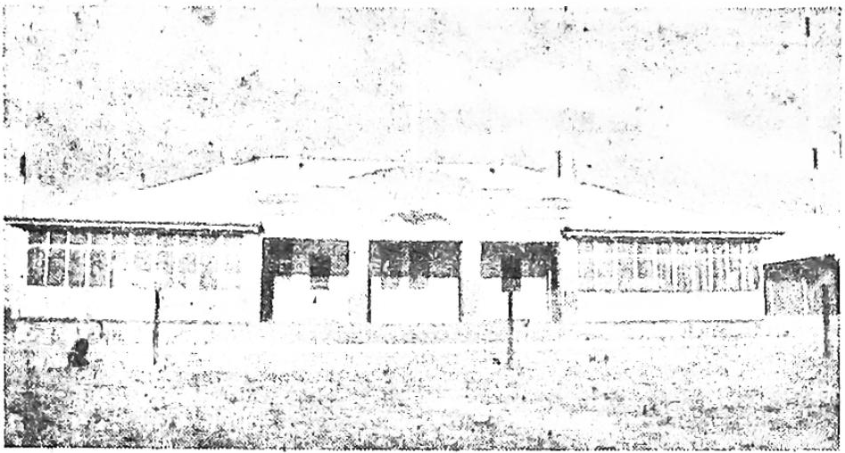
The Base Wireless Station at Broken Hill - VK8SK
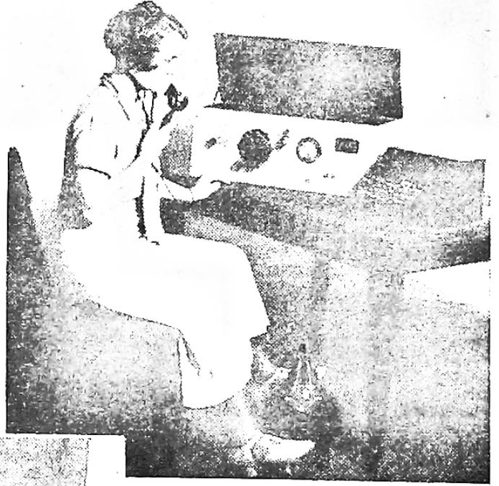
An early type of transmitter. The machine with typewriter keys is an automatic sender for morse code.
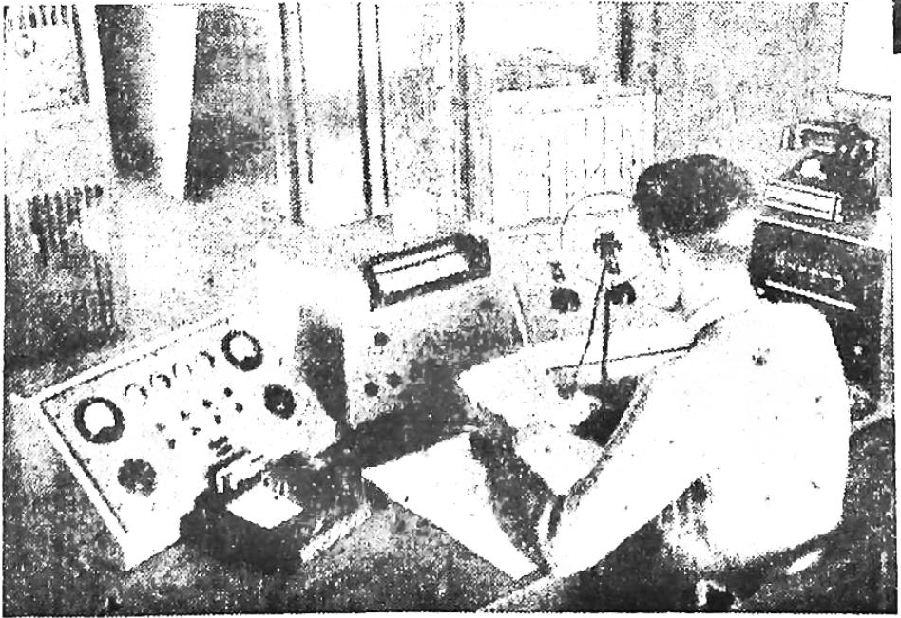
The radio operator’s desk at 8SK, Broken Hill.
This is the headquarters station for the Australian Aerial Medical Services.

