9756.1
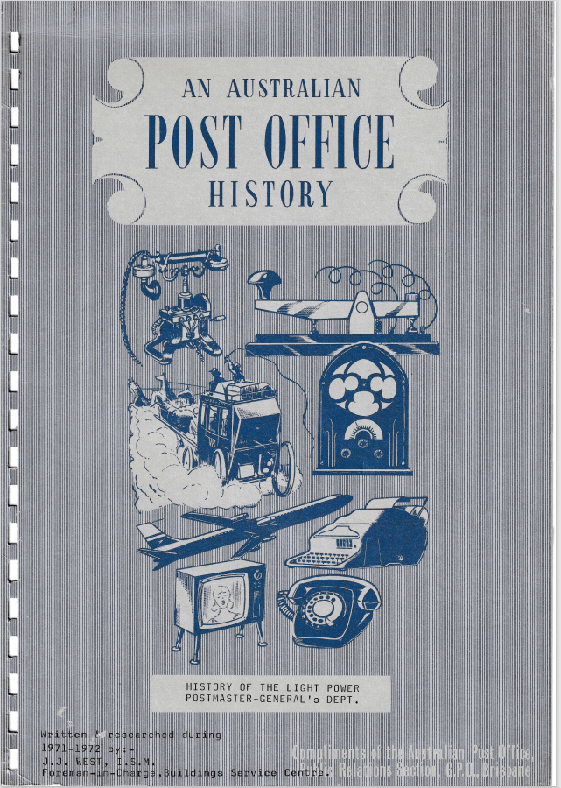

HISTORY OF THE LIGHT POWER
POSTMASTER-GENERAL'S DEPT.
Research into the history of the Light Power of the Postmaster-General's Department has been made under various data headings as follows:
- Historical - dealing with the electricity supply associated with the main P.M.G. departmental buildings and activities.
- Administration and early staff
- Building construction main G.P.O. Area
- Location of Light Power Section period 1901-1968
- Installation date and data on the first type of equipment installed or maintained by the L.P. Section.

HISTORICAL ELECTRICITY SUPPLY
The early State P.M.G. Light Power section was associated with the first Brisbane commercial power supply company Messrs. Barton and White.
The power station was located in Arcade Lane (adjacent to the G.P.O.) off Creek Street. The P.M.G. department was the first consumer connected to the station in the year 1888.
The power station site is now used as an electricity supply 5000-volt substation by the Southern Electricity Authority. The substation is a portion of the present P.M.G. light power head office maintenance Section in the basement of the Edison Automatic Exchange building. The hands of the clock have turned a full circle. The electricity supply to the P.M.G. G.P.O. being mainly for lighting in the Mail Room, Telephone Exchange, Telegraph Office, and office areas.
In the year 1893 the Barton White power plant was moved to the Old Normal School grounds to prevent flooding (the site now occupied by the Public Curators Building).
In the year 1896 the firm was reformed as a public company The Brisbane Electric Supply Company.
In the year 1898 a new power station was built in Ann Street adjacent to George Street, the site now occupied by Lennons Hotel.
In the year 1904, the company was reconstructed to form the City Electric Light Company Ltd.
In the year 1911 a new power station was built in William Street.
It must be noted that Messrs. Barton and White were not the first to generate electricity in Brisbane. In the year 1883 the State Government Printing Office had electric light installed from a small generator driven off a printing press. In the year 1884 the Brisbane Courier paper composing room had electric light installed. This supply was provided from a D.C. generator in a foundry in Foundry Lane (Isles Love Lane). In the year 1953 the City Electric Light Company was reformed to become the Southern Electric Authority.
In the year 1963 the supply of electricity to consumers in the metropolitan area was controlled by the Brisbane City Council.

LOCATIONS LIGHT-POWER SECTION
PERIOD 1901 - 1968
1901 Ground floor old Barton-White power house Edison Lane. Now Southern Electric Authority 5000-volt Sub Station No. 174 Edison Telephone Exchange Building, Elizabeth. Street.
1908 Rented premises Charlotte Street, between Edward and Albert Streets. Records fail to pin point location.
1912 Mezzanine Floor, G.P.O. Courtyard Elizabeth Street section then of Telegraph Workshop (now Pastry Cook section, Food Services Division).
1914 Mezzanine Floor, Pneumatic Tube Room (now section Telephone Accounts Branch, Edward Street, Bank Lane corner).
1918 Mezzanine Floor, Telegraph Workshop, Telegraph Battery Room (ground floor) end G.P.O. Courtyard.
1924 Main P.M.G. Workshops first floor O'Reilly's Bond Store, Margaret Street (between George and Albert Streets).
1930 Telegraph Workshop first floor Elizabeth Street frontage G.P.O. Courtyard (now G.P.O. Cafeteria).
1938 Basement Central Automatic Exchange Building Amalgamation Telephone Plant Maintenance Section.
1947 Mezzanine Floor, Elizabeth street frontage, G.P.O. Courtyard area.
1951 Basement - First/Second floors of annexe Howard Smith building, Cnr. Wharf & Adelaide Streets (now Mt. Isa House) (Sub Section retained at G.P.O.).
1955 Paul Gray Building, 223 St. Pauls Terrace - Sub Section retained at G.P.O.
1958 Holman Street, Kangaroo Point (Sub Section at G.P.O.). 1964 Sub Sections G.P.O. - Chief Parcels Office, Roma Street. 1968 No. 220 Roma Street, adjacent to Chief Parcels Office.

RESEARCH LIGHT POWER
BUILDING CONSTRUCTION G.P.O. AREA
A brief summary of the building construction in the G.P.O. area is necessary to a follow up of the succeeding data on Light Power section location and installation data.
In 1871 the first section of the existing G.P.O. (Creek Street side queen Street frontage of centre lane) was built for use as administrative offices, Mail Branch and Manual Telephone Exchange. The unit was built by J. Petrie for £7,450.00. In 1872 the first clock was erected in (pediment) facade.
The second section of the queen Street frontage of existing G.P.O. (Edward Street side of centre lane) and clock tower built by J. Petrie at a cost of £19,784.0.0.
This section was for use as the Central Telegraph Office, Telegraph Despatch, Manual Telephone Exchange and office area. The clock tower was not completed and left as it exists today.
1900 The erection of another section on the Elizabeth Street frontage (Creek Street side of centre lane) was completed in 1908. The section was to be used for P.M.G. Stores Branch, Mail Exchange, Clerical and Engineering offices.
The proposed new Common Battery telephone exchange building with Elizabeth Street frontage (Edward Street side of centre lane) was built by Mr. Herbert Stronack (built A.M.P.). This section completed the G.P.O. block from queen to Elizabeth Streets.
Third floor Elizabeth Street frontage built for Engineers in 1905?
The first telecommunication multi-storied building Central Telephone Exchange (6 stories and basement) Elizabeth Street was completed in 1928.
The expansion of the Mail Branch required the acquisition of the old Patterson Lang and Bruce building (adjacent to the old single storied Parcel Post) Elizabeth Street in the year 1946? Records show that tenders were called for a new G.P.O. not to exceed £150,000 (no tenders received).
The purchase of the Commercial Travelers Association Sample Rooms in Elizabeth Street (adjacent to St. Stephens Cathedral) in year ???? for office space for Engineering Branch and renamed Hesketh House. This Branch had to evacuate floors in the Central Automatic Exchange building to allow for installation of a new Chief Telegraph Office as well as expansion of local and trunk telephone equipment.
The acquisition of the Commercial Travelers Club building in Elizabeth Street (adjacent to Engineering Branch) in year 1967? This building was reconditioned and was for use as Telecommunication House.

ADMINISTRATION - STAFF
LIGHT POWER SECTION 1901 - 1969
The pre-Federation administration and staffing for the P.M.G. electrical services was a function of the State Government.
In March 1901 the transfer of the P.M.G. Department was made from the State to the Commonwealth Government. The control of all technical services in the P.M.G. Department in Qld. was under the Chief Engineer, Mr. J. Hesketh. The Assistant Engineers were Messrs. J. Sutton, R.T. Scott, J.R. Bradford.
Assistant Engineer Mr. J. Sutton assumed responsibility for the Light Power section. This officer had previously served with Messrs. Barton-White Electricity Supply Company. Mr, Sutton eventually became the State Engineer after Mr. J. Hesketh retired from the service. At the transfer date, the field operating staff were known as Instrument Fitters, the leading hand as an Assistant Mechanician, Mr. W. Hedger.
The only record of instrument fitters then were B. Hayes and O. Bennett.
Shortly after the transfer was completed all were designated as Senior or Instrument Fitter. In 1904 the control of the section was amalgamated with the Telephone and Telegraph staff under the Mechanician, Mr. S.H. Smith.
A change of designation of staff was made in the year 1912 to Postal Mechanics and Senior Postal Mechanic. The field staff included Mr. W. Hedger Senior and Mr. G. Joseph, R. Duffy, I. Goldsworthy.
In 1912 Mr. G. Joseph was seconded for special duty on the installation of commercial radio stations at Darwin, Cairns, Townsville, Rockhampton and Brisbane. The administration of the section was placed under the Telephone Equipment Engineer, Mr. R.T. Bourne?
Two officers of the L.P. staff Messrs. R. Duffy and I. Goldsworthy enlisted for active service and paid the supreme sacrifice. In the year 1916, the first electric light power apprentice commenced duty. He was Mr. E.L. Kelly.
The years 1919/1920 saw an expanded staff including returned servicemen J. Heywood, T. Broad, J. Schofield, F. Townsend, W. Hannington, etc. Mr. W. Hedger retired as the Senior Mechanic and was replaced by Mr. G. Joseph. In the year 1923, the administration of the section was transferred to the Divisional Engineer, Telegraphs, Mr. (Barney) Burnham and Asst. Engineer, C. Sandercock.
In 1938 the Divisional Engineer General Works, Mr. H. Pilgrim, assumed control and administered the section until 1949.
Also in 1938, the Section was amalgamated with the Telephone Exchange Plant Maintenance Section.
The transfer of administration to the Superintendent, Building Services Branch, was effected in 1949.
In the year 1969, the section was retransferred to the Engineering Branch Works Service Division with Mr. Baker as Supervising Engineer, Works and Services.
Written and researched during 1971-1972 by:-
J.J. West, I.S.M.,
Forman-in-Charge,
Buildings Services Centre,
General Works,
ENGINEERING DIVISION.
From 1938 to 1964
and
Member of the Post Office Historical Society
of Queensland.

LIGHT POWER
Installation dates and data on first type Equipment installed or maintained.
1888 First electricity service to Postmaster General in the State of Queensland, terminated on a marble switchboard first floor, G.P.O. clock tower.
The voltage being 110 direct current, and used for lighting in Administrative offices, Mail Room, Telephone Exchange, Telegraph Operating Room, Public Counters. The lighting units were Carbon Arc lamps.
1871 First G.P.O. clock located in the apex of the facade Queen Street frontage Creek Street side of centre lane. The clock was a mechanical one four feet in diameter costing £150, The unit required a weekly wind.
1904 The first electric clock system installed in G.P.O. by Synchronome Electrical Co.
1906 Installation of Manual operated Postmarking Machines in Mail Branch, G.P.O. Kragg type.
1909 The existing tower clock installed by the Synchronome Electrical Co. for £88.0.0. The first carbon filament lamp installed was in lieu of the carbon arc lights.
1910 Installation of 440/220 direct current electricity supply from the G.P.O. tower to the Central Telegraph Office (first floor end of G.P.O. courtyard off Elizabeth Street). Installation of additional Main electricity Switch Board, Elizabeth Street frontage, ground floor in section of C.B. Telephone Exchange cable tunnel (now Section Chief Telegraph Office despatch room). The service was a 440/220 direct current three wire system.
1911 First Motor Generator set installed in the Common Battery Telephone
Exchange Power Room, G.P.O. courtyard, Elizabeth Street. The generator was a Westinghouse open ring using copper gauge brushes. The motor was a 440-volt unit.
1912 The first Pneumatic Tube system installed, operating from C.T.O.
and Money Order counters, Central Telegraph Office. The two vacuum pumps used were Roots type belt driven by 440-volt D.C. motors located in the lower room (now portion of Telephone Accounts Branch - Elizabeth Street, Bank Lane corner). The original contract price was £1917.0.0. A new direct current three conductor 440/220-volt tie cable was installed in the G.P.O. centre lane from Main Switchboard in clock tower to C.B. Telephone Exchange Elizabeth Street (power room).
Installation of 220V D.C. power to Central Telegraph Office for Wheatstone-GEM, Perforator systems. Provision of electric power to first Carpenters, Blacksmith and Tinsmiths shop, Cnr. Wickham Street and Montpieler Road, Newstead.
1913 Installation of first motor drive stamp cancelling Machine in Mail Branch; G.P.O. Type American Flier 220-volt DC.
Provision of power for first P.M.G. rotary converter test set 440 V.DC to 5000 Volt AC located in Pneumatic Tube Room, G.P.O.

1914 Installation of first Electric Motor Telegraph Workshop to operate line shaft for Lathes, Drills etc. (area now Pastry Cook section, Food Services Division G.P.O.). The motor was 2.5 HP 220-volt DIEHL.
1911/1915 Installation of electricity services to Post Offices at Red Hill, Paddington and Woolloongabba from Brisbane Tramways system (direct current voltage 220).
1915 Provision of power for battery charging, Central Telegraph Office Lead Acid Accumulators from Electricity supply mains using Carbon Filament lamps.
1923 Provision of power for first Murray Multiplex Automatic Telegraph Systems Central Telegraph Office.
1924 Provision of power and light for Main Workshops first floor O'Reilly's Bond Store Margaret Street (between Albert-George Streets) including first 7.5 HP 440-volt DC motor for plant line shaft operation 90 feet length ceiling mounted.
1925 Installation of first primary letter sorting machine (5 section) (at posting slots in G.P.O. centre lane) Mail Branch G.P.O.
1925 Installation of first O.A. (other articles) sorting machine in Mail Branch, G.P.O. This installation was the first mail sorting unit in Australia.
1925 Installation of first A.C. motor driven generator battery charging sets (415 V.AC 25 HP motor direct coupled to 90-volt 200 ampere generator) - at South Brisbane Automatic Exchange.
1926/1928 Provision of power for. Battery charging generators at Central, Albion, Newmarket and other Siemens type automatic Exchanges in Metropolitan area.
1929 Provision of power for Telephone Carrier Systems, Central Telephone Exchange, 3rd floor.
1931 Provision of power for first Telegraph Carrier Systems Central Telegraph Office, G.P.O.
1932 Installation of Pneumatic Tube System from Chief Telegraph Office, G.P.O. to Courier Mail Building, Queen Street.
1933 / 1939 Installation of Publicity Displays R.N.A. Exhibition Brisbane.
1938 Assisted installation P.M.G. publicity display Captain Cook Memorial Hall, Royal National Show, Sydney.
1942 Manufacture and installation of (7) temporary Engine-generator battery charging plants for Satellite automatic exchanges in Metropolitan area. Engines were suitable second-hand automobile units adapted and coupled to 90-volt 50 ampere DC Generators. The above necessary as new units unprocurable due to war.
1944 Provision of power to automatic telegraph systems, conveyor belt systems etc. in new Central Telegraph office, 2nd floor Central Automatic Exchange Building.
1943 Installation of Emergency Electricity Supply, Diesel Alternator set in Power room basement Central Automatic Exchange. Engine Ruston Hornsby H.R.C. diesel, operating a multiple belt driven alternator ( ) at 600 RPM.

1946 Replacement of Roots type Pneumatic Tube system with high-speed rotary turbine units in new location, Central Telegraph (C.T.O.) office battery room, G.P.O. Courtyard.
1949 Provision of power for Picturegram Service equipment C.T.O., 2nd floor, G.P.O. courtyard adjacent to Telegraph Office.
1954 Removal of Emergency power plant (Ruston Hornsby Diesel set) from basement of Central Automatic Exchange. (Unit transferred to New Guinea). Installation of new Emergency power plant in Telegraph Battery room area G.P.O. courtyard.
A direct coupled Diesel Alternator set. 415/240-volt 4 wire 375 K.V.A. engine 8-cylinder 600 RPM National Type Diesel.
1954 Manufacture and installation of first "A" class letter sorting machine in Mail Branch G.P.O. (5 section unit).
1955 Installation of first belt conveyor system in Mail Branch, G.P.O.
1963 Relocation and provision of power for new Pneumatic Tube Pumps (turbine type) from G.P.O. to top of Electric Lift Motor Room rear Central Automatic Exchange building.
1964 Installation of first NO BREAK MOTOR ALTERNATOR SET FOR TRESS TELEGRAPH OFFICE.
1967 Installation of new Emergency power plant Diesel Alternator Set basement Edison Automatic Exchange building. Engine Lister Blackstone 6-cylinder Diesel direct coupled to a 240/415 volt 384 K.V.A. alternator at 750 RPM. Removal of existing Diesel/Alternator Set from G.P.O. Courtyard area to basement Edison Exchange (L. & P. Section).

