9750.2
Alfred Hermann Traeger, OBE
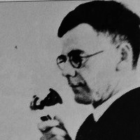

Full name: Mr. Alfred Hermann Traeger
Alternative names: Alf Traeger
Date of Birth: August 2, 1895
Place of Birth: Glenlee, Victoria, Australia
Date of Death: July 31, 1980
Place of Death: Rosslyn Park, South Australia
Gender: Male
Occupations: Communications Engineer, Electrical Engineer, Inventor
In 1928 a friendly but self-effacing Adelaide man, Alf Traeger, revolutionized communications in the Australian outback by inventing the pedal wireless. Working in close association with John Flynn of the Australian Inland Mission, he provided people in remote areas with a simple, cheap and reliable way of communicating with each other and, if necessary, requesting medical help.
Alfred Hermann Traeger was born on 2nd August 1895 at Glenlee, near Dimboola, Victoria, the son of South Australian-born farmers Johann Hermann Traeger and his wife Louisa (née Zerna). In 1902 the family returned to South Australia and Alfred attended the Balaklava Public School and the Martin Luther School, Adelaide. At the age of twelve he built a telephone line from his house to the toolshed, improvising the diaphragms from tobacco tins, the magnet from the prongs of a pitchfork and the carbon granules for the microphone from the charcoal of the kitchen stove.
In 1915 he gained his Associate Diploma in Mechanical and Electrical Engineering from the South Australian School of Mines and Industries. By 1923 he was working for Hannan Brothers in Wakefield Street, Adelaide, doing car generator and electrical repairs. In addition, he was building his own crystal sets, valve radios and transceivers, and in 1926 obtained his Amateur Operators Proficiency Certificate.
At this time John Flynn was also experimenting with radio for the A.I.M. and in 1926 he engaged Traeger as his assistant, at a wage of £6 per week. Over the next two years Flynn and Traeger toured the outback together, testing and attempting to improve the cumbersome and expensive transceivers then in use. What was needed was a set that could be easily operated, powered and maintained by people who knew nothing about radio. The pedal wireless, developed by Traeger in 1928, was essentially a floor-mounted generator (driven with bicycle pedals) which powered a radio transceiver capable of sending and receiving Morse code. In 1929 a base station was established at Cloncurry, Queensland, and the first pedal wireless set was installed at Augustus Downs station, 150 miles north. The first transmission was made on 19th June 1929 by Gertrude Rothery, the manager’s wife, to Traeger’s assistant, Harry Kinzbrunner, at Cloncurry. Due to Mrs. Rothery’s unfamiliarity with the equipment, the message, intended to be ‘Hello, Harry’, came out as ‘O hell, O hell, O Harry’.
Over the next eight years Traeger continued to manufacture and improve the pedal sets. He usually spent six months in his Adelaide workshop, followed by six months in the outback, installing the sets at homesteads, hospitals, missions and the bases of the Aerial Medical Service (later the Royal Flying Doctor Service). In 1931 he developed the automatic Morse keyboard (so that operators would not need to learn Morse code) and in 1935 telephony was introduced to the network. By the 1950s hundreds of Traeger sets were in use throughout the remote areas.
On 11th September 1937 Traeger married Olga Emilie Schodde and they had two daughters. He became an independent radio contractor, operating his business, Traeger Transceivers, from a factory at Marryatville. In 1944 he was appointed O.B.E. His first wife died in 1948 and on 2nd August 1956 he married Joyce Edna Mibus (née Traeger), a distant relation. She was a widow with two daughters, and she and Traeger had one son.
A quiet and unassuming man, Alf Traeger thought himself lucky because his hobby was his job. He died on 31st July 1980 and was buried at Centennial Park Cemetery. He is commemorated by a park in Alice Springs, a plaque at the Alice Springs airport and memorabilia in many R.F.D.S. bases.
The monument commemorates engineer and inventor of the pedal wireless,
Alfred Traeger (1895-1980).

Front Inscription
To commemorate the invaluable services of Alfred Traeger, O.B.E., whose invention of
1927 of the Pedal Generator Set and its development at Alice Springs solved the problem
of radio communication with the remote areas of the inland thereby making possible the
Flying Doctor Service operations throughout Australia.
Erected by the South Australian section of the Royal Flying Doctor Service 1968.

Traeger's knowledge of radio attracted Flynn who asked him to accompany him to Alice Springs to conduct some experiments and develop a cheap, efficient radio to connect people of the outback with a central station.
Traeger adapted a World War 1 idea.
The idea of using pedals to generate electricity, to create a transmitter-receiver, and in 1929 launched the Traeger Pedal Radio at a then cost of £33 ($66.00). By 1933 these sets were extensively used, and new models were frequently launched.
Traeger then overcame the problem of outback people having to use morse code by designing a morse keyboard, similar to a typewriter, which sent out the correct signal at the touch of a key. By 1939 he had developed a set which used vibrator units instead of pedals, however, as recently as 1962, the Traeger Radio Company was exporting pedal sets to Nigeria. In 1970 the School of the Air in Canada, and 20 developing countries relied on the Traeger Pedal Radio for communications in remote areas.

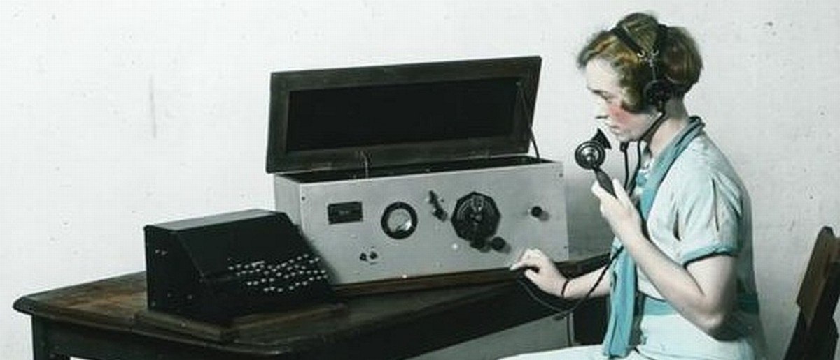

The Traeger Typewriter

by Robert Messenger

ETCetera No. 95 / September 011 / 9

Australia has produced at least one typewriter inventor—of sorts. Alfred Herman Traeger is best known for his development of a pedal-powered radio, which from the late 1920s provided a means of direct contact to the outside world for Aboriginal communities and white Australian settlers living in the nation’s vast “outback.” But Traeger’s wireless sets required a working knowledge of the Morse code, which few of the people in need of his radios had. In 1933, Traeger overcame this problem by devising a Morse typewriter.
When he developed his wireless, Traeger was aware of earlier, World War I-era pedal powered electricity generators. As a young man, he had seen a travelling Pathé picture show, the screening of which was made possible by a bicycle-mounted power unit. While it generated only a low voltage, it gave Traeger the idea he would, in 1929, turn into the vital element in the success of the Royal Australian Flying Doctor Service.
As one biographer would have it, Traeger made “generator armature winding an art form.” His two-way network became “the heartbeat of outback life.”
The Traeger Morse typewriter is rudimentary to say the least, yet it was highly functional. Strictly speaking, the Traeger “typewriter” is no more than an automatic Morse keyboard. While it resembles a typewriter, it simply comprises of keys connected to a working face of pivoted steel bars, with notched long and short spacings corresponding to the Morse alphabet. An oil-filled dashpot was necessary to produce smooth movement of the keyed arms.
Yet the Traeger machine helped provide what the Flying Doctor Service founder, the Reverend John Flynn (right), had described as a “mantle of safety” for Australians living in extreme isolation.
An image of “Flynn of the Inland” is featured on the Australian $20 note, and Flynn is revered within the Uniting Church as one of its equivalents of a saint. Traeger, on the other hand, is almost forgotten. Though he continued inventing almost to the time he died, in 1980, and though his pedal-powered radio was later used to aid people in parts of Africa and North America, Traeger’s achievements have disappeared from Australian consciousness. Alfred Traeger was born on August 2, 1895, at Glenlee, near Dimboola, 225 miles north-west of Melbourne in Victoria, Australia.
His father, Johann Traeger, was a farmer, born in South Australia, where Johann’s German parents had migrated in 1848. Johann took his family back to South Australia in 1902, when Alfred was seven. The Traeger’s settled near Balaklava, 58 miles north of Adelaide where Alfred attended the Balaklava Public School.
Alfred was described as a “curious, patient, precise child.” At the age of 12 he made a crude but effective telephone receiver, and was able to transmit between the tool-shed and the family home, 55 yards distant. Traeger used whatever he could lay his hands on: bits and pieces of equipment from around the farmyard were patched together to make a microphone and earpiece; the diaphragm for the earpiece was made from a tobacco tin lid, the magnet was the prong of a pitchfork and the carbon for the microphone came from the kitchen stove. Farm fencing wire was also called into service.
Traeger was sent to the Martin Luther School in Adelaide before spending two years at a technical high school. From 1912 he studied mechanical and electrical engineering at the South Australian School of Mines and Industries, gaining an associate diploma in 1915. Traeger’s special interests were in ammeters and generators. He went to work for first the Metropolitan Tramways Trust and later the South Australian Postmaster-General’s Department.
By the outbreak of World War I, Traeger had also developed a passion for aircraft, and during the war he tried to enlist with the Australian Flying Corps. However, he was turned down because of his German ancestry, even though his grandparents had long since become naturalized Australians.
Traeger’s bent for inventing led to him applying to the US Patent Office in March 1920 for a combined variable-speed clutch and free-wheel device for motorcycles.
In 1923 Traeger joined Hannan Brothers in Adelaide, handling their car generator and electrical repairs.
He had already become intrigued by radio. While at the school of mines and industries, Traeger had studied the work of Guglielmo Marconi and Heinrich Hertz on the nature of radio waves. Traeger obtained an amateur radio operator’s licence, with the call sign VK5AV, and became a member of the Wireless Institute of Australia, the oldest amateur radio society in the world (established 1910).
For his initial practical examination at the school of mines and industries, Traeger had to build a high-voltage generator.
It was through this device that, in 1925, Traeger was introduced to John Flynn. On a salary of £500 a year, Traeger joined Flynn’s mission.
Flynn had founded the Australian Inland Mission of the Presbyterian Church of Australia in 1912, and in 1928 the AIM established an Aerial Medical Service.
At the time of meeting Traeger, Flynn had declared “the practicability of the Flying Doctor proposal depends almost entirely on the widespread adoption of wireless by bush residents.” In 1926 Flynn and Traeger carried out wireless experiments in outback areas and succeeded in transmitting the first radio telegram. But the awkwardly sized and weighted, heavy-duty copper oxide Edison batteries proved unsuitable for remote homesteads.
Traeger overcame this problem by inventing a small, low cost (£33 each), durable, easy-to-operate pedal-driven generator which was “comfortably” capable of producing 20 watts of direct current power at a pressure of 300 volts, sufficient to run a high frequency transceiver. He enclosed the generator’s flywheel and gears in a cylindrical metal housing, with pedals outside and a cast base to be screwed on to the floor beneath a table. Traeger built the transceiver into a box, employing a master switch to separate the crystal controller transmitter from the receiver.
From 1929, Traeger travelled to outback areas across Queensland, South Australia, the Northern Territory and Western Australia, installing these sets and teaching the users Morse code and how to use their radios. He found, however, that for many people, grasping a working knowledge of the Morse code presented a fresh challenge. So in 1933, Traeger invented his typewriter Morse keyboard, enabling outback users to type their message in plain language and have it transmitted in Morse and then to have their message repeated back to them by listening to the voice transmission from the more equipped base station.
He later developed a voice capable transceiver. Traeger was honoured for his work with the Flying Doctor Service (as it had become known in 1942) by being appointed an OBE (member of the Order of the British Empire) in 1944. Traeger had suggested the idea of a School of the Air, and in 1951 this became a reality through the work of Adelaide Laetitia Miethke, a South Australian teacher.
Traeger continued inventing: In 1974 he patented a gas turbine-driven car and used solar power to convert salt water to fresh water. He died on July 31, 1980, at Rosslyn Park, Adelaide.

