Traeger’s Pedal Radio
January 23, 2019Written by Graeme Ussing
Leave a Comment
Most Aussie’s are aware of the Royal Flying Doctor Service and many of us have had need of this great service a few times in the bush. From humble beginnings the RFDS now has evolved into the most comprehensive aerial medical service in the world. More than 60 aircraft working from 21 bases care for some 300,000 people each year.
A chance meeting with a young electrician was to solve one of John Flynn’s greatest problems in creating the Flying Doctor Service. Flynn had raised enough money to start the service, he knew he could find suitable doctors and aircraft, but he could not overcome the problem of communication. What was the use of a Flying Doctor if the sick and injured of the outback could not contact him in a hurry? The answer was radio, but radio technology in the 1920’s was still very primitive. Flynn needed something that had not yet been invented; a simple sturdy radio transmitter-receiver with an in-built power supply. A device anyone could operate under all conditions.
John Flynn was able to enlist the services of radio enthusiast, George Towns, who helped assemble a bulky and complex outfit to be fitted to the back of a new Dodge buckboard (utility). While in Adelaide preparing for a test trip to the outback, Flynn and one of his experts, Harry Kauper, discovered that the two generators supplied with the radio were totally unsatisfactory. The radio-telephone was to be powered by a generator run from Flynn’s car engine, but the generators were unsuitable. Kauper remembered that a young electrician, Alf Traeger, might have a suitable replacement. Flynn hurried to Hannan Brother’s workshop, found Traeger and purchased a 600-volt generator.
The radio worked, and Flynn’s trip proved that mobile communication was possible. However, Flynn realised that a complicated radio powered by a car engine and a huge generator would be unsuitable for emergency service. Kauper persuaded him to settle for a less complicated radio using Morse code for communication and much less power to run. But even this type of equipment was not available, and Flynn returned to Traeger for help.
Alfred Hermann Traeger was born in the family home at Glenlee, about 25 kilometres from Nhill in the Wimmera district of Western Victoria. Alf, together with his two older sisters and younger brother, were brought up in the traditional German-based Lutheran manner which probably included a German-speaking teacher at the local school. When aged 12, Alf’s family moved back to the old Traeger farm at Balaclava in South Australia. Alf enrolled at the Adelaide School of Mines where he studied engineering. He eventually became an electrical engineer winding generators at Hannan’s Garage in Wakefield Street in Adelaide. It was here that he first met John Flynn.
John Flynn was an ideas man. He was a tireless worker with an immense vision of the needs of Outback Australia. He knew people died regularly and needlessly in the outback due to lack of access to doctors. John Flynn had a vision of doctors flying quickly to all isolated parts of Australia to provide what he called a ‘Mantle of Safety’ over the bush. Flynn also knew that any idea of connecting isolated station properties by telephone were totally impractical. The cost of building and maintaining telephone lines could not be justified. John Flynn believed radio was the answer and he sensed that Alf Traeger had the ability, the quiet religious zeal and the youthful enthusiasm to help Flynn develop a suitable radio.
During the next two years Traeger helped Flynn with his experiments. One important step was to develop a radio powered from a 32-volt electric lighting plant. These units were becoming popular with farmers requiring power and many thousands were installed in Australia between 1930 and 1950. The first base station was installed at Alice Springs and smaller outpost radios set up at Hermannsburg and Arltunga. After some minor problems these sets worked satisfactorily for some years. However, the cumbersome radios with their heavy banks of batteries were only suited to stationary situations and Flynn badly wanted a simple portable radio.
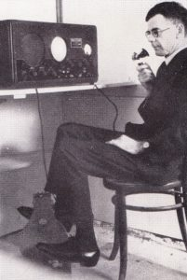
Simple portable radio
Traeger continued to work on the problem and eventually invented a foot-powered generator, pedalled like a bicycle. Radio historian, Mervyn Eunson, claimed that ‘it was Traeger’s inventive genius, his down-to-earth engineering skills, and his experience in winding electrical armatures which set him apart in Australian history as the solitary individual mastermind behind the creation of the unique pedal wireless generator’. Traeger’s mobile pedal radio was ready to go into production.
Within six months Alf Traeger had arranged for an Adelaide engineer to do the difficult job of machining the pedal generator gears. Alf had also worked tirelessly to build ten ‘baby’ radio sets and the 5CL radio station in Adelaide built a base station to serve what was to be the first of John Flynn’s cluster of outpost radios. By mid-1929 Traeger’s pedal radios were being installed in outlying areas around the much larger mother set or base station installed in the church vestry in Cloncurry.
Traeger spent five months installing ten pedal radios and teaching people to operate the Morse-code system. Learning Morse-code was a time-consuming task and, in most cases, left to the women of the station. One radio was installed in the Birdsville Hospital and operated by the two nurses in attendance. Birdsville was one of the most isolated towns in the outback but the hospital was usually busy due to the number of drovers using the Birdsville Track and the reliance placed on Birdsville by station people. Unfortunately, the hospital radio failed at a critical time when Sister Maude Gilbert developed peritonitis and eventually died.
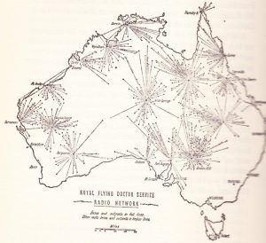
The beginnings of the RFDS radio network

Alf Traeger was constantly on the move either installing new radios in the bush or working on new modifications in his Adelaide workshop. He soon found that the sets needed to be built in a metal cabinet because white ants quickly ate the wooden ones. Improvements in radio technology also meant that radios constantly needed modification but one of his most difficult problems was to overcome the difficulty station people had with the use of Morse code.
Morse-code was required because the broadcasting of sound took too much power resulting in the need for a very large power supply and radio unit. Traeger also found that he didn’t have time to teach each individual operator, but the use of the correct number of dots and dashes was imperative to understanding messages. Traeger puzzled on this problem for some time before conceiving the idea of building a machine to send the code. His machine was ingeniously simple; use a keyboard similar to a typewriter and link each arm to a device which would send the appropriate signal. This new Morse keyboard was successfully used until sound technology became viable in 1935.
Improvements to radio technology brought sound reception and transmission to outpost radios in 1935. Sound also brought about the ‘Galah’ session which started each morning at 7 o’clock, about the time the galahs started waking from their night’s sleep and started screeching in the gum trees. Each morning Sister Amy Bishop, from the Birdsville Hospital, called women from Clifton Hills, Pandi, The Bluff, Beetoota, Bedourie and Monkira. Each had the opportunity to discuss the common things of life, a pleasure before denied to them. This simple act of communication broke the isolation and loneliness suffered by people in the bush. The Galah session became an institution throughout Australia; a feature of the outback now replaced by, but not improved upon, by the telephone.
When Australia came into World War 2 families operating Traeger transceivers suddenly found that they were able to pass on vital information, especially when Japanese planes started bombing Darwin and Broome. Isolated homesteads around the northern coast were able to alert army intelligence about waves of bombers flying overhead. Special radio operators were recruited by Major Basil Hall to undertake secret intelligence work along the northern coast and the islands of the Timor Sea. Many of these men carried with them portable Traeger radios. Both men and radios were required to work in appalling conditions
The Traeger factory continued to develop and refine radios for the outback. Even when most radios were now battery operated improved pedal radios were built especially for drovers and travellers. Twenty specially modified pedal radios were built for use in Nigeria and Traeger’s first portable hand-held two-way radio was built in.
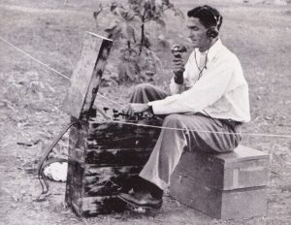
Portable radio
The Flying Doctor flew on his first mission on 17th May 1928, and soon after that so many outback folk were demanding the pedal radio that Traeger could not keep up with the demand. Flynn rejoiced, “At last the dumb Inland speaks”, even though it was in the stuttering accents of Morse code keyed by amateur hands, including John Flynn himself.
Fifty years later the Flying Doctor’s “Mantle of Safety” woven from radio, aviation and medical care, had covered the remotest parts of the outback. The radios have become compact little units that are used as simply as a telephone, but they are the direct descendants of Alf Traeger’s pedal radio.
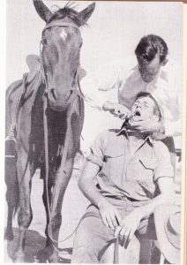

How Alfred Traeger gave the outback its voice

DATE PUBLISHED
27 Sep 2019
During 2018, almost 40,000 Australians were flown by the Royal Flying Doctor. Most of these flights began with a call for help, letting the pilots, flight nurses and doctors of the RFDS know they’re needed, but making that call hasn’t always been as simple as picking up the phone or switching on the radio.
In the mid 1920’s Alfred Traeger invented the pedal powered radio, revolutionising communication in the outback. The invention was integral to the founding of the Royal Flying Doctor Service, allowing the Service to make contact with the people who needed their help and vice versa.
The radio was the product of Alfred Traeger’s lifelong love of inventing which is something his daughter, Anne Smallwood, remembers well. “He would always be drawing circuit diagrams of some sort...in later years I can remember he was making an orbital engine that was going to use a third of the amount of petrol compared to a normal engine...and the other thing that he had was that he converted the whole roof of the flat that we had attached to our house into a desalination plant”. Even as a child Traeger was drawn to inventing. “He set up a telephone connection between the shed, which was some distance away, and the house just using things like charcoal from the stove and bits of fencing wire and it worked! It wasn’t just electronics that fascinated him, it was also anything scientific.”

Traeger’s love of radio never left him and it even flowed over into his parenting techniques which Ms Smallwood has fond memories of. “I’d go to bed and then I’d call out to him in the next room. He’d say ‘I’m not going to answer you unless you talk in Morse Code...and so I had to learn Morse Code in order to talk to him from my bed at night. Naturally the conversations didn’t last very long!”
During his twenties, Traeger worked repairing car generators and doing electrical repairs, alongside building his own valve radios and transceivers. Then, in 1926, he gained his Amatuer Operations Proficiency Certificate. At this time, RFDS Founder, the Reverend John Flynn was also experimenting with radio. Flynn was looking for a radio and heard that Traeger had one.
Flynn quickly realised Traeger’s talents and hired him as his assistant, paying him six pounds per week. They headed to Queensland and over the next two years, traveled to the outback together testing and attempting to improve the problematic transceivers that were being used at the time. They needed to develop a radio that could be easily operated, powered and maintained.
Graphic: Gertrude Rothery of Augustus Downs Station
In 1928 Traeger developed the pedal-powered radio. A floor mounted generator, driven with bicycle pedals, powering a radio transceiver which could send morse code. The following year, a base station was established at Cloncurry, Queensland and the first pedal wireless was installed at Augustus Downs Station, 150 miles out of town.

The first transmission was made on the 19th June, 1929 by Gertrude Rothery, the manager's wife, to Traeger’s assistant Harry Kinzbrunner at Cloncurry.

Over the next 8 years Treager continued to manufacture and improve the pedal sets, installing them at homesteads, hospitals, missions and the bases of the Aerial Medical Service, which later became the RFDS.
By the 1950’s hundreds of Traeger sets were in use. Betty Marchant, from Eromanga, remembers using one and she says they were monumentally beneficial in helping with the isolation that came with living in the outback. “All around they had what they’d call the Galah Sessions and every morning people would come on and have a yack and people would share stories or news. What your kids were up to and if there was rain or if somebody had gotten lost or anything, it was just a general gossip session!”

Treager’s sets didn’t just help to improve health and combat isolation in the bush. Ms Smallwood the pedal-powered radio also greatly improved education. “I can remember one day when he was really excited because he wanted to show us the School of the Air sets that he’d just invented and they had been a roaring success. He saw that as a huge plus...that the kids of the outback could have access to some sort of normal education. That really gave him a buzz.”
Despite all of Traeger’s remarkable achievements he was an incredibly humble man. “He wasn’t proud of it, it was just something that he did and he was pleased to do. He didn’t see it as anything particularly wonderful, he just saw it as an opportunity. In 1944, Traeger was awarded an Order of the British Empire, Ms Smallwood said it was years before he shared news of the award with his family.
Traeger's sets spread across two thirds of the Australian continent, covering more than five million square kilometers and they are now recognised as a fundamental element in the inception of the RFDS in Australia, allowing people in the outback to contact the Service no matter where they were.
To hear more about Traeger’s life and his remarkable inventions, listen to the RFDS Queensland Section website here.

Pedal-powered radio brings back memories for creator's daughter
ABC Northern Tasmania
/ By Fred Hooper
Posted Wed 10 Aug 2016 at 11:47amWednesday 10 Aug 2016 at 11:47am
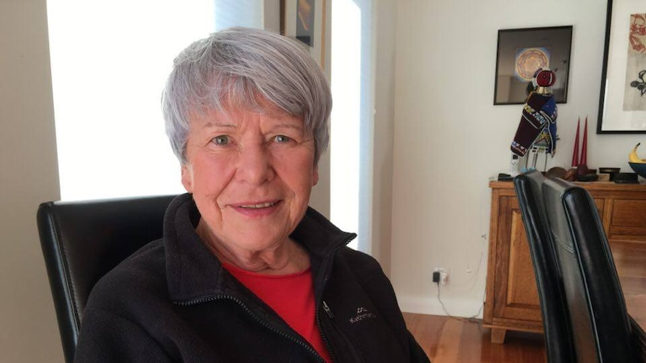
When she went to bed, Ms Smallwood would talk to her father in Morse code.(ABC Northern Tasmania: Fred Hooper)
Help keep family & friends informed by sharing this article
abc.net.au/news/pedal-powered-radio-brings-back-memories-for-creators-daughter/7712918
Link copied
COPY LINKSHARE
As a young girl, Anne Smallwood remembers her father tinkering and inventing, and one of his inventions is still used today in rural and remote parts of Australia.
Alfred Traeger invented the pedal-powered radio that was used by the Royal Flying Doctor Service (RFDS), and one of the original radios is kept at the RFDS base in Launceston.
Visiting family in Launceston, Ms Smallwood recalled her father's experiments after seeing one of the radios at the base.
"The technical details will escape me entirely because the gene skipped my generation altogether," Ms Smallwood said.
"The idea basically was that you needed power for these sets to work, and the power was generated by the turning of the pedals."
Because she was quite young when her father was creating and tinkering, Ms Smallwood admits the significance of her father's invention was a little lost on her.
"It wasn't until I was quite a bit older that I realised that maybe it was a bit special," she said.
"He was fortunate in that he was in the right place at the right time. I keep saying to people that if he hadn't done it, someone else would have."
John Kirwin, former Launceston General Hospital (LGH) chief executive and now Royal Flying Doctor chief executive in Tasmania, said he was amazed by the longevity of the pedal-powered radio.
"I find it interesting coming out of the LGH, where we talk about digital technology and broadband and telehealth, to now work for an organisation that have been doing it for 90 years," Mr Kirwin said.
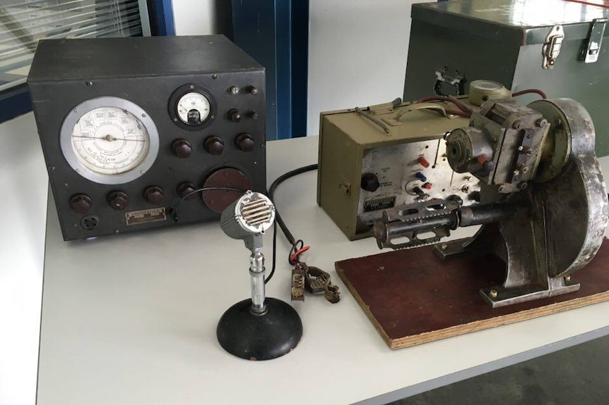
One of the original pedal-powered radios invented by Alfred Traeger.(ABC Northern Tasmania: Fred Hooper)
Along with coming up with the idea for the pedal-powered radio, Mr Traeger actually suggested School of the Air, where the radios were used for children in remote areas.
"So there's a whole generation of children that were educated through that communication," Mr Kirwin said.
"And those that have worked in remote and rural areas know that the RFDS radio network is what is used to say 'Look, I'm travelling down this track, I'll call in'.
"[It is part of] all of those sorts of safety nets that those of us who live in cities now just forget."

Saturday afternoons spent in the workshop
Ms Smallwood has fond memories of her father, saying he was a particularly shy and religious man, but he had a certain way of making sure his children were included in his inventive lifestyle.
"He would take us down to his workshop, which was the factory in Marryatville, and that was our Saturday afternoon outings I suppose," Ms Smallwood said.
"He'd buy a tub of ice cream and we'd sit down there while he'd do his drawings and his circuit drawings and intentions.
"When I went to bed I would have to talk to him only in Morse code, so I would do the dots and dashes for goodnight, which is fine, but much further than that and the conversation would peter out quite quickly."
Coincidently, Ms Smallwood's son now works with the RFDS in Tasmania, which she describes as a nice way to round out the involvement with the medical service.
"That gives me a lot of pleasure and I think it would give Dad an enormous amount of pleasure, to know that somehow Michael has ended up working in the Royal Flying Doctor Service," Ms Smallwood said.
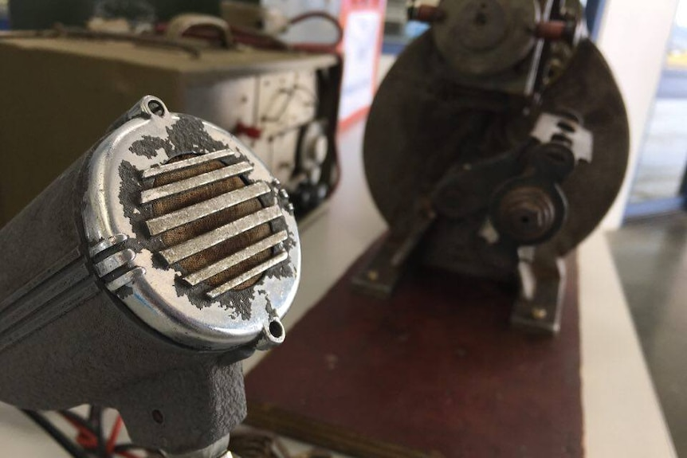
"It wasn't until I was quite a bit older that I realised that maybe it was a bit special," Ms Smallwood said.(ABC Northern Tasmania: Fred Hooper)

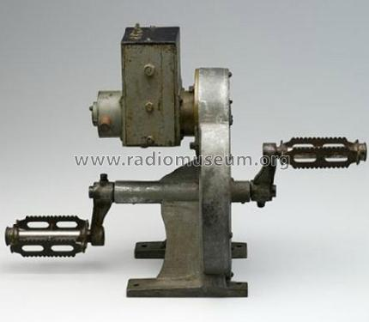
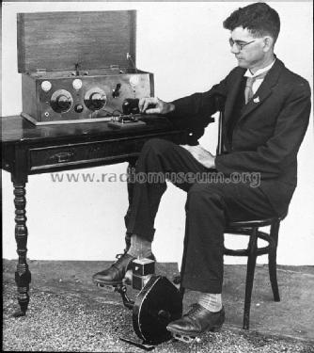

Country:  Netherlands
  Brand: | Philips; Eindhoven (tubes international!); Miniwatt
  Developer: | Philips; Eindhoven (tubes international!); Miniwatt
  Tube type: | Triode, vacuum Power/Output
   | Ca. 1925 up to 1945 rare.
Identical to | B205 = BX604 = P2_Record = P215_Marconi
Similar Tubes | Normally replaceable-slightly different:  215L ; KP2C ; M72 ; P215_Mazda ; P2_Commontype ; SP2_Triotron  Other base:  B205_UX4
First year | 1926 Tube leaflet collection E.Erb Analysis by original leaflets
First Source (s) | 15.Jan.1926 : Radio Luistergids, The Netherlands

Base | Europe 4-Pin B4 (Eu A, E, 4A) 1914 (Codex=Eo)
Was used by | Radio/TV-reception etc.
Filament | Vf 2 Volts / If 0.15 Ampere / Direct / Battery =
Tube prices | 1 Tube prices (visible for members only)
Information source | L'ABCDaire des lampes de TSF des jeunes années p. 33  - - Manufacturers Literature R149H 1-11-1926  Babani, International Radio Tube Encyclopaedia  Taschenbuch zum Röhren-Codex 1948/49

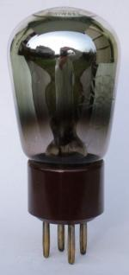

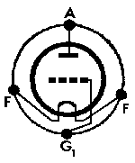 B205: RVF-Röhrenbuch-M1,1947  Anonymous 15 Collector | 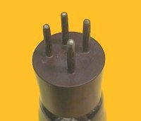  Just Qvigstad | 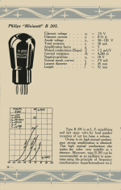  B205: own collection  Peter den Boer  More ...

Usage in Models | 1= 1926? ; 1= 1928? ; 1= 1928 ; 1= 1929?

Quantity of Models at Radiomuseum.org with this tube (valve, valves, valvola, valvole, válvula, lampe):4

- Valves / Tubes
- B205 A141 A141
- Main principle
- TRF (Tuned-Radio-Frequency but use of regeneration unknown)
- Wave bands
- Broadcast and Short Wave (SW).
- Power type and voltage
- Batteries / addl. power jack / 2 × 1.5 & 9 or 180 Volt
- Loudspeaker
- - only for Earphone!
- Material
- Wooden case
- from Radiomuseum.org
- Model: Pedal Wireless Baby - Traeger Transceivers Pty. Ltd.
- Shape
- Tablemodel, low profile (big size).
- Notes
- Alf Taeger with help from Harry Kauper built the first Pedal Transceiver in 1928 and the first practical test took place in November. Six Pedal Wirelesses were built in 1929, for the Air Medical service, the predecessor to the Royal flying Doctor Service.
The transceiver used a B205 triode as a crystal oscillator, output stage with an RF output of 1.5 W.
It transmitted Morse code on a frequency of 2230 kHz. Morse was used because voice transmission was not practical at the time due to the higher power consumption required. Low power battery valves suitable for voice transmission did not become available till mid-1930’s.
The 2 valve regenerative receiver used two A141 tetrodes. The receiver covered the broadcast band up to approximately 4 MHz.
The filament supply was from two 1.5 V dry batteries and one 9 V battery. Treager developed a pedal generator to supply the B+ producing 180 V.
Silicon Chip magazine of November 2010 describes a replica of this radio built by John Sheard.
- Mentioned in
- Silicon Chip magazine, November 2010, Page 98
- Author
- Model page created by Gary Cowans. See "Data change" for further contributors.
- Other Models
- Here you find 6 models, 4 with images and 1 with schematics for wireless sets etc. In French: TSF for Télégraphie sans fil.

Country:  Netherlands
  Brand: | Philips; Eindhoven (tubes international!); Miniwatt
  Developer: | Philips; Eindhoven (tubes international!); Miniwatt
  Tube type: | Space Charge Tetrode RF/IF-Stage
Identical to | A141
Similar Tubes | Normally replaceable-slightly different:  U107D  Other base:  A141_UV ; PR33_Condor
First year | 1925 Tube leaflet collection E.Erb Analysis by original leaflets
First Source (s) | 1924 : Saga of the Vacuum Tube, Tyne p.421

Base | Europe 4-Pin B4 + side contact
Was used by | Radio/TV-reception etc.
Filament | Vf 1.3 Volts / If 0.06 Ampere / Direct / Battery =
Description | Heizung 1 - 1,3V/0,08A; Sättigungsstr. 10mA; Ruhestrom 4,5mA; Anodenspannung 2 - 20V; Verstärkungsfaktor 4,5; Durchgriff 22%; Steilheit 1mA/V; Innerer Widerstand 4500Ω; Anwendung: H.A.N.L.; Preis 1927: 17,50ATS. Daten aus dem WEKA-Katalog 1927, Seite 163.
Information source | Radios von gestern, 2. Auflage Seite 227  - - Manufacturers Literature R149H nov. 1926  L'ABCDaire des lampes de TSF des jeunes années  Babani, International Radio Tube Encyclopaedia
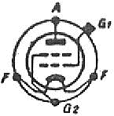 A141: W.Sprick: Austausch-Röhren-Lexikon 1947  Günther Stabe † 19.8.20 | 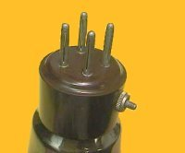  Just Qvigstad | 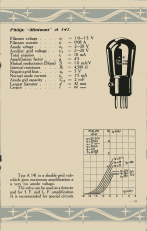  A141: own collection  Peter den Boer  More ...

Usage in Models | 4= 1925 ; 3= 1927 ; 1= 1928 ; 1= 1929 ; 1= 1930 ; 1= 1933

Quantity of Models at Radiomuseum.org with this tube (valve, valves, valvola, valvole, válvula, lampe):11

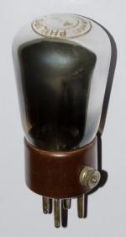

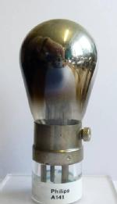

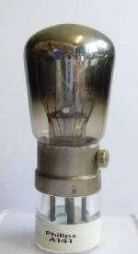

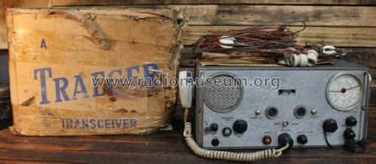
Traeger Transceivers Royal Flying Doctor Transceiver TS3 (2)
eBay sale in Australia _184239079344
PreviousNext
Technical Specifications
- Number of Tubes
- 1
- Valves / Tubes
- Number of Transistors
- 13
- Semiconductors
- Main principle
- Transceiver
- Wave bands
- Wave Bands given in the notes.
- Power type and voltage
- Batteries / addl. power jack / 12 Volt
- Loudspeaker
- Permanent Magnet Dynamic (PDyn) Loudspeaker (moving coil)
- Material
- Metal case
- from Radiomuseum.org
- Model: Royal Flying Doctor Transceiver TS3 - Traeger Transceivers Pty. Ltd.
- Shape
- Tablemodel, with any shape - general.
- Notes
- Royal Flying Doctor transceiver with Zephyr microphone.
Wavebands.
Receive | Transmit | Notes
550 - 1250 kHz |  | RX Only,Tunable
6.95 MHz | 6.95 MHz | Xtal Locked
5.41 MHz | 5.41 MHz | Xtal Locked
2.02 MHz | 2.02 MHz | Xtal Locked

- Literature/Schematics (1)
- - - Manufacturers Literature (Treager Transceiver Instructions.)
- Author
- Model page created by Keith Ellison. See "Data change" for further contributors.
- Other Models
- Here you find 6 models, 4 with images and 1 with schematics for wireless sets etc. In French: TSF for Télégraphie sans fil.

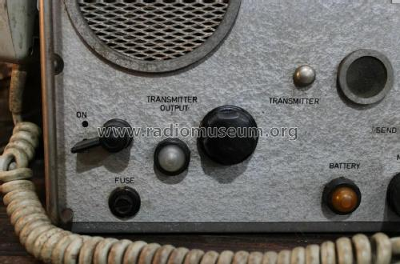
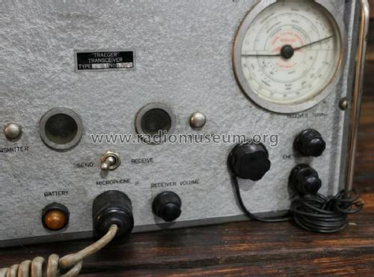

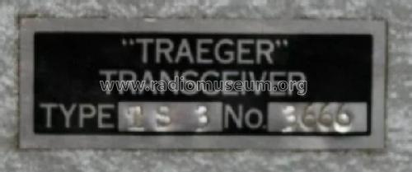

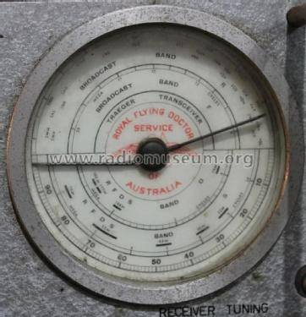

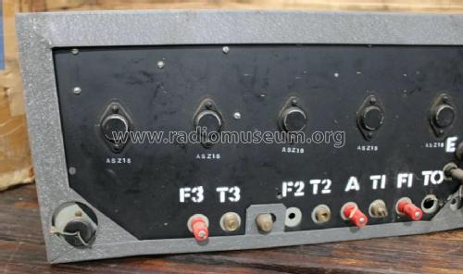

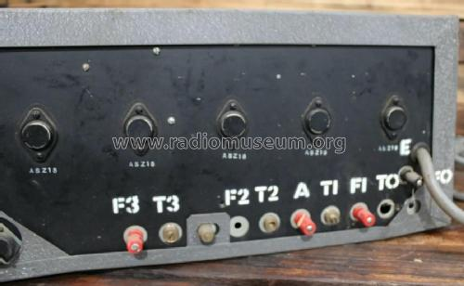

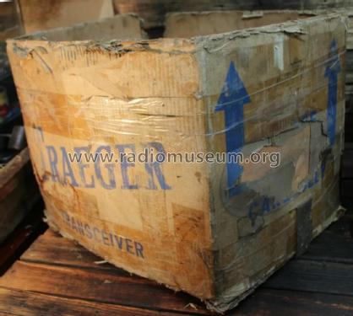

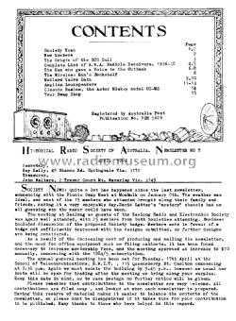

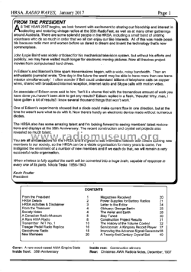

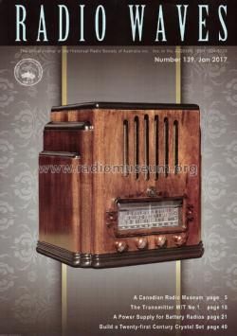

Foot Pedal Radio
Title : | Foot Pedal Radio | 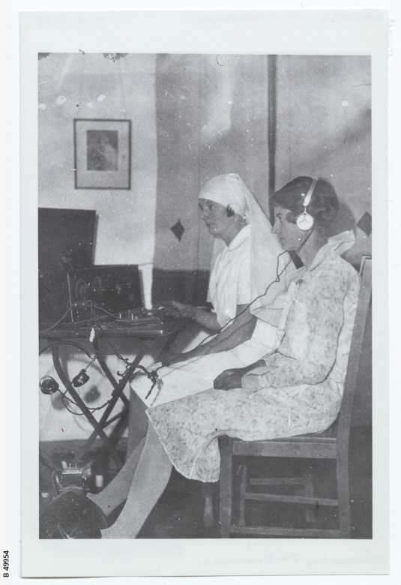
Date of creation : | ca. 1930
Format : | Photograph
Contributor : | State Library of South Australia
Catalogue record
The State Library of South Australia is keen to find out more about SA Memory items. We encourage you to contact the Library if you have additional information about any of these items.

Copyright : | Reproduction rights are owned by State Library of South Australia. This image may be printed or saved for research or study. Use for any other purpose requires permission from the State Library of South Australia. To request approval, complete the Permission to publish form.
Description : | The wireless pedal radio was invented in Adelaide by Alfred Traeger in 1927. Traeger had been working with Reverend John Flynn of the Australian Inland Mission (AIM) to establish radio communication for the Service. In 1929, the first pedal wireless for use by the AIM Aerial Medical Service (later the Royal Flying Doctor Service) was installed at Augustus Downs near Cloncurry, Queensland.  This photograph shows two nurses operating a pedal wireless.
Subjects | - flying doctors  - radio transmission  - schools by radio
Related names : | Traeger, Alfred
Period : | 1927-1939
Further reading : | McKay, James Frederick. Traeger: the pedal radio man: he gave a voice to the bush and to flying doctors, Moorooka, Qld: Boolarong Press, 1995  McPhee, Margaret. The dictionary of Australian inventors and discoveries, St. Leonards, NSW: Allen & Unwin, 1993  Port, Leo with Brian Murray. Australian inventors, Stanmore, NSW: Cassell Australia, 1978
Internet links : | BankSA Heritage Icons list (National Trust of South Australia) - Pedal radio  Royal Flying Doctors Service of Australia: See Our History

