48S20

Traeger Transceivers Pty. Ltd.; Adelaide
- Country
- Australia
- Manufacturer / Brand
- Traeger Transceivers Pty. Ltd.; Adelaide
- Year
- 1948
- Category
- Commercial Transmitter & Receiver (TRX not Amateur)
- Radiomuseum.org ID
- 284289
- Picture
- Schematics

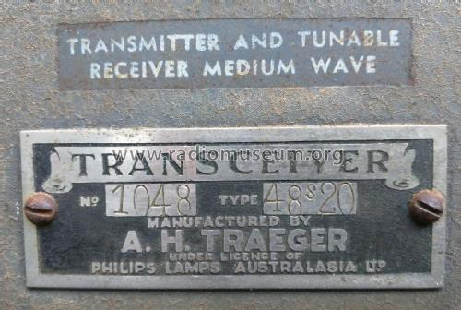
Traeger Transceivers 48S20 (1)
Technical Specifications
- Number of Tubes
- 10
- Valves / Tubes

- Number of Transistors

- Semiconductors

- Main principle
- Transceiver; 2 AF stage(s)
- Wave bands
- Broadcast and Short Wave (SW).
- Power type and voltage
- Storage Battery for all (e.g. for car radios and amateur radios) / 12 Volt
- Loudspeaker
- - This model requires external speaker(s).
- Material
- Metal case
- from Radiomuseum.org
- Model: 48S20 - Traeger Transceivers Pty. Ltd.
- Shape
- Boatanchor (heavy military or commercial set >20 kg).
- Dimensions (WHD)
- 590 x 310 x 360 mm / 23.2 x 12.2 x 14.2 inch
- Notes
- This set appears to be a higher powered version of the 48S3. 20W vs 3W? Crystal control of transmitter. Receiver continuous tune or crystal locked depending on mode. The receiver valves are the first five in the list.
- Net weight (2.2 lb = 1 kg)
- 41 kg / 90 lb 4.9 oz (90.308 lb)
- Literature/Schematics (1)
- - - Manufacturers Literature
- Author
- Model page created by Stuart Irwin. See "Data change" for further contributors.
- Other Models
- Here you find 6 models, 4 with images and 1 with schematics for wireless sets etc. In French: TSF for Télégraphie sans fil

