History of the manufacturer

Traeger Transceivers Pty. Ltd.; Adelaide

ID = 17114
As a member you can upload pictures (but not single models please) and add text.
Both will display your name after an officer has activated your content, and will be displayed under «Further details ...» plus the text also in the forum.
Name: | Traeger Transceivers Pty. Ltd.; Adelaide (AUS)
Abbreviation: | traeg
Products: | Model types
Summary: | Traeger Transceivers Pty. Ltd.  Adelaide  Alfred Hermann Traeger OBE (1895 – 1980) of Adelaide developed pedal transceivers for the Rev Dr John Flynn in 1927. Pioneering a simple radio communication system for people in the outback and providing the call system for Flynn's "mantle of safety" for the Australian inland Flying Doctor service  Alf Traeger transformed the lives of many outback Australians through his development of the famous ‘pedal radio’. This was an essential underpinning of the successful operation of the Flying Doctor Service established by the Rev. John Flynn and a contributor to the success of the School of the Air. Traeger was born in Dimboola, Victoria, but grew up in the Balaklava, SA district. He studied mechanical and electrical engineering at the South Australian School of Mines from 1912 to 1915 and worked for the Metropolitan Tramways Trust and the Post Master General’s Department. Traeger became an amateur radio operator (VK5AX) and formed a company, Traeger Transceiver Pty Ltd. His genius was to develop, in 1928, a portable, high frequency radio transceiver that could be used by non-technical people. The sets were cheap, durable, small and easy to operate. Bicycle pedals drove a generator which produced about 20 watts at around 200 volts.
Founded: | 1927
History: | Traeger went on to develop, in 1931, a Morse code keyboard which enabled people to send perfect code over the radio regardless of their skills. In the mid-1930s voice transmissions became increasingly common. The first pedal sets, introduced into Queensland in 1929, revolutionised communications in outback Australia and linked people with essential medical, educational and social support and reduced the sense of loneliness so much a feature of outback life. Traeger was a member of the Institution of Radio Engineers, Australia. He was appointed to the Order of the British Empire in 1944.  Alf Traeger lived on and went on inventing. He designed a turbine driven car and used solar power to convert salt water to fresh water. He died in 1980.
This manufacturer was suggested by Gary Cowans.

Some models:
Country | Year | Name | 1st Tube | Notes
AUS | 28 | Pedal Wireless Baby | B205 | Alf Taeger with help from Harry Kauper built the first Pedal Transceiver in 1928 and the f...
AUS | 48 | 48S3 | 1M5G | 6 Volt type vibrator powered Traeger Flying Doctor Radio.
AUS | 45 | 43A | 1M5G | This transceiver was made specifically for the Flying Doctor Service of Australia for use ...
AUS | 48 | 48S20 | 1M5G | This set appears to be a higher powered version of the 48S3. 20W vs 3W? Crysta...
AUS | 68 | Royal Flying Doctor Transceiver TS3 |  | Royal Flying Doctor transceiver with Zephyr microphone. Wavebands. ReceiveTransmitNo...
AUS | 66 | TS2 |  | Royal Flying Doctor transceiver.

[rmxhdet-en]
Further details for this manufacturer by the members (rmfiorg):
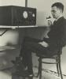
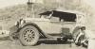

Forum contributions about this manufacturer/brand
Traeger Transceivers Pty. Ltd.; Adelaide

An excellent description of the Flying Doctor Network in QLD
Gary Cowans  03.Sep.21 | ONLY RADIO HAS MADE POSSIBLE THE FLYING DOCTOR  One-man-power Wireless Network in Far North Links Outpost and Enables Telegraphic Communication with World  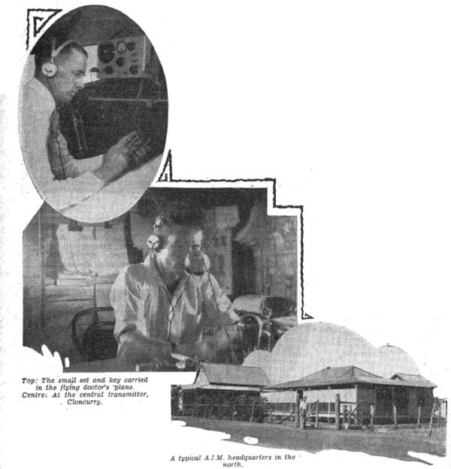  Before the Australian Inland Mission established its wireless station at Cloncurry in 1923, it was not unusual for a settler to have to travel a couple of hundred miles to reach the nearest telephone or telegraph station. In some cases a journey of this distance would take as long as a month, or if there had been recent heavy rains might be altogether out of the question. In the area covered by the A.I.M. Wireless Service, it is now possible to establish communication with the “outside” in a few hours. It will readily be realised what such a service means to the scattered settlers in the lonely parts and to isolated mission stations around the shores of the Gulf of Carpentaria, for example, at Groote Island and at Mornington Island. For about twenty years the Church has had a missionary at Mornington Island. The first was murdered by a half-civilised native from the mainland. His wife was forced to barricade herself in the mission house for a week until the small vessel. Morning Star, returned from a trip to the mainland and enabled her to escape. For fifteen years the island awaited the advent of the wireless system, and now the Morning Star has no longer to make long and hazardous journeys to keep open communication with the outside world, for every day the cheerful voice of the Cloncurry operator conveys them news, as well as telegrams, which in the old days could only travel the last part of the journey by lugger.  50 MILES TO TELEGRAPH  For Birdsville in the south, the nearest telegraph station is at Boulia, two hundred and fifty miles away. By linking Birdsville up with the wireless service, communication is provided for the settlers in that area, and the long, slow journey obviated. During the wet season, Birdsville may be isolated from the rest of Queensland for an indefinite period, for, while it does not rain very much in the district, the heavy rains in the north flood the rivers and so isolate the township. The nearest doctor is at Boulia, and the medical requirements of the community are attended to by the A.I.M. Sisters at the “Brisbane Home.” The doctor in charge of the Aerial Medical Service is able to wireless instructions to the nurses in the time of need. As with these two extremely isolated places, so it is, to a less degree, with every station established. It is interesting to note that communication with Groote Island, apart from letter, is entirely through the A.I.M. station at Cloncurry, and all the Press news comes through this channel.  CLONCURRY CENTRE  The central station of the service is at Cloncurry, 250 miles south of the Gulf of Carpentaria, and the centre of a very large area of sparsely-populated country, which, stretches to the shores of the gulf in the north, away into Northern Australia in the west, and south to Birdsville. Much of this country is without any telegraphic facilities, and during the wet season, it is quite possible to be cut off for weeks at a time. The broadcasting station at Cloncurry operates on three different wavelengths, according to conditions, 34 metres, 42 metres, and 146 metres, and uses the call sign VJI. The current for the transmitter is supplied by a 32 volt Lister Plant. This engine has to be switched on and off between the receiving and transmitting of messages, as the brushes on the generator cause interference with the incoming signals. It is hoped that the near future will provide a Diesel power plant, which will enable the operator to give at least three more hours actual operating time per day to the Pedal Stations.  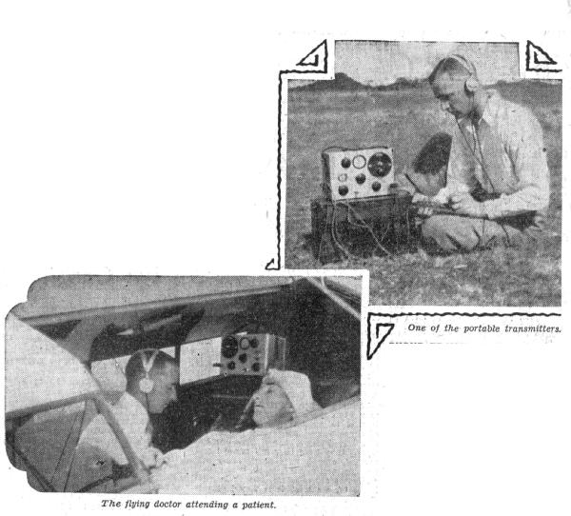  28 PEDAL STATIONS  There are twenty-eight radio outposts, or Pedal Stations, as they are called, in daily communication with the wireless base. These are distributed at various strategic points in the gulf country and Western Queensland, covering an area from Innamincka, 500 miles south, to the shores of the gulf in the north. Others are situated at Mornington Island, 100 miles up the gulf from Burketown, Groote Island, Milingimbi, and Goulboum Island, 750 miles away.  NO BATTERIES—GENERATORS  Years of experimenting proved to Mr. Alf. Traeger, who is now the chief radio officer, that battery power would be too expensive and altogether unsatisfactory for these outpost transmitters. Finally, he designed the simple form of generator now in use. Prolonged use under all conditions has proved that these generators are as efficient as they are simple. They are operated by a pair of pedals, similar to those of a push bicycle, and can generate a power of about 20 watts at a pressure of 200-400 volts. The gears are encased in an oil-tight casing, filled with oil, thus minimising wear. The transmitter is crystal controlled, the crystal maintaining the wavelength and keeping the note steady, thus making the signals easy to read, even if the generator is driven unevenly. The receiver is a three-valve regenerative circuit, the valves used being of the A109 types. The “A” battery is a 1.5 volt dry cell, and the “B” battery consists of one 45-volt battery. One set of batteries gives from four to six months’ service. By plugging in a larger coil into the receiver, broadcast programmes can be received under favourable conditions. Earphones are used generally, but at times a small loudspeaker can be used quite efficiently. The wavelength used at the Pedal Stations varies. Some operate on 34metres, others on 42 metres and 150 metres,'' according to conditions of the locality. Their call signs are prefixed by the number 8 in each case. The aeroplane used in the Aerial Medical Service always carries a receiving and transmitting set when on long trips or on new airways. This little set uses dry cells for its power and messages are sent out by an ordinary Morse key. By the use of this set, the aerial medical office is able to keep in touch with the operator at Cloncurry and receive any urgent calls which may have been received in his absence, and, if necessary, give advice from wherever he may be.  PHONE TRANSMISSIONS  Messages are sent out from the central station by radiophone, received at the Pedal outpost, and heard through earphones. But the transmitting plant at the outposts is not sufficiently powerful to send out the voice, so Morse code is used. This does not necessarily mean that the outpost operator has to be a skilled Morse code operator, for an ingenious automatic keyboard resembling that of a typewriter is part of the outfit at each Pedal Station. For each letter or sign of the code there is a corresponding key, which, when pressed home, turns a disc. After the finger has been withdrawn the disc automatically revolves, at a governed speed, to its original position. During the return, cams on the circumference of the disc make contacts, which, through the attached transmitter, produce at the receiving station 200 to 800 miles away a perfectly spaced Morse signal. Thus, any intelligent person may in a very short time become competent to send out a message. He sends out his signal in Morse mechanically, and simply listens-in to the voice of the operator from the base, who in turn receives and interprets the signals from the outposts.  WOMEN OPERATE TRANSMITTERS  Many of the women of the outback have learnt to operate the “baby” transmitting sets, installed for them by the Australian Inland Mission, and have become enthusiastic wireless fans. The wireless represents their link with the outside world. They maintain their operating efficiency in between times by having conversations with other Pedal Stations. At other times they are kept busy sending messages to the “Mother” station, ordering a new axle for the Ford, a roll of dress material, sending greetings to their friend in the bigger centre, and negotiating the many other items of business that arise in the management of a large station. When illness descends on the household, they are able to obtain medical advice promptly, and, if necessary, a visit from the Flying Doctor and swift and comfortable transport to a hospital is assured. Ability to call up the Flying Doctor by wireless is essential where no telephone or telegraph wires exist, and it is a great comfort to the settlers to know that they have this facility. Each year many consultations with the Aerial Doctor are made in this way. As an integral part of the Aerial Medical Service, the wireless is doing much to eliminate the dread of sickness and to remove the loneliness of the outer bush. Although this Wireless service is a charitable one, as are indeed all the services of the Australian Inland Mission, for the convenience of the man in the backblocks, in those cases where no telegraphic or telephonic communication is available, it receives telegrams from the Cloncurry Post Office and sends them on the- rest of their way through the radio. In the same way the station takes telegrams from the settlers and hands them into the post office for transmission. Last year 5600 telegrams, totalling 89,054 words, were handled, meaning a revenue of £390 to the Postal Department. During the first half of this year 3117 wires, totalling 55,831 words, and representing a revenue of £220 to the department, have passed through the Wireless base. The records at the “Mother” station provide an amazing testimony to the value of the “Service,” and are a tribute to the patience, tact, and good nature of the officer in charge, Mr. Maurie Anderson, whose voice is known and appreciated by hundreds of people dwelling in a wide area of the inland more than three times as big as the whole of New South Wales. Day after day, from sunrise to sunset, for the past three years, he has been sending cut messages of cheer, news items, telegrams, and even on occasions musical items to the outback dwellers of this far flung continent; and receiving their telegrams and other messages and sending them to the appropriate destination. Sometime this calls for infinite patience, particularly in that part of the year when electrical storms are bad and reception at the Pedal Stations is unsatisfactory. Under such conditions it may become necessary for him to repeat a message at least a dozen times before it is pieced together by the listener. Morse reception is not interfered with to the same extent as the radio-telephonic, but it is a tax on the equanimity of an expert wireless operator to sit for hours listening to the signals from the amateurs at the Pedal Stations. However, his sense of humour and cheerful disposition help him out on most occasions.  A moments reflection will enable those who have become used to the facilities in the favoured south to realise just what this service means to the men and women living in the back of beyond, and will move them to admiration for those untiring workers who have made such a service possible andhave brought happiness and contentment into the lives of these sturdy pioneers.  Wireless Weekly December 15, 1933, Pages 22, 23 & 104

