“ON AIR’
D G Sanderson. 1988

Presented to the Institution of Engineers Heritage Panel, Brisbane. August 1993.
(signed) D G Sanderson.
THE INSTITUTION OF ENGINEERS, AUSTRALIA
QUEENSLAND DIVISION
447 UPPER EDWARD STREET, BRISBANE, 4000
4RK GRACEMERE
Although the Queensland Government had obtained a license in 1924 to build a radio station in Rockhampton, it had not accomplished this before the formation of the National Broadcasting Service (NBS) had removed the Qld Government from further active interest in broadcast station operation.
In fact the station was built in 1931 by staff of the Postmaster General's Department (PMG) in conjunction with the equipment suppliers Standard Telephones and Cables Pty Ltd. 1 , as by this time the Postmaster General was responsible for all stations of the now national network.
This was the beginning of STC's involvement with the NBS, an effective association which was to last for the next 50 years with the supply of some 40 transmitters to Queensland and Papua New Guinea.
The siting of the station on a low hill at Gracemere 6 miles west of Rockhampton in sight of the city seems obvious enough to the casual observer, but was no doubt the result of a field investigation by officers of the Melbourne Research Laboratories of the PMG Department. Part of the historic Gracemere cattle station had been subdivided in 1920, and a 12 acre block was bought for the new station.
The transmitter building was in typical Queensland style, a low set bungalow of timber with a tiled roof. It was set back from the road nearer the crest of the hill at the end of gravel drive. At the front gate a house for the Foreman Mechanic was erected, also in timber. Both buildings are still in use, the latter having been occupied by station staff since the beginning. The transmitter building however, is not quite in its original form, some additions and internal modifications having been made over the years.
The T type aerial erected adjacent to the building was suspended between two tapered self-supporting steel towers 128 feet high. These were supplied by STC and had been designed by C.F. Elwell of 197 Queens Gate Road, London on a drawing dated April 1930. The towers were assembled on the ground and erected by jury.
The horizontal part of the T aerial was 60 feet overall and consisted of four parallel wires spaced 6 feet apart.
The earth mat for this aerial was composed of 95 parallel copper wires spaced 3 feet apart, each 180 feet long, buried below and at right angles to the flat top [the horizontal part of the T aerial].
The base impedance at the original frequency of 910kcs was 12 ohms and the transmitter supplied between 1.5 and 2kW to this aerial.
The STC transmitter, one of the first in this country to be crystal controlled, was installed by PMG Department staff with contractor supervision. The installation team was Les MacDonald, Harry Conway, Fred Emerson, Roy Ferguson, George Coley, Bert Jack, Ian (Blue) Hamilton and Nat Gould. The STC representative was Claud McQuillan.
This equipment represented ari intermediate stage in the development of large broadcast transmitters,
(Standard Telephones and Cables Ply Ltd (later STC plc) was a British researcher, developer and manufacturer of telephone, telegraph, radio, telecommunications, and related equipment. During its history, STC invented and developed several groundbreaking new technologies including pulse code modulation (PCM) and optical fibres. - Footnote added 2018 by Margret During, using information from Wikipedia.)
With direct current for filaments and anodes supplied by motor generators rather than the more conventional transformers and rectifiers. The transmitter was mounted within a metal cage about 8 feet square with black, polished front panels on which were meters, adjustable controls and switches. The motor generators were installed in an adjoining room which also contained the motor driven pump supplying cooling water for the valves of the power amplifier.
Filament supply at 24 volts DC and grid bias of 250 volts DC was obtained from a single motor, two
generator set, while the high tension supplies at 800, 1600 and 4000 volts DC were obtained from another single motor two generator set with the double wound armatures connected in series. Two complete suites were provided for main and standby operation. This room was known as the "machine room".
Low-level program amplifiers were rack mounted in the "amplifier room" with their batteries in a "battery room" next door.
A small repair room was also provided and an equipment spare parts store. There was no office or staff room, although the repair room was used later as an office.
Water supply was from rainwater tanks. The crystal controlled oscillator operating at 910kcs used two valves, 4102D and 4012A. This was followed by a class B separator 4242A driving the modulated amplifier, a class C 4212D. Heising choke anode modulation was obtained from a class A modulator, 4212D, driven by a speech amplifier 4211D (or MC1/75).
The mod amp was followed by a class B linear stage of two 4212D in parallel, and this drove a parallel pair of 4228A water cooled triodes giving 2kW to the aerial. A sample of the modulated output was rectified by a 4211D to provide audio monitoring.
All valves were triodes with DC filaments. To equalise emission, the direction of current flow in the filaments of the final valves was reversed daily.
A control desk equipped with a General Radio modulation monitor was situated facing the transmitter, and in the amplifier room with its three racks of audio and test equipment, was a studio desk fitted with a microphone and two turntables. The electric "pick ups" were Western Electric oil damped units using steel needles. It is not certain whether the control and studio desks were provided on installation or somewhat later. Existing photographs show type 663 microphone which is certainly not of 1931 vintage. If a microphone was supplied initially it would probably have been an early condenser type in a wooden box with 4102D amplifier, as this was typical of studio equipment at that time. It is believed that the GR mod monitor, 731A, was installed in 1935.
Opening day finally arrived and at 8 PM on Wednesday 29th July 1931 the great event took place.
It was held in the School of Arts and the official program for the evening shows that the local Musical Union Choir, assisted by the Rockhampton City Band, sang the National Anthem and "Advance Australia Fair", to open the proceedings.
Sir Benjamin Fuller, Vice-Chairman of the Australian Broadcasting Company introduced the speakers — Hon. A.E. Green, Postmaster General, Hon. Frank Forde local M.H.R. and Minister for Customs, and Alderman T. Lee the Mayor of Rockhampton.
Others present included Harry Brown the Director of Posts and Telegraphs, J.J. Verney of the Chamber of Commerce and the Anglican Bishop of Rockhampton F. L. Ash. Vocal and instrumental items were presented by Reg Robertson, R. Cruickshank, George Gardiner, C. Bibby, T. George, Edward Streeton, son of the choirmaster, E.N. and E.H. Symons and Mrs F. Oswald.
The program was relayed to stations of the Australian Broadcasting Company's "network" in other States.
At 10 PM, 4RK crossed back to the Brisbane program line and closed at 11 PM.
4RK was the first station in Queensland outside Brisbane, where 4QG was operating. In July of the following year, commercial station 4RO was opened in Rockhampton which became the first Queensland town to have two [radio] stations.
After some catastrophic events related to accidental high line levels causing damage to valves in the early days, the station settled down to routine operation. In those times with no audio limiters and only one transmitter, station staff lived in constant fear of disaster. Even the depth of modulation could only be roughly gauged by observation of the onset of grid current in the modulator valve. The first officer in charge was Harry Conway who stayed until 1936. In this period, the station surroundings were improved and an avenue of pine trees was planted between the street entrance and the transmitter building. Half a century later, they are a fine sight and a monument to those early station operators.
In November 1933, H.R. Adam, an engineer of the PMG Research Labs in Melbourne, visited 4RK and made a series of field strength measurements to determine the polar pattern produced by the T aerial. The shape was irregular, thought to be due to the steel aerial support towers and the rocky nature of the surrounding country. His Research Labs Report is number No.257.
Due to the direct connection of the aerial at the transmitter output, some instability due to the high RF field was troublesome at times, and when a new transmitter was installed, the aerial circuit was altered to permit the location of the aerial tuning equipment in a metal box at the base of the down lead and to feed this by a transmission line from the transmitter.
An emergency power supply for the station was obtained from a three-phase alternator of 33.6kW rating, driven by petrol fuelled Gardner engine. It may have been installed in 1931, but this has not been confirmed. It was mounted in the machine room but was moved to the north-west corner room of the building in 1948.
During 1948 a new transmitter was installed to replace the original STC. This was a 2kW AWA type 4J5129R, serial No.7. The valve line up was oscillator 42 pentode, followed by a three stage amplifier using type 807 buffer push pull 805, final parallel push pull 833A. The audio submodulation used two stages of triode connected 6J7G followed by a mod driver 8003. The modulator used four 833A in parallel push pull. High tension rectifier was six mercury vapour diodes type 872A.
Geoff Beetham supervising technician, with Bill Graham-Wilson and Col Crick went to 4RK in July 1948 to install this new transmitter and dismantle the original equipment.
The old STC transmitter and its motor generators were removed and the emergency engine generator repositioned. This Gardner engine was very large and its shift to the new area in the north west corner of the building was a difficult operation.
The holding down bolts were cut and the engine jacked up and placed on rollers. Using crowbars as levers it was rolled into the new position and jacked up. Then with the aid of some wallaby jacks borrowed from the local line depot the engine was slid sideways along greased wooden beams. The jacks worked against one wall of the building and great fears for the stability of the whole structure beset the 4RK OIC Bert Cowling. However, no damage was done and finally the engine was lowered onto its new bolts and secured to the concrete bed block.
The AWA transmitter was installed where the Gardner had been and was connected to the aerial by a run of coaxial cable. For the first time, a coupling box was mounted below the aerial and the coax matched in this with a simple L—C network. This removed the problems which had been present with the direct feed from the original STC transmitter. The old "machine room" floor was built up with concrete and made ready for a new STC 10kW transmitter. The installation team unpacked this but did not install it as no aerial was available at that time for a 10kW output.
This new transmitter had been ordered for the proposed new Longreach site at Cramsie, but was diverted to Gracemere as Longreach was not likely to be established for some time due to various delays with property and building plans.
Proposals to enlarge the scope of 4RK included a vertical radiator and earth mat to go with the new 10kW transmitter, so additional land was required. Two blocks totaling 38 acres adjacent to the site were acquired from John Gilmore and William Thorsen, giving a neat 50 acre rectangular site large enough for the new aerial system. The acquisition was noted in Commonwealth Gazette No.241 of December 1947.
The station operating frequency was changed in September 1948 from the original 910 to 940kcs.
About this period in the late 1940s, building alterations were made and the present office added onto the eastern side. The old battery room area was modified to provide a staff lunch room.
To augment the rainwater supply a bore was sunk in October 1949, 75 feet deep and 8 inches in diameter. Water was tapped at a depth of 50 feet. This supply was in use until 1971 when silting and corrosion rendered it ineffective. A new bore was drilled by "Drill Engineering and Pastoral Co." of Rockhampton and remains in service, although town water was connected in 1978. In 1951, equipment was installed in the recently completed control room and is described in a report by engineer Frank Sharp. The equipment was a mixture of AWA, STC and locally made items and included a new control desk with microphone and gramophone turntable. The installation was ready for us in December 1951.
The new radiator was erected by Johns and Waygood, using five men, between 6th April and 15th June, 1954. It was sectioned with an inductor at 320 feet with, at the top, at 420 feet, a 30 feet diameter top loading armature, giving an electrical height of 0.50 wavelengths. The base resistance was 86 ohms. Frank Sharp adjusted the radiating system.
An earth mat laid by Radio Section line staff, comprised 120 radials each 420 feet long of 2001b per mile hard drawn copper wire.
The figure of merit of the new radiator and the field survey to determine the service area were subject to an investigation by Doug Sanderson and Maurice Palmer in September and October 1954.
The new transmitter was installed by Gordon Gilbert, Ian Byrnes and Col Williams and was put into service on 15th September 1954.
On the 1st September, the station frequency had been changed from 940 to 840kcs, the readjustments being made by Ralph Bongers, supervising technician and Bill Rohde, divisional engineer of the Brisbane office.
As the new transmitter used a 200 ohm, 6 wire transmission line, a matching unit and switch for the AWA 2kW transmitter was built so that it could operate into either the new aerial or the old. The transmission line to the old aerial was a length of 70 ohm coaxial cable.
The valve line up for the 10kW transmitter was oscillator 6V6G, isolator 6V6G, buffer two B07 in parallel, driver push pull TG10 and final high level anode modulated stage of two 3J221 E triodes in push pull. The audio chain was push pull throughout. First audio 6J7G, second audio 6V6G, third audio 3CA50A, driver to mod TG10 and modulator 3J221 E. The EHT rectifier used six 4078Z mercury vapour diodes, giving a DC supply of 10,000 volts.
These valve rectifiers were replaced in 1975 by silicon diodes. The bias and 2600 volt supplies had been converted to silicon diodes in 1960.
The original rubber insulated wiring of the power amplifier stage deteriorated quickly and was replaced by Gordon Gilbert in March 1962, the unit being at that time about 14 years old.
This large impressive transmitter was painted in what was the standard STC colour at that time, a creamy orange known as "Corio Sand". In October 1963 a 2kW STC transmitter, type 4SU-14C recovered from 4QN, was installed in the transmitter hall and replaced the AWA as a standby. The latter then went to 4QB Pialba which already had a similar unit.
The RF exciter of the 14C used 6V6G and 807 valves, a driver of 3C/150A and a push pull pair of large glass envelope triodes 4279Z. The first two audio stages were 6J7G and 6V6G, followed by a 3C/150A amplifier, 3C/150A driver and 4279Z modulator. All audio stages were push pull.

These two transmitters operated until 1988, with a final frequency change to 837kcs being made in November 1978.
In 1980 the main transmitter TG10 valves were replaced by 5T30 as the TG10s had become hard to get.
The large, heavy and expensive 3J221 E valves also became scarce and were replaced by a lighter Philips made TBL 12/25 in 1984, much appreciated by the operating staff.
4RK remained fully staffed from opening to June 1988.
When the station was established, a studio was built in the Rockhampton Post Office on the top floor. The equipment was similar to that used for emergency purposes at the transmitter. There were two gramophone turntables and condenser microphone. The amplifiers were battery-powered. At that time there were two new services daily with cattle sale information from the Gracemere saleyards. George Gardiner was the announcer. Subsequent moves took the studios to their present location in Quay Street.
A recent event of some importance was the golden jubilee of the establishment, held on 29' July, 1981. The local ABC staff were enthusiastic and gave the event much publicity. A children's competition for the design of a 4RK birthday card was held and on Jubilee Day refreshments were dispensed to visitors to the studio. Records of the early days were played and the staff dressed in old style costumes.
It was open day at the transmitter also and a barbecue was held that night. ABC and Telecom staff attended as well as several retired officers who came from as far afield as Brisbane. Bill Rohde, Frank Nolan and Ern Venables were present, all having served at 4RK in the past.
A decorated iced birthday cake featuring the old T aerial masts had been prepared by Shirley Sanderson, wife of Senior Engineer Broadcast operations, Doug Sanderson, and families and friends enjoyed an evening of reminiscences. The station had been started that morning by David Long and the other staff members were present at the festivities. They were Mery Hxon, OIC, Don Anderson, Jim Gray and Ray Coombs.
Forty one signatures were recorded in the station visitors' book that day.
A goodwill message was broadcast by John Norgard, Chairman of the ABC. Rockhampton Regional Manager for the ABC at the time was Ralph Elphinstone.
All things change with time and within seven years from the 4RK Jubilee, circumstances at the station had changed dramatically. A Broadcast Service Centre was to be set up in Rockhampton and the Mount Hopeful TV site and 4RK were to be operated unattended. The 10kW STC transmitter installed in 1954 and the building erected in 1931 were both showing signs of age and it was decided to replace them. In 1988 then, a small Logan type building was erected behind the original, and a new 10kW Nautel transmitter, type Amphet 10, serial number 235 was installed.2
As the new building was adjacent to the terminal tower of the main 6 wire transmission line, a short connection from the new transmitter was possible. At the same time the new coaxial cable was laid from the Logan building to the coupling box below the old T aerial standby, and the matching network renewed. To reduce the high base reactance of the original T, the top loading wires were increased in length. The new base impedance at 837kcs was now 13 j54 ohms and an L-C network was installed to match from the 50 ohm coax.
An emergency engine generator was provided in the end room of the Logan. It was a reconditioned Lister diesel which had seen service in the Ascot telephone exchange. The directly coupled Dunlite generator was rated at 35kVA giving a comfortable margin for the two room air-conditioners and the 10kW transmitter.
So 4RK in its 571h year has moved into new quarters and its fifth transmitter, and is set for another long run, operating now 24 hours a day.
Transcribed by Margret and Carl Doring in July 2018, from a coarse photocopy (or copy of a copy) of the 1988 paper.

While checking the spelling of the Nautel Amphet transmitter (mentioned near the end of the 1988 paper) we found an eBay advert for a second- hand Nautel Amphet 50 AM Transmitter, located in California. It appears to be on sale (or to have sold?) for US$12,599 on 1st May 2018.
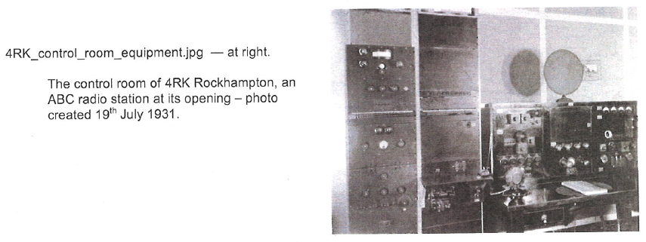
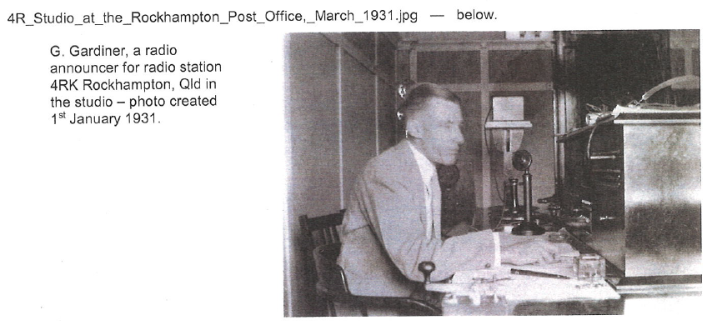

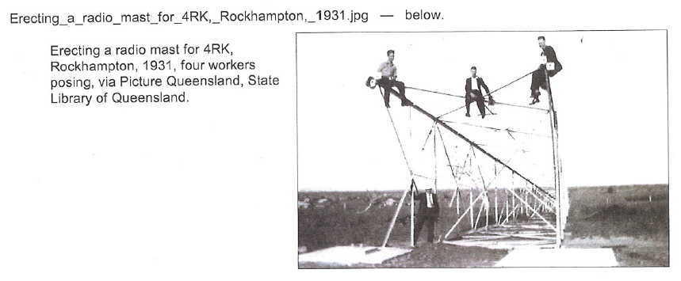
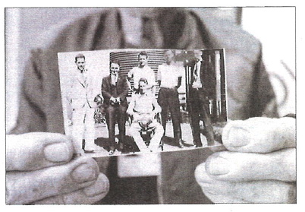
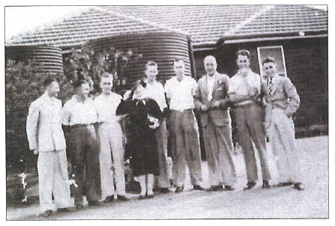
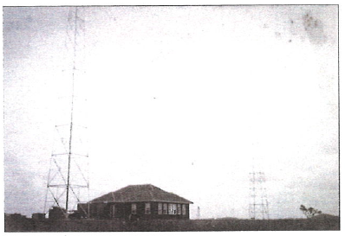
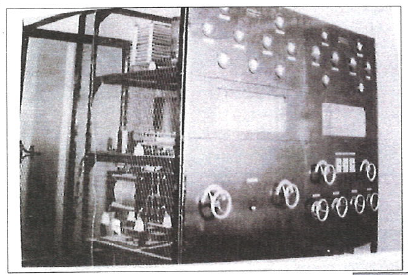

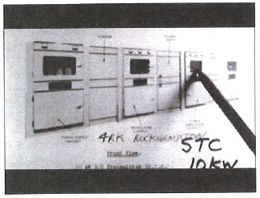
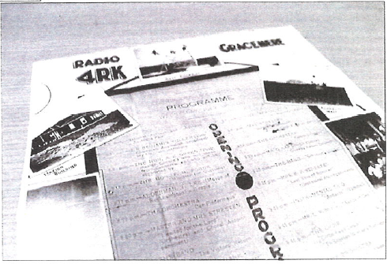

The history of ABC Capricornia by Martin Powley
FROM: abc.net.au — http://www.abc.net.au/local/stories/2008/02/29/2176209.htm
ABC Capricornia is one of the ABC's original radio stations. Known originally as 4RK, the station pre-dates the inception of the Australian Broadcasting Commission on July 1st 1932. It was the first radio station in Queensland outside Brisbane.
ABC Capricornia (4RK) started as a non-commercial Station, owned by the Australian Broadcasting Company, beginning its broadcasts on the 29th July 1931. According to information received from radio history enthusiast, David Brownsey, quoting an unpublished book by D.G. (Doug) Sanderson, On Air, the first broadcast was from the School of Arts building in Rockhampton at 8pm on Wednesday 29th July 1931. The official program of the evening shows that the local Musical Union Choir, assisted by the Rockhampton City Band, sang the national Anthem and Advance Australia Fair to open the proceedings.
A photo in the ABC Capricornia foyer indicates the studio was also situated at the Post Office in Rockhampton in its early years. The station has been located at various places around the Rockhampton city centre over the years. It moved to its present location at 236 Quay Street in 1963.
The ABC has moved to identify its stations according to the regions they serve, hence 4RK is now known as ABC Capricornia. The station celebrated its 75th birthday in 2006.
While ABC Capricornia (formerly 4RK) has transmitted programs through its 837AM transmitter at Gracemere since 1931, our relay stations are more recent additions. FM transmitters at Gladstone, Biloela and Alpha have come on stream in later years. We also have a powerful transmitter near Emerald, broadcasting on 1548AM. We frequently get calls from interstate and overseas, from listeners who pick up our broadcasts through the Emerald transmitter.
From 1963 until 1985, ABC Television also broadcast regional programs from Rockhampton. In the mid 1980's, the ABC decided to centralize its television broadcasts, ending the regional programs broadcast from Rockhampton and Townsville. Legend has it that, to mark the end of local television programming in 1985, our cameraman at the time, Bruce Black, tipped a bucket of water over the presenter live on air.
In 2007, an archiving project was started in cooperation with Central Queensland University, to copy as much of the old television news footage as possible. Our cameraman, Mike Tregaskis and CQU PhD student Christina Hunt have been the backbone of this project.
Staff at ABC Capricornia cover all areas of ABC radio operations. We have news journalists, a rural reporter, program presenters and producers and an online producer who maintains our website along with field reporting. Our news team has a studio in Gladstone, ensuring coverage of the city and the Curtis Coast.
ABC Capricornia is also the base for a television reporter and camera operator/editor. This duo covers a vast area of Queensland from the Wide Bay to the Whitsundays and west to the Northern Territory border.
ABC Capricornia has a strong history of community service, which is today demonstrated by the station's involvement in community and industry events around central Queensland.
Our main studios at 236 Quay Street, Rockhampton, were refurbished in 1998. The building is the former headquarters and gold store of the Mount Morgan Gold Mining Company. The wealth coming from Mount Morgan is responsible for much of the heritage architecture in Quay Street and we are proud to be part of that history.
