B.J.MAGEE
18 St. Clements Rd.
OXLEY
BRISBANE
QUEENSLAND
AUSTRALIA
4075
Phone: 61 07 3379 6437
Email: bjmeng@bigpond.com
17 January 2009
Dear Leo,
I may have mentioned when I was talking to you last year that I was upset with the ABC for giving no recognition to the engineers and technicians who made early broadcasting possible.

About a month ago I contacted them and suggested they make a program to correct this rather grave oversight. Their reaction was very positive, and they seem rather enthusiastic about the project.

I have given them all the stuff I have been collecting over the last couple of years including the unpublished book by Doug Sanderson, so a lot of the research has been done for them.

However, nothing can compare with a primary source of information, so I have suggested they contact you and Leon Gregg, more specifically visit the museum when you are all there. I hope this is OK with you.

The name of the ABC bloke interested in the program is Ian Townsend.
The program needs a focus, and the old 4QN transmitter site seems a good candidate. It has been very difficult to establish its exact location and to get any photos.

Doug Baker came up with the exact location and provided an early colour photo of the 4015-A drivers to the water- cooled 4220 class B "linear" final. Doug Sanderson mentions that the radiation at QN was from three mast supports in a triangular configuration. The triangular pattern left on the ground may be an indication of this.

Since the dissipation of the of the 4015's decreases with modulation, they would have looked interesting handling complex program material.

A MARCONI MT7A TRANSMITTING TUBE
I have had one of these for a number of years. It is suspended in its original box, the filament is intact, and there are no shorts between the elements.

It came from the Queensland Museum. I thought it was probably out of a Marconi ship transmitter, but on reading the operating instructions for the original 4QG transmitter, I now realize that it was a replacement for one of the RF tubes.
If you think it an appropriate exhibit for the Museum let me know and I will get Ian Gregg to give me a hand in getting it to you.
After reading the instructions carefully, I think I could get that transmitter on air. That they had only one piece of test equipment, a comparatively insensitive absorption wavemeter, I find absolutely amazing. No wonder they made provision for the final to "self-oscillate " to test the tuning.
There also seems to be a bit of snobbery about that new fangled jazz.
To quote:
" For violin and other music rich in harmonics the grid current change (in the modulator) should be kept as low as possible, but for speech and jazz music the movement of the meter can be as high as 5 to 6 milliamps. "
So there: a bit of distortion on jazz won't hurt you.
EARLY NON-TUBE REPEATER AMPLIFIERS for TELEPHONY
At the museum you showed me a single tube line amplifier from somewhere out
West.

Did you know that Edison had high gain telephonic line amplifiers patented on the 27 of April 1886?
One of my interests is the design of early recording systems — particularly acoustic recorders. It was here engineers first struck the problem of designing dynamic systems to handle signals of entertainment quality.
In acoustic recorders the tradeoff between dynamic response and sensitivity is acute, since the average recording horn only gathers a few microwatts of acoustic power from a recording studio.
I set myself the task of writing a computer program to study the dynamics of Edison acoustic recorders.

It took me a couple of months to go through all the patents — over two thousand.
The language is arcane and modern technical jargon had not developed.

For instance: a transformer is an inductorium: non-linear distortion is aberration:
low frequencies are grave tones and so on.

It was all worth it, since I came across a lot of stuff I never imagined existed.
Edison had two different types of audio amplifiers.

One works on the capstan principle and has a mechanical input and a large acoustic output. I had come across this. There is one in a large Edison cylinder phonograph used to supply music to garden parties at Government House.

The second really surprised me. It gives a large acoustic output for a very small electrical input.

Edison first used it in a loud speaking telephone patented and marketed in 1879. Patent 221,957.

He then produced a high gain repeater amplifier for telephony by providing tight acoustic coupling between the diaphragm of this system and a carbon microphone. 1886 Pat. 340,707. More patents appeared shortly after with the amplifier embedded in hybrids for two-way transmission.

He then coupled it to the diaphragm of an acoustic recorder to produce an electrical cutting head. This first appeared in a telephone message recording machine of 1905. Pat. 1,012,250. Since the thrust from the amplifier was rather indeterminate, it had to be AC coupled to the recorder.

This was accomplished by placing the diaphragms on either side of a chamber with a small hole. Fast changes would pass but slow ones would leak out through the hole. This can be clearly seen in the third drawing of this patent.

Electrical cutting heads were called telegraphic recorders in Edison jargon. The telephone message machine came with a small lathe to erase the cylinder when it was full.

Edison started making sound movies in 1910, but the acoustic recorders proved a problem because the actors kept moving away from the recording horn. The solution was to plaster the walls with carbon microphones, sum their outputs, and pass the composite audio to an electrical recording head built as above. The matching transformer was called a power amplifying inductorium. 1913 Pat.1,286,259.

The working principle of the Edison audio amplifier is well illustrated in the loud speaking telephone patent, but a brief description would not go amiss.
Imagine a circular speaker diaphragm with a flat platinum strip attached at right angles to the center.

A rapidly rotating wheel composed of chalk touches the strip on one side and a spring loads the system and ensures contact on the other.

The chalk is saturated with a solution of sodium hydroxide.

A DC current is passed along the shaft of the wheel, through the sodium hydroxide in the chalk, onto the platinum strip and then off through the loading spring.

Hydrogen is liberated by electrolysis at the chalk platinum interface.
It so happens that hydrogen is an excellent lubricant, and so the coefficient of friction, and hence the thrust, is modulated by the DC current. If, say, a milliamp of audio is now added to the DC bias, the audio will modulate the coefficient of friction and hence produce a large drive on the loudspeaker cone.

If the surface velocity of the wheel is fast enough, the system will respond at an audio rate.
Who the hell thought of that!

In the original patent for the loud speaking telephone power was provided by turning a handle on the side. In the next patent there is drip system to keep the chalk wheel saturated and a clockwork motor replaces the handle.
ACOUSTIC RECORDER
Since the recording horn behaves like a non-uniform transmission line miss-terminated at both ends it may be of some interest.
In an acoustic recorder the viscous forces must predominate over the inertial and elastic force. This ensures all resonance is suppressed and the correct constant velocity recording characteristic is achieved.

Edison had completely solved this problem by 1903. The recording diaphragm and stylus cantilever were sliced into small sections with viscous material between the sections. Audio caused bending and the viscous material went into shear.

All DC forces were removed from the recording diaphragm by supporting the recording head on a highly polished tracker ball. There was then no need to clamp the circumference of the diaphragm. It could then be supported and sealed by more viscous gunk. This removed the correct boundary conditions for many of the free modes of vibration of the diaphragm.
The fly in the ointment is the conical horn. It is impossible to terminate its output impedance with a recording head. The consequent reflections up and down the horn give acoustic recording its characteristic sound.

In the computer simulation the horn was broken up into 800 sections and the partial differential equation replaced by 800 simultaneous DE's. The dynamics of the recording head added about another 20 to the order, so the computer was solving an 820 order DE. I never thought I would ever see any digital computer do that, much less one sitting on the table beside me.
I have included an example of a typical print out. In the step function response nothing happens while the signal travels down the horn for the first 3.2 milliseconds. Reflection occurs and again at the mouth, so in another 6.4 milliseconds there is evidence of a strong reflection.

This results in the peaky steady state response when reflections add or interfere.
Incidentally, the magic damping material in an Edison recorder is made by burning a stick of rubber and banging it on a plate.

The recordings were made not on wax but on Pears soap. The friction of the cutting stylus causes a charge on the wax swarf and it clumps under the cutting stylus. Soap conducts and does not do this.
Well enough of this! Probably too much Edison.
Let me know about the Marconi MT7A tube
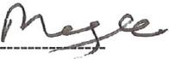
With best wishes,
Brian Magee
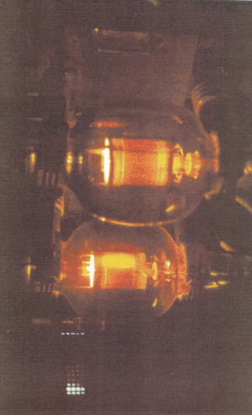
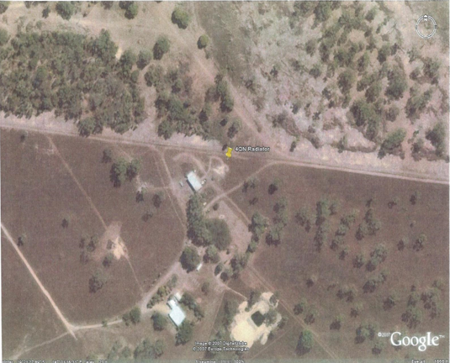

ptIntec
Lincln

