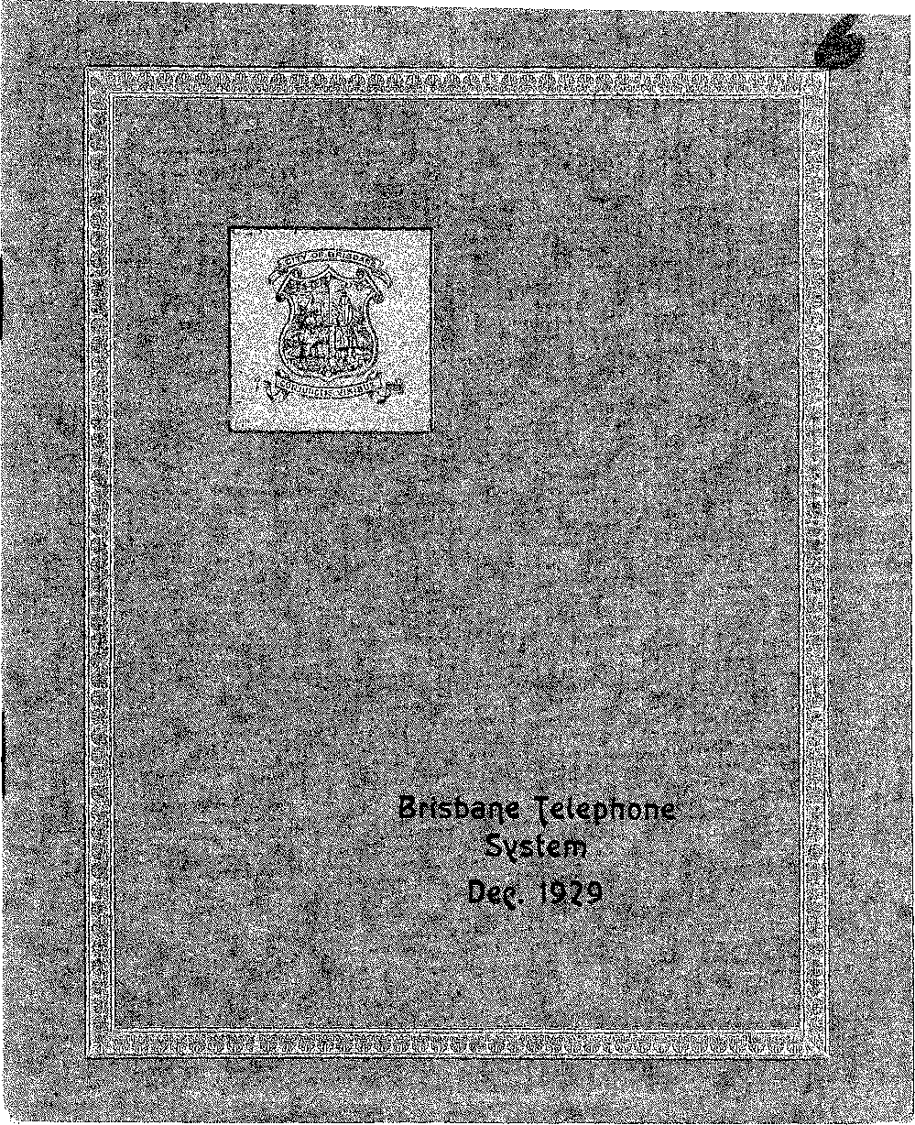

MAJOR STEP in the modernisation programme of the Brisbane Telephone Service was completed at 2 p.m. on Saturday, 30th November 1929, when Central and Paddington Automatic Exchanges were brought into service.
Brisbane now has ten automatic exchanges to which are connected 85 per cent of the subscribers' lines in the network.
The transfer of the many thousands of sub-scribers' and miscellaneous services from the former manual system to the new automatic exchanges and the simultaneous introduction of new trunk and toll exchanges was one of the most complicated Works so far attempted by the P.M.G.'s Department in Australia.
Consistent with modern telephone progress, many. entirely new features have been introduced and Brisbane. citizens now enjoy a telephone service equal to that given in any other part of the world.

The World's first practical telephone instrument was produced by Professor Graham Bell in the year 1876, and the following year saw the establishment of the first telephone exchange. Queensland was not slow in taking advantage of a modern invention, and in 1880 was installed. Brisbane's first telephone exchange, with 36 subscribers. The growth of Queensland's telephone system, although slow at first, has been remarkably rapid within recent years, and there are now 900, exchanges serving 50,000 subscribers.
The automatic exchange buildings in Brisbane were designed and erected under the supervision of the Commonwealth Works and Railways Department, and in the case of the main exchanges, have been equipped with air conditioning plant for, dehumidifying and cleaning the air in the apparatus room.
The whole of the automatic switching equipment in the various exchanges was supplied by Siemens Bros. & Co. Ltd., London, and the installation work was carried out by the Department's own officers.
With one of the finest and most up-to-date plants in Australia and with handsome new buildings with ample space for expansion, the Telephone Department in Brisbane is in a position to. furnish the highest grade of service to its subscribers for many years to come.
The numbering scheme at present in use for the Brisbane Metropolitan Network is as follows :—
Central B1000-999J
South J1000-5999
Coorparoo J6000-6999
Yeronga J8000-8999
Bulimba JY1000-1999
Paddington F9000-9999
Albion M1000-1999
Nundah M6000-6999
Newmarket M7000-7999
Sherwood U7000-7999

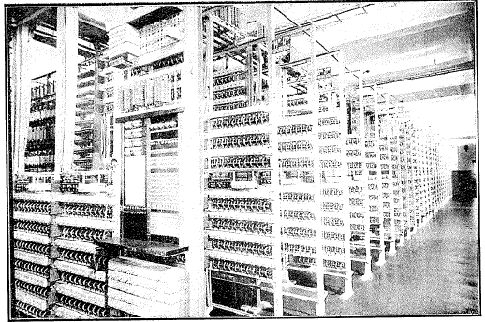
PORTION OF CENTRAL MAIN AUTO. ROOM
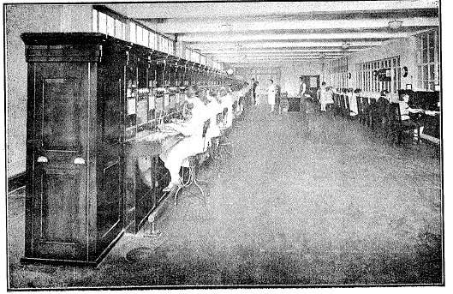
TRUNK SWITCH ROOM.

BRISBANE
AUTOMATIC TELEPHONE
EXCHANGE
BUILDINGS,
1929.

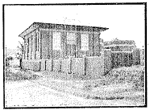
NEWMARKET.
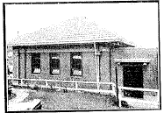
PADDINGTON.
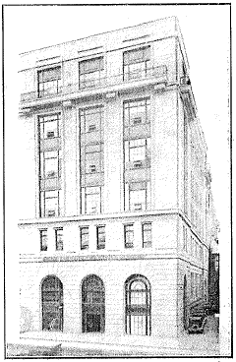
CENTRAL
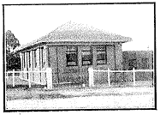
SHERWOOD
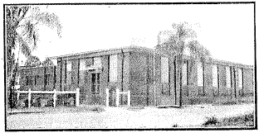
ALBION.
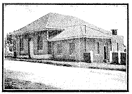
NUNDAH.
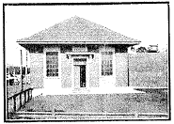
BULIMBA
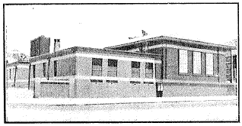
SOUTH
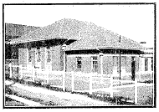
YERONGA
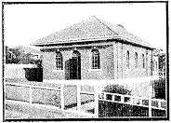
COORPAROO

The new automatic equipment has been designed to operate in conjunction with equally efficient long-distance apparatus, which is also accommodated in the Central building.
Modern invention has made it possible for several telephone conversations and telegraph messages to be sent simultaneously over a single pair of wires, and the equipment installed in Brisbane embodies these latest developments.
Incidentally, this increase in efficiency is reflected in the line construction, and the underground and overhead lines radiating from Brisbane are of an exceptionally high standard.
The ideal, already set by the Department, is to develop the long distance service so that ultimately a telephone subscriber in any part of Australia may be placed in communication with any other, whatever may be the distance of separation.
But who can foretell what the future holds! It would seem that the telephone engineer has already provided for the possibility that the world at large will be a common exchange and the trunk operator able to link up a girdle around the earth in a period of time compared with which "Puck's" forty minutes seems eternity.
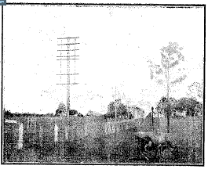
TYPICAL TRUNK POLE LINE
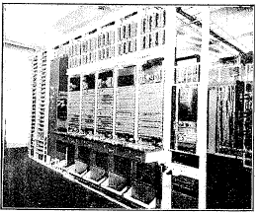
TRUNK TEST BOARD.

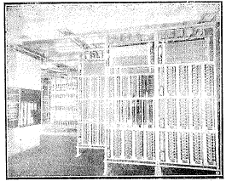
JUNCTION PRESELECTOR RACKS.
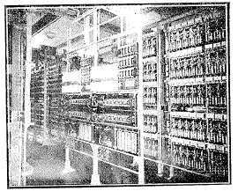
MOTOR INTERRUPTER RACKS.

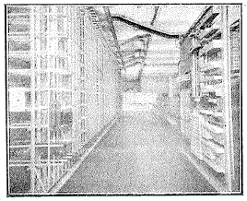
MAIN DISTRIBUTION FRAME AND TEST DESK.

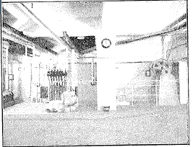
AIR CONDITIONING PLANT.

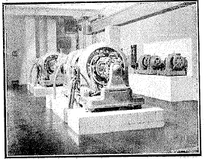
40 KW MOTOR GENERATORS

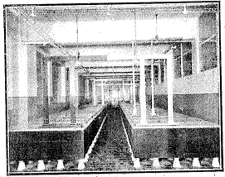
· DUPLICATE 3000 A.H. BATTERIES.

The equipment has concluded its term of service to the public after functioning successfully for nearly twenty years.
A staff of over two hundred girls was required to operate these boards, the service provided being one of the best of its kind in the Commonwealth.
The introduction of the automatic means that only a small staff is now required and many will miss the cheery “Number, Please” of the telephone girl.
But no Public Telephone System would be complete without the “Hello” girl and her patient voice may still be heard on “Information” and “Long Distance” Connections.

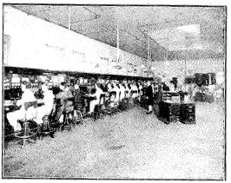
FORMER TRUNK SWITCHBOARD
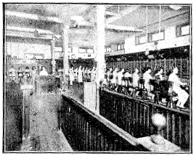
FORMER CENTRAL MANUAL EXCHANGE
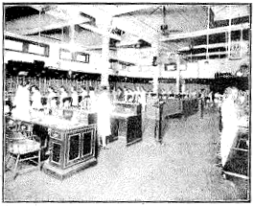
ANOTHER VIEW OLD CENTRAL

