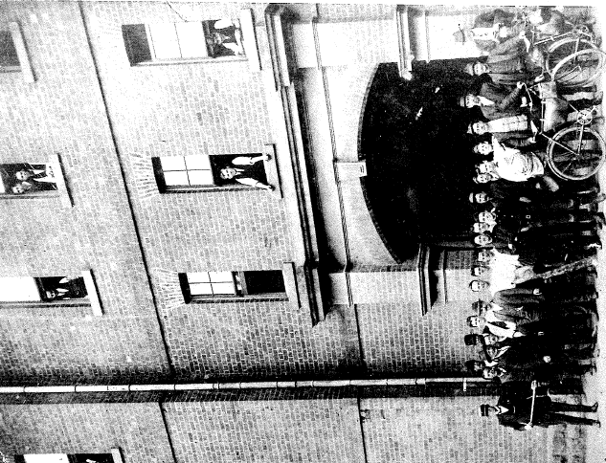

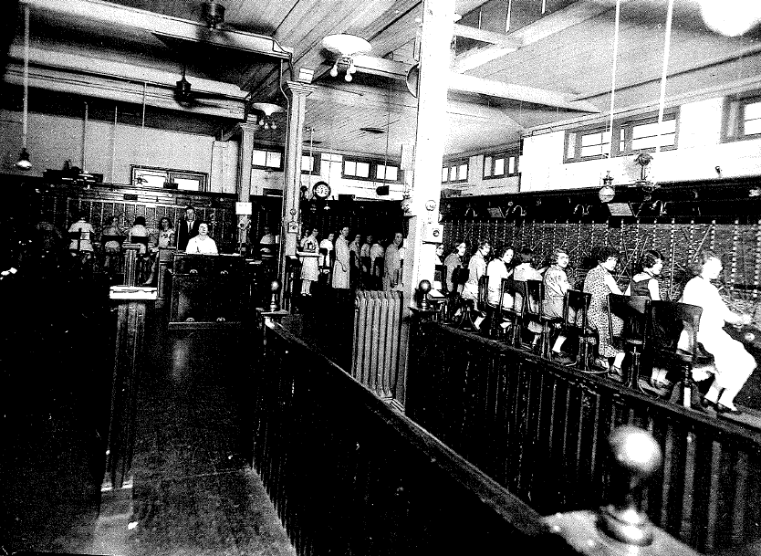
Brisbane CB Exchange between 1926 and 1929
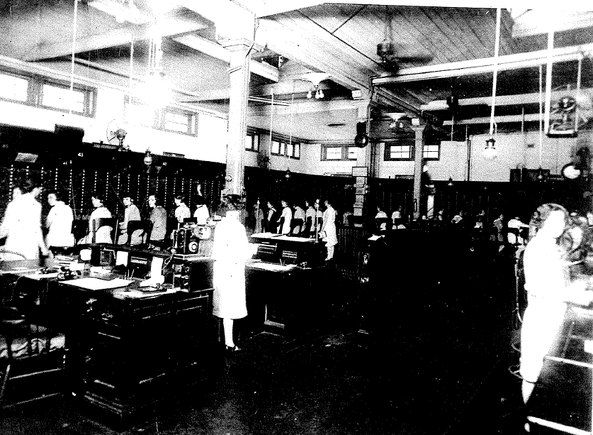
Brisbane CB Exchange between 1926 and 1929

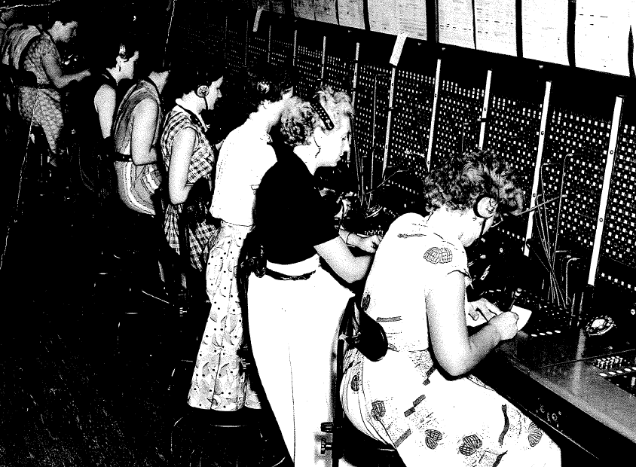
Brisbane CB Exchange between 1926 and 1929
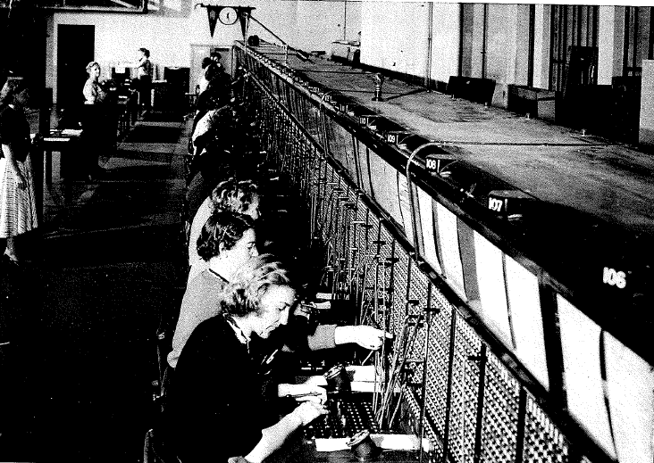
Suite of switchboards in the main trunk exchange Brisbane June 1953 or 19/1/1955

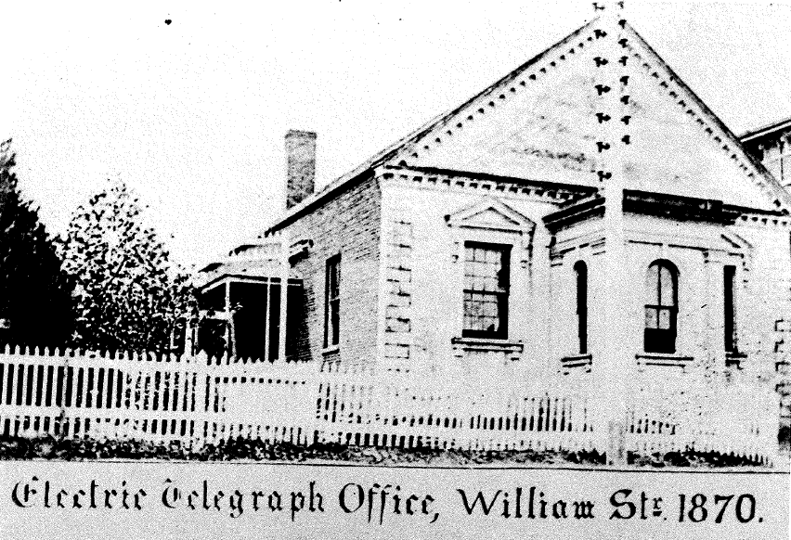
Brisbane’s first Electric Telegraph Office opened on 13/4/1861 Building originally a church owned by Dr. John D. Lang
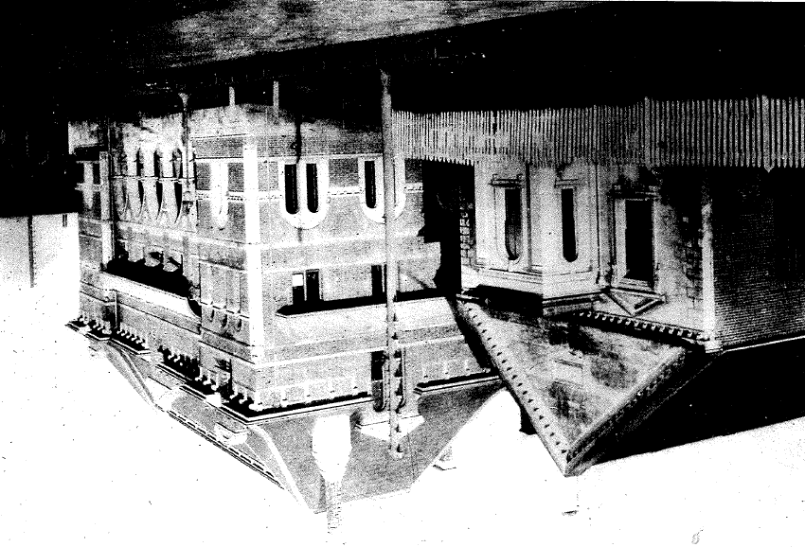
Electric Telegraph Office (left) and QLD Government Printers Office William Street (note telegraph poles and gas lamps
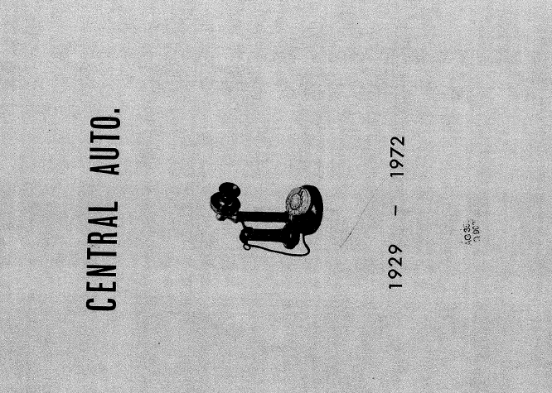

CITY SWITCHES

TO AUTOMATIC
A major step in the modernization programme of the Brisbane Telephone Service was taken at 2 p.m. on the 30th November 1929, when the Central Automatic Telephone Exchange was brought into operation.
No longer would telephone users have to pick up the handle of their "Candle Stick" telephones and wait for an operator's voice to say "Number please".
For on this day, they were introduced to the finger-in-the-hole, turn-the-dial automatic telephone system.
This automatic miracle was a far cry from the first telephone system provided in Brisbane in 1880.
Just four years after Professor Alexander Graham Bell had made the world's first telephone call, the Queensland Postmaster-General issued an instruction that all governmental offices should be placed in telephonic communication with each other through a central telephone exchange.
CONNECTION OF
FIRST PHONES
On the 8th October 1880, the offices of the Colonial Secretary, The Colonial Treasurer, Post and Telegraph Department, Education and the Ministers' room in the Legislative Assembly were given their first telephone services. Other Government offices were brought into the system as quickly as wires could be stretched over the buildings.
It had also been announced that the public would be allowed to participate in the benefits of the new system of communications.
Several applications were received from private firms for the erection of lines to connect their different places of business, either through the exchange or direct.
Messrs. Quinlan, Gray and Co. (now Castlemaine Breweries) were the first to apply for a telephone between their offices in Queen Street and their Milton brewery.
Their line was erected several weeks prior to the commencement of the exchange.
The first instruments used were the Edison carbon transmitter and bell, coupled with a "Bell" receiver.
By the 1st of June 1881, there were 36 instruments in circuit with the exchange — "all working well and giving general satisfaction to those persons using them".
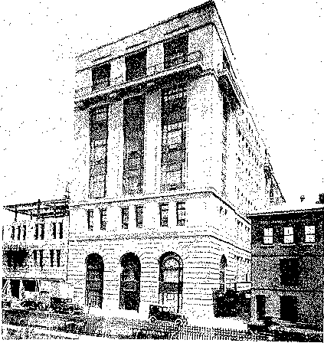
Central Telephone Exchange Building, Elizabeth Street Brisbane.

Public demand for connection to the new system continued at a high rate, and by 1927, there were 7000 subscribers' services connected to the Common Battery Manual Exchange in the Brisbane city area.
Connections were made by 200 telephonists at the G.P.O.
To keep abreast with the latest telephonic developments, $895,000 was provided for the construction and installation of a new automatic telephone exchange to cater for the ever increasing number of subscribers.
The Automatic Exchange Building was designed and erected under the supervision of the Commonwealth Works and Railways Department; and was equipped with air conditioning for de-humidifying and cleaning the air in the apparatus room.
The Exchange was located in Elizabeth Street, on the first floor of the new building near the rear of the G.P.0.
Formerly, the site had been used as Police Courts, and the construction staff wandered about the cells which had been exposed by the excavation work.
Central Automatic Exchange (with subscribers' numbers ranging from B-0100 to B-0699 and B-1000 to B-9999), was the tenth automatic exchange to be erected in
Brisbane's Metropolitan area, but was the first to serve the city sector.
Automatic exchanges commissioned previously were South Brisbane — J1000 to J1199 and J1300 to J8299; Paddington — F7000 to F9999; Sherwood — U7000 to U8999; Newmarket — MX7000 to MX9699; Albion M1000 to M8499; Nundah — MX5000 to MX6999; Bulimba — JX4000 to JX6999; Yeronga — JX7000 to JX8899; and Coorparoo — JY1000 to JY3499.
The first automatic exchange to begin operation was South Brisbane, which was brought into service on 11th July 1925.
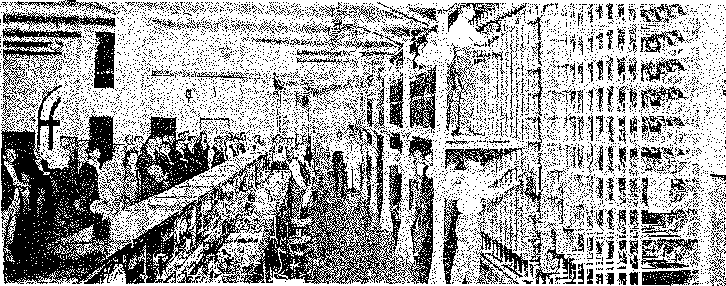
All of the switching equipment for Central Auto was supplied by Siemens Bros. Co. Ltd. of Woolwich, London, and the installation was carried out by the Post Office technical staff, under the supervision of a Siemens representative — Mr. Bayne.
Commissioning: The cutover operation at 2 pm, on 30th November, 1929, which brought Central Auto into service, was watched by an interested gallery of spectators.

The equipment was the then well known No. 16 type, which was identical to that supplied to the British Post Office by Siemens.
This meant Brisbane's new telephone system was backed by the finest and most up to date plant in Australia, in a new building with ample room for expansion, and it was thus in a position to furnish the highest standard of service for many years to come.

MILLIONS OF
PHONE CALLS
And provide service it did in fact, over its 43 year life, Central Exchange handled more than 2,500 million telephone calls.
During its life, Central Auto was the means of conveying joy and heartbreak, information to various news organisations, emergency calls for police, ambulance or fire brigades, State and Commonwealth Government business, in addition to supplying essential information to the business community, and a means of instant social contact.
But its most important role was probably during World War II, when General MacArthur, with temporary Headquarters in the AMP Building, had all his communications channelled through Central Auto.
In its 43 year existence, thousands of Post Office trainee mechanics and technicians walked its labyrinth of equipment racks, cleaning, oiling, dagging, soldering, replacing fuses etc., to qualify them for future service to Australia's communications network.
Indeed, many Post Office engineers and other professional officers first learnt their skills in the Central Exchange.
"Central" also had its share of colourful personalities who left their mark in the minds of those associated with the exchange. Its first Engineer-in-
charge was Mr. E.M. Dowse, who gained renown for his organisation of concert parties, and other engineers were Messrs. E.C. Lather, O. Hoskin, W. Engerrian and G. Newton.
Mr. T. Goggins was the Foreman Mechanic in charge of exchange installations, and he was assisted by senior mechanics W. Stretton, P. Adams, C. Beswick, R. Ferguson, J. Swan and I. Burrows.
One of its best-remembered staff members would be Bert Murphy, instigator and Editor of "The Dial", a humorous, sometimes libelous magazine which recorded incidents and episodes at the exchange. It was liberally illustrated by a mysterious character who sketched under the name of "Billo".
A memorable incident was what became known around Central as "our flood". In 1931, rainfall was decidedly excessive for a period, and the water
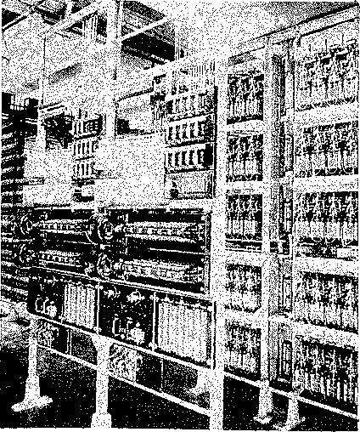
Third digit selectors (right).
Ringing and tone machines (left).
seepage in the building caused many problems, and staff became concerned about possible water damage to equipment. However, the magazine records that the problems and solutions were generously interspersed with laughter.
But now, like all mechanical apparatus, its useful life has ended.
The Exchanges' incompatibility with the more sophisticated Crossbar equipment in general use at other exchanges, has made it inefficient and costly to maintain, and its inability to permit Subscriber Trunk Dialling (STD) calls, has rendered it inconvenient to subscribers.
There has been a gradual phasing-out of the exchange, and with each new issue of the metropolitan telephone directory since August 1968, a percentage of subscribers' services have been transferred from Central to the modern Edison Exchange.
In retrospect, Central Auto has been an extremely reliable and dependable servant to its 10,000 subscribers connected.
At its cessation, it was the only large exchange in Australia, and indeed, one of the very few in the world, which was fully equipped with Siemens equipment.
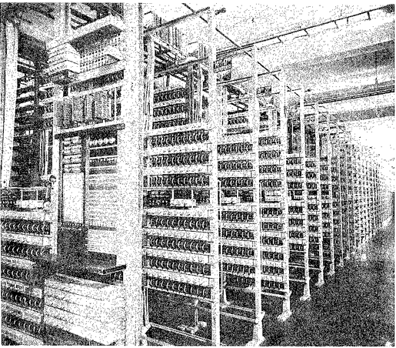
Transfer of the final batch of 1942 services was made in August last, concurrent with the issue of the 1972/73 Brisbane Telephone Directory,
First and second pre-selector racks which provided access to dialling channels for subscribers.and the exchange has essentially discontinued its services.

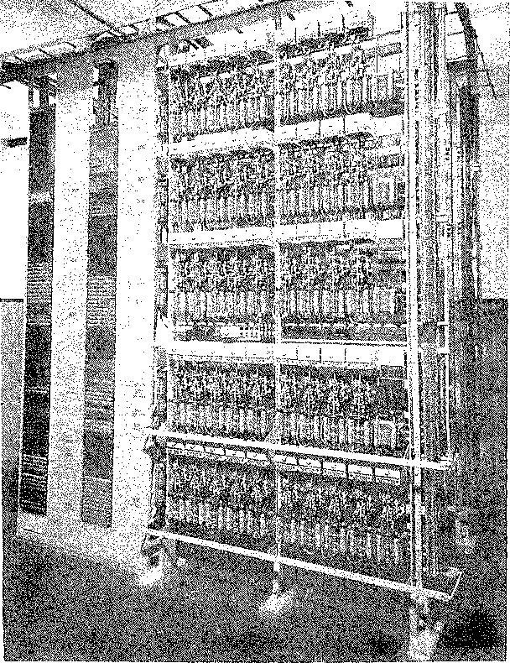
Fourth selectors which connected subscribers to telephonists providing information and enquiry services.
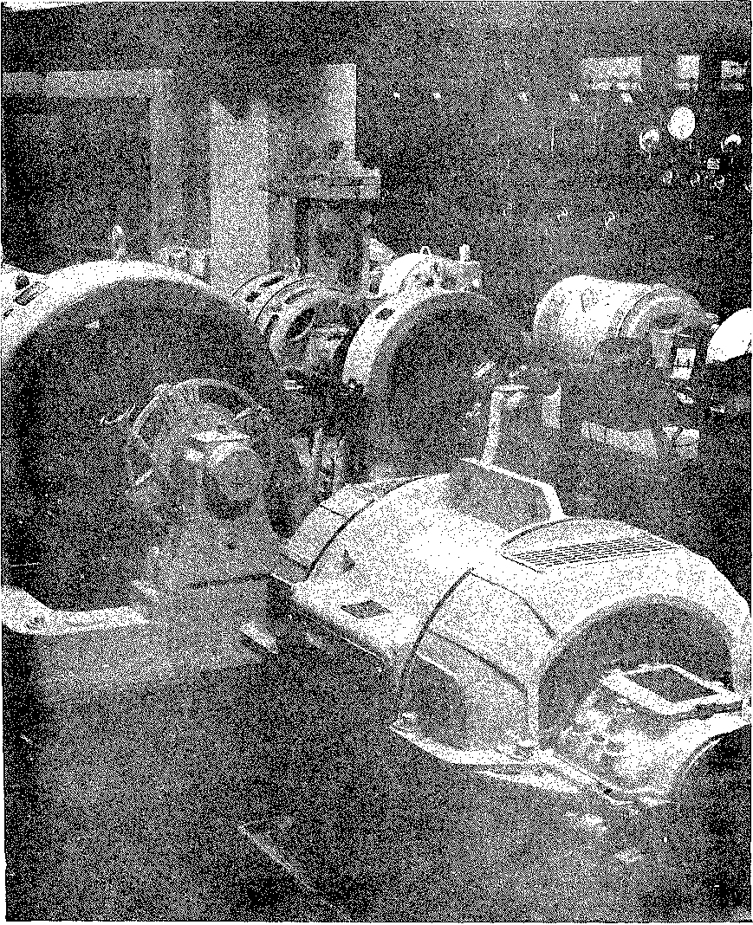
Power Room, located .in the basement of the Central Exchange Building, showing motor generation for charging of Exchange Batteries.
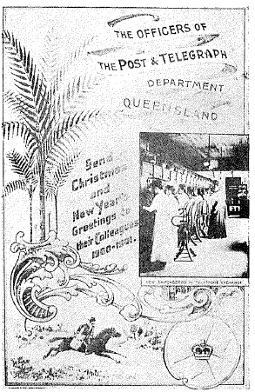
Subscribers whose services were formerly connected to Central and have since been transferred to Edison, are now reaping the benefits from available services such as Telegraph, TRESS, Telex and an Automatic Trunk Exchange incorporating the most recently developed operating aids.
The Edison Exchange, located only a short distance from the old Central Auto, provides accommodation for the expanding needs of the Brisbane telephone network.
And while the old has given way to the new, there is no doubt the air will be heavy with nostalgia on 30th November, 1972, when many retired and senior P.M.G. officers return to lay the ghost of the old exchange at a "Back to Central Auto" function to be held in the former exchange building.
Departmental Christmas Card 1900 (right). Inset features first female telephonists, appointed 1899, at old manual exchange. Male operators (below) manning Brisbane's first exchange which opened in 1880.

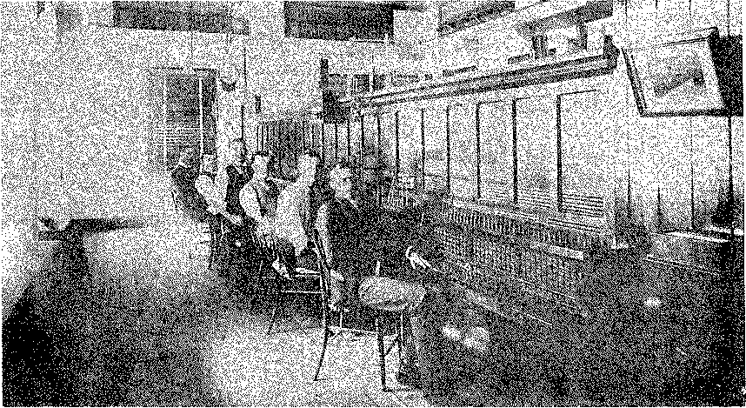

A HIDDEN

MESSAGE
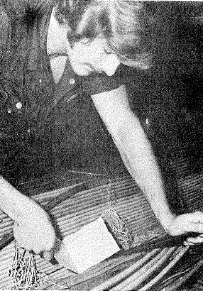
While cabling was being installed at Central Auto, the mechanics (as technicians were then known) who worked on the project, "planted" a message for posterity.
They recorded some details on a sheet of paper, which they signed and placed in a sealed envelope (see reproduction of document below).
The envelope was then plaited into the cabling above racks of subscribers' meters where it remained for more than 44 years.
Neil Skinner, a technician from Exchange Installation staff, found the hidden message in October 1972, while working on the dismantling of the old equipment (see photo right). After its long slumber, the document has now found a permanent resting place in the Historical Archives of ost Office.

