Hello Norman,
This Tools of Science visit to the Telemuseum is a very fortuitous coincidence for us. We had been planning to make contact with this group, to see if it might advance a piece of research that we are currently pursuing.
Beverley and I are involved with the Chermside and Districts Historical Society. One of the areas of research being carried out at the moment is to document information regarding the group of Australian Women Army Service Personnel (WASP) in the Chermside Military camp during WW2, whose military grouping in those days was Central Bureau Intelligence Organisation, and who worked the 24-hour shift roster at 21 Henry Street Ascot. They operated under the Official Secrecy Act, in those days — their families had no idea of the high-level work that they were doing, and we can see that without so much as a brass plaque around the place to acknowledge their contribution to the WW2 war effort, now, our CDHS web page can provide something of the public acknowledgement that they deserve.

But the previous equipment in that garage were IBM tabulator machines - - an early form of computer. These were replaced with teletype machines. The comment was that they were noisy, and generated heat, which necessitated that the building be air conditioned.

it is mentioned in war records, that the prior equipment being IBM tabulator equipment, was moved from there to the Hamilton Fire Brigade.
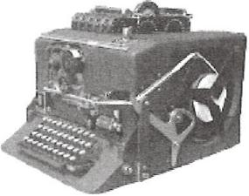

SIGABA Machine
The enciphering and decoding equipment that they used at the premises (called Nyrambla House) was the SIGABA Machine

To quote Peter Dunn's http://www.ozatwar.com/sigint/sigaba.htm web page :-
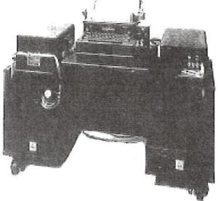
Central Bureau had banks of IBM Tabulators, the forerunner of computers, which were used by the cryptanalysts to sort and strip away ciphers which concealed the original text. They were located in the garage at the rear of 21 Henry Street.

This may have been the IBM Tape Operated Equipment used at 21 Henry Street and then at the Fire Station at Hamilton Park
As we write up this AWAS information for our CDHS web page, we realise that it would be good to add further information about the equipment that these ladies used in that very important secret work for General

Macarthur's Central Bureau Intelligence organisation, and the most likely source of such information would be the Telemuseum. What a nice coincidence!
Our CDHS database has considerable information about the military Camps. Men's and Women's, but this current development has been sparked by the donation of a set of military personnel identification discs. The Women's Military Camp area was re-surveyed after the war and became a typical suburban residential area. In the early 1950s a family residence in Meemar Street commenced a chook yard along the back fence, and the scratching of the chooks, over an extended period, unearthed the ID discs— 43 of them, which the children of the family gathered and kept in an album. Our CDHS was very pleased to receive that donation in 2013, from Peter Hill.
It was an astounding 'find' and the mystery just got even more curious when our CDHS researchers traced Australian War Memorial and Australian National Archives information, and established that of this group of 43 personnel, many occupations were represented over a wide range of ranks. Seventeen of the personnel, all male, were members of Macarthur's Central Bureau Intelligence Organisation including Alister Wallace Sandford, SX 11231, S213533, Wayville S.A. Lieutenant Colonel Intel. Corps Central Bureau & Tsps.
s Arj) /2- ₂)
R h1
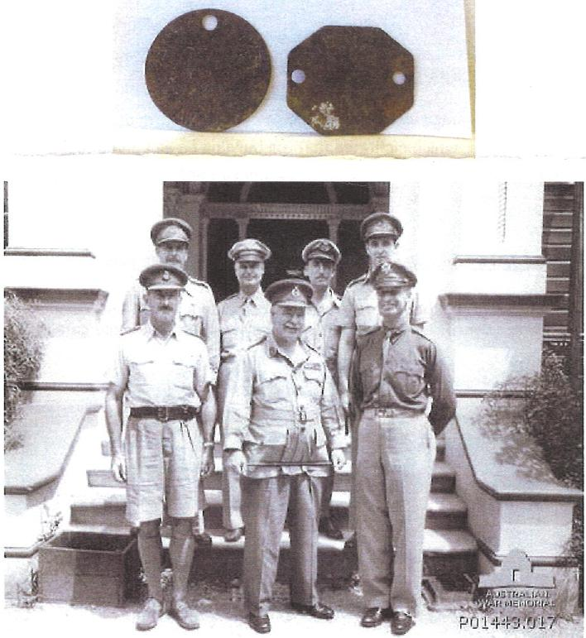
P01443.017 Photograph
Description
BRISBANE, QLD. 1944. VISIT OF THE AUSTRALIAN COMMANDER IN CHIEF, GENERAL SIR THOMAS BLAMEY, TO THE CENTRAL BUREAU OF INTELLIGENCE. THIS WAS THE COMBINED AUSTRALIAN ARMY, RAAF AND US ARMY ORGANISATION WHOSE FUNCTION WAS TO INTECEPT AND DECODE JAPANESE MILITARY SIGNALS. LEFT TO RIGHT: BACK ROW: MAJOR M. PORTER, AIF, ADC TO BLAMEY; COLONEL H. S. DOUD, US ARMY, DEPUTY DIRECTOR OF CENTRAL BUREAU; WING COMMANDER H. ROY BOOTH, RAAF, DEPUTY DIRECTOR; LIEUTENANT COLONEL A. W. SANDFORD, AIF, DEPUTY DIRECTOR; FRONT ROW: COLONEL J. D. ROGERS, AIF, DIRECTOR OF

Extract from :-
Central Bureau Intelligence Corps Association.
August 2013 newsletter. (pre-printing draft only),
From Editor, Helen Kenny.
CHOOKS AT CHERMSIDE (A CB Mystery)
During the war, young AWAS — including CBers were put into camp at 67 AWAS Barracks, Chermside (a Brisbane suburb).
They were driven in three-ton trucks to work at 21 Henry St, Ascot Park, and most belonged to 11 Aust Cipher Section.
A young officer, Helen Rex, now Bond, ran the camp, which was in bushland among gum trees. The road to the camp was dirt, and crossed a gully, sometimes flooded. A cattle grid at the entrance and barbed wire fence were more farm-like than military. Each fibro hut held three girls.
The only men on the site were those who cooked and chopped wood for coppers in which we washed our clothes. Cooking was done on fuel or Soyer stoves. Lavatories were unsewered, and green snakes and frogs frequented the rec. hut and latrines, much to the surprise of many, including Madeline Chidgey and Coral Hinds.
After the war the land was sub-divided, and a hospital and new homes went up. The Hills family bought a block at 97 Meemar St, Chermside and made a home there, with garden and chook yard.
One day, young Peter, aged 12, saw the chooks scratching up 47 objects that turned out to be Army Identity discs worn by Australian soldiers in WWII.
Identity discs worn by men and women of the Australian Army were of a material strong enough to withstand the wearer's death. The discs gave little information other than name, date of birth, rank, serial number, blood group and religion.
Peter cleaned up the tags and put them away in an album as neatly as if they were stamps. Recently he handed the discs to Mr. Rob. Isdale and his wife Beverley, of the Chermside and District Historical Society.
The discs scratched up by the chooks in that Chermside backyard are a puzzle for local historians who went to the records to find out who the wearers were, and in which units they worked.
The list provided shows these CBers and members of ASIPs and ASWG:-
BAKER, Charles: b 1915, enlisted Nyngan, NSW and was a Lance Sergeant in CBIC;
DAY, John: b 1925, enlisted Melbourne in CBIC, rank corporal;
DENTON, Frederick: b 1912, enlisted Adelaide River N.T., in ASWG as a signalman;

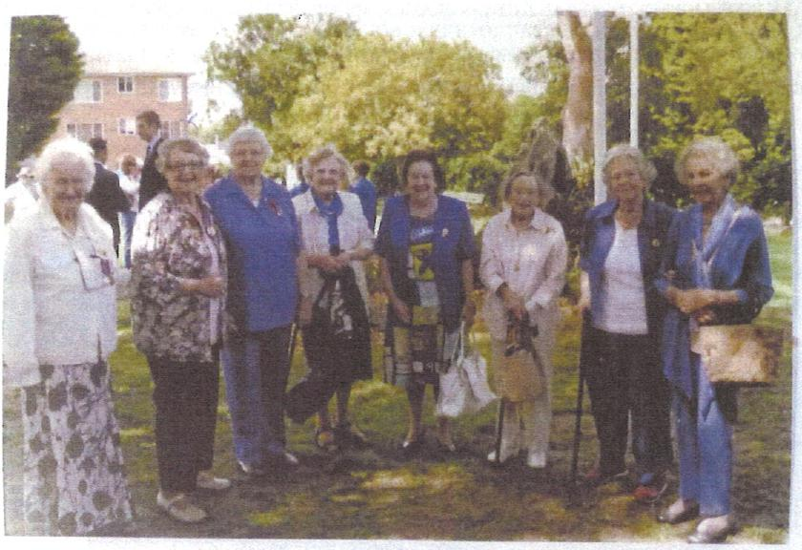
Photo from: Coral Hinds (nee Osborne).
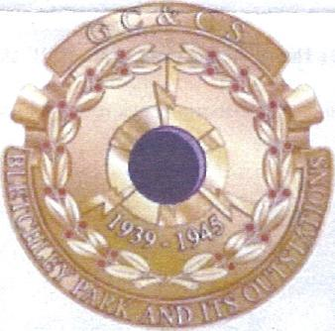
Here are the same 'girls' in 2011, Remembrance Day.
Helen, Coral, Joyce, Ailsa, then another C.B. girl Joy, and Madge
then another C.B. girl Noni.
We are receiving our Bletchley Park medals.

Regards, Robert Isdale.

MILITARY INTELLIGENCE; GENERAL THOMAS BLAMEY; MAJOR GENERAL SPENCER B. AKIN, US ARMY SIGNALS
CORPS, DIRECTOR OF CENTRAL BUREAU. (ORIGINAL HOUSED IN AWM PRIVATE RECORDS COLLECTION)
One of the Personnel Identification discs is stamped: SANDFORD, Alister Wallace, SX 11231, S213533, Wayville
S.A. Lieutenant Colonel Intel. Corps Central Bureau & Tsps. Photo at 21 Henry Street Ascot.
The garage at 21 Henry Street has been re-built, but we have photos of the B shift ladies — at work — in uniform, and in recent years, receiving their Bletchley Park medals.
I will attach an article from the CBIO newsletter, which we hope will encourage some feed-back that may throw some light on our little mystery. After this length of time, we are not all that hopeful, but it is worth a try.
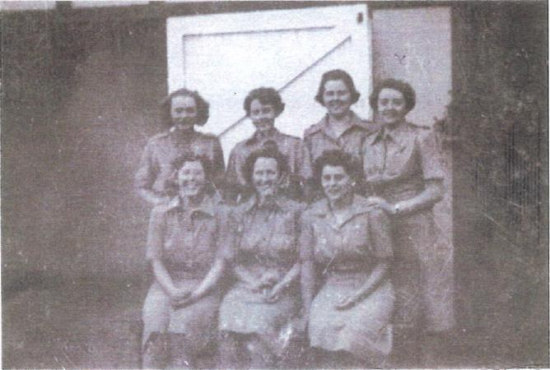
Taken in front of "The Garage", 21 Henry Street Ascot. Part of `B' shift. Helen Frizell (Kenny) centre,
Yours truly (Coral Hinds, nee Osborne) back row right end. Joyce next to me.
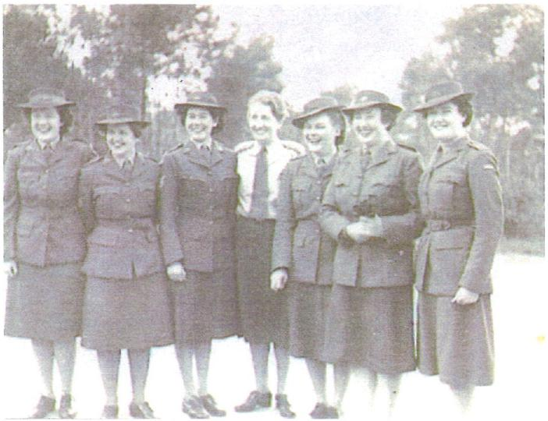

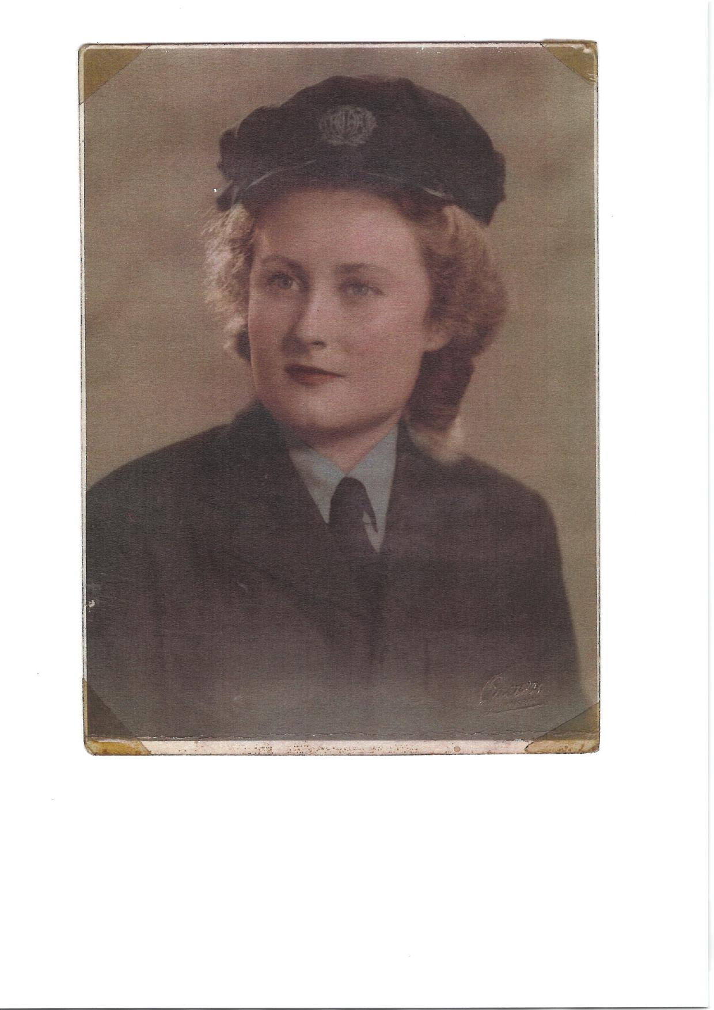

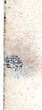
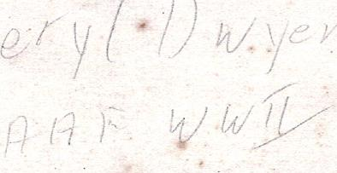
4 /
/
ri
I
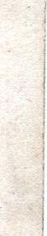
p
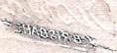

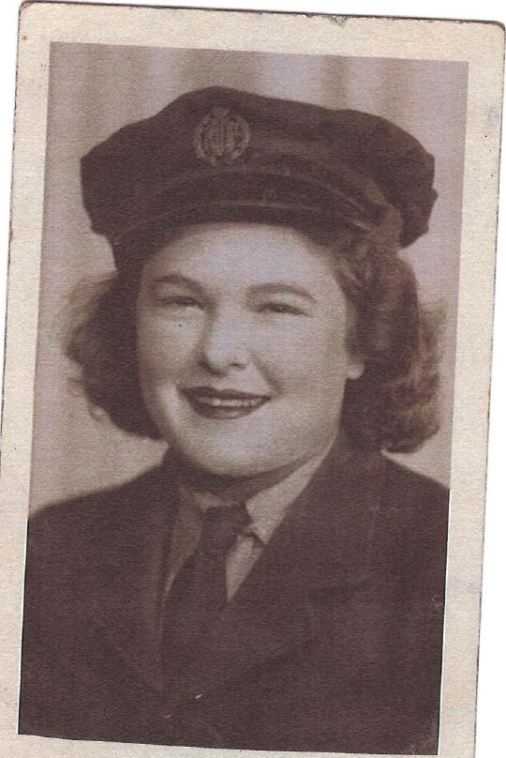
- LI

