brisbane's  living heritage  network  ACN 108 737 695 | c/- Museums Australia QLD  Level 3, 381 Brunswick Street  FORTITUDE VALLEY QLD 4006  Phone 07 3215 0843 Fax 07 3215 0841  info@brisbanelivingheritage.org
01 November 2005
Reprint of Brisbane's Living Heritage Experience Guide
Dear member
With the generous support of The University of Queensland, Brisbane's Living Heritage Network is able to reprint the Experience Guide. Our aim is to have the Guide ready for distribution by mid-December 2005.
Attached is a copy of your organisation's entry in the new Experience Guide. Please check all the details including the map placement.
Complete the details below and return with the copy of the layout with changes (if any) to the BLHN office, preferably by fax.
Fax (preferred return): 07 3215 0841
Post: c/-MAQ. Lv. 3, 381 Brunswick Street, Fortitude Valley QLD 4006
Please return by Tuesday, 8 November 2005. Note, if your entry is not received at the BLHN office by 5.00pm on this date your entry will be printed as represented in the attachment to this notice.
NAME: Leo Moloney
ORGANISATION: Telstra Museum
APPROVED WITHOUT CHANGES
APPROVED WITH CHANGES (AS PROVIDED ON LAYOUT):
Signature Date 8/11/2005
COMMENTS
Please don't hesitate to call with any enquiries.
Regards,
Kerri Laidlaw
Co-ordinator
Brisbane's Living Heritage Network Ltd.

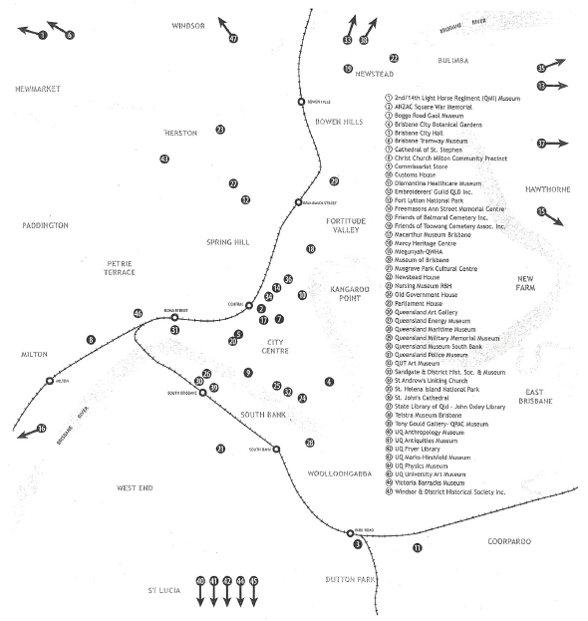

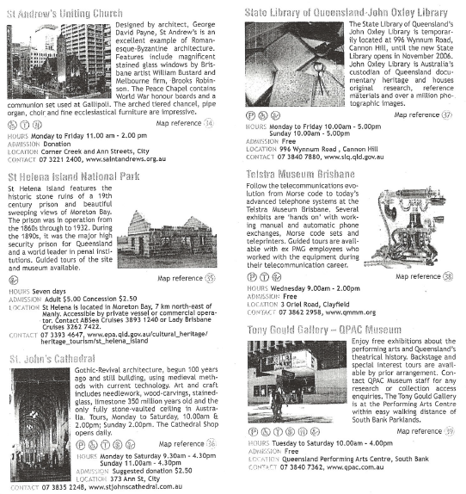

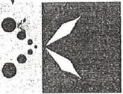 | brisbane's  Living heritage  network | c/- Museums Australia QLD  Level 3, 381 Brunswick Street  FORTITUDE VALLEY QLD 4006  Phone 07 3215 0843 Fax 07 3215 0841  info®brisbanelivingheritage.org
ACN 108 737 695

17 October 2005
RE: Securing Funding Workshop
Dear Member
Please find enclosed registration forms for the Securing Funding Workshop, to be held November 24th 6t 25th. This is a joint project between Brisbane's Living Heritage Network and Museum &Gallery Services Queensland Training and Professional Development Program, and has been funded by Brisbane City Council.
This two day workshop is for volunteers and paid staff from member organisations within
Brisbane's Living Heritage Network, Museums Australia Qld and Regional Galleries Association of Qid.
The focus of the workshop will be on developing skills in planning and writing successful funding submissions, developing creative partnerships with business and local government, and sourcing funding from the philanthropic and corporate sectors. The workshop consists of two days dedicated to a practical approach to securing funding through which participants will be given access to funding program managers to assist your' organisation to identify key grants, as well as providing professional and practical advice for finding funding for that project.
This workshop will make use of the knowledge of: cultural heritage organizations and their expertise in the area of grant submissions; local, state and national grants fund managers; business-arts partnership facilitators; corporate partnership managers; and, local government.
There will be the minimal cost of $50-00 (inc. GST) for members of Brisbane's Living Heritage Network, Museums Australia Queensland a Regional Galleries Association of Queensland. Places are strictly limited. I have enclosed registration forms to be given to your staff, or perhaps placed on a notice board, or in an area where your staff gather. Please feel free to copy the registration form should you run out.
Please contact Kerri Laidlaw, on 07 3215 0843 to register, and for further information.
Regards,
Kerri Laidlaw
BLHN Co-ordinator

