Telstra Museum Brisbane
From: Telstra Museum Brisbane [o104480©bigpond.net.au]
Sent: Wednesday, 17 August 2005 12:53 PM
To: barnett@mackay.net.aul
Subject: Morse Jigger
Dear John,
Thank you for your letter of 27 July 2005.
We are very interested in your Morse Jigger, as we don't appear to have this particular model. We do have many models on show and feel that your unit would indeed be a valuable asset to us.
Currently we have three active Morse Men here who give talks to our visitors about the history of Morse. When you get a chance to visit us, please note that we are open every Wednesday from 9 am to 4 pm.
Should you wish to mail the unit please send it to :
Telstra Museum
P.O. Box 651
ALBION B.C. 4010

All Best Wishes
Gordon Wadsworth
For Secretary.
17 Aug. 2005

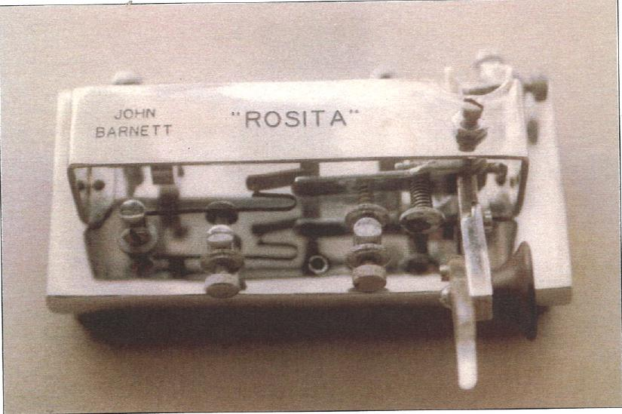
17/08/2005
19 Weir St.
MACKAY QLD 4740
27 July 2005
Email Barnett@mackay.net.au
Mr Richard Youll
Qld Historical Society
Albion Telephone Exchange
Cnr Oriel & Sandgate Rds.
CLAYFIELD 4011
Dear Richard.
I have been given your name as the Custodian of the the PMG Telegraph Museum.
My name is John Barnett. I was a Telegraphist in Training Brisbane in 1949, Telegraphist Brisbane C.T.O. in the 50's and Telegraphist Innisfail in the 60's.
In about 1949/50 I acquired an old Morse Code "Jigger" and "Did it up". I do not know how old it is but it was an old machine when I got it. I have been told it was one of the original Simplex Auto but I cannot be sure of that.
I have attached a photo of it. If it is of any use to your collection, I will send it down to you.
If ever I get down to Brisbane, I would like to have a look over your Museum.
Best Regards
John Barnett

Trading as TELSTRA MUSEUM BRISBANE
PRESIDENT: Margaret BARTLETT
SECRETARY: Richard YOUL TELEPHONE (07) 3862 2958
TREASURER: Leo MOLONEY FAX (07) 3262 1199
Minutes of the Special meeting held on 20 July 2005;
President were Vice Presidents Leon Gregg ( Chairman) & Rod Tune, Treasurer Leo Moloney, Secretary Richard Youl, General members Geoff Battersby and Gordon Wadsworth.
Business of the meeting was to rearrange the financial management of the Society in view of the departure of previous treasurer Neil Harbottle and the impending completion of the fixed term deposit with CUA.
Mr Moloney indicated that an initial query at CUA showed that only Neil Harbottle & Richard Youl were registered signatories. ( this was later found to be incorrect & President Margaret Bartlett was also shown as a signatory ). He submitted the following proposals to the meeting and moved their adoption.
- Messrs Gregg & Moloney be added to the approved signatories, Mr Harbottle be deleted and that any two of the four signatories ( Bartlett, Youl, Gregg & Moloney ) be authorized to operate on all accounts.
- That application be made to operate a cheque book on the "Only Account".
- That when 1 &2 were finalised the balance in the account with CBA be transferred to the "Only Account" with CUA and the CBA account closed.
The proposals were seconded by Rod Tune and carried by the meeting.
The only business having been completed the Chairman closed the meeting.
PLEASE NOTE NEW POSTAL ADDRESS ABOVE

copy to Robin Black
Automatic Telephone Operation in Queensland
The 80th Anniversary of Automatic Telephone operations in Queensland on July 11th. was celebrated by an Engineering Heritage presentation in the Hawken Auditorium on July 14th.
The presentation was by Leon Gregg FIEAust and Geoff Battersby MIEAust. A feature of the evening was the demonstration of the working model exchange produced by Siemens Bros. of Woolwich, England in 1923. The photo shows the presenters and the model on the evening.
This unit was initially used for training of the installation staff of the first exchange at South Brisbane which was placed in service in 1925. It was then used for training of PMG technical staff at the Central Technical College and later in the PMG training system. It was also a demonstration unit for publicity and recruitment purposes and as a centrepiece of PMG displays at the Brisbane Exhibition up to the end of WW2.
The unit was in a state of extreme disrepair due to old age, mechanical damage and the effect of the 1974 flood until it's restoration was undertaken by Messrs Gregg and Battersby. Now fully restored to working order it will shortly be displayed in the Telstra Museum (at 3 Oriel Rd., Albion behind the Albion Telephone Exchange ) which is operated by The Queensland Post & Telecommunications Society. Other displays includes a multitude of items, from the past 150 years of communications, many of which are in full working order. The Museum is open on Wednesdays only, expert volunteer guides are available and admission is free.
Suggested text for IEAust Newsletter

200 words

Mrs Hazel Splawinski
3/66 Booth Avenue
Morphettvale 5162

Dear Mrs Splawinski,
We would like to thank you very much for the kind donation of this most unusual telephone for display in our museum. Enclosed is a cheque for $15.00 which we trust will cover your expenses.
Thanks also to Zita for her part in this donation.
Should either of you come to Brisbane one day, we would be very happy to welcome you to our Museum.
Yours sincerely,
Richard YOUL
Secretary
23 June 2005

Helen Brodie
Commercial Manager
Australia Post
G.P.O. box 6000
Brisbane 4001
Dear Ms. Brodie,
Thank you very much for accepting the position as our Patron, Australia Post, and also for the very kind donation which will go a long way towards covering our postal expenses.
Should you have the time to spare one Wednesday, we would be very happy to welcome you our Museum.
Kind Regards,
Richard Youl
Secretary,
13 July 2005
Mr John Jayo
Telstra Director of Operations
Level 1, 192 Ann St
Brisbane 4000

Dear John,
At a recent meeting of this Society, members voted to invite you to be our Telstra Patron.
We would be honoured if you are able to accept this position.
Should you have a little time to spare on a Wednesday, we would like to see you at the Museum and show your our display.
Yours faithfully,
Richard YOUL
Secretary.
23 June 2005

The Manager,
Australia Post Business Centre
Albion 4011

Dear Sir,
This Society for many years has had its mail addressed to GPO Box 6000, Brisbane (the official address for Australia Post at the GPO.
With the pending closure of this section within the GPO, it is necessary for us to make alternative arrangements for mail delivery, so other arrangements are required, thus the application for a Private Box.
Confirmation of existing arrangements can be made with Pauline Ledden, GPO Brisbane on 3405 1524.
Yours faithfully,
Richard YOUL
Hon. Secretary.

Leo MOLONEY
Hon. Treasurer.

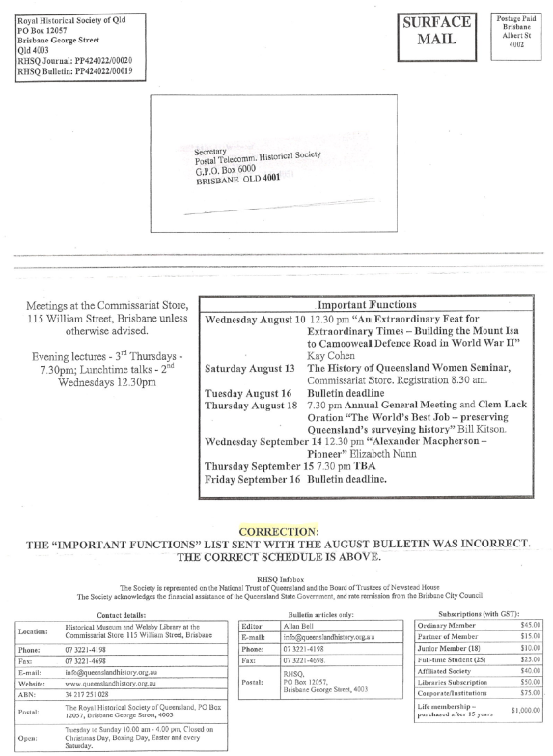

Post Office Box 977
Slacks Creek 4127
6 August 2005
The Secretary
Postal Communications Historical Socy of Qld
P.O. Box 651
Albion B.C. 4010
Dear Sir,
It is with regret that I must tender my resignation from the position of Society Secretary as from 1 August 2005. I
do still wish to retain my Society membership and correspondence should still be sent to the above address.
Enclosed are a few Society items which were not returned earlier.
I wish my successor every good luck in the position.
Yours sincerely,
Richard Youl

MINUTES OF THE GENERAL MEETING HELD ON 18 AUGUST 2004

PRESIDENT Margaret Bartlett opened the meeting at 10.am. Lisa Enright was welcomed. 9 members were present with apology from Ron Warnock.
The treasurer indicated that as a result of the sudden, but not unexpected departure of the Secretary he had temporarily undertaken some of the secretarial duties but unfortunately had not been able to distribute the minutes of the previous meeting. These were available and distributed to those present.
As a further consequence of the secretary's departure it was necessary to make some immediate financial arrangements and a special meeting was held for this purpose on July 20th. The President read these minutes to
the meeting.
The minutes of the previous General Meeting and the Special Meeting were confirmed on the motion of Gordon Wadsworth, seconded Rod Tune with the correction of the name of Don Pinel ( shown as Pinell).
Inward & Outward correspondence received & approved. Moved Tune Sec Gregg
It was noted that Lisa Enright had sent a letter of appreciation to Richard Youl . This action was supported by the meeting which also formally acknowledged our appreciation of his work for the Society.
Treasurers Report.
Action to activate a cheque facility with CUA had been completed in accordance with the Special Meeting and the account with CBA will be closed in the near future with the balance transferred to the CUA account.
Expenditure since the last meeting totalled $672.13 made up as follows:-
Subscriptions $107.00
P.O.Box Rental $ 52.67
Splawinski ( heritage phone) $ 15.00
Trolley Cart ( Siemens 16) $ 89.76
Bench Drill $279.50
Petty Cash $128.20 Total $672.13
Receipts were as follows:-
Equipment rent $35.00
Public Donations $28.00
Aust Post Sponsorship $250.00 Total $313.60
Workshop Report
Business was continuing as usual. The Creed teleprinter which had been overheating had been repaired and was now fully functional. The Siemens 16 display & lecture for Engineers Australia had been most successful and was well received. The assistance of Don Pinel was recorded and the excellent assistance provided by the carriers. The display of WW 2 items has been loaned to the Redland Bay Museum who are mounting a special display for the anniversary of the end of hostilities. The loan is being acknowledged and will provide significant publicity for our activities.
New Member:
Membership of Brad Beitzel was accepted on motion of L. Moloney secended Rod Tune. The work of Brad in
organizing the insulators on display was acknowledged.
Curatorial Visit
The visit of the curators from Victorian Museum, National Museum of Australia, Queensland Museum, Powerhouse Museum, Sydney together with Stef Novak from Victoria was recorded. Lisa Enright expressed appreciation of the handling of the visit by locals and indicated that it had made a favourable impression on the visitors.
General Business:
Supply of a number of Telstra Historical Collection shirts arranged by Lisa was acknowledged.
The Centenary phone obtained from Mrs. Splawinski was displayed. This is a special phone manufactured in Wales for the 25th. Anniversary of the accession of Queen Elizabeth 2. It had been connected to Tunbridge
Wells exchange in England and after minor repairs is now in working order.
Another acquisition was a Simplex Jigger believed to be an early model from retired telegraphist John Barnett now in Mackay.
Next Meeting: The date for the next meeting is 11th. November
Meeting closed at 11.15.

Telstra Museum Brisbane
From: Telstra Museum Brisbane [o104480@bigpond.net.au]
Sent: Wednesday, 17 August 2005 12:36 PM
To: 'bill.jordan@hunterlink.net.au'
Subject: newsletter
Bill Jordan
At request of Robin Black attached are two versions of the photograph of the Siemens Model Exchange to be included with the text forwarded to you as Siemens 16 exchange model2.doc;Battersby Gregg Siemens.jpg
However there should be a minor correction to Robin's text. The last line of the second paragraph should read " .... equipment in all automatic exchanges in Brisbane with the last ...." instead of " in Queensland "

Robin Black
From: "Robin Black" <rgblack@powerup.com.au>
To: "Bill Jordan" <bill.jordan©hunterlink.net.au>
Sent: Thursday, 4 August 2005 9:55 PM
Attach: Siemens 16 exchange model 2.doc; Battersby Gregg Siemens .jpg
Subject: Newsletter
Dear Bill,
Article about a rare model exchange attached. It was written by Leo Moloney and edited by me. I have scanned a photo of the presenters with the exchange model but I am asking Leo to send you the original JPEG from his digital camera. That may take a week or so as he is not on the net.
Robin
A rare working model exchange
"As far as we can determine this is the world's only working model of a Siemens 16 automatic telephone exchange". This is the claim of Leon Gregg of Brisbane's Telstra Museum as he pats the 82 year old model exchange. "We have made lots of enquiries overseas and haven't located another". Leon and Geoff Battersby are retired Telstra engineers who have put several years of Wednesdays into restoring the model exchange to working condition
The model exchange was initially used for the training of installation staff of Queensland's flrst⁻automatic-exchange at the PMG (now Telstra) exchange in South Brisbane which was placed in service on 11th July 1925. The model was then used for training of PMG technical staff at the Central Technical College and later in the PMG's own training system. Up to the end of World War 2 it was a centre piece of PMG displays at the Brisbane Exhibition where it stimulated publicity and recruitment. The PMG used Siemens 16 equipment in all automatic exchanges in Queensland with the last equipment removed in the early 1980's.
The unit was in a state of extreme disrepair due to old age, mechanical damage and the effect of Brisbane's 1974 flood until it's restoration was undertaken by Engineers Gregg and Battersby. In restoring the model the engineers had only their own personal notes and memories to guide them.
On the 14th July 2005 the restored model was again a centerpiece, this time for a paper on Automatic Telephony at Engineers Australia's Hawken Auditorium in Brisbane. The model was transported, with extreme care, in its three original boxes and has enough equipment on it to illustrate dial tone generation, switching within a four subscriber exchange and connection to manual exchanges. The paper covered both manual and automatic exchanges, their history, and their technology. Gregg and Battersby finished with a hands on demonstration of the equipment with much audience participation.
Now that the model is fully restored to working order it will be displayed in the Telstra Museum in Queensland. The Museum is operated by expert volunteers of the Queensland Post & Telecommunications Society. Their collection includes a multitude of items from the past 150 years of communications, many of them in full working order. The Museum occupies buildings behind the Albion Telephone Exchange at 3 Oriel Road (cnr Sandgate Rd), Clayfield. It is open each Wednesday from 9am to 3pm. Admission is free to all, but groups need to book on (07) 3862 2958.
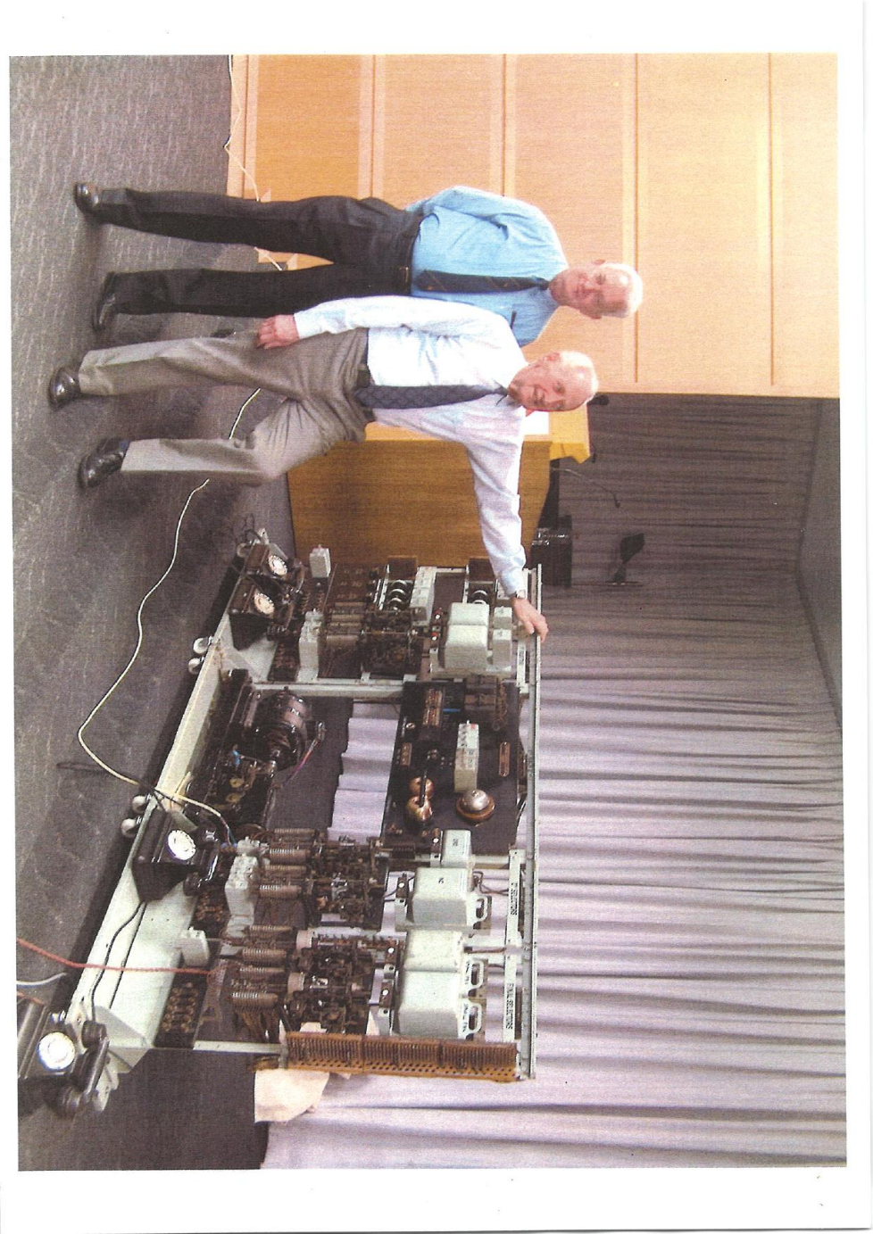

Telstra Museum Brisbane
From: Geoffrey J Battersby [geoffbattersby@bigpond.com]
Sent: Thursday, 13 October 2005 6:00 PM
To: Telstra Museum
Subject: Fw: Telstra
Telstra.JPG (564
KB)
Original Message
From: "Geoffrey J Battersby" <geoffbattersby@bigpond.com>
To: "Don Pinel" <Don.Pinel@team.telstra.com>
Sent: Thursday, October 13, 2005 5:58 PM
Subject: Telstra
- Don
- Thought attached might interest you. .Hope you receive it safely.
- Regards
- Geoff Battersby
- 13.10.05.

Geoffrey J Battersby
From: "Merv" <opticmeratpg.com.au>
To: "Geoffrey J Battersby" <geoffbattersby©bigpond.com>
Sent: Thursday, 13 October 2005 11:40 AM
Subject: Re:
Dear Geoff,
I sold all my Telstra shares just before they crashed.
With all the competition Telstra has coming, in the near future, I don't
see the shares improving
We know the copper network is not being maintained and the Wireless
network will really start to
to hurt Telstra soon.
My son in law who lives on a farm had his cable damaged by lightning in
November last year.
Telstra laid a new section of cable on top of the ground, said they
would bury it later.
He can't get this done because Telstra said that it was laid by a
contractor, and they can't force him to come back.
In the meantime he accidently cut the cable with a mower, because it was
in long grass.
They repaired the fault with a joint on top of the ground but wouldn't
bury the exposed cable
So people will leave Telstra because of the poor shoddy service
Also we have all the minor players who are starting up, using Telstra
capacity, but a lot cheaper
I only use Telstra for local calls, but even then, if I dial 1428 before
the number, I get local calls for18 cents.
Trunk calls are via Ezytel which are much cheaper than Telstra.
Overseas calls, I use a phone card through my Internet provider [TPO) so
my calls to London are 1 cent a minute.
That is not a spelling mistake, it is 1 cent a minute, so we can speak
for 1 hour for 60 cents, over a high quality line
I think the American cowboys are in for a lot of trouble.
regards,
Mery
Geoffrey J Battersby wrote:
> Hello Mery
> Small misprint in mine of 6th Oct.
> _Sir Alexander Downer was widely regarded as one of the Stately
> /HOMES /of England when High Commissioner, so I am informed.
> Regards
> Geoff
DON
IN CONFIDENCE, COPY OF MY LATEST EMAIL FROM MERV LETTE. THIS IS THE INEVITABLE OUTCOME WHEN POLITICIANS LET ACCOUNTANTS AND LAWYERS RUN A HIGH-TECH COMPANY.
COME AND HAVE LUNCH WITH US AT THE MUSEUM SOON AND LISTEN TO US TALKING A LITTLE TREASON.
MANY REGARDS
GEOFF BATTERSBY

Geoffrey J Battersby
From: "Pinel, Don B" <Don.B.Pinel@team.telstra.com>
To: "Geoffrey J Battersby" <geoffbattersby@bigpond.com>
Sent: Thursday, 13 October 2005 8:16 PM
Subject: RE: Teistra
Thanks Geoff and yes I will get out for lunch as soon as I can. I have
put it in my diary for next week but will have to see what crops up in
the meantime.
Don Pinel
MD Teistra Country Wide
Queensland
07 3898 6130


26 July 2005
Qld Postal Tele Hist Soc Qld
P O Box 651
ALBION DC QLD 4010
Dear Sir/Madam
MEMBERSHIP NUMBER : 5214187
We have received your request to change the signatories on the above account.
To date this request has not been actioned. Before this can be processed we require you to supply a copy of the Minutes of the Meeting appointing the new signatories to the account, or a letter from the previous signatories relinquishing their authority to transact on the account.
This copy will be retained in our records for the duration of your membership.
If you have any queries in relation to the above please contact CUA Direct on 07 3365 0055.
Yours faithfully
Credit Union Australia Ltd.
J Garbowski
Team Leader, Transaction Services
BNK27

O Credit Union Australia Limited D ABN: 44 087 650 959 El BSB: 804050
Cl 175 Eagle Street, Brisbane QLD 4000 H GPO Box 100, Brisbane QLD 4001 E1 Phone: (07) 3365 0000 O Fax: (07) 3221 5109

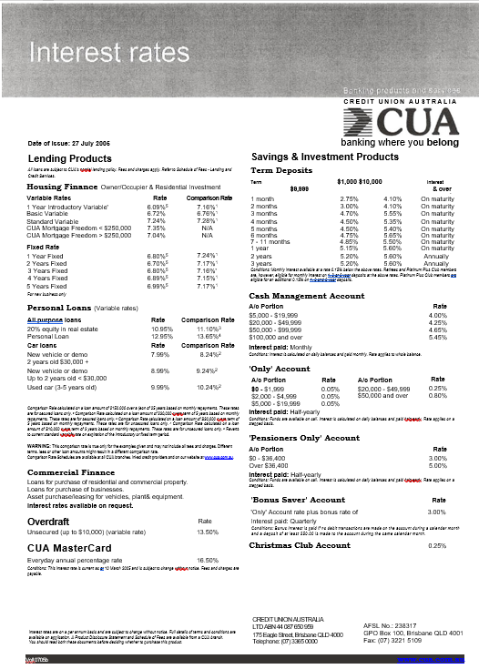



4 July 2005
Telstra Museum
Cnr Oriel & Sandgate Rd
Clayfield
Dear Richard and Gordon
Many thanks for showing the group of men around the museum last Wednesday. There have have been many favourable comments about the exhibitions of communications equipment and your knowledge in highlighting it. Certainly most of the men can remember when having a telephone at home was a novelty. How times have changed.
I hope that the museum continues to receive wide support as it contains an important part of our history.
Yours sincerely

Bill Gibson
(On behalf of The Gap Uniting Church Men' s Group)

 | where:  Hawken Auditorium First Floor Engineering House 447 Up. Edward St BRISBANE 4000 | when:  Thursday  14th duly 2005  at 5:30 for 6:00pm
ENGINEERS  AUSTRALIA  Queensland Division |  | when:  Thursday  14th duly 2005  at 5:30 for 6:00pm

Engineering Heritage Australia (Queensland) Invites you to hear Leon Gregg and Geoff Battersby present:
The 80th Anniversary of Automatic Telephone Operation in Queensland
On the 11th July 1925 life for everyone in Brisbane changed forever when the South Brisbane Telephone Exchange became the first automatic exchange in Queensland. The exchange used equipment built by Siemens Brothers of Woolwich, near London. All Brisbane exchanges were progressively equipped by Siemens. In 1942 three Siemens exchanges were hurriedly constructed for the Allied war effort (Albion, Toowong, and Somerville House!). The last operating Siemens exchange was phased out in the early 1980s.
Because automatic equipment was a totally new experience for staff a portable model exchange was provided in 1923 for training of installation and maintenance staff. The model was subsequently used as a demonstration unit for publicity and recruitment purposes throughout the state. It was the centre-piece of PMG exhibits at the Brisbane Exhibition from 1934 to after WW2. After a long period in storage, and one flood, the model exchange was donated to the Queensland Branch of the Postal and Telecommunications Historical Society. Starting in 2002 it has been restored to working order by the voluntary efforts of members, principally Mr Gregg and fellow engineer Mr. Battersby. It appears that the model may be the only working example of this equipment in the world. It will be on display and it will be working on the night.
Leon Gregg FIEAuSt and Geoff Battersby tiltAust wer e "formerly technicians of⁻the PMG Department (now Telstra). Leon started in 1941 while Geoff started in 1952, and was later in the first batch of PMG trainee engineers at UQ. At retirement Leon was a Regional Engineer and Geoff a Superintending Engineer. Both Leon and Greg are volunteers at the Telstra Museum.
The Telstra Museum is at 3 Oriel Road (cnr Sandgate Rd), Clayfield, is open Wednesdays 9am-3pm, admission is free to all, but groups need to book on 3862 2958.

More detail? contact:
Engineers Australia
Daniel Seguin
Robin Black
www.engqId.org/htge

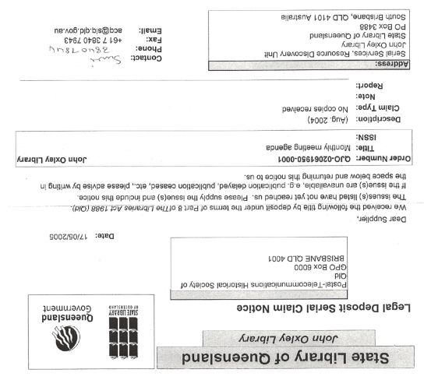

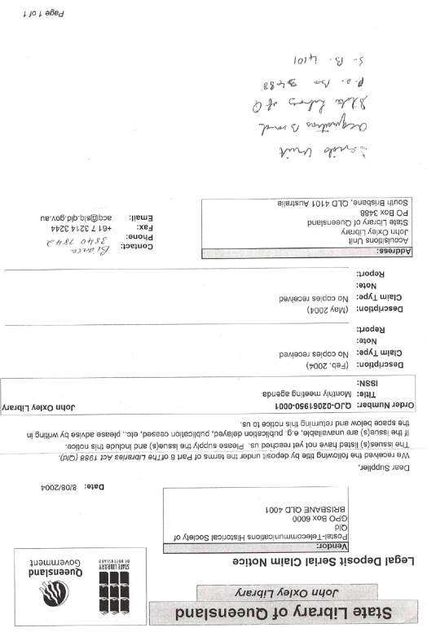

Fax to Kangaroo Bus Lines
5498 6466
Attention Rhiannon
From Telstra Museum
Leo Moloney
A few notes about the museum as discussed by phone.
TELSTRA MUSEUM
( General Information)
The museum is operated by volunteer members of the Queensland Postal Telecommunications Historical Society.
The space in the museum is limited and it is only possible to include group of about 25 at the same
time. There are four general sections and these cater for about 6or 7 people at once. A tour of the full collection would normally take about one hour but this can be shortened or lengthened to suit special interests.
The museum is only attended on Wednesdays and is available for visits between 9 a.m. and 3 p.m.
The Society does not make a direct charge but suggests that commercial operations should make a donation of $1 per head.
The museum is located in separate buildings at the rear of the Albion Telephone Exchange on the corner of Oriel and Sandgate Roads.
There is parking available on site or on Barlow St. which has direct access to the museum.
As there a few steps involved between the sections wheelchair access is not particularly convenient.
The exhibits include a mixture of static and operational displays ranging from morse equipment dating from the 1860's up to modern telephone items and covering most variations of the intervening period.

To: Officeworks
From: Telstra Museum, Brisbane
Subject: Change of address
Your reference code P8255947 YA6Q
Please amend address to the following:
Secretary,
Telstra Museum, Brisbane
P.O. Box 651
ALBION B.C.
4010

Telstra Museum Brisbane
From: Enright, Lisa [Lisa.Enright@team.telstra.com]
Sent: Wednesday, 12 January 2005 2:34 PM
To: Telstra Museum Brisbane
Subject: comments for the Nov meeting minutes
Richard
as discussed:
- with the outcome of the recent Federal election and the now imminent privatisation of Telstra it has become necessary to assess the long term future of the Telstra Museum sites as the historical function will not be ongoing within the organisation..
- a business case has been put forward to Telstra senior management outlining a plan to establish a museum consortium including the major Federal, State & Regional museums that would take over management and eventually orwnerahip of the Telstra historical collection over the next 3-5 years.
- the museum consortium plan is at very early stages of development and an undertaking has been made that all planning and negotiations in relation to the future of the collection and the relationships with the individual musuems and the consortium will include the imput and involvement of the museum volunteer groups and their representatives.
- clear rationale underpinning the plan and the proposal is the protection and longevity of the Telstra historical collection for the people of Australia over time and the maintenance and longevity of the volunteer groups whose custodianship has meant the survival of the collection over the years.
hope this is OK - please call and discuss is you have any thoughts or issues
oh - just got the mail with the DVDs in it - thanks
have a good week - speak next Wed - take care of yourselves
Lisa
Lisa Enright
Historical Collections Adviser
37/242 Exhibition St
Melbourne VIC 3000
ph: 03 9634 0401
mobile: 0400 949 227
"Nothing splendid has ever been achieved except by those who dared believe that something inside them was superior to circumstance" Bruce Barton
 | Postal-Telecommunications  Historical Society of Queensland
 | 3 Oriel Rd (Cnr. Sandgate Rd) CLAYFIELD 4011 [Postal address: P.O Box 651 Albion B.C. 4010]
Trading as TELSTRA MUSEUM BRISBANE
PRESIDENT: Margaret BARTLETT
SECRETARY: /Weird c---WMF1t, TELEPHONE (07) 3862 2958
TREASURER: Leo MOLONEY FAX (07) 3262 1199
Russell
Australia Post
Shop 3 8 Maple St.,
MALENY Q 4552
Dear Russell,
As requested, we have pleasure in sending some of the historical documents relating to the early days of Maleny Post Office and Telephone Exchange.
Trusting that you will be of interest to those visiting your display on 1 November 2005. Best wishes,
Gordon Wadsworth {for Secretary}
12 Oct 2005

PLEASE NOTE NEW POSTAL ADDRESS ABOVE

