REPORT

on the

CURRENT STATUS AND POTENTIAL

FUTURE USE

of

BELLENDEN KER BROADCASTING SITE.

This report is intended to record the present functions of the Bellenden Ker Broadcasting Site, outline historical details influencing the establishment of the site, assess potential continued future usage against the predicted and possible future requirements for the area, assess alternative methods of providing for future Broadcasting requirements in the area and draw attention to matters which may have a significant influence on future activity in the area and should be considered for future detailed investigation.
There are no specific terms of reference against which this report has been produced.
SOURCES OF INFORMATION.
The majority of the information contained herein has been obtained from records available within the State Broadcasting Branch but in many cases it has been necessary to consult records and people of various groups both within and outside Telecom. These groups have included:-
Department of Communications State Office; specifically for current service area information.
Department of Housing and Construction
F.N.Q.E.B.
National Parks
Department of Aviation
Telecom Network Engineering
Telecom Field Studies Group
Telecom D.T.M. Cairns
Telecom District Engineer, N.Q.

L.W. MOLONEY
25/11/1987
CONTENTS.
P2 Current Facilities
P4 Broadcast & Telecom Services
P5 Department of Air and Other Services.
P6 Historical Background to Site Selection
Broadcast Coverage
P7 Financial Considerations
P8 Operational Aspects
P9 Projected Future Use of Site
P10 Status of Present Facilities.
P12 Summary
P13 Recommendations
APPENDICES
1 Broadcast Sites Cairns TV Service Area
2 Site Location Map
3 Field Strength Contours ABNQ and Translators.
(Source: D.O.C.)
4 Specified Service Area FNQ
(Source : D.O.C.)
5 Bellenden Ker Transmitter Antenna Pattern.
(Source : Co. EI Handbook)
6 Predicted U.H.F. Field Strength Contours Bellenden Ker Site
( Source: D.O.C.)
7 World Heritage Proposed Wet Tropics Boundaries
(Source: Dept. of Environment etc.)
8 Transmitter Building Layout Dwg. QSK 650007
9 Original Proposal & Final Site Area. D. of I. Sketch 68/32/1

CURRENT FACILITIES
Location:
The transmission site is located immediately adjacent to the Centre Peak of the Bellenden Ker Range about 40 km south of Cairns and about 7 km west of the Bruce Highway. The site is approximately 1520 metres above sea level.
Access.
Access to the site is obtained via a private road approximately 2 km long and an aerial Cableway 5.2 km in length terminating in an annexe of the main transmitter building.
The limiting factor in the access is the Cableway which is designed to handle a maximum load of 1 tonne. Provision is made to carry long loads within the envelope of 9 metres long, 600 mm. wide by 1200 mm. deep although loads exceeding these dimensions, but meeting the weight limit, can be carried after special arrangements have been made. (The attached photograph illustrates a typical recent abnormal load.)
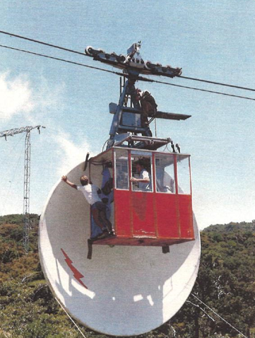
ABNORMAL LOAD 4.7 m Aussat Dish to Tx. Site.(cf. Normal limit 9m. x 0.6m x 1.2m.)
Access time from Cairns is approximately one hour of which 20 minutes represents the transit time of the cableway.
Alternative access to the transmitting site and to the vicinity of three of the intervening cableway towers is possible by helicopter. This is limited to suitable weather conditions for flying and the limiting load of currently available helicopters is approximately 450 kg, which may be further reduced by aerodynamic stability requirements.
Property.
The overall site consists of two Special Leases with a term of 30 years commencing on April 1st, 1972, for the Transmitting site ( including the Top Station of the Cableway) and the Bottom station of the Cableway, together with a road easement partly through private property and partly in National Park ${226}^{1}$.
The total area of the two Sites is approximately 2.001 hectares having been reduced from the original proposed area subsequent to a decision that a combined Radiocom / T.V. Tower about 85 metres high would be provided instead of a 150 metre T.V. tower and a lower radiocom ${tower}^{2}$. It was acknowledged that an additional area could be made available should erection of a higher tower become desirable at a later date, provided that the minimum area adjacent to the building was used but specifically excluding extension to the knoll south of the leased ${area}^{3}$. The original proposed area is shown on Department of Interior Sketch 68/32/1 a copy of which is attached as Appendix 9. The finally approved site is outlined on this sketch in red.
The area under the Cableway and the power line is not included in the lease but their existence in parts of National Park 226 and State Forest R 310 has been confirmed by relevant State Authorities together with permission for the Commonwealth to maintain and service the ${facilities}^{4}$.
Buildings.
The main building on the transmitting site is a two-story construction with a floor area of approximately 460 square metres, together with a lower ground floor area incorporating emergency power plant, air intake filtering, water, and miscellaneous storage areas. General details are shown on Drawing QSK 650007 Sh. 1 - 3 attached.
The ground floor incorporates an amenity area with overnight staff accommodation as well as a Telecom Battery Room, D.O.A. equipment room and an Other Services equipment room which includes provision for R.F. Management and Commercial Television mobile R.T. base equipment.
The first floor is primarily allocated for Broadcasting purposes viz. T.V. Transmitters plus the National F.M. Transmitter but includes the Telecom Communications Equipment Room which houses, inter alia, the microwave link equipment providing the programme input for the Commercial T.V. Transmitter.
The Bottom Station of the Cableway has a permanent structure which houses the Cableway drive, Control facility, emergency drive equipment and Ropeway maintenance equipment. A transportable construction building has been refurbished for use as an Office, Store and Air Conditioner maintenance facility.
Tower
The tower is an E.P.T. Type 106 self-supporting structure, 61 metres high, with a 24 metre high T.V. aerial column superimposed.
The tower is the supporting structure for V.H.F. T.V. and F.M. Transmitting Antennae, Telecom Microwave dishes and numerous communications antennae for D.O.A. , Telecom and various other miscellaneous services.
Consequent on the decision not to provide a separate T.V. tower the structure was erected as a direct charge against Telecom Australia Trunk Radio funds with specific antennae and feeders being provided against the funds of the individual users.
References:
1. Lease Approval QB 601-1-12 Folio 173 11/9/7 2
2. Reduction of Area QB 601-1-12 Folio 152 28/9/7 0
3/4 Forestry Agreement QB 601-1-12 Folio153 A/C 7/10/7 O.

BROADCASTING SERVICES
Currently Installed Equipment
The National Television service ABNQ 9 is provided by a pair of A.W.A. TVH 5A 5 Kilowatt Transmitters, operated in parallel and feeding a set of 24 Coel panels mounted in 6 levels to provide a horizontally polarised nominally omnidirectional radiation pattern.
The Commercial Service FNQ 10 was originally provided using similar equipment but this has recently been replaced using N.E.C. PCN 1410 /AH1 10 kilowatt transmitters operating in a main and standby configuration.
The Commercial and National transmitter outputs are combined and fed to the common antenna array using dual feeders to provide an Effective Radiated Power of 100 kw per channel.
The National F.M. service is provided by an N.E.C. FBN 7510 E 20 Kilowatt transmitter operating at 105.9 megahertz feeding a Shively side mounted antenna type 6814, circularly polarised and optimised for operation on 102.1, 105.1 and 105.9 megahertz.
Programme input for both the National T.V. and F.M. services is provided via AUSSAT receive only equipment installed on site at the top station.
Programme input for the Commercial T.V. service is provided from Townsville via Telecom microwave links.
TELECOM SERVICES
Currently Installed Equipment.
The main telecom equipment is the Microwave bearer equipment providing the Cairns -Atherton and Cairns - Millaa Millaa telephony bearers plus the Television bearer for the Commercial T.V. service. The bearers are all protected and the Cairns - Bellenden Ker Telephony and Television bearers use a common protection bearer. A disused T.V. bearer, previously utilised to provide the National service programme, is retained on site and has access to the same protection bearer.
Lower capacity equipment is installed to provide channels for telephone and leased line facilities while V.H.F. base station equipment is installed to provide a Telecom in-house mobile telephone service.
Telecom equipment is battery powered and a floating dual-battery installation is provided in the separate Battery Room on the Ground floor. This battery installation also provides some capacity for Department of Air equipment.
DEPARTMENT OF AIR SERVICES.
Currently Installed Equipment.
The Department of Air maintains an extensive installation of V.H.F. services to provide an Air - to- Ground facility for Commercial Aviation operators, General Aviation and Air Traffic Control purposes as well as equipment providing links to Cairns Airport.
An extensive aggregration of V.H.F. antenna is located on the tower in connection with these services. The extent of the installations can be seen on the photograph attached, the majority of the antennae being provided for aviation purposes.

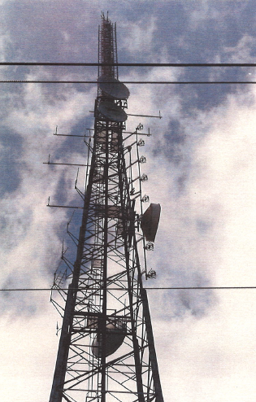
BELLENDEN KER Transmitting Tower Miscellaneous Antenna

OTHER SERVICES.
Currently Installed Equipment
The Other Services Room , located on the Ground floor, has a number of V.H.F/U.H.F Services for Departmental, State & Local Government and Commercial Users. The equipment is installed in an un-coordinated fashion and includes the following services.
D.O.C. Radio Frequency Management.  State Emergency Service  Main Roads Department  F.N.Q.  Cairns Amateur Radio | V.H.F. Mobile Service  2 U.H.F. Tx./Rx. Installations  1 U.H.F. & 1 V.H.F. Tx./Rx. Installation  1 V.H.F. & 1 U.H.F. Tx./ Rx. Installation  V.H.F. Talk Through Repeater.

HISTORICAL BACKGROUND TO SELECTION OF BELLENDEN KER
The proposal for a television service for the Cairns Area was included in Cabinet
Submission 142 on 18/5/62 at a notional cost of £360,000 including road construction costs of £123,000 and was approved on this basis.
Subsequent investigations based on photogrammetric surveys indicated that the probable cost of the road for a Bartle Frere site would be double the original estimate resulting in total cost of £560,000 which was the highest cost of the 20 sites included in the Phase 4 proposal. Cabinet approval for the project was granted on this basis.
The anticipated increased cost of the Bartle Frere road led to consideration of alternative access based on a previous proposed cableway to Bellenden Ker. It was nevertheless considered that the access road option was the economically viable option.
During this time and prior to the Cabinet decision numerous alternate proposals had been considered either with a single main station with a small number of low powered transmitters and translators or a multi station alternative with 2 or more High Powered Transmitters and subsidiary low powered installations. The former category was condensed to two alternative sites, Mt. Bartle Frere North Peak and Mt. Bellenden Ker Centre Peak. The most promising of the latter group was the Mt. Fisher Scheme with High Powered transmitters at Mt. Fisher and Mt. Whitfield together with low powered installations at a minimum of four other sites.
Field investigation of the access route by ground survey parties indicated that the anticipated road costs were seriously underestimated by about £250,000 . This was due to the presence of a number of extremely deep gorges within the tropical rain forest whose presence had not been revealed by the photogrammetry.
The magnitude of this unexpected cost was sufficient to prompt further consideration of the site decision. Further multi-station options had also been suggested notably the Mt. Hugh Nelson scheme but after consideration of all the alternatives and the anticipated costs a Cabinet Recommendation was made to proceed with the Mt. Bellenden Ker proposal with a cableway access at an estimated cost of £1.1 million (1968 prices). This recommendation was adopted and announced by the Postmaster General on${29/8/68}^{5}$.
A significant factor in the final decision to proceed with the Bellenden Ker site was the suitability of the site for telecommunications access to the Tableland area and a vast improvement in the effective range of Air-to-Ground communication facilities of the Departmental of Civil Aviation in the area. There was no significant difference between Bartle Frere and Bellenden Ker for Aviation purposes, but the latter provided significantly better T.V. coverage of Cairns itself, was considerably better for Radio communication purposes and incurred lower costs for provision of the necessary T.V. Programme Links.
A list of the current operational sites and other significant sites considered during this period together with an outline map indicating the approximate locations is attached as Appendices 1/2 .
BROADCAST COVERAGE OF THE SERVICE AREA.
The field Strength Contours for the National Service ABNQ 9 as determined by the Department of Communications are shown on the map attached as Appendix 3 together with an overlay showing the 75 & 65 dbU contours for the associated National Translators.
The coverage of FNQ 10 main transmitter is basically identical due to the similar operational parameters and the closeness of the frequencies but the Translator coverage varies somewhat as a result of channel allocations at particular sites.
The Service Area for FNQ 10 as formally determined on 21/11/85 is shown in Appendix 4 attached but it should be noted that not all translator locations in the Service Area are shown.
The effective Service Area is heavily terrain limited as indicated by comparison of the 65 dbU contour with the antenna pattern for the main station as shown in Appendix 5 attached. The topography in the Service Area is such that this overriding terrain effect will dominate in consideration of any. site but is progressively more significant as the height is reduced below that of the dominant Bellenden Ker or Bartle Frere sites.
(Reference: 5 Postmaster General Statement to House of Representatives)

FINANCIAL CONSIDERATIONS
The financial arrangements attached to the shared use of this site are complicated because of the number of major users, the variation of cost during the construction period, alteration to the tower erection proposal and the effects of the Sharing Arrangements applicable to Commercial T.V. Operators at that time.
Significant Capital costs were:-
Original estimated overall cost (1968) $1.1 million
Revised overall estimate (1970) $1.34 Million
D.C.A. Capital contribution $ 116,000 Note 1
P.M.G. Capital contribution $ 130,000 Note 1,2
F.N.Q. Capital contribution $ 81,250 Note 3
Notes "
1. Capital contributions of P.M.G. and D.C.A. were based on the "assessed" cost to them of providing equivalent facilities at independent sites at 1968 prices. These were not adjusted in line with revised estimates or final costs.
2. An effective additional contribution was made from P.M.G. funds with the decision to utilise a common tower for Radiocom and Television purposes. The tower was constructed with Trunk Radio funds and maintenance of the structure was charged against Radiocom maintenance up to the establishment of the Broadcasting Directorate.
3. The contribution of the Commercial operator was calculated in accordance with the then operational sharing agreement which provided for a percentage of the cost of various Capital items with a maximum for any one item. The total was composed of Cableway $20k, Building $30k, Power Line $31,250.
No contributions to maintenance of facilities by D.C.A. or P.M.G. were specified except that each was responsible for power consumption of their own equipment and for any maintenance of individual equipment items. FNQ were also liable for contribution to maintenance cost of common equipment of approximately $4,000 per year.
It should be noted that the submission to the Parliamentary Standing Committee on Public Works stated :-
“…….maintenance and running costs included in the annual charges to be contributed by the Post Office, Department of Civil Aviation and the Commercial Licensee have also to be negotiated."
Except as noted above this does not appear to have occurred but it should also be noted that at various Radiocom sites, as shown in Appendix 1, Broadcasting facilities share Site, Building and/or Structures without specific contribution towards general maintenance costs.

OPERATIONAL ASPECTS.
The Operation and Maintenance costs for the Bellenden Ker site are significantly affected by 3 special factors:-
1 Age and Type of installed equipment.
2 Local Climatic Conditions
3 Accessibility
1 Age and Type of Equipment.
The National T.V. Transmitters are generally considered to require above average maintenance attention. The Commercial operator has recently replaced his similar equipment with more modern units requiring less floor space and maintenance attention. Different financial constraints apply to the National equipment but it is anticipated that these units will be replaced at an early stage.
2. Local Climatic Conditions.
The height of the site, closeness to the coast and the particular local topography combine to produce one of the heaviest rainfall areas in Australia, if not the heaviest, with a consistent cloud cover. This results in conditions conducive to accelerated corrosion problems with the external plant and necessitates special treatment to ensure reasonable humidity control for the internal plant.
3. Accessibility.
The over-riding factor affecting any consideration of the operational economics which distinguishes this particular site is its accessibility.
Access time from Cairns of approximately one hour is in the upper acceptable range for an unstaffed main station but is not totally intolerable provided the reliability and operational redundancy of the installed equipment is adequate.
Operational and on-going maintenance costs of the Cableway installation however result in unusual cost penalties on all activities associated with the site including construction work when compared with "normal" installations. The implications of these costs are considered in more detail in an addendum to this report.

PROJECTED FUTURE USE OF THE SITE.
A. BROADCASTING ACTIVITIES.
i) F.M. Broadcasting.
Since the establishment of the Site the only major change of the Broadcasting use of the site has been the establishment of the National F.M. service. This was not specially recognised in the original design of the facilities and provision has been made for this service by conversion of Store space for equipment purposes , relocation of some minor antennae and installation of a non-optimum side mounted antenna on the support structure. It is envisaged that provision will be required for a number of other F.M. services but the number is not yet determined.
It is considered that unless use of the site is very heavily subsidised it will not be particular attractive to Community Broadcasters who will be more likely to optimise coverage in particular local areas of interest.
It is therefore considered that provision for expansion up to a maximum of 4 High Power services would adequately meet future needs for this site.
ii) Television Equalisation.
Resolution of plans for equalisation of Broadcasting services and extension of Special Broadcasting services will necessitate provision for at least 3 further T.V. services. The predicted coverage area is shown in Appendix 6. Consideration of this pattern in conjunction with contour information indicates that it can be achieved effectively with tower antenna height than the current VHF antenna.
Current planning is for this to be met by U.H.F. services, probably in Band 4 and Channels 33 and 39 are presently proposed for equalisation purposes and Channels 30 and 42 are tentatively allocated for future expansion.
This will require provision of a major U.H.F. antenna on the structure.
B. TELECOM ACTIVITIES.
Telecom has for some time proposed to re-route the Microwave services using Bellenden Ker as a repeater site. This was planned to occur subsequent to the establishment of a new route via Freshwater to Mareeba with subsequent extension to Charters Towers. This was to be established progressively to coincide with extension of the Digital Microwave network to North Queensland.
It was envisaged that the route would be operational and the through services de-commissioned by the end of 1988. It now appears that this programme has slipped and is unlikely to be achieved before the 1989/90 financial year.
A critical step is the completion of a new Repeater site to the north of Cairns. The site has been selected at Mt. Formartine, NW of the Buchan Point repeater, and final approval for use of the site is expected in the near future. The site is located in State Forest Reserve which is scheduled for inclusion in the World Heritage listed "Wet Tropical Rainforest Area". This area includes most potential or existing Radiocom or Broadcasting sites in the area. The proposed limits are shown in Appendix 7.
There are no scheduled plans for provision of extra TV bearers to the site nor was recovery of any existing equipment envisaged. Excluding T.V. bearer requirements for the present Commercial operator and future proposed services the only requirement for
Telecom services would be for local links for Telephone, two-way base stations etc. This requirement would depend on the policy adopted by Telecom and the Commercial operators but may have a critical effect on the adequacy of building space for Broadcasting services.
C. DEPARTMENT OF AIR SERVICES.
It is expected that the Department of Air will have only minor expansion which will not involve any significant requirements for building space and only minor tower requirements. Proposed major expansion of Radar services in the area are not expected to involve Bellenden Ker.

STATUS OF PRESENT FACILITIES.
1. Buildings
The structure of the main building on the Top site is in sound condition. After completion of current minor maintenance, which had been delayed because of the Cableway problems, it is not anticipated that any significant work will be required in the next 5 years.
The available building space is considered to be adequate to provide for anticipated Broadcasting development, without a building extension, provided the current space allocation is considerably amended. This would require extensive alteration to internal partitioning and the projected removal of most Telecom equipment is essential.
A possible layout is shown on Drawing QSK 650007 Sheets 4 & 5 attached but many variations would be practicable.
2. Tower.
The status of the existing tower is somewhat conjectural. Full details of the existing tower loading have been provided to the Directorate Structures group for analysis and determination of its ability to carry the current loading under the present Codes. The result of this analysis is awaited.
Inspection of the tower by a competent Structural Engineer is considered essential to assess the extent of any corrosion damage and its effect on the structural integrity of the tower. Routine inspection by Radio Lines staff have recorded that there is severe corrosion on ancillary steelwork e.g. cable trays, hangars etc., surface corrosion on some bracing members with localised problems with tower bolts.
Provision of further D.O.A. antenna, together with provision of permanent F.M. and U.H.F. T.V. antennae will almost certainly require upgrading or replacement of the existing structure or provision of an auxiliary tower. The extent and urgency of this work cannot be predicted until the results of a structural check and design analysis are available. (Completion of the latter will be affected by a decision on the future requirement for microwave antenna on the structure.)
3. Access.
The Cableway providing access to the site has recently undergone major repair work and further work is proposed for this financial year.
The completed work has included replacement of the main Track Rope and the Hauling Rope. It is expected that the service life of the new ropes will be in excess of the 15 years achieved by the original ropes.
Proposals for the replacement of the Car Hanger and car are currently being considered and it is expected that completion of this work would extend their service life by at least the same period.
The most recent inspection of the structure by an overseas Cableway Consultant indicated that the towers were in very sound condition and should only require minor maintenance for many years.
4. Power Line.
The high voltage power line to the transmitting site is currently limited to a total capacity of 200 kVA by the capacity of the step-down transformers installed at the site. Two transformers, each of 100 kVA rating , were provided because of the weight limitation imposed by the cableway. The transformers are understood to be in good condition.
The Supply Authority, FNQEB, have indicated that the actual line is capable of considerably increased capacity as the conductor size and spacing have been dictated by mechanical considerations rather than the current capacity.
The mechanical integrity of the support structures used in the power line is viewed with some concern because of the fabrication methods employed in the original construction. FNQEB have been requested to inspect the structures in conjunction with routine maintenance of the line in the near future but is also considered that detailed inspection by a competent Structural Engineer should be arranged.
The number and rating of transformers required for future expansion would depend on the ultimate load required but FNQEB have indicated that higher rated transformers may be available which are within the maximum load of the cableway . They have also envisaged the possibility that higher loads may be transported by helicopter. (In this regard it must be reiterated that operational helicopters currently available in North Queensland are unable to lift loads in excess of 450 kg at the required altitude.)
5. Emergency Power Plant.
The existing emergency power plant will be totally inadequate to operate all existing and proposed services at full power.
The relatively small incidence of commercial power outages for the site is such that serious consideration should be given to operating parameters under these conditions. Operational records show that the Emergency Power Plant has operated for only 500 hours during the four years to 1/11/87 including all test running. The longest period of operation was 53 hours in the aftermath of the 1986 cyclone.
Reduced power operation is considered to be an acceptable option and if all future installations are designed for operation in this fashion a significant reduction in the cost of the plant could be achieved. It is noted that the Commercial T.V. transmitter design using a main and standby transmitter of equal power has not been based on this criterion.
The existing plant is rated at 175 kVA and the present maximum demand is approximately 140 kVA.

SUMMARY.
- The Service Area for the Cairns T.V. Transmitters is very difficult to cover adequately principally because of the terrain but compounded by the scattered pockets of population. The geography of the area has not changed since the original installation but there have been significant changes in the population distribution and the expectations of service by residents in the area,

- As long as the basic programme source is land based some form of multiple station access will be required. The current translator locations have generally used pre-existing sites and these may not be adequate or available for extra UHF translators. The alternative of a full satellite service is not seen to be an acceptable alternative at this time.

- The currently adopted solution of a single central high powered transmitting site as the primary source for the area and the parent for a number of low powered installations to service pockets in low signal areas is considered the best available option for the immediate future. Input signal level to existing Translator sites is expected to be adequate with the possible exception of the Mossman area service located at the Newell Beach Radiocom site.

- Expansion of services at the existing site in the most economical fashion is dependent on timely withdrawal of major Telecom Communication services from the site.

- 5, Resolution of the method of apportioning running costs between the major users of the site is required. It is noted that it may be desirable that the apportionment be on a notional basis only.

- 8 Provision of modern equipment with lower maintenance requirements and improved remote control/monitoring facilities offers the possibility of considerable reduction in operating costs particularly if a greater degree of redundancy is provided. Improved reliability of the major equipment has the consequential effect of increasing the relative importance of reliability of ancillary equipment items.

- Access to the present site by Cableway is considered to be the best option currently available.

- The existing antenna support structure is inadequate for the existing services and those planned for the immediate future. The extent of relief required is dependant on structural analysis and determination of long term Telecom requirements.
Plans for existing and proposed services at the site should be closely examined to determine whether unusual aspects of the site justify departing from the normal methods of dimensioning equipment. Particular attention should be given to the aspects of emergency power generation and reduced power operation under emergency conditions.

RECOMMENDATIONS.
1. Television and Public F.M. Broadcasting services for the Cairns area should continue to be based on the existing centralised site at Mt. Bellenden Ker.
2. Detailed discussions should be initiated with the appropriate Branch of Telecom to establish clearly the continuing requirements for Radiocommunication circuits to and through Mt. Bellenden Ker. A clear timetable must be established for decommissioning and removal of redundant equipment and external plant as well as relocation of residual equipment.
3. A Structural Engineering inspection of the existing structure should be arranged as soon as possible. This is essential to permit a decision on the alternative means of meeting future needs viz;
a) Strengthen the existing structure.
b) Provide a single new structure.
c) Construct a supplementary structure for new services.
2. D.A.S. should be requested to initiate action to extend the site to the South to accommodate a new or additional structure.
3. Subject to results of Recommendations 3 & 4 above a supplementary structure should be erected to the South of the existing building to support the permanent UHF TV and FM transmitting antenna.
4. Direct Operational and Maintenance costs relating to the Building, Structure, Access and Power Supply should be analysed and a reasonable apportionment of costs be established with the major users. (Fees for site usage for incidental users may also require adjustment.)
5. U.H.F. propagation tests should be undertaken from the existing structure to establish the minimum required antenna height and establish the extent of the area where degraded service requires establishment of translators, particularly in the direction of the Town of Innisfail.
6. Operational practices and costing procedures in regard to Cableway operation and maintenance as well as Power Line, Top Station (Transmitting Site) and Building should be reviewed to ensure that recorded figures properly reflect the actual costs.
7. Emergency power requirements of all equipment should be closely scrutinised to contain the essential load within the capacity of the existing plant. All High Power transmitting plant should be required to operate at a reduced output and other load minimised to achieve this end.

Site List Cairns Television Area
Operating Sites.
Main Station Mt. Bellenden Ker

Translators
Mossman | Newell Beach Radiocom
North Cairns | Buchan Point Radiocom
Babinda | Graham Range Radiocom
Tully | Mt. Myrtle Radiocom
Mareeba | Mareeba Radiocom
Atherton | (U.H.F. repeater only.) Radiocom Site.
Gordonvale | 4 QY Broadcast Site
Ravenshoe | Broadcast Site.
Herberton | Broadcast Site
Mission Beach | Dunk Island . Rented Premises
Tully Falls/ Cardstone | (F.N.Q.E.B. owned

Other Sites Considered
Mt. Bartle Frere
Lamins (Lamonds) Hill
Bone's Knob
Bells Peak
Green Hill
Lamb’s Head
Mt. Whitfield
Mt. Hambling
St. Patrick Hill
Cassowary Range
Mt. Fisher
Bald Rock
Mt. Hugh Nelson
Lake Newell

Appendix 1
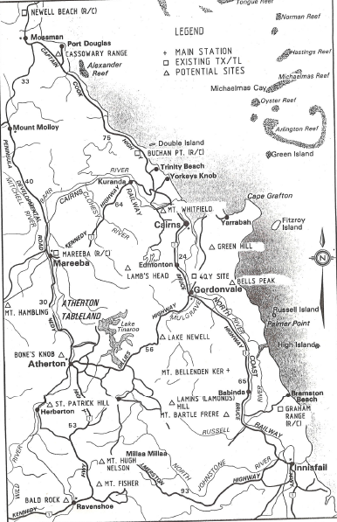
Appendix 2
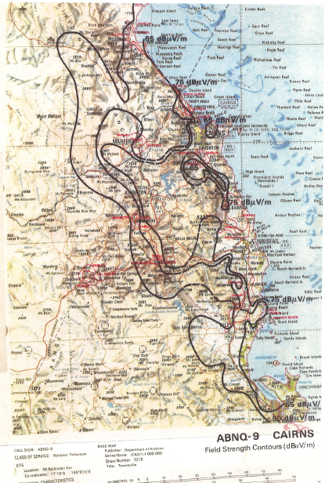

Appendix 3
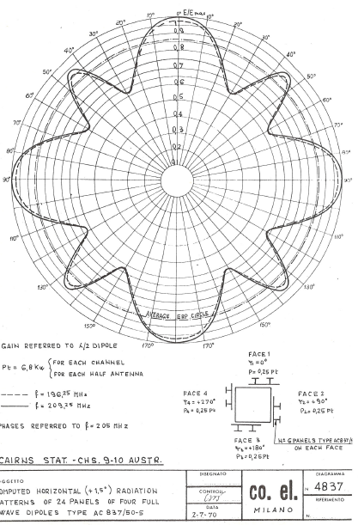

Appendix 4
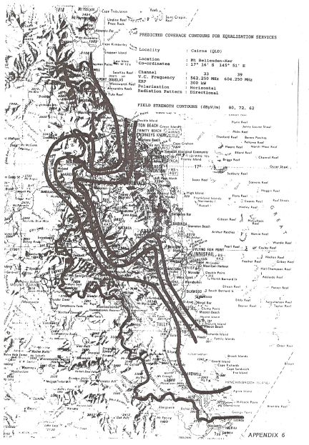

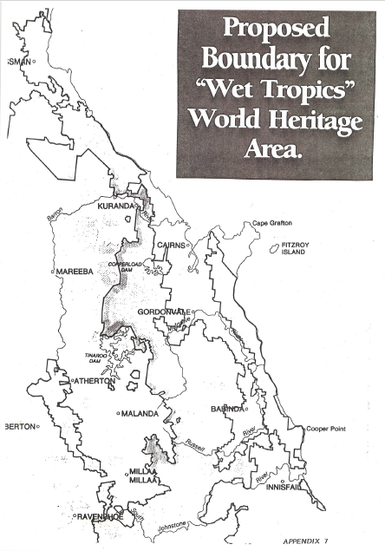

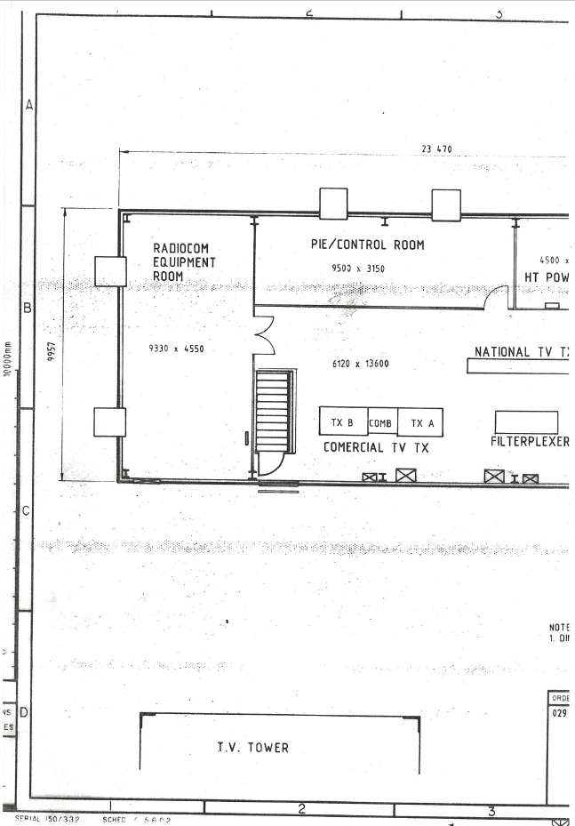

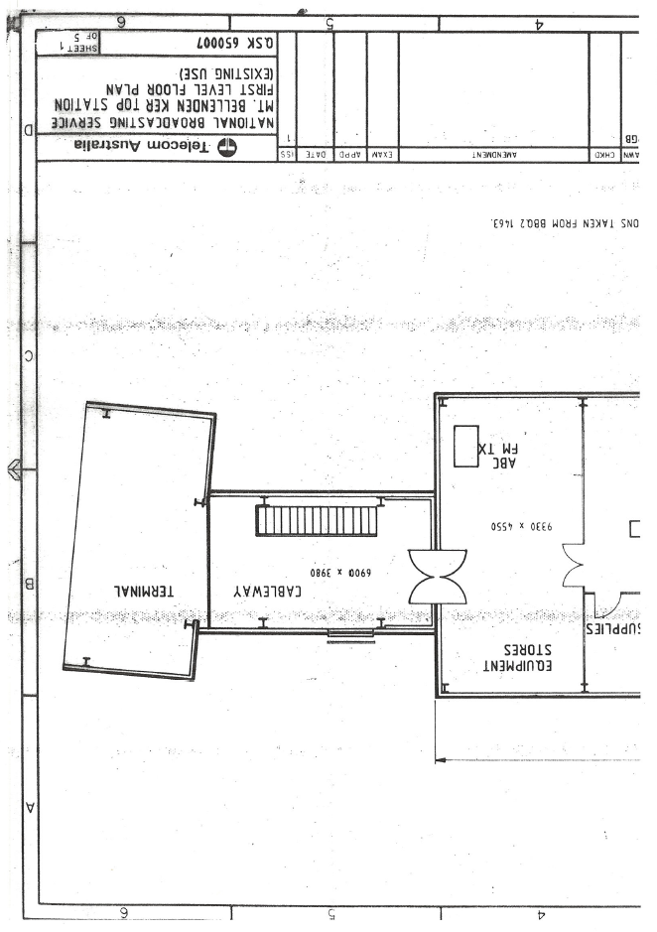

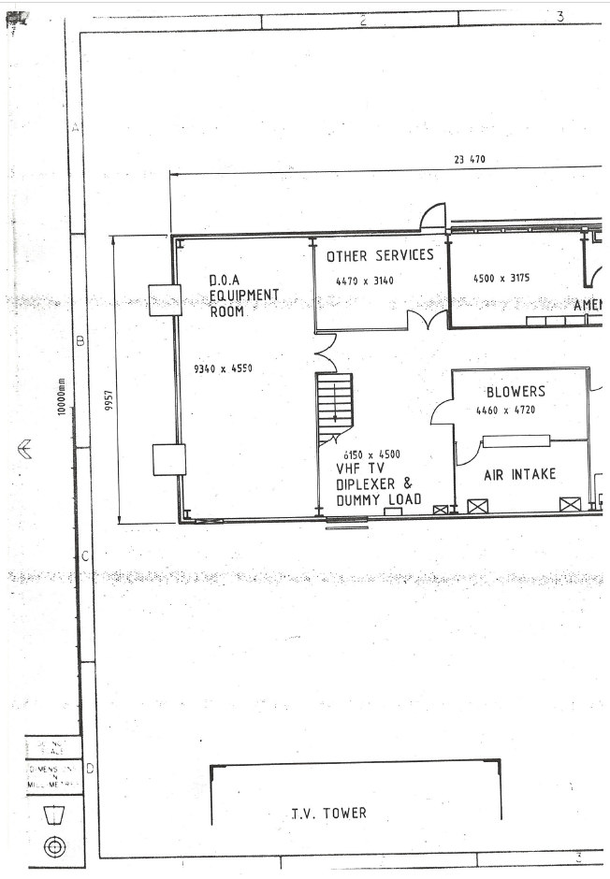

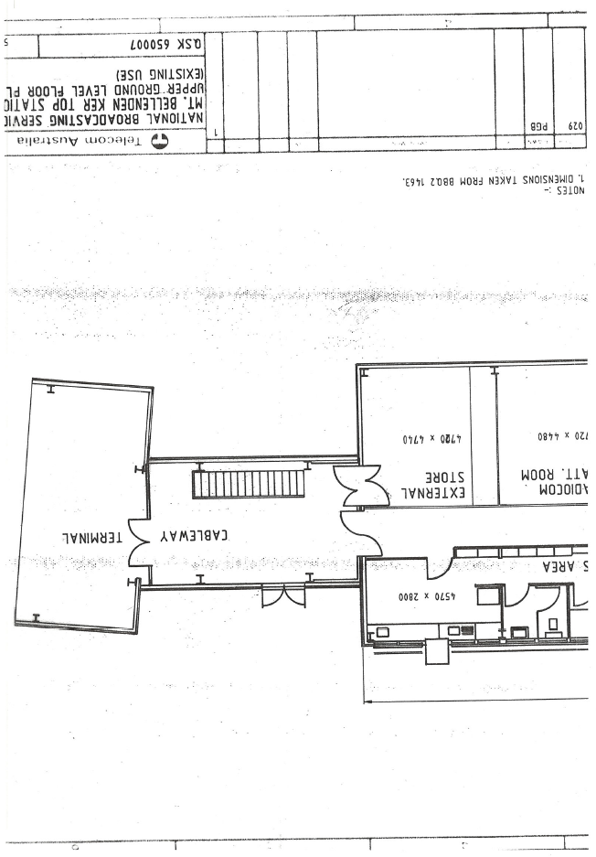

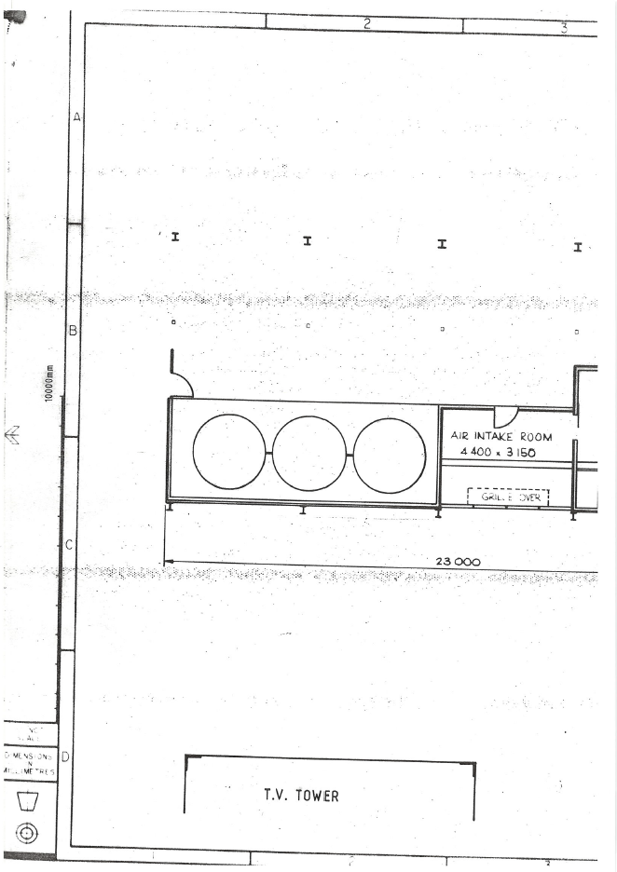

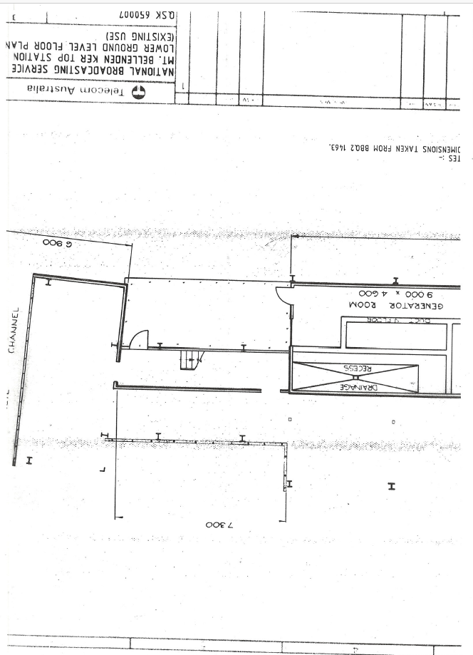

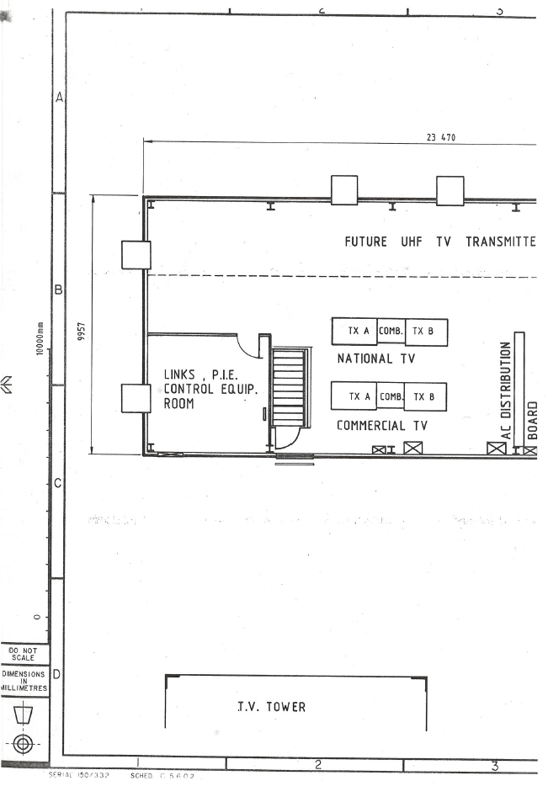

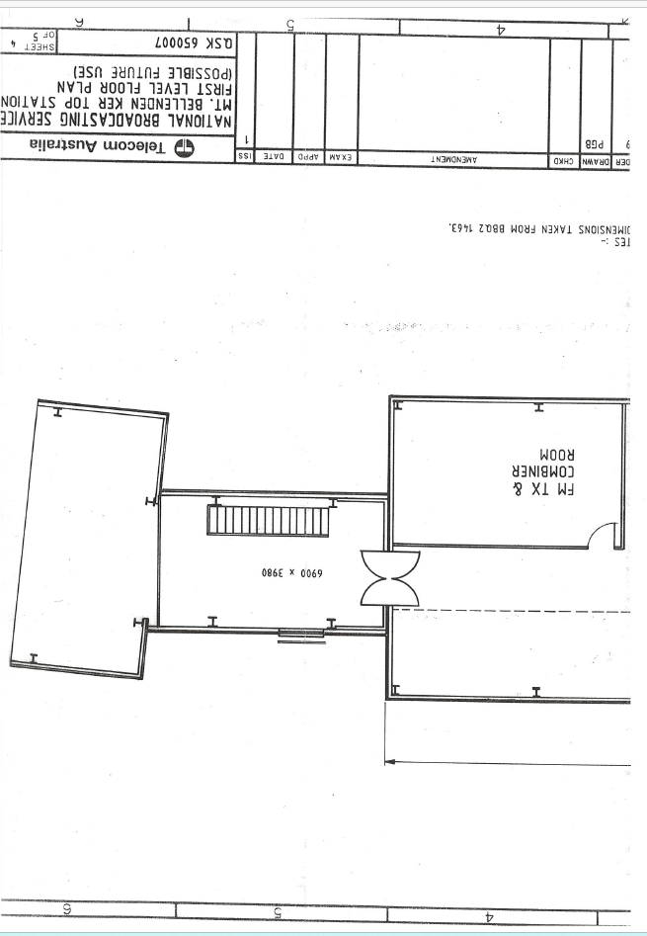

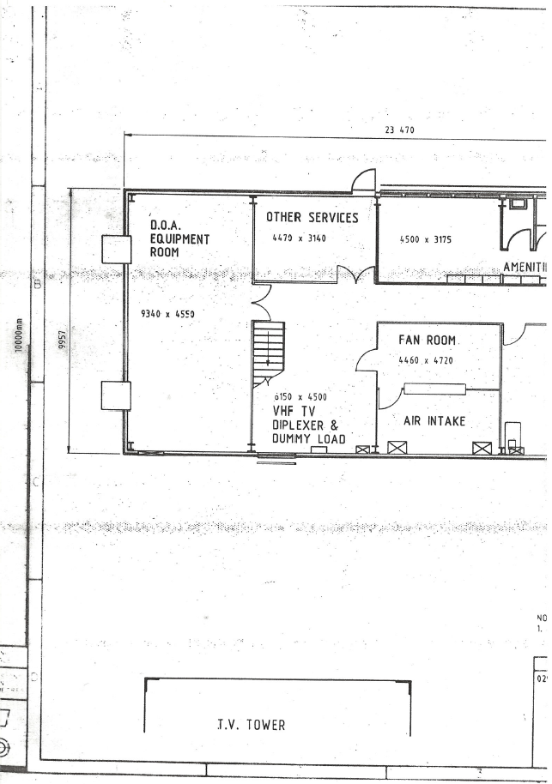

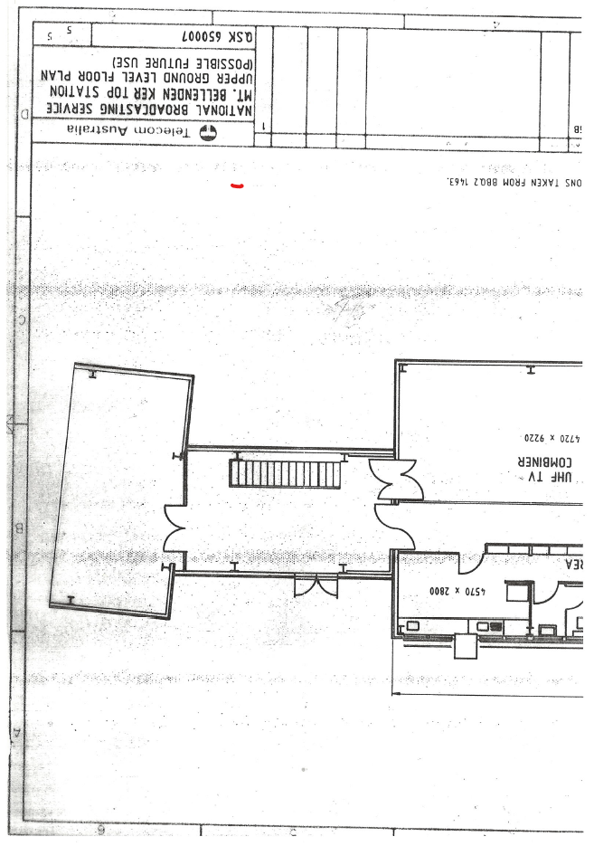

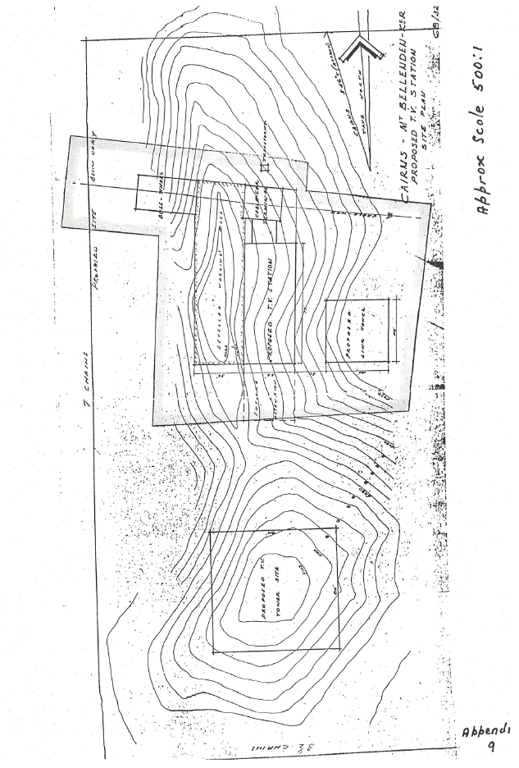
Addendum to
REPORT ON THE FUTURE USE OF BELENDEN KER TELEVISION SITE

An Important factor in evaluation of operational economics of the Bellenden Ker site is the operational cost of the Cableway.
The Cableway staff comprises an STO, Fitter, 2 Riggers and a labourer - operate and maintain the Cableway, provide routine and repair maintenance for Broadcasting and non-Broadcasting Air-Conditioners in the area, undertake site maintenance of the Transmitter Site and provide general maintenance of the power line to the Transmitter Site. The staff is self-relieving except for the 0.I.C or long-term leave for other staff members.
Up to the commencement of the current financial year costs involved have been to a standing Works Authority 1058 / T 8954. The costs recorded for the 1986/7 financial year were:-
Manhours. | Labour  $K | Material  $K | Incidentals  $K | Sub-Total  $K | 10%  $K | Total  $K
6647 | 144.336 | 15.867 | 12.274 | 172.479 | 17.247 | 189.727

On the assumption that the above figures represent a typical year and ignoring the distorting effect of emergency repairs, Transmitter installation activity and costing duplication the distribution of costs is seen to be:-
Labour 76%
Material 8%
Incidentals 7%
Mark-up 9%
These costs are highly labour intensive and are therefore subject to some distortion by the use of an Australian average manhour rate. They have been further distorted by the fact that items which should have properly been costed against Administrative and other accounts initially have been debited directly to this W/A on the simplistic basis that Cableway staff were involved. When FAMAD is fully operational it will be possible for these costs to be analysed in a more meaningful fashion.
DISTRIBUTION OF COSTS.
As noted in the main report although the original intention was that common operational and maintenance costs of the site, including access costs, would be apportioned among the major users in a manner to be determined this did not in fact occur. As a consequence, all such costs have been borne by Broadcasting funds although, as also noted in the main report, some offsetting costs have been fully carried by Telecom.
Although there are many possible means of apportioning costs in such instances two possible distributions are noted for purposes of illustration in this report.
If Cableway costs were to be distributed in proportion to the numbers of people using the facility the distribution for the 12 months ended October 1986 was :-
Broadcasting Staff 61%
D.O.A. Staff 24%
Radiocom Staff 8%
Others 7%
Another possible means of apportioning costs could be on the basis of area of the Transmitter building allotted for exclusive use of the parties. On this basis and ignoring any common use areas the basis of distribution would be:-
Broadcasting 66%
D.OA. 12%
Radiocom 18%
Other users 4%

OPERATIONAL PROCEDURES.
Operational procedures for the Cableway have been complicated by a number of factors. These have included the unique nature of the installation (within Telecom and indeed within Australia), safety requirements and rescue facilities and staff attitudes to those aspects, operational reliability of the control equipment, and industrial issues affecting staff qualifications and classification.
The unique nature of the installation is clearly indicated by the difficulty experienced during the recent problems with the faulty Track Rope in obtaining adequate expertise in Australia to assess the extent, advise on the required repair work and undertake final repairs. Despite prolonged attempts involving firms with expertise in manufacture and installation of wire ropes, Authorities responsible for oversight of operations of ropeways, lifts etc. and companies active in operation and repair of chairlifts and similar installations the best available expertise was found to be among those already involved with the actual ropeway. These included our existing Consultant, Mr. E.S. Reier, Mr. N. Krogh (H.&C. Structural Engineer), who had both been involved in the original construction, and existing Telecom staff (Broadcasting and non-Broadcasting) . The success of the repair work underlined the competence and skills available but also underlines the necessity to ensure continuity of this availability. This feature is also evident in regard to expertise.
The safety requirements and rescue facilities have a significant effect on the level of staffing required and consequently on the operating cost of the Cableway. Fail-Safe features of the design have two significant aspects :-
Track Rope Brake Operation.
The Track Rope brake is designed as a mechanically actuated safety facility which locks the car to the Track Rope under a number of conditions which include failure of the Haul Rope, loss of tension in the Haul Rope and manual operation by the Car Operator. Once operated this Brake can only be reset from the top of the car using a control handle which is electrically interlocked to the control system. This operation does not fall within the ambit of Technical Staff duties and there is an understandable reluctance on the part of most staff.
Control System.
The control system permits control of the Car by the Operator in the car under normal circumstances. A number of redundancies are built into the system to cover failures of the control and telemetry system and the Fail-Safe philosophy dictates that the car can only be manoeuvred by the Bottom Station Operator under manual control in these circumstances. This applies also during A.C. power failure when the car hydraulic motor is driven by a direct driven diesel hydraulic pump unit. Although recent modifications have eliminated the necessity for this to be done by direct manipulation of the diesel controls this cannot be extended to the car operator.
Rescue Facilities.
The original concept of a self-powered rescue car crawling along the Track Rope has been abandoned following a near fatal accident. Under the worst-case condition of the car stranded in mid-span the available recovery methods are controlled descent to the ground using Mast-Rescue type equipment or Helicopter. In either case this requires the availability of appropriate equipment and, most importantly, the presence of adequately trained personnel in the Car.
The operational reliability of the control equipment has been aggravated by the use of electronic components not suitable for the tropical conditions (a not uncommon problem with European equipment of the vintage), and this has been further exacerbated by excessive adjustment of pre-set variable components and connectors resulting in unreliable performance. It is anticipated that this can be overcome by replacement by suitable modern equipment but enquiries to date have resulted in excessively costly quotations, partly due to over-complicated nature of the standard Cableway equipment proposed.

