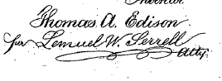
N. PETERS, PHOTO-LITHOGRAPHER, WASHINGTON, D.C.

2 Sheets--Sheet 1.
T. A. EDISON.
Telephone.
Patented Nov. 25, 1879.
No. 221,957.
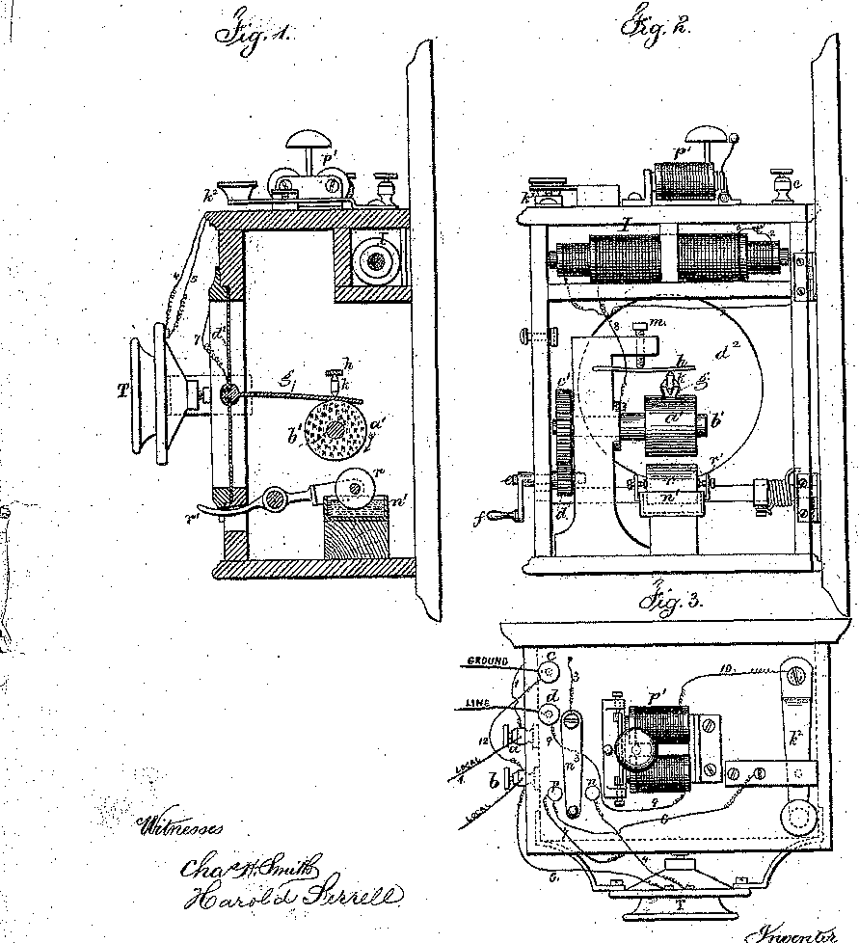
a

2 Sheets, Sheet 2.
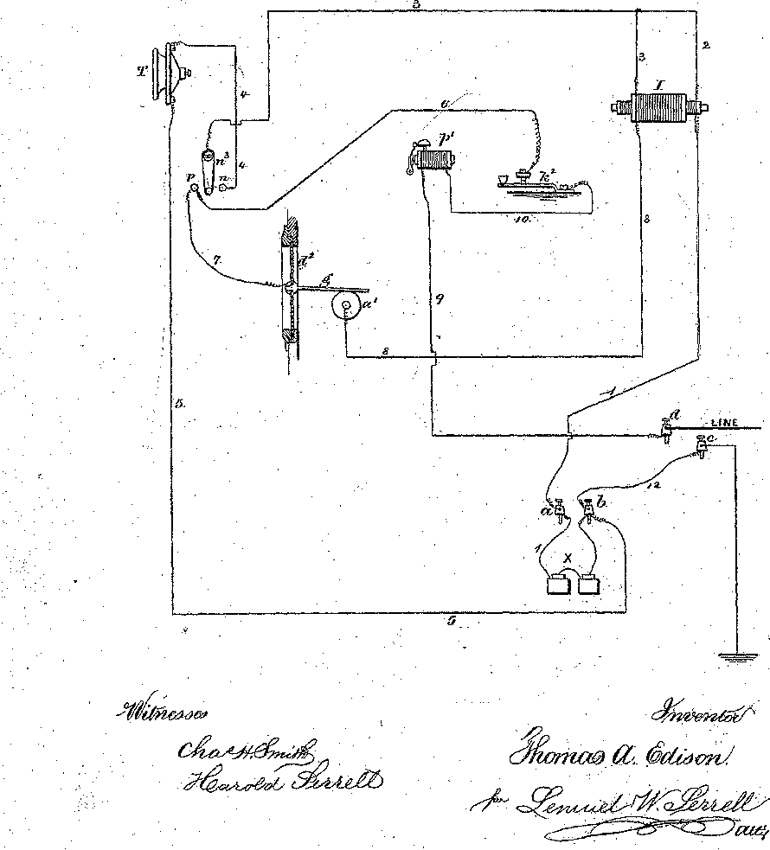
T. A. EDISON.
Telephone.
No. 221,957. Patented Nov. 25, 1879.
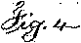
N.PETERS, PHOTO-LITHOGRAPHER, WASHINGTON, D.C.

UNITED STATES PATENT OFFICE

THOMAS A. EDISON, OF 'MENLO PARK, NEW JERSEY.
IMPROVEMENT IN TELEPHONES.

Specification forming part of letters Patent No, 221,957, dated November 25,1879; application filed March 31, 1879.

To all whom it may concern:
Be it known that I, THOMAS A. EDISON, of Menlo Park, in the State of New Jersey, have invented an Improvement in Telephones, (Case No.175,) of which the following is a specification.
The Object of this invention is to transmit sounds electrically to a distance and reproduce the same with great power and without loss of volume.

The peculiar action upon which this invention is based was patented by me January 19,
1875 and numbered 158,787. An application of, 'this action to telephony was also applied for by me July 20, 1877, No. 141, in which. there is a band of: paper moving beneath a point connected to the diaphragm. This feature, therefore, is not broadly claimed herein.

The present application consists more particularly in devices which make the in invention perfectly practicable for use in commerce and render the same reliable and effective.
In the drawings Figure 1 is a section of the apparatus Fig. 2 is a view of the back of the box Fig. 3 is a Plan view, and Fig. 4 is a diagram representing the connections to the line, local circuit, and various parts of the apparatus.

a’ is a cylinder of compressed chalk soaked in an electrolytic solution such as a caustic alkali, that it may become a conductor of electricity. I will mention that any finely-divided non conducting material or porous body having capillary pores, and which has no chemical action upon the absorbed solution may be used. This cylinder is secured to a shaft, b’, and the whole, is rotated by the operator by means of the toothed wheels c’ shaft e, and handle f Worm and, pinion may, be substituted, and motor power of a clock-work or analogous motor replace the hand of the operator.

Resting upon the cylinder a' is a flat spring, g' connected to the diaphragm d2. This spring is pressed upon the chalk with a pressure of several, pounds by means of the wire k and spring h the screw m serving to increase or decrease the amount of pressure.

The line-wire is connected to the spring y while the earth-wire is connected to the shaft on which the cylinder a' is, secured. If now, the cylinder be rotated. In the direction shown by the arrow and no current passes, the normal friction of the spring g upon the surface of the cylinder, a' will be very great, and the spring will be carried forward in the direction of the rotation of the cylinder thus pulling inwardly the diaphragm d2. If now a current passes whose direction is such that hydrogen will be produced upon the surface of the spring y in contact with the chalk, the friction will be reduced to an extent proportionate to the strength of the current, hence the diaphragm will regain its natural position and continue there as long as the current-passes. If now, the current ceases, the normal friction at once is reestablished, and the traction increases, and the diaphragm is instantly pulled inwardly again. If now a current in the opposite direction is transmitted, the effect is scarcely noticeable, as the evolution of oxygen upon the surface of the spring g does not except with a few saturations decrease the friction like hydrogen but, on the contrary, generally tends-to increase the normal friction; hence I allow A constant current to circulate on the line, and am thus enabled to utilize the opposite waves by: causing thein to weaken the constant current, which is always in a direction to evolve hydrogen on the surface of the spring g.

If no constant current were upon the line, the waves in one direction only would produce a limited effect: but, by using a constant current circulating upon the line in addition to the waves of similar and opposite: polarity one polarity of wave is added to that of the current, and the other wave neutralizes or nearly neutralizes, the constant current thence the tendency of one wave is to produce a lessening of friction of, say; five units, which, added to that produced by the constant current say five together give, ten units. If now, an opposite current is. sent, it neutralizes the constant current, and we have the normal friction of the cylinder whereas if no constant current were used one current would lessen the friction by five units, and' the opposite current would perform no work.

n' is a receptacle containing water, and resting in the water is a roller, r, composed of any flexible absorbent substance, such as sponge or felt.

A lever, r', to which the roller is attached, and by which the roller may be brought in contact with the cylinder a', extends through the box to the outside. The object of this device is to supply the cylinder with water lost by evaporation and make it a conductor to the electric current.
In practice, when all the apparatus is inclosed in a cast-iron case, the loss by evaporation is very small and if the roller be held against the cylinder and the cylinder be rotated three or four times the chalk will take up sufficient moisture so that it will perform its functions for a week or more without again wetting it.

The connections are as follows: T is a carbon telephone-transmitter, placed in a local circuit with an induction-coil, I, and local battery X If the position of the switch-lever n3 is on the button n, then the current proceeds from the local battery X via wire 1, primary coil of L, wire 2 to 3; thence to the switch lever a', wire 4, through the carbon transmitter T thence by wire 5 to the post b; thence to the battery.

The sonorous waves of the voice are translated into electric waves of a positive and negative character in the secondary coil of the inductorium I in the well-known manner.

The connections of the main line are as follows: The line from the distant station enters at the post a; thence via wire 9 to the call- bell p'; thence via wire 10 to the key-lever k2; thence by wire 6 to the point p of the switch, and by wire 7 to the spring g of the receiver; thence through the moist chalk to wire 8, to and through the secondary coil; thence via wire 3 to the switch-lever, which, it will be remembered, is in n; thence by wire 4 through the transmitter to wire 5; thence to post 5, and by wire 12 to the post c, which is connected to the earth. I will mention that either of the posts d c may be connected to the ground or line.

It will be noticed that the main line passes through the transmitter, which is connected to the local battery; hence a portion of the current leaks into the main line, and it is this portion which thus leaks into the line that serves as a constant current for short lines; but if the line be too long or has too great resistance, this small leakage current is so weakened as to be insufficient to produce a lessening of friction between the spring y and the chalk; hence I insert one or more in the main line.
While the switch is in this position—i. e., the lever in contact with n—transmitting and receiving can go on simultaneously. By turning the switch lever to the point p the telephonic apparatus is disconnected, and the call-bell apparatus p' becomes operative. The line enters at the point d, passes through the call-bell magnet via wire 9, and by 10 to key k2; thence via 6 top, and by switch to wire 3, and by 2 through the primary coil and via 1 to local battery, through that to post 5, and by 12 to post c and to earth. By depressing the key k2 the circuit is opened and closed, and the two local batteries—one at each end of the line become operative to the bell.

I will mention that the two receivers herein described and the two transmitters may all be connected in one line and operated without the aid of induction coils, but the results are not equal to that from the use of the coil; also, that the receivers will act as transmitters by reason of the fact that when the spring g and chalk are at rest the resistance of the whole is generally about twenty-five hundred ohms, and this resistance is reduced instantaneously to two hundred or three hundred ohms by the slightest movement of either the chalk or the spring; hence the movement of the diaphragm d2 by the voice produces the same result, or nearly so, as the carbon transmitter. If advantage is to be taken of this fact, the surface of the spring g should be reduced to increase the effect, and an induction coil having a primary coil of high resistance used in connection with the apparatus, although it is not absolutely necessary, as the direct results are nearly as good.

In preparing the chalk I prefer to use a salt of mercury mixed with caustic soda. The action takes place no matter what the proportions are. The mercury salt I prefer to use is the acetate of mercury.
I will mention that this moisture of the chalk may be regulated automatically by taking advantage of the fact that the normal friction of the chalk increases as it becomes drier.

A spring resting on the chalk is connected to the wetting-roller and has such a pressure and counteracting spring that when the chalk has its proper moisture the friction during rotation is insufficient to produce the necessary traction to lift the roller; but when it becomes drier the traction becomes sufficient to lift the wetting-roller, and it supplies moisture until the traction is reduced below a certain point and it falls.

I claim as my invention-
- The combination, with the acoustic telegraph and diaphragm, of a roller that receives a revolving motion and contains an electrolytic material, and a spring or presser connected with the diaphragm and resting upon the roller, substantially as set forth.

- The combination, in an acoustic telegraph, of a moving surface containing electrolytic material, a diaphragm, a presser or spring extending from the diaphragm and resting on such surface, a screw through fixed support acting upon the presser to vary or adjust the friction between the moving surface and the presser, substantially as set forth.

- The roller a', revolved by power, and the presser g and diaphragm ti2, in combination with the receptacle n' for liquid and the transfer-roller r, substantially as set forth.

- The arrangement of local circuit, magnetic call, telephone-receiver, telephone transmitter, switch, and line-connections, substantially as set forth, whereby the, call and the receiving-instrument are in the line-circuit, and the local battery is also put upon the line, substantially as specified.

Signed by me this 24th day of March, A. D. 1879.

THOMAS A. EDISON.
Witnesses:
STOCKTON L. GRIFFIN,
WM. CARMAN.

