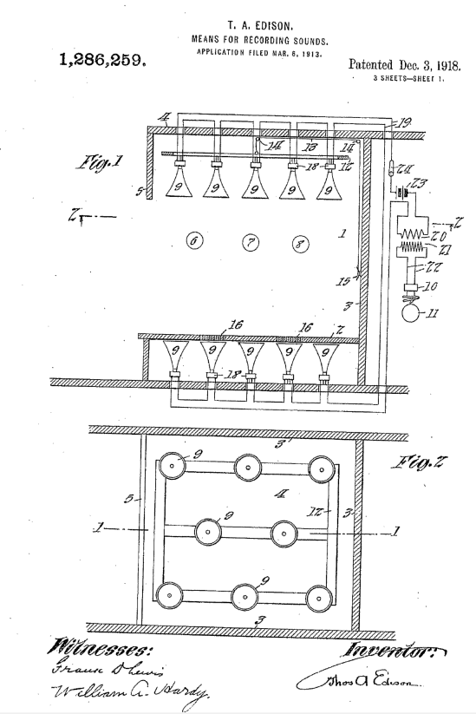
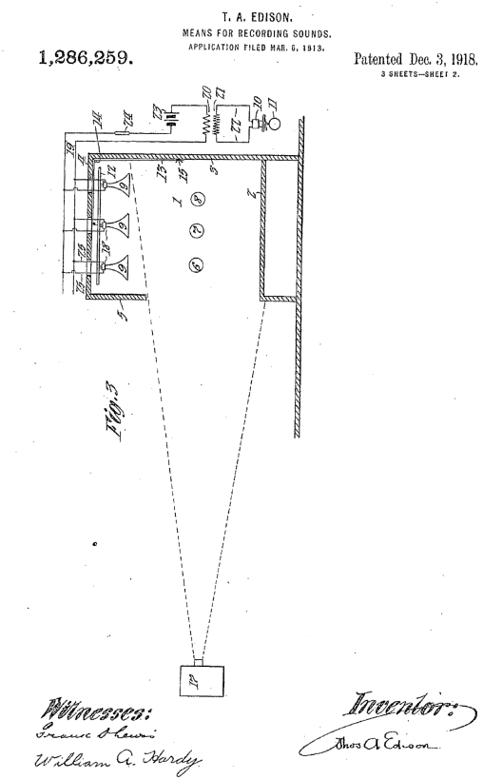
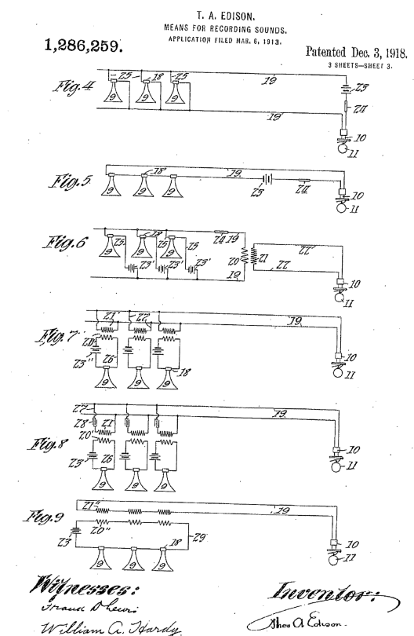
UNITED STATES PATENT OFFICE.

THOMAS A. EDISON, OF LLEWELLYN PARK, WEST ORANGE, NEW JERSEY, ASSIGNOR TO NEW JERSEY PATENT COMPANY, OF WEST ORANGE, NEW JERSEY, A CORPORATION OF NEW JERSEY.

MEANS FOR RECORDING SOUNDS.

1,286,259. Specification of Letters Patent. Patented Dec. 3, 1918.

Application filed March 6, 1913. Serial No. 752,275,

To all whom it may concern:
Be it known that I, THOMAS A. EDISON, a citizen of the United States, and a resident of Llewellyn Park, West Orange, Essex
5 county, New Jersey, have invented certain new and useful Improvements, in Means for Recording Sounds, of which the following is a description.
My invention relates to improved means is for recording sounds.
10 In the methods heretofore followed in synchronously recording the optical and audible impressions of an object or scene for making records for talking pictures a moving picture
15 camera is focused on the field of the object or scene and a single horn or receiver of a phonograph or other recording instrument is located at a considerable distance from the object or scene and out of the range
20 of the camera and the object or scene is then photographed by the camera and the sounds associated therewith simultaneously recorded by the recording instrument. Such a method is disclosed in a pending application of Daniel
25 Higham, Serial No. 687,967 filed April 2, 1912 and entitled "Methods of synchronously recording and reproducing optical impressions and sounds associated therewith".
While it is true that it is impractical, in
30 recording the optical and audible impressions of a scene for making records for talking pictures, to locate the horn or receiver of the sound recording instrument close to the source of sound for. reasons indicated in
35 the application just referred to, yet the method of recording sounds disclosed therein and similar methods are objectionable for the following reasons : The horn or receiver of the recording instrument is located at
40 such a distance from the source of sound that the sound waves reaching the receiver are comparatively weak and few in number, and the comparatively weak sounds emitted from the source of sound are often not recorded
45 at all; the master sound record thus obtained is formed of vibrations of such small amplitude that in order to obtain a clear and sufficiently loud reproduction it is necessary to make an amplified copy thereof;
50 and the field of the scene is necessarily very limited on account of the fact that the sound waves are collected substantially only at a single point. and as a source of sound is removed or moves from that point, the number and strength of the sound waves which
55 reach the receiver decrease out of all proportion to the increase in the distance of the source from the receiver. As in scenes of the character of which it is desired to make records for talking pictures, as well as in
60 demonstrations of which it is desired to make records only of the audible impressions, as for example, an orchestral piece, the sounds frequently emanate from various more or less separated points, this latter phenomenon
65 often results in the production of a sound record having vibrations' of greater amplitude for weak sounds than the vibrations corresponding to loud sounds, where the source of the loud sounds is farther
70 removed from the receiver than the source of the weak sounds. The principal objects of the present invention are to provide a method and means ) whereby the above named objections are
75 eliminated and whereby an observer of the impressions of objects or scenes reproduced from a record or records made in accordance with, or by the use of my invention, will receive, as nearly as possible, the same effects
80 on the ear, as when observing the original objects or scenes. In accordance with these objects, I collect the sound waves at a plurality of points which are so separated as to extend over the field in which the object or
85 scene, the impressions of which are to be recorded, may occupy or is located,' and transmit pulsations or impulses corresponding to the collected sound waves to a single recording device and make a record of the transmitted impulses.
90 These impulses are preferably electrically transmitted from receivers located at the separated points and all the impulses simultaneously produced at the receivers are preferably combined into single
95 impulses before reaching the recording device. My invention also comprises the augmenting and sharpening of the latter impulses before they reach the recording device, in order to obtain a record which will
100 have well-defined and clear-cut vibrations of sufficient amplitude to obtain a clear reproduction directly therefrom, without the necessity of making an amplified copy thereof.
Other features and objects of my invention
105 will appear more fully in the following description and appended claims:
In order that my invention may be more

1,286,260

clearly understood, attention is hereby directed to the accompanying drawings, forming a part of this specification, and in which;
5 Figure 1 is a view in vertical cross section
on line 1— 1 of Fig. 2 illustrating a stage or setting for an object or scene of which it is desired to obtain a record or records, and means, shown somewhat diagrammatically
10 and in accordance with my invention, for recording the-sounds associated with the object or scene; , Fig. 2 is a sectional view taken on line 2---2 of Fig. 1 looking upwardly, parts being
15 omitted;
Fig. 3. is a view similar to Fig. 1 and somewhat diagrammatic, showing- the relative positions of means for recording the sounds associated with an objector scene on
20 the stage and of means for recording the optical impressions of the object or scene; the means for recording the sounds being a modification of that of Fig. 1; and Figs. 4 to 9 are diagrammatic views showing
25 the receivers and recorder of my sound recording' means and various modifications of the connections between the receivers and the recorder which may be employed. Referring to Figs. 1 and. 2, reference character
30 1 represents a.-stage or setting for a scene or object of which it desired to record, either the optical or audible impressions or both these impressions. The stage shown herein has the usual raised floor 2,
35 side walls 3, and the top wall or ceiling 4, and is 'preferably provided at the front with a drop or overhang 5 depending from the top wall or ceiling 4. Reference characters 6, 7, and 8 may represent different objects
40 in a scene presented' on the stage or different positions which one or more objects may assume during the recording: of the impressions thereof. In order to 'obtain a clear and true record
45 of the sounds emitted from the object or objects comprising the source or sources of sound on the stage, I provide an improved sound recording apparatus preferably comprising a plurality of collectors or receivers
50 9 which are preferably bell shaped and arranged in such a manner as to embrace or cover substantially the entire field which any scene or object on the stage may occupy. The sound recording apparatus also comprises
55 a single recorder 10 and suitable means (hereinafter more fully described) whereby pulsations or impulses correspond in to the sound waves, collected by the receivers 9 are transmitted therefrom to the
60 recorder 10 to make a record on the blank 11, As shown in Figs. 1. and 2. A plurality of the receivers 9 are spaced over and above the stage floor 2. adjacent the top wall 4 and preferably behind the drop or overhang 5.
65 These receivers are 'preferably secured to a frame 12 which is preferably vertically adjustable so that the receivers may be properly positioned. above the object or scene on the stage floor 2. The frame 12 is adjustably supported by any suitable means, 70 as by a cord:13 attached thereto and passing over pulley's 14. secured to the walls of the stage, the cord then passing downwardly adjacent suitable means such as a cleat 15 to which it may be belayed to hold the frame
75 12 and thereby receivers 9 - in the desired vertical position, A plurality or battery of receivers 9 may also be positioned below the floor of the stage as shown in Fig. 1 and are preferably spaced evenly over the stage
80 floor similarly to the receivers 9 attached to frame 12. The floor adjacent the mouth of each of these receivers is preferably perforated as shown at 16 to allow the sound waves to pass freely from above the floor
85 to the receivers. Preferably the means for communicating pulsations corresponding to the sound waves collected by receivers 9 above the stage floor from those receivers to the single recorder 10 also serve to communicate
90 like pulsations to the recorder from the receivers 9 below the stage floor. Fig. 3 Shows diagrammatically the relative arrangement of a moving picture camera and sound recording means for making
95 records of, the audible and optical impressions of an object or. scene' on stage 1. The receivers 9 of the sound recording apparatus are arranged similarly to the arrangement shown in. Figs. 1 and 2, except that the receivers 9
100 below the stage floor are dispensed with, and means is likewise provided for communicating pulsations from. the receivers 9 to the single recorder 10. It will be understood of course, that, if desired, a
105 plurality of receivers 9 may be located below the stage floor 2 as in Fig. 1. Reference character 17 represents the motion picture camera which is focused on stage 1, the field of the camera having the limits indicated
110 by dotted lines in this figure, It will be seen that the receivers 9 are without the field of camera 17. In the operation of the apparatus in. Fig. 3, the record' blank 11 and the motion picture camera 17 are operated
115 in synchronism by any suitable means (not shown) but preferably by means such as disclosed in Patent No: 1,054,203 to Daniel Higham, dated February 25., 1913, and entitled Combination phonograph tend moving
120 picture apparatus. The pulsations or impulses corresponding to the sound waves collected by receivers 9 may be transmitted from the receivers to the recorder 10 by any suitable means. Preferably,
125 these impulses are electrically transmitted and accordingly I provide each receiver 9 with, a microphone 18, construct the recorder 10 so as to convert electrical into mechanical impulses (the construction of
130
1,286,259
the recorder preferably being similar to that disclosed in my pending application, Serial No. 616,757, filed March 24, 1911, and entitled ."Phonographic telegraphs") and provide
5 suitable electrical connections between all the microphones 18 and the recorder 10. There may be numerous constructions and arrangements of the connections between the receivers 9 and the recorder 10, and I have
10 shown several different arrangements of such connections in Figs. 1, 3; 4, 5, 6, 7, 8, and 9. Any of the arrangements of connections shown in these figures may be employed in the sound recording apparatus shown in
15 either Fig. 1 or Fig. 3. In Fig. 1 the microphones 18 of the receivers 9 are in a circuit which includes recorder 10, the microphones. as shown being connected in series by the main conductors 19
20 with the primary 20 of an induction coil, the secondary 21 of which is connected to the recorder 10 by conductors 22. Current is supplied to the circuit by a battery 23 and a suitable switch 24 is provided for making
25 and breaking the circuit. It will be apparent that the sound waves collected by receivers 9 act on microphones 18 to produce electrical impulses in the circuit which includes- recorder 10, and that the impulses
30 simultaneously produced at the different receivers are electrically combined and trans-mitted to the recorder 10 where they are converted into mechanical impulses to produce a record on the blank 11. The induction
35 coil in the circuit serves to augment or intensify the electrical pulsations or impulses transmitted to recorder 10 whereby a record groove is produced, the undulations of which are well defined even for the comparatively weak
40 sounds emitted from an object or scene on stage 1.. .
In Fig. 3, microphones 18 of the receivers 9 are arranged in parallel or multiple in the circuit instead of in series as in Fig: 1. by
45 means of conductors 25 connecting the microphones with the main, conductors 19 as
shown.
The arrangements of the circuits shown diagrammatically in Figs. 4 and 5 are the 50 same as in Figs. 3 and 1 respectively, except that the induction coil is omitted.
In Fig. 6 the arrangement of, the circuit is the same as shown in Fig. 3 except that, instead of a single battery being provided for
55 the main conductors 19 of the circuit, a battery 23’ is provided in series with each microphone 18 in conductors 25 which are arranged in parallel with the main conductors 19.
60 In Fig.7 the microphone 18 of each receiver 9 is, by means of conductors 26; arranged in series with a battery 23" and the primary 20' of an induction coil. The secondary 21' of each induction coil is, by means
65 of conductors 27 arranged in parallel or multiple with main conductors 19, which in the arrangement herein shown, are directly connected with recorder 10.
The arrangement of the circuit in Fig. 8 is the same as in Fig. 7 except that a
70 condenser 28 is arranged in each conductor 27 in series with each of the secondaries 21' of the induction coils. The condensers 28 serve to sharpen the electrical impulses transmitted from the receivers 9 to the recorder 10
75 whereby a clearer record is obtained. In Fig. 9 I have shown an arrangement in which all the microphones 18 of the receivers 9 are arranged in series by means of conductors 29.
80 The battery or source of current 23 and the primaries 20". of the induction coils, corresponding' in 'number to the receivers 9, are also arranged in series with each other and with the microphones 18 by the conductors 29. The secondaries 21". of the induction coils
85 are arranged in series with each other and with recorder 10 by main conductors 19.
By the arrangement of the receivers 9 as shown in Figs. 1, 2, and 3, it will be apparent
90 so that, no matter where an object or performer is situated or moves to on the stage, a large number of the sound waves emitted from that object or performer will be collected by one or more of the receivers 9, the receivers being so evenly distributed as to gather substantially the same amount of sound waves emitted by a source of sound, irrespective of its position on the stage. As each of the receivers is provided with a microphone,
100 the apparatus is rendered very sensitive, and a record is obtained of the comparatively weak sounds as well as the loud sounds. It will also be obvious that sound recording apparatus constructed in accordance with
105 my invention is admirably adapted for recording the sounds emitted by a plurality of performers or objects scattered over the stage, as for example, a chorus or orchestra. While I have shown and described various
110 ways and forms in which my invention may be carried out and embodied, it is to be understood, of course, that I am not limited thereto, but that my invention may be embodied in numerous modifications without
115 any departure from the spirit and scope thereof.
Having now fully described my invention, what I Claim and desire to protect by Letters Patent is as follows:
120
In a device of the class described, the combination of sound recording means comprising a receiver located above a source or sources of sound, a receiver located below the source or sources of sound, a single recorder, and operative connections between said receivers and the single recorder, substantially as described.

In a device of the character described, the combination of sound recording means

1,288,206

comprising a plurality of receivers located at separated points above a source or sources of sound, a plurality of receivers located at separated points below the source or sources
5 of sound, a single recorder, and. electrical connections between all the receivers and the single recorder, substantially as described.
3. In a device of the character described, the combination of sound recording means
10 comprising a plurality of receivers located at separated points above a source or sources of sound, a plurality of receivers located at separated points below the source or sources of sound, vertically adjustable means for 16 supporting the receivers located above the source or sources of sound, a single recorder, and operative connections between all the receivers and the single recorder, substantially as described.
20 4. In a device of the character described,
the combination of sound recording means comprising a plurality of receivers located at separated points above a source or sources of sound, a plurality of receivers located at
25 separated points below the source or sources of sound, vertically adjustable means for supporting the receivers located above the source or sources of sound, a single recorder, and electrical connections between all the receivers
30 and the single recorder, substantially as described.
5. In a device of the character described, the combination of a plurality of receivers located at separated points above a source or sources of sound, a plurality of receivers
35 located at .separated points below the source or sources of sound, a single recorder, and electrical connections between all the receivers and the recorder, substantially as described.
40
6. In a device of the character described the combination of a vertically adjustable frame above a source or sources of sound, a plurality of receivers secured to said frame at separated points, a plurality of receivers
45 located at separated points below the source or sources of sound, a single recorder, and electrical connections between all the receivers and the recorder, substantially as described.
7. In a device of the character described;
50 the combination of sound recording means comprising a single recorder, a. plurality of receivers located at separated points below a source or sources of sound, and operative
55 connections between all of said receivers and the single recorder, substantially as described.
This specification signed and witnessed this 28th day of February, 1913.
THOS. A. EDISON.
Witnesses:
WILLIAM A. HARDY,
MARY J. LAIDLAW.

