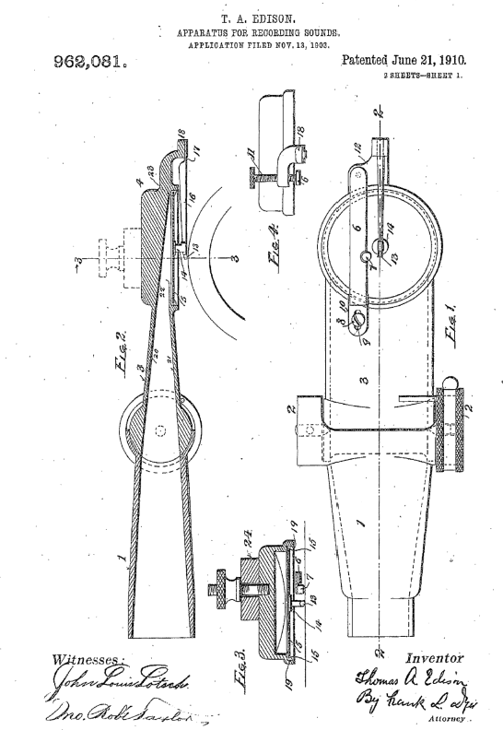
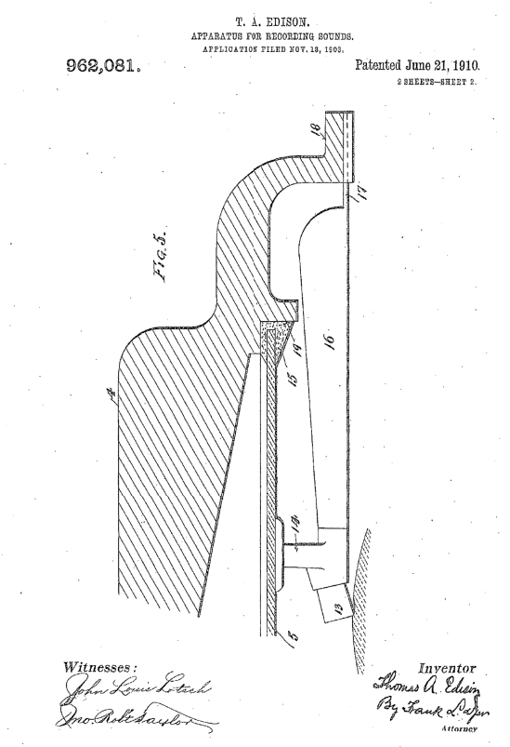

UNITED STATES PATENT OFFICE.
THOMAS A. EDISON, OF LLEWELLYN PARK, ORANGE, NEW JERSEY, ASSIGNOR TO NEW JERSEY PATENT COMPANY, or ORANGE, NEW JERSEY, A CORPORATION OF NEW JERSEY.
APPARATUS FOR; RECORDING SOUNDS.

962,081. Specification of Letters Patent. Patented June 21, 1910. Application filed November 13, 1903. Serial NO. 180,998.

To all whom it may concern:

Be it known that I, THOMAS ALVA EDISON, of Llewellyn Park, Orange, in the county of Essex and State of New Jersey, have invented

5 certain Improvements in Apparatus for Recording Sounds; of which the following.is a description. My invention relates to improvements in apparatus for recording sounds, particularly
10 of. that type in which phonographic records are formed, and which records are of varying depth, but the invention may be employed: in connection. with records of the gramophone type, which are of uniform
15 depth but of irregular conformation. The object of this invention is to produce a recording mechanism capable of recording sound waves phonographically, as truly representative as may be of the original waves
20 and their quality, eliminating excessive and false amplitudes of vibrations without any consequent loss in Volume of the sound produced.
The invention consists in the production
25 of a phonographic device whereby sound waves throughout the range of music may be recorded and reproduced truly, false amplitudes of vibration of the recording mechanism being eliminated, and the recording and
30 reproduction of both grave fundamental notes and overtones rendered possible.
The invention further consists in the various details of construction for the improvement of phonographic recorders generally,
35 as more fully set forth hereafter in the specification and the appended claims.
At the present time those skilled in the art have been unable to record and reproduce music having all the tones within the
40 range of music sufficiently like the original to obtain a record that is saleable commercially; this is especially true of music of the piano, and, notwithstanding many millions of phonograph records have been made and
45 sold, records formed of piano music alone are not sold and are not found in any catalogue of the manufacturers. With recording instruments existing before this invention, it is impossible to produce as satisfactory
50 piano record. If it is attempted to record the overtones which give music its pleasing qualities, the instrument must be made very sensitive, as the waves which form overtones are many times weaker than the fundamentals. If the recorder is made
55 sufficiently sensitive to so record these over-tones, the powerful fundamental tones of the bass act so violently upon the recorder as to throw the recording knife out of the recording material in the case of cylindrical records
60 and give excessive amplitudes in the case of fiat records. If the recorder is made so insensitive as to prevent this latter action no overtones, are recorded and the. quality is lost. While at' the present time manufacturers
65 of cylindrical records use the piano as an accompaniment, the deep bass notes are never used, but only those in the higher register; in addition the vibrating part of the recorder itself is sympathetic to the grave
70 tones and serves only to intensify these surface defects. I have by exhaustive experimentation discovered that the true sound waves over the whole range of, music from the most grave to the highest pitched tone do
75 not actually have the amplitudes which are. implied by the throwing of the recording knife out of contact with the record surface and the vibrating periods of the recorder itself need not necessarily be grave that
80 this is due to defective mechanism constructed upon a wrong principle and that if certain changes are made in the mechanism so that it will operate upon a different principle, it may be adjusted with sufficient sensitiveness
85 to record the necessary overtones and the most powerful bass notes of a piano and permit the reproduction of the original tone with almost perfect quality and with a greater volume than has hitherto been
90 thought possible. I have traced down and ascertained by experiment that the cause of the excessive and false amplitudes of vibration is due to the elasticity of the recording mechanism itself and by eliminating the
95 principal part of this elasticity, the true amplitude due to the sound waves do not cause the recording knife to be thrown from the recording surface when the recorder is rendered sufficiently sensitive and that the
100 grave tones of the diaphragm may be changed to a higher rate and of such a small amplitude as not to distort the record:
The ordinary, recording. mechanism now in general use consists of a circular diaphragm
105, generally of glass about. 1 ¼ inches in
2 662,081

diameter and from .005 to .007 of an inch in thickness. This diaphragm is secured to a chamber by being placed between two or more. rings of rubber at its edges and
5 clamped or cemented to the edge of such opening. The recording knife is generally fastened to the center of the diaphragm and connected to a lever secured to the edge of the chamber to take the thrust of the knife
10 in cutting the record. The elastic members of this device are two, viz: the glass disk which is flexed by the pressure of the sound waves and the elastic rubber which is strained by the flexing of the disk. For the
15 purposes of illustration let such a disk be cut in sections like the spokes of a wheel, there will be a number of vibrating reeds each elastic and flexing by itself as well as flexing by distortion of its rubber support,
20 and sympathetically resonant to some tone in the lower register of the piano, harp or similar instrument. Independent of the fact of it having a tone or vibrating period, it has a mass and possesses weight and if
25 moved by a force applied at the end of such a section a large amount of the power applied must be used in distorting the rubber clamp in addition to that used for flexing the section, and this mass under the action
30 of the stored power in the rubber tends to make several movements when only a single impulse was given to its end; thus it cannot possibly follow the sound waves of music. If a number of impulses are applied to the
35 end which impulses have the same period of vibration as the section itself, the amplitude due to the first few waves will be less than the following waves, although the original sound waves may all have the same amplitude,
40 hence there can be no true record of a tone the same as that of the sector, and this is true of the whole diaphragm which is formed of a large number of sections, so to speak. It is impossible to make the rubber
45 clamps of uniform elasticity, hence there will be many parts or sections of the diaphragm with different vibrating periods. Even in the case of waves having vibrating periods unlike the diaphragm, their action
50 on the diaphragm causes energy to be stored up in the elastic clamp, and the action of this stored energy on the mass of the diaphragm tends to force it to make more vibrations than there are sound waves producing
55 interference and false amplitudes not corresponding to the sound waves, and a large proportion of the energy contained in each sound wave is lost as heat in deforming the rubber (which extends around the
60 periphery of a circle about 3 inches in circumference), which energy, if applied to flexing the very elastic glass would greatly, increase the volume of sound, and permit of the recording of the exceedingly weak overtones.
65 I may mention that the heat lost by distorting rubber is very much greater that by distorting glass, as the latter is a sub-stance of great elasticity and minimum in-ternal friction, while rubber is, just the contrary. The recorder in general use is also defective
70 by reason of certain other causes which cooperate to produce distortion of the diaphragm. First, the diaphragm is placed under strain by the pressure which is necessary to force the recording knife into the
75 record material. This pressure varies not only with 'the material but with different degrees of hardness occurring upon different parts of the surface of the record material. Second, the record itself cannot be made to
80 run absolutely true. These two causes work in conjunction to ,produce an ever varying flexure of the diaphragm, independent of the action of the sound waves; and this continuous flexure of itself distorts the record
85 produced by the sound 'waves. Third, the fact that the fundamental tone of the diaphragm and its elastic support is grave and of great amplitude, and constantly varies as the tone is prolonged, produces
90 additional distortion. In the recorder of my invention, a very wide departure in construction is made. The diaphragm is not secured at the edges but floats in a mass of viscous liquid or semi-
95 liquid material. The diaphragm is secured at its center to one end of a reed which is supported at its other end by an elastic connection from the chamber, i and has the recording knife fastened at its end about the
100 center of the diaphragm. When assembled the diaphragm and knife are afloat so to speak, and are sustained entirely by the supported end of the reed. The viscosity of the semiliquid material around the edges is
105 such that when the recorder is adjusted so the knife tracks the record material to the proper depth, the diaphragm will have no stress upon it. It is in its most sensitive condition, and if the record cylinder is eccentric
110 or a part of the record harder than another part, the viscous liquid offers scarcely any resistance to a motion of translation to such slow movements but on the other hand acts nearly as a rigid body to movements
115 of great frequency similar to sound waves. The edge of the diaphragm makes scarcely any movement and yet is free of all strain whereas if the record is untrue the edge of the diaphragm may make movements several
120 times greater than those produced by the sound waves. Thus no matter what variation in the hardness of the material or what reasonable amount of eccentric motion of the record takes place, the diaphragm
125 is unstressed and in its most sensitive condition. The viscous semi-liquid material acts to close the chamber completely and thus permits of a rise and fall of barometric pressure which permits sound waves, and
982,081

being non-elastic no energy is stored up to distort the sound waves, and the amount of energy abstracted is less than if the diaphragm were between rings of rubber or
5 other elastic material, and such energy is not returnable to the mechanism as motion to. produce distortion. In addition, this want of elasticity changes the fundamental note of the diaphragm and environment
10 from a grave note of high amplitude to a very much higher note and of a greatly reduced amplitude so much reduced that the combined effect of the sound wave and the diaphragm in tune with it is entirely insufficient -
15 to throw the knife from the record or disturb in an appreciable amount the quality of the recorder sound. The viscosity of the material used around the edges is such that its surface tension prevents it from flowing to any
20 extent at ordinary temperature at slight gravity gradients, hence the recording apparatus if kept level will be serviceable for several days and then the viscous semi-fluid material is quickly and easily renewed.
25 In order that the invention may be better understood, attention is directed to the accompanying drawings, forming a part of this specification, and in which— .
30 Figure 1 is a bottom view of the recorder; Fig. 2 is a sectional view thereof taken on the line 2 —2 of Fig. 1; Fig. 3 is a sectional view taken on the.-line 3-3 of Fig. 2; Fig. 4 is a front view of the body;
35 and Fig. 5 is an enlarged sectional view of the body, diaphragm and recording knife. In all of the above views corresponding parts are represented by the same numerals of reference.
40 The hollowed tube 1, which is connected to, or is a continuation of the, usual horn or funnel, is carried by the usual support (not -shown) and has ears 2-2 between which is pivoted the head or barrel 3. To
45 the latter is secured the sound box or body 4 to the lower. face of which is connected the glass or mica diaphragm 5. Across the lower face of the body and below the diaphragm is the tracking lever 6, Which serves
50 as a support for the ball 7, which latter rests upon the record cylinder and supports the body, allowing it to oscillate about the pivot between the ears 2-2 and accommodate itself to all large irregularities. in the
55 surface of the blank.
The ball 7 is of a comparatively little curvature, but sufficient to permit of universal adjustment, and is preferably made of a jewel, of which sapphire seems to be
60 the best material, as it does not have any appreciable chemical effect upon the. record blank; furthermore, it is susceptible of taking a high polish, so that its passage over the record will not scratch or otherwise injure it.
65 The lever 6 is connected to one end of the body 4, by means of a. screw 8, which passes through a slot 9 formed within an elastic extension 10 of the lever which forms an elastic' connection, so that the lever, together
70 with the ball 7 may be adjusted in relation to the center of the diaphragm. The other extremity of the lever engages with an, adjusting screw 11, passing through a threaded opening in an extension 12 on the body, and
75 by means of which the relative position of the ball 7 and the body. may be adjusted when the machine is running. The knife 13 is attached to the diaphragm adjacent to its center and on the same line
80 of travel as the ball 7, by means of a support or foot 14 which is formed preferably of magnesium on account of lightness. The foot 14 is secured to the diaphragm by a suitable cement, such as melted shellac.
85 The diaphragm is connected at its periphery to the bottom of the chamber or body by means of a mass of viscous or semiliquid material 15, so that it 'will be entirely supported against gravity and the thrust of
90 the cutting knife solely by the elastic reed 16, the material 15 forming a, seal to close the joint between the edges of the diaphragm and the chamber. The reed is preferably made of white pine or similar light wood
95 and is of a varying vertical section, deeper than it is wide and. is secured to the foot 14 by a cement, preferably melted shellac. The end of the reed at 17 is made much thinner, so that it will vibrate easily and the
100 reed increases gradually in vertical dimensions, toward the fixed extremity, the configuration of the entire reed being such that it will be practically unsympathetic with any note of great amplitude, and on account
105 of the varying vertical section will give no harmonics that would tend to disturb the record. The end 17 of the reed is secured to a pillar 18 formed upon a continuation of the body 4.
110 The stiffness of the reed at 17 should be sufficient, so that the act of tracking the knife in the record will not cause the edge of the diaphragm to be forced against the edge of the body 4, but only moved in the
115 viscous liquid. The knife illustrated is of usual form. The reed 16 forms a continuation of the knife and is in the direct line of thrust caused by the action of the record upon the knife. When the reed is arranged
120 at an angle to the thrust caused by the action of the record on the knife, the knife has a tendency to. "chatter" which injuriously affects the record.
The mass of viscous or semi-fluid material
125 15 does not serve to support the diaphragm against gravity but serves as a moving point or points about which the diaphragm vibrates. It is necessary to keep the quantity of viscous material in use in the manner
130 shown, down to the smallest quantity to permit of its surface tension being sufficient to hold it up in position and not flow to any appreciable extent by gravity. Of the many
5 viscous or semi - liquid materials experimented upon, that produced by burning pure crude para-rubber is the best. A piece about ¼ of an inch thick and two inches long is set on fire at one end and as it softens
10 and melts it is rubbed while still burning upon the edge of a dish. In character it resembles a thick varnish, it has great surface tension and great viscosity, it is not changed by action of the atmosphere and altogether
15 is a peculiar substance and well adapted, for the purpose. It can be produced of varying degrees of viscosity by a proper manipulation of the heat and thus give a range, for varying conditions. The space between the
20 inner edge of the diaphragm and the body 4 will usually be .020 of an inch and between the edges of the diaphragm and the inside encircling flange 19 about .010 of an inch
and below the lower edge of the diaphragm
25 and the flange 19 should project a sufficient distance to hold the viscous material. These dimensions can be varied to meet varying conditions. The form of recorder which I have de-
30 vised and which is illustrated in Figs. 1 and 2 also has some advantages over that in common use, as the chamber for producing the final pressures upon the diaphragm is small and of a proper proportion, and is so
35 arranged in relation to the, receiving funnel or horn that the sound waves do not suffer either partial or total deflection at any point and at the same time the wall friction is reduced. This is accomplished by forming
40 the head or barrel 3 of the same width practically throughout (see Fig. 1) and not tapering it as it laterally enters the body 4 as has hitherto been the practice. The top and bottom 20 and 21 respectively of the
45 opening within the head 3 approach as they near the diaphragm, but the sides do not. The top 20 of the head forms a line practically continuous with the upper surface 22 of the inside of the body 4, which upper
50 surface inclines from a point co-incident with the connection of the head, to the other edge of the diaphragm at 23; and there are no angles or obstructions in the path of the sound. waves. -By connecting the head 3
55 with the side of the body 4, the air passageway is straight, consequently the sound waves do not suffer any deflection, and by the, use of the proper funnel angle the power of the sound waves to act upon the diaphragm
60 is greatly increased. A small weight 24 is preferably removably carried on the head 4, and which may be changed or varied to suit the conditions of .work, or character of sound required.
65 The center of gravity of the weight should ordinarily be directly aver the center of the tracking ball 7.
By adjusting the position of the ball 7 upon the record by means of the screw 11 the whole recorder can rapidly and easily
70 be made to approach and recede from the face, of the recording material and thus permit of the adjustment of tracking of the recording knife to the required depth into the record material after the machine is started.
75 In the act. of forcing the knife into the record material, the reed 16 is flexed at its point fastening 17. If the reduced section of the reed at 17 is made stiff the reed as, a whole will be very little flexed and there will be but a slight movement
80 of the edge of the diaphragm in the viscous semi-liquid and during the act of flexing of the reed, the diaphragm will also be flexed due to the retardation of its movement
85 through the viscous liquid, but when the knife once tracked all stress on the diaphragm is removed. To rapid movements, like sound waves, the resistance to motion is powerful and the diaphragm has little,
90 if any, to and fro movement at its edges, the recording being due almost entirely to flexing of the diaphragm. If the part 17 of the reed is made very thin, the reed will be flexed to a greater
95 extent and the movement of the diaphragm in the viscous liquid will be greater, but in no case will the edge of the diaphragm touch the metallic parts but will always be free and immersed in the liquid. A movement
100 of more than .02 of an inch will seldom be required and the proportions illustrated should be sufficient to permit of movements of this amount. The thickness of the reed at 17 is easily changed, and
105 serves to adjust the sensitiveness of the whole vibrating portion of the recorder and the energy stored up in the elasticity on that portion of the reed at 17 is quite small as compared to that of a diaphragm clamped
110 in rubbers at its edges, hence the movements of the vibrating apparatus due to its own elasticity or capacity to return the stored up energy is very small and negligible and therefore the full effect of the condensations
115 and rarefactions of the sound waves conies into full play without the disturbance produced by elastic mechanism of the recorder mechanism as now used. It is obvious, that the principle of operation
120 can be varied in many ways and that it can be employed for recording on machines of the disk form, to prevent the making of a record of excessive amplitudes, produced by the conjunction of the sound waves and elastic
125 recording mechanism and which the reproducing needle does not and cannot follow, but jumps across, and also to record the sound more perfectly, strengthen the overtones and increase the volume of sound.
962,061.
While I have described nay improvements as being particularly designed for 'use in apparatus of the phonograph type, it will be understood that parts of it may be used in
5 any art in which diaphragms are employed for recording: or transmitting sounds: In the various claims, it is to be understood that wherever the term "liquid- material" is used, denoting the means by which 16 the periphery of the diaphragm is connected to the sound box, a generic construction is to be given the same, including substances which -flow more or less readily, some of which are sometimes termed semi-liquid materials,
15 the consistency of the material being only determined by the qualification that it must be characterized by great internal friction or viscosity.
Having now described my invention what
20 I claim as new and desire to secure by Letters Patent, is as follows:
1. In a device for recording sound waves, a vibratory plate or disk, connected. to a frame by a permanently liquid material
25 which is characterized by great internal friction or viscosity, substantially as set forth.
2. In a device for recording sound waves, a vibratory plate or disk connected to a frame by burnt rubber, substantially as set forth.
30
3. In a device for recording sound waves, a vibratory plate or disk, the edges of which are connected to a frame by a permanently liquid material which is characterized by
35
great internal friction or viscosity, substantially as set forth.
4. In a device for recording sound waves, a vibratory plate or disk supported at or near its center and connected to a frame by
40 a permanently liquid material which is characterized by great internal friction or viscosity, substantially as set forth.
5. In a device for recording sound waves, a vibratory plate or disk supported at or
45 near its center and connected to a frame by burnt rubber, substantially as set forth.
6. In a device for recording. sound waves, the combination of a record 4simfate, a diaphragm .and stylus capable of moving as a
50 whole toward and away from said surface and a reed connected, at one end to the diaphragm and at its other end to a support and operating. to support the. diaphragm and by flexure to permit movements of the diaphragm,
55 substantially as set forth.
7. In a device for recording sound waves, the combination of a record surface, a diaphragm and stylus capable of moving as a whole toward and away from said surface a
60 reed connected at 'or near one end to the diaphragm and at its other end to a support and operating to support the diaphragm and by flexure to permit movements of the diaphragm, said reed extending longitudinally
65 in line with the thrust of the record surface upon the recording stylus, substantially as set forth.
8. In a device for recording sound waves, the combination of a sound box having an opening, a diaphragm 'occupying a position.
70 within said opening and a seal between said 'diaphragm and opening composed of a permanently liquid material characterized 'by great internal friction or viscosity, substantially as, set forth.
75
9. In a device for recording sound waves, the combination of a sound box having an opening, a diaphragm occupying a position, within said opening and a seal between said diaphragm and opening composed of burnt so rubber, substantially as set forth.
80
10. In a device for recording sound waves, the combination of a sound box having. an opening, a diaphragm within said opening, a support connected to said diaphragm at
85 or near its center and a seal between said diaphragm and opening composed of a permanently liquid material having great internal friction or viscosity, substantially as set forth.
90
11. In a device for recording sound waves, the combination of a sound box having an opening, a diaphragm within said opening, a support connected to said diaphragm at or near its center and a seal between said diaphragm
95 and opening composed of burnt rubber, substantially as set forth.
12. In a device for recording sound waves, the combination of a vibratory diaphragm connected to a frame by a permanently
100 liquid material characterized by great internal friction or viscosity; and a reed connected. at one end to the diaphragm and at its other end to a support, and operating by flexure to permit movements of the diaphragm;
105 substantially as set forth.
13. In a device for recording sound waves, the combination of a vibratory diaphragm connected at or near its edges to a frame by a permanently liquid material, characterized
110 by great internal friction or viscosity and connected at or near its center to a vibratory support, substantially as set forth.
14. In a device for recording sound waves, the combination of a vibratory diaphragm
115 connected at or near its edges to a frame by burnt rubber and connected at or near its center to a vibratory support, substantially as set forth.
15. In a device for recording sound waves,
120 the combination of a record surface, a diaphragm and stylus capable of moving as a whole toward and away from said surface, and a reed of tapered vertical section connected at one end to the diaphragm and at
125 its other end to a support, and operating to support the diaphragm and by 'flexure to permit movements of the diaphragm and stylus substantially as set forth.
16. In a device for recording sound. Waves,
130 the combination of a record surface, a diaphragm and stylus capable of moving as a whole toward and away from said surface, and a wooden reed connected at one end to the diaphragm
5 the diaphragm and at the other end to a support and operating to support the diaphragm and by flexure to permit movement of the diaphragm and stylus, substantially as set forth.
10
17. In a device for recording sound waves, the combination of a record. surface, a diaphragm and stylus capable of moving as a whole toward and away from said surface, and a reed connected at one end to the diaphragm
15 and having its other end of reduced section and connected to a support, said reed operating to support the diaphragm and by flexure to permit movement of the diaphragm and stylus, substantially asset forth.
20 18. In a device or recording sound waves, the combination of a record surface, a diaphragm, a stylus moving toward and away from said surface and a reed of tapered vertical section connected td said diaphragm,
25 and having its other end of reduced section and connected to a support and operating by flexure to permit movements of the diaphragm and stylus, the largest vertical section of the reed being adjacent the reduced
30 portion, substantially as set forth.
19. In a device for recording sound waves, the combination of a sound box having an opening closed by a diaphragm and a second opening for receiving the sound waves, said
35 latter opening being substantially equal in width to the diaphragm opening, substantially as set forth.
20. In a device for recording sound waves, the combination of a sound box having an
40 opening closed by a diaphragm and a second opening for receiving the sound waves, said latter opening being substantially equal in width. to the diaphragm opening and situated at one side thereof, substantially as set forth.
45

21. In a device for recording sound waves, the combination of a sound box having an opening closed by. a diaphragm and a second opening communicating with a passage for conveying the sound waves, said latter opening
50
being substantially equal in width to the diaphragm opening, and situated at one side thereof, and the lateral walls of the said passage being parallel, substantially asset forth.
22. In a device for recording sound waves,
55 a sound box having an opening in which the diaphragm is situated, a wall opposite said opening, and a second opening at one side of the diaphragm opening, said walls sloping uniformly from a point adjacent the second
60 opening to a point adjacent the far edge of the diaphragm substantially as set forth.
23. In a device for recording sound waves, the combination of a sound box having an opening in which the diaphragm is situated
65 and a sound conveying tube opening into the side of said box, the upper and lower walls of said tube and sound box converging as they approach the diaphragm, substantially as set fort
70
24. In a device for recording sound waves, the combination of a sound box having an opening in which the diaphragm is situated and a sound conveying tube opening into the side of said box, the upper and lower walls
75 of said tube and sound box converging as they approach the diaphragm and the top of the sound box being practically a continuation of the upper wall of the tube, substantially as set forth.
80
This specification signed and witnessed
this 11th day of November 1903.
THOMAS A. EDISON.
Witnesses:
LEONARD A. DYER,
JNO. Robt. TAYLOR.

It is hereby certified that in Letters Patent No. 962,081, granted June 21,.1910, upon the application of Thomas A. Edison, of Llewellyn Park; Orange, New Jersey,
for an improvement in "Apparatus f0r Recording Sounds," errors appear 'in the printed specification requiring correction, as follows: Page 4, line 42, the word
" laterally" should be stricken out and inserted after the word “it,” same line,
first occurrence, and same page, line 116 the word "rarefications" should read rarefactions; and that the said Letters Patent should be read with these corrections therein that the same may conform to the record of the case in the Patent Office.
Signed and sealed this 20th day of September, A. D., 1910.
[SEAL] C. C. BILLINGS,
Acting Commissioner of Patents

