T. A. EDISON.
SOUND RECORDING APPAIIATIFS,
APPLICATION FILED, NOV. 10, 1903. RENEWED JUNE 10, 1909.
943,664. Patented Dec, 21, 1909

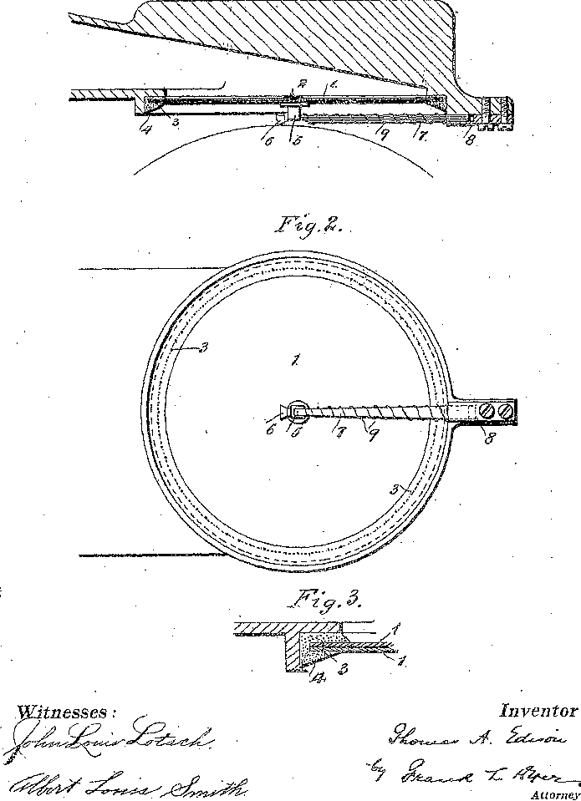
4
7.
5
•
Inventor
Attorney

UNITED STATES PATENT OFFICE.
EDISON, OF LLEWELLYN PARR, ORANGE, NEW JERSEY, ASSIGNOR TO NEW JERSEY PATENT COMPANY, OF ORANGE, NEW JERSEY, A CORPORATION OF NEW JERSEY.
SOUND-RECORDING APPARATUS.
943664 Specification of. Letters Patent. Patented Dec. 21, 1909.
Application filed November 18, 1908, Serial No. 181,590: Renewed June 10, 1909. Serial No. 501,414.

To all whom it may concern:
Be it known that I, THOMAS ALVA EDIS0N, of Llewellyn Park, Orange, in the county of Essex and State of New Jersey, have
5 invented certain Improvements in Sound Recording Apparatus, (Case No. 1122,) of which the following is a description.
My invention relates to an improved, apparatus for recording sounds, preferably of
10 the phonograph type wherein the record is of varying depth and width, but it maybe Utilized in connection with gramophonic apparatus wherein the record is of the same depth and width but of sinuous formation.
15 The object of the invention is to as far. as possible, sympathetic vibrations in sound recording apparatus, whereby the vibrations will be always forced and the recording of extraneous or distorted sound
20 waves will be prevented.
In applications for Letters Patent filed November 13, 1903, I describe a method and apparatus for recording sounds, wherein is used a diaphragm whose edges are immersed
25 in a viscous semiliquid, whereby the diaphragm is free to respond to forced vibrations.
With an ordinary diaphragm arranged in this way, its fundamental tone is , so high that it responds sympathetically only
30 to very high notes, and with such tones generally the amplitude is so slight that the recording knife is not disturbed to any great extent. At the same time tones which are in sympathy with the diaphragm are unduly
35 emphasized, so that it is desirable to eradicate even this small disturbance when the perfect quality of music is to be recorded and reproduced, especially when of instruments the majority of the notes of which are
40 very high, like a piccolo. To this end the invention consists, first, in the employment of a diaphragm of a new type, which while free to respond to the sound waves, is dead and non-elastic, so that
45 when once flexed to one side of its medial line, it has no tendency of itself to vibrate to and from like an elastic body having a fundamental tone of its own. This is important because if the diaphragm is elastic
50 it stores up energy when forcibly flexed to either side of its medial line, and when released vibrates in accordance with its fundamental tone, which vibrations detract from or add to succeeding sound vibrations,
55 thereby producing interference. With my non-elastic diaphragm, the energy stored up by said flexure is quickly absorbed as heat and work when the diaphragm is released, and the diaphragm has no tendency in re-turning to pass its medial line because the
60 said energy is consumed during the return of the diaphragm to the medial line, in this respect resembling a dead beat galvanometer. There is practically no tendency for it to swing past the said medial line. In other
65 words, I provide a composite diaphragm comprising members, which while in themselves elastic and capable of flexure or forced vibrations are so hindered in their movement as to be practically incapable of
70 any independent vibration, their elasticity merely serving to bring them back to their medial position when flexed.
The invention consists secondly, in making the so-called reed, which connects with.
75 and receives the thrust of the-recording knife, also dead and non-elastic, and incapable of vibration of itself, although free to follow the forced vibrations of the diaphragm by means which operate upon substantially
80 the same principle as the diaphragm.
In order that the invention may be under-stood, attention is directed to the accompanying drawing forming a part of this
85 specification and in which— figure 1 is a longitudinal view on an enlarged scale of a phonographic recording apparatus embodying my invention in its preferred form; Fig. 2 a plan view of the
90 same; and Fig. 3 an enlarged sectional view of a part of the diaphragm. In all of the above views corresponding parts are represented by the same reference numerals.
95 The diaphragm is composed of a plurality of disks 1 as shown, preferably formed of mica and of the usual diameter. These disks may all be of the same thickness, but they preferably are of different thicknesses, one
100 being say 1/1000 of an inch in thickness, the second 2/1000 of an inch in thickness, etc, Under ordinary. Conditions it is not desirable to use more than three of these disks in the make-up of the composite diaphragm. The
105 disks are, assembled together with a thin layer of a" Very viscous permanent Semi-
liquid, such as burned rubber, between them and are secured by a rivet 2 at the center, made preferably of aluminum, and at their
110
edges by a sewing 3 of silk thread. It will, of course, be understood that the disks may be sewed together by additional stitching’s, arranged concentrically between the center
5 and circumference, but under ordinary conditions a single line of stitching is sufficient. The edges of the composite diaphragm are immersed in a body 4 of a viscous semi-liquid, as I describe in my said applications.
10 A Composite diaphragm constructed in this way has its capacity to execute movements sympathetically entirely destroyed for the reason that the elasticity of the disks which under ordinary conditions would cause the
15 diaphragm. to vibrate to and fro, is here absorbed by friction developed between the surfaces of the disks and the viscous semi-liquid and by friction developed between the molecules of the said semi-liquid, the result;
20 being. that while the diaphragm is free to execute forced vibrations due to sound waves, no single impulse has a tendency to cause the diaphragm to execute a series of vibrations. The structure may be appropriately
25 called a dead beat diaphragm. Although my improved composite diaphragm is very sensitive to forced vibrations so as to accurately follow and record the sound-Waves, yet if flexed to one side or
30 the other of its medial line the pressure released, it immediately returns to its normal form without-partaking of vibrations. Secured to the under-side of the rivet 2 is an aluminium foot 5 held in place by shellac
35 or other cement and carrying the recording knife 6 of any suitable construction. The so called reed 7 whose front end is cemented to the foot 5 and which receives the thrust of the recorder, is secured at its
40 rear end by a clamp 8 and embodies the same idea as the improved diaphragm, inasmuch as it is also dead and non-elastic and incapable of vibrating sympathetically, This reed is therefore composed of a series
45 of thin glass sections preferably of varying thickness, separated by thin layers of a viscous permanent semi-liquid like burned rubber, the whole being wound by a silk thread 9. Instead of securing the reed sections together
50 by a silk thread, a series of small rubber bands may be employed with good results. It will of course be understood that the reed may be made of other material than glass, such as thin splints of bamboo.
55 With the arrangement. described, I eliminate all vibrations other than those which are forced so that a record formed is characterized by being composed solely of graphic representations of the sound-waves
60 themselves recorded with absolute accuracy and free of extraneous disturbances and distortion.
Having now described my invention what I claim as new and desire to secure by Letters
65 Patent, is as follows;
A composite diaphragm, comprising an elastic member and a permanently semiliquid material a great internal friction or viscosity applied over the surface thereof, whereby said member is rendered practically
70 incapable of sympathetic vibration, substantially as set forth.
A composite diaphragm comprising two or more elastic members and means applied over the adjacent surfaces thereof for
75 rendering said members practically incapable of Sympathetic vibration, substantially as set forth.
A composite diaphragm comprising two or more elastic members and a permanently
80 semi-liquid material characterized by great internal friction or viscosity applied to said members over the surfaces thereof, whereby said members are rendered practically incapable of sympathetic vibration,
85 substantially as set forth.
A. composite diaphragm comprising two or more rigid disks secured together with a viscous semi-liquid between the disks, substantially as set forth.
90
5. A composite diaphragm comprising two or more rigid disks of different thicknesses secured together with a viscous semiliquid between the disks, substantially as set
forth.
95
6. A composite diaphragm composed of two or more rigid disks secured together at the center with a viscous semi-liquid between the disks, substantially as set forth.
7. A composite diaphragm composed of
100 two or more rigid disks secured together at their center and edges and a viscous semiliquid between the disks, substantially as set
forth.
8. A composite diaphragm composed of a
105 plurality of disks riveted together at the center and sewed at their edges with a viscous semi-liquid between the disks, substantially as set forth.
9. A composite reed for receiving the
110 thrust of a phonographic recorder comprising an elastic member and means for rendering said member practically incapable of sympathetic vibration, substantially as set forth.
10. A composite reed receiving the thrust
115 of phonograph recorders composed of a plurality of thin leaves with a viscous semi-liquid between them, substantially as set forth.
11. A composite reed for receiving the
120 thrust of phonograph recorders composed of a series of leaves of varying thickness with a viscous semi-liquid between them, substantially as set forth.
12. A reed for receiving the thrust of
125 phonograph recorders composed of a series of glass leaves with a viscous semi-liquid between them, substantially as set forth.
13. A composite reed for receiving the thrust of phonograph recorders composed of
130
943,664

a series of thin leaves with a viscous semi-between them and wound with an exterior thread, substantially as set forth
14. In a phonograph recorder; the combination
5 of at composite diaphragm comprising an elastic member and means for rendering practically incapable of sympathetic, vibration; as recording stylus connected to the diaphragm; and a
10 composite reed receiving the thrust of said stylus
and comprising an elastic. member and means of rendering said member practically incapable of sympathetic vibration, substantially as set forth.
15 15. In recording apparatus, the combination of a composite diaphragm composed of a plurality of disks with a viscous semiliquid between the disks, a recording stylus connected to said diaphragm and a composite reed connected to the stylus and com-
20 posed of a series of leaves with a viscous between them substantially as set forth.
This specification signed and witnessed this 16 day of Nov. 1903.
THOMAS A. EDISON,
Witnesses:
Frank L. Dyer
J. F. Coleman.

