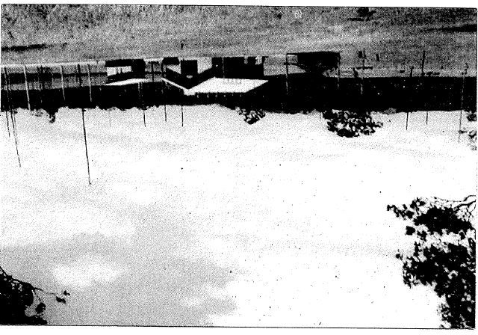

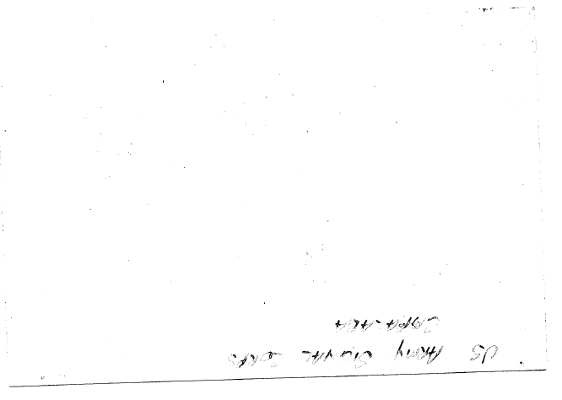

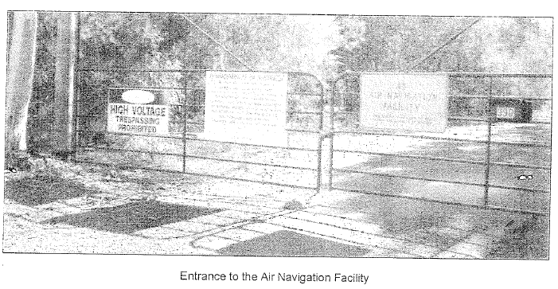
After WWll, the land was taken over by the PMG Department on 20 August 1946. An Air Navigation Facility operated by the Australian Communications Authority on the 260 acres of land was later used for the control and guidance of aircraft. They operated from a newer building (DCA Building) which was erected in the 1950/60's. This building cannot be seen from the main road.

A PIECE OF HISTORY - 2 SEPTEMBER 1945
This message announced the signing of the formal surrender by the Japanese on that day on the battleship Missouri in Tokyo Bay.
This message came into the Signal Center used by the 832nd Signal Service Company on the 7th Floor of GHQ, SWPA in the AMP building in Queen Street, Brisbane. It was received at the overseas radio station (probably this site Capalaba) and was transmitted to the Signal Center via teletype. It was received in "Clear' Classification.
It was the first message to pass between Japan and the United States over an Army Circuit since Pearl Harbor. It was sent from Radio Station WVLX on USS Teton in Tokyo Bay on 2 September 1945. It was a message from the Supreme Commander for the Allied Forces, General Douglas
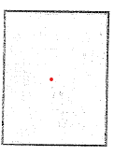

US ARMY SIGNALS CORPS
HEMMANT TRANSMITTING SITE
YOUNGS ROAD, HEMMANT, BRISBANE, QLD
DURING WW2
The US Army Signals Corps built a radio transmitting station on many acres of land at 180 Youngs Road, Hemmant in Brisbane, Queensland in 1943. The transmitter building was a tee shaped. building. There were some 100 feet high rhombic aerials erected by the Americans at the Hemmant site. The aerials have long gone, but the old transmitter building and diesel (250 kVA Buckeye) building still remain to this day.
1st Lt Henry W. Flora was the Commanding Officer of the US Army Signal Corps. Transmitting site at Hemmant in Brisbane from February to September 1944.
Whilst Henry W. Flora was at Hemmant, the US Army Signal Corps operated a powerful Western Electric D-155000 twin channel single sideband transmitter linked to San Francisco as part of the Army Command and Administrative Network ACAN. There were a number of other Radio transmitters to SWPA bases and other theatres located at Hemmant. The one 10Kw transmitter may have been for Delhi, India. Whilst Henry was at Hemmant, the very powerful Press Wireless 40Kw amplifier that was used earlier in the war was no longer being used in 1944 for transmissions.
Channel A of the Western Electric D-156000 transmitter carried Sigsaly encrypted telephone conversations to San Francisco while channel B was used for sending automatically encrypted teletypewriter generated messages to the USA. This meant the Sigsaly secure voice communication signals for General Douglas MacArthur located in GHQ, SWPA in the AMP building were sent via Side A of the transmitter and six reliable encrypted Teletypewriter TTY circuits were sent simultaneously on channel B as per the diagram below The TTY circuit went from Base Section Three Headquarters in Somerville House Girl's School at South Brisbane and the Sigsaly circuit went from the AMP building to Hemmant via Base Section Three Headquarters at the School. Henry W. Flora told me that the audio input to the transmitter consists of two 3000kc kc channels prepositioned by HQ carrier terminal equipment. Channel A, is input to a modulator with a carrier frequency of 125kc its output goes through a 125.1 to 130kc filter. Channel B is fed the same carrier frequency and goes through a 130.1 to 135 kc filter. These are then combined and the signal is one sideband with a carrier frequency of 125kc. The sideband containing the audio information is 125.1kc to 130kc.

generously shared some of his photos and his memories of his time at Hemmant and with Seaborne communications. Henry went on to tell me that he has continued to keep in regular contact with his buddy, 100 year old Murray Hannah, the former Commanding Officer of the Capalaba Receiving Station.
I'd like to thank Lionel Sharp for his assistance with this home page. Lionel worked at both the Hemmant and Capalaba sites back in the 1950's and has provided much of the above technical information. They were both "one man" stations when Lionel worked there.
I'd like to thank Christopher Mcllwain (Ian's son) and Roy Mcllwain (Ian's brother) for their assistance with this home page.
I'd like to thank George E. Boileau, Jr. of Gilbert, Arizona USA, for his assistance with this web page. His father George Edward Boileau, Sr. worked at the Hemmant Transmitting Station during WW2. George died in 1987 and is buried in New Orleans, Louisiana USA in the family tomb.
I'd like to thank Laurie Murray, Michael O'Leary and Leo Maloney for their assistance with this web site.
Can anyone help me with more information?
