Author Unknown

1. The "PALUMA" a last century gunboat. My father was a naval reserve gunner on her. When de-commissioned she was stripped, the sides were built up to the level of the main deck and she became a coal and gravel hulk on the river. She was finally beached, in front of the PALACE HOTEL at Woody Point, and is rusting away there as a breakwater.
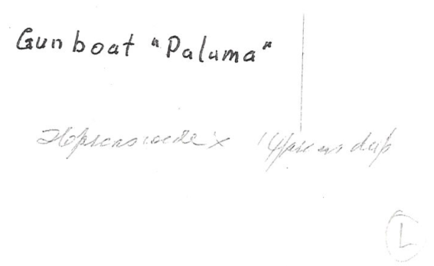

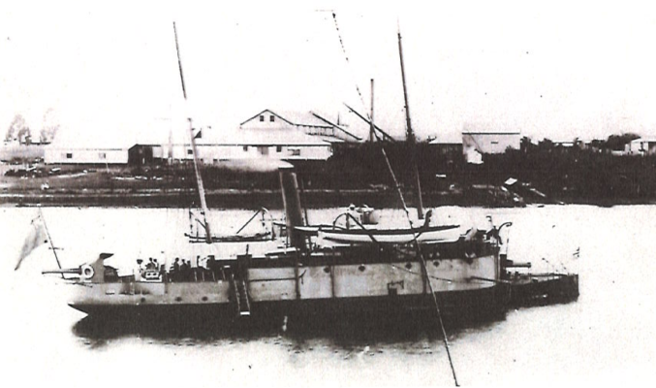

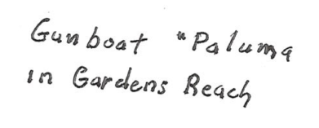

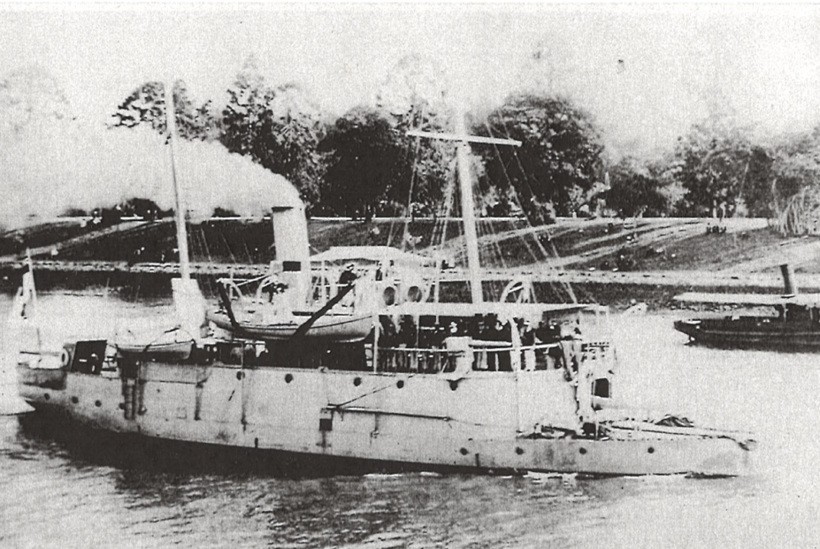

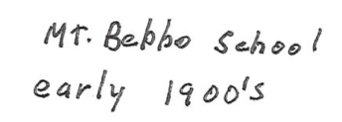
2. School room at the MOUNT BEPPO school early in the century. The name rings a bell but I don't know where MOUNT BEPPO is. The lady is a trainee teacher. (MT Seppo near Sommerset Dam)
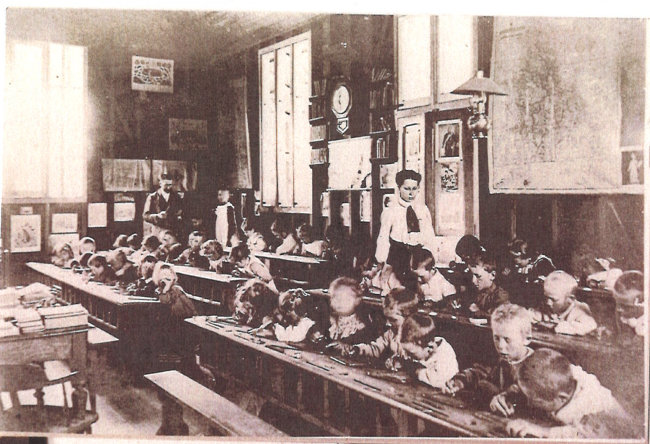

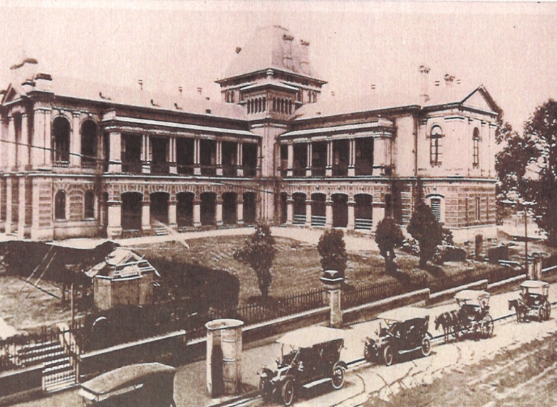
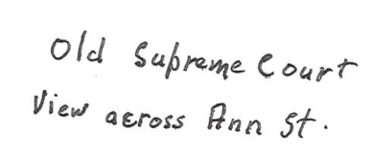
- Looking across Ann St., at the old SUPREME COURT. Cab rank in foreground, the Council still has the cast iron urinal in its store.

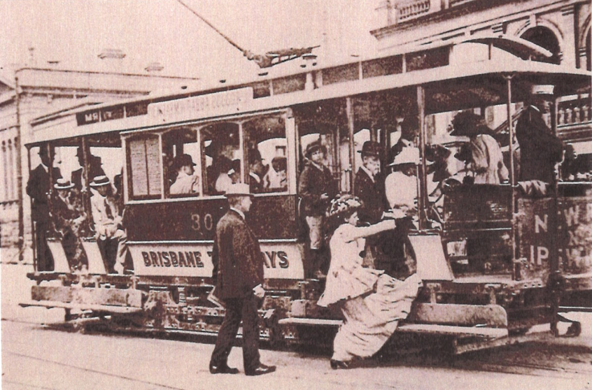
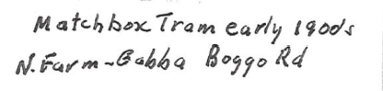
- "MATCHBOX" tram and an old one at that I can recall metal boxes on front dashboard with interchangeable destination plates. Holes punched in the letters allowed light from bulbs behind to show through so they could be read at night, that was 1917-8.

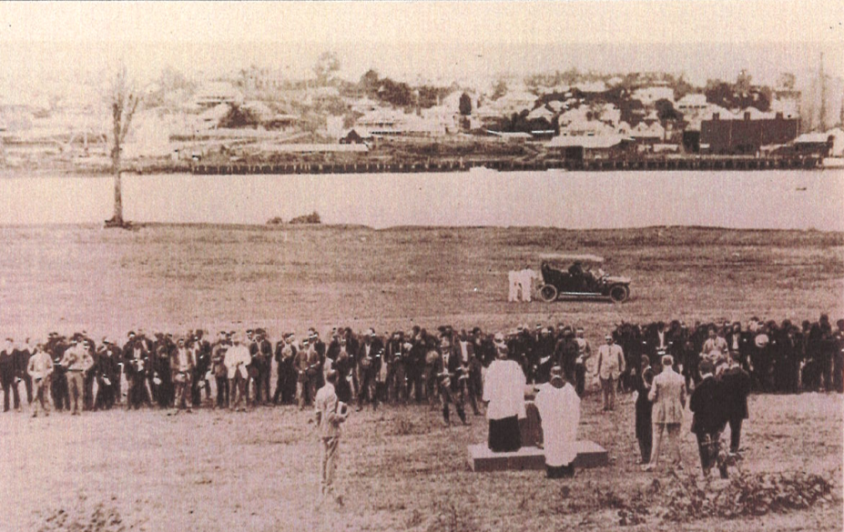
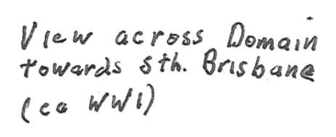
- Looking across DOMAIN at the site of EXPO. Big building on right could be BARNES FLOUR MILL. They produced "DEFIANCE" Flour.

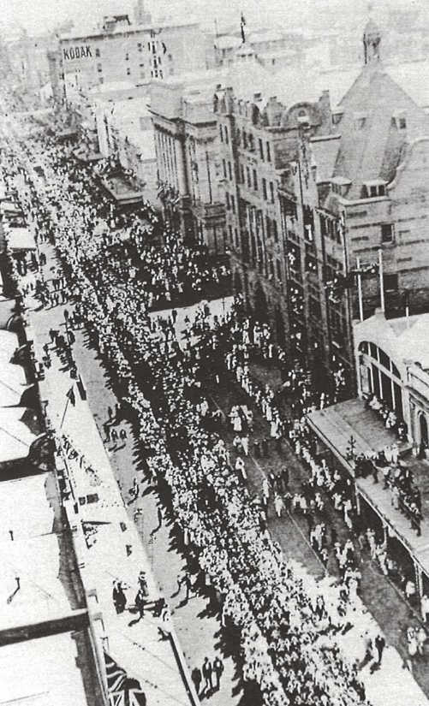
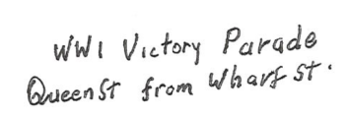
- VICTORY PARADE after Armistice '14-'18 war. Looking up Queen St., past Creek/Queen st. intersection. They appear to be marching towards the camera so probably heading for the EXHIBITION. On these parades collection were made for various good causes and they were collected in kerosene tins tied to short poles with a man on each end. So much was collected at times that the two men could hardly carry the weight.

- Looking up Edward St., from it's intersection with Adelaide St. Note the intersection of the tram rails under the policeman's feet. The building with the trees is part of the old NORMAL SCHOOL. Uphill, on the corner of Ann St., can be seen the building on the bottom floor of which I got my first driving licence in 1927 aged 16. My father inadvertently added a year to my actual age and me being a big lad for my age, it was accepted without question.
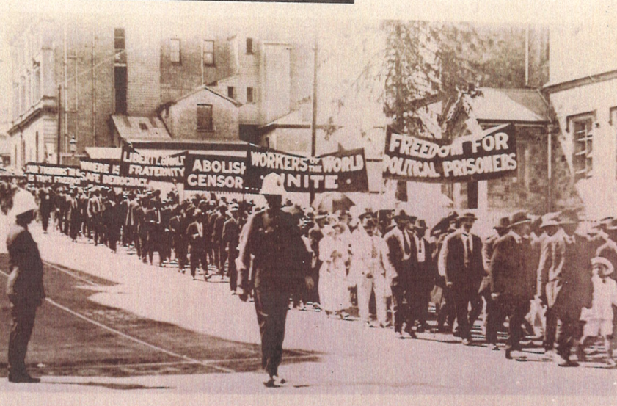
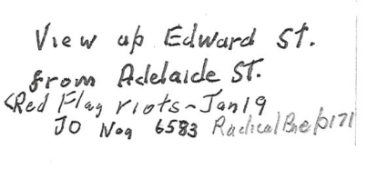

8. If you stood on top of Wallace Bishops building at the corner of Adelaide and Albert sts. and looked at the front of the TOWN HALL, this is what you would have seen early in the century. It. wasthe.0 Albert Square and where the line of hoardings is, is now the front of the TOWN HALL. Probably Special Constables 1912 General Strike
