Telecom News May 1991

Phones are fashionable. From the realms of interior decoration, they have leapt into focus, smaller and sexier, to become the ultimate personal accessory.
LISSA MITCHELL looks at the history of the telephone and finds some surprising facts — and artifacts.
Historical collection shows just how times change.

Matching telephones with your walls is no longer enough. In the car and in the street they are making a statement as something like a high tech equivalent of the handbag.
But there was a time when telephones were somewhat less than "hot". In fact, in the early 1900s, their place in the social scale was almost on a poi with toilet rolls now.
Although, for convenience sake, phones were normally located on the hall table, Edwardian sensibilities were so revolted at having to look at such naked technology that a thriving craft developed making "Dolly Varden" covers for them.
Few of these covers survive, but in a Collingwood warehouse a "Dolly Varden" phone cover, along with around 10,000 other items of telephone memorabilia, has been catalogued as part of a national Telecom historical collection being set up in Melbourne.
David Henry, Telecom's National Manager, Historical Services, said similar collections from WA and NSW are being brought to Melbourne for re-firing and cataloguing, which he hopes will be complete by the middle of next year.
"Over the years we have collected far more historical material in each state than we really need, much of it repetitious," he said.
"Establishing a national collection will allow us to keep only the best examples of each item and ensure that they are catalogued and stored properly.
"Tasmania, South Australia and Queensland have well established state collections and we are negotiating with their state museums to take them over.
"The retired Telecom employees who have worked so hard on these. collections should be able to continue to care for them as Museum volunteers," Mr Henry said.
"Telecom does not receive taxpayers' money, so the Telecom Historical Collection is being preserved as both a corporate investment and an investment in Australia's heritage."
Rosemary Clencie, Telecom's only trained Museum Cataloguer, will be responsible for establishing the new national collection in Melbourne before a permanent museum home is found for it.
Rosemary joined Telecom in 1985 after cataloguing at the Metropolitan Fire Brigade Foundation, the Children's Literature Museum, Heidelberg Historical Society, Como House and the Performing Arts Museum.
Since then, she has almost completed photographing and describing in detail Telecom's entire Victorian collection, which ranged from a jar of pickled white ants, taken from a telegraph pole, to antique exchange equipment.
Even though the collection is not yet open to the public, Rosemary is kept busy with dozens of enquiries from university students, researchers, historical societies, the Historic Telephone Society, museums, theatre and film producers.
She said Telecom lends so many items to theatre, film and television productions that replicas have been made of the popular "Candlestick" phones, for example, to save wear and tear on the originals.
"The ABC regularly, borrows from us and we recently supplied the "Spotswood" production with some antique office furniture, old phones and an unusual half-length phone box," Rosemary said.
"Our selection of old red phone boxes is regularly in demand for ads."
She said that 99 per cent of the collection was donated.
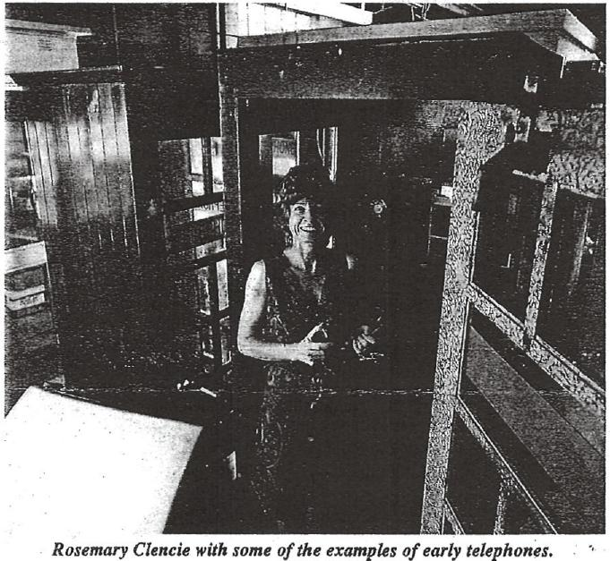

ABOVE: A section of the air conditioned store showing a range of collection items.
LEFT: A linesman's cart recently acquired from Australia Post.
BELOW: The magnificent cedar clock from the former CTO.
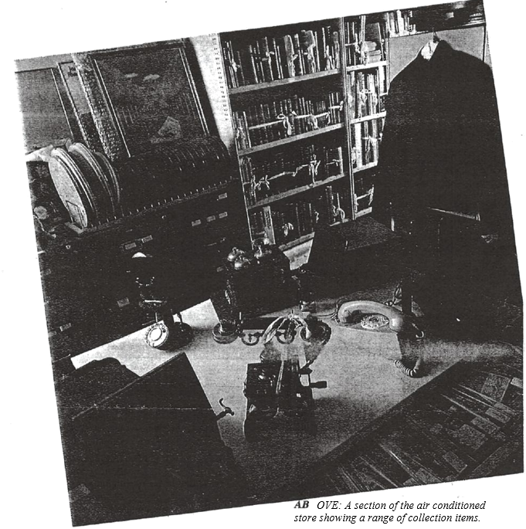
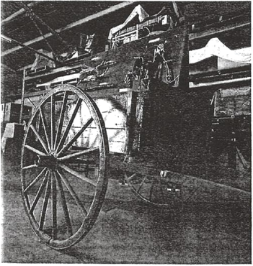

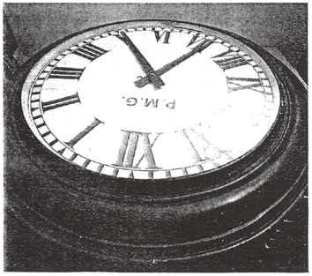

"One of the oldest and most valuable items is a Hunningscone wall telephone from 1890. There are only five of these left in Australia."
Another feature of Telecom's historical collection is its range of antique and replica costumes.
Along with old PMG, and Telecom uniforms, there is an outfit made by Jeannie Little from plastic ears and phone parts and a wardrobe of Operator Fashions from the early 1900s, based on designs taken from contemporary photographs.
Phones of course, make up a large part of the collection, but not all of them are Telecom standard issue.
Rosemary has several "character" phones by David Woodlands, including a spikey-haired punk phone and a bowler-hatted, Chaplinesque version. Her cupboards are full of toy phones recently returned from an exhibition at the Museum of Victoria.
"Toys are very important clues when looking at social history," she said.
"Telecommunications technology is advancing so rapidly that in decades to come our current phones and their toy equivalents with interesting historical artefacts that speak volumes about the phone's place in our society.
"Already, in less than a century, we have seen attitudes to phones change from something to be hidden away, to something to be flounted in the street."

ABOVE: David Woodland's novel ceramic telephones on the clock front
the former Chief Telegraphist's Office
RIGHT: Rosemary in the section of the store where the large items are kept.
BELOW: The switchboard inside emergency exchange caravan,
