9763.3

Alice Springs and its

Telecommunications Facilities --

Then and Now

Part 2: From Telegraphs to Stored Program Exchange
John Leahy, Telecom Australia
Alice Springs is today a large and thriving rural centre, a far cry from the township of less than 1000 people at the beginning of the Second World War. This article describes some aspects of the living style of the residents and the changes to telecommunications that have occurred over five decades.
ALICE SPRINGS TODAY
Alice Springs at the edge of the nineties is a large modern township, some would say city, of 23 — 24 thousand permanent population. This is increased by between 2 — 3 thousand itinerants during the tourist season which officially runs from March until October. It is a far cry from the 800 souls who resided here in 1938.
The construction of a mall, several large multi-storey commercial buildings, modern hotel and motel complexes, and the advent of Coles, Woolworths and K-Mart type shopping facilities has forever altered the character of the town. It has gone from that of an outback frontier peopled by cattle drovers, horses and dogs as portrayed in some movie productions to that of an up to date, thriving community.
Today the town is largely supported by the tourism and transport industries, The mining and cattle industries, once the dominant forces, play a somewhat lesser role than previously.
Henley on Todd
Alice Springs is internationally famous for the 'Henley on Todd' regatta, held annually in September. It regularly attracts crowds of 10 — 12 thousand people. The event is a 'mock up' of more normal regatta's held on water. 'Henley on Todd' is held in a dry river bed. The regatta is contested by homemade boat shells supported by crews whose legs protrude through the bottom of the boat so that they may run along the dried bed. If you think it is easy, try staying in step with 6 — 7 other people, bunched together in some type of boat frame, running in deep sand, with a useless sail flapping above. You will find out that it is not for the unfit.
The highlight of the day is a race for the 'Australia's' cup between a team from the American contingent based at Pine Gap, just south west of the town, and a local crew. The team that can lodge the most protests generally appears to win.
Other events such as surfing and lifesaving help to make the day memorable.
Many schools and clubs combine his event with a trip through the centre.
The Camel Cup
Another event with an international flavour, which up until a few years ago, was unique in Australia to Alice Springs, is the Camel Cup. The event originally started between local camel owners about thirty years ago as a race along the bed of the Todd. It is row an annual event held at the local showgrounds.
Every second year a team of enthusiasts from Nevada, USA, come to participate in the cup, A reciprocal visit follows from Alice Springs in the next year.
It is not widely known that Australian camel stock is regarded as the best in the world. Ir the past few years our stock has been exported to Arabian countries so that the quality of herds in those countries can be improved.
The Ghan
The railway line from Port Pirie to Alice Spring which carries the train known as 'The Ghan' is named after the Afghan cameleers who pioneered the route. The train is internationally famous and has been listed as one of the 'Great Railway Journeys of the World'. In the past it was indeed an adventure those who travelled it. The old German made carriages, with their polished wood decor exuding old world charm, and the camaraderie that was produced by groups of people kept together in a confined space for a short span of time, made for a relaxed and interesting journey. Today the line and rolling stock have been upgraded to provide a fast, modern service. The trip is still worthwhile.
For those who long for the past the 'Ghan Preservation Society' has preserved 35 kilometres of the old track to Ewaninga. They have obtained several sections of the Birdum route. On the Huckitta route there is only about 60 miles of cleared road, the remainder of the journey being over bush tracks, across wide creeks, and over some very rough hilly country. There is still one camel mail service operating in North Australia, being that which leaves Rumbalara once monthly and serves the stations north and north-west of there.
The Alice Springs' Line Foreman's district extends from Oodnadatta to Taylor's Crossing (about 26 miles north of Barrow Creek), a distance of 510 miles. The whole section is patrolled by him twice each year, usually just before and just after the wet season. The portion north of Alice Springs (205 miles) mostly follows fairly well defined tracks or bush roads, but on the southern section to Oodnadatta (305 miles) there are very little of even tracks, and he just follows the telegraph line, whether it be through sand-hills, over gibber plains and clay flats or across creek and watercourse beds. Some of these plains a few days after a rain appear to be quite dried up and firm, but beneath a thin crust is a real quagmire. In October, 1938, the Line Foreman and his assistant were returning from the patrol to Oodnadatta and about 120 miles north of there, were passing over what appeared quite firm and dry ground, when all of a sudden the truck broke through the crust and straight away dropped until it was resting on the running boards. Immediately water began to ooze through, and in a few seconds was almost flowing from where the crust had been broken.

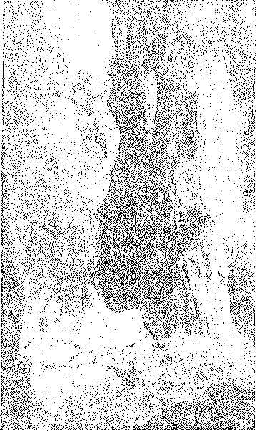
Looking down into Stanley Chasm
It took them until midnight that night digging drains to carry the water away. The next day was spent in trying to build up a corduroy under the truck with timber cut from the sparse mulgas nearby. Although the weather was very hot (the shade temperature at Alice Springs being over 100), they had to wait until the water had drained away before they could move, and then their disappointment can be imagined when, after going only a few yards, down they sank again and were no better off than they had been 24 hours earlier. It meant doing the same thing over again, and it was not until two days later that they got out of this hole. Usually a good supply of provisions is carried, but as the patrol had finished and they were returning home and anticipated replenishing at Finke tie evening they first got bogged, the supply carried was not large, and so, after the second day, although they still had plenty of good water, the only foodstuff remaining was tinned pineapple, and for two days they lived solely on this. On the evening of the third day they managed to get out of the second boghole, but on examining the surrounding country decided to wait at least another day before attempting to go any further. They were thoroughly tired out after cutting scrub, digging trenches to carry water away and attempting to get the truck out of bogs. On the evening of the fourth day they managed to reach Finke (30 miles away) but not before some more anxious moments had been spent in crossing other bad patches of country.
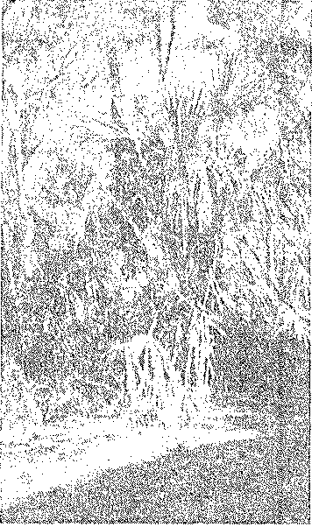
View in Palm Valley, near Alice Springs. This particular variety of palm is not found anywhere else in the world.
It is not often that we get a good downpour of rain, but we usually manage one good one each year.
On constructed at the rate of 110 miles per month, was accepted, and heavy penalties for non-completion of the line in the time were provided for in the agreement. Actually it was not until about the middle of August that year that the construction was commenced. The route was divided into three sections - from Port Augusta to latitude 27 deg. S. (about 60 miles north of where Oodnadatta is now, a distance of 550 miles), from 27 deg. S. to 19 deg. 30 mins. S. (approximately where the present town of Tennant Creek is, about 570 miles), and thence to Darwin, approximately 650 miles. The first section was in more or less settled country and provided very little difficulty, the northern section had some difficulties but not very great, but the centre section was in practically unknown country and therefore was the most difficult. Each section was subdivided into many sub-sections, and a party allotted to construct each sub-section. A small exploring party went ahead of each main party and marked out the route to be taken. The equipment of each party included 15 horse wagons, 17 bullock drays, one bullock wagon, five express wagons, 165 horses and 200 bullocks. A depot was established at the Finke River (about 830 miles from Adelaide) for the provision of fresh meat for the men working on the adjoining sections, and 2,000 sheep were sent there. It must be remembered that all the material, provisions, etc., had to be hauled from either Port Augusta or Darwin by horse, bullock vehicle, or camels, and some idea of the difficulties experienced can be realised by the fact that it took Harvey's party, who constructed one of the central sub-sections, eight months to reach the beginning of their section.
It was far too big a job to be done in the time, and when the period had expired (December, 1871), there were still many gaps in the line. A delay had also occurred in the cable construction, and although not far off completion, the cable was not completed on the contracted date. A compromise was reached regarding the infliction of penalties, which were considerably reduced but not entirely abolished, and the South Australian Government redoubled its efforts, but it was not until 22nd August, 1872, that the last gap was closed and telegraphic communication established between Australia and England. The total cost of the line was £479,154.
The original line was a 7/14 stranded iron wire conductor, and although most of it was removed and replaced by a 400 lb. G.I. conductor many years ago, there are still some small sections of the original wire in use.
During October, 1938, it became necessary to remove a small piece of the original wire in connection with the establishment of a Telephone Office at Finke, and it was found that the old wire was in perfect condition and not showing any signs of deterioration, Several types of insulators appear to have been used. One type was of porcelain, about 4 inches across at the bottom, but having a metal top, two inches in diameter, screwed on to the porcelain. A metal plate bolts on to the metal top, and two holes, through which a wire could be passed were formed when the plate was screwed down. Apparently only one hole was used, but the tightening of the bolt held the wire firmly between the plate and the metal top of the insulator. There were thus no tie wires necessary with this type. Another type is similar to the present day trunk line insulators, a little smaller, but completely covered with a metal armour. The metal armour is shaped exactly like the insulator, and the wire was tied to this similarly as is done on present day porcelain insulators. The porcelain was set into the armour by a kind of cement, and a thread was provided in the porcelain for the spindle. A number of these insulators are still to be seen lying along the line, and although over 66 years old, do not show the slightest sign of rust or deterioration.
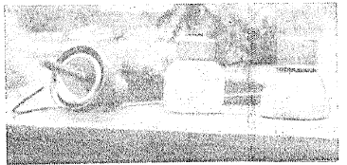
Old types of insulators used on the original Overland Telegraph Line and a piece of the original iron wire. The two outer insulators are the metal armoured type and the holes through which the wire was passed can be seen in the top of the centre insulator.
In many instances the line did not take a direct route between various points but followed creeks and watercourses. The reason for this was that most of the poles were cut from the timbers growing along these watercourses, and also that it was necessary to follow them in order to obtain water. However, the white ants soon showed their presence, and although there are some of the original butts still to be seen besides the present iron poles, most of the wooden poles had very short lives, perhaps only of a few years' duration. In 1880, re-poling with Siemens and Oppenheimer poles was commenced in places, but it was not until 1898, when a 265 lb. copper conductor was added that the line was fully iron-poled. During the erection of the copper wire and the final iron poles, the line route was considerably straightened, now following a more direct route and not keeping to the watercourses. No more wires have been added since then, but the methods of telegraphy used have kept abreast of the times and enabled the growing volume of traffic to be handled satisfactorily.
Originally the messages were repeated by hand at several stations along the route, and in between these stations were many others at which linemen were located. These latter were placed at points where water could be obtained, and varied in distance from 95 to 180 miles apart. As the country became opened up and telegraph systems improved, it became possible to abolish many of these stations, and one by one they have passed out of the Department's control. Some are now police stations, some are cattle station homesteads, and others railway stations. Today the only repeater stations apart from Port Augusta, in the circuits, are Alice Springs on the copper line, and Marree, Powell Creek and Alice Springs on the iron. Besides these the only other stations remaining in the Department's hands are Tennant Creek, Daly Waters and Katherine.
In time, hand repeating gave way to "pole changer" repeaters, and about 1926 relay repeaters were installed at the three repeater stations. Just recently the B.P.O. relays have been replaced (on the copper circuit) at this station by Creed 1927 type, and although Alice Springs is the only repeater between Darwin and Port Augusta (1,775 miles) no difficulty was experienced in working Creed duplex at 100-120 words per minute. Creed working has now given way to the 'Teleprinter, and I understand that this is the longest physical in Australia on which Teleprinter working is done. In these areas during summer, an amount of foreign current is noticeable, sometimes as much as 6 mA. Providing
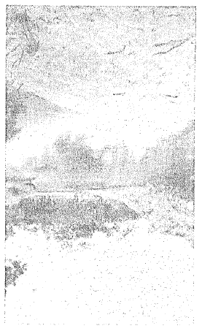
Jay Creek Wafer-hole, 28 miles from Alice Springs.
it remains steady, it can be overcome by adjustments to repeater and home station receiving relays, but occasionally the foreign current will vary from spacing to marking or vice versa within a few minutes, and continue doing this for hours, and then Teleprinter working becomes very difficult.
Nearby the pool which the first party had mistaken for springs, the Alice Springs Telegraph Station was built. For many years it was a lonely outpost, receiving its mail only once every six weeks or two months. At first it came by packs and camels from Port Augusta, later from Marree, still later from Oodnadatta, and in 1927 the railway line was completed to Stuart Town, two miles south of Alice Springs Telegraph Station. Although Stuart Town was surveyed in the late 1890s, it did not take shape until the completion of the railway. With the growth of the town it became necessary to establish an official office, and in 1932 the old telegraph station at Alice Springs was closed and a new post office opened in what was originally Stuart Town, but which now had its name changed to "Alice Springs". Business has continued to grow, and the office is now quite a busy Grade 2 office. Some idea of the town's growth can be gauged from the population, which increased from 398 in June, 1936, to 700 at June, 1938. There is also a quite large outback population served by the office. Many substantial buildings have been erected in the town and many more are in the course of erection, including a large business house, hospital, and other Government buildings. The streets are well made and properly kerbed, and thousands of ornamental trees have been planted along them. The town is dependent on the pastoral and mining industries, and these, especially the latter, are growing steadily. Many ores are found in the surrounding country, including wolfram, tin, mica, gold, silver-lead, and other base metals.
The climate is certainly hot, but it is a clear heat, and it is seldom that we do not have a cool night. In the winter many frosts are experienced, some so severe that I have seen limbs of quite big shrubs covered with ice because the frost had caused the bark to break and had frozen the sap where the bark had split. Citrus fruits, vines, vegetables and most flowers do remarkably well, but the stone fruits do not thrive, principally because of the frosts. The town nestles in between mountain ranges and is becoming popular as a tourist resort. Most of the better scenic attractions are, however, some miles out, but they are well worth visiting, and there are people who claim that our Stanley Chasm is quite equal to the famous Grand Canyon of Arizona.
Some lengthy mail services radiate from here — that to Tennant Creek being 341 miles, Birdum 657 miles, and Huckitta 502 miles. Motors are used on all these services, but in the wet season (November to April) packhorses are used on the Powell Creek-Birdum section of the Birdum route. On the Huckitta route there is only about 60 miles of cleared road, the remainder of the journey being over bush tracks, across wide creeks, and over some very rough hilly country. There is still one camel mail service operating in North Australia, being that which leaves Rumbalara once monthly and serves the stations north and north-west of there.
The Alice Springs' Line Foreman's district extends from Oodnadatta to Taylor's Crossing (about 26 miles north of Barrow Creek), a distance of 510 miles. The whole section is patrolled by him twice each year, usually just before and just after the wet season. The portion north of Alice Springs (205 miles) mostly follows fairly well defined tracks or bush roads, but on the southern section to Oodnadatta (305 miles) there are very little of even tracks, and he just follows the telegraph line, whether it be through sand-hills, over gibber plains and clay flats or across creek and watercourse beds. Some of these plains a few days after a rain appear to be quite dried up and firm, but beneath a thin crust is a real quagmire. In October, 1938, the Line Foreman and his assistant were returning from the patrol to Oodnadatta and about 120 miles north of there, were passing over what appeared quite firm and dry ground, when all of a sudden the truck broke through the crust and straight away dropped until it was resting on the running boards. Immediately water began to ooze through, and in a few seconds was almost flowing from where the crust had been broken. It took them until midnight that night digging drains
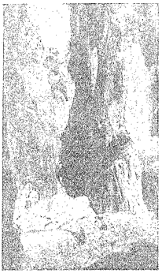
Looking down into Stanley Chasm
to carry the water away. The next dot,' was spent in trying to build up o corduroy under the truck with timber cut from the sparse mulgas nearby. Although the weather was very hot in the shade temperature at Alice Springs being over 100), they had to wait until the water had drained away before they could move, and then their disappointment can be imagined when, after going only a few yards, down they sank again and were no better off than they had been 24 hours earlier. It meant doing the same thing over again, and it was not until two days later that they got out of this hole. Usually, a good supply of provisions is carried, but as the patrol had finished and they were returning home and anticipated replenishing at Finke that evening they first got bogged, the supply carried was not large, and so, after the second day, although they still had plenty of good water, the only foodstuff remaining was tinned pineapple, and for two days they lived solely on this. On the evening of the third day, they managed to get out of the second bog hole, but on examining the surrounding country decided to wait at least another day before attempting to go any further. They were thoroughly tired out after cutting scrub, digging trenches to carry water away and attempting to get the truck out of bogs. On the evening of the fourth day, they managed to reach Finke (30 miles away-) but not before some more anxious moments had been spent in crossing other bad patches of country.
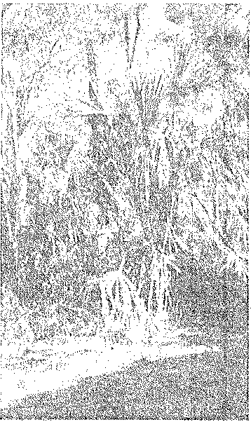
View in Palm Valley, near Alice Springs. This particular variety of palm is not found anywhere else in the world.
It is not often that we get a good downpour of rain, but we usually manage one good one each year. On 19th February, 1938, from two to five inches of rain fell from Alice Springs to Oodnadatta. Rivers ran bankers, and at one time the Alberga was flowing 16 feet above the railway bridge and over half a mile wide. Communication with Adelaide was completely cut off for several days, and the train service was not restored until six weeks later. Miles of railway line was washed away and many sections of the telegraph line carried away in the floods. Where the telegraph lines cross the Alberga there were two 28 ft. iron beam poles, but after the water had subsided they were found in different places about a quarter of a mile downstream, one end of each just showing through the mud and the other end under between six and seven feet of mud and silt. Some food supplies were brought to Alice Springs by aeroplane, but by the time the train service had been restored, there were many items which were unprocurable in the town, despite that rationing had been resorted to.
When the waters had subsided sufficiently to allow movement, Mr. E. Colson, of Bloods Creek Telephone Office (the nearest resident to the Alberga River), offered to attempt repairs to the lines, and set out on camels to do the job. Progress was slow, as it is a fair day's ride to do 30 miles by camel, especially in wet country, and stoppages were frequent in order to clear debris away from the lines. In addition, many detours had to be made to get across creeks and rivers which were still flowing, and he estimated that to traverse the 100 miles of line from his place to Oodnadatta, he travelled 160 miles. At the Alberga crossing he and three natives worked most of one day in water up to

their arm-pits, rigging up temporary supports for the line. These were tripods about 10 feet high and were constructed from timber cut from the trees growing nearby. Insulators were tied on to them, and the lines in turn tied to the insulators. Altogether it took eight days to travel and repair the 105 miles of line between Bloods Creek and Oodnadatta.
On the south side of the Alberga no wire was left on the poles (which were washed out and bent all shapes) for a quarter of a mile, the wire evidently having been caught and carried away by debris which was washed down. Many miles of railway line, and two bridges were washed away, and it took nearly five months to repair the permanent way. It is interesting to note that none of the railway bridges carried away have been replaced. Instead, the line is laid on a built-in rock foundation in the bed of the creek or river. Excavations are made to some depth in the riverbed and stone or rock firmly packed therein and the line laid on top of the stone. This method was first tried out when the Finke bridge carried away about six years ago, and has proved to be quite effective for, at the most, the damage amounts only to a short length of railway line being twisted, instead of an irreparable costly bridge.
Still, with all nature's vagaries, there are many who do not wish to leave here. The town is complete with most of the modern comforts, including an excellent electric lighting and power service, we have three air mails each week, a remarkably well-built office which keeps cooler in summer than some southern offices I have worked in, and last, but not least, a good-hearted public to commune with.
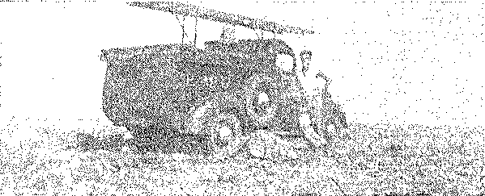
"On the South Patrol," Many miles of country, such as this, have to be traversed.

