Port Moresby: Radio.
(File Q 315/30/19)
This is a summary of information on this file concerning the establishment of a
Broadcasting station in Port Moresby initially to provide a service for army amenities
and subsequently to establish a National Broadcasting Service service.
In brief, the initial installation was done by the PMG in 1944, operated by the Australian / US army, and taken ever as an NBS service from July 1, 1946.
Abbreviations.
VFK Vern Kenna, PMG Radio Engineer
ABC Australian Broadcasting Commission
PM Port Moresby
DG Director General, PMG
Dep Deputy Director, Qld.
SE Supervising Engineer
WA Works authority
CF Claude Faragher
1943
1944
14/12 VFK & McCall / Robin Wood (ABC) by civil aircraft, ANA, (cancelled) then by military aircraft direct to PM.
16/12 Trip approval VFK &C. F. McCall (ABC). (? R. McCall ).
17/12 DG to Dep. Proposal
- Service for military personnel of a 500 watt Tx provided by PMG with programming by ABC / US special services including rebroadcast from VLQ., Brisbane
- provision of 10 W Tx at some appropriate advanced bases to rebroadcast
- Investigate possible installations at Buna and Milne Bay.
12/1 Dep to DG: Army to provide a site & building, PMG to provide equipment from state resources
15/2 DG to Dep Approval of expenditure, £5k ex L'reach Tx, £10k ex 4QG 10 kW replacement (file marked SECRET)
28/2 SE to Dep. Col Elworthy advises 9PA on air Saturday 25th. Mr Witt, ABC absent seeking other sites.
24/2 WA approved £8607, prep A J Ciarke NFK / CF / Jim Malone
12/5 Robin Wood to VFK, copy of standard 9PA schedule.
2/6 VFK to Elworthy c/-Public Relations Field Unit, H.Q. New Guinea
Force re reduction of breaks in transmission.
1945

7/1.2 DG to Dep. Army took over complete operation of 9_AA on June
17th. 1945.
1946
30/1 DG to ABC & Dep: Propose 'restore 9AA & 5 DR to ABC/PMG operation
14/2 Dep to DG: Recommend inspection re takeover 9AA
12/3 DG to Dep: Approve inspection, ABC rep Mr Kirke. (Still referred to as 9AA)
18/3 Postal (DG) to Dep: arrangements VFK to PM
18/4 VFK to SE (Sam Ross): 6 page report re take-over. Station now being designated as 9PA Recommends retain W.O. Marcus as Super Tech Gr 1. Marcus Was an exempt Tech. released to the army previously ABC rep ro be Robin Wood.
23/4 Dep to DG : re VFK report

1947  1948  1949 | 14/5 SE to Supt Eng: re report and emphasising proposal to resume control on 1/7/46 at a new site  20/5 Postal to Dep: Urgent Telegram-Take-over from 1/7/46 approved  3/6 Dep to DG; Detail of proposed new site  11/9 From Army Amenity Services: Army relinquished service on 5/4/46 and operation continued by Admin until resumption by PMG/ABC on 1/7  ?/2 DG to Ext Territories: Proposed compulsory acquisition of Badilli site  14/2 DG to Dep: re new site, proposed joint OTC/9PA.Admin use  31/3 DG to Dep: Copy of correspondence. to OTC / Ext Territories re site acquisition & new receiving site at four mile.  11/8 DG to Dep: Further detail PMG to provide Tx site for all parties, Admin to provide receiving site & ABC to provide new studios.  14/8 DG to Dep. HF Tx to go in existing site  18/12 WA approved for HF Tx £6030  3/2 Dep to Admin: HF Tx on way Install staff Beetham, Graham-Wilson, Hayward  29/6 ' VLT opened 28th.  18/11 DG to Ext Terr.: OTC withdraw from proposed Badilli site  1/9 DG to Dep: PNG Admin withdraw from Badilli site and will  co-locate with OTC at 5 mile '
1962
19/6 DG to Dep: Query delay in increasing power of Tx's
6/7 Dep to. DG: Response, including provision of 9RB and necessity for stdby radiator at to allow guy replacement
(prepared by L. Moloney in May 2007 )

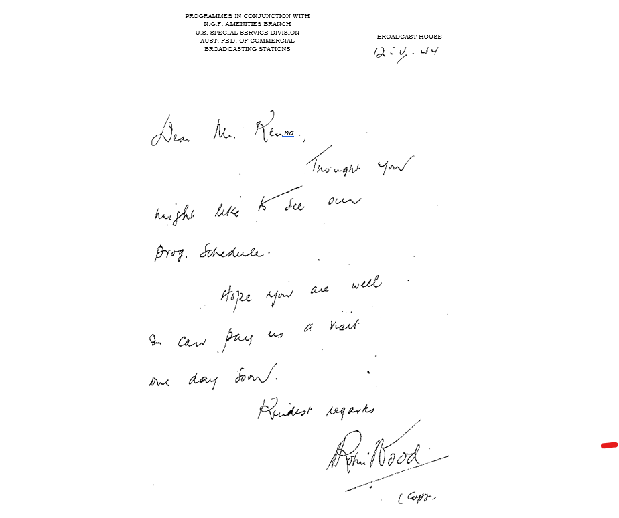

AUSTRALIAN BROADCASTING COMMISSION
STATION 9 P A PORT MORESBY
WEEKLY PROGRAMME SCHEDULE
(Sunday to Saturday Inclusive

(Subject to alteration)

STANDARD PROGRAMME SCHEDULE FOR SUNDAY. 9PA PORT MORESBY.

7.15 Light Classics.
7.45 Hymns From Home,
8.00 Highlights of Melody (Ensembles).
8.15 Personal Album.
8.30 Music For Sunday.
9.00 National News,
9.15 Sporting Results from Guinea Gold,
9.20 Organ Music.
9.30 Divine Service,
10.15 Music.
10.30 CLOSE.

5-15 530 OFF THE AIR

5,30 Charlie McCarthy Show.
6.00 U.S. News.
6.10 9 P A Service Bureau.
6.15 Spotlight Band.
6.30 Famous Tenor's Session.
6.5O The Music of England.
7,00 National News.
7.15 Sammy Kay Show.
7.45 Guest Speaker of the Week.
8.00 Jack Benny Show.
8.30 Play Font Line Theatre.
9.00 Overseas & Aust News
9.15 From the Concert Hall.
10.00 The Contented Hour,
10.30 CLOSE

STANDARD PROGRAMME SCHEDULE FOR MONDAY, 9 P A PORT MORESBY,

7.15 Morning Melodies.
7,45 Nat News.
8.00 G.I. Journal.
8.30 Hospital Request Hour.
9,15 Everyman’s Music.
10.00 U.S,News.
10.10 Music While You Work.
10.00 CLOSE.
10.30 – 12.15 OFF THE AIR.
12.15 Melody Roundup.
12.30 Nat News.
12.45 Luncheon Music.
1.15 Keyboard, Rhythms.
1.30 One Night. Stand.
2.00 Music Lovers' Hour.
3.00 Guest Artist.
3.15 Music from Films.
3.30.2026 Concert Hour.
4.00 Army Education Session,
4.30 Waltz Time. .
5.00 Light Ensemble,
5.15 CLOSE.
5.15 – 5.30 OFF THE AIR.
5.30 Fibber McGee and Molly.
6.00 U.S.News,
6.10 9 P A Service Bureau.
6.15 Melody Time.
6.30 Red Skelton Show.
'7.00 Nat News.
7.15 News Review.
7420 Duffyts Tavern.
7.50 News Magazine.
.8,00 ABC Out Of the Bag.
8,45 ABC Songs at Eventide.
9.00 BBC News
9,15 California Melodies,
9.45 BBC Feature.
10.00 Dancing Time.
10.30 CLOSE.

STANDARD PROGRAMME SCHEDULE FOR WEDNESDAY. 9 P A PORT MORESBY.
7.15 Morning Melodies.
7.45 National News.
8.00 Personal Album,
8.15 Sound Off,
8.30 Hospital Request Hour.
9,15 Everyman's Musics
10.00 U.S. News,
I0.10 Music While You Work.
10.30 Close.
10.30-12.15 OFF THE AIR.
12.15 Spotlight Bands.
12.30 Nat News,
12.45 Luncheon Music.
1.15 Musical Comedy Gems,
1,30 One Night Stand,
2,00 Music Lovers Hour,
3.00 Guest Artist_.
3,15 Music From the movies.
3,30 Concert Hour,
4.00 Army Education Sessions
4.30 Bob Crosby Show.
5.00 Light Ensembles.
5.I5 - 5.30 OFF THE AIR.

5.30 Music From America,
6.00 U.S. News.
6.10 9 P A Service Bureau.
6.15 Melody Time,
6.30 Comrades in Arms
7.00 Nat News, 7.15 News Review.
7.20 "Truth or Consequences"
7.50 News Magazine.
8.00 Salute to the Services,
8.30 Drams. Suspense.
9.00 BBC News.
9.15 Song Folio.
9.30 Symphony Orchestral Concert,
10.30 CLOSE.

STANDARD PROGRAMME SCHEDULE FOR THURSDAY. 9 P A PORT MORESBY.
7.15 Morning Melodies.
7.45 National News.
8.00 Down Beat.
8.30 Hospital Request Hour.
9.15 Everyman's Music.
10.00 U.S. News,
10.10 Music While You Work.
10.30 CLOSE.
10.30.-12.15 OFF THE AIR.
12.15 Mid-day Melodies.
12.30 National News.
12.45 Luncheon Music.
1.15 Bands and their Music,
I.30 Harry James Orch.
1.45 Fred Waring Show,
2.00 Music Lovers Hour,
3.00 Guest Artist.
3.15 Music from the Films.
3.30 The Concert Hour.
4.00 Army Education Session.
4.30 Burns and Allen Show,
5.00 Light Ensembles,
5.I5 CLOSE.
5,15-5,30 OFF THE AIR.

5.30 Kay Kyser Show,
6.00 U.S. News.
6.10 9 P A Service.Bureau.
6.I5 Melody Time.
6.30 Bing Crosby Show.
7.00 National. News. 7.15 News Review
7.20 ABC Victory Show.
7.50 News Magazine
8.00 Comedy Caravan.
8.30 Basin Street.
9;00 Overseas News.
9.15 ABC Roadhouse.
9.45 Celebrity Artist.
10.00 Recorded Feature.
10.30 CLOSE.

STANDARD PR OGRAMME SCHEDULE FOR FRIDAY: 9 P A PORT MORESBY.
7.15 Morning Melodies.
7.45 National News,
8.00 Melody Roundup.
8.15 Great Music.
8,30 Hospital Request Hour.
9.15 Everyman's Music,
10.00 U.S. News.
10.10 Music While You Work,
10.30 CLOSE..

10.30-12.15 OFF THE AIR.
12,15 Band Wagon.
12.30 Nat News.
12.45 Luncheon Music.
1.15 At the Console.
1.30 Mail Call
2.00 Music Lovers' Hour.
3.00 Dr. Mac.
3.15 Music From the Movies
3.30 Xavier Cugat Show.
4.00 Army Education Session.
4.50 Carnival of Music.
5.00 Light Ensembles,
5.15 CLOSE.
5.15-5.30 Off the Air

5.30 The Great Gildersleeve"
6.00 U.S. News.
6,10 9 P A Service Bureau.
6.15 Melody Time.
6.30 Race Preview from. Melb/Sydney
by Mel Morris and Hal Hooker
6.45 Dinner Music.
7.00 Nat News. 7.15 News Review.
7.20 ABC Dick Bentley Show,
7.50 News Magazine,
8.00 Dinah Shore Show.
8,30 Fred Hartley Quintet.
8.45 Dance Ensemble.
9,00 Overseas and Aust News.
9.15 From The Concert Hall.
I0.00 Dancing Time.
10.50 CLOSE.

STANDARD PROGRAMME SCHEDULE FOR SATURDAY. 9 P A PORT MORESBY.
7.15 Morning Melodies.
7.45 National News.
8.00 Yank Swing Session.
8.30 Hospital Request Hour.
9.15 Everyman's Music,
10.00 U.S. News,
10.10 Music While You Work.
10.30 CLOSE,
10.30-12.15 OFF THE AIR.
12.15 Light Classics.
12.30 Nat News.
12.45 Luncheon Music,
1.15 Variety Show.
1.30 Harry James Orch.
I.45 Keyboard Rhythms,
2.00 These were Hits.
2.30 Musical Comedy Gems.
3.00 Stars of today.
3,30 Film Favourites.
4.00 Aroun4 the Band Stand.
4.30 National Barn Dance,
5.00 Light Music.
5.15 CLOSE. Racing Results at intervals throughout afternoon.
5.15-5.30 OFF THE AIR.

5.30 Light Ensembles„(And review of race results from 3 states.)
6.00 U.S. News.
6.10 9 P A Service Bureau.
6.15 Hit Parade.
6.45 Sporting Results Relay from Melb, Sydney and Brisbane.
7.00 Nat News.
7.15 News Review.
7.20 The Stage Presents.
7,50 News Magazine.
8.00 Fanny Brice and Frank Morgan.
8.30 Village Glee Club.
9.00 Nat News & BBC News:
9.15 From the Music Hall.
9.45 Guest Artist - Vocalist.
10.00 Witches Tales.
1(Y.50 Tonight We Dance.
11.00 CLOSE.

