Bulletin
ISSN No. 0035 8916 Newsletter of the Royal Historical Society of Queensland, No.694 February 2006 www.queenslandhistory.org.au info@queenslandhistory.org.au
Ph: 07 3221 4198
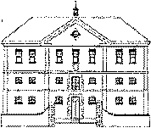
COMMISSARIAT STORE 1820
RHSQ
Royal Historical Soddy of Queensland
Patron: Her Excellency Ms Quentin Bryce AC, Governor of Queensland
PRESIDENT: Jean Stewart
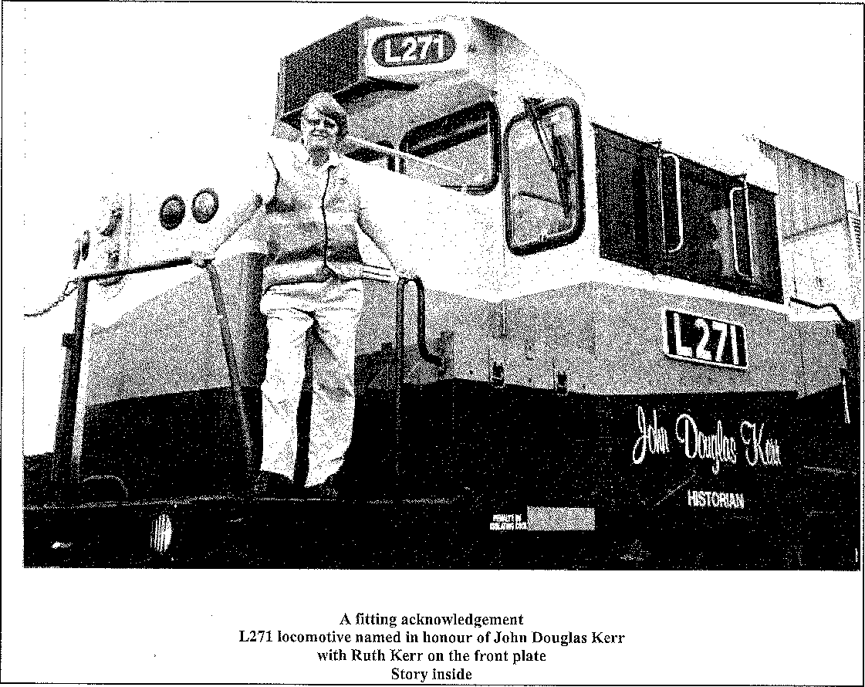
A fitting acknowledgement
L271 locomotive named in honour of John Douglas Kerr
with Ruth Kerr on the front plate
Story inside
President's Report February 2006
We start the New Year with optimism and hope that we can continue to serve the membership of the Society and the history world of Queensland in the professional manner for which the Society has long been known and for which it is greatly respected.
A short break over the Christmas period has been followed by very high temperatures which can make the Commissariat Store very uncomfortable for visitors and workers although we are very grateful for the relief offered in the air conditioned section of the Welsby Library. Visitor numbers remained steady
over the Christmas period although the research enquiries diminished slightly reflecting the seasonal preoccupations of historians and researchers.
It is time to consider making nominations for the John Douglas Kerr Memorial Award and details will be found in this edition of the Bulletin. The Award in 2005 was an outstanding success and we hope that we will be able to recognise and reward another of one of the many outstanding historians of Queensland.
With assistance from the Office of Women of the Queensland Government, the University of Queensland Press has been able to make available for

RHSQ Bulletin, February 2006— Page 2
our members copies of the current edition of • Queensland reView. This edition contains most of the papers presented at the February 2005 Conference managed by the Society on "A Celebration of the • Centenary of Women's Suffrage in Queensland" and
"The Achievement of Queensland Women in Parliament". An introductory article on the conference and on the history of the suffrage movement by me as President of the Society was included.
An important event will be held in the Commissariat Store on Friday 3 March. Dr Helen Henderson, President of the Federation of Australian Historical Societies, will be visiting the Society and will present to Dr Ruth Kerr OAM the posthumous award of Fellow of the FAHS for John Kerr. There will also be a presentation of a Fellowship to Dr Lorna McDonald OAM of Rockhampton. She has written extensively on the New England tableland, central Queensland and about the Archer family, presenting papers in Norway and Scotland. A leading advocate in Queensland, she has shared her research widely. She has been a member of the Queensland Heritage Council for nine years and has been Patron of the Queensland Professional Historians Association since 1992. Lorna has been a pivotal figure in the Rockhampton Historical Society for more than thirty years and has written on women's history in central western Queensland. She is now writing a book on her travels as an historian over many decades. Presentations will also be made to members of 50 years membership of the Society. All are invited — see the flyer included with this Bulletin.
Jean Stewart President
•
Highlights and Achievements of 2005
At the start of a new year it seems appropriate to •
list some of last year's highlights. They are not in any particular order. The Society:
- presented the inaugural John Douglas Kerr • Memorial Award for Historical Research and Writing to Dr Raymond Evans;
- invited the Lord Mayor, Honourable Campbell • Newman to launch the book Brisbane's Historical North Bank in June in the presence of Her • Excellency Ms Quentin Bryce AO, Governor of
Queensland; •
- established the Commissariat Store as a suitable venue for a variety of community functions and • celebrations;
- continued the regular monthly series of lectures • on Wednesday lunchtime and Thursday evening with outstanding speakers;
held two very successful conferences relating to the centenary of women's suffrage in Queensland and the history of women in Queensland;
organised material from the conference "A Celebration of the Centenary of Women's Suffrage in Queensland and the Achievements of Queensland Women in Parliament" for a special edition of Queensland reView published by the University of Queensland Press with assistance from the Office of Women of the Queensland Government;
published four issues of the Journal;
published regular monthly Bulletins to keep members informed of the Society's activities; provided guest speakers for many community organisations;
presented Certificates of Appreciation to members of 25 years standing;
participated in the Museum of Brisbane's Brisbane Heritage Expo in the Brisbane City Council Auditorium in May;
refined and extended the Society's Web site; used a National Library of Australia grant to restore three important illuminated addresses held in the Society's collection;
hosted a meeting to foim an Historians Working party to commemorate the Sesquicentenary of Queensland in 2009;
installed two new exhibitions in the Commissariat Store — one on J D Lang and one on the Petrie family;
held a successful function to unveil a framed tribute to former Librarian, John Kerr; held a very successful dinner to commemorate Queensland Day on 6 June;
held a very successful fully booked tour to the Warwick district of the Darling Downs in May; supplied responses to over 300 enquirers for historical research from the Society's Library and collection of manuscripts and photos; acknowledged the efforts of volunteers who supplied over 6,000 hours of service to the Society;
made a submission to the State Government on changes to the Queensland Heritage Act;
produced CDs of the Welsby Library Catalogue to add to the items of publications for sale; contributed guides for Brisbane's Living Heritage Network's World War II tours of Brisbane; made a submission to the Productivity Commission's Heritage Inquiry;
contributed material on Fernberg for a display at a Government House Open Day;
•
•
•
•
•
•
•
•
•
•
•

RHSQ Bulletin, February 2006— Page 3

- received several donations of books from deceased estates: some of these will be added to the collection and some will form the basis of a Book Auction;
- nominated Dr Lorna McDonald OAM for the Award of Fellow of the Federation of Australian Historical Societies;
- received a visit from Her Excellency the Governor, Ms Quentin Bryce AC and Mr Michael Bryce in November.
It was a very busy year and reflected the continued devotion and skill of many dedicated volunteers. The Council of the Society appreciates greatly their efforts and the coordination work of Allan Bell. We look forward to an equally imaginative, busy and successful 2006.
Jean Stewart President
Councillor profile
Dr Ian Hadwen
My first Annual General Meeting as a member of
RHSQ was Dr Drury Clark's first as President, almost 25 years ago. Over ensuing years I attended many of the lectures and day seminars. However, it was not until Michael White approached me in 1998 about organising a seminar to commemorate 200 years since Flinders explored Moreton Bay in the sloop
Norfolk (1799-1999) that I began to take an interest in the organisational activities of the society.
I became a member of Council in 1999, was President 2001 to 2004 and currently hold a position of semi-invalidity, namely that of Immediate Past President. Organising the Society's lecture program is now my principal societal role.
My principal interests in Australian History have always been early discovery, exploration, and settlement. During my late primary and all my secondary school years I lived in close proximity to the Glass House Mountains, so Captain Cook is my hero.
As part of my continued involvement in RHSQ affairs I have responsibility for finding and scheduling suitable speakers for the Wednesday and Thursday lectures as well as the annual full day seminar. Looking at the program details on page 4, this year promises to just as busy as the last.
Cheers!
Ian Hadwen
Library services
Books added to the Welsby Library in the last two months include: Johnny Cassim: Coolie, convict,
catechumen and colonial entrepreneur (1814-1884); Clump Point and district: An historical record of Tam o'Shanter, South Mission Beach, Mission Beach, Bingil Bay, Garners Beach and Kurriminie; A history of Wheatville and district: Comprising the districts of Allan, Bony Mountain, Greymare, Pratten, Rogers Creek, Than, Thanes Creek and Wheatville.
CALENDAR
February 2006
Wednesday February 8 12.30 pm "Victory in the Licensing Court: the issue of the licence for Cooroy's second hotel in 1910" Ruth Kerr
Thursday February 16 6.00 pm Ernie Hood of Gatton, farmer, irrigator, timber miller, Shire chairman — his story", Jean Stewart
Tuesday February 14 Bulletin deadline
March 2006
Wednesday March 8 12.30 pm "Katherina Benfer —
early German settler at Mt Cotton" Jasmine Sommer
Thursday March 16 6.00 pm "Nineteenth Century St
Lucia" Peter Brown.
Friday March 17 Bulletin deadline

Manfred Cross donated A rush for grass, Minute by minute: A history of the Anglican Parish of Springsure, Springsure centenary booklet 1859-1959: A short history of Springsure and district; Folktales from Banana Shire's past: Reprints of how early stories were told in the Central Telegraph; A church for its times: The story of St Thomas Church, Toowong; Roads of yesterday and the folk who travelled them; In their own hands; Townsville: Commercial and industrial- centre of North Queensland; A history of the Graziers' Association of Central and Northern Queensland 1889-1989; Outback insights: A social history of north-west Queensland 1925-1950; Two white swans: Reminiscences of Irvinebank and Stannary Hills Far North Queensland 1915-1935; Malanda: In the shadow of Bartle Frere; A pictorial history of the Mulgrave Shire 1800-1980; Introduction to Cook⁻town and its museum; Souvenir book of the MM Min Festival 14th to 22nd August 1976⁻ celebrating the centenary of Boulia Capital of the Channel Country Queensland 1876-1976.
Ruth Kerr donated Rights of passage: Emigration to Australia in the nineteenth century; Gulf of Carpentaria scientific study report, a tale of converging paths and The Evo Owen story.
Kay Cohen has donated Brisbane: People, places and progress; Queensland in the 1860s: The photography of Richard Daintree; River of gold; Up

tebruary 2000— Page 4

rode the squatter: The savage beginnings of Queensland's west; Looking back along Fassifern Valley; Toowoomba is a garden.
A new Subject file was created for the Frank Corley Collection and includes a listing of photos of houses identified in Brisbane suburbs and regions towns and held by John Oxley Library.
A donation from the Estate of Caroline Isbel is Women and their role in World War II: Wartime experiences of women in the Coorparoo and surrounding Districts.
Judy Rechner Librarian
PROGRAMME REPORT
Happy New Year! Welcome to our lecture programme for 2006. As usual, the Society is holding lectures every second Wednesday lunchtime and every third Thursday evening of each month.
Please note that the time of the evening lectures for 2006 has changed from 7.30 pm to 6.00 pm, with supper to follow. The earlier time has proved popular in interstate historical societies. It allows for workers in the CBD to attend, without first travelling home. I apologise for any inconvenience this change may cause to our band of regular attendees of evening lectures.
The theme for the first three months' lectures is `local history' — in particular, noteworthy individuals within the local history context. The 2006 inaugural lecture on Wednesday 8 February at 12.30 pm will be delivered by Dr Ruth Kerr, who will talk on another aspect of the local history of her home town of Cooroy.
The February evening lecture on Thursday 16 February will be given by our President, Jean Stewart; this time about a `bloke', Ernie Hood, of Gatton.
Keep a lookout, and an ear to the ground, for our feature day-long seminar later in the year. The seminar will be our contribution to the Australia on the Map programme, commemorating the 400th anniversary of the first European to come ashore on the Great South Land. There will be details in the next Bulletin.
I look, forward to meeting as many members as possible at our lectures throughout the year.
Ian Hadwen
QR L271
QR National/Interail locomotive L271 was named in honour of "John Douglas Kerr, Historian", on
Wednesday 16 November at a ceremony in New South Wales. The locomotive, a former L class standard gauge locomotive of Westrail, L271 has been on proving trials since early 2005 for Interail, which is the service delivery provider for QR National. Interail was the first step in QR becoming a national operator, and is now part of QR National, the national transport and operator arm of QR.
It was considered important to ensure that in honouring John, who was renowned as a painstaking, thorough, and hard working researcher, that a currently operating locomotive be chosen. The naming was undertaken in recognition of John's contribution to QR and his role in interpreting Australian railway history. John travelled extensively, not only in Queensland but beyond the state borders, and it was in recognition of his contribution as an ambassador of the QR story beyond the traditional homeland of QR, that the offer was made to name one of the "big power fleet" in his honour.
The ceremony, attended by representatives of Interail, Centennial Coal, QR National, the Australian Railway Historical Society and members of the Kerr family was held after L271 had been accepted into regular service and begun operations at Centennial Coal's Newstan colliery. QR National currently hold a contract to transport coal from Newstan colliery to Vales Point powerhouse near Newcastle. L271 "John Douglas Kerr, Historian" will no doubt venture further afield as requirements dictate.
FROM THE FEDERATION
New Vice-Presidents elected and a new delegate:
Following the early resignation of the two Vice-Presidents, Mr David Lewis, Royal Australian Historical Society (RAFIS) and Dr Alison Alexander, Tasmanian Historical Research Association (THRA), Mr Nigel Ridgway, History Council of South Australia (HCSA) was elected Senior Vice-President and Professor Ian Jack (RAHS), Vice-President at the Federation's Annual General Meeting in Hobart on 30 October 2005. With the welcome addition of Dr Dianne Snowden, THRA now has two delegates on the Federation's Committee.
Fellowship award
At the AGM, Dr Lorna McDonald OAM, historian of Rockhampton Queensland was awarded an FAHS Fellowship. Dr McDonald has written extensively on the Archer family — on the New England tableland, central Queensland and Norway and Scotland — having presented papers and published there. Lorna has also researched and published extensively on central Queensland history with major publications on both cities — Rockhampton and

RHSQ Bulletin, Yebruary ZUUO— Page

Gladstone. A leading advocate for history in Queensland she has been a member of the Queensland Heritage Council for nine years and Patron of the Professional Historians Association Queensland since 1992. Lorna has been a pivotal figure in the Rockhampton Historical Society for more than thirty years and has written on women's history in central western Queensland. She is now writing a book on her travels as a historian over many decades.
Staff changes
Mr Gerard Hogan has resigned his position as Administrative Officer but is staying on as the Federation's Public Officer. He will continue to maintain the Federation's presence in Canberra as required under the ACT's Incorporations Act. Gerard's contact information has not changed. Ms Kellie Bennett, previously Executive Officer of the RWAHS, has been appointed to the position of Administrative Officer. Kellie's email address is: fahs@westnet.com.au.
Meeting with CEO of the Collections Council of Australia
At the end of October, Dr Ruth Kerr and I had a very productive meeting with the CEO of the Collections Council of Australia, Ms Margaret Birtley. Many issues were discussed including the need for:
- Government surveys of custodians of moveable cultural heritage to include community owned and managed museums and that the reports of those surveys clearly differentiate results according to whether they relate to government or community run museums;
- greater understanding of cultural heritage residing in historical societies;
- recognition of the autonomy of historical societies; and
- appropriate training of volunteers.
Productivity Commission's draft report, Conservation of Australia's Historic Heritage Places
This draft report was released on 9 December 2005 and it can be read at the following website address: http://www.pc.gov.au/inquiry/heritage/draftreport/ind ex.html. Printed copies are available from Jill Irvine, phone (02) 6240 3223. Public hearings to discuss the draft report will commence in late January. For further information visit the following website: http://www.pc.gov.au/inquiry/heritage/.
Helen Henderson
President
Events and functions of interest
Archives on-line — How best to find and use national archives on the Internet. Saturday 18 February and Wednesday 22 February from 9.00 am to 10.0 am at 16 Corporate Drive Cannon Hill, phone 3249 4226.
"A long view down the theodolite: the history of Queensland surveying" by Bill Kitson Wednesday 1 February at Queensland Museum, South Bank theatre 12.30 pm to 1.30 pm, free admission with tea and coffee to follow.
"Being modern: living in flats in interwar Brisbane" by Helen Bennett Wednesday 1 March at Queensland Museum, South Bank theatre 12.30 pm to 1.30 pm, free admission with tea and coffee to follow.
National Archives of Australia
The National Archives of Australia at 16 Corporate Drive, Cannon Hill will be open on the third Saturday of each month from 9.00 am to 1.00 pm. Records must be pre-ordered.
History course
RHSQ member Associate Professor Clive Moore of the School of History, Philosophy, Religion and Classics, University of Queensland has re-introduced the teaching of Queensland history. These are the only courses at a Queensland university that provide an introduction to Queensland's history. Contact: c.moore@uq.edu.au; or telephone 07 3365 6800.
HIST2248 Interpreting Queensland's History
First semester 2005: Lecture-Workshop Monday, 2-4, Tutorials 4-5; 5-6.
Course Description: Queensland is where we are: a state of the Commonwealth of Australia since 1901, and before than a British colony from 1859, a New South Wales convict settlement from 1824, and a part of the colony of New South Wales since 1788. But in 1788 there was a large indigenous population, probably well in excess of 100,000. Some people say Queensland is also a `state of mind' and is different from other Australian States; this certainly was a prominent view during the 1970s and 1980s, motivated by frustrations with the government of Joh Bjelke-Petersen. But there are also good reasons to support this view, based on historical evidence. This course is based around the "Is Queensland different?" question, and examines the development of the colony and state, searching for an answer.
HIST7248: Queensland History: Working with Sources
The companion post-graduate course is HIST7248: Queensland History: Working with Sources. This is also available in first semester 2006. HIST7248

RHSQ Bulletin, February 2006— Page 6

students will be expected to attend the lecture/workshops of HIST2248 (or have an already-existing detailed knowledge of Queensland's history), and then attend regular seminars designed to fit with their particular interests in Queensland history. The aim is to establish projects that work with a variety of sources, but are also tailored to individual student needs. HIST7248 is structured for concentrated study of aspects of Queensland's history and is linked to developing students through the Graduate Certificate/Graduate Diploma and Master of Arts in History Graduate Certificate/Graduate Diploma in Arts (Applied and Local History).
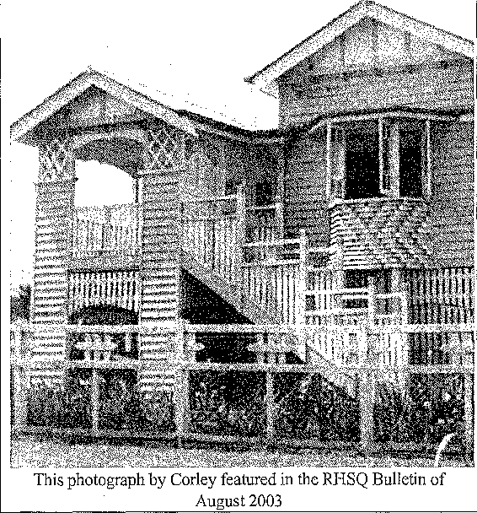
Corley Collection at JOL
The State Library of Queensland recently advised that in the near future over 50 photographs from this outstanding collection of Queensland houses will be available on their web site at www. sl q. ql d. gov. au. Simply select "Queensland Heritage " and "Picture Queensland " then search for Corley. John Wilson at JOL would welcome information, particularly address and reference code, on any B&W postcard size of houses readers may have.
Book bargain
Another outstanding local history publication, Robert Cribb: from an Iceberg to Brisbane Town is still available at the very attractive price of only $60.00 plus p&p of $7.50 (Brisbane) or $9.00 (outside Brisbane). This biography, written by Beth Johnson, is approximately 300 pages A4 size and includes 50 illustrations, an index and bibliography.
Copies of this book can be obtained by mail from the author at 40/32 Dunmore Terrace Auchenflower, 4066.
The Deanery 1855 - 2005
Incredibly, the Deanery's sesquicentenary slipped by unnoticed during early December of last year. This vital relic of Queensland's history, a jewel in the state's heritage register, was sadly not accorded the honours commensurate with its importance (and age). For one hundred and fifty years, this building has rendered distinguished service to Brisbane's secular and Anglican life, variously as private home, Government House, private school and residence for the deans of St John's Cathedral.
The Deanery's life started when Andrew and John Petrie erected `the best residence in town' in 1855 for Doctor William Hobbs, medical practitioner. At that time, it was widely known as `Hobbs' folly', considered to be too distant from the township's commercial and social activity.
Nevertheless it was deemed to be eminently suitable as the temporary Government House — a rental property for Queensland's first vice-regal representative, Sir George Ferguson Bowen. It was from the balcony of this residential `folly' in December 1859 that the state of Queensland was declared and Bowen, hung over with sea-sickness, was sworn in as first governor.
The Greater Corporation of the Diocese of Brisbane purchased Adelaide House in 1899 when it was decided to construct St John's Cathedral on the present Ann Street location. Until 1909, the building housed the diocesan office and bookshop. In that year it was renovated by the illustrious architect, Robin Dods as a residence for the first sub-dean and his wife, Canon J. A. and Mrs Gertrude Teresa Pattinson. Thus, for ninety-five years, Adelaide House has been home to the vast majority of the cathedral deans and their families.
As the records provide virtually not one iota of evidence of the good works of the deans' wives (let alone their Christian names), the talents of their children, the functions held within the deanery walls and the notables who have been wined and dined, etc, Dr Mackenzie-Smith is hoping he will be inundated with information from the readership of the Brisbane Diocesan newspaper Focus and the RHSQ Bulletin, arising from their knowledge and experience to breathe life into the volume.
Please send recollections to: 28 Lethem St, Hendra 4011, or e-mail jma92897@bigpond.net.au Ultimately, the colour and human interest of the end product will depend to a certain extent upon those much appreciated efforts.

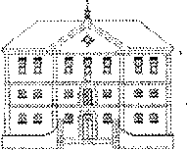
CONACISSARLit STORE Eta,
RHSQ
Royal Histodcal Society of Queatslakl

ISSN No. 0035 8916 Newsletter of the Royal Historical Society of Queensland, No.693 December 2005 www.queenslandhistory.org.au info@queenslandhistory.org.au Ph: 07 3221-4198
Patron: Her Excellency Ms Quentin Bryce AC, Governor of Queensland
PRESIDENT: Jean Stewart
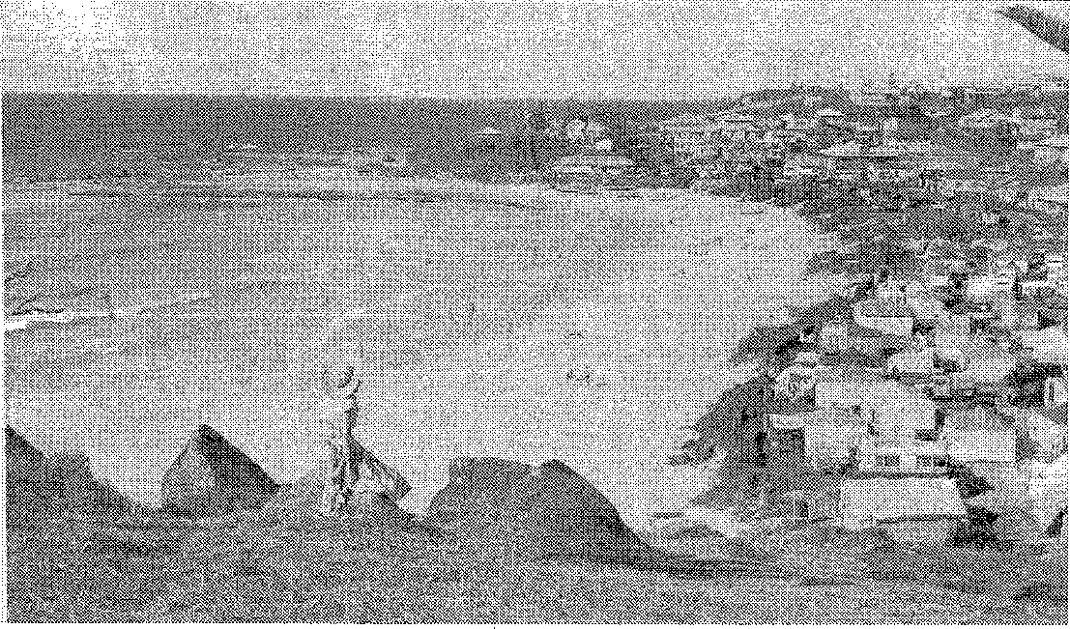
Rainbow Bay from Greenmount Hill, Coolangatta
Central Photographic Bureau photo no 1599, 1954.
RHSQ collection
President's Report December 2005
As the year draws to a close we look back on a most successful period for the Society. Visitor numbers have remained healthy and the sales of publications have been comfortable. Allan Bell has overcome some problems in obtaining reception staff who have been so efficient that they very quickly go off to paid employment, but he has managed to maintain and increase the number of guides and other volunteers who are such an asset to the Society. He was able to take a well earned break in the latter part of November.
At the end of October, the honorary secretary Dr Ruth Kerr and I attended the Annual general meeting of the Federation of Australian Historical Societies in
Hobart. This is the peak body in Australia representing the interests of all historical societies. I delivered the report for RHSQ and it was interesting to hear how other societies in other states manage their affairs. Ruth was able to report on her many activities on behalf of the historical societies in Australia as she attends the National Cultural Heritage Forum and the Regional Cultural Alliance and was co-author of the Federation's submission to the Productivity Commission's Enquiry into Heritage. She also prepares an e-Bulletin for the Federation. It was an interesting weekend of historical discussion, as well as meeting people and enjoying a guided tour of historic Richmond. For my part it was a pleasure to meet representatives from other states and to put faces

RHSQ Bulletin, December 2005— Page 2

to the voices heard on teleconferences.
At the last Wednesday meeting for the year, a
presentation was made to thank Mr Peter Mutzelburg
for preparing the certificates of appreciation recently awarded to Society members of twenty five years standing. His outstanding skill with inscribing these certificates was much appreciated.
During November there were several events in the Commissariat Store. The State Library of Queensland held a luncheon for its volunteers, once again using the ground floor for such an occasion. During November our patron Her Excellency the Governor Ms Quentin Bryce and Mr Bryce visited the Store for an inspection and stayed for afternoon tea.
During the month of November I was pleased to represent the Society at HER/izons — a Symposium, Imagining the Future of Women, held by the State Library of Queensland in the Convention Centre. Later I launched The Scottish Presence in Moreton Bay 1837-1859 by John Mackenzie-Smith at a meeting of the Brisbane History Group. It is a significant addition to the early history of the new settlement of Brisbane.
The Society was delighted to accept a significant amount of Australia Post Archive Material which had been dispersed to various repositories by Australia Post. This material will be a valuable addition to the Library's collection when it is sorted and catalogued.
It is with pleasure that I introduce the Councillor for this month. Manfred Cross, vice-president, is a member of fifty years standing having passed this milestone in September. When he joined in 1955 meetings were held in Newstead House. Sir Raphael Cilento was President, Alexander Morrison was Secretary and Colin Austin Librarian, all significant historians of their time. Manfred was elected MHR for Brisbane and was so busy that during that period he was only an occasional attendee at meetings. He represented the House of Representatives on the National Library Council from 1973 to 1975 and 1980 to 1989. After his retirement from Federal Parliament Manfred became active again in the Society in 1990. He became a member of the Society's Council in November 1997. He has served six years as Chaiiman of the Library Board of Queensland. Manfred is a wonderful contributor to the Society's affairs. He has an encyclopaedic knowledge of Queensland history and has organised and conducted wonderful excursions. I congratulate him on his long membership of the Society and thank him for a magnificentl contribution.
Another highlight recently has been the naming of a new locomotive for Queensland Rail after John Douglas Kerr, Historian. Dr Ruth Kerr attended the naming ceremony in Newcastle. It is a rare honour
and a wonderful tribute to the memory of John whose work on documenting railway history in Queensland is legendary. It is timely to remind members that
nominations will soon be called for the John Douglas Kerr Award for Research and Writing. We would ask members to consider the names of appropriate people for submission by the closing date of 31 March 2006.
As the year draws to a close on behalf of the Council I wish all members and volunteers of the Society the Season's Greetings and look forward with confidence to a successful New Year.
Jean Stewart President
News from the Society's Council
At its meeting on 27 October 2005 the President Mrs Jean Stewart welcomed all Councillors. Council:
- expressed appreciation of the number of visitors including large school groups;
- noted the pleasing level of book sales;
- confirmed plans for the Proclamation Day function at Newstead House which this year includes displays from the Queensland Women's Historical Association;
- discussed plans for the program for 2006;
- expressed appreciation for the work done by the team working on identifying photographs.
Country News
(Collected by Ruth Kerr from personal Queensland contacts, Affiliated Societies and Newspapers)
Atherton - Some of Railco's rolling stock and station building have been sold and the new owner and rail enthusiasts plan to restart the Atherton-Herberton service. New leases are being negotiated with Queensland Rail. (Tablelands Advertiser 12 October 2005 p.12)
Blackbutt-Benarkin - The Blackbutt and District Tourism and Heritage Association co-ordinated the recent Blackbutt-Benarkin Pioneer Festival Day event. The association is gathering historical photographs and building a bullock wagon which will be located in Jessie's Well Park. (South Burnett Times 28 October 2005 p.2)
Gympie - The Gympie Historical Society Museum recorded and celebrated the achievements Clyde Kunst for the Society with the publication of a large article in the Gympie Times of 18 June 2005 pp 20-21 including four photos. One of the particular projects he was involved in included removal of Andrew Fisher's house from Maori Lane to the museum.
Herberton celebrated its 125¹¹¹ anniversary on the weekend of 28-29 October 2005 with musical and

RHSQ Bulletin, December 2005— Page 3

concert activities in town and re-enactments and displays at the Mining Centre. (Tablelands Advertiser 26 October 2005 p.38 including three photos)
Ravenshoe-Tumoulin Railway - Railco hopes to gain funds to secure the future of the Ravenshoe - Tumoulin service. The volunteers hope to recommence the service after Transport Department has inspected the upgraded track. (Tablelands Advertiser 12 October 2005 p.12)
Rockhampton - The Rockhampton and District Historical Society has prepared numerous historical plaques for erection in the city. Mayor Margaret Strelow launched one of the three Thozet plaques on 1 November 2005. Permission is being sought to erect a plaque re Frank Forde in Frank Forde Park. He was State member for Rockhampton from 1917 to 1922 and then became member for Capricornia in the Federal Parliament from 1922 to 1946. He was Prime Minister from 6 to 13 July 1945. (Rockhampton and District Historical Society Newsletter October 2005)
New Members
Mr Peter Brown, St Lucia
Mrs Joan Crane, Caboolture
Mrs Patricia Lack, Ormiston
Mrs Juliette Milner-Thornton, Willawong
Mrs Marion Standfast, Chapel Hill
Research services
An interesting research project conducted by Researcher Lyndsay Smith brings home forcefully the value and power of the Internet and e-mail. The enquirer was in Ottawa, a collector of old horse drawn vehicles, one of which was a sulky made by Stewarts of South Brisbane. It was a puzzle, still unsolved, how the sulky got to Canada but we were asked to find out about the maker. After several weeks work Lyndsay was able to provide several photographs of the business in South Brisbane around the 1900 period and a list of names as the partnership of owners changed over the years. We had a very happy customer who is now facing the challenge of finding how the sulky travelled so far and who owned it. Other queries included information on Brisbane's Tivoli theatre, the Lucy Gray diaries, St. Lucia, oystering in Moreton Bay, Aboriginal people in Brisbane, dispensaries in Brisbane in the 1870s period, and Edward Hess, draper and clothier of Queen Street. Our researchers enjoy the challenge of finding answers to our enquirers' questions and are generally successful in providing some suitable material.
Jean Stewart
Honorary Research Officer.
Program Report
What a busy program it has been in 2005, with a marked emphasis on women and women's history. There have been two full day seminars on the history of women in Queensland, plus a number of papers delivered at the Commissariat Stores on various Queensland women. I found the presentations very interesting, the papers of high standard (as would be expected considering the calibre of the authors) and I suspect we have only touched the surface. The year 2006 will see a return of emphasis to the history of "blokes" as well as women.
Next year, 2006, marks 400 years since the first European (a bloke) set foot on land that was to become known as Australia. In particular, we will celebrate the feats of two blokes, Janszoon and Torres. On a date yet to be decided, but most likely in July, the Society will hold a one day seminar as part of the Australia on the Map program. I hope to have more details in the first Bulletin for 2006.
In addition, it is now only three years till Queensland celebrates its sesquicentenary. Despite the State Government's tardiness in preparing for these celebrations, in 2006 the Society will begin preparations of its own program. Some of the lectures will cover the lead up to the granting of statehood: separation from New South Wales in 1859. The publication committee also has projects in hand. If anybody has ideas for projects or lectures pertaining to this part of our state's history, please contact me or Jean Stewart or Allan Bell.
The Society is experimenting with the time slot for the evening lectures. In 2006 the evening lectures, commencing Thursday February 16, will start at 6.00 pm (not 7.30 pm as at present).
The final program event for 2005 is the Proclamation Day function on December 10 to be held at Newstead House in conjunction with David Gibson and the Board and Friends of Newstead House. The Queensland Women's History Association from Meigunyah also are participating. Our Society has recently had restored thanks to a National Library Community Grant, an illuminated address to Governor Bowen by the Working Men of Queensland. This illumination will be on display for the first time. Remember Saturday 10 December —details are included in this Bulletin.
My sincere thanks to Manfred Cross for organising the Queensland Women in Politics seminar and the bus trip to the southern Darling Downs, and his invaluable assistance to me throughout the year. My thanks also to all those who supported the program by their attendance and participation in the lecture program.

RHSQ Bulletin, December 2005— Page 4

Merry Christmas and a Happy and Prosperous
New Year to you all.
Ian Hadwen
CALENDAR
December 2005
Saturday December 10 4.00 pm to 7.00 pm
Proclamation Day function
Newstead House
February 2006
Wednesday February 8 12.30 pm to be advised
Thursday February 16 6.00 pm to be advised
Friday February 17 Bulletin deadline
Please note that all Thursday evening talks will commence at 6.00 pm. Free parking is available at the rear of the Commissariat Store, off Queens Wharf Road for both Wednesday and Thursday talks.

Library services
A very useful book donated by Queensland Health is Health buildings in Queensland: An historical overview and from Ruth Kerr, Rufashell Street and the Tin Mill at Rocky Buffs on the Stannary Hills Tramway, north Queensland, 1903 to 1920. Carolyn Nolan has donated Brisbane's inner city, Brisbane's north eastern suburbs, and heaps of photocopies with material on various districts including St George, Dirranbandi, Bollon, Hebel, and these have been added to the District files and appropriate Subject and Family files.
Donated by Nancy Tow and added to the Welsby Library are Maleny 1878-1978 — One hundred years: By Obi Obi waters: Stories and photographs of early settlement in the Maleny district, Blackall Range, South Eastern Queensland; Pioneer days: Stories and photographs of European settlement between the Pine and the Noosa Rivers, Queensland edited by Stan Tutt; The history of Pomona, Cooran, Kin Kin, Cootharaba and Skyring's Creek; and Early Chronicles of Cypress Land. Nancy Tow has also donated some fabulous cuttings and newspaper articles on the 1974 Brisbane flood.
Added to the collection are Taroom and her people; In Leichhardt's country: A pictorial history of Taroom and Wandoan; The history of the first twenty-five years of the Wandoan Show Society; Daughters of the Dawson; and Mending matters: An anthology of reflections and flights of fantasy prompted by one hundred years of women's suffrage edited by Katherine Lyall-Watson.
Judy Rechner Librarian
New books
Gulf of Carpentaria Scientific Study Report edited and published by the Royal Geographical Society of
Queensland, Brisbane, 2005 (Geography Monograph Series No.10, 390 pp, index, illus, maps, appendices) The book covers assessments of human impact, Sweers Island, McKenzie Massacre, Pennyfather River,
terrestrial invertebrates, butterflies, cicada,
geomorphology, birds, reef and shore fishes, crustacea, and archaeological reconstruction of the lime burning works on Sweers Island.
Queensland School Pupils Index - Part 3, CD with QFHS datasearch Version 1.6. Published by Queensland Family History Society, November 2005, ISBN: I 876613 98 X. Cost: $51.50 incl GST. Available from: QFHA, P.O. Box 171, Indooroopilly Q 4068. Part 3 includes 304,000 names from over 200 Queensland schools, from 1874 to 2004. -- -
War memorial trees
To commemorate Remembrance Day on 11 November, Lord Mayor Campbell Newman called on residents to share their stories and information about memorial tree plantings in Brisbane. Brisbane City Council is participating in the 2015 Avenues of Honour project to find and document the many trees planted in Brisbane as memorials to lives lost in war. If anyone has information for the 2015 Avenues of Honour project please contact 3403 8888 or address mail to 2015 Avenues of Honour project, Natural Environment and Sustainability Branch, Brisbane City Council, GPO Box 1434, Brisbane 4001.
Events and functions of interest
What's next for Archives? Meet the Brisbane Director of the National Archives over morning tea and chat about the Archives' plans for 2006 on Saturday 17 December from 10.00 am at 16 Corporate Drive Cannon Hill, phone 3249 4226.
"The Glory Box: a chest full of hopes and dreams" is an exhibition running at the Redcliffe Museum until February 2006. For further information phone 3883 1898.
From Experimemental Plot to City Oasis, Thursday 29 December at 9.30 am City Botanic Gardens, bookings on 3403 2535. Free.
Open Day at Government House. On Australia Day, 26 January 2006, Government House at 168 Fernberg Road will be open from 10.00 am to 4.00 pm. BYO picnic and listen to police and military bands and tour the house and grounds.
Proclamation Day 2005
A day to remember and celebrate is 10 December

RHSQ Bulletin, December 2005-- Page 5

2005, the day in 1859 when the Colony of Queensland was proclaimed from the verandah of Adelaide House in the presence of the just-arrived Sir George Bowen, his wife Lady Roma Diamantina. Today, Adelaide House is the Deanery adjacent to St John's Anglican Cathedral.
For over a quarter of a century, historic Newstead House has celebrated this most significant Anniversary. In association with the Royal Historical Society of Queensland and the Queensland Women's Historical Association, the Newstead House Trust together with the Friends of Newstead Inc present:
gibtonicat p tap
9",tocecuitation Da* t2ui'z
a peNfounattee fiy, membem of the St Pl^{i}tte6 atallteattee
.53and
.News teal Notoe"thteisoect" fo4 the ge4titte Sews as
taclitionat cctitots mug mound the Demi-gum&
ef^{i}lA4Stitta4 &aft/3 eetthat
Comptimentcvitl tef)te4fmtettts
ifime: 4pm to, 7pm
ghee EVA* to Neuotead Mown
Queensland State Archives
For the whole of 2005 the Queensland State Archives will open every second Saturday of the month.
National Archives of Australia
The last Saturday that the National Archives of Australia at 16 Corporate Drive, Cannon Hill will be open in 2005 is 17 December. The opening hours are 10.00 am to 4.00 pm.
At Christmas
A recent letter from Loraine Rayner of the Childers-Isis District Historical Society tells a story of historical research very appropriate at this time of year. Whilst rummaging through the items at a jumble sale in Toowoomba, a Townsville tourist turned up a post card addressed from Childers. On the return journey, she delivered the card to the Childers Historical Complex on Taylor Street.
The Post Card, addressed to Pte W.C. Lockwood, D Coy. 3/4 Pioneers. A.I.F Abroad. It read "Dear Charlie, with love and XXXX from the children and myself, wishing you a Happy Xmas and Bright New Year, from your loving wife Nell from Childers, Qld." It showed a photograph of the children.
Pte Lockwood was serving on the Western Front in France at the time.
Several phone calls located Mrs Nyra Lockwood,
wife of George Lockwood, the third of Charlie's and Nell's children.
Charlie, who survived the traumas of the war, died tragically in a single vehicle accident. The vehicle evidently ran off the road between Childers and Maryborough and plunged into a waterhole in Deadman's Gully, and submerged. Only twelve months later was Charlie's body discovered.
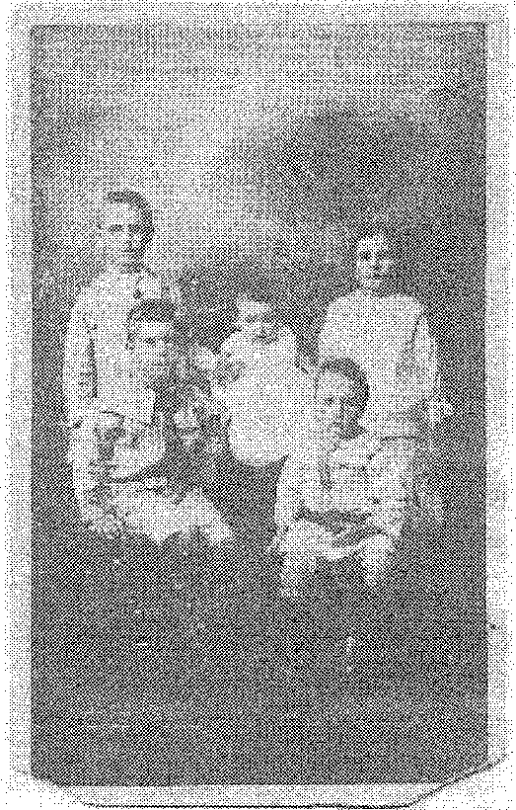
History course
Two new history courses are being offered by University of Queensland in 2006; a Graduate Certificate and a Graduate Diploma in Arts (Applied and Local History). Both courses offer training in the practical, professional and conceptual aspects of public history. Local themes and topics are studied in the general context of Australian and Queensland history and heritage. Details can be obtained from Dr Geoff Ginn at 14iiirtfcLuc .edu,au or on (07) 3365 6407.
Front cover
While there is no indication of when in 1954 this photograph was taken, it does show a typical "Christmas at the Beach" scene of many tents and caravans on the foreshore at Rainbow Bay. This scene is representative of many beach areas along the length of the Queensland coast even today.

Royal Historical,SOciety of Old
PO Box 12057
Brisbane George Street
QM 4003
RHSQ Journal: PP424022/00020
RHSQ Bulletin: PP424022/00019
SURFACE MAIL
Secretary
Postal Telecomm. Historical Society
P.O. Box 651
ALBION OLD 4010
Postage Paid
Brisbane
Albert St
4002

Important Functions and Events
December 2005
Saturday December 10 4.00 pm Proclamation Day function, Newstead
House
February 2006
Wednesday February 8 12.30 pm to be advised
Thursday February 16 6.00 pm to be advised *note new time*
Friday February 17 Bulletin deadline

RHSQ Infobox
The Society is represented on the National Trust of Queensland and the Board of Trustees of Newstead House
The Society acknowledges the financial assistance of the Queensland State Government, and rate remission from the Brisbane City Council
Contact details:
Location: | Historical Museum and Welsby Library at the Commissariat Store, 115 William Street, Brisbane
Phone: | 07 3221-4198
Fax: | 07 3221-4698
E-mail: | info@queenslandhistory.org.au
Website: | www.queenslandhistory.org.au
ABN: | 34 217 251 028
Postal: | The Royal Historical Society of Queensland, PO Box 12057, Brisbane George Street, 4003
Open: | Tuesday to Friday and most Sundays 10.00 am - 4.00 pm, Closed on Christmas Day, Boxing Day and Easter.

Subscriptions (with GST):
Ordinary Member | $45.00
Partner of Member | $15.00
Junior Member (18) | $10.00
Full-time Student (25) | $25.00
Affiliated Society | $40.00
Libraries Subscription | $50.00
Corporate/Institutions | $75.00
Life membership — purchased after 15 years | $1,000.00

Bulletin articles only:
Editor | Allan Bell
E-mail: | info@queenslandhistory.org.au
Phone: | 07 3221-4198
Fax: | 07 3221-4698.
Postal: | RHSQ,  PO Box 12057,  Brisbane George Street, 4003

