First Use of Digital Technology in Australia by General MacArthur in the AMP Building.
(Peter Dunn’s “Australia @ War” web site at www.ozatwar.com )
By 1 November 1943, a high security voice communication system known as "Sigsaly" was installed in the basement of the AMP building in Queen Street, Brisbane. "Sigsaly" was used by General Douglas MacArthur and his staff at his General Headquarters for secure voice communication to Washington, London, Algiers and other locations in Australia for MacArthur and his staff. Many secure conferences were held.
"Sigsaly" was developed for the War Department by Bell Laboratories. "Sigsaly" was also known as "The Green Hornet" or the "X system". It was the first unbreakable scrambler for radio messages used by the military. President Roosevelt could pick up his telephone and talk to Churchill and MacArthur, or MacArthur could make contact with the War Department in Washington without the enemy listening in. The Germans did in fact monitor "Sigsaly" in Europe for two years but were never able to unscramble the voice communications.
"Sigsaly" relied on the Army Command and Administrative Network (ACAN) for its transoceanic radio links via the Capalaba Radio Receiving Site and the Redland Bay Radio Transmitter site which was later replaced by the Hemmant Radio Transmitter Site.
MacArthur also ordered the installation of a Sigsaly Terminal in a small ship moored at Bulimba. It became part of Seaborne Communications unit of the Armed Forces Pacific (AFPAC). MacArthur was then able to be in contact with battle commanders during the many beach landings in New Guinea during WWII.
All of the "Sigsaly" equipment was returned to the USA after the war and destroyed. It took until 1976 before information on "Sigsaly" was declassified by the American government.
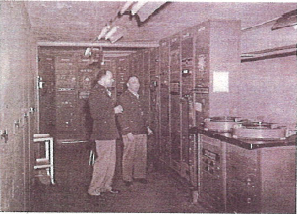
Sigsaly Terminal equipment. Note the two phonographic turntables at right which contained the secret codes.

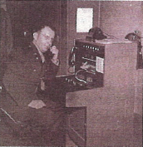

The Conference Room was connected by the above switchboard to the Terminal equipment.
Air Raid Shelters designed by BCC.
The Brisbane City Council adopted an innovative design for its public air raid shelters such that after the war, the brick walls around them could be removed leaving a cantilevered roof concrete structure ideal for bus shelters or general shade.
It is generally unknown by most Brisbane people that many of these air raid shelters are still partially standing and used as bus shelters or shade shelters in parks around Brisbane. Many people stand under them or drive past them not realising their original use during WWII.
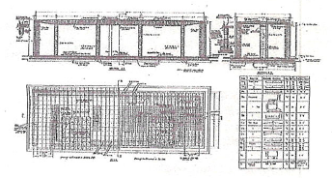
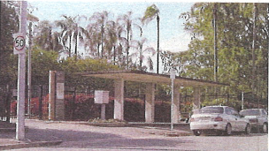
Air Raid Shelter at "Spring Hill Corner" entrance
to Albert Park on Wickham Terrace near the
intersection with Albert Street
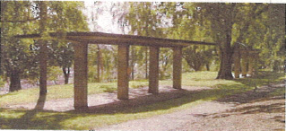
Two air raid shelters in Wickham Park on
Spring Hill beside Wickham Terrace
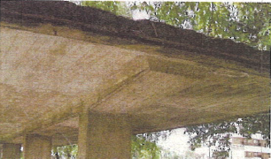
Close-up of the cantilevered roof.

PIVITOL LEADER
TODAY the guns are silent. A great tragedy has ended. A great victory has been won.
As I look back upon the long, tortuous trail from those grim days of Bataan and Corregidor, when an entire world lived in fear, when democracy was on the defensive everywhere, when modern civilisation trembled in the balance, I thank a merciful God that he has given us the faith, the courage and the power from which to mould victory.
We have known the bitterness of defeat and the exultation of triumph, and from both we have learned there can be no turning back.
Men since the beginning of time have sought peace... Military alliances, balances of power, leagues of nations, all in turn failed, leaving the only path to be by way of the crucible of war. We have had our last chance. If we do not now devise some greater and more equitable system, Armageddon will be at our door.
FROM MACARTHUR'S RADIO ADDRESS minutes after Japan signed the instrument of surrender on the USS Missouri on September 2, 1945
General Douglas MacArthur ruled the roost in the Pacific war, says David Homer
GENERAL Douglas MacArthur arrived in Australia like a messiah in March 1942, after his escape from The Philippines. "Mr prime minister, we two, you and I, will see this thing through together," he told John Curtin. "You take care of the rear, and I will handle the front."
This strange pairing of the anti-conscription Labor leader and the imperious, conservative 62-year-old general was forced by circumstances.
Singapore had fallen, Britain could no longer help, and Australia seemed open to invasion. The mere presence of MacArthur offered hope the United States would send reinforcements, and the Australian government agreed that he be appointed commander-in-chief of all Allied naval, land and air forces in the Australian area.
MacArthur also had a personal mission. His errors had contributed heavily to the defeat of his US-Filipino army by the Japanese and soon after his arrival in Australia he declared: "I shall return." Henceforth his campaign to recover The Philippines would be a personal crusade.
MacArthur's air commander, US General George Brett, described him as "a brilliant, temperamental egoist, a handsome man, who can be as charming as anyone who ever lived, or harshly indifferent to the needs and desires of those around him". And Australian General Thomas Blarney, commander of the Allied land forces, said the best and worst things you heard about MacArthur were true.
As US army chief of staff in the early 1930s MacArthur kept a Eurasian mistress, formerly a shanghai chorus girl, while his mother helped him with official entertainment. He married for a second time and arrived in Australia with his wife, young son and an amah.
In January 1942, in the midst of MacArthur's defensive campaign in The Philippines, the country's president Manuel Quezon secretly awarded him SUS500,000 as "recompense and reward" from the Filipino people.

MacArthur gained the confidence of the Australian government, which readily acceded to his demands for support. His press communiques became the only source of news about the war, and the Australian and US forces were deployed at his direction. His prestige and influence in the US meant large forces were despatched, and these had a considerable impact on Australian society.
In July 1942 MacArthur moved his headquarters from Melbourne to Brisbane for the coming offensive, but the Japanese beat him to the punch. Landing near Buna on the north coast of Papua, they struck inland over the mountains, heading for Port Moresby. Having failed to anticipate the attack, MacArthur and Blarney hurried Australian forces to Papua. The Japanese also landed at
MacArthur was a military showman who ensured he received maximum credit for his troops' exploits.
Milne Bay at the south-eastern tip of Papua, but two Australian brigades forced them to withdraw.
The Papuan campaign did not show MacArthur at his best. Fearing another defeat, he blamed the poorly supplied Australians when they were driven back along the Kokoda Trail, and he persuaded Curtin to send Blarney to take personal command.
MacArthur had no idea of the conditions. The Australians had fought well, but Blarney relieved the Australian commander and then, unable to resist MacArthur's demands for more speed, Blarney relieved several more senior officers.
For the fugal stages MacArthur moved to Port Moresby, urging his forces to capture Buna as quickly as possible. Dramatically, he ordered US General Robert Eichelberger to "take Buna or don't come back alive". He did neither-.
In contrast with Papua, the subsequent New Guinea campaigns of 1943 were a brilliant orchestration of Australian and American land and air forces. Australia still provided most of the land forces, which, under Blarney, seized Salamaua and Finschhafen in September October. The US and Australian air force destroyed a Japanese fleet in the Bismarck and crippled the Japanese air force.
By April 1944 the Americans had assumed the brunt of the fighting. Taking advantage of excellent signals intelligence, MacArthur's forces landed where the Japanese were weakest, and advanced rapidly along the north coast of New Guinea.
In truth, the well-known "island hopping campaign" had been suggested by the US joint chief of staff. It was, however, a brilliant display of military manoeuvre.
MacArthur promised Curtin the Australia would take part in the approaching Philippine campaign, but that never happened. He had already sidelined Blarney as Allied land commander and was unwilling to allow the Australians a big role in the recovery of US territory. In September he left Australia for the last time and was present for the US landing at Ley Gulf in The Philippines in October.
Nevertheless, MacArthur continued in command of the Australians, directing their operation in Borneo in May and June 1945. Blain opposed the final operation at Balikpapan in June but MacArthur demanded it go ahead, and it did. The war did not end one minute earlier as a result. Though he shunned the social limelight, Mac Arthur was a military showman who ensured he received maximum credit for his troops' exploits. His relationship with the Australians highlighter his skill at the political and strategic level. .In Blamey, MacArthur had a formidable opponent but with the support of Curtin and with US power he held the trump cards.
David Homer is professor of Australian defence history at Australian National University.

Code breakers and Cyber Aces

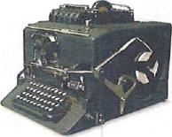

Australians excelled in the art of decoding the enemy's cryptic messages, says Chris Clark

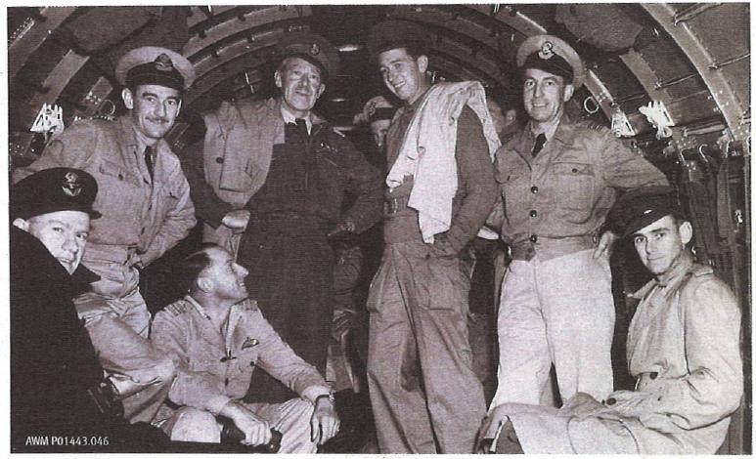
Knowledge is power: Alastair Sandford (third from right) with other Australian and US officers of the Central Bureau on their way to Manila with MacArthur; An IBM machine used to break codes (top).

What is clear from the record is that the special intelligence Central Bureau provided formed a vital ingredient in MacArthur's battle plan.
As the Japanese and Allied navies clashed in the Coral Sea, experts in Melbourne, more than 3000km south, were preparing to play a role crucial to the war's outcome.
Cranleigh, an ivy-clad mansion in Domain Rd, South Yarra, was the makeshift headquarters for General Douglas MacArthur’s "Y" intercept service, later to become the Central Bureau, a unit of US and Australian codebreakers who fed special intelligence to the Allied command from mid-April 1942.
Signals intelligence, or "sigint", became a potent weapon in the war against Japan. MacArthur's chief of intelligence, Major General Charles Willoughby, said it shaved perhaps two years off the war.
The Battle of the Coral Sea was the first important engagement in which the Allies were successful in analysing intercepted radio messages to anticipate Japanese movements, eliminating the element of surprise that had proved so deadly at Pearl Harbour.
The Allies were able to predict a major amphibious landing was being planned by the Japanese for early May 1942 using fast aircraft-carrier units.
The Allies had not fully broken the main Japanese naval code and could understand only 10 to 15 percent of each message. But they surmised the landing should be at Port Moresby or the north Queensland coast, with Port Moresby the most likely.
The US immediately sent two carriers to the Coral Sea area and assembled other forces, including Taskforce 44,1ed by Rear Admiral John Crace, containing the RAN cruisers Australia and Hobart.
A small radio team was placed on board the carrier Yorktown to listen to Japanese tactical frequencies, giving the Americans knowledge of when the enemy carriers were launching or recovering aircraft and when Japanese patrols were reporting possible sightings. They also gave strong clues about the location of enemy carriers.
MacArthur's intercept service began just weeks before the Battle of the Coral Sea. He envisaged combining US Army code and cipher specialists, who had come from The Philippines, with Australian army signallers and a handful of RAAF experts.
Though it was headed by Americans, Lieutenant Colonel Joe Sherr and Brigadier General Spencer Akin, the bureau's executive officer was an Oxford-educated Australian, Major Alastair "Mic" Sandford, who had served with the AIF in the Middle East.
MacArthur wanted, and got, more US personnel for his service. More importantly, he received IBM machines - the first generation of computers - that had already proved their worth in the US analysing volumes of intercepted messages.
Initially the work of intercepting enemy communications in the field was carried out almost exclusively by sections of the Australian Special Wireless Group and RAAF wireless units. Only later were many US squadrons brought into action. Within bureau headquarters, traffic analysis - an important element in sigint-was done mostly by Australians.
In July 1942 MacArthur transferred the headquarters to a large house in Ascot, 5km northeast of Brisbane. The Ascot fire station housed the banks of IBM Tabulators that were used to electronically "strip" the ciphers from enemy messages.
Japan's leading naval strategist, Admiral Isoroku Yamamoto, was a significant victim of signals intelligence. He was killed in an ambush by US warplanes after his travel itinerary was intercepted.
Intercept units in the field often shifted to follow Allied advances. In late 1944 a bureau echelon accompanied the US landings at Leyte in The Philippines, and established itself at Talosa, 50km from Tacloban. Another group went with Australian troops into Morotai in the Dutch East Indies.
In the months before Japan surrendered there were as many as 2000 bureau personnel - half of
them Australians - encamped with MacArthur's field headquarters at San Miguel, north of Manila.
During its three-year existence -the bureau broke many codes, although many of those were low-grade systems whose use was local and of short duration. But it had at least one success against a major code system. Further successes came from windfalls provided by other means, such as code-book material recovered by frontline troops.
What is clear from the records that the special intelligence Central Bureau provided formed a vital ingredient in MacArthur’s battle plan.
At a minimum it enabled MacArthur to adopt his famous “island hopping” strategy, making rapid advances by bypassing enemy garrisons that were redundant or irrelevant, not on the basis of inspired guesses but from highly reliable information derived from the Japanese themselves. .The Australian part in that achievement has not, so far, received the recognition that is its due.
Chris Clark has written widely on Australian defence history and is the RAAF's historian in Canberra.

General Douglas MacArthur and GHQ SWPA
General Douglas MacArthur escaped from the Philippines arriving at Batchelor airfield in the Northern Territory on 17 March 1942. After another short plane flight and a long train journey, he arrived in Melbourne on 21 March 1942 where he established his first Headquarters in 401 - 403 Collins Street.
While in Melbourne, General MacArthur received two visits from members of the "Institute of Engineering". Below are two entries from my copy of General MacArthur's office diary:-
Friday, 15 May 1942
Mr. Bassett and Mr. Walters of the Institute of Engineering called relative to honorary membership in the Institute at 1100.
Monday, 25 May 1942
Mr. Bassett and Sir David Rivett of the Institute of Engineering called at 1100.
Sir Walter Eric Bassett, a leading consulting engineer in Melbourne, was a foundation member of lEAust and became President of lEAust in 1942. During World War II, he was chairman of the Army Mechanisation Board and a member of the Commonwealth Advisory Committee for Aeronautics, while his firm undertook wartime engagements. (Reference —"Engineering in Australia, A Professional Ethos" by Brian E Lloyd AM DipEE DipBA MA(Hons) PhD)
Sir David Rivett was Chief Executive Officer and later Chairman of the Council for Scientific and Industrial Research.
General MacArthur departed Melbourne by train on 21 July 1942. After a short breakfast stopover at Admiralty House in Sydney he continued by train arriving in Brisbane on 23 July 1942 where he established his General Headquarters Southwest Pacific Area (GHQ SWPA) in the AMP building in Queen Street.
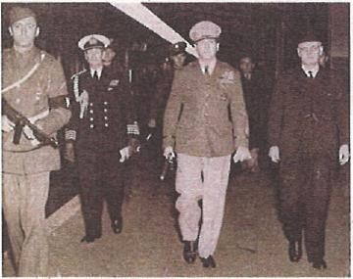
General MacArthur and Prime Minister John Curtin at Sydney Railway Station on 22 July 1942. MacArthur was on his way to his new Headquarters in Brisbane.
General Douglas MacArthur and his senior staff were located on the 8th floor of the AMP Building. Both these rooms have been restored as part of the MacArthur Museum Brisbane which now occupies the 8th Floor of MacArthur Chambers. General MacArthur maintained his GHQ SWPA in Brisbane until 9 September 1944.

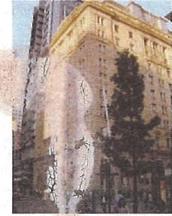
AMP Building - corner of Queen Street and Edward Street
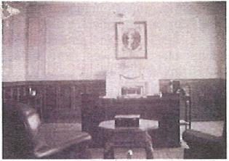
General MacArthur's office on 8th Floor, AMP building
IBM Tabulators used in Brisbane during WWII
General MacArthur established an Intelligence unit called Central Bureau which was responsible for the interception and cryptanalysing of Japanese intelligence. Central Bureau immediately followed MacArthur to Brisbane, establishing its headquarters in a huge house at 21 Henry Street, Ascot.
Central Bureau had banks of IBM Tabulators, which were used by the cryptanalysts to sort and strip away ciphers which concealed the original text.
The Americans had to overcome the issue of the differing voltage and frequency standards between Australia (240 volts, 50 Hertz) and USA (110 volts, 60 Hertz). Special transformers had to be built.
These IBM machines were set up in the garage at the rear of 21 Henry St. They were later relocated to the Hamilton Fire Station in Ascot Park next to Eagle Farm Racecourse.
IBM Tabulators were also used by the 61st Machine Records Unit (US Army) in a building in lower Edward Street. Records on the movements of troops were stored on IBM Punch Cards and then compiled into reports and sent back to the USA by the US Signal Corps.
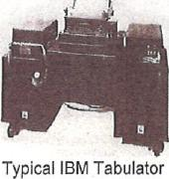
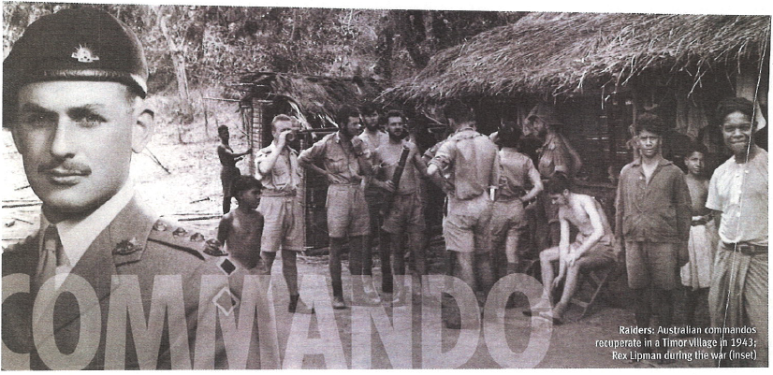
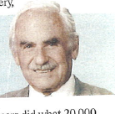
Prominent South Australian businessman, one-time dentist and now vigneron. Rex Lipman says his misadventures started before he saw action behind the lines
IT was the first Sunday in September 1939 when prime minister Robert Gordon Menzies addressed the nation: "Fellow Australians, it my melancholy duty to inform you that we at war."
This was the bugle call I had been expecting for months. On the following day at 9am I reported to the local barracks. I was hell-bent on joining all my friends who had enlisted in the AIF but, having qualified to be an officer, I was repeatedly reminded it was against the law for any officer to go overseas until he had turned 21. For me this seemed nothing less than catastrophe.
Fortunately, the government decided to form four Australian commando squadrons. It was thus that, as a 19-year-old lieutenant, I moved to a windswept training camp on Wilson's Promontory in southern Victoria with the rest of 2/4th Independent Company.
Our first operational task was to patrol a wide area the Northern Territory. It was tough work in rugged conditions and welded the unit into a cohesive force. I was in bed back in Adelaide nursing an infected foot when my unit was sent behind the Japanese lines in Timor to relieve the 2/2nd Independent Company. In the army hospital in Adelaide there was the best of everything, including a gorgeous VAD (hospital aide) whose charm, happy disposition and sense of humour knocked me off my feet.
Even so, in 1942 there were no anti-biotics, and osteomyelitis - a golden staph infection-was difficult to cure. I was one of the lucky was downgraded to B Class and sent (along with my medical papers) to a base unit in Victoria.
Unfortunately, my papers blew out of the window as we were going through a tunnel on the train journey from Adelaide. At Victoria Barracks I was paraded in front of the commander of special operations and, as he had received no reports on my unit's activities, I was shown into a small office, told to keep my mouth shut and write a detailed report.
When I presented my report to the colonel, he informed me that I was to take 60 reinforcements and re-join my unit in Timor. I was thrilled. They told me that, in case I could not make contact with my unit, I must learn to speak Malay.
Books were handed to me and I was ordered to get cracking as I had to leave within two weeks. I studied night and day and after 10 days, when an interpreter asked me several questions, he nodded his head — my answers demonstrated that I should be able to cope.
I left Victoria Barracks and, three weeks later, in the depth of night, we were rowed into Japanese-held Timor where, as Army headquarters was later surprised to learn, Tetun is the language spoken by all and Malay by nobody. The following day I reached the village from where our unit operated and reported to my CO, Major Mac Walker, who asked me: "Where are the rest of the 60 reinforcements you were meant to bring?" Most of them were untrained and unfit, which I'd told Major General Jackie Stevens in Darwin the day we arrived in the NT He'd told me it was up to me to test them and make a decision about their fitness for such a task.
I decided that on the afternoon before we were due to board the Dutch destroyer that was bringing us to Timor, we would do an overnight march to Darwin with all our gear, and that those who could not keep up would miss the boat. The two officers and 21 men who were there with me covered the 68 miles (110km) in 25 hours.
We stayed in Timor making nuisances of ourselves until malaria, dysentery, dengue fever and tropical ulcers did what 20,000 Japanese could not do - make the higher command decide we should come home.
From September 1939 until January 1946, I had lived with some of the finest Australians ever, and I had served under some brilliant and wise commanders who taught me nearly all I know
By accident Eve, the VAD I'd met in the hospital, and I both arrived back in Adelaide the same week We married in 1947 and 58 years of fun and laughter, five children, 15 grandchildren and 1½ great-grandchildren later, I tell myself daily what a lucky bastard I am.

