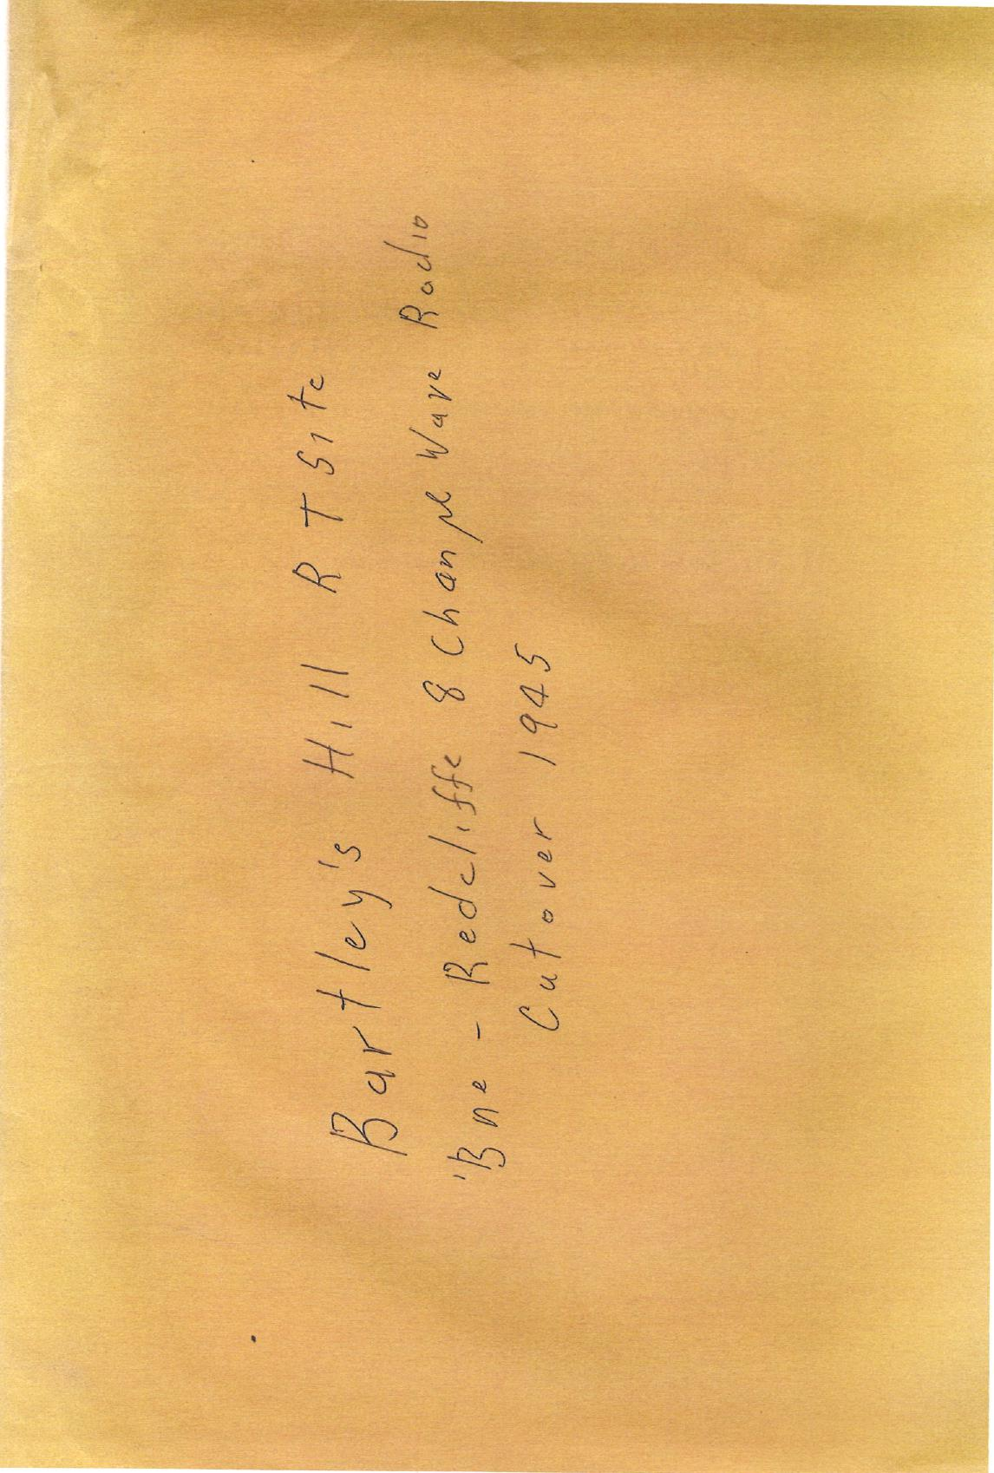
ITEM 9763.5 Bartleys Hill Radio BNE REDC

1.B.47/686. B078 552.
24th October 1949.
Dear Sir,
G.42058/47: Sites for Radio Telephone Stations.
Approval was vented by the council on the 7th January, 1948 for the use of portion of Bartley's Hill Water Reservoir Enclosure by the P.M.G.'s Department, for the establishment of a small building and aerial mast.
The actual location of the proposed installation was fixed by the Council’s Engineer for Maintenance, in conjunction with this Department's representatives. The site selected is on the Eastern side of the Reserve on disused concrete foundations.
The establishment of a multi-channel radio telephone system between Brisbane and Redcliffe is an urgent commitment, and the Council's approval to proceed with the erection of the necessary building and mast at the above location is requested. The installation would be of a temporary nature only, as action has been taken to acquire a block of land in the immediate vicinity of the proposed site which will be used for the permanent station.
The equipment which the Department intends to install will not cause inconvenience to other radio communication systems or broadcasting systems as the operating frequency is 4,750 megacycles.
The attached drawing indicates the building it is proposed to erect to house the equipment.
Early advice of the Council's decision will be appreciated, as it is desired to bring the system into operation early in the New Year.
Yours faithfully,
(I Tarbit)
For Deputy – Director,
Posts and Telegraphs
Again 5/12/49

The Town Clerk,
Brisbane City Council,
Box 1454.T., G.P.O., BRISBANE.
B/U PROPERTIES
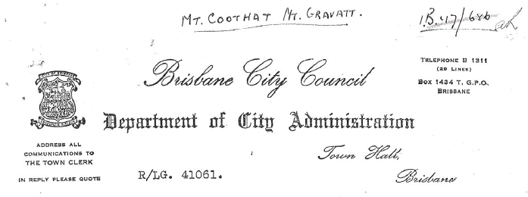

2nd. December, 1949.
The Deputy Director,
Posts and Telegraphs,
General Post Office,
BRISBANE.
Dear Sir,
Reference 1.B. 47/686.
Attention Mr. I. Tarbit.
Relative to your letter of the 24th. ultimo in connection with proposed temporary building on this Council's Water Reservoir Enclosure at Bartley's Hill. I have to advise that confirmation is given of approval granted on January 7th. 1948 for the erection of this building.
Approval is also given for type of building as shown on drawing E.S.I.(C) and location as shown on site plan Q49/209E.
The following conditions will apply to your Department's occupancy of the proposed site.
(a). The approval granted covers a temporary tenure of the site only pending erection of permanent station by your Department on its own property.
(b). The work carried out will be subject to the approval of Mr. K. Heenan, Maintenance Engineer, Water Supply.
(c). Your Department agrees to return the site to its present condition, upon removal of building and mast at completion of occupancy.
(d). Staff of your Department entering the property for any purpose will advise Resident Officer before doing so.

DEC 1949

Q.L. 2094 CC/BU
MEMORANDUM TO:
Surveyor & Property Officer
Radio Telephone Station Bartley/s Hill
On P.M.G. Departments request, we acquired Sub. 1 of Resub. 4 of Sub.3 of Portion 124. (22 perches) Parish of Toombul, from Mr. W.W. Groom, the purchase price was £905/5/0.
2. P.M.G. negotiated a lease from the B.C.C. of part of the Water Reserve at Bartley's Hill at a rental of £1.1.0. per annum., and on this land the radio mast and control room have been erected. These installations are on massive concrete foundations.
0. The block acquired from Groom is not in use.
1. Mr. Harlen recently did a contour survey of the block and repegged the corners, and during a talk with a P.M.G. Engineer he gained the impression that the block of land acquired from Groom was not as suitable as the leased area for the radio telephone site.
5. What are your instructions on this case, please.
(C. CARTER)
CARTER)
L.A.0.2
4.1.52

(Handwritten note)
[From
Refer this information to PMG. Will PMG declare the land for disposal.
Is the water reserve BCC land (no interest to roads Department) and have we arranged suitable lease protecting the assets.

8/1/52]
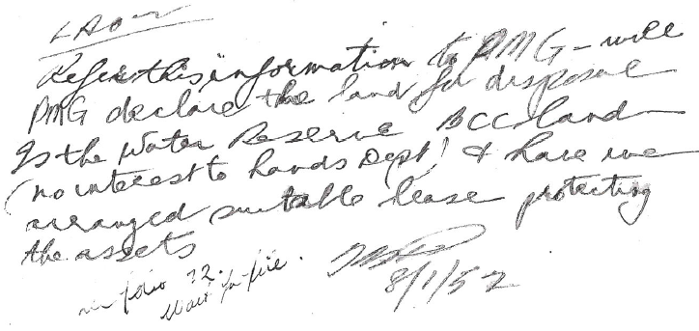
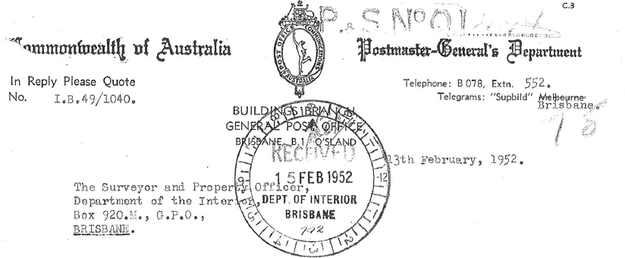
QL.2094:C.C: Bartleys' Hill - Radio Telephone Station Site.
I refer to your Memorandum of the 22nd January, regarding the above subject.
It is advised that the only improvements erected on the land at Bartleys' Hill leased from the Brisbane City Council by this Department consist of three telephone poles and a small, prefabricated building. The concrete foundations on which the building is erected, referred to by one of your surveyors, were constructed many years ago by the State Authorities for the purpose of establishing an observatory thereon. This proposal was subsequently abandoned.
It is not considered necessary that a formal Lease Agreement with the Brisbane City Council should be effected, but that occupancy of the site should rest on relevant correspondence. A copy of the Council's offer to lease the area to the Commonwealth for the sum of £1.1.0 per annum was forwarded to you on the 19th February, 1948.
Preliminary plans are in course of preparation for the permanent Radio Telephone Station building, which is to be erected on the recently acquired block located next to the leased area. Therefore, the disposal of this site cannot he considered.
(I TARBIT)
For Director
Posts and Telegraphs.
