


MT BELLENDEN KER CABLEWAY

REPORT ON INSTALLATION OF

NEW TRACK AND HAULING ROPES 1987

FOR

TELECOM AUSTRALIA

PREPARED BY
DEPARTMENT OF ADMINISTRATIVE SERVICES CONSTRUCTION GROUP, QUEENSLAND REGION AUGUST 1987



MT BELLENDEN KER CABLEWAY

REPORT ON INSTALLATION OF

NEW TRACK AND HAULING ROPES 1987

FOR

TELECOM AUSTRALIA

PREPARED BY
DEPARTMENT OF ADMINISTRATIVE SERVICES CONSTRUCTION GROUP QUEENSLAND REGION AUGUST 1987

TELECOM

MT. BELLENDEN KER CABLEWAY

INSTALLATION OF NEW TRACK AND HAULING ROPES - 1987

CONTENTS

INTRODUCTION
PART 1 HISTORY
1.1 Original Construction
1.2 1985 Track Rope Fault and Repair Operation
1.3 Need for New Track Rope

PART 2 MATERIALS AND EQUIPMENT
2.1 Track Rope and Haul Rope
2.2 Pulling Equipment
2.3 Letting Out Equipment
2.4 Other Equipment
- Coupling Cone
- Twist Stick
- Cutoff Machine
- Rope Stoppers
- Communication

PART 3 FIELD OPERATION
3.1 Preparatory Work
- Top Station
- Intermediate Towers
- Bottom Station
3.2 Personnel
3.3 Track Rope Hauling
3.4 Track Rope Anchorage and Socketing
3.5 Haul Rope Replacement

PART 4 CONCLUSION
INTRODUCTION

As with the 1985 emergency repair of the track rope following the discovery of a major fault, this 1987 replacement of track and hauling ropes was carried out by Telecom personnel.

Planning of the method of execution and procurement of materials and equipment, and the field direction and supervision of the operation was undertaken jointly by Telecom, Department of Housing and Construction, and a Technical Advisor experienced in Cableway design and operation.

This report details a technique believed to be unique in Australia for the pulling in of a large diameter track rope.

PART 1 - HISTORY.

  - Original Construction

The cableway was constructed for Telecom in 1971/72 to access a T. V. transmitter at the top of Mt. Bellenden Ker, servicing the Atherton Tableland to the west, and Cairns to Innisfail on the coast.

Additions since commissioning have been F.M. transmitters, Department of Aviation air to ground installation, as well as numerous mobile base stations for various organisations.

There are 9 ropeway towers, a Top and Bottom Station, and a parallel transmission line. (See Figure 1) Mt. Bellenden Ker is 1.5 km in height.

The track cable is 36 mm diameter of 19 x 7 non-rotating construction, approximately 5400 metres long. It is anchored around a bollard beyond the Top Station and is attached to a 20 tonne counterweight below the Bottom Station. The cable is free to slide over curved saddles on each tower. Allowing the cable to slide rather than being fixed to each tower minimises the lateral loads on the towers from track rope tensions.

The car hangs from a bogey which is pulled up and down by an endless 22 mm diameter haul rope through a drive mechanism in the Bottom Station Haul rope tension and length are controlled by an inclined railed counterweight beyond the Top Station.

At the time of construction, it was the longest single track cable ropeway in the world.

  - 1985 Track Rope Fault and Repair Operation

In 1985 Telecom purchased a non-destructive Magnetic Induction Testing Machine which hangs on two wheels from the track rope and is towed behind the car. It responds to changes in magnetic intensity of the track rope passing through the body of the machine, giving an output on paper tape. During a routine inspection in August 1985 a major discontinuity was observed 898 metres below the Top Station, or 347 metres below Tower 2.

Emergency repairs were effected in October/November 1985 by coupling an immediately available 942 metre length of 36 mm diameter 34 x 7 non-rotating wire rope to the bottom of the existing track rope and pulling out the fault at the Top Station. This operation was carried out by winching at both ends, without the aid of sophisticated equipment, and is fully documented in a separate Report, "Telecom Mt. Bellenden Ker Cableway, Repair Damaged Track Cable - 1985".

Since that time, the Cableway has been used on a restricted basis, between Tower 6 and The Top Station, because the car could not pass over the coupling which was in the Tower 6 Tower 7 span. (Figure 2 shows one half of the original coupling).

  - Need for New Track Rope

Apart from the obvious inconvenience of using this facility on such a restricted basis, the coupling in the Tower 6 - Tower 7 span could not confidently be guaranteed for longer than one and a half to two years, as it could not be periodically inspected.
After the discovery of the fault in 1985, investigation revealed that a new rope of the required construction, diameter, and length could not be produced in Australia. This would result in a longer lead time for delivery, and necessitated prompt ordering of the new track rope.

PART 2 - MATERIALS AND EQUIPMENT

2.1 Track Rope and Haul Rope

A replacement haul rope was on order at the time of the discovery of the track rope fault in 1985. Delivery was delayed, to coincide with projected delivery of the track rope.

Telecom's calling of tenders for supply and delivery of a new track rope resulted in a contract with the Australian firm of Bullivants Lifting Gear Division, who ordered and imported from Austria Draht Gesellschaft M.B.H., the Austrian firm which had absorbed the company that supplied the track rope for the original construction in 1971. A test report was provided, which included non-destructive magnetic induction testing, record of welded joints in the wires, and load versus elongation data. The rope was to be delivered lubricated with a compound suitable for tropical conditions and wound onto a steel reel designed for the specified 6 tonne tension.
Due to various delays, the track rope could not be delivered earlier than the end of 1986.

2.2 Pulling Equipment

The 1985 repair operation using the on-site winches achieved an overall average rate of movement of 0.876 metre per minute and took 6 days of actual winching. Since the new track rope is more than 6 times this length, faster means of hauling were sought.

Research produced preliminary details of a rope pulling machine that had been developed and successfully used on a similar sized project in Austria, pulling twin track ropes into a Top Station.

The basic configuration of the rope pulling machine, which was built by the Austrian company J. Koller was as follows:
Two sets of sliding wedge clamps are fitted to the machine. One of them serves as a holding clamp and is permanently attached to the frame in such a way that the rope can only run in the direction of hauling. Two self-locking wedge-shaped jaws in the clamp prevent the track rope from sliding backwards. The second identical clamp is the working clamp, which is moved in the same frame by two hydraulic plungers. With suitable control of these hydraulic plungers, the track rope can be drawn about a meter uphill in each working stroke of the moveable clamp. On the return stroke with the working clamp open the rope is arrested by the fixed clamp. The machine has a rope drawing speed of up to three meters a minute and develops a rope tension of the order of 16 to 17 tonnes.

A third wedge clamp was installed in front of the rope pulling machine during the rope drawing operation to offer additional safety. The machine is shown in the photographs.

The pulling tension was known to be 16 to 17 tonnes from the 1985 repair operation, having initially introduced additional sags into the spans by letting out an additional 40 to tit) metres of track rope. Therefore, further details were sought, which verified that this machine would be suitable. Steps were taken to hire this machine and have it transported to Queensland, at the same time obtaining details of the hydraulic drive. Rather than transport this component from Austria, it was decided to construct the drive in Brisbane. This was basically an electric motor driving a hydraulic pump with a valve arrangement to allow reversal of the flow to the hydraulic plungers. Flow reversal, and therefore stroke reversal was automatically controlled by limit switches on the frame of the pulling machine. The plungers had a bore diameter of 100 mm for the working stroke and a rod diameter of 70 mm for the return stroke.

A pressure gauge was incorporated, which had a calibrated gauge marked in tonnes force at the head of the plungers, which closely approximated the line pull on the track rope. Also, a counter was mounted to record the number of working strokes, which was used to establish the distance pulled in at any time throughout the operation.

2.3 Letting Out Equipment

Telecom entered into a contract with Bullivants to supply drum stands and associated hydraulic winching equipment to let out the new track rope, and to let out the new haul rope while taking in the old haul rope. The drive points on the track rope drum to be supplied from Austria were specified to be compatible with Bullivants drive equipment. Bullivants own operators were to be in attendance.
This equipment, which can be seen in the photographs, consisted of chain drives from hydraulic motors to the drum reel. The hydraulic motors were connected to a hydraulic pump, which was driven by a petrol motor. Hydraulic brakes were added to the hydraulic motors, to act on the "deadman principle", that is, they were spring activated and held off by hydraulic pressure, so that in the event of any type of hydraulic failure, the brakes were immediately and automatically applied. They could also be applied manually for normal operation.

Agreed operational requirements for the track rope let out equipment included holding a 6-tonne track rope back tension at a rotation speed to achieve a let out of up to 3 metres per minute. This back tension was known from the 1985 repair operation.

2.4 Other Equipment

- Coupling Cone
Two couplings would be required to pass the towers; these being the one in the Tower 6 - Tower 7 span, and the one at the bottom counterweight tower onto which the uphill end of the new track rope was to be coupled.

To allow the track rope to pass over the towers, it was proposed to use the same nylon rollers bolted to the saddle that were used in 1985. For each coupling, a split cone was machined, to bolt onto the track rope immediately on the uphill of the coupling. This was to allow smooth entry of the coupling onto the rollers, thus removing the necessity to stop hauling as each coupling reached a tower and lift it across the tower. Figure 2 shows the form of the cone.

- Twist Stick

A twist stick (which should more accurately be called an anti-twist stick) is required to be clamped to the uphill end of the track and haul ropes during hauling. The stick, (which is actually a steel pipe welded to the clamp), has lead weights attached to provide a torque moment preventing twisting and subsequent unwinding of the rope.

To pass the towers using a conventional straight twist stick and flat-plate clamp (as used in 1985) it is necessary to stop at each tower when the twist stick arrives downhill of the saddle, attach a second twist stick uphill of the saddle, then remove the downhill twist stick before recommencing.

To eliminate this time interruption and the necessity to have 2 or 3 men on each tower to pass the twist sticks, a new twist stick was developed and manufactured. A split clamp shaped similar to the coupling and cone of Figure 2 was used. The stick was bent in a gooseneck shape to allow it to pass to the side of the saddle beam, but still have the weight directly below the rope.

Figure 3 diagrammatically shows the track rope twist stick arrangement as it passes over a tower saddle. The haul rope twist stick was of similar geometry to allow it to pass the haul rope sheaves.

It was foreseen that at times during the track rope operation, the haul rope could be lower than the bottom of the twist stick, with the likelihood of the haul rope returning closer to the track rope on the incorrect side of the twist stick. Figure 3 shows this problem, which would result in crossed ropes at the next tower, and would be difficult to rectify. Therefore, a haul rope deflector was welded to the twist stick as shown, to force the haul rope to return on the correct side of the twist stick.

(c) Cutoff Machine

Since the old track rope would be continuously pushed out the back of the pulling machine, the problem of disposal gave rise to the development of a travelling cutter. This was a commercially available high speed disc cutoff machine operated by an electric motor. A travelling bogey was fabricated based on railway wheels and track used on the local sugar cane hauling network. As it was planned to cut the old track rope into 4 metre lengths, more than 2,500 bindings of the rope would be required (one each side of the cut to prevent the strands springing as they were cut and damaging the cutting disc). Metal strapping tensioned, locked and cutoff by an air operated device was adopted.

Salvage and disposal of the old track rope was considered, but 100 m (500 kg) was the maximum length possible for transport by local helicopter, and 400 m (2, 000 kg) the maximum length by cable. Transporting by cable posed handling problems at the top, and problems of clearance under the car for transport downhill. Therefore, salvage was not considered feasible.

- Rope Stoppers

The previous method of holding the rope was by friction clamp plates held by high tensile bolts, tightened to a specified torque. As this was heavy and time consuming, lighter and quicker clamping equipment was investigated. To this end, three sets -of Carpenter's Rope Stoppers were imported from the United Kingdom. The body of the stopper closes loosely around the rope and is held closed by a knock-on/knock-off lock. Within the body is a sliding wedge which, when knocked in against the rope, continues to slide with the rope and wedge it against the body, which is shackled to an anchorage. The wedge must match the lay and construction of the rope, so a sample piece of the actual rope is used as a mould for casting the wedge.

- Communication

The same communication equipment from 1985 was again used. This was a dedicated link between the top and bottom winch operators, plus hand held radio sets for all other communication.

PART 3 - FIELD OPERATION

3.1 Preparatory Work

- Top Station
Some of the smaller ancillary equipment (sheaves, slings, shackles, etc) required at the Top Station was taken up in advance by using the cable car in a double handling type of operation. Since the car could not descend lower than the coupling in the Tower 6 Tower 7 span, a work buggy was used to transport equipment from the bottom to the socket. This buggy (shown in one of the photos) ran on the track rope and was clamped to the haul rope. As it travelled uphill to the socket, the unattended car, being in its normal state of attachment to the haul rope, would travel uphill from Tower 6 by a corresponding distance. On reaching the socket, equipment would he winched clown to the ground, and the buggy returned to the Bottom Station. This travel would return the car back down to Tower 6, where it could be boarded by someone who had walked up from the bottom. The buggy would be unclamped from the haul rope, the car brought down to the socket, and the equipment previously lowered to the ground from the buggy would be winched up to the car. Then the car could travel through to the Top Station.

It was proposed to transfer the larger equipment to the top by helicopter. This included the pulling machine (dismantled into lighter components), the power pack, and the cutoff machine. However, weather conditions made it impossible to fly into the top, so these components were flown to the helipad near Tower 6, manhandled on a steel skid downhill to Tower 6, then winched up to the car for transport to the top.

- Intermediate Towers

The installation rollers, track rope lifting gear, and miscellaneous items of equipment required at the towers were generally positioned as the car passed on one of its journeys uphill.

The fabricated support frames of the installation rollers were bolted to the saddle beam at the locations shown in Figure 3. The number of rollers at each tower depended on the saddle length and the weight of track rope they were required to support.

- -
Each tower is equipped with a lifting cathead approximately 2 metres above the saddle. The saddle is not continuous, to allow a lifting beam to be secured around the track rope at these discontinuities. By attaching lifting gear between the lifting beam and the cathead, the track rope can be lifted clear of the saddle. The lifting gear requires reduction sheaves at the towers with adjacent long spans of track rope to be lifted. A brass saddle liner is screwed to the saddle with countersunk brass screws. This sacrificial liner requires periodic replacement as it wears due to the sliding uphill and downhill of the track rope due to car travel and temperature movements.

The same procedure as this maintenance operation was now followed to lift the track rope off the saddle, with additional lifting gear then being used to pull the track rope sideways to a position directly above the installation rollers. When lowered out the installation rollers the track rope at the particular tower was ready for the hauling operation.

- Bottom Station

The track rope and haul rope were setup on their stands in front of the Bottom Station, on the rope centreline. The two stands were tightly slung together to provide stability during let out, and the drums oriented so that let out was from the bottom of the drum to reduce the tendency to overturn.

The track rope was passed through the building, around the deflection sheave at the base of the counterweight tower and coupled onto the end of the old track rope which had previously been disconnected from the counterweight.

3,2 Personnel
The following personnel were located as indicated :
Top Station: O.I.C. (Overall control)
1 winch operator ) interchangeable
2 riggers )
3 general hands (one used as a Tower 2 observer).
1 cook
Towers 3 and 4:
1 observer
Tower 5:
1 observer
Bottom Station:
1 Co-ordinator
1 rigger
1 general hand
1 socket follower (to clear twist stick from fouling trees).

2 Builivants Operators.

In addition:
1 Technical Advisor
1 Site Engineer.

3.3 Track Rope Hauling

The Top Station winch rope was reeved to give 8 falls and clamped to the track rope to take the tension off the back span of rope down to the anchorage bollard. The track rope was then cut at the location of the pulling machine and secured into its jaws.

On the first day, 56 metres was pulled to ensure familiarization with the equipment, allow the Top and Bottom winch operators to establish a pattern of communication, and establish a desirable working speed. This became established at 2.2 to 2.3 metres per minute, with the pace being set at the Top by the pulling machine, and the Bottom winch operator adjusting his speed to follow.

The pulling machine averaged 860 mm per stroke (after slippage losses at both ends of the stroke), so a pattern of timing the strokes become established as a speed control. Also, the operator knew his line tension at any time by simply looking at the calibrated pressure gauge. Generally, the Top Station pulled at an average of 17 tonnes.

The Bottom Station Operator had a pressure gauge on his drive, but this could not be readily calibrated as the load changed as subsequent layers were let off the drum. A tension measuring clamp (shown in one of the photos) was used to check tensions at the bottom. With familiarization, a continuous approximation of the tension evolved, namely the "calibrated tree". Since sag is inversely proportional to tension, the operator was able to gauge the approximate tension by the position of the track rope relative to two branches on a tree uphill of his station. Generally, let out tension was five and a half to 6 tonnes.

After the initial settling-in day, the complete track rope was pulled in during 6 working days (on 2 days, over 1 kilometer was pulled). Distances moved were recorded by the stroke counter on the pulling machine at the Top Station, and by allowing the track rope to pass over the haul rope deflection sheave in the Bottom Station, which has an operational electronic distance recorder attached.

The detailed summary of each day's hauling is given in Table 1.

TABLE 1

DAILY TRACK ROPE MOVEMENTS

(All distances in metres)

 | Bottom Station Letout |  | Top Station Haul-in
Date | Daily | Total | Daily | Total
Preliminary | 51 | 51 | 4 | 4
20/5/87 | 50 | 101 | 56 | 60
21/5/87 | 694 | 795 | 682 | 742
22/5/87 | 1050 | 1845 | 1063 | 1805
23/5/87 | 707 | 2552 | 722 | 2527
24/5/87 | 1066 | 3618 | 1066. | 3593
25/5/87 | 946 | 4564 | 953 | 4546
26/5/87 | 725 | 5289 | 953 | 5274
27/5/87 | ---- |  | 124 | 5398

The preliminary Bottom Station let out was to introduce initial sag into the system.

On the 27th, the hauling was at the Top Station only, to the bollard plus 3 lock turns, plus three and a half spare turns for future rope let outs to move the wearing sections downhill of the tower saddles.

Another control was a chart of socket positions, which is shown to reduced scale on Figure 4. This was used to estimate the next event of a coupling passing over a tower, to enable personnel to be positioned at the appropriate time. Initially speed of travel was slowed as a socket passed a tower, but this was shown to be unnecessary. As the cone leading the socket contacted the first roller, the resistance would arrest the travel until track rope tension rose slightly and pulled the socket onto and over the roller. Often this buildup of momentum would cause the socket to pass over subsequent rollers on the tower without further interruption.

A lubricating cylinder was fixed around the track rope in front of the Bottom Station, and the track rope was pressure lubricated as it passed through. However, due to higher than expected consumption and problems with the seals, the lubricant supply was exhausted when only half of the track rope had passed through. The lower half will now require later lubrication from the travelling car, since immediate supply of the lubricant could not be obtained.

As described in Section 2.4 (c), the old track rope was cutoff in 4 metre lengths and stacked in an adjacent depression beside the helipad. When the second or uphill socket arrived at the Top Station, the track rope was clamped, the socket cut out, and the rope secured into the jaws again in a similar manner to the initial startup. This was then the beginning of the new section of 34 x 7 track rope installed in 1985.

Rather than cut this relatively new rope, the extra effort was expended to lay it out in one length on the level area beyond the Top Station, as shown in the photos. Future use, if any, of this rope is unknown at this time.
When the first or bottom socket arrived at the pulling machine, (which was the arrival of the new rope) a further 130 metres approximately was required to reach the bollard plus the turns around it. Rather than pass the new track rope through the pulling machine and risk the possibility of damage from the worn jaws, a 70 metre length of old track rope was introduced into the pulling machine, and the other end clamped to the new track rope at Tower 1, which is 70 metres away. Thus, this old length of track rope pulled in the new rope, a procedure which had to be repeated a second time to achieve the required length.

To give a visual and recorded assessment of the new track rope condition, the nondestructive tester was installed onto the rope inside the Bottom Station. However, problems with the tester, mainly due to its overheating and giving a very light or unreadable paper trace, eliminated a significant length from the record.

3.4 Track Rope Anchorage and Socketing

Having locked the track rope around the Top Station bollard,
the Bottom Station winch was used to pull back the excess slack rope out of the system. When a dynamometer on the winch rope indicated a track rope tension of 20 tonnes, the track rope was cut, socketed and attached to the counterweight. A
counterweight movement of approximately a half metre indicated reasonable accuracy of the tension assessment. However, it is expected that the counterweight will drop as the track rope stretches with time and usage, and re-socketing will be required.

At this time, lifting of the track rope onto the saddles and removal of the installation rollers commenced. This was carried out by reversing the procedure described in Section 3.1 (b).

3.5 Haul Rope Replacement

With the track rope anchored at the top and back on the saddles on Towers 6, 7 and 8, the car was brought down to the Bottom Station to prepare for the haul rope replacement operation. At the top, the haul rope counterweight was slung from the tower to prevent its downhill travel.

The car was disconnected from the bogey, and the haul rope disconnected from both the haul and return sides of the bogey, and the sockets cutoff.

The new haul rope was to travel up the car side of the towers, through the Top Station, down the return side of the towers, and through the Bottom Station. It was to be hauled in over its normal operational sheaves by pulling in the old haul rope. The new haul rope was attached to the old haul rope by a half long splice, and the other end of the old haul rope attached to the now-empty track rope drum which was to act as the wind-on drum.

A twist stick as described in Section 2.4 (b) was attached to the new haul rope at the splice. The Cableway's hydraulic drive inside the Bottom Station was disconnected to allow it to free wheel as the haul rope was pulled in. Since the drives for both haul-in and let out drums were located together at the bottom, communication was not a problem. Haul-in and let out commenced, with an estimated haul-in tension of two and a half to 3 tonnes. It soon became apparent that the haul-in hydraulic drive could not sustain this load, so the Cableway's hydraulic drive was re-connected to assist. This actually provided most of the haul in force, with the drive on the drum doing little more than wind on the rope and provide a tension for the friction drive to operate.

An operating speed of 15 to 16 metres per minute was established, but it took 3 working days to pull in the 11,000 metres because of several holdups due to minor mechanical breakdowns.

The speed of operation, plus monitoring of the distance moved by the installations electronic distance recorder, gave estimates of the location of the twist stick at any time. At the Top Station, the twist stick had to be removed as it arrived at the building, and replaced downhill of the building on the return side. Friction on the counterweight's deflection sheaves prevented excess rotation during this operation.

When the new haul rope had been completely pulled in down the return side, the cutting and socketing back to the bogey was carried out after pulling in the haul rope to move the counterweight close to the top of its travel.

Substantial stretch is expected in the new haul. rope, and it is anticipated that cutting and resocketing will be required after some initial operation.

PART 4 - CONCLUSION

- Advice from the Koller Company was that one set of jaws for the pulling machine should be sufficient for the job.
However, it now appears this advice was based on their use of smoother locked coil ropes and not this rougher construction non-rotating rope. As the jaws started to wear during the operation, they tended to seat further down in the rollers, transferring the gripping surface to one end rather than uniformly along the jaw. This gave less grip, with the tendency to slip. Figure 5 shows this situation diagrammatically, which was rectified by welding steel flats to the back of the jaws to restore the critical dimension.

- The Carpenter's Rope Stoppers were rated at a safe working load of 17 tonne, and proof tested in Brisbane to 34 tonnes. However, one of them in service at the Top Station slipped and allowed the track rope to move almost half a metre. Why this slippage occurred could never be determined, but it is felt that their capacity could be de--rated when used on these ordinary lay rather than Lang's lay ropes. Also, with the rope under tension, the lay length increased and did not fit perfectly into the stopper's wedge, which had been moulded on a sample of relaxed rope.

- The installation rollers again operated successfully, with only one requiring replacement.

- There was some pitting and surface corrosion evident on the new track rope. Whether this affects its service life will not be known for many years.

- As described in Section 3.3, the lower half of the track rope will require lubrication from the moving car.

- When the non destructive tester is again functioning reliably, it should be run over the whole length of track rope to ascertain its condition.

- The number of personnel proved to be correct. The operation was delayed in commencing due to some failures of minor plant, and the unexpected bad weather delaying the positioning of equipment. (Helicopter usage to the Top Station was much less than planned).
However, once commenced, the operation was completed close to the planned schedules.

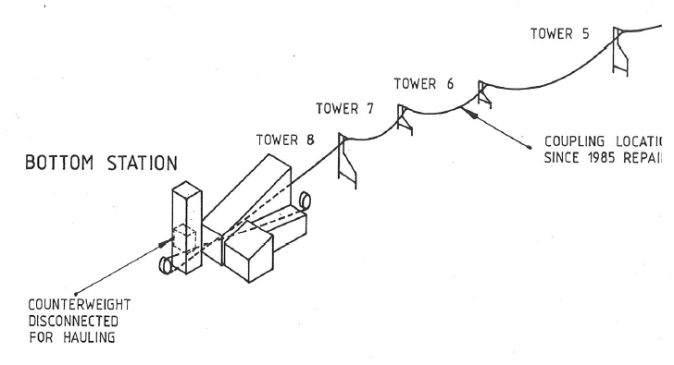

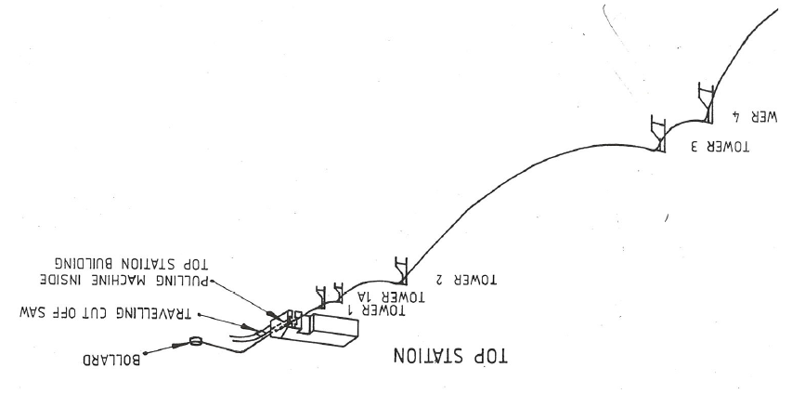

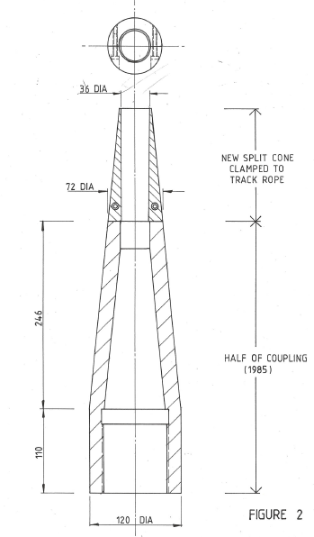
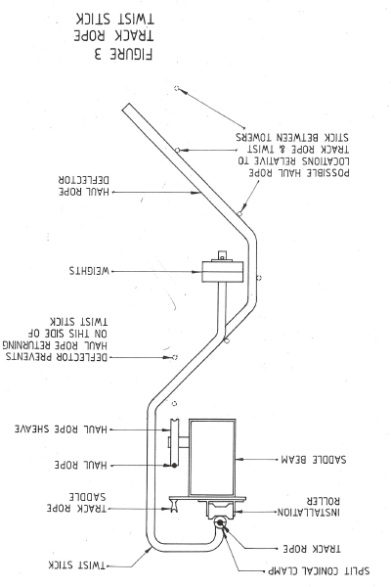

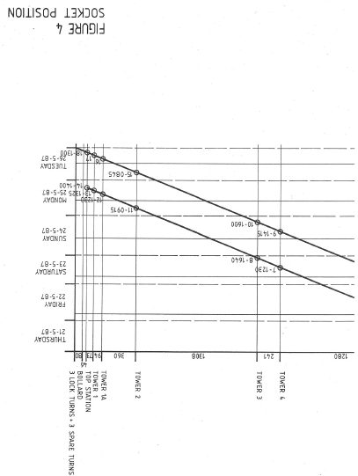
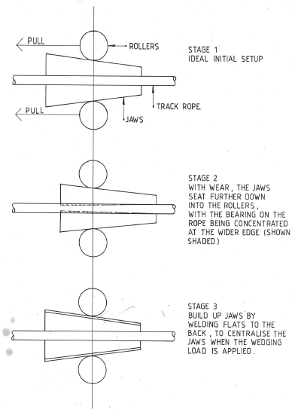

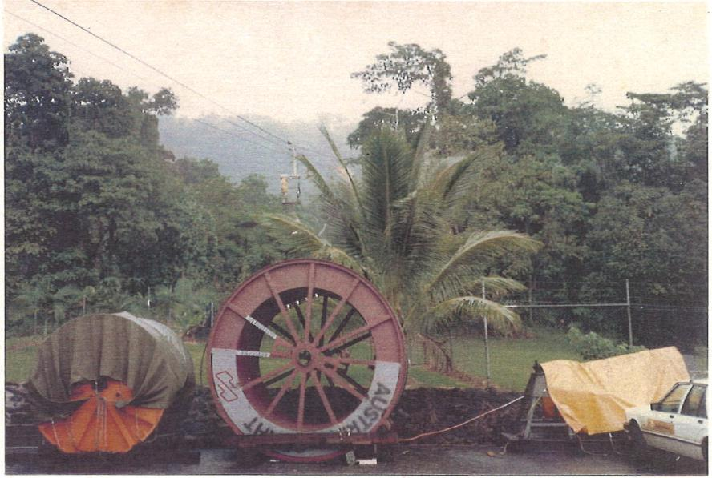
Work Buggy travelling from Bottom Station to the socket.
Haul Rope (left) and Track Rope (right) in foreground.

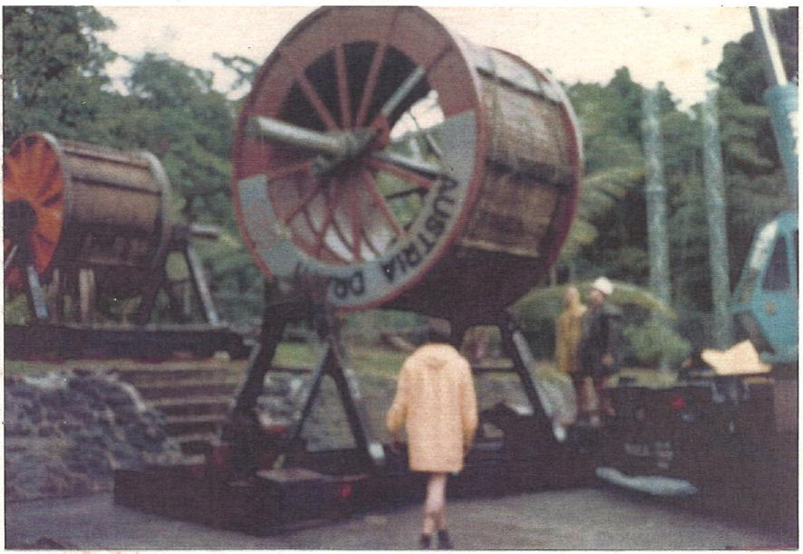
Mounting the Track Rope on As stand.
Haul Rope already mounted, uphill of the Track Rope. (Weather is typical of most of the operation).

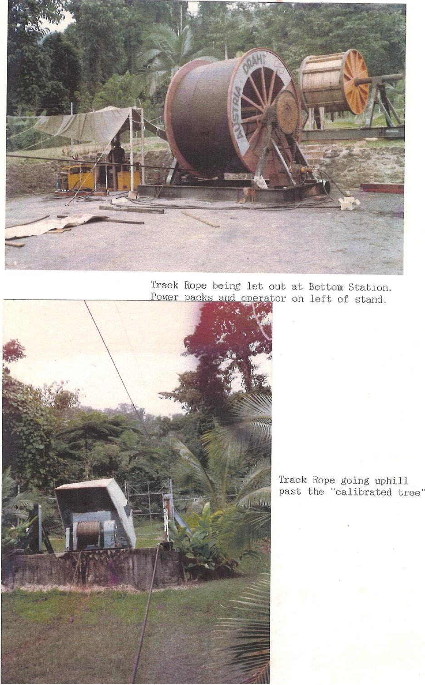
Track Rope being let out at Bottom Station.
Power packs and operator on left of stand.
Track Rope going uphill past the "calibrated tree"
Z.045,0
At
'tom
4.4 1
, .
ikial,- ₋•.ternialhaeavmr,0
_....,,.....^{/r MW} ..„Aiga^{llftm}g..........
AO,
......-- - .....
-----.

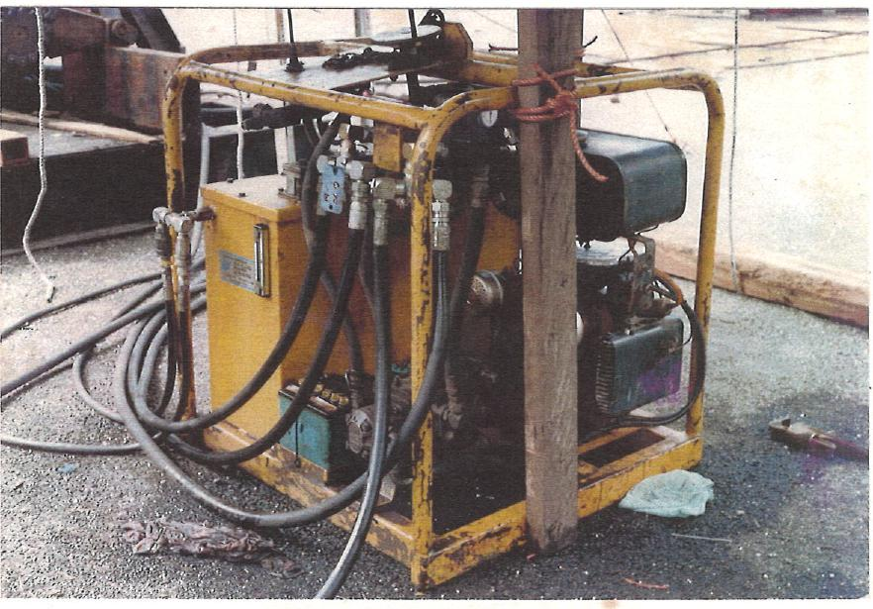
Close up of Power Pack Driving Track Rope Drum

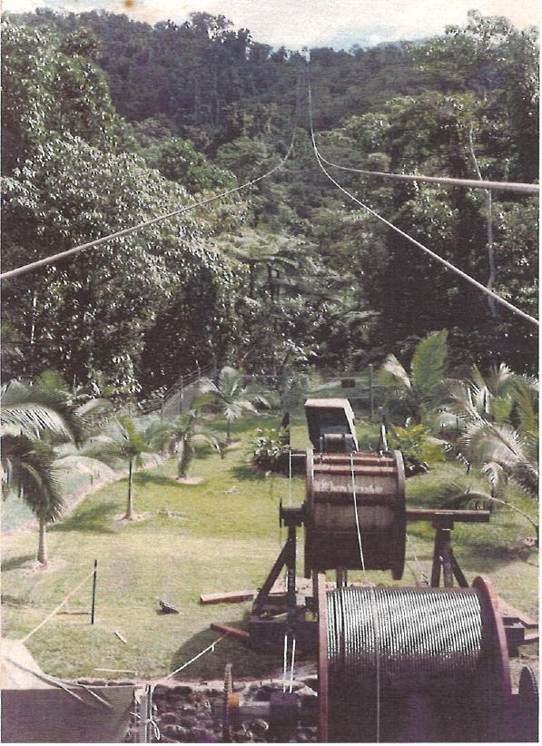 | Looking uphill towards Tower 8 from Bottom Station

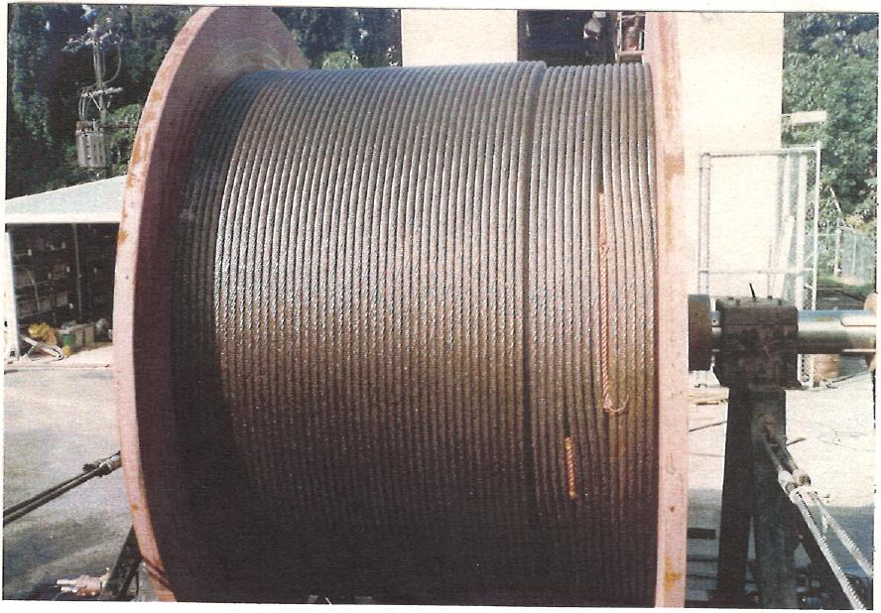
Packing gaps on one of the layers of the track. rope.

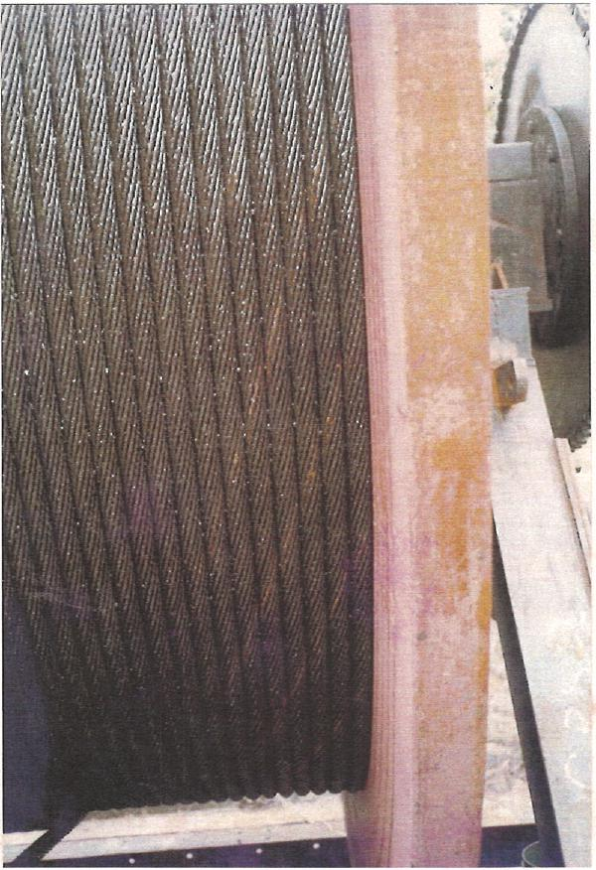 | One of the Track Rope strands showing inadequate lubrication and the beginning of surface corrosion.

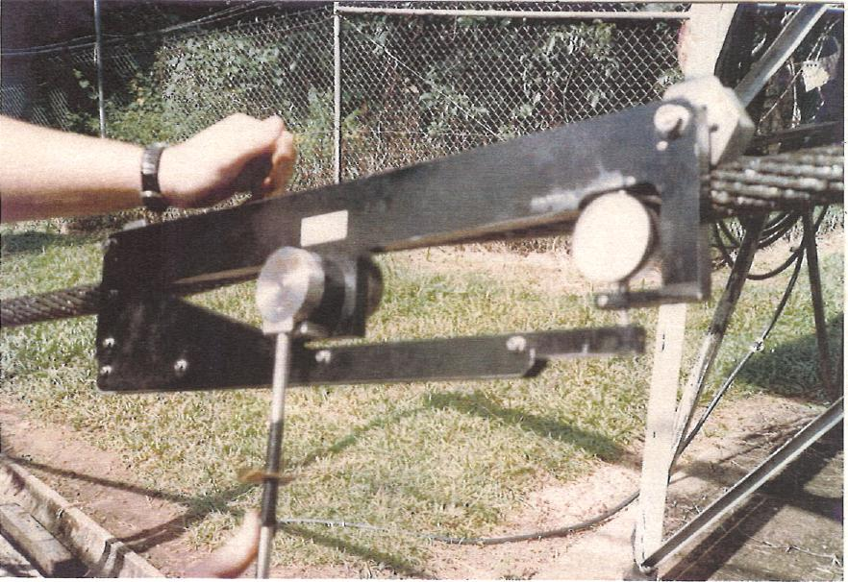
Checking tension in the Track Rope at the Bottom Station.
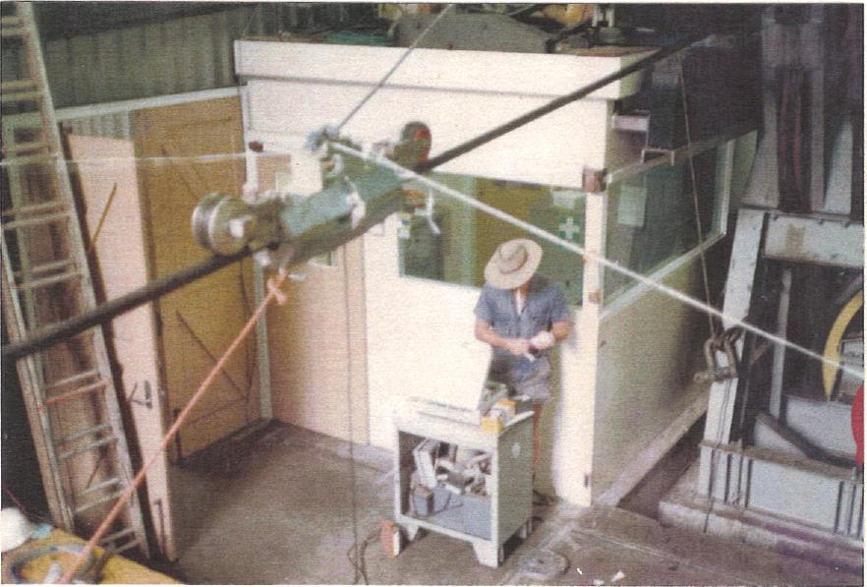
The Magnetic induction Tester inside the Bottom Station.
The Operator is observing the movement of the paper trace.

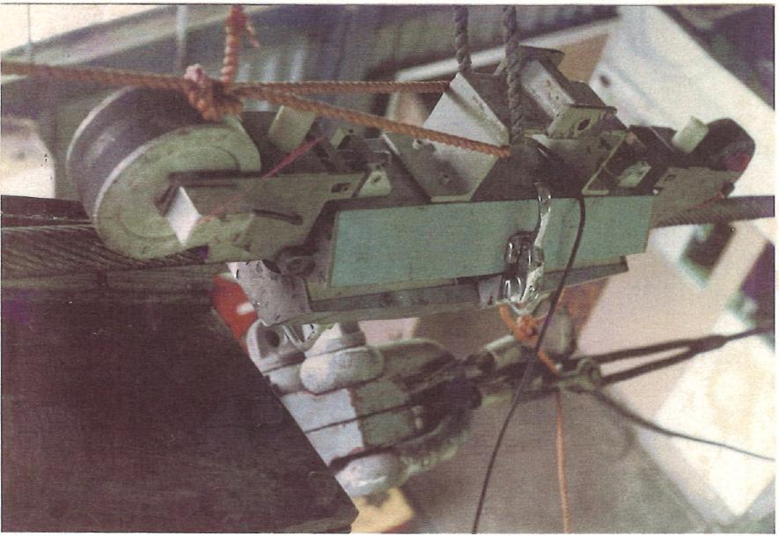
Close-up of Magnetic Induction Tester mounted on Track Rope.
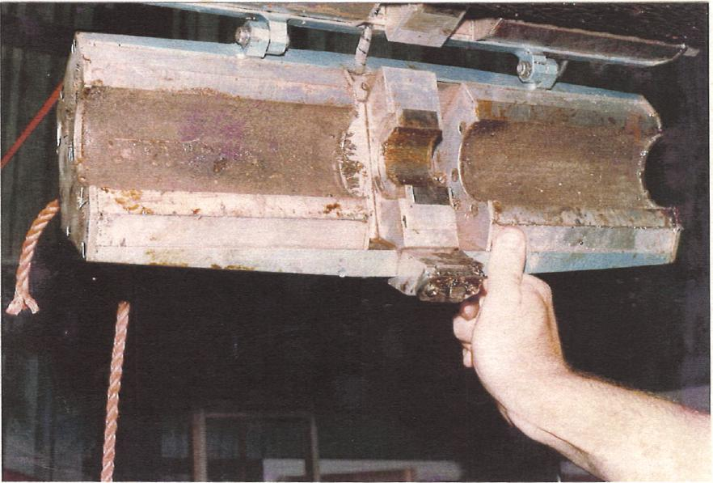
Body of Magnetic Induction Tester in open. position.

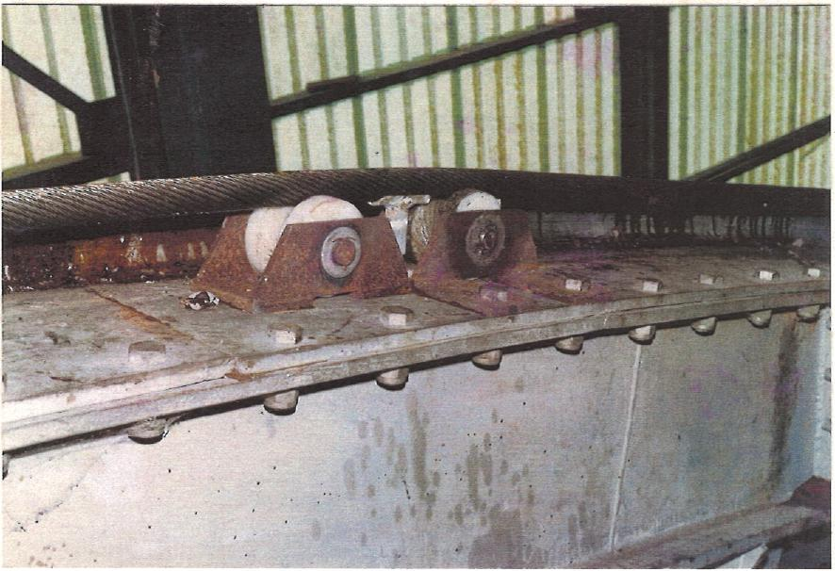
Temporary Installation Rollers on the saddle beam inside the Bottom Station.
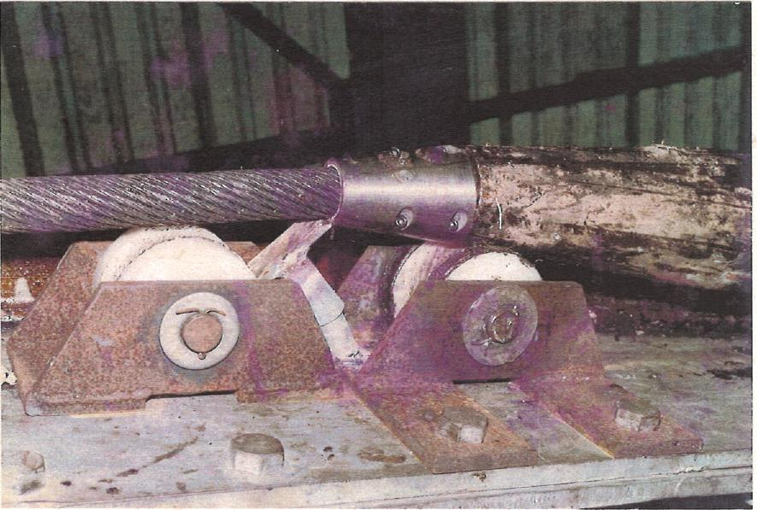
Split cone (as shown in Figure 2) passing over a roller. (It has just broken off the earthing clip - travelling left to right.)

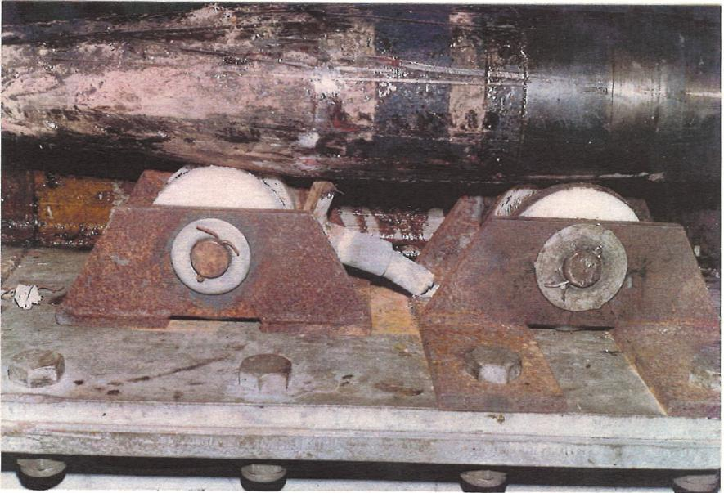
Body of the Coupling passing over the Rollers.

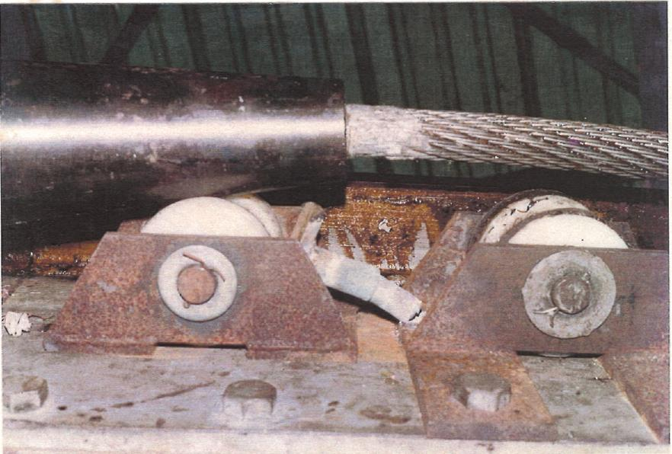
Coupling leaving the Rollers (travelling left to right)

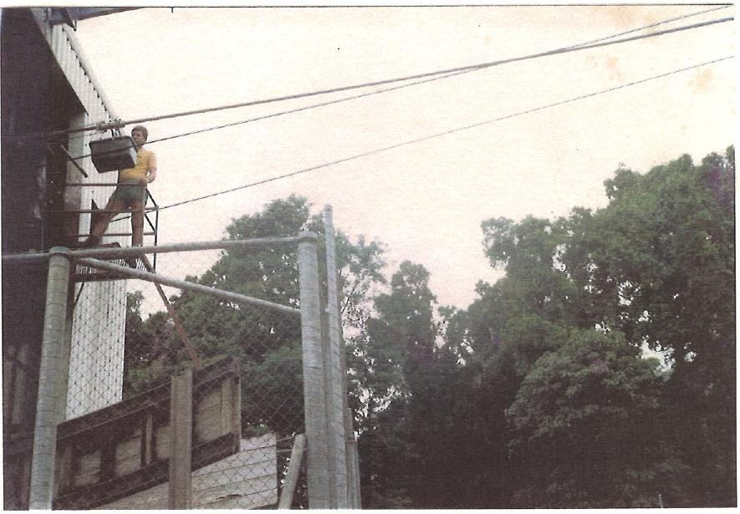
Checking the Track Rope lubricating collar.

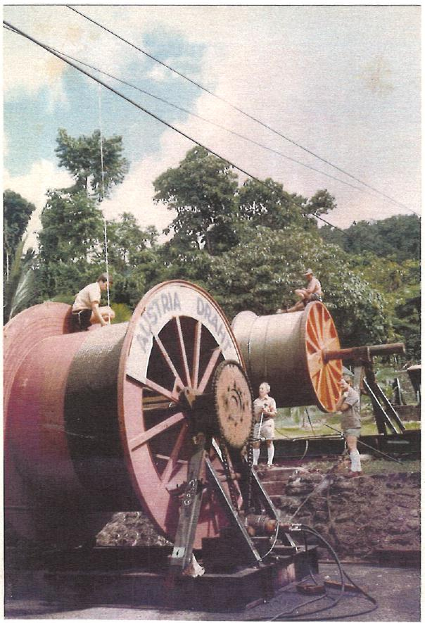 | Measuring clearance for the return of the oar over the empty Track Rope Drum.  Chain drive, hydraulic motor and brake are seen on the right hand side of the drum.

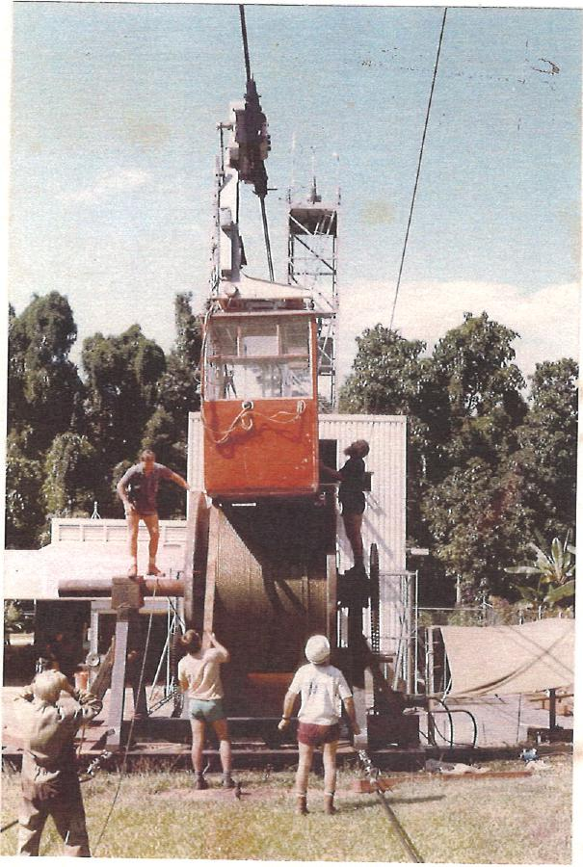 | Car returning to Bottom Station over Track Rope drum.

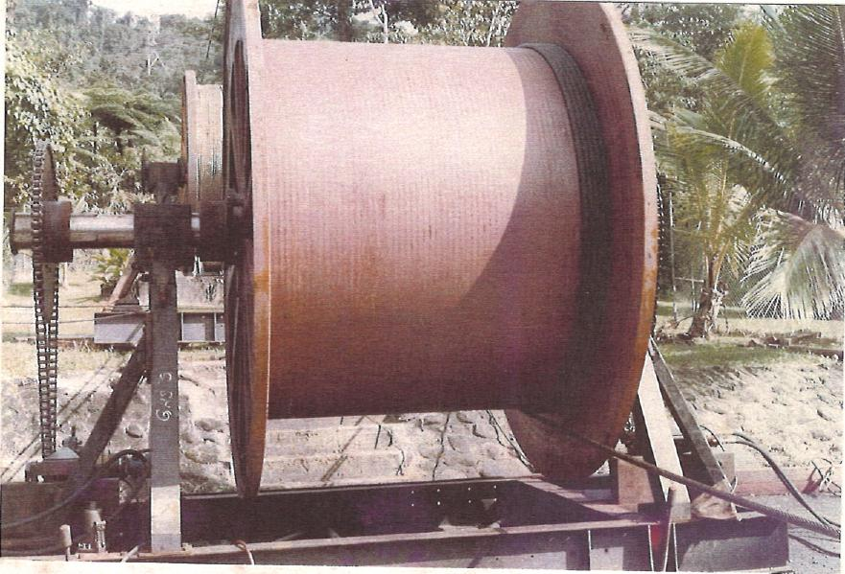
5 turns remaining on Track Rope Drum after locking off at Top Bollard.

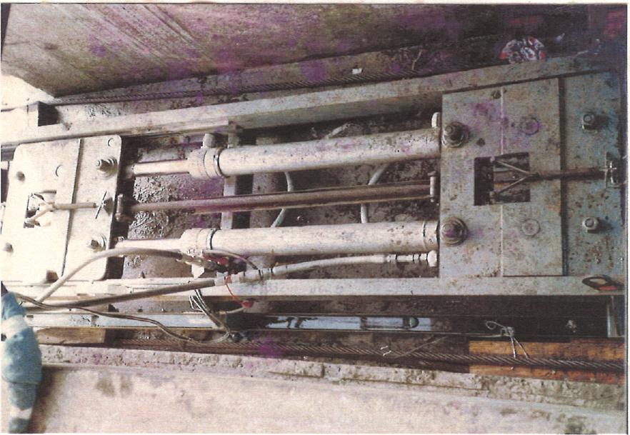
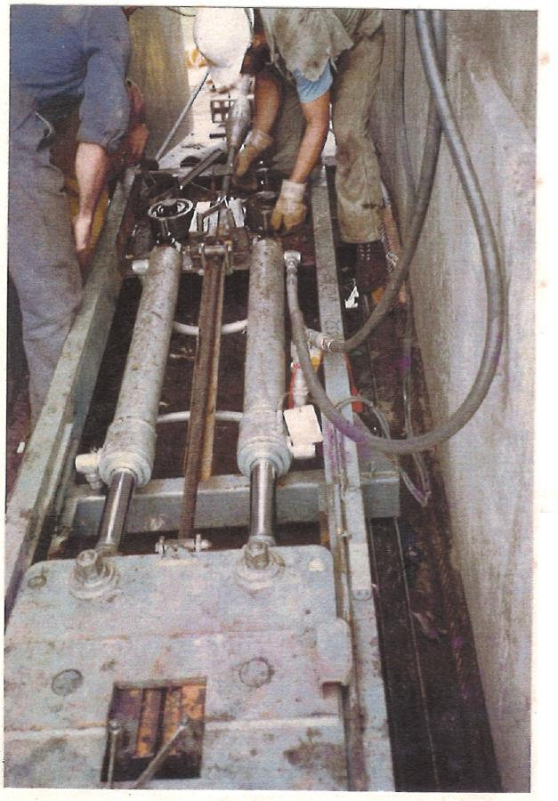
Top: Pulling machine operating inside the Top Station.

Left: Pulling machine being partly dismantled to restart after cutting out a socket.
(Note: The socket
directly below the safety
helmet in the photo.
The gloved hand is on one of the rollers which apply the force to the wedges.
Bottom of photo shows the moving clamp).

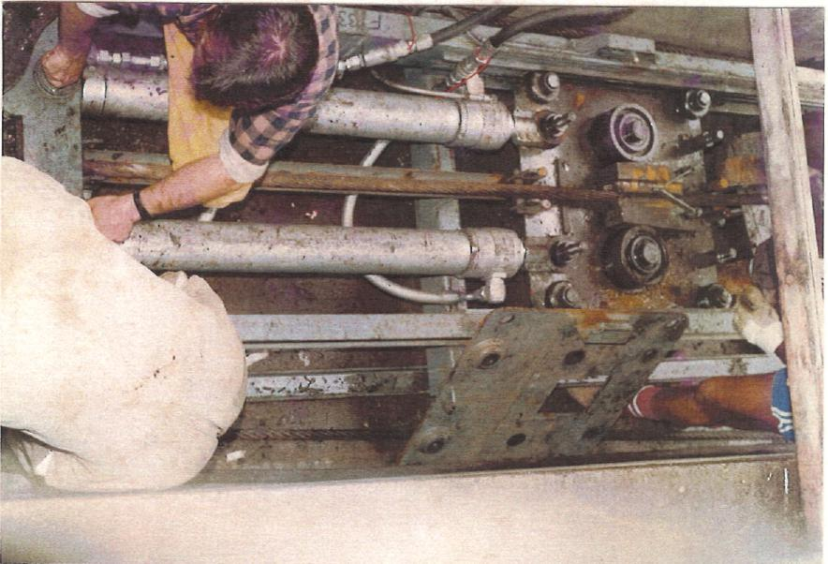
Re-assembly of Pulling machine.

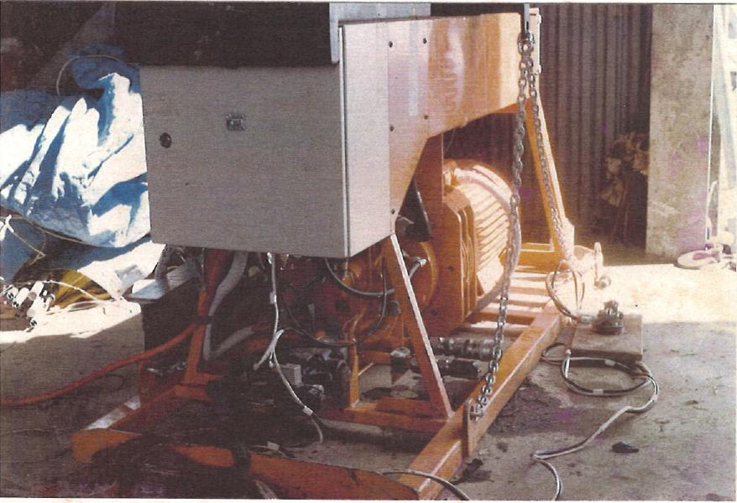
The Pulling machine's Power Pack.

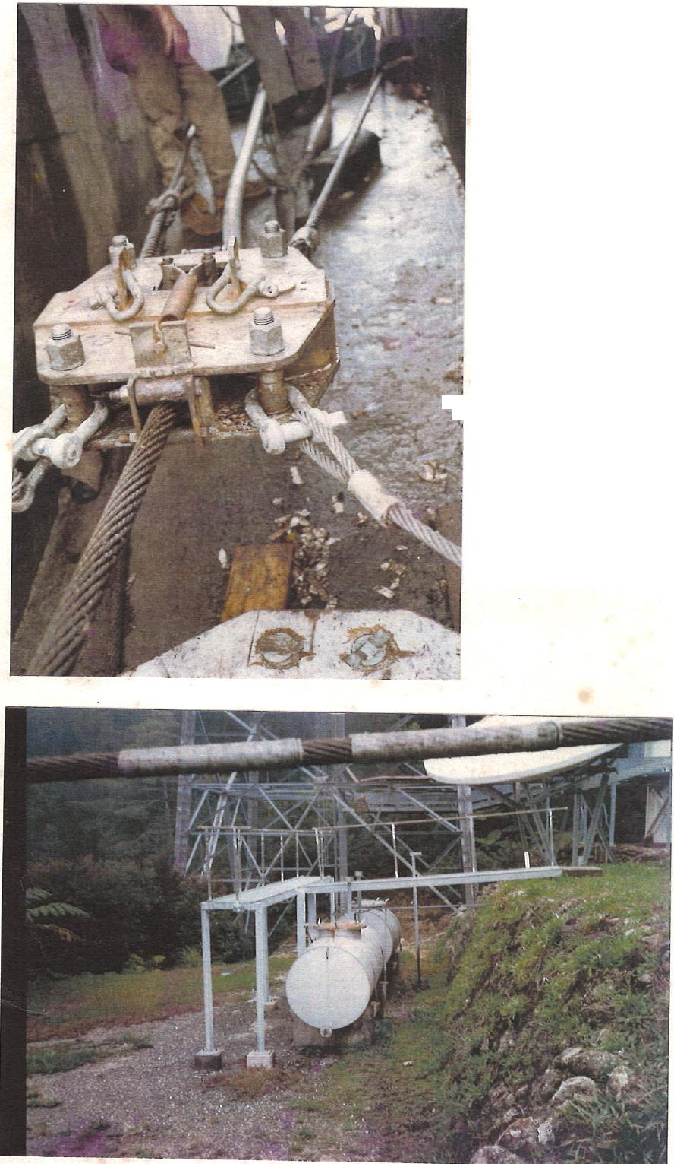
Wire sizing on new Track Rope arriving at the Top Station.

The additional
wedge clamp in front of the pulling machine. (Note the socket on the floor beyond the clamp, and the pulling machine in the background).

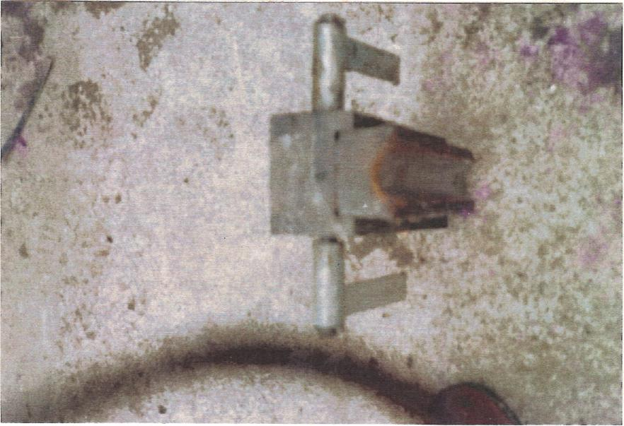

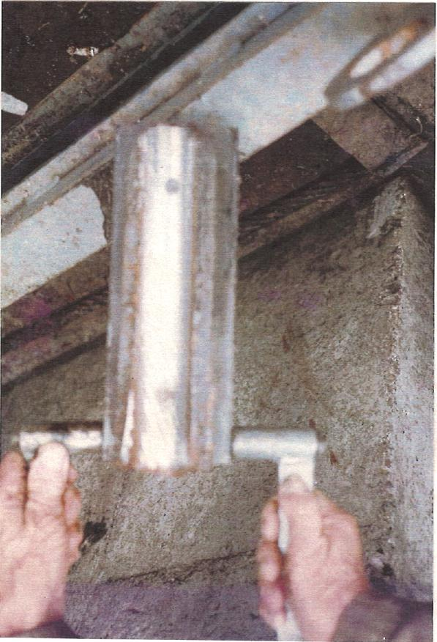 | One of the wedge clamps from the pulling machine (Top photo shows the end of the reinforcing flat welded to it).

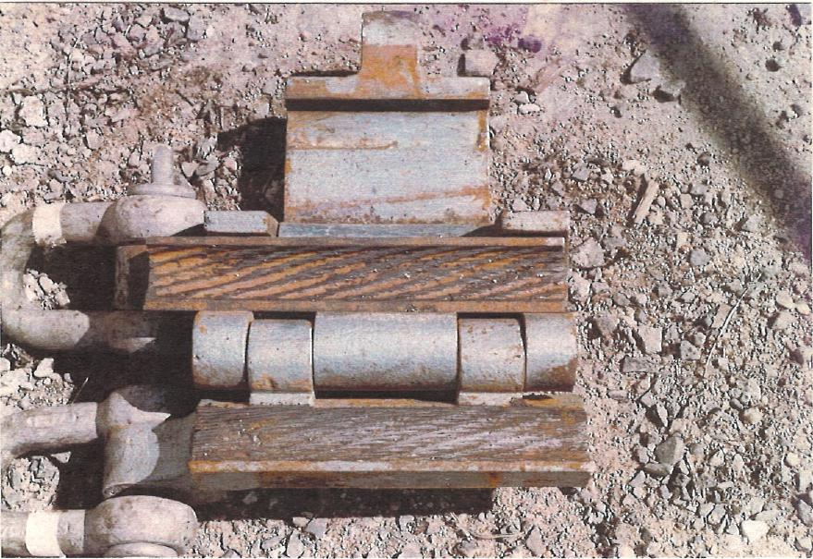
Opened Carpenter's Rope. Stopper.
The sliding wedge is laying in the upper halt of the
body.
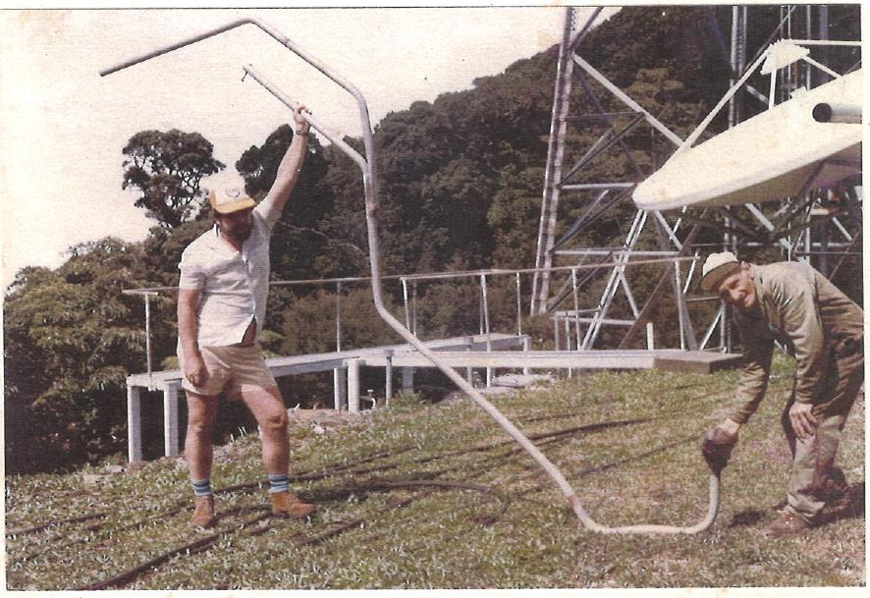
Track Rope Twist Stick alter removal at the Top Station

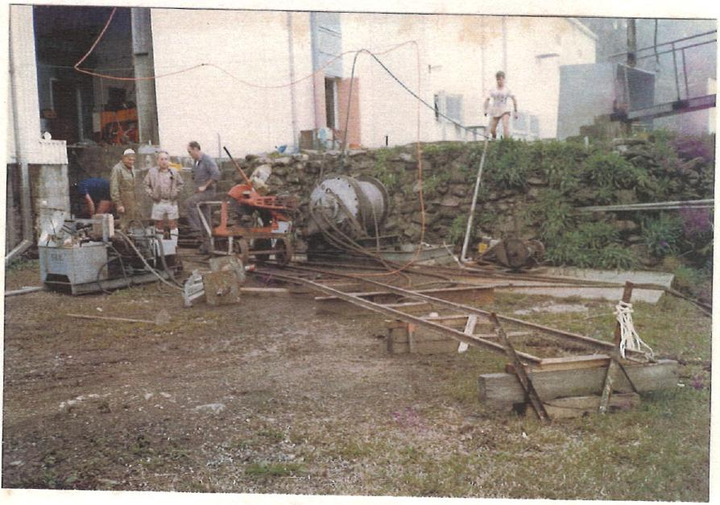
Operating the cutoff machine.

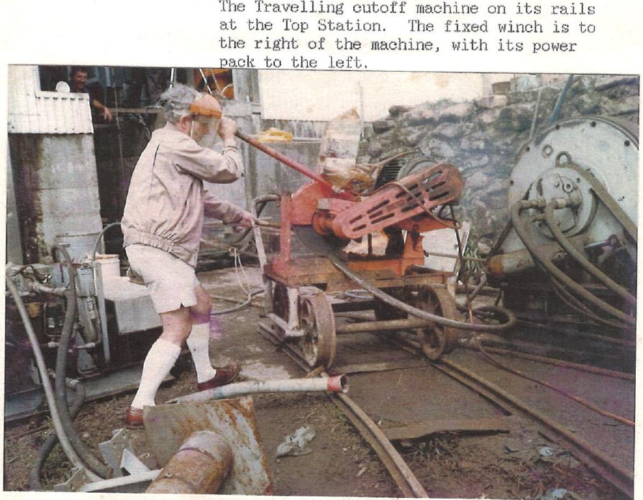
The Travelling cutoff machine on its rails at the Top Station. The fixed winch is to the right of the machine, with its power
Jack to the left.

The 4 metre lengths of the old Track Rope. (The background is cloud, not bad exposure).

• | 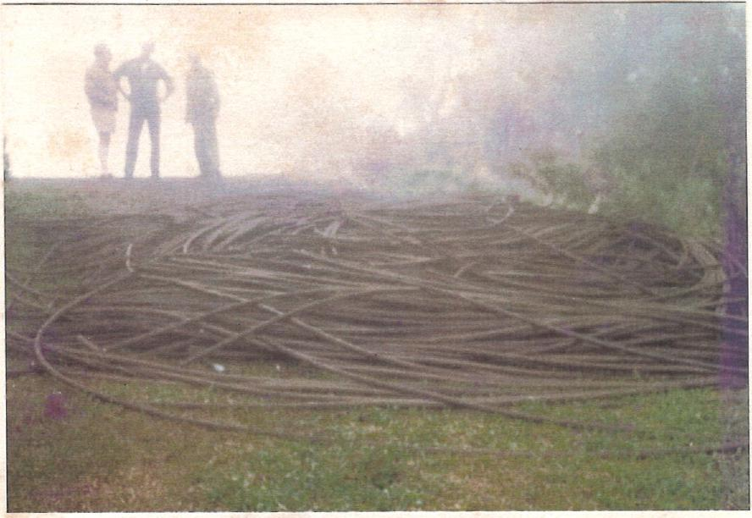

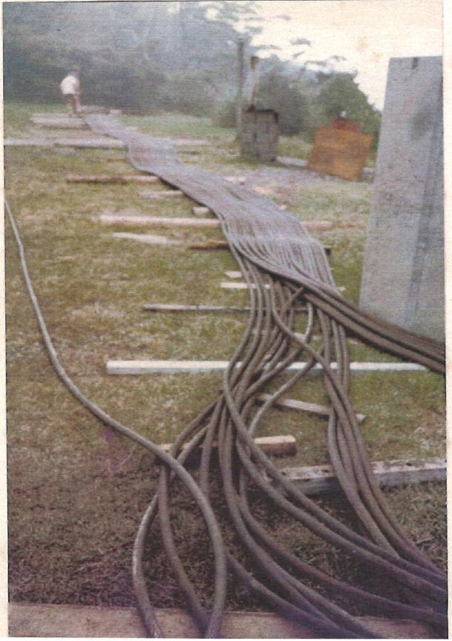 | The laid out length of the 34 x 7 section of Track Rope introduced into the system in the 1985 repair.



