Original Document
Provided by The Thomas A. Edison Papers at Rutgers University
[CA042F], Instructions, Edison General Electric Co, February 26th, 1890
Thomas Edison Papers Digital Edition (rutgers.edu)

THE EDISON SYSTEM
UNDERGROUND ELECTRIC TUBES.
The description of Electric Underground Tubes and Fittings, which is given in the following pages, it hoped will be of aid to our customers in becoming familiar with many of the system's details, and so be of use in ordering material.
An Electric Tube consists of one or more conductors contained in and insulated from an iron pipe. In the Three Wire System which we propose to describe, three copper rods are placed in each pipe. The system is a sectional one, and each tube is Complete when it leaves the factory as is a rail from a rolling mill. Like a rail it needs only to be joined to other similar units to become part of a continuous line.
Unlike a conduit system, electric tubes may make as many bends as circumstances call for, while a conduit must run in a practically straight line from man-hole to man-hole.
In the three-wire system of distribution the conductors whether overhead or underground, are divided into two classes. Feeders which run from the dynamos to centres of distribution constitute the first-class Mains radiate from centres of distribution and loop the ends of the feeders together, constituting the second class. All taps to supply customers with electric current are taken from the mains. Electric tubes are accordingly divided into feeders and mains. A main electric tube or more briefly a main has three insulated copper conductors of equal size.
A feeder electric tube or feeder has two principal conductors and one smaller conductor to serve as a neutral wire. A feeder also has three insulated cables of seven No 19 B.W.G., wires each. These

small cables from independent circuits from the station to the point of distribution and enable us to read in the station the electrical pressure at the outside end of the feeder. Hence these lines are called pressure wires. The size of any tube is the number of thousand circular mils in its positive or negative conductor. Thus, a rod one half inch in diameter has 250,000 circular mils area, and a tube having three such rods would be a 250 main.
Four sizes of pipe are used in our standard tubes, and the range of sizes is given below. All pipe diameters are nominal inside diameters.

80,000 circular mils to 120,000 circular mils in 1 ½ inch pipe
150,000 circular mils to 300,000 circular mils in 2 inch pipe
350,000 circular mils to 600,000 circular mils in 2 ½ inch pipe
700,000 circular mils to 1,000,000 circular mils in 3 inch pipe

The copper rods are all 20 feet 4 inches long, and project from each end of the pipe. All 1 ½” and 2” pipes are cut 20 feet long, allowing: projection of copper: 2 ½” pipes are cut to 19’ 9” long giving 3 12” projection of rod.
The rods are drawn to exact gauge of the finest and purest lake copper and have a conductivity in excess of 98 percent. The pipes are the best grade of lap welded steam pipe free from imperfection an of full weight.
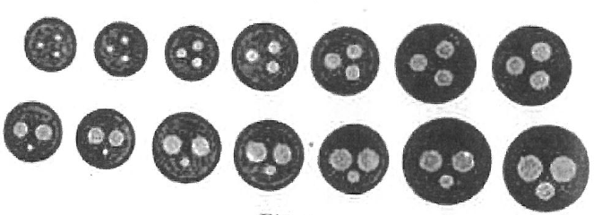
Fig 1.
Fig 1 shows sections of our standard sizes of mains and feeders. Two additional small mains, No 67 and No 41 are made of 1 ½” pipe for service work only.
In making up a tube the ends of the copper rods are firs chamfered and tinned. The pipe is thoroughly cleaned inside. Each rod is wound separately with a prepared rope, and 3 rods so wound are made into a triangular bundle and wound with a fourth rope. This bundle of rods bound with rope is slid into the pipe, which is afterwards filled with insulating compound. A special process insures an entire absence of air bubbles. The ends of the pipe are closed with rubber
plugs. The tube is now tested by means of a Thomson reflecting galvanometer. The tube after testing is painted to preserve the iron from rust and is ready for shipment. In order to compete the system, we require a means of joining the ends of the conductors in consecutive tubes, and of protecting and insulating such a joint when made.
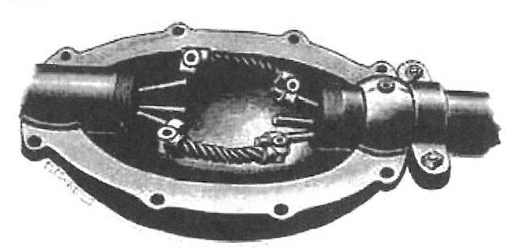
Fig 2.
Fig. 2 Shows a joint between two twin tubes partially completed.
The side on neutral, joint is in position ready to solder. The top coupling joint is being slid into place, while the bottom coppers are untouched.
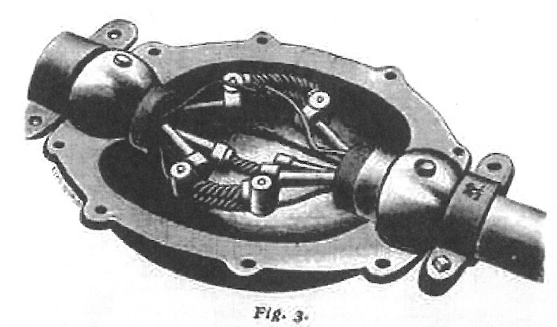
in Fig. 3 is shown a feeder joint partially completed. In feeder tube joints, after the copper rods forming the main conductors are joined, the pressure wires, referred to in the definition of a feeder,
are connected by soldering a wrapped splice, and then taping of the splice with insulating tape. The coupling joint which connects the rods is made of pieces of flexible cable with sockets cast on each end.
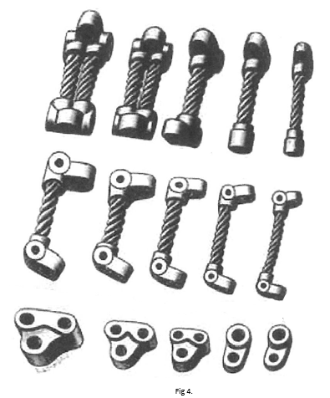
Fig 4.
These sockets are drilled to fit easily over the rods which the joint is to connect. Fig 4 shows a number of sizes of coupling joints in different views. Shorter and longer joints are made for use in turning corners, and a re called elbow joints. Various combinations of elbow joints for different angles are given on page 10. A branch or service joint is for use where a tap is taken from a main line to supply a customer. They differ from other joints in having a socket on one end only, and a round pin-like projection or teat at the other end of the piece of cable. This teat fits into the holes noticed in the sides of the sockets of the coupling joints. Fig 4.
Fig. 5 shows the branch joints and link used on all service connections up to and including 120,000 circular mils area.
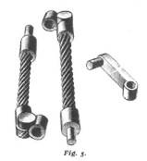
Having provided the joints for straight lines, bends, and branches we come to their protection and insulation. For protecting straight work, an iron box made in 2 halves and called a coupling box is used.
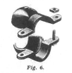
In Fig. 6 is shown a ball clamp which is bolted around the tube as in Figs. 2 and 3. These clamps are split collars, and grip the tube firmly. The sockets at each end of the coupling box forms with the ball of the clamp a ball and socket joint. Ball clamps are made in three styles for use with 3”, 2 ½” and 2” coupling boxes. The 2 ½” style is made in 3 sizes for use with 2 ½ “ , 2” or 1 ½” pipe. The 2” style is made in 2 sizes for 2” and for 1 ½” pipe. A clamp for use on a pipe whose inside diameter is less than that of the largest tube used in
the coupling box is called a reducing clamp. Thus a 1 ½” pipe when used with a 2 ½” coupling box takes 2 ½” x 1 ½” reducing ball clamp.
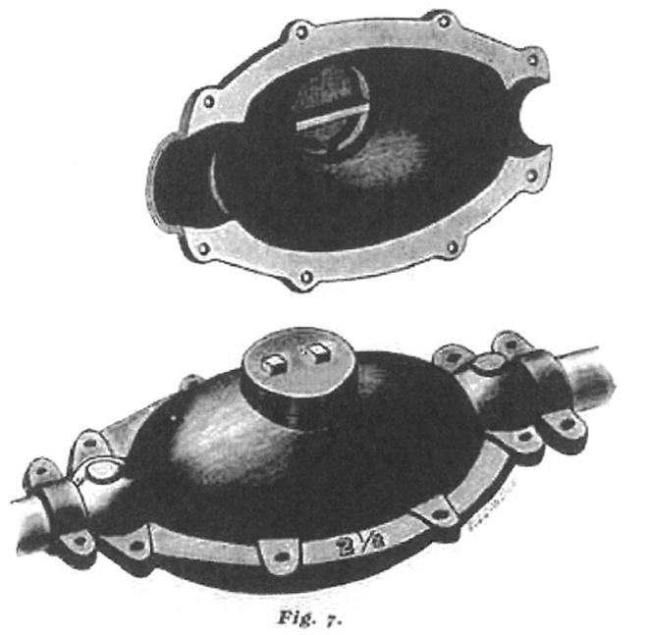
A 2 ½” coupling box is shown in Fig. 7. The 3”and 2" coupling boxes do not differ, except as to size, `The two halves of the box are bolted together by bolts through the flange. In the top half is a round hole closed by a cast iron cap. Through this hole the box is filled with hot insulating compound, which surrounds and insulates the copper rods, the joints, and the tube ends. This compound does not grow brittle on cooling or with age but remains plastic even at temperatures below the freezing point. An elbow box 2 ½” 90˚ is shown partially inclosing an elbow joint between two main tubes in Fig. 8 the 55˚ and 20˚ elbow boxes are similar in general design. All elbow boxes allow a range of 18˚ on either side of their mean position. Thus any angle between 37˚ and 73˚ may be made with a 55˚ elbow box. The 3” elbows differ from the 2 ½” only in being larger. All elbow boxes take special clamps called cup clamps. These clamps have spherical surfaces
like ball clamps but are designed to give greater range of movement to the ball and socket joint formed with the elbow box.

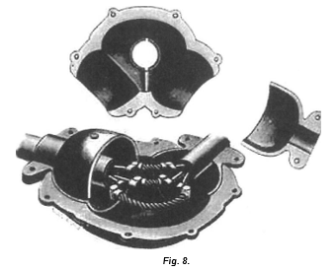
These clamps for the 3” elbow boxes are similar to the 2 ½ inch cup clamp shown in Fig. 8. All boxes, whether coupling or elbow, have a round hole in the top half through which they are filled with compound.
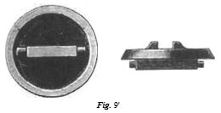
This hole is closed by a round iron cap which is locked securely in position by turning it through ¼ of a revolution. This tap makes a dirt-tight but not air-tight joint, and is called a ventilator top (see Fig, 9.)
Having disposed of the main line, we come to the branches to the customer's premises, or as they are commonly called the services. These

are short lengths of tube which tap the main line by means of a three-way box called a tee box (see Figs 10 and 11). 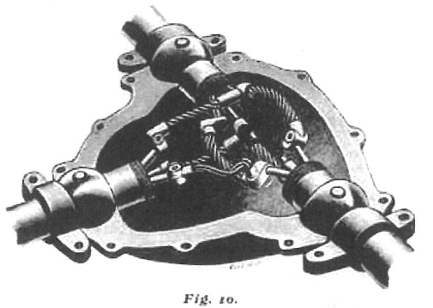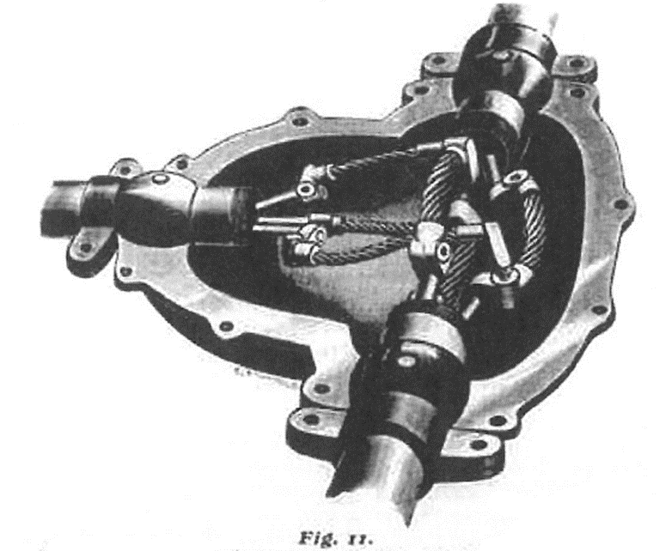
These boxes are made in two styles, 2” tee and 2 ½” tee, which differ from the 2” coupling and the 2 ½” coupling only in having three nozzle instead of

two. Owing to the main portion of a tee being the duplicate of a coupling of the same size any 2” coupling or 2 ½” coupling may be replaced by a 2” or 2 ½” tee without disturbing the main line. A modified form to the tee is called a “Y” box is used where the service makes an angle of 45˚ with the main line. A four-way or cross box, really a double tee, admits two services being taken from one joint. Mains are placed in the ground that the positive and negative conductors are on one side of the vertical plane through the centre line of the tube, while the neutral or balancing wire is on the other (see Fig. 12).
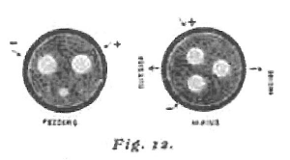
The side of the tube which the neutral is on is called the inside because the main tube is so placed that the neutral copper is nearest the curb line. The feeders are laid symmetrically, with the right-hand copper as the positive conductor as the tube leaves the station. Services are never taken from feeder line. A service to the side of the main line marked inside, and called an inside service, is shown in Fig 10, while Fig. 11 shows a service to the opposite side called an outside service. On this basis all services are classed as either outside or inside. The same distinction is made with regard to bends in a main tube, all bends in which the neutral joint is shortened or before on the inside of the curve are inside elbows, while those in which the neutral joint is longest of the three joints are called outside elbows. The table appended gives the size service joints required for different service connections, the branch line not being larger than 120,000 circuit mils.

Size of Main Line | Joints Required for Inside Service
No. 80 to No. 300 | 3 Short Branch Joints
No. 350 to No. 500 | 3 Long Branch Joints
 | For Outside Service
No. 80 to No. 500 | 2 Short and 1 Long Branch Joints 1 Branch Link

For larger services we provide a complete tee joint, which consists of the necessary main line coupling joints with the branch joints attached. In ordering a tee joint, always give size of main line, size of service, and whether the service is to the side marked inside or to that marked outside Fig 12. The combinations of elbow joints given below cover a range of 18˚ on each side of their mean position.
ELBOW JOINTS FOR MAIN ELBOWS
 | Joints required Inside Elbows
Style Angle Box | Coupling | Short | Medium | Long
20˚ | 1 |  | 2
55˚ |  | 1 | 2
90˚ |  | 1 |  | 2
 | Joints required Inside Elbows
Style Angle Box | Coupling | Short | Medium | Long
20˚ | 2 |  | 1
55˚ |  | 2 | 1
90˚ |  | 2 |  | 1

ELBOW JOINTS FOR ALL FEEDER ELBOWS
Angle Box | POSITIVE AND NEGATIVE COPPERS |  |  |  | NEUTRAL COPPER
 | Coupling | Short | Medium | Long | Medium | Long
20˚ | 1 |  | 1 |  | 1
55˚ |  | 1 | 1 |  | 1
90˚ |  | 1 |  | 1 |  | 1

In referring to what constituted a feeder line, we stated that it was a line from the source of current to some centre of distribution from which mains radiated. This requires that the feeder should be split up or branch out, or, what is the same thing, that it should be connected to two or more mains.
The safety catch box is designed to accomplish

this object. Inside of a safety catch box all wires of like polarity are connected together, thus allowing the current coming in on one or more lines to split up and supply the remaining lines from which customers obtain their current for light or power. The safety box serves then, first, as a centre of distribution; second as a centre of equalization of electrical pressure between the different parts of the system.
It also affords a really means of inspecting and testing any line, or of disconnecting a line from the system when work is to be done on it, such as the connection of services, etc. It may be noted here that men thoroughly familiar with the work do not find it necessary to interrupt the current while making service connections.
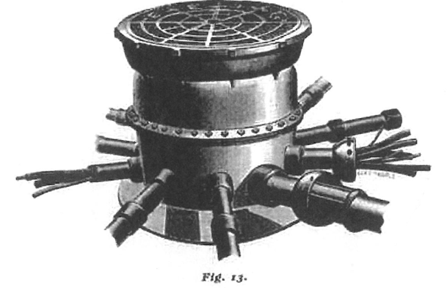
Fig 13 shows a perspective view of a ten-tube safety catch box, i.e. one intended for connection to ten or any less number of lines or tubes. The safety catch boxes are built in three sizes for use with four, six and ten lines respectively. A 4 -tube box has four stubs, short lengths of pipe, for connection to as main line s of main tubes. A 6-tube has four stubs for connection to mains, and two larger stubs for connection to either feeders or mains. A 10-tube safety catch box has eight stubs for connection to mains, and two for connection to either feeders or mains. The top of the box is closed by two covers, the lower of which is bolted down upon a rubber gasket making a water tight joint. The upper or top cover, shown in position in Fig 13, is heavily ribbed and takes the

Pages 12 and 13 missing???
These 2 pages are missing because they were missed while the pages of this publication were being scanned.
As at 18/8/2023 they are unlikely to be scanned while the Edison project is still in operation digitizing 5 million pages of the works and writings of Thomas Edison.

Pages 12 and 13 missing???

Ordering them give size of tube, and state whether it is a feeder or main tube. A hard rubber board secured on top of rings and shown in figure 14 carries the terminals needed for the small cables running in the feeders and called pressure wires. In this way the electrical pressure at the box can be transmitted through these small cables to the station and there be measured by a suitable voltmeter enabling the attendant to maintain the pressure at the proper point under varying loads.
The system may seem burdened with details, but when the consideration comes in that the system takes the current from the dynamo and delivers it to the customer, that the tube is equivalent to three ducts in a conduit and three insulated cables, and that the system has a flexibility far ahead of any underground method of either gas or water distribution, we see that the system is, when compared to its work, exceedingly simple. Ten years of experience have enabled us to produce our standard system of the present freed from the weakness of the original types. We have entirely obviated all liability to burn outs, and are prepared to make and fulfill strictly a ridged guarantee on every installation made by us. We manufacture a complete 2 wire system and telephone conductor system. We have made many special forms and are prepared to furnish plans and estimates for any class of underground work.

NOTES ON THE INSTALLATION
OF
EDISON ELECTRIC UNDERGROUND TUBES

The trench in which electric tubes are to be laid should, as a rule, be 30” deep and 20” wide at the bottom. Such a trench is wide enough for two lines of tube, but it never should be dug narrower, even though but one line to be laide. A Workman cannot work to advantage in a narrower trench.

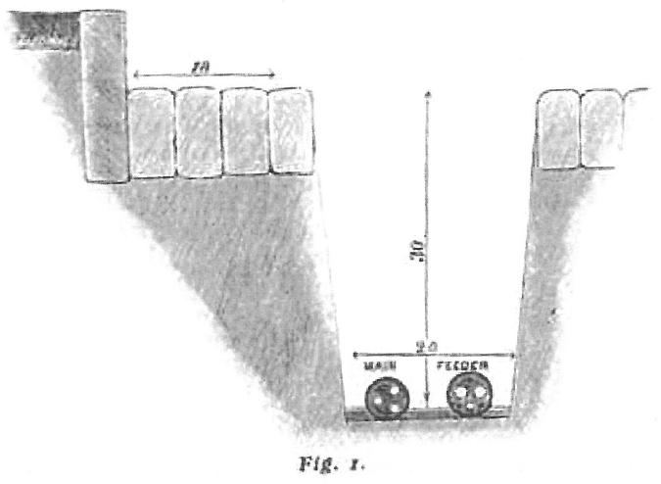
Fig I shows a section of a trench with tubes. It is good practice to have the inside of the edge of the trench at least 18” from the side-walk curbing in order to avoid disturbing the curb-stone. Two tubes are shown, a feeder on the outside and a main on the inside of the ditch. As noted in describing the system, feeders run from the dynamo or source of current to centres of distribution, and the mains radiate from these

centres and are tapped to supply customers.
The main is therefore laid nearest the curb to facilitate the taking off of taps or services to the houses. Such services run under the sidewalk into the basement or cellar of a building. Should there be only a line of main on one side of the street, it is laid about 6” higher than the feeder, should there be one, in order that services or taps may be taken from either side of the main.
Where more than two lines of tubes are to go in one trench, a wider ditch is required. The table below gives the proper size ditch for the different number of lines laid at the same depth.
For three lines of tubing 28” wide at bottom 30” deep
For four lines of tubing 36” wide at bottom 30” deep
For five lines of tubing 44” wide at bottom 30” deep
For six lines of tubing 50” wide at bottom 30” deep

The above is based on the space required for 2½” inside diameter tubing and fittings, 3” tubing takes 10% more width and 2” and 1½” 10% less width, the depth remaining 30”.
Safety catch boxes require excavation as follows:
AS.C Box for connection to 4 lines (4 Tube Box) 6” in diam 31” deep
AS.C Box for connection to 6 lines (6 Tube Box) 17” in diam 31” deep
AS.C Box for connection to 10 lines (10 Tube Box) 18” in diam 31” deep

All trenches should have as nearly perpendicular side as the nature of the soil will permit without caving in. The trench should run at a straight line and be free from crooks and bends, and where corners are to be turned, the ditch should make a square turn and not be rounded. To secure a level and uniform bottom, which is the foundation for the line, all bolders and, stones must be removed.
In order that the tubes may lie on a solid foundation, excavate a pocket in the bottom of the ditch under each joint. This pocket should be about 9” x 9” x 28” to accommodate the coupling or elbow box covering the joint. See that the bottom of the ditch between the pockets is level (see Fig. 2). which shows the outlines of the bottom of a ditch.
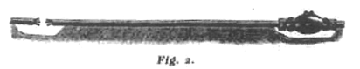
After the work on the line tubing is finished, the trench may be filled in and paved, observing the following precaution to prevent the shifting of the tubes by the settling of the soil.

Until the tubes and coupling boxes or joint covers are well covered, use only fine dirt, i.e. soil free from rock, shale or bolders. The tubes and boxes should be well packed around with soil by using tie tamping bars, care being taken to pack the soil well under the tubes and boxes. Leave no portion of the line unsupported. After the tubes are well covered, heavy rammers should be used as the dirt is shoveled into the ditch, to thoroughly settle it. In cities where a great deal of excavating is done by different companies and individuals, it is an excellent plan to place a 5’ x 2” plank, creosoted pine, over each tube to protect it from injury by the tools of workmen. In cases where the ditch is a little too deep, or the line must be raised to get over some obstruction, it is best to fill up to the required level and settle with heavy rammers. If blocking of any kind is used to support the tubes, let it be of wood, and never of paving blocks or stones. Where a tube has been blocked up, be sure that the soil is well packed under it in filling in. It is a good rule to let the line rest on only on dirt, and in no case to rest on any ridged body such as a gas pipe.
On the bedding or filling in too much care cannot be used
All main tubes are so placed in the ditch that one copper lies on the side towards the curb as shown in Fig. 1, This copper is the third or neutral wire, and one rod in each tube has a small slot sawed in each end to assist in keeping the coppers in their proper positions while laying. The neutral is laid towards the curb for convenience in making service connections. As taps are not taken from feeders, the neutral wire is run on the bottom (see Fig. 1). The feeder lines are so connected at the station that the right hand rod in the tubes leaving the station is positive, or carries what is usually called the outgoing current. The pressure wires which run from the outer end of the feeder back to the station are equally well insulated from all other conductors, and should be run its independent circuits
Before placing the tubes in the trench, clean the tinned ends of the rods with emery cloth (No. o) and remove any burs received in transportation with a file. The ends of the pipe and the threads cut on it are free from dirt. The tube is now placed in the ditch, attention being paid to the directions for bedding.
The coupling joints are slid into position by first slitting on to one copper, and then slipping back and on to the opposite rod in the next tube.
The coppers are allowed to project from 1-8“to 1.16” through the sockets at each end of the coupling joints, The joint is then soldered by means of a flame. Some form of blast torch is best for this purpose. Both ends of the joint and their inclosed rods are heated at the same time, two lamps being used. Be particular not to scotch or burn the

Rubber plugs int eh ends of the tubes. When the heat is first applied a few drops of solution of soldering salts should be applied, care being taken not to get any soldering solution on the plugs. When the joint is hot enough for the solder to run freely, it should be soldered by running the metal in between the joint and rod. The hole in the former being a trite greater in diameter that the diameter of the rod. The outside of the socket and especially the underside, should be cleared of all lumps and teat of solder. In the case of a feeder after the main coppers have been soldered to their joints the ends of the pressure wires are cleaned. They are slid into a tinned wire spiral, large enough for the two small cables to lie side by side. This joint is heated and soldered, making a wrapped splice. When the soldering is finished, the joints, projecting rods and pressure wires are wiped clean and dry with a strip of cotton cloth.
After this the pressure wires are taped with E. M. W Pargon tape. The ends of the pipe and the threads must be clean and free from moisture. The rubber plugs are scraped to insure a clean surface. The joint is inspected and is then ready to be inclosed in a box and insulated, a pair of ball clamps are bolted on to the tubes at even distances back from the ends of the pipe. The two halves of a coupling box are slipped over the clamps and bolted together. The flange of the box should be level and not tilted sideways. As soon as the box is bolted together the line should be tested for insulation, and after this is done, the coupling boxes should be filled full of compound at a temperature from 200˚ to 300˚ Fahrenheit. This compound should be strained through a fine strainer before it is put into the coupling box and should never be heated above 300˚ Fahrenheit. Allow the box to stand for about 15 minutes, and then fill full again to make up for any shrinkage and settling. After the second filling the cast iron cap which fits over the hole in the top of the box, should be locked in place by a quarter turn. The trench can now be filled with earth and paved according to the directions on page 16.
In putting a safety catch box in position, the excavation should be of such a depth that the top of the box is just level with the pavement or half an inch above that level.
The bottom of the hole should be level and well rammed down to afford a firm foundation. It is well to select a spot as much out of the way of traffic as circumstances will permit, in order that if the box is opened it will not form and obstruction. Where a tube is connected to a safety catch box the rods in the tube are soldered to the cables in the projecting stub of the safety catch box by means of sockets drilled to fit cables and rods. These are soldered in place similar to an ordinary…..

