Display Boards Text-use White lettering on Black background
Central Information between Tube samples
EDISON STREET TUBES- William Street Brisbane
World renowned American inventor, Thomas Alva Edison designed the two core 110 V DC Street Tube for the world's first commercial underground electricity mains. They were patented in 1881 and manufactured by the Edison Electric Tube Company in New York, USA. They were first laid in London in 1882, and quickly followed in New York City, other American Cities, Milan and Brisbane. Brisbane's installation in 1884 was to supply Parliament House with new electric lighting from a new Government Printery power station some 1350 ft. away (410m), buried 12 inches (305mm) under William St. Finally switched on in 1886, Brisbane was the first and only city in the southern hemisphere to install Edison Street Tubes.
The tubes were supplied ex-factory fully sealed and insulated with a compound of Trinidad pitch, linseed oil, beeswax and paraffin wax, and ready for installation with jointing every 20 ft. The cast iron joint boxes allow for tube expansion with flexible connectors and were also filled with this compound. The three-core was laid alongside the two-core in 1892 to reinforce the voltage supply and provide for a new wing of Parliament House in Alice St. with increased lighting. By 1906, after 20 years' service and needing substantial reinforcement with newer underground supply, the street tubes were disconnected, but never recovered.
Extensive excavations for the Brisbane Queens Wharf Casino project (2016 -2022) required removal of all the remaining tubes and boxes between the Old Printery and Margaret St crossing. These samples were recovered in Feb. 2018 by the owners Energex and site Project Managers Probuild under direction of the developers Destination Brisbane Consortium, Archaeologists from Urbis, and Queensland Government Departments. Researchers from Engineering Heritage Queensland have arranged for full 20 ft. lengths, joint boxes and short samples to be preserved for Queensland Parliament House, local and interstate museums, and overseas museums in London UK and in the USA.
Brian Becconsall, Stuart Wallace, Mick Purcell -EHQ Brisbane Feb. 2018.
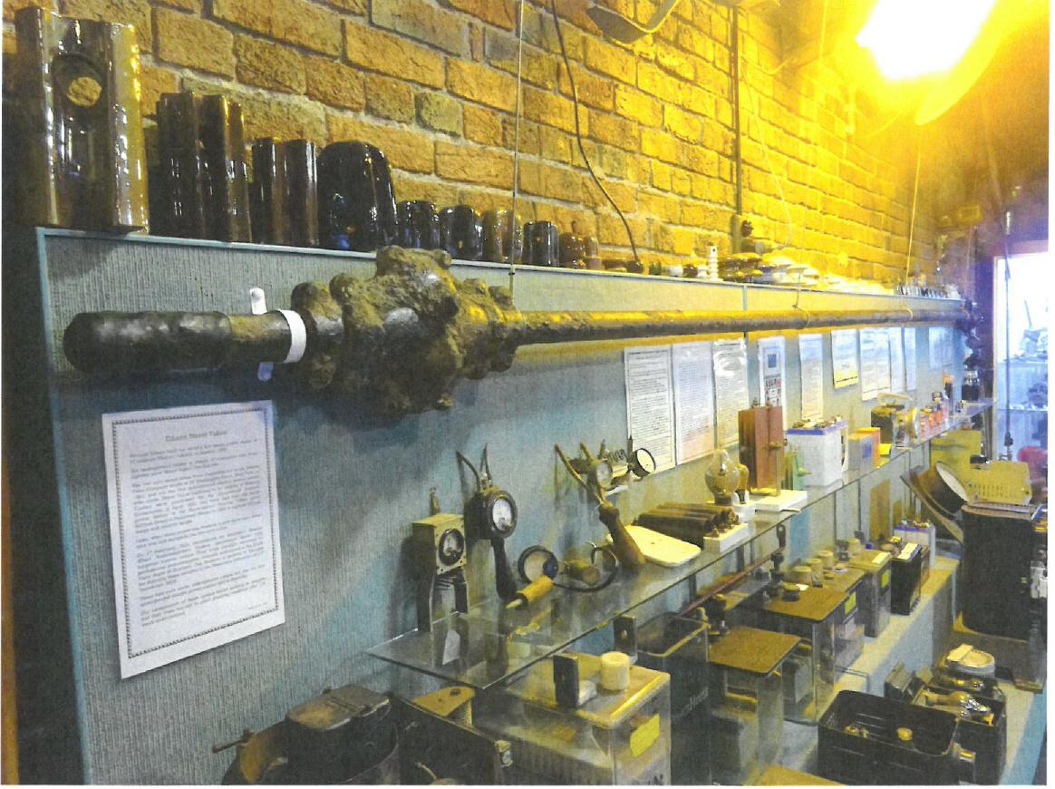

Photo: taken by B. Becconsall Tamworth Powerhouse Museum 2019

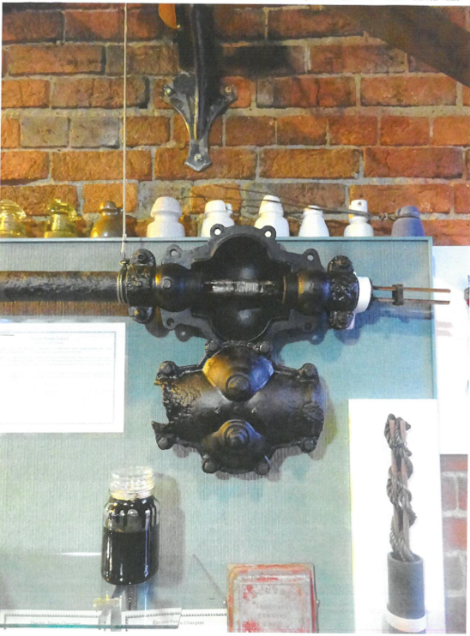
Photo: taken by B. Becconsall Tamworth Powerhouse Museum 2019

First Underground Electricity Mains in Brisbane
by S A Prentice.
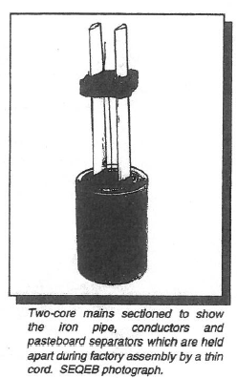
The installation of the first underground electricity mains in Brisbane was a sequel to the city's first display of commercial electric lighting. The display was on 9 December 1882 and its purpose was to promote the formation of a local electricity supply company. The company offered the 'Brush' system for outdoor lighting with arc lamps and the 'Lane-Fox' system for indoor lighting with incandescent filament lamps. The main display comprised eight arc lamps arranged along half a mile of Queen Street and supplied by a steam-engine driven generator. The display was continued on and off for a few weeks but it was only at the end of December that the 'Lane-Fox' system was shown briefly in a shop window. In spite of the publicity, the embryo company failed to interest possible investors in commercial electricity supply.
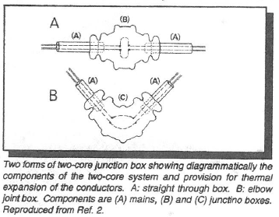
However, early in 1883 Major S. Flood Page, the General Manager of The Edison's Indian and Colonial Electric Company Limited visited Brisbane and offered the Edison system of incandescent lighting for areas in the Queensland Government Printing Office used for typesetting. The offer was accepted by the Government and the installation of 50 carbon filament lamps was completed on 9 April 1883 by the Edison Company electrician, J W Snow. A Printing Office steam-engine was used to drive the generator. Encouraged by the success of the scheme Flood Page gave the Queensland Colonial Secretary an estimate dated 11 April for far more extensive lighting of the Printing Office and partial lighting of Parliament House. There were to be 180 lamps in the Printing Office and 150 in Parliament House to replace a corresponding number of gas burners. All lamps were to be 16 candle power. Within two days the estimate was accepted by the Government, seemingly without realisation of the likely overall cost. One uncosted item was the 110-volt direct current mains required to the Printing Office, with Parliament House. A requirement of the time was that electricity mains were laid underground; the route length of the first mains has been estimated as 1350ft (410m). These mains, believed to be the only such installation in the Southern Hemisphere, and the supplementary mains added later are described in this article which is based on Refs one and two. A few years earlier than the Edison Company tender to the Queensland Government, Edison had developed generators in a range of outputs to the factory production stage and at the same time had developed incandescent lamps. However, underground mains for a 110-volt direct current distribution network were still in the experimental stage and seemed likely to hold up his plans for lighting New York.
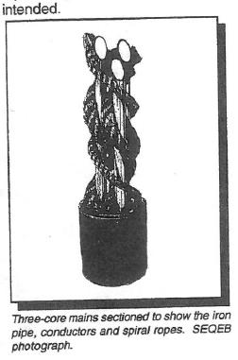
The scheme which he finally devised, and which was used in Brisbane, comprised two copper conductors in a two-inch (50mm) nominal internal diameter iron pipe with insulating spacers to separate the conductors from each other and from the pipe. A bitumastic compound provided the main insulation. The construction is shown in Figure one. The mains - known as Edison Street Tubes - were factory made in New York in 15 and 20ft (4.6 and 6.1m) lengths to be connected together on site with cast-iron junction boxes at one or other of these intervals. From the list of lengths supplied to Brisbane there would have been about 70 junction boxes in the route length. The D shaped conductors were each 0.2 sq.in. (129sq.mm) in area.
A two-core straight junction box and an elbow joint box are shown diagrammatically in Figure two which also shows the provision for thermal expansion of the conductors. After soldering the joints, the boxes were fitted with cast-iron tops and filled with the bitumastic compound through a plug hole The installation of the mains in William Street, Brisbane was carried out in mid-1884 presumably by J W Snow but could not have been quite completed at this time since the power station was still under construction.
The sub-contract for excavating and restoring the road surface imposed very strict conditions. The components of the two-core system and provision for thermal about one third of the contract price. The depth of excavation in the street was specified as 12 inches (305mm), much shallower than for the same type of mains in New York.

in fact, the regular use of the mains did not begin until July 1886 when the complete system was handed over to the Government. The conductor area was presumably chosen to give an acceptable voltage drop with the installation as originally tendered for. However, with subsequent additions to the lighting of the Parliament buildings the voltage drop was reported by a consultant as excessive and was evidently coped with by using lower voltage lamps in Parliament House than intended.
No action to correct this was taken until 1891 when tenders were called for the supply of supplementary mains. The Government Electrician, EGC Barton, specified three-core mains, possibly because the two-core type had become obsolete with the change in USA from a 110 volt two-conductor system to a 220 volt three-conductor system. This change had become a necessity when the voltage drops experienced with the two-core system became unacceptable.
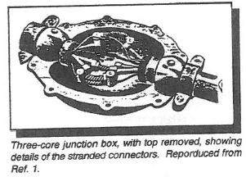
The construction of the three-core mains was quite different from that of the two-core type and is shown in Figure three. The following is a contemporary description: The conductors...are copper rods which are drawn into convenient lengths so that in the first instance each can have a layer of rope twisted around, and afterwards the three rods are similarly treated and placed in the wrought iron tube which resembles a gas pipe. The outer windings of the spiral come into contact with the inside of the tube and a liquid insulating material is then poured in which flows along the spiral convolutions of the cords thoroughly saturating them, and insulates the conductors from each other and from the tube...'
The tubing supplied to Brisbane had the same nominal diameter as the two-core mains; the area of each conductor was 0.12s in. (77sq.mm). The assumed route of the 1892 installation (and thus of the two-core mains) was shorter than previously by about 70ft (21m) as the route length was increased at the power station end and shortened at the other end to terminate in a wine cellar adjacent to the end of William Street.
The available lengths of 15 and 20ft for the mains required junction boxes at these intervals as with the two-core mains. Flexible connections within each junction box provided for thermal expansion of the conductors as shown in Figure four. Barton - who was credited at this time with the construction of one 20ft length of three-core mains - rearranged the distribution system within the Parliament buildings (to which a new wing had been added) so that each of the three cores was connected to a specified area while the two cores of the original installation were bonded together as the return conductor.
The expected improvement was less than hoped for due in part to the gradual extension of the lighting system. A newspaper report of a test in June 1892 showed that the power station voltage of 115 was reduced to 94 volts at the entry to the Parliamentary buildings area. The recorded average current was 240 amps corresponding to about 400 lamps. This may be compared with the plan in 1883 to provide 150 lamps. In this connection it should be noted that the original Edison Company offer was for two generators each of '250 light' capacity, one to be regarded as a reserve. The inadequacy of this arrangement was evidently realised as each of the generators supplied was of '400 light' capacity. By 1892 both had to be used to meet the lighting loads in the two areas. The voltage drop problem can be appreciated from the range of lamp voltages quoted in an 1891 Government purchasing order. This called for '110 Edison lamps...16 candle power, 110 volts, (presumably for the Printing Office) also 150 Edison lamps,...16 candle power, assorted 93, up to 98 volts'... The voltages of the 1892 stocks of lamps were shown as 92, 96, 98 and 110.
No complete record of the route of the mains has been found but excavations in William Street and the grounds of the Parliamentary buildings in the last several years have uncovered lengths of the two types of mains and four types of junction box all in surprisingly good condition after over 100 years in the ground. Elbow joints for each type were found at one site and it is probable, since only two two-core elbow joints were supplied, that elsewhere the mains were curved for part of the route e.g. the mains within the Parliamentary grounds. The feasibility of such curving is deduced from an illustration of the New York installation of similar two-core mains shown in Figure five.
Examination by the Queensland Museum of the material recovered in William Street and vicinity confirms the description given in contemporary literature. The material is held by the Museum and illustrated in Ref. two. Use of the Edison mains was discontinued in about 1906 and the system converted to three-wire 220/110 volts. Supply was given by a private company, the City Electric Light Company Limited. In contrast with the Edison system, supply was given by lead-sheathed mains, available in Brisbane in long lengths since the 1890's. Evidently there was no action to recover the original mains after disuse. By 1989 a route length of about 50ft (15m) has been located and the two types of mains removed for conservation. As a reminder of the developments described in this article, there is a plaque outside the Brisbane SCIENCENTRE depicting the first Government power station as built in 1886.
Acknowledgments: The author is indebted to the Queensland Museum and the Southeast Queensland Electricity Board for permission to use illustrations from their collections.
References:
1. Prentice S A 1988. Edward Barton, Pioneer Electrical Engineer. Memoirs of the Queensland Museum 27 (I): 1-110.
2. McKenzie E D and Prentice S A 1994. The First Underground Mains for Electricity Supply in Brisbane. Memoirs of the Queensland Museum 35 (I): 181-192.
