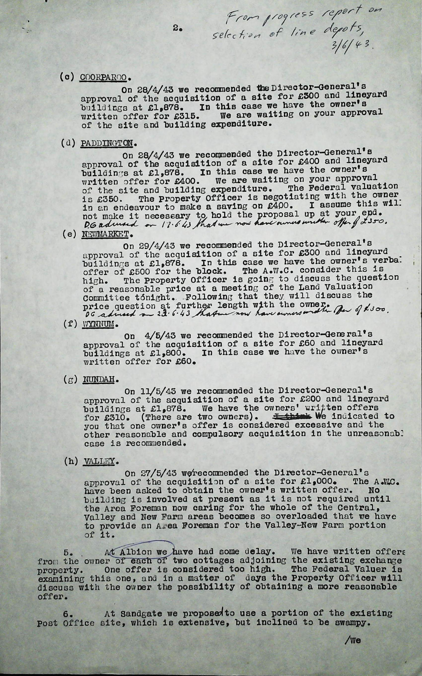

9771. From progress report on selection of line depots 3.6.43
From progress report on selection of line depots 3.6.43
5. At Albion we have had some delay. We have written offers from the owner of each of two cottages adjoining the existing exchange property. One offer is considered too high. The Federal Valuer is examining this one, and in a matter of days the Property Officer will discuss with the owner the possibility of obtaining a more reasonable offer.

