CAPE YORK HISTORICAL
EXPEDITION 1973
1883 Route Retraced by Horsemen
By MALCOLM M. REA
(Read at a meeting of the Society, 18 April 1974)
(All rights reserved)
(Mr. Rca conceived. organised and led the 7-man expedition from Fairview, North Queensland, to Thursday Island in June/July 1973. The party followed the Electric Telegraph line route explored by John R. Bradford and his party of seven men 90 years before. Mr. Rea is Historical Officer, Public Relations Section. Australian Post Office and Secretary, Post Office Historical Society of Queensland. He is 44 years old, married with five children and lives at Tarragindi, Brisbane).
PROLOGUE (Bradford's Expedition)
In the early eighties of the last century, Sir Thomas McIlwraith's government took a very serious view of the commercial and strategic importance of Torres Strait and of the necessity for telegraphic communication between the Strait and the Capital'. The Queensland Government, through the Post and Telegraph Department, had already built thousands of miles of electric telegraph lines in the State; the most northern was the Cooktown-Maytown route opened on 25 April 1876. On 1 July 1876, a line was built from Junction Creek (Mt. Surprise) to Palmerville via May-town. Thus, the goldfields were in telegraphic contact with Cooktown, the nearest port and with the southern capital via Junction Creek, Townsville and Charters Towers.
The line to the Gulf, Cardwell to Normanton and Norman Mouth (now Karumba) had been operating since 1871/72 (completed October 1871 and opened to traffic 3 January 1872). Cape York Peninsula, remote, harsh, hostile and largely unexplored was one of the last frontiers which challenged man's conquest by "the single thread of life" — the Electric Telegraph.
Also by the 1880's Torres Strait was a sea lane frequently used by steamers to carry mail, passengers and freight to England via the Suez Canal (opened 1869). The Russian scare also had great bearing on the importance of Thursday Island and Cape York. It was essential to build a line to the top, so thought Government officials, but first a route had to be explored.
The Post and Telegraph Department selected John Richard Bradford, Inspector of Lines and Mail Route Services for the job. It was a wise decision as Bradford was an experienced bushman and had been "employed in surveying, and supervising the construction of telegraph lines, in different parts of Queensland on the line from
Cooktown to Palmerville and Maytown from October 1874 to July 1876"². The plan was to examine the country between the Cooktown-Palmerville Line and the tip of Cape York Peninsula.
Upon receiving his commission, Bradford sailed for Cook-town from Brisbane in May 1883. Obtaining provisions and horses and increasing his party to seven men — five white men, a Chinese and an aborigine, the expedition set out on 9 June for Laura Telegraph Station, 66 miles from Cooktown. After arriving, several days were spent there. Their camp was then moved to "The Lagoon" on "The Blacksoil" (now Fairview Telegraph Station), the point where the new line was to branch off from the existing Cooktown-Palmerville line, 15 miles from Laura.
The party left the Lagoon or Blacksoil on 18 June 1883 travelling north 55 degrees west. At each camp site on their journey northwards, a tree was marked with a broad arrow over the letter B under which was the number of the camp in Roman numerals. They made 50 such camps, the last one being nine miles north of Somerset where the famous Frank Jardine resided (311 miles from Coen or 460 miles from Fairview).
Their journey commenced on 18 June 1883, was successfully completed (to Somerset) on 29 August 1883, 83 days later. Of the original 36 horses only 13 reached Somerset. After sending his men, except Healy his second-in-command, back to Cooktown on the Gympie, Bradford and Healy crossed to Thursday Island by boat (after spending the night at Roko, a fishing station) the next morning Sunday, 2 September 1883. The two men obtained information locally on the soundings, bottom, currents, shortest route, tide and prevailing winds of the passage for cable laying operations. With their epic journey fully complete, Bradford and Healy left for Brisbane on the s.s. Corea on 5 September 1883.
Bradford's detailed report to his superiors was followed by the calling of tenders in 1884 for the construction of a telegraph line from Fairview near Laura to Cape York and Thursday Island.
The telegraph line was erected on iron poles (Oppenheimer type) by two teams of contractors during the period July 1884 and October 1886 or even later. Stations were opened at Fairview, Musgrave, Coen, Mein, Moreton, McDonnell, Paterson (later named Cape York) and Thursday Island by 1887. The mainland buildings were constructed as fortresses to withstand native attack and up to 25 years later were used intermittently for defence.⁴
The completed line provided more than communication with a strategic outpost of civilisation or comfort to the cattlemen and miners who followed the explorers.
It meant Australia uniquely, was spanned from Cape York in the far north to Hobart, Tasmania at the southern extremity of the continent, more than 2,500 miles away. The construction of this overland telegraph line with undersea cable near both ends was an engineering feat of which Australians can be justly proud. Our communication pioneers were men of iron will, resourcefulness, courage and foresight.

1973 EXPEDITION
Their story has never been fully told. This was one of the important reasons behind my decision, about five years ago, to follow the trail that John Richard Bradford blazed in Cape York Peninsula. Study, preparation, organisation and a thousand other things took months and years to accomplish. However, by 9 June 1973, a 7-man party was ready to leave Brisbane for Laura in North Queensland.
EQUIPMENT
Pack and riding saddles, hobbles, bells, bridles, halters, harness repair kits, provisions for two months, bedding, firearms and ammunition, fishing gear, photographic equipment and films; portable telephone and radio transceiver, diaries, maps, medical pack and philatelic mail made up a truck and trailer load for road transport to Cape York Peninsula.
MEMBERS AND QUALIFICATIONS
The expedition members consisted of men selected by me from more than 60 applicants scattered over most of the States of Australia. Their qualifications included the ability to ride, experience with horses, initiative, resourcefulness, camping and outdoors experience, interest in Cape
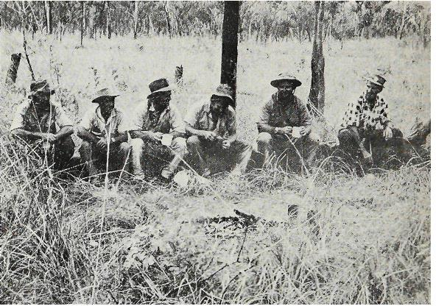
Boiling the billy on the Cape York trail.
Left to right: Bob Greenfield, Ted Knauer, Ron Berry, Dick Lakey, Bob. Anthony, Jim Green.
Photo: M. Rea
York and the purpose of the expedition, medical and dental health plus special talents required for the expedition. As well, each member had to be available for a minimum of six weeks and share one-seventh of the total cost of the expedition. The party comprised myself as Leader, Robert Anthony, 48, from Tweed Heads, professional still and movie cameraman (assigned with my approval by a film making company in Brisbane), Ron Berry, 53, Proprietor, Caravan Park in the Snowy Mountains, N.S.W., in charge of fishing and supplies; E. W. (Ted) Knauer, 57, Post Office Linesman, in charge of firearms and hunting; Bob Greenfield, 36, Technical Assistant Tropical Agronomy, C.S.I.R.O., Brisbane, in charge botanical specimen collections, pack gear and stock; Richard Lakey, 21, Geologist, also in charge stock and Jim Green, 52, Signwriter, Queensland Government Railways, qualified cook also in charge saddlery repairs. Each man's responsibilities overlapped in some aspect of the total daily work.

COLOUR SLIDES
In order to illustrate the progress of our "Cape York Historical Expedition 1973" I have brought along about one hundred 35 mm colour slides. These photographs were taken by me mostly from horseback. I shall explain each one in chronological order.
Slide I —The yellow Datsun truck displaying the name of the Expedition and members and advertisements of several sponsors who assisted with provisions and goods, was owned and used by Ron Berry. He drove it from the Snowy Mountains to Brisbane where we loaded it with provisions and equipment.
Slide 2 — Here Ron stands near the vehicle parked in front of my house at Tarragindi a few days before we departed on Saturday, 9 June 1973. We used this vehicle and Ted Knauer's Holden and trailer to transport men and material.
Slide 3 —This shows the Hinchinbrook Passage and Island from the Bruce Highway (No. 1) south of Ingham. Jim Green and Ted Knauer view the picturesque scenery from the roadside while we climbed higher for photographic advantage.
Slide 4 —Tall sugar cane in flower near Cairns with the heavily timbered Great Dividing Range in the background can be seen from the Bruce Highway.
Slide 5—The main street of Mareeba with its wide streets and centre line of beautiful trees was pleasant during the warm midday.
Slide 6 — Wolfram Hotel at Mt. Carbine on Highway 87, 19 miles from Mt. Molloy. The galvanised iron hotel appears to be the only inhabited building in the vicinity. It's obvious Mt. Carbine has seen better days. We photographed a few of the old buildings nearby just for the record.
Slide 7 — Looking across the rugged ranges which dissect the Kennedy Highway. The feeling of remoteness and isolation begins in country like this.
Slide 8 — This one shows one of the many cattle trucks which passed our two vehicles leaving clouds of thick dust. For safety sake, we often pulled to the side of the road and allowed the dust to settle before proceeding. The gravel road was extremely rough and narrow.
Slide 9—Looking toward the ranges near Laura, with the road snaking through the bush and disappearing into ridges on the horizon. We were getting close to our destination by this time and looked forward to seeing Laura. Ron Berry was the only member of the vehicular party to have been there before.
Slide 10 —Lakeland Downs built up by Mr. Clive Foyster was of interest to us. We stopped there for an hour and saw houses, workshops, a general store, a school, motel and farms. The settlement appeared to be a thriving community. The stop provided us with a good stretch for our legs even though we were anxious to move on.
Slide II — Aboriginal cave paintings at the famous Split Rock Gallery on the Palmerville road near Laura. It is alleged the aborigines practiced cannibalism on Chinese labourers and miners who travelled the road during the gold-bearing days of the Palmer River.
The ant hill near the paintings is claimed to have been used as an oven. Whatever the reason for the paintings to be located on this high rise sub plateau, they are most intriguing and should be preserved for all time.
Slide 12 — After a long tiring journey of 1,440 miles by road from Brisbane, the party finally arrived at Laura. The Non-official Post Office and store run by the Gostelows was one of the few buildings at Laura. The galvanised iron building was the main centre of commerce in the area although the "pub" next door rivalled the Post Office. Mrs. Gostelow gave great co-operation to the party especially with the mail and telephone service.
Slide 13 — Here some of the boys socialise with locals in front of the hotel made of galvanised iron. Seats were found on the ground or on the very low-level verandah.
Slide 14 — On Saturday, 16 June 1973, we arranged for the philatelic mail to be postmarked with the special pictorial postmark at Laura Post Office. Fortunately, we were able to hire 12 horses from Mr. Graham Elmes, a local Station Owner (Olivale Cattle Station—seven riding and five pack animals. Horses for hire were extremely scarce at the time as the late wet season meant a late muster for the stockmen. We started our journey to follow Bradford's trail from the same spot he did 90 years before. The date was Monday, 18 June 1973 at 4.00 p.m. It was late in the day as the horses previously had broken down the yard gate and escaped
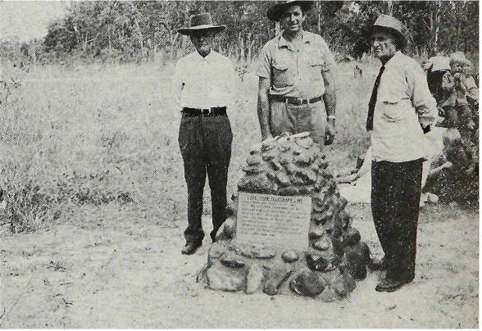
Monument raised to Bradford, surveyors and builders of telegraph line to Cape York by P.O. Historical Society of ()Id. and members of Cape York Historical Expedition 1973.

At unveiling ceremony (17/6/73). Reginald Berry (left), Malcolm Rea (leader of expedition) and John Berry. Messrs. Berry arc descendants of original line repairer Enos Berry of Fairview Telegraph Station.
Photo: M. Rea

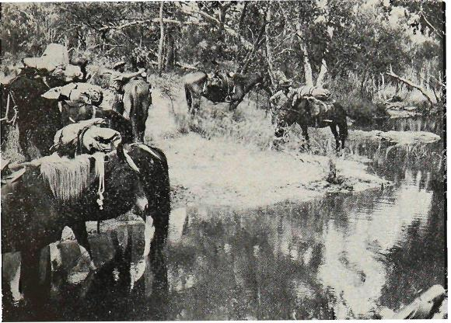
A welcome stop for a drink and rest along the trail between Fairview and
Musgrave, Cape York Peninsula, North Australia.
Photo: M. Rea
into the bush. It took nearly all day to find them and bring them back to the stockyards for harnessing. However, before leaving Fairview (called Blacksoil by Bradford) we erected a monument to the explorers, surveyors and builders of the telegraph line from Fairview to Thursday Island. The cairn was made 1 metre high, 1 metre square and 1 metre deep (in its foundations) and built of river stone and concrete. A marine stainless-steel plaque was fitted into the cairn to commemorate the intrepid communication pioneers. I had arranged for this to be manufactured in Brisbane on behalf of the Post Office Historical Society of Queensland. This scene shows a pleasant creek of clear water we crossed on the second day of our journey. It was most welcome to man and beast after a hot morning ride.
Slide 15 — Jim Green leading and Ted Knauer following on horseback negotiate long grass under the telephone line on the third day from Fairview.
Slide 16 — Another view of the riders under the iron telephone poles and aerial telephone lines. Notice the tall termite hills set in a magnetic north and south direction. We were to see thousands of these varying greatly in size and colour.
Slide 17 — This slide shows the tall wiry brown grass amidst the stunted saplings with ant hills hidden in the grass. In my imagination it reminded me of a neglected cemetery — the ant hills were the headstones.
Slide 18 - This view of the pack animals following in single file is typical of the manner in which the expedition travelled about 20 miles daily.
Slide 19 — Midday break meant a camp around a fire seated on a log. Hot drinks or cool water from the creeks washed down small dampers or bannocks (as cook Jim Green of Scottish origin called them). A half to an hour break refreshed men and animals and the next 10-12 miles, before making camp for the night, didn't seem as difficult as before lunch.
Slide 20 — The marvel of modern communication is illustrated. Assisted by linesman Ted Knauer, I've pulled down with a rope, two wires of the overhead telephone line. Hooking on a portable telephone carried in a pack bag, I wound the handle to a coded number of turns and within seconds contacted Laura Telephone Exchange and Brisbane was soon on the line. On this occasion, Wednesday, 20 June 1973, at 12.30 p.m., I telephoned the Board Room in the Brisbane G.P.O. where a monthly meeting of the Post Office Historical Society of Queensland was in progress. What a surprise it was to everyone. After reporting on the erection of the plaque at Fairview and our progress, I spoke briefly to about a dozen members before terminating the call. During the call, it rained slightly.
Slide 21 — That afternoon we arrived at the Hann River. The bridge and road are shown in this slide. We camped a few hundred yards off the road in Kalinga Station after obtaining permission from the owner, by using our portable telephone on his aerial telephone line.
Slide 22 — As you can see from this slide, the Hann River is only a small stream of water in the winter but during the wet season like most of the Cape Rivers, swells to an incredible size. We caught a few fish and they were a welcome addition to our diet.
Slide 23 — The next major river course crossed was the Morehead which like the Hann flows into Princess Charlotte Bay. At this picturesque spot, we were fortunate to find stockyards and a drover's camp site. Our photographer took some extremely colourful movie scenes on the morning we departed. The slide shows us harnessing up the horses with a small lagoon in the background. This camp site was one of the prettiest in our entire journey. Had we no schedule to keep, everyone would have voted for a few days rest at this spot.
Slide 24 — A typical freshwater creek crossing along the telephone line. Some bushmen note that "blue water is new water" and I can vouch for the sweetness of this water which lay in shallow pools surrounded by white sand. Water courses such as this are distinctive of the Cape topography.
Slide 25 —The date was 22 June 1973, and we were close to Musgrave Station. The low range or stony ridge ahead is a little south of Musgrave. We decided to push on in spite of the distance travelled to this spot. Thus we arrived at Musgrave just on dark after a long day having ridden a distance of 22 miles or more.
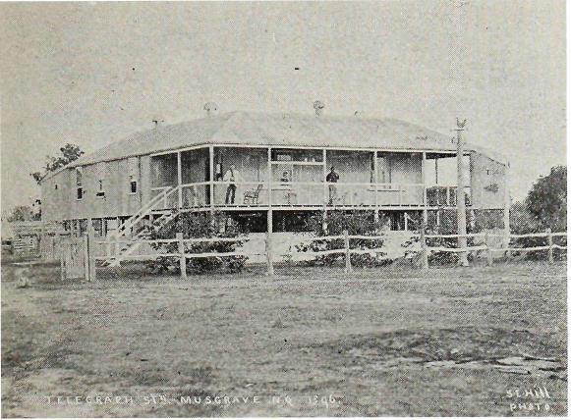
Musgrave Telegraph Station 1896, showing gun ports at front and rear of building. Photo: Courtesy Public Relations. Australian Post Office. Brisbane.
Slide 26 —Mr. and Mrs. Jim Hale who own the building (and surrounding property) seen in this slide, welcomed us. They made a camp site available for our use about half a mile to the rear of the station. This building at Musgrave, although altered by having the front verandah enclosed with glass louvres, is the only one of its kind still intact in this State and in Australia. It was opened as an Electric Telegraph Repeater and Repair Station on 23 December 1886. Gun ports were located on the front and rear corners of the building so that wild blacks could be discouraged from getting too close. Water tanks were located underneath the house to prevent waste or damage by aborigines. Internal stairs provided access from the ground floor to first floor levels for utility and security. The whole building was constructed with a wooden frame, galvanised iron sheeting and supported on high wooden stumps set in iron bases to prevent termite attack.
Slide 27 —This view taken from the north side shows the present existing external water tanks and the old roof mounted ventilators.
IT IS MY STRONG RECOMMENDATION THAT THIS UNIQUE AND TYPICALLY QUEENSLAND BUILDING ONCE OWNED BY THE COLONIAL POST AND TELEGRAPH DEPARTMENT, THE FEDERAL P.M.G. DEPARTMENT AND NOW BY THE HALES SHOULD BE PRESERVED AT ALL COST FOR OUR POSTERITY AS ONE OF THE PRIZES OF OUR NATIONAL HERITAGE.
Stewart Riven several times the Expedition arrived at Coen about 70 miles from Musgrave. Here is a panoramic view of that settlement and the hills which surround it.
Slide 33 —This is the main street of Coen looking toward the Australian Inland Mission Hospital on the hill. The non-official Post Office and Store owned by Mrs. Irene Taylor is the large galvanised iron building on the right. Coen was to prove it was one of the most interesting places in our entire journey.
Slide 34 —This is a close-up of the Post Office and the public telephone cabinet with Mrs. Williams (daughter of Mrs. I. Taylor), non-official Postmistress in front of the building. Mrs. Williams was very friendly, efficient and most co-operative. The Coen people were extremely interested in our expedition and helped us considerably. We hired a new plant of 12 hones from Mrs. Taylor for the next stage to Moreton. Mr. Elmes of Laura planned to collect his horses when next visiting Coen during the annual races which were only a few weeks away.
Slide 35 —Here I stand near the road leading north out of the settlement. The sign post says — Cape York, Weipa, Hospital and Police.
Slide 36—These small stockyards are located behind Mrs. Taylor's Post Office Store. The small houses in the background have cement floors and galvanised iron roofs. They house aboriginal families whose washing was "persil" white. There are more aborigines than whites at Coen. The flat-topped mountain is Mount White, which is part of the MeIlwraith Range. Coen at the time was very dry with warm days and cool nights.
Slide 37 —This house in the main street of Coen is claimed to be the original telegraph station from Mein which is about 60 miles north of Coen. The building was bought privately many years ago, greatly altered and finally erected on this site. It is hard to imagine it in the same form as the Musgrave building we saw earlier.
Slide 38 —This tall chimney towering over the bush, is located at the abandoned Great Northern Gold Mine about two miles from the Coen settlement past the racecourse. Some of the rusted machinery is still there reminiscent of earlier days. The gold mining lease No. 24 for this mine was applied for on 19 September 1901 and forfeited for non-payment of rent in 1914, so the mine has been abandoned for 60 years.
Slide 39 —John Harris, the local publican (Exchange Hotel), had driven us in his landrover to the Great Northern Mine. Later he drove a few miles along the northern road to the abandoned Mt. Wilson Mine. The huge metal drive wheel in the picture was carried In two pieces by horse teams in early days and assembled at the mine. With all the unfenced mine shafts in this area, I certainly wouldn't walk there after dark. The Mines Department have no record of this mine and presumably it operated before the turn of the century. We felt more like tourists, while viewing these interesting places, than expedition members.
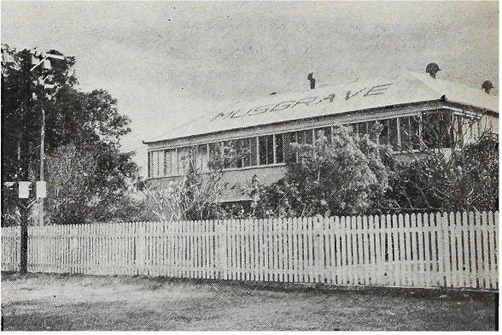
Musgrave Station 1973, showing alterations to building. Original wooden telegraph pole far left near steel telephone pole.
Photo: M. Rea
Slide 28 — In front of the building is located this wooden telegraph pole probably erected 16 March 1887 as it has the date stamped in the pole about 7 feet above the ground. My finger is pointing to the date. Unfortunately some years ago, a vandal fired a bullet into the pole in the centre of the impression. Thankfully Mr. and Mrs. Hale realise the historic value of their property and care for their "living museum."
Slide 29 — In front of the house yard is an air-strip (and even a small cemetery). Whilst we were at Musgrave, this helicopter en-route from New Guinea to Cairns stopped for fuel, as did a Cessna aircraft with an aerial mineral survey team aboard. Mr. and Mrs. Hale are kept busy with a fairly regular stream of aircraft, government officials, survey teams and tourists who replenish fuel stocks at their station. Our stay was an enjoyable one especially with cold drinks and home-made bread.
Slide 30 — Near our camp was this hot sulphur pool and here we see Jim Green, Dick Lakey and Ron Berry enjoying the therapeutic benefits of their ablutions. The only problem was a foot of mud and decayed leaves on the bottom of the pool. However care in ingress and egress ensured little disturbance of the sediment.
Slide 31 —These old trucks dumped nearby were relics of the 1920's and must have travelled thousands of miles over impossible roads before their final demise. What tales they could tell if they could speak.
Slide 32 — We left Musgrave on 24 June and camped at this pleasant spot — a tributary of the Annie River, having crossed many flowing creeks in the 20 miles. After crossing the Stewart and Little
Stewart Rivers several times the Expedition arrived at Coen about 70 miles from Musgrave. Here is a panoramic view of that settlement and the hills which surround it.
Slide 33 — This is the main street of Coen looking toward the Australian Inland Mission Hospital on the hill. The non-official Post Office and Stare owned by Mrs. Irene Taylor is the large galvanised iron building on the right. Coen was to prove it was one of the most interesting places in our entire journey.
Slide 34 —This is a close-up of the Post Office and the public telephone cabinet with Mrs. Williams (daughter of Mrs. I. Taylor), non-official Postmistress in front of the building. Mrs. Williams was very friendly, efficient and most co-operative. The Coen people were extremely interested in our expedition and helped us considerably. We hired a new plant of 12 horses from Mrs. Taylor for the next stage to Moreton. Mr. Elmes of Laura planned to collect his horses when next visiting Coen during the annual races which were only a few weeks away.
Slide 35 — Here I stand near the road leading north out of the settlement. The sign post says — Cape York, Weipa, Hospital and Police.
Slide 36 —These small stockyards are located behind Mrs. Taylor's Post Office Store. The small houses in the background have cement floors and galvanised iron roofs. They house aboriginal families whose washing was "persil" white. There are more aborigines than whites at Coen. The flat-topped mountain is Mount White, which is part of the Mcllwraith Range. Coen at the time was very dry with warm days and cool nights.
Slide 37 — This house in the main street of Coen is claimed to be the original telegraph station from Mein which is about 60 miles north of Coen. The building was bought privately many years ago, greatly altered and finally erected on this site. It is hard to imagine it in the same form as the Musgrave building we saw earlier.
Slide 38 — This tall chimney towering over the bush, is located at the abandoned Great Northern Gold Mine about two miles from the Coen settlement past the racecourse. Some of the rusted machinery is still there reminiscent of earlier days. The gold mining lease No. 24 for this mine was applied for on 19 September 1901 and forfeited for non-payment of rent in 1914, so the mine has been abandoned for 60 years.
Slide 39—John Harris, the local publican (Exchange Hotel), had driven us in his Land Rover to the Great Northern Mine. Later he drove a few miles along the northern road to the abandoned Mt. Wilson Mine. The huge metal drive wheel in the picture was carried in two pieces by horse teams in early days and asse_{m}bl_{e}d _{a}t the mine. With all the unfenced mine shafts in this area, I certainly wouldn't walk there after dark. The Mines Department have no record of this mine and presumably it operated before the turn of the century. We felt more like tourists, while viewing these interesting places, than expedition members.
Slide 40 — After spending an enjoyable four days at Coen, Bob Greenfield's poisoned hand had healed considerably and we had obtained the hire of 12 horses. We were now ready to move northwards again. The youngsters seen in this view sitting on the stockyard rails, came down to see us leave as it was a Saturday (20 June 1973). Horses to them are like motor bikes and cars to their city cousins.
Slide 41 — Mrs. Taylor's aboriginal stockmen assisted with the harnessing and loading of the stock, and the handling of several difficult pack-horses. However, after some bucking and "high spiritedness" the animals settled down and with one of the aboriginal stockmen in lead we reluctantly said goodbye to many newly made friends.
Slide 42 —The familiar iron telegraph poles soon appeared to direct our party toward Mein, the next Telegraph Repeater Station site northwards.
Slide. 43 —However, before leaving Coen we filled our water bottles and ourselves with the sweet water of the sandy bottomed Coen River. Bob Anthony seems to be enjoying his cup of "nectar."
Slide 44 — Across the river the party and pack-horses followed the road uphill to the top of the bank. A few dogs gave us a noisy welcome as we rode along the road.
Slide 45 — On the northern side of the river we passed these $17,000 houses being built by the State Government for Aboriginal families. When completed they will be the finest in the Cape. However, some doubted the wisdom of the project fearing insufficient numbers of socialised aborigines were available to handle modern houses.
Slide 46 — Miles along the line we saw huge ant hills like this one up to 20 feet in height. Ted Knauer, rifle cradled in his arm, poses nearby.
Slide 47 — We saw small conical shaped ones like these about 2 to 8 feet in height.
Slide 48 — At one place a couple of days north of Coen, we travelled through very deep sand making the going difficult for the horses. We met a local cattleman in this sandy country droving about 100 head of stock to market.
Slide 49 — As we approached the Archer River the country changed to granite and many boulders similar to those in South-east Queensland were seen. This balancing rock reminded us of similar sights on the Queensland/New South Wales border near Stanthorpe and Wallangarra.
Slide 50 —This is the road crossing of the Archer River — at the time inaccessible by four-wheel vehicles. Our plans were to stay a day for rest and recreation at the Archer but the weather was poor — it was about the time Brisbane was being battered by high winds and rain.
Slide 51 — However, we camped near a small lagoon with plenty of feed for the stock on the south side of the river. Here the horses are seen resting and grazing while we take shifts in "horse tailing" or "catching up" our diaries or laundry.
Slide 52 — This is our camp at the Archer. The sun came out for brief tantalising moments while the high wind buffeted our makeshift tents. That night most of us slept wet as the driving rain poured under the waterproof covers into our sleeping bags.
Slide 53 — These huge steel poles carry the weight of the telephone lines across the Archer and replace the earlier used wooden
poles. During the rainy season the wide river bed is covered
with 40 feet or more of roaring flood waters which almost reach the base of these poles.
Slide 54 — On the first day after the Archer we made good progress and arrived at the site of the old Mein Telegraph Station about the middle of the afternoon of Tuesday, 3 July. This was near Bradford's Camp 17 which he reached on 13 July 1883⁵. His camp was on Sugar Bag or Seary Creek between Mein and Pine Creek cattle station. The telegraph line from Coen to this spot followed Bradford's track closely except where he diverged to the west because the aborigines had burned the grass.
Slide 55 —This is all that remains of Mein — two 1,000 gallon galvanised iron water tanks, iron footings for the building (removed to Coen), some drums, "fallen down" fences, a "lead-in" iron telegraph pole, a dump and a grave. As the whole area was pitted with deep melon holes (dish shaped holes up to 4 feet deep) hidden under long grass and no water or dry timber readily available, we moved on to a camp site on the Snider Creek (we saw the Weipa turn-off about a mile past Mein).
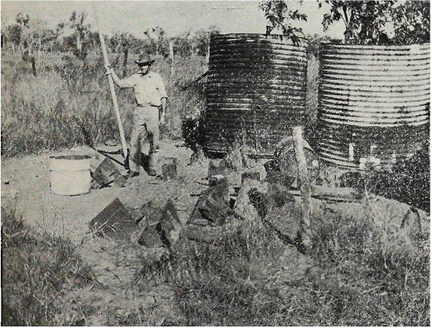
Author on the site of the old Mein Telegraph Station, Cape York Peninsula. The party of 7 men and 12 horses arrived at 3.30 p.m. on Tuesday, July 3, 1973.

Slide 56 — After leaving our very pleasant camp at Snider Creek where we had clear pools for drinking and bathing, we travelled about seven miles and came upon these open plains. Treeless, they stretched for miles on both sides of the line as far as the eye could see. Tall blue/green grass covered the entire area to a height of three feet or more. The few cattle we saw, were literally "rolling fat"; while wild plain turkey soared overhead disturbed by our noisy cavalcade.
Slide 57 — Ant nests high in these ti-trees (Melaleuca viridi flora) provided an interesting diversion as we rode many monotonous miles along the bush track. These green tree ants (Oecophylla smarag-dina)⁶ make their nest in a house of leaves. Teams of ants, using their strong jaws, pull the green leaves together for the construction of the walls of their high level home. While these leaves are held in place, edge to edge, other ants carry the white grubs (which later turn into ants) from their nest and use them to weld the leaves together. This is done by a silk-like sticky substance exuded by the grubs. The leaves are then held in place until the silk adhesive drys. In this manner a large number of leaves are used to form a waterproof nest.
Slide 58—This beautiful scene of cabbage tree gums, tall grass and blue skies unfortunately was somewhat offset by the deep "melon holes" hidden in the grass which made going difficult and dangerous. Instead of viewing the beauty around us we had to keep our eyes fixed on the grass track ahead to prevent the horses stumbling. Fortunately, we had no serious accidents along this section of the line (south of Moreton) even though the horses' hoofs often broke through the surface or slipped into hidden holes.
Slide 59 — After about seven miles, the country changed from grassy plains to open forest and we reached our destination—Batavia Downs Cattle Station — for the day at about 3.30 p.m. In this slide, the men and horses are spread out across the unused airstrip a short distance from the station buildings. A swim in the lagoon, fresh clothes, hot damper made in the cookhouse and a brief exploration around the uninhabited buildings was very refreshing and stimulating. The property, owned by the Duda Brothers (U.S.A.), is used as an outstation infrequently by station hands so we made ourselves at home. (I believe present plans are to restore it to a main station). Sleeping in a bed that night wasn't hard to take, even though a bat kept disturbing me with its fluttering wings and "radar" squeaks.

Slide 60—The next stage to Moreton was most uninteresting country — mainly undulating sandy plans and iron stone ridges. However, large ant hills such as this one (with me and Benzine standing in front) provided brief diversions or stimulated discussion about their height. Water was very scarce along this stretch of the line.
* These dish-shaped depressions are caused by topsoil collapsing into "limestone solution cavities," i.e. limestone underneath the soil dissolves in water especially during the wet seaso❑ leaving a cavity into which topsoil subsides.7
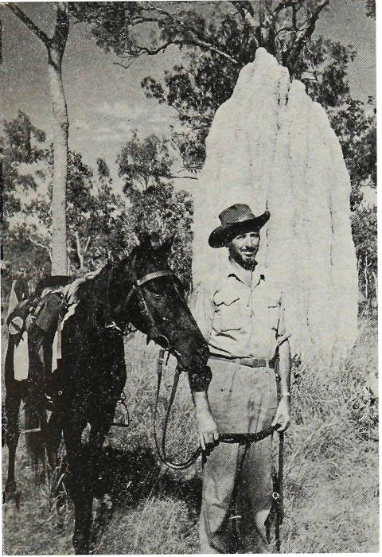
Expedition leader poses near large "magnetic" ant-hill a few miles north of Batavia Downs Cattle Station, about 16 miles from Moreton. Horse is "Benzine" from Coen.
Photo: M. Rea
Slide 61 —We arrived at Moreton on the Wenlock (Batavia) River about 3.00 p.m. as planned on Friday, 6 July. The river crossing was about four feet deep. As this picture shows, the P.M.G. owned area is like a park with open spaces interspersed with large mango trees or various other trees. Mr. and Mrs. Dale Halbert welcomed us and were most co-operative and friendly during our stay. Mr. Halbert is the P.M.G. line foreman while Mrs. Halbert conducts the Non-Official Post Office and weather report station. It is interesting to note that Mr. Halbert and his staff maintain the only P.M.G.-owned airstrip in Queensland at Moreton.
Slide 62 — The cemented area seen here was once the under-house portion of the original Telegraph Station building. The flood marker shows 53 feet, which is about six feet above ground level.
During the last wet season, the nearby Wenlock River rose to about four to five feet over this site and the Halberts' were catching fish where this P.M.G. truck is standing.
Slide 63 —While at Moreton we camped underneath this high-set lineman's house (P.M.G. staff residence) which was located a few hundred yards from the Post Office and near ---
Slide 64 —this grave. The headstone and rails are made of hardwood and painted white. We could not discover who was buried there although locals believe it was a little girl and a lineman speared. by blacks many years ago.
Slide 65 —Here I'm checking our maps against the distances shown on the Moreton sign posts, i.e.:
Ramage 120 miles
Bramwell 22 miles
The Top 147 miles
Coen 120 miles
I calculated we had travelled 120 miles from Coen to Moreton in six days on an average of six hours riding time daily.
Slide 66 -The expedition members waited at Moreton for a few days in order to contact Mr. R. Heinemann. owner of Bramwell Cattle Station, 22 miles north of Moreton. Our plan was to finalise the hiring of a plant of horses for our final stage of the journey to the top. Mr. Heinemann was away mustering stock and it was not known exactly when he would return, but he was expected at any time. In the meantime, Mrs. Heinemann invited us out to see the Station. On the way we saw these two swamp black snakes fighting on the roadway. They were so engrossed in their combat that I was able to creep to within a few feet of them for this photograph. They were probably Black Whip snakes (Denzansia olivaeea)s and were in territorial conflict or perhaps pre-mating behaviour.
Slide 67 —After negotiating the very rough and twisty roads to the property, our vehicle turned into the "house paddock" seen here. The huge red anthills guard the entrance like silent sentinels. The house, typically high set on ironbark stumps with galvanised iron walls and roof was none the less cool during the day and fairly warm at night. Eating is done on the ground floor level, which is cemented, while guests and owners sleep upstairs. A tour of the house, gardens, stockyards, was of great interest to each of us. It was obvious to us that Mrs. Heinemann enjoyed having visitors at her home which is one of the most northern privately owned stations in Australia.
Slide 68 —The next day. Mr. Heinemann arrived back with his mustered stock and by negotiations we were able to hire 15 horses from him. However, before these animals could be "rounded up" we had a day or so to wait. There is no rush in that country. What can't be done today is done tomorrow. As a result, I saw no one with hyper-tension symptoms. Therefore, we decided to spend au entire day assisting the Heinemann's cull, earmark and brand, the
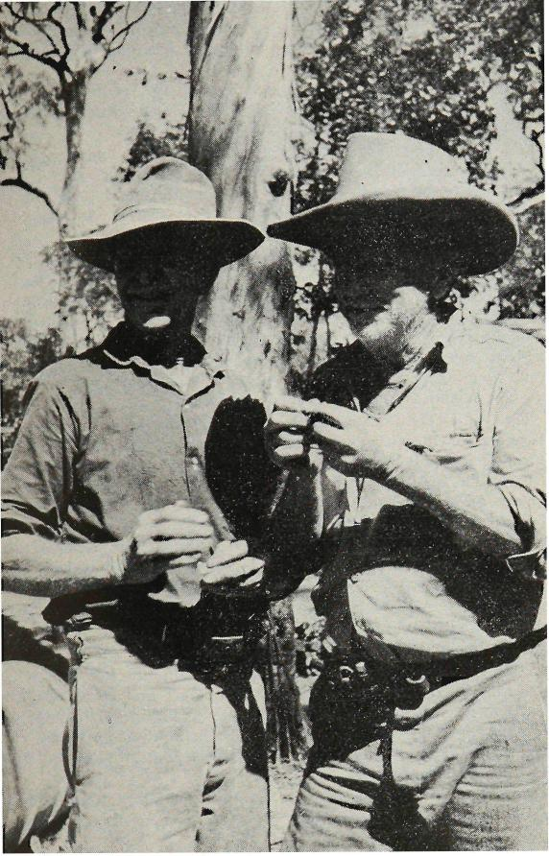
Typical bushmen of the North.
Roddy Heinemann and his brother "Cush" at Bramwell Downs Station.
Photo: M. Rea
newly mustered stock. This slide shows Mr. Roddy Heinemann and his brother "Cush" who are typical "old timer" bushmen with their battered hats, riding trousers and boots and pouched pocket-knife and the inevitable rolled "durry"9.
Slide 69 —Here are some of the huge beasts mustered into the stockyards. They were a mixture of several breeds — probably early Short Horn and Devon and later Hereford, Brahman and Drought-masterlo.
Slide 70 — The aboriginal stockmen have this young steer down for branding and earmarking. Some interesting sequences for the movie documentary were shot during these activities.
Slide 71 —The larger animals were run into this crush for branding. Some of them were quite wild and difficult to handle. We soon learned it was unwise to stand in the main yard with the stock as many will charge without any provocation. So we sat up on the rails.
Slide 72 — After completion of the day's work we returned to Moreton. The next morning, Tuesday, 10 July 1973, we farewelled the Halberts at 7.15 a.m. and rode our horses the 22 miles to Bramwell, arriving at 1.30 p.m. Upon arriving we received an invitation from the Heinemanns' to stay the night as their guests. This proved to be an enjoyable experience and the following morning this photograph was taken of the entire household. Reluctantly we farewelled our new friends and again headed northwards.
Slide 73 Ted Knauer pulls down the telephone line north of
Moreton for me to make a telephone call to Mr. W. G. Hagen, retired Telephone Foreman Mechanic who was celebrating his 100th birthday in Brisbane with members of the Post Office Historical Society of Queensland. The date was 10 July. Although almost deaf, he was able to hear my voice clearly and later told me he really enjoyed receiving the call. (Mr. Hagen is now deceased).
Slide 74 —This bark "hut" was used by drovers to keep their camp-fire dry during wet weather. We made our camp 17 nearby on the North Alice Creek. It rained all night and made this camp somewhat miserable especially as the next day two or three horses misbehaved badly. The light rain continued all day.
Slide 75 — However, we reached the Dalhunty River by 11.30 a.m. in spite of our handicaps. The Manager and Head Stockman of Comalco Station were waiting (by pre-arrangement) to spray our animals for cattle ticks. Comalco have endeavoured to keep their large pastoral holdings tick free and request that all stock travelling the perimeter be sprayed.
Slide 76 — This view of the beautiful Dalhunty River with its rocky bottom is unforgettable. Bradford was at this spot on 31 July 1883.
Slide 77 — After leaving the Dalhunty we passed through heath country with its low "turkey bush" stretching for miles. White magnetic ant hills protruded at intervals above these bushes to give the termite portals a "fairy castle" appearance. Finally we came to the Skardon River (called Cockatoo Creek locally), the site of the old McDonnell Telegraph Station. The Skardon River is, in my estimation, one of the most beautiful rivers I've ever seen in my life. All that remains of a large station building (located on the north bank), fruit trees and garden are a few wooden stumps, and water tanks as seen in this slide. My horse is standing in the middle
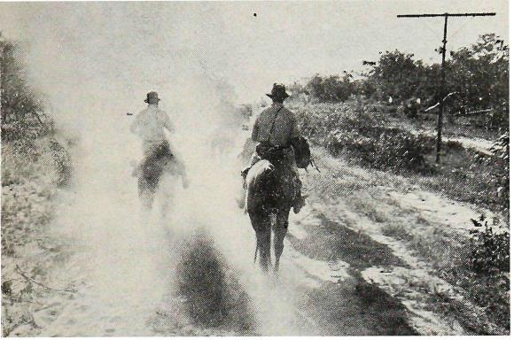
"Bull-dust" rises over the heads of horsemen of the Cape York Historical Expedition
in the far northern section of the Peninsula.
Photo: Bob Anthony
of the site of the old building. In 40 years the area has become overgrown with tropical trees and grass.
Slide 78 — After leaving the Skardon our journey led us across many creeks, ridges and low level open forest. We were very excited to see the sea in the Gulf of Carpentaria from one of those stony ridges about 10 miles north of the Skardon. The latter portion of the 18 mile section travelled was very dry until we reached this P.M.G. lineman's campsite on Canal Creek. Drums on which to sit, a roof over our heads and plenty of clean sweet water helped to make this site one of the best camps in the entire trip. The date was 13 July and the camp was number 19.
Slide 79 — Here you see me enjoying a swim in the rocky pool of blue water. The entire party spent a couple of hours swimming, washing and filming in this pool. It was better than any private pool or public swimming baths. Hunger for the evening meal finally terminated our recreational activities and we returned to the camp site nearby.
Slide 80—The next day we climbed a high stony range then descended gradually for about three miles, crossing several clear running creeks, a wooden bridge, more heath country, more stony and some sandy ridges, cut a crossing across a steep sided deep canal, before arriving at the Jardine._ River. About 4.00 p.m. Here the horses are resting on the south bank while we explore for a suitable camp site. We finally decided on one near the road crossing, a couple of miles up the river.
Slide 81 — After spending an enjoyable night at the Jardine, early the next morning Ted and I rode back to the telephone line to call Bamaga to obtain details about accommodation for the men and
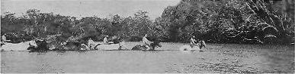
Crossing of the Jardine River. Bob Greenfield leads, followed by Ron Reny,
Ted Knauer and Dick Lakey.
Photo: Bob kuhony

horses. Here you see the portable telephone across my shoulder while riding "Starlight" on the wide sandy shore of the river near our camp.
Slide 82—After checking the depth of the 200-300 yard wide Jardine River we drove the horses into the water with some difficulty and swam them across while our cameraman took movie film. This scene shows the horses entering the water with Dick Lakey, Jim Green and Bob Greenfield keeping them bunched together. Our equipment was carried across by boat kindly provided by a party of Victorian fishermen. They also provided us with some large barramundi fish caught downstream. Cooked over the open fire it was delicious.
Slide 83—This is the muddy exit awaiting us on the other side. However, the stock was crossed over safely even though the river was running fairly swiftly. No equipment got wet or was lost and harnessing proceeded as normal on the north side of the river. As we had been advised, the desire to spend many leisure hours at places like the Jardine crossing would increase the further north we went, was found to be true. The entire party was anxious to spend more time at the many beautiful spots in the far northern portion of the Peninsula than our schedule allowed. However, we had to push onwards and northwards.
Slide 84—The terrain north of the Jardine changed greatly from the land further south. The soil was mainly sandy, trees were stunted, hills were low and many swamps were seen. This is a typical scene of the area near the Jardine which changed eventually to the long sandy undulating plains and stony ridges. However, before we emerged from the low level plains we had difficulty following the telegraph line through swampy sections. I have the highest praise for Bradford and his men who without maps, roads or lines negotiated this treacherous country.
Slide 85 — Our arrival at the outskirts of Bamaga was heralded by many aboriginal children staring at us, waving or calling out to us as we passed. The redness of the soil, the intense green of the tropical foliage and the orderliness of the settlement impressed us. Accommodation was provided by a number of friendly Post Office and Department of Aboriginal and Island Affairs people. The Department of Aboriginal and Island Affairs paddocked the horses and provided a stockman. This is a line-up of the expedition in front of Mr. Pegg's residence opposite the State Government Motel.
Slide 86—Our journey was not finished at Bamaga. We still had another 15 miles to reach the site of the Cape York Telegraph Station. The final stage of the mainland journey began on Monday, 16 July. Here we see the expedition proceeding along the north road out of Bamaga past the Kindergarten, bakery, butcher, open air movie theatre and private houses. Dozens of Aboriginal and Islander people stood in front of shops or houses to see us pass.
Slide 87 —From this. view we see the old telegraph line now inoperative (as a radio telephone system operates between Bamaga and Thursday Island) cutting through the jungle. Fortunately the swathe cut by linemen either side of the line was still rideable although grass and bushes were up to six feet in height. Once over the first hill we could see the blue ocean from there and were excited at the prospect of reaching our destination later that day. One hazard encountered was the vicious yellowish-green wasps (Ropalidia romandOn which make a ball shaped paper nest in the trees. Most of us were stung as our horses pushed aside bushes and tall grass.
Slide 88—The pole line was very difficult to follow from about four mites north of Bamaga as it zigzagged across ridges through the bush, because the wire had been dismantled years ago and vegetation grown up between the poles. Several times we lost the direction of the line and only after scouting the area, relocated the thin iron poles. This slide shows Dick Lakey following the pole route.
Slide 89—Finally after viewing some World War 2 army camp sites and dumps, we emerged from a bush track on to the beach Parisand 'Bay where the undersea cable joined the Cape York Electric Telegraph Station with Thursday Island. The promontory in the distance is the tip of Cape York itself. It was the first time our horses had been on a beach and they showed some alacrity to moving near the water.
Slide 90 —This is all that remains of the Cape York Telegraph Station—scattered sheets of iron, rusted galvanised tanks and half burnt or rotted timber and hundreds of bottles. What cyclones haven't destroyed, bushfires have. The only relic still standing is a tall coconut tree probably planted by the early telegraphists. Cape York previously called Paterson after the Postmaster-General, the Honourable MacDonald Paterson was opened on 25 August 1887. The cable ship Recorder laid an undersea armoured cable 18 sea miles across the Strait to Thursday Island via Horn Island by 15 October 1886 at a cost of £10,000.¹² The present state of this station is a sad ending to a once important link in the unique telegraph system of this Nation.

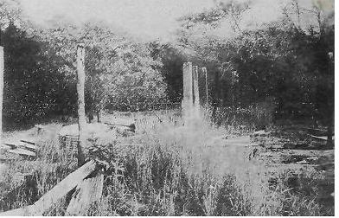
All that remains of the Cape York Telegraph Station. Cyclones and fires have completed the ruin.
Photo: Af. Rea
Slide 91 — As water was scarce near the station site we turned away and spent the night camped on a small headland near a tin miner's house about a mile along the beach. This was the last night we were to spend together in camp (No. 22) and it was befitting I think, that a bright moon should illuminate the scene of a long white sandy beach with gentle waves breaking on the shore. As I lay in my blankets on the ground. I reflected upon the exigencies and difficulties of the trek and realised we had travelled over 450 miles without a serious mishap or loss. It was with delight and satisfaction that I gazed again upon the shining beach and the dark islands in the distance. Indeed, the magic scene conjured up by the soft moonlight was a sight I'll never forget. The night had hardly gone when this beautiful view of the islands and the sea emerged with the rising sun. It was nature's grand finale to the beautiful scenes presented to us as each act was unfolded throughout the entire expedition.
Slide 92 —Our return journey by horseback across country between several ranges to Lockerbie Cattle Stational where Freak Jardine spent his last days was rough in places. These aboriginal stockmen took charge of our horses while harness and equipment were placed in trucks to be taken back to Damage. Due to the courtesy of the Department of Aboriginal and Island Affairs, who control the large reserve of the northern Peninsula area, the Manager, Mr. Shane O'Connor and several of his staff conducted us on a tour of inspection of Lockerbie and Somerset.
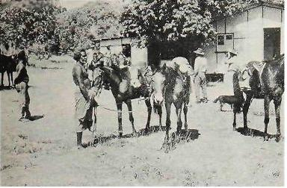
Aboriginal stockmen at Locke:hie Station—the end of the journey by horse.
Photo: M.. Rea
Slide 93—Here are some of the trees at Lockerbie planted by Jardine around his homestead. A tall coconut was used as a lookout for hostile natives.
Slide 94 —This grove of coconuts at Somerset was also planted by Jardine. The effort required to knock down a coconut from these tall trees must be the reason why the green coconut juice is so sweet —it's a reward for hard work. Caretakers are located at Somerset as many historic relics of the last century still exist — monuments, cannons, anchors, graves, fresh water wells, bathtub, cave paintings etc. Somerset dating back to the mid-I860's, when John Jardine (father of Frank and Alick) was appointed the first Government Resident's must be one of the most interesting and beautiful places in Australia.
Slide 95—The original residence was set on the cliff top and had a commanding view of Albany Passage. The cottage presently there, although lower down the hill, is nevertheless in a very beautiful and strategic position. This slide shows me in front of the caretaker's house near two small cannons. Jardine's old bath is used as a water container at the rear of the dwelling. Unfortunately, our tour of Somerset came to an end all too quickly and we had to return to Bamaga. Our trip back was by motor vehicle through cool vine forests and recently developed tropical stock pastures. Plans are in hand to raise beef cattle on Lockerbie as is done in some other aboriginal reserves.
Slide 96 —Our final stage of the Cape York Expedition was by motor launch from Red Island Point near Bamaga to Thursday Island. This scene shows our equipment being loaded aboard the 50.foot motor vessel at the Department's jetty. The three-hour journey took us through the sapphire-blue waters of Endeavour Strait between Possession (Cook's landing spot) and Entrance Islands, the Boat Channel and between Prince of Wales and Horn Islands to Thursday Island.
Slide 97 — Here we see Thursday Island from the launch just before we docked at 3.40 p.m. on Wednesday, 18 July 1973. We had reached the end of our journey exactly 29 days after setting out from Fairview on horseback on Monday, 18 June 1973. The expedition had been successful —* we'd travelled more than 450 miles by horseback along the route of the Electric Telegraph line. our journey had captured the imagination and interest of thousands Australians especially Queenslanders, through mass media publicity. we'd built a monument to Bradford and his men, the surveyors and those who erected the Cape York telegraph line.
we'd documented our experiences on film and paper.
gained great personal satisfaction from our very rewarding experiences.
proved that the 20th Century man has as indomitable and adventurous spirit as his 19th Century counterparts.
POSTSCRIPT
The party members returned by air to Cairns where the motor vehicles were collected.
REFERENCES AND ACKNOWLEDGMENTS
- JACK, Robert Logan — "Northmost Australia" The Cape York Telegraph Line 1883-7 Chapter 88, page 662.
- BRADFORD, John R. — "The Cape York Expedition of 1883" p.1016 read before Royal Historical Society of Queensland 27 June, 1937. JACK, Robert Logan — "Northmost Australia" The Cape York Telegraph Line 1'88341 P.655.
- "Thursday Island" archival box, Post Office Historical Archives, A.P.O. Administrative Centre, 131 Barry Parade, Fortitude Valley, Qld.
- JACK, Robert Logan — "Northmost Australia — The Cape York Telegraph
Line 1883-87" p.655.
- MONTEITH, G. B.Sc. — Curator of Insects, University of Queensland, St. Lucia, Brisbane, Qld. (provided scientific names and other details).
- WILSON, M. M. Dr. — Department of Geology and Mineralogy, University of Queensland, St. Lucia, Brisbane, Old. (provided explanations of cause of "melon holes").
- COVACEVICH, Jeanette A. — Curator, Reptiles and Amphibians, Qld. Museum, Brisbane, May, 1974.
- Australian slang term for cigarette.
- WYTHES, Jennifer Miss — Beef Cattle Husbandry Officer, Department of Primary Industries, Brisbane, Old.
- MONTEITH, G. B.Sc. — Curator of Insects, University of Quensland, St. Lucia, Brisbane, Old.
- Report of the Post and Telegraph Department of Queensland for the year 1887 — presented to both Houses of Parliament by command (2 July, 1888) by John Donaldson, Postmaster-General p.25. (Paterson-Thursday Island link actually opened 25 August, 1887).
- JACK, Robert Logary, "Northmost Australia" Somerset and its background Ch. 47 — "Frank Jardine . . . took up Bertie Haugh in 1887, afterwards started two outstations, Lockerbie, on the Laradunya Creek and Galloway on Black Gin Creek" p.345.
- JACK, Robert Logaw— "Northtnoat Australia)"`;—Somerset and its back.-ground Ch. 47. "Mr. Frank Jardine planted coconut trees on an area at Somerset itself" P.342.
- Ibid — pages 340-341 — John Jardine First Resident 1863-1865.
BYERLEY, Frederick J., Engineer of Roads, Northern Division of Queensland "Narrative of the Overland Expedition of the Messrs. Jardine from Rockhampton to Cape York, North Queensland" 1867. Introduction page 11.

