This the Blasting Stage of the Cobar to Ceduna Coaxial Cable Project with Project Manager John Cooper explaining the type of rock encountered as it was impossible to rip it with the D9 Ripping Tractors so they had to resort to using Track Drills so the Blasting is to follow.
The holes are drilled four feet apart, and the operators work as a two man crew.
Each hole takes five minutes to drill to a depth of nine feet.
Cotton waste is placed into the hole to prevent moisture or dirt filling the hole.
First thing in the morning, they line the truck over the trench, and the hopper is loaded with ammonium nitrate and has two drums, one with diesel and the other with a sensitiser.
Each hole has a length of cordex which is pushed to the bottom of the hole, then it is secured in place when the hole is filled with Amonium Nitrate.
They turn the handle sixteen turns at each hole, and this is around sixteen pounds.
Each of these holes are connected to a branch line that is connected to the main trunk.
The cordex burns roughly at a speed of three miles a second.
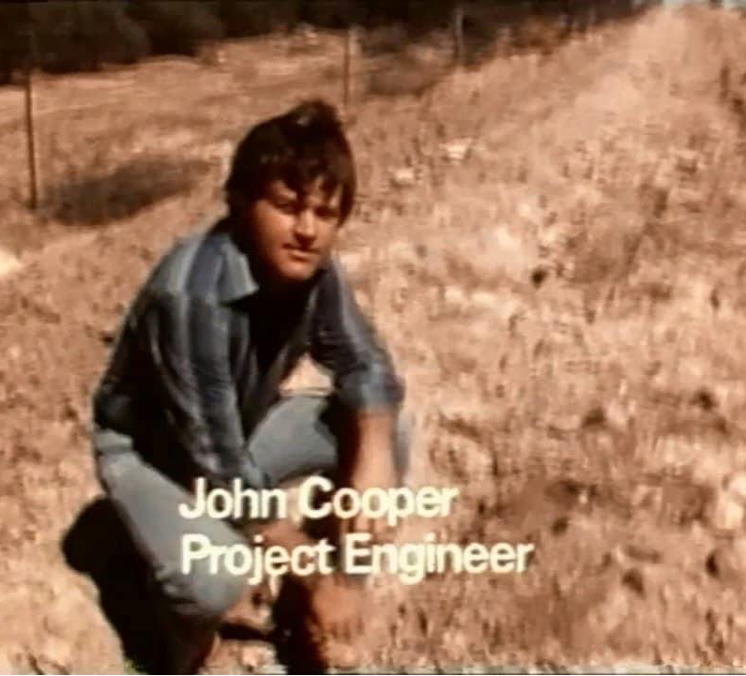
Project Engineer John Cooper talking about the type of rock that they have encounter on the West Coast that has proved difficult and cannot be ripped with the D9 Ripping Tractors.
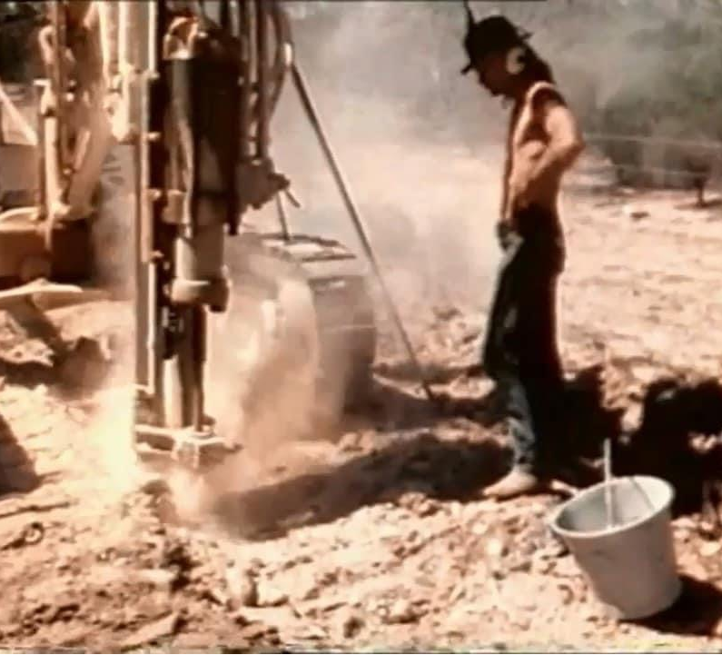
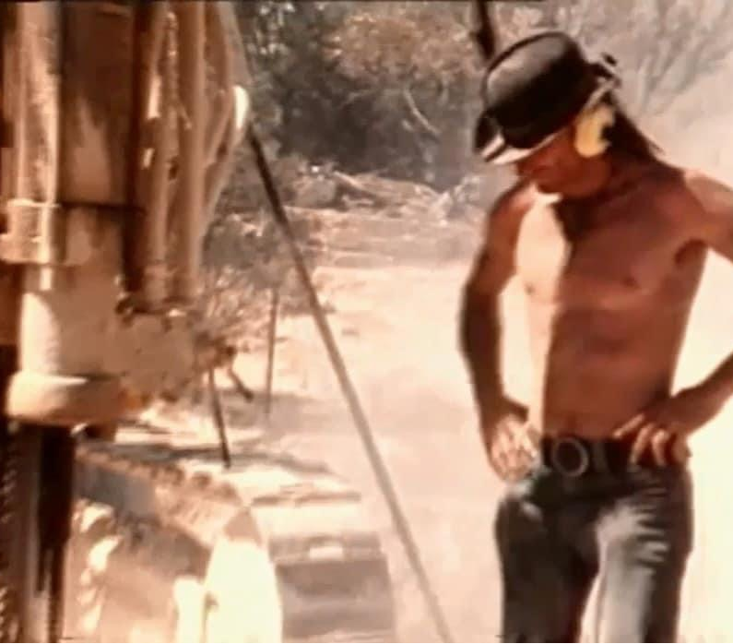
Ian (Slack) Williamson
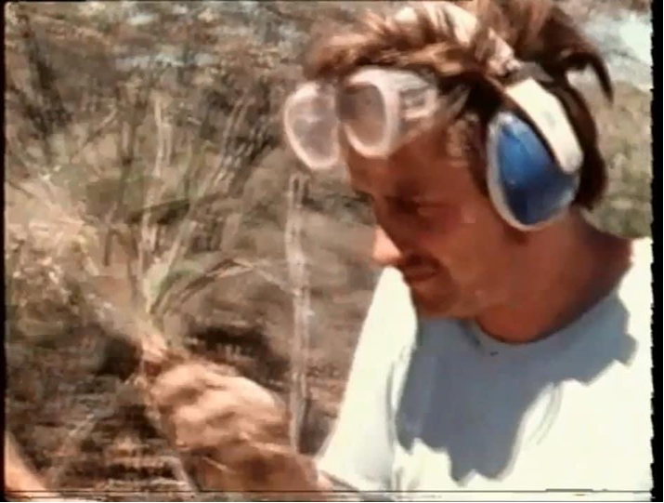

Ron Hendrikson
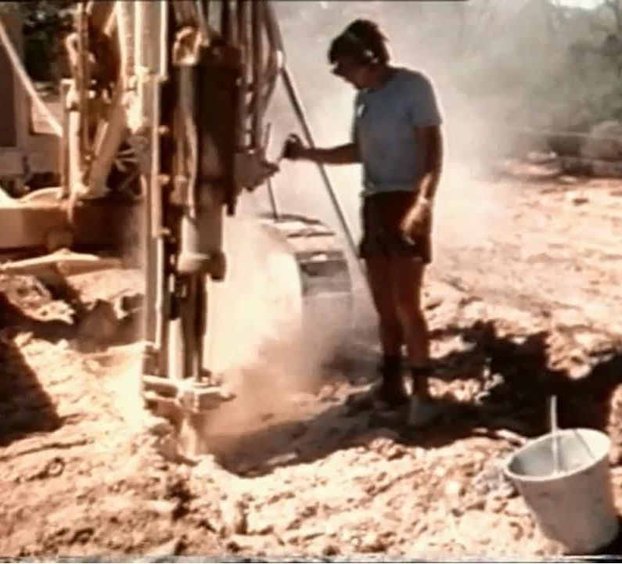
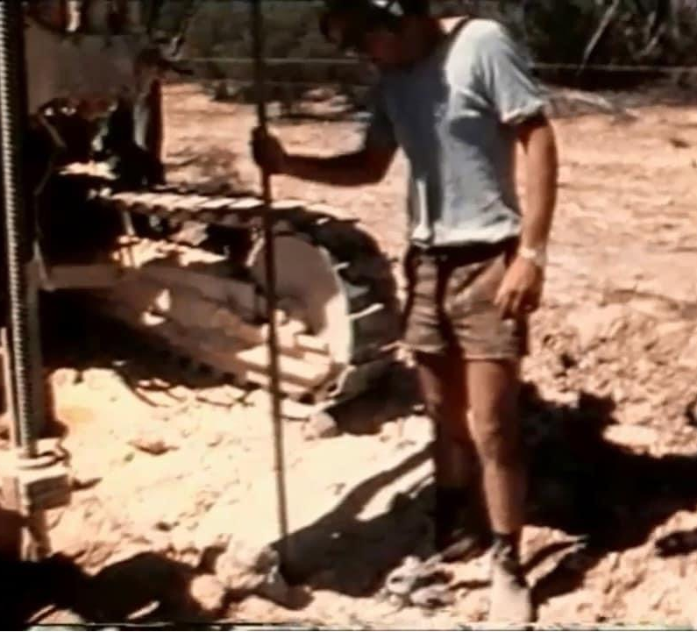
Tamping in the cotton waste
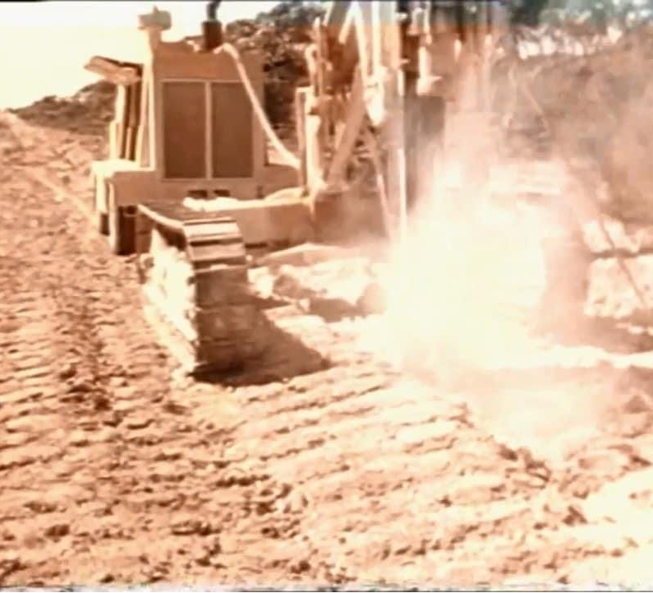
Air Compressor and Track Drill
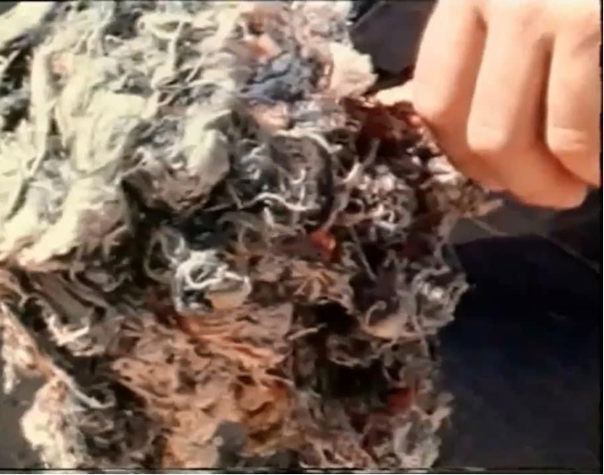

Cotton waste
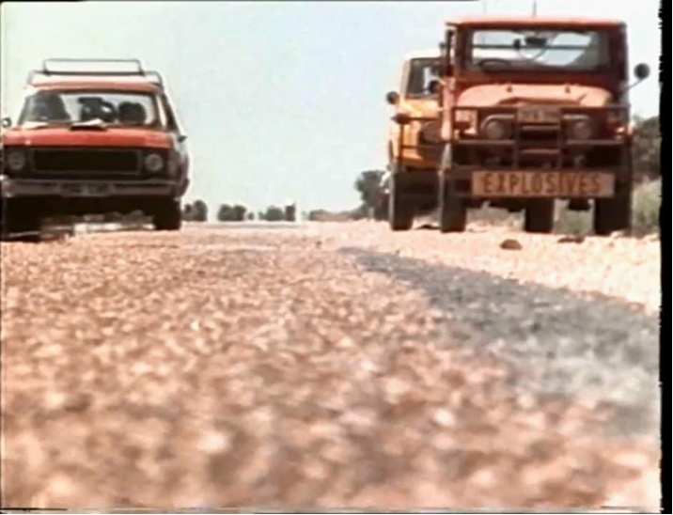

Types of vehicles used for placing signs out when it was time to close all traffic along the Eyre Highway.

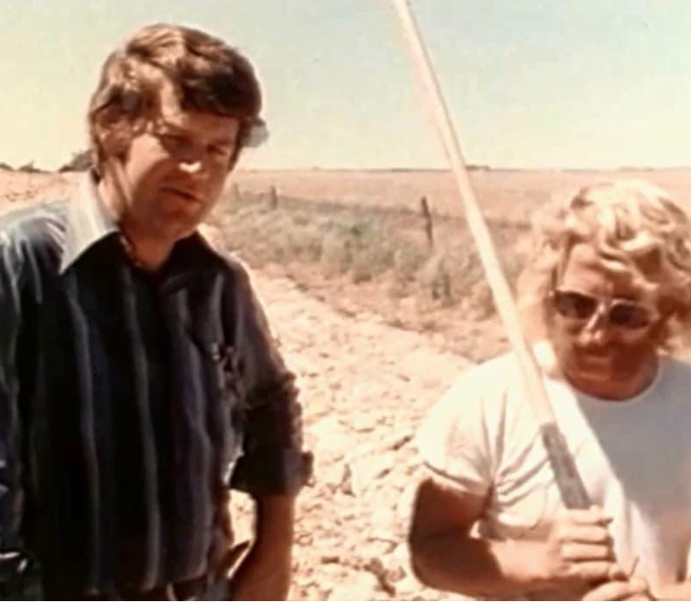

John Cooper with Peter Wagner The Shot Firer.
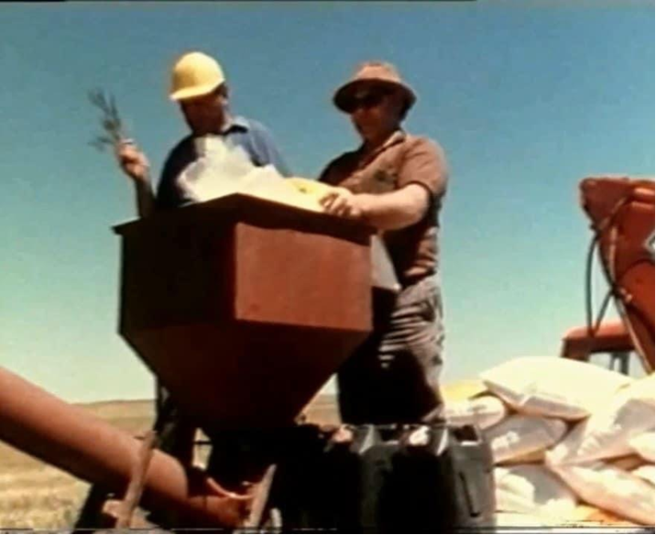

Loading hopper with Amonium Nitrate
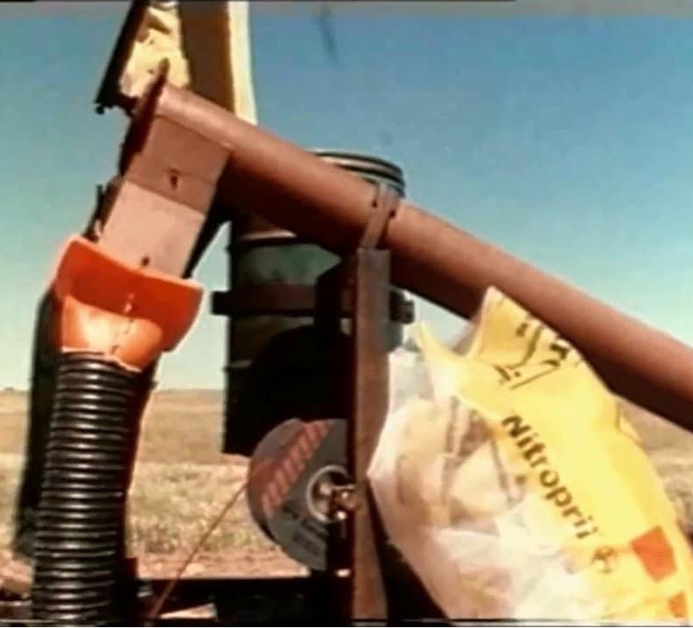
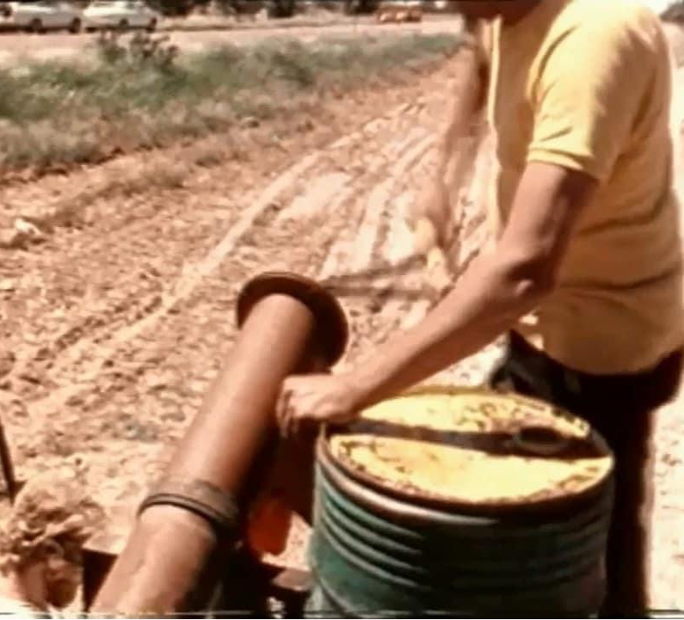
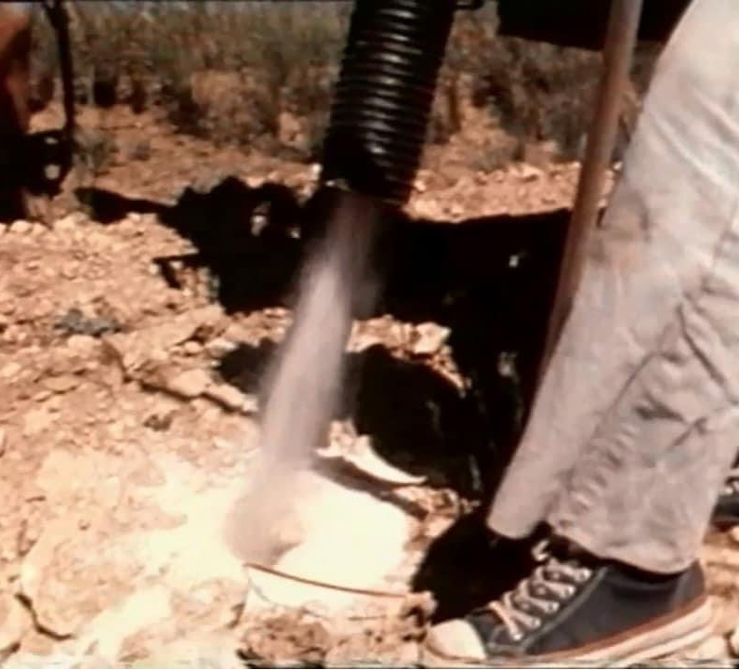

Hopper dispensing Amonium Nitrate

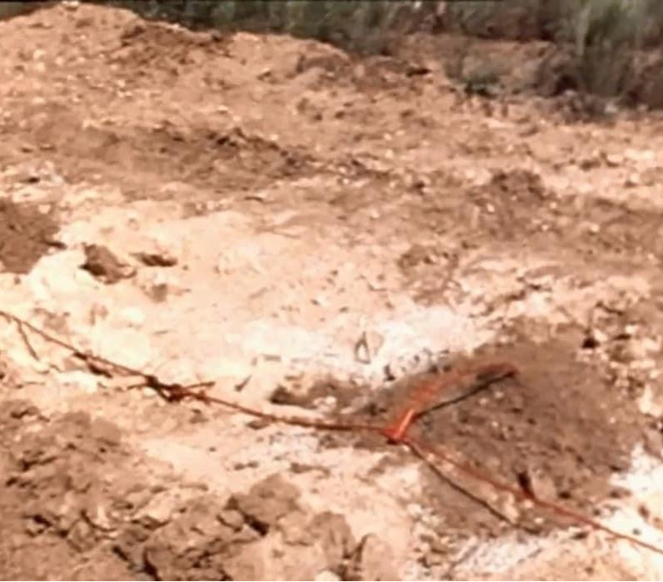

Picture showing the loaded hole branch line connected to the main trunk.
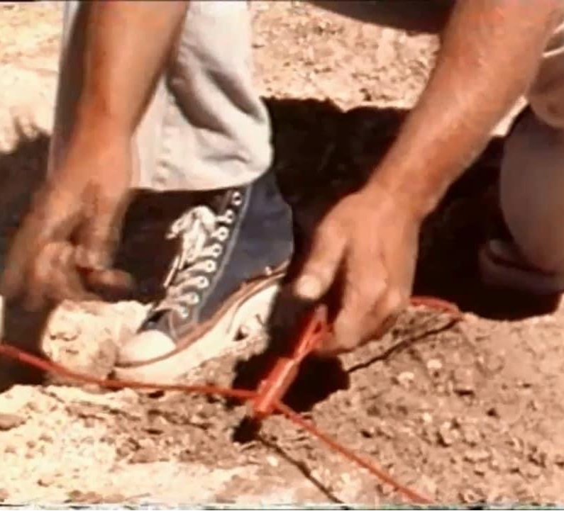
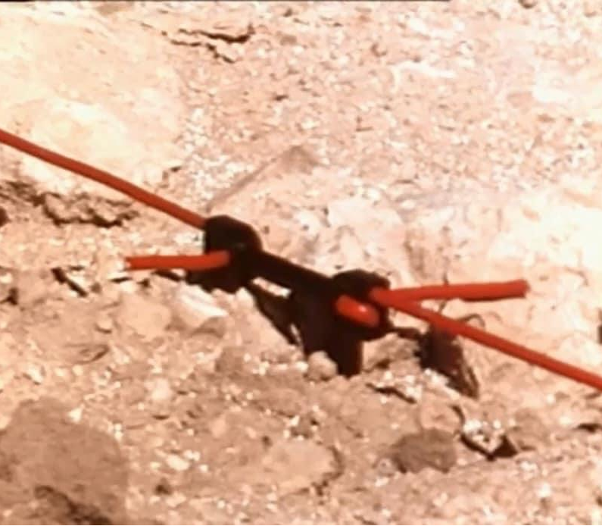
Branch Line (Hole loaded with Amonium Nitrate) connected to Main Trunk

This delay has two number eight detonators with a delay element.
The cordex sets off the detonator then the delay element on and off, and the other detonator ignites the cordex so it is able to travel along to the next two number eight detonators and the delay element.
This process continues this way all the way along until it reaches the end of the holes to be blasted.
One vital operation is never neglected is the test burning of the safety fuse.
A length fuse is cut and tested as it should take between ninety to one hundred and ten seconds to completely burn which was spot on.
So a Iength of four feet nine inches is cut and the detonator will be placed on it before the blast.

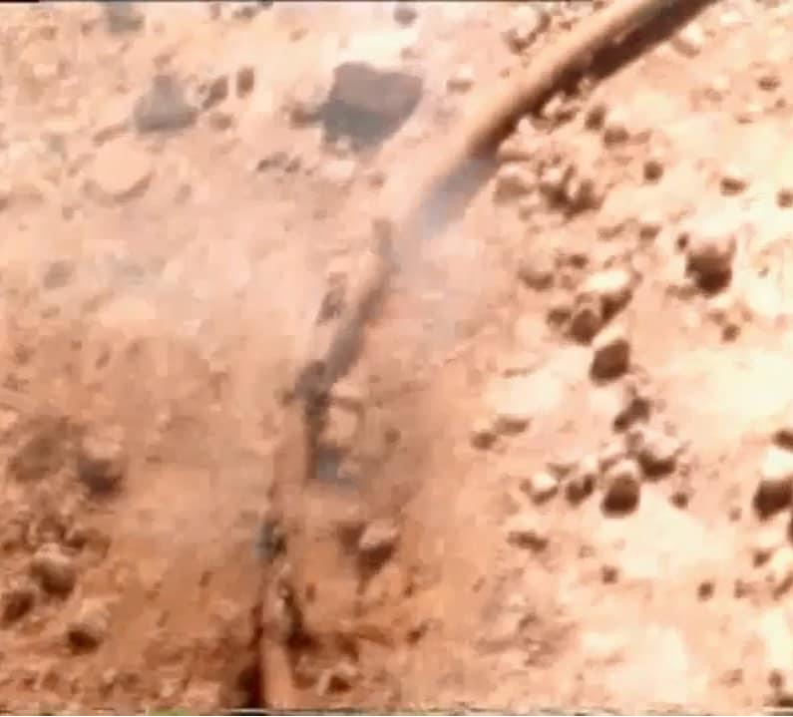

Safety fuse test burning.

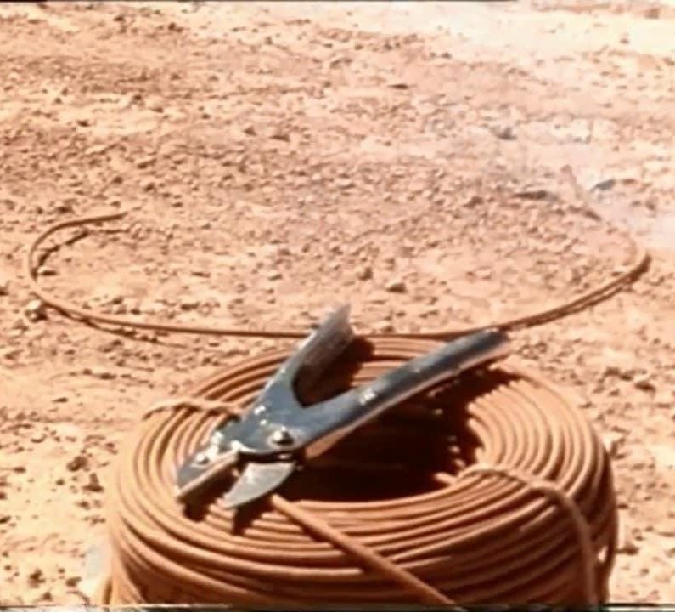

Safety fuse coil

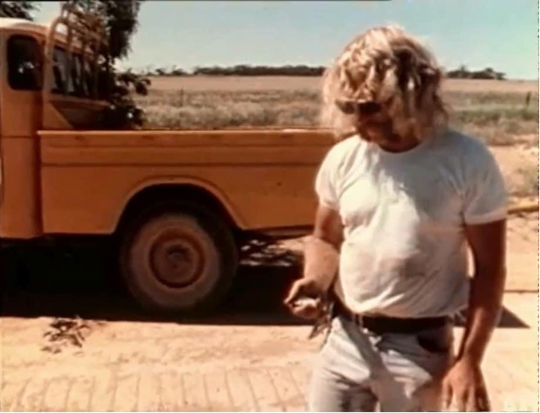
Shot firer timing the safety fuse test burn

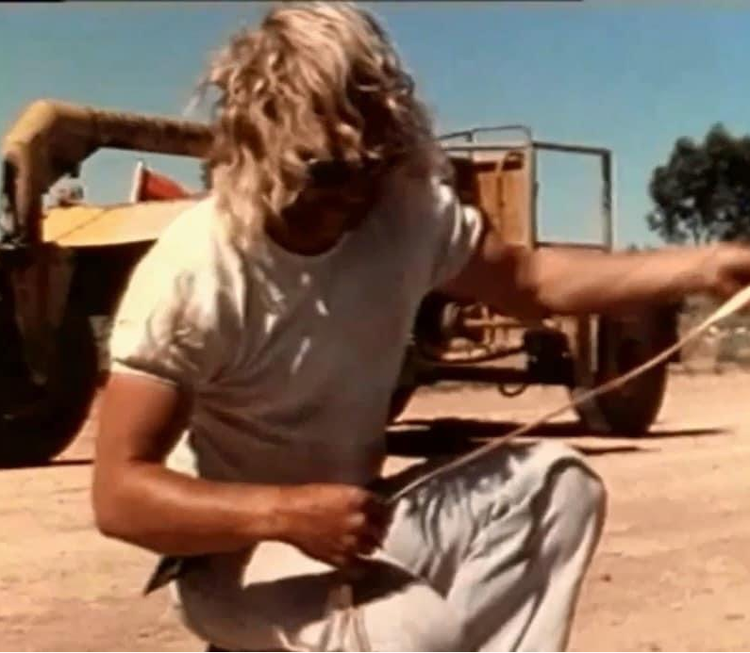

Measuring four feet nine inches, this will have a detonator placed on it just before the blast allowing the shot firer sufficient time to get to a vehicle and travel to a safe distance away.
