The Series 800 Telephone and How to use it.
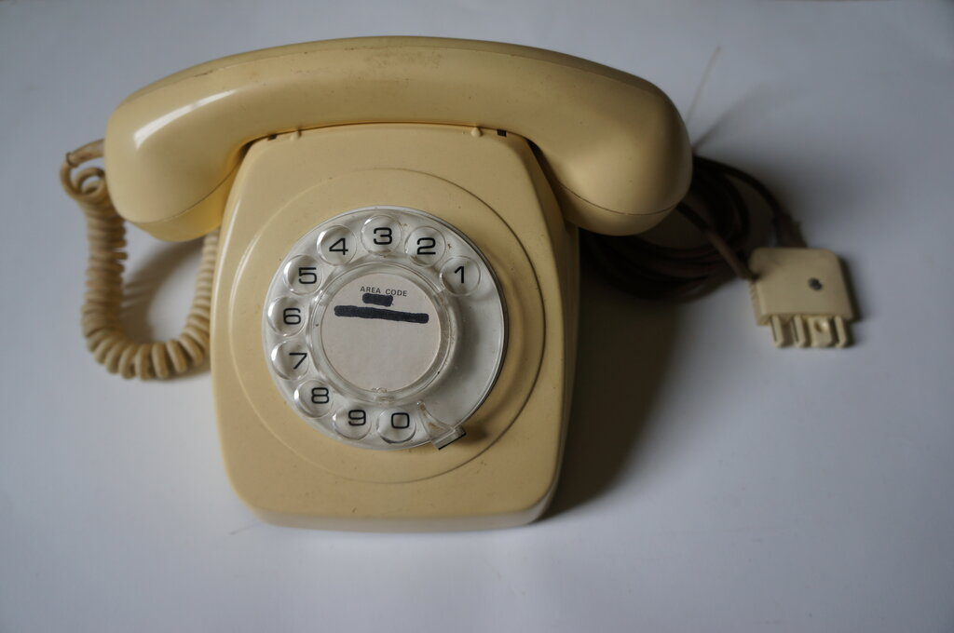
The Series 800 phone was released in Australia in 1963 and was issued until the mid 1980's. It was a replacement for the existing bakelite series 300 and 400 phones which had been standard issue for many years.
The external design of the 800 was taken from a telephone used in Belgium, but the internal design is entirely Australian. With the casing made of plastic, it was possible to produce the phone in various colours at no extra cost.
The PMG, and later, Telecom, advertised it as the "Colorfone". The 800 was only ever made for automatic and C.B. working. There was never a 'modern' telephone for magneto services, with existing instruments retained and reconditioned right up until the end of manual exchanges (1980).
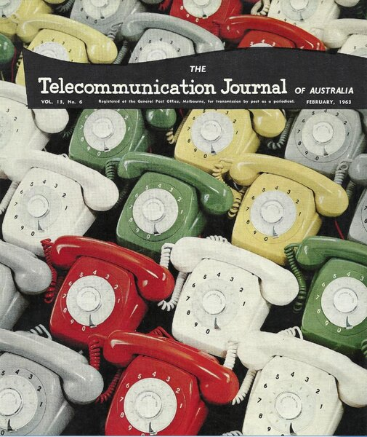
Electrically, the 800 series had several improvements over the bakelite 300/400 series instruments. Automatic current regulation was incorporated so that the phone could be used on long and short lines with no modification.
Prior to this, it was necessary to connect a 330 ohm resistor in series with the phone on short lines to keep transmitter current to a safe level.
A six pin plug (type 603) and socket (type 610) was used with the new design. This allowed greater flexibility with configuring the phone to work with different wiring plans, compared to the previous four pin plug and socket - which was only used with portable services.
Until now, the 300/400 series phones were connected permanently to the line via a 20/4 (20 bar 4) terminal block, unless a portable service was installed.
With the introduction of the series 800, all phones would be connected via plug and socket. If for some reason the connection needed to be made permanent, the design allowed for the plug to be made 'captive'.
Previously, the 300/400 series used screw terminals with links to configure the phone for its intended wiring plan. The 800 series was built on a printed circuit board and used miniature quick connect lugs.
The plugs and sockets, patented by AWA, were made by Transpro (TP), and the cords were made by Bly. Until 1975, the line cords were three conductor as standard, and of the same colour as the phone. From 1975, cords were 'teak' coloured and four conductor.
Six conductor cords were available when required.
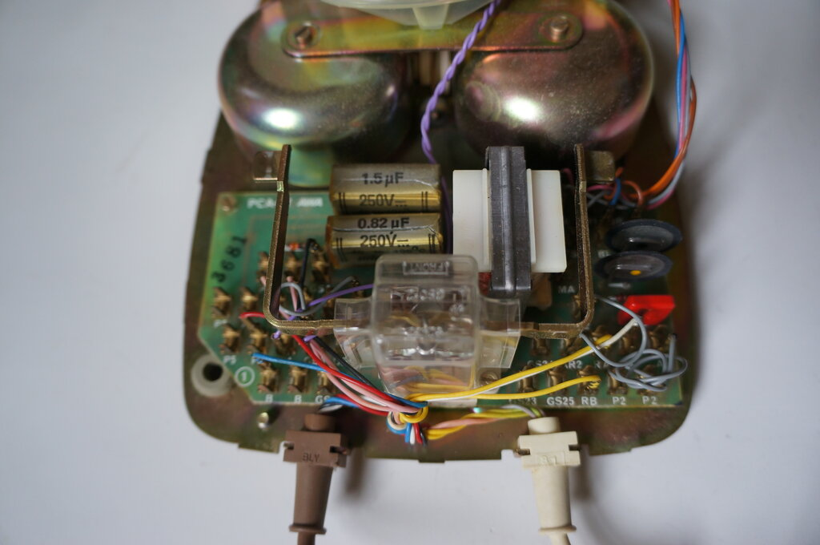
Internal wiring. Connections are made with quick connect lugs onto a PCB.
Several dials were used, initially made by STC, and finally by AWA.
The handset cord anchorage was improved in later instruments.
Commonly seen would be an 800 series phone with the individual handset conductors exposed when the clamp lost its grip.
This was just a simple clamp relying on friction against the cord grommet and was not very effective. Later design provided a special moulded grommet which engaged in slots in the clamp.
The transmitter was the same No. 13 type used previously but now fitted with quick connect terminals. Towards the end of the 800 series, an NEC manufactured solid state replacement had been developed, using a condenser microphone.
The receiver was the 4T rocking armature type, previously used with the 400 series handset.
However, a back-to-back diode assembly was now wired across it to prevent loud acoustic shock.
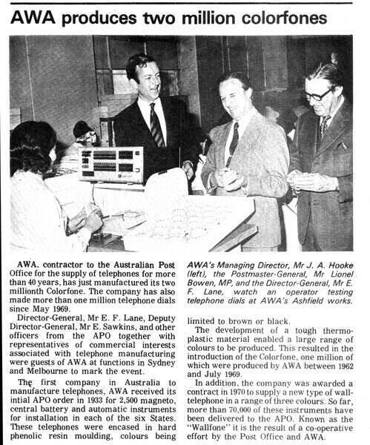
From Electronics Australia, October 1973. Two million 800 series phones were produced in 10 years.
Wiring of the 800 Series Phone.
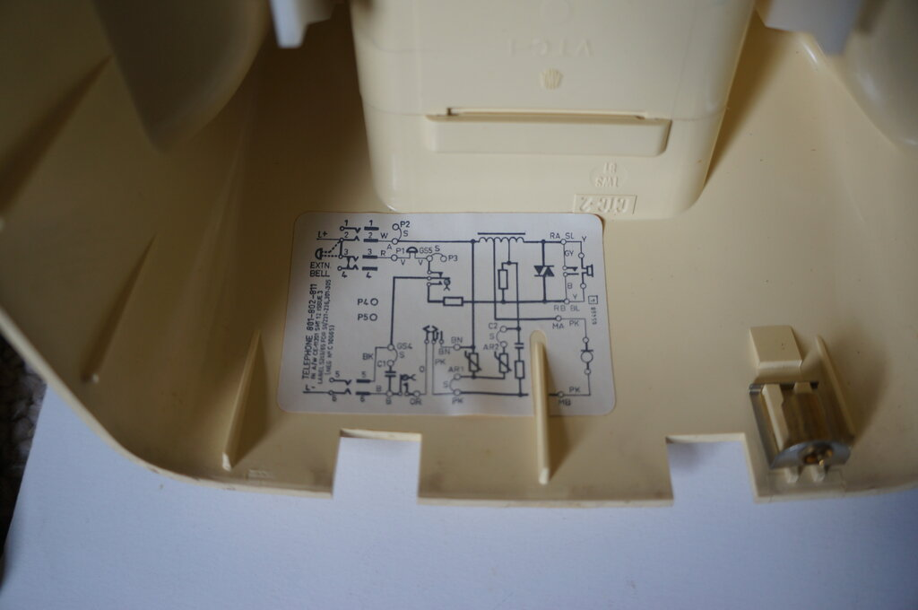
Circuit label inside phone casing.
(Note that this is a later model (from 1982) and has a four conductor line cord).
There were many wiring plans and configuration for the 800 series phone.
There were several types of parallel working, instruments fitted with recall buttons, hearing aid amplifiers, multi line variants, and so on.
In this article, we'll concentrate on the typical domestic instrument used on its own. For parallel working, some description is given here.
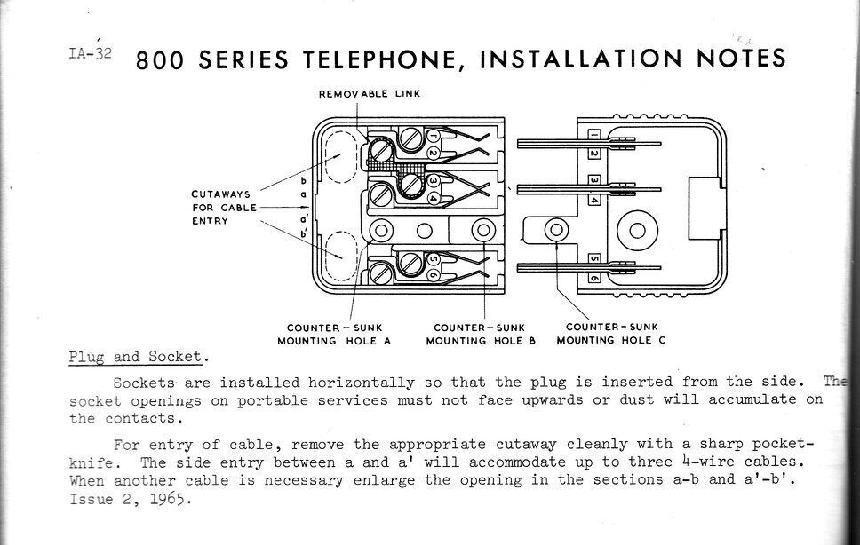
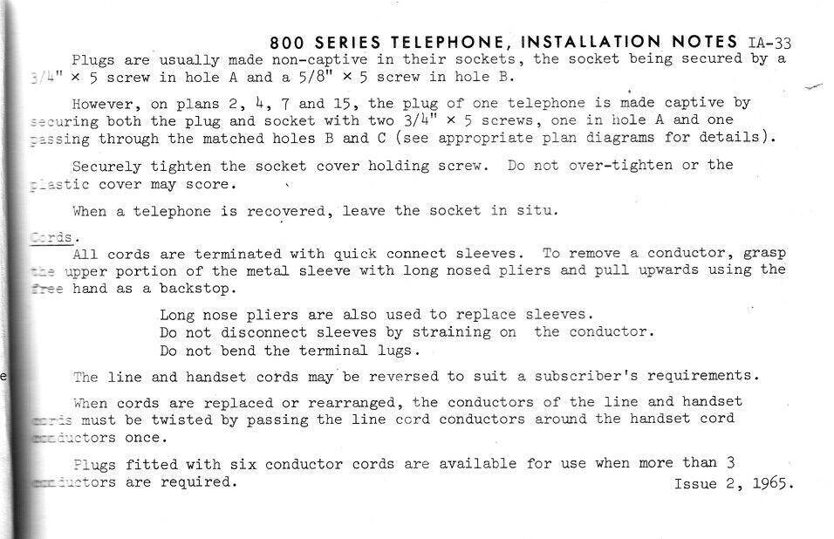

Getting your 800 Series Phone Working over the nbn.
The removal of exchange lines coming into a house are now at an end, any users of an 800 phone will be using it on a VOIP service, from a modem or ATA (Analog Telephone Adaptor). In Australia this is typically provided by the NBN.
This is where a lot of owners of 800 series phones have encountered problems.
There are two things to deal with. The most obvious is that VOIP services do not work with decadic dialling. They are DTMF only.
That means the loop disconnect pulses generated by a mechanical telephone dial are ignored, and it's only possible to accept incoming calls.
Therefore, an adaptor is required which converts the dial pulses to DTMF. The best known of these is the Dialgizmo, which is described further here.
With a Dialgizmo installed between the phone and the modem or ATA, it's now possible to dial out.
The Dialgizmo counts the dial pulses and generates the required tones.
No modifications are required to the phone, and for all practical purposes, what comes out of the Dialgizmo simulates an automatic analogue exchange line.
The Phone Doesn't Ring!
So far so good, but a very common complaint when attempting to use an 800 series phone is that it no longer rings on incoming calls.
To see why this is, and what to do about it, you need to look at the circuit of the phone.
Looking at the wiring plan below, we can see in this example it has a connected three conductor cord:
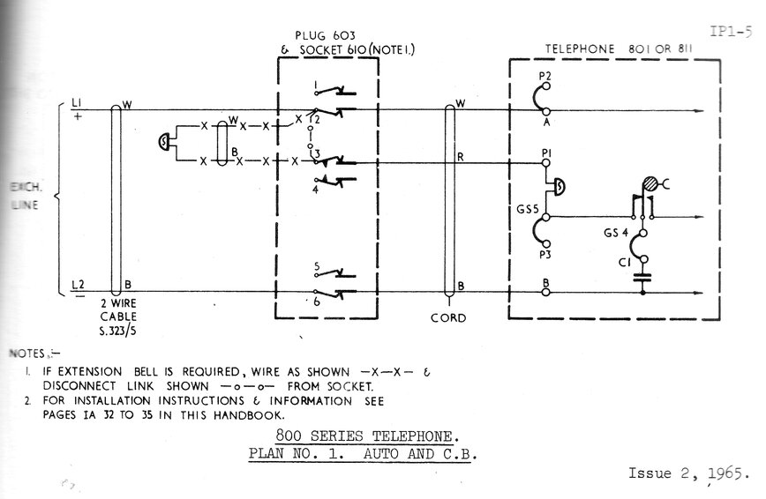
Plan No.1. Basic exchange line to single instrument wiring plan.
When a four conductor cord is fitted, the black wire connects to GS4 and pin 5 of the plug.
By default, there is a link in the socket between pins 2 and 3.
We can see that ring current flows from pin 2, through the link to pin 3, then to the bell via the red wire to terminal P1 inside the phone.
From the bell, current flows through the gravity switch contacts (closed with the handset on hook), through terminal C1 to the DC blocking capacitor, and out via the blue wire connected to terminal B and thence to pin 6 of the socket.
When an extension bell is fitted, the link between pins 2 and 3 is removed, and the bell is connected in its place. Connected, the extension bell is in series with the telephone bell.
The problem of the phone not ringing occurs because of two possibilities;
1) the phone was previously configured for parallel working, or
2), there is no connection between pins 2 and 3 of the socket.
If the phone has been set up for parallel working, it will either be as the first phone, or a second phone. For parallel working, one phone (the first phone) provides bell current to the second (and/or third) phone.
In the case of the first phone, the link between A and P2 will be moved from A to P1.
The red wire previously connected to P1 will now connect to GS5.
The link between pins 2 and 3 in the socket is removed, and the red wire is connected to pin 3.
If this phone happens to be plugged into a socket where the link exists between pins 2 and 3, the bell will be short circuited and the phone will not ring.
Aside from that, the DC blocking capacitor will be connected directly across the line, resulting in muffled speech.
If the phone was configured for parallel working, but as a second phone, the link between C1 and GS4 will be removed.
A and P1 will be linked, and the red wire will connect to GS4.
Again, this phone will not ring when plugged into a socket wired for a single phone, whether or not pins 2 and 3 of the socket are linked.
With the DC blocking capacitor out of circuit, no current can flow through the bell. See here for more on parallel operation.
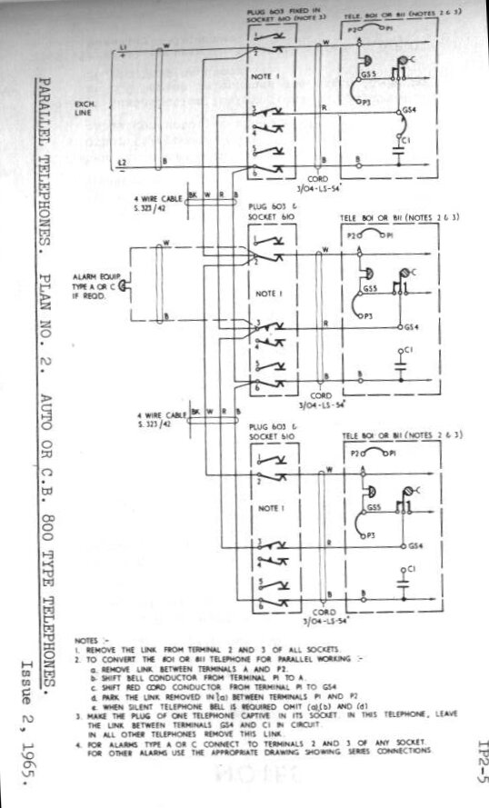
Plan No.2. Wiring for parallel connection of 800 series phones. Note the different configuration for the first and subsequent phones.
So, the first thing to do when using a single 800 series phone is to ensure that the internal configuration is as per the label inside the casing (or Plan No.1). The phone will then suit a 'normal' two wire service, as a single phone.
RJ11 to 610 adaptors.
Invariably, with a modem/ATA/Dialgizmo, or any other modern phone accessory, RJ11 connectors become involved.
This is the U.S. standard "modular" connector which has also been adopted in Australia in recent years.
So, to use your 800 series phone, you'll need an adaptor. And, this is where problems occur.
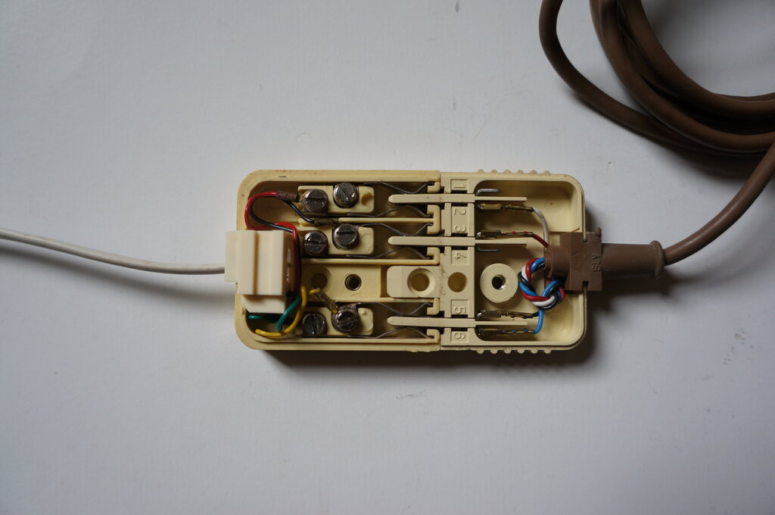
800 series phone plugged into an RJ11 to 610 adaptor. A problem exists!
Look closely at the above adaptor. You will note that there is a black wire to pin 3 in the socket. Since the modem/ATA/Dialgizmo will be wired for two wire working (only the red and green wires of the RJ11 plug are used), this black wire goes nowhere.
Immediately, we can see that with no connection between pins 2 and 3, the phone will not ring.
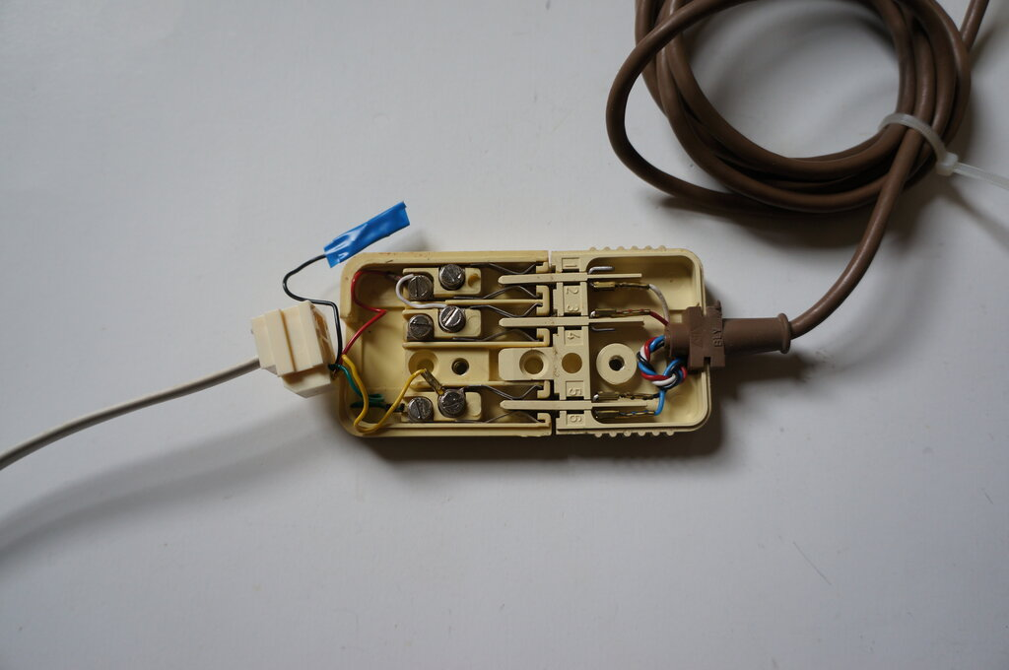
Adaptor modified. Note the white wire between pins 2 and 3. Phone will now ring.
All that needs to be done is to connect a link between terminals 2 and 3 of the socket.
The black wire could be left in situ, but just in case there was an internal connection in the modem, etc., it's probably best to disconnect and insulate it as shown.
Alternatively, if it's desired to configure an 800 series phone for genuine two wire working, connect the link which was from A to P2, from A to P1, and connect the red wire of the line cord to P2 (an unused terminal).
In this way, the phone will work in any 610 socket as long as the line is connected to pins 2 and 6.
Some 300 and 400 series phones were fitted with 603 plugs, and the wiring patterns follow that of the 800, although of course with different terminal designations inside the phone.
Note that while the Ericofon also uses the same plugs and sockets as the 800 series, the configuration is again quite different. See here for further information on using the Ericofon.

Central Battery Series 800.
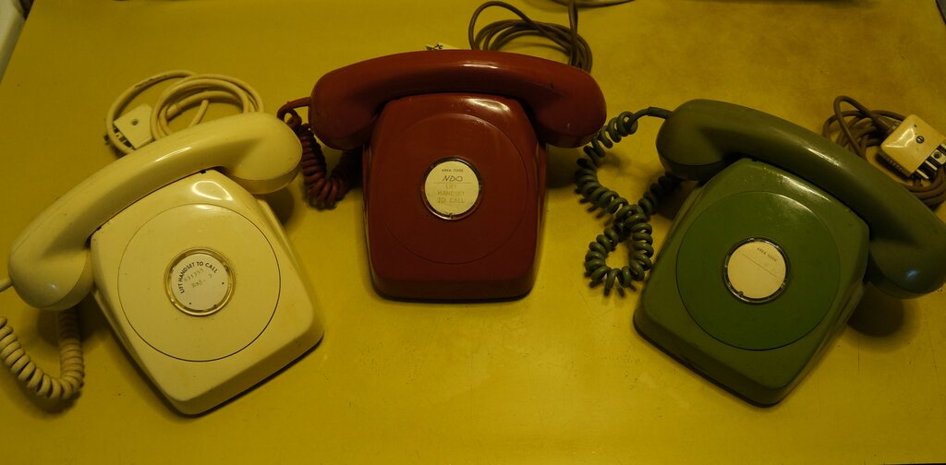
Series 800 Central Battery.
The CB version of the 800 is of course internally the same as the automatic version, except that the dial is omitted and the loop disconnect contacts are jumpered.
It can be used to take incoming calls in the normal way, and in this regard a Dialgizmo is not required.
As previously described, the socket connections and internal jumpers need to be correct for the bell to ring.
An interesting project would be a voice recognition circuit connected across the line, so that the phone could be used to make outgoing calls by reciting the required number, as one does with a manual exchange.
In other words, an 'electronic' operator. When the handset is lifted, a synthesised voice would say, "number please".
Then the user says the required digits, which the voice recognition circuit converts to DTMF tones.

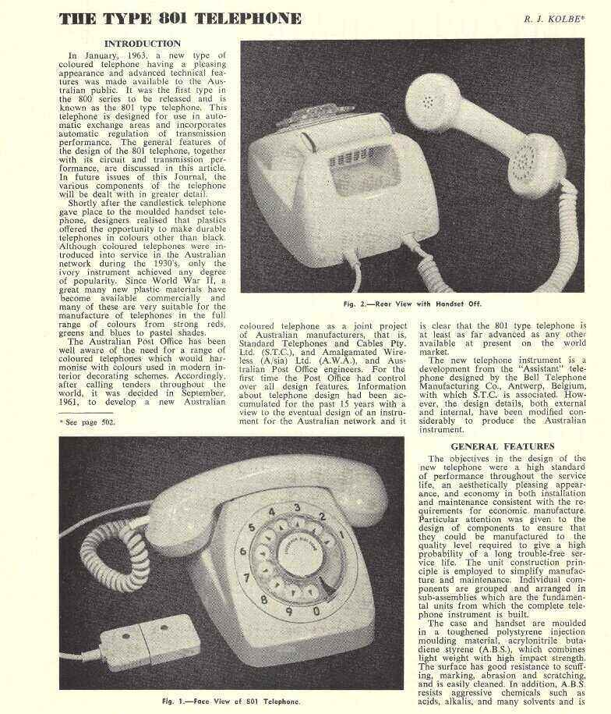
Notes on the Series 800.
