The Task...
The task was to build a single-wire telegraph line 3200 kilometres long north and south across Australia. The line was to join with a submarine cable from Java and so integrate into the growing world telegraph service.
It was to fulfil a contract made by the government of South Australia with the British Australian Telegraph Company, which undertook to provide the cable if South Australia built a line from Adelaide to Darwin:
The contract was made in June 1870.
It stipulated that the line had to be ready for operation by January 1, 1872.
This would end the communications isolation of the news-hungry colonists scattered in their different pockets of settlement around the Australian coast.
It would let them know what was happening in the world as it happened, not three months later when the mail steamer arrived.
The task involved penetrating into country — mercilessly cruel country in many parts — of which relatively little was known beyond Lake Eyre.
Tremendous organisation
Men and materials had to be obtained, leaders appointed and working parties organised. Transport, mainly horses and bullocks, had to be provided.
Poles — 36,000 of them — had to be cut and erected, some of them hauled many kilometres to places where wood was scarce.
To provision the working parties, herds of beef cattle and sheep had to be taken on the hoof over hundreds of kilo-metres of gibbers, sandhills and spinifex. The animals were slaughtered and eaten as required. There was no refrigeration in the 1870s.
The task had to be completed in eighteen months.
`And then, perhaps for the first time, I fully realised the vastness of the undertaking I had pledged myself to carry out." Charles Todd —on starting to plan construction of the 3200 km OT line after authority was granted by the South Australian Government — June 1870.
The Men...
The sweat of many men went into the building of the OT line. But of them all — engineers, surveyors, explorers, adventurers and labourers — the name that history knows is Charles Todd.
Charles Todd was postmaster-general, super-intendent of telegraphs and government astronomer of South Australia.
But that is not why his name is remembered. It is as the creator of the OT line, often still referred to in the Centre as Todd's line.
Charles Todd did not put up any poles. He did not survey the route.
He was not at Frew's Ponds when the final join was made there in the afternoon of August 22, 1872; that was engineer Robert Patterson's moment of glory.
But the planning was his; the organization was his; and the drive that carried the great project through to its successful conclusion was his.
Todd had a mind that could grasp the magnitude of the 3200 km project and divide it into such little pieces as the type of wood to select for poles; size of poles; job organization for winning; building specifications for repeater stations; sinking of wells; discipline; morale; care of animals; and food rationing details per man per day.
When mishaps in the north looked like wrecking the project, Todd went north to take charge.
After work there was resumed, he did not take the easy way home by ship. With a small party, he set out on a long, lonely journey overland.
He travelled south, the length of the line, inspecting construction and calling on the men (telegraph operators and line maintenance men) at the widely separated stations.
The journey took four months.
After it was over, Todd commended "the energetic officers and men who have, with so much credit to themselves, and in the face of difficulties not easily realised, carried out their part of the work entrusted to them."
It's a simple acknowledgement without heroics. Todd, practical and painstaking, was not the type of man for heroics.
But it acknowledges that the job was done; that the men who built the line and the operators who gave it life were tough, tenacious and resilient.
They had to be to survive.
The Country
Tough and treacherous; harsh and hostile; parched, arid and relentless — these and a dozen other similar adjectives are the stock-in-trade of every writer on inland Australia.
There is truth in them too. Even today, with the thin network of station and tourist roads, with the Royal Flying Doctor Service, with two-way radio and with four-wheel drive, inland Australia is a place where it is dangerous to be lost even for a few hours.
A hundred years ago there were no roads, no RFDS, no two-way radio and no four-wheel drive. Nor were there any ready-sunk bores extracting water from deep below the surface of the soil.
But there would have been the same merciless heat, the same burning gibbers, the same tangles of mulga scrub, and the same storms to whip the fine, penetrating sand into a fiery red fog.
Scanty knowledge
The knowledge that the men of the OT line had about this country before they set out on their gigantic task was scanty.
It was based on the reports of John McDouall Stuart who, eight years earlier, had shown that it was possible to cross the country south to north.
But, half blind and beset with his own troubles of searching for water and battling against heavy scrub, Stuart had not made a thorough survey.
His reports could be little more than guide lines for the OT parties.
The country along the route undergoes many changes —stony sparsely timbered plains north of Port Augusta; red sandhills and rocky bluffs and ranges through the Centre; and dense, tangled scrub further north towards tropical Darwin.
It is all difficult country, sometimes terrifying. Much of it even today is still untamed.
My Dearest Alice
Just before he left England in 1855 to take up his tele-graph appointment in Australia, Charles Todd got married. He was then 29 years old. His bride was a 17-year-old girl from Cambridge. Her name was Alice Gillam Bell.
Alice, from all accounts, was a lively young lady who knew her own mind.
"I will many you, Mr. Todd," she is alleged to have said at the age of 12, when the serious young Cambridge assistant astronomer called one day on Mrs. Bell.
Alice wasn't even supposed to be in the room at the time.
Still less was she supposed to be eavesdropping when her mother told the young visitor that it was time he thought of getting married.
Even less was she supposed to interject when the rather embarrassed Todd replied that he did not know any young lady who would want to marry him.
A good thing
It was a good thing that Mrs. Charles Todd was so naturally enterprising. She needed to be in her new life in colonial Australia. And adaptable too.
For she was often left to her own devices.
Only three years after arrival in the colony, her husband left her to go to Melbourne to negotiate the first inter-State telegraph link. His return overland over the route of-the Melbourne-Adelaide line prolonged his absence many weeks.
Then, when work on the OT line started, Todd was again away from home quite often.
First, he went up to The Peake to organise the difficult centre operation. Then, for the greater part of 1872, he was at the Roper River and on his long overland journey down the full length of the line to Adelaide.
While waiting at the Roper for work to be resumed after the wet season, Todd spent many of his frustrated hours writing.
My Dearest Alice
He wrote official reports; he wrote numerous work details and reminders in his diaries; and he wrote page after page to My Dearest Alice.
There were, of course, no regular mails to Adelaide — or to anywhere. It was necessary to wait until a ship was going south.
So the letters went on, day after day, and many pages were covered before the somewhat stilted ending: I am, Your Affectionate Husband, Charles Todd.
Those pages, some written in ink and some in pencil, contain his day-to-day thoughts on progress, or lack of progress, in the work; descriptions of conditions on the ship and at the Roper camp — the rain, the thunder, the lightning, the mosquitoes and the snakes; and husband-to-wife type remarks about others in the party.
There are also comments on the countryside.
"I wish you could see it, especially at sunrise and sunset, when the tints and reflections on
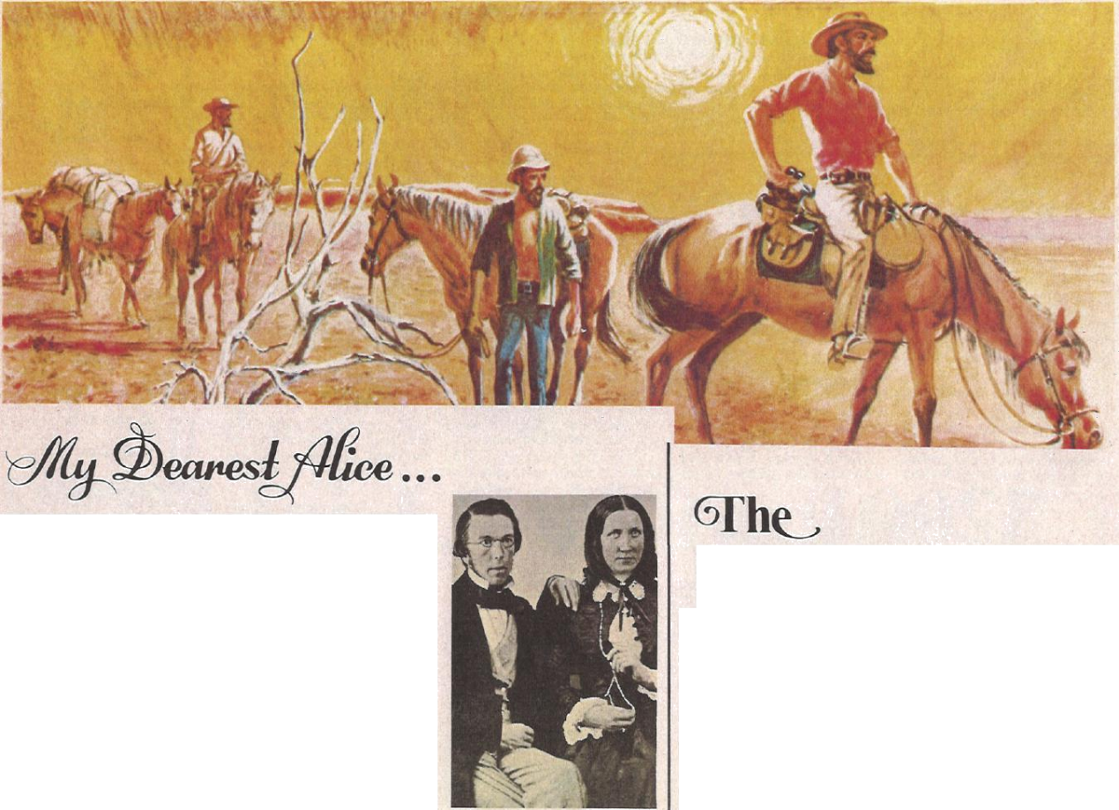
Above: canaries and Alice Todd, photographed shortly after their arrival in Australia.
Below left: The Alice Spring. . Below: Part of the old Alice Springs repeater station, now preserved as a museum.
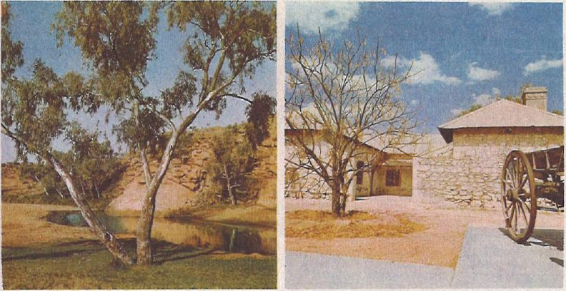
the water are most beautiful," he said of the Roper.
Gossipy little bits about friends and family intrude only rarely, just often enough to give a homely touch.
Perhaps more than any other of the numerous Todd documents the letters to Dearest Alice reveal Todd the man —capable, clear thinking, and impatient to get on with the job.
Dearest Alice. Her name lives on, thanks to party leader William Mills, who named a pool of water in the heart of Australia the Alice Spring.
A repeater station was built there. A township grew up nearby. It is now the hospitable tourist town Alice Springs.
Such was the destiny of little Alice Bell when she said, "I will marry you Mr. Todd."
The Casualties
Only six men died during construction of the OT line.
This, considering the numbers engaged, the demanding physical work, the heat in the centre, and the storms and floods in the north, was remarkable.
It is a tribute to Todd's organisation and efficiency.
He insisted on all provisions being the best possible quality. All parties were well equipped with medicines.
Medical officers were appointed. Dr. Renner, medical officer for the centre section, drove from party to party in a buggy. Dr. Rix accompanied Patterson as he moved among the parties in the difficult north.
The six deaths were C. W. Kraegen, a telegraph operator who died of thirst between Charlotte Waters and Alice Springs; C. Palmer, illness near Central Mount Stuart; Jeremy Harcus, lost while looking for horses in the north; and three others in the north — Daniel Kavenagh, Thomas Hawkins and Edward Powell — from sickness or drowning.
Patterson (left) and another mourner beside the grave of Kavenagh at the Roper River. Though many men were ill in the northern camps when supplies ran short, the deaths were remarkably few.
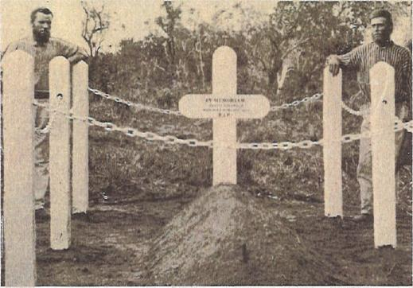

Mr. Frank Kraegen (grandson of C. W. I. Kraegen), of Sydney, and his son, John, beside Kraegen's grave on Maryvale station, 128 km south of Alice Springs. They discovered the grave in 1962.
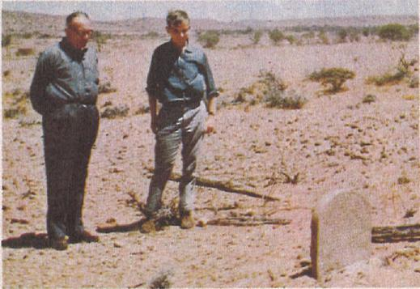
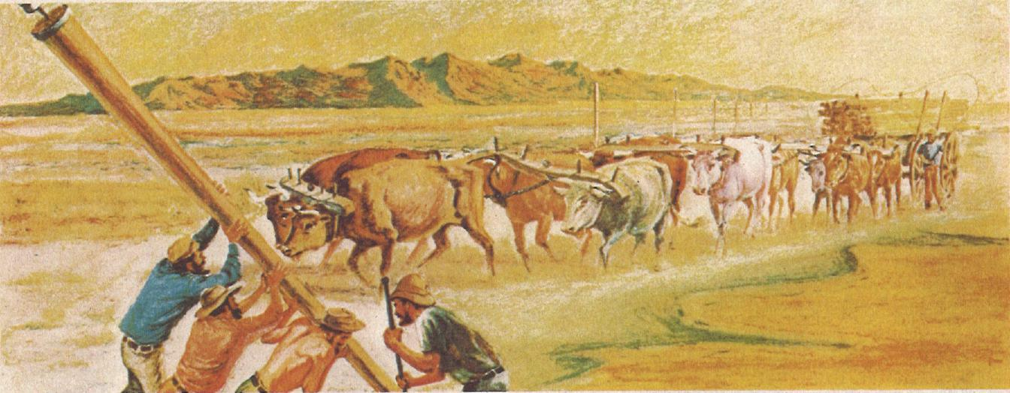

Construction of the 3200km Wire Link
The story of the construction of the overland telegraph line is of epic proportions.
To contemporaries, it was first and foremost the means of obtaining quick communication with Britain.
To the South Australian government, it was a top business deal and a political triumph.
It was good business because it meant that all Australian overseas telegraph traffic would pass through South Australia accordingly.
Politically, it was a victory over proposals supported by other States. One would have taken the line through Queens-land, another through Western Australia.
But, to the more imaginative people of the day, it was more than all that. It was heroic enterprise, with stimulating overtones of the exploits of the great explorers.

Like going to the Moon
That is why there was no dearth of applicants for the construction parties. There was a touch of glamour about the whole affair, like going to the Antarctic, or even to the moon today.
Postmaster-General Todd saw it both ways. He was imaginative enough to conceive its feasibility and its challenge; and he was astute enough to appreciate its political and economic advantage to his State.
That was why he had taken such great interest in the comings and goings of the overland explorers, especially Stuart.
When the South Australian government at last made its contract with the British Australian Telegraph Company and, on June 18, 1870, voted £120,000 ($240,000) to construct the line, he saw it differently again.
It was now a problem of organization. "Perhaps for the first time, I fully realised the vastness of the undertaking I had pledged myself to carry out," he said.
Todd's plans
Charles Todd made his plans. Every detail was specified; every contingency considered.
He divided the construction into three sections.
The southern and northern sections were to be built by private contractors. The central section, which was assumed to be the most difficult, was to be done by government teams.
With a compliment of men, materials and animals was on its way out of Adelaide.
Provisions and tools
All provisions and tools were of the best quality. Horses were selected by two of the best judges in Adelaide, and every draught horse was tested with a heavy load up a steep incline.
The southern section was from Port Augusta (already linked telegraphically with Adelaide) to the Macumba River, near Oodnadatta, a distance of 816 km. It was through semi-arid but settled pastoral country, and it was completed without mishap in the specified time.
The centre section was planned to extend north as far as Tennant Creek.
As the country was virtually unknown, explorer John Ross was sent ahead with a team of surveyors to select the best route. They left Adelaide on July 8.
For the actual construction Todd divided the section into five parts, A, B, C, D, and E.
Each party consisted of twenty men. The appointed leaders were Richard Knuckey (A), Gilbert McMinn (B), James Beckwith (C), Alfred Woods (D) and William Harvey (E). Woods was leader-in-charge.
Beckwith, unfortunately, be-came ill before reaching his starting-point and had to return to Adelaide. His place as leader was taken by William Mills.
Party A had 1280 km to travel before starting work. Party E had 2100 km, a journey which took eight months.

Instructions clear
The instructions for all parties were detailed, clear and the organisation for the southern section (contracted to Edward M. Bagot) and for the government parties was meticulous organization within the parties and working procedures, but also rationing, stores accounting, water conservation, care of animals, and many other details important to a large body of men on the move in strange country.
Todd himself went up as far as The Peake to confer with Ross and make arrangements with the party leaders before they began the long trek north.
As part of the huge provisioning organisation, drover Harley Bacon took 2,000 sheep to a base depot on the Finke.
For all parties, it was tough going all the way. But the job was done in the time stipulated in the contract.
Southern section (Bagot's contract)
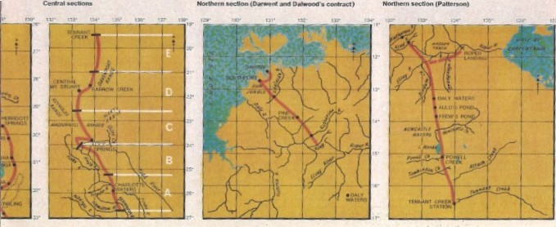
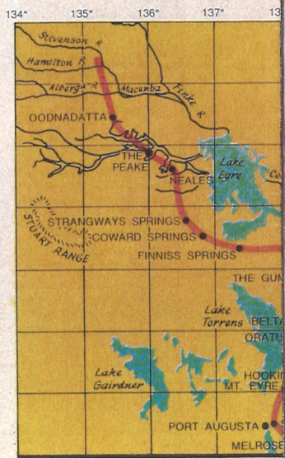
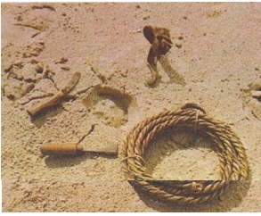

Some instruments and other items actually used in the construction of the OT line. In the top picture are two tools for tending horses' hooves, a riding spur, and a stock rope made from animal hide.
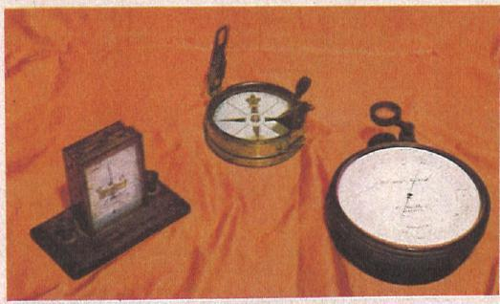
Above are some instruments used by Todd; they are (from left) a galvanometer, a prismatic compass and an aneroid barometer.
Below are a surveyor's chain and an iron stirrup which was used for climbing poles and trees
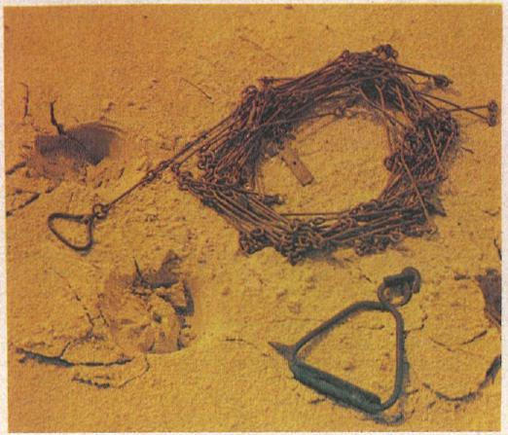

The line was open right through to Tennant Creek, 1810km north of Port Augusta, in December 1871.
Cable ashore
In the meantime (November 7, 1871), the company cable had been brought ashore at Darwin.
But neither the cable nor the Adelaide-Tennant Creek line could do the job it was built for until the 960 km gap in between was completed.
And this was where the trouble occurred.
Not that there had been any lack of enthusiasm at Darwin, where the contract for the long line southward had been let to two men, Joseph Darwent and William Dalwood.
Indeed, work had started in a great flurry of excitement, with ships arriving from Adelaide and unloading men, animals and equipment.

First pole at Darwin
September 15, 1870, was a gala day for the population (50) of Darwin, who witnessed the ceremonious erection of the first pole. It was almost like Royalty planting a tree, as Miss Harriet Douglas (daughter of the Government Resident) tamped down the earth with a polished hardwood rammer.
"In the name of Her Most Gracious Majesty Queen Victoria," Miss Douglas said, "I declare this pole well and truly fixed, and I wish the telegraph expedition every success."
But success was not destined for the Top End party.
Work started briskly enough, with 142 km of line up in 54 days. Then came the wet season.
Rivers which had been dry became raging torrents. Tracks became bogs. Animals floundered. Many of them were drowned.
Food went bad in the humid weather. Fresh supplies could not be got through the floods.
Work continued nonetheless, even though pole-holes filled with water as they were dug. Rafts were made to ferry men and equipment across the flooded rivers.
By the end of January 1871, the construction party had reached the Katherine River. They had erected 323 km of poles in four months.
But conditions worsened. The food position became desperate.
Some of the men refused to work.
The government overseer, dissatisfied with progress, cancelled the contract. Work stopped completely at the King River.
There was great consternation when this news reached Adelaide. A new expedition, a government one this time, was hastily organized.
Robert Patterson, an engineer, was in command.
It was August before Patter-son's party arrived. Many of his animals were sick and unable to make the journey to the King. A ship on which he loaded supplies to be taken round to the Roper River was grounded on a reef on the way.
Time running out
By the time he had sorted out his troubles, it was almost time for the next wet season. And time for completion of the contract was fast running out.
Meanwhile, Todd had instructed the leaders in the centre section to go further north, and to continue poling until they made contact with Patterson's parties. More supplies — materials and pro-visions — had to be sent inland; 1810 km inland.
With the onset of the wet season, the little work it had been possible to get started in the northern section ceased altogether.
Conditions were appalling. Patterson, beleaguered at the supply depot on the Roper River was in a desperate position. Men were sick; animals were lost in the floods; food was in short supply.
On the day the contract expired, there were still 630 km to be completed.
Todd left Adelaide with fresh horses and supplies on January 4 and arrived at the mouth of the Roper three weeks later.
He then asked the captain of the ship (Omeo, 1020 tonnes) to take her up the river to the supply depot landing.
No half measures
When the captain demurred, Todd pledged the government to full indemnity in case of damage. "Half measures were not to be thought of," he said.
It was April before work got under way again.
And there were no half measures here either.
With 300 men, now well equipped, on the job, progress was good. It needed to be. The cable company was pressing for compensation for failure to meet the contract date.
So, in an attempt to keep commitments, the completed sections were put into operation, and a pony express was organized to carry messages over the now fast diminishing gap.
This was actually how the first overseas messages were carried through to Adelaide.
First lucky break
But not for long. On June 24 came the first lucky break that the South Australian government had had since the northern debacle began.
The cable between Darwin and Java broke down. No more was heard about compensation.
From then on, it was just a matter of time — short time too
— until the two ends met near Frew's Ponds on August 22.
"In about five minutes I had the joint complete," Patterson said, "and Adelaide was in communication with Darwin. It would have been with England had the cable not broken down.
"We drank success to the overland telegraph and fired off twenty-one rounds from our revolvers and immediately adjourned to Frew's Ponds."
Charles Todd had stayed in the north two months after work was resumed. On June 22nd he began
his long overland journey and, by August 22, had reached Central Mount Stuart.
Greatly excited
There, greatly excited, he made camp for the night.
On his little pocket relay, he received messages of congratulation from all over Australia. —from governments, from municipal bodies, from foreign consuls, from representatives of all kinds of organizations likely to benefit from the telegraph.
It was a bitterly cold night.
"I was nearly frozen," he said, "and completely knocked up with fatigue and excitement. I called for hearty cheers from my companions, and nearly choked my valuable cook who eagerly essayed to respond with a chilli in his mouth."
The job was done
The job was done; the tension was off.
"I may with confidence assert," said the highly gratified Todd, "that no line passing through a similar extent of uninhabited country, where the materials had to be carted over such long distances, no line of equal length and presenting similar natural obstacles has been constructed in the same short space of time."
There was excitement in Adelaide too, where the news was greeted with peals of bells.
But they waited until November 15 for the biggest celebration. By that time, the cable had been repaired (October 21) and Todd was back in Adelaide (October 30).
November 15 was a public holiday in Adelaide, and the enthusiastic colonials celebrated with uninhibited fervour. At night, the members of the construction parties were entertained at a banquet.
Cost of the line
The cost of the line, naturally enough, had greatly exceeded the original $240,000.
The final capital cost was $479,175, which included the building of eleven repeater stations.
The repeaters were, in order south from Darwin, at Yam Creek, Katherine, Daly Waters, Powell Creek, Tennant Creek, Barrow Creek, Alice Springs, Charlotte Waters, The Peake, Strangways Springs and Beltana.
These stations, and the men who lived in them for long, lonely months on end, kept the line alive; kept Australia in what Todd so picturesquely called "the giant electric chain which unites all nations of the earth".
Even today, with more sophisticated communications ready at hand, the men of the OT line are a legend in the Northern Territory.
Those who know the Territory and its hazards know just what Todd and his men achieved.
They challenged the unknown; and they won.

